NAME – AMAN SHARMA

REGISTER NO – 21BCE5769

REMAINDER 0

**1. CODE:**

**USING ONLY LEX:**

%{

#include <stdio.h>

#include <string.h>

int count = 0;

%}

%%

[a-zA-Z][a-zA-Z0-9]* {

int n = strlen(yytext);

for(int i = 0; i<n; i++){

if(yytext[i] >= '0' && yytext[i] <= '9')

count++;

}

if(count >=1 && count <= 3)

printf("Valid String\n");

else

printf("Invalid String\n");

}

[0-9][a-zA-Z0-9]* {printf("Invalid String\n");}

\t {return 0;}

\n {return 0;}

. {return 0;}

%%

int main(){

yylex();

return 0;

}

int yywrap(){}

**OUTPUT:**

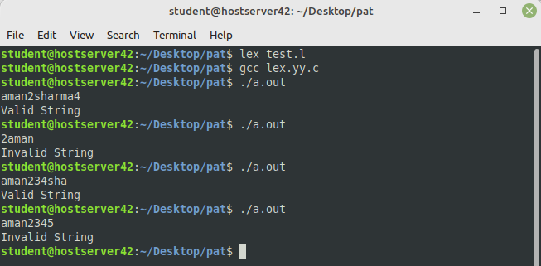

**LEX:**

%{

#include "y.tab.h"

%}

%%

[a-zA-Z] {return char;}

[0-9] {return num;}

\n {return NL;}

%%

int yywrap(){}

**YACC:**

%{

#include <stdio.h>

#include <stdlib.h>

int yylex();

void yyerror(const char* msg);

int count = 0;

%}

%token char num NL

%%

S: E NL

E : E T

E: char

;

T: num {count++;}

;

%%

int main(){

printf("Enter the string\n");

yyparse();

if (count <= 3){

printf("Valid");

}

return 0;

}

int yyerror(char *msg){

printf("Error: %s\n", msg);

exit(0);

}

**OUTPUT:**

SHIFT/REDUCE ERROR

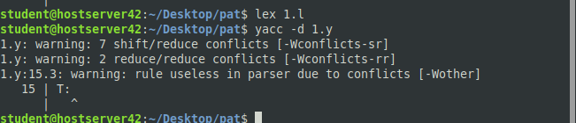

**2.CODE:**

**LEX:**

%{

#include "y.tab.h"

%}

%%

[0] {return ZERO;}

[1] {return ONE;}

[2] {return TWO;}

[3] {return THREE;}

[4] {return FOUR;}

[5] {return FIVE;}

[6] {return SIX;}

[7] {return SEVEN;}

"\n" {return NL; }

. {return yytext[0]; }

%%

int yywrap(){}

**YACC:**

%{

#include <stdio.h>

#include <stdlib.h>

#include <math.h>

int yylex(void);

int yyerror(char *s);

int count = 0;

%}

%union{

float f;

}

%token <f>ZERO <f>ONE <f>TWO <f>THREE <f>FOUR <f>FIVE <f>SIX <f>SEVEN NL

%type <f>N <f>L <f>R <f>B

%%

E: N NL {printf("Result = %f\n", $1); return 0;}

N: L '.'R

L: L B {$$ = $1*8 + $2;}

| B {$$ = $1;}

R: R B {$$ = ($1*8 + $2)/pow(8,count);}

| B {$$ = $1; count++;}

B: ZERO {$$ = 0; count = 1;}

| ONE {$$ = 1; count = 1;}

| TWO {$$ = 2; count = 1;}

| THREE {$$ = 3; count = 1;}

| FOUR {$$ = 4; count = 1;}

| FIVE {$$ = 5; count = 1;}

| SIX {$$ = 6; count = 1;}

| SEVEN {$$ = 7; count = 1;}

;

%%

int main() {

printf("Enter the Octal Number\n");

yyparse();

}

int yyerror(char* s) {

printf("Expression is invalid\n");

}

**OUTPUT:**

