Министерство образования Республики Беларусь

Учреждение образования

БЕЛОРУССКИЙ ГОСУДАРСТВЕННЫЙ УНИВЕРСИТЕТ

ИНФОРМАТИКИ И РАДИОЭЛЕКТРОННИКИ

Факультет компьютерных систем и сетей

Кафедра электронных вычислительных машин

Лабораторная работа №6

Создание приложения для базы данных

Студент: В.С. Шевцов

Преподаватель: Д.В. Куприянова

МИНСК 2024

**СОДЕРЖАНИЕ**

1 СОЗДАНИЕ ПРИЛОЖЕНИЯ 4

1.2 Подключение к базе данных 4

1.3 Графические окна 4

1.4 Извлечение данных из базы и запись изменений 7

ЗАКЛЮЧЕНИЕ 8

ПРИЛОЖЕНИЕ А 9

# СОЗДАНИЕ ПРИЛОЖЕНИЯ

Для создания приложения был выбран язык C# .Net Core 5.

Для работы с PostgreSQL был установлен пакет Npgsql, обеспечивающий все необходимые функции для работы с бд.

Графический интерфейс был реализован с помощью windows forms.

## Подключение к базе данных

Для подключения к бд требуется указать имя базы данных, пароль, порт на которой база запущена и другую конфигурационную информацию.

Скрипт подключения к базе данных представлен на рисунке 1.1

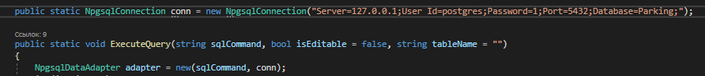

Рисунок 1.1 – Скрипт подключения к базе данных

## Графические окна

Для взаимодействия с базой были созданы следующие окна: окно выбора операции и ее запуск (рисунок 1.2), окно вывода результата запроса (рисунок 1.3), окно выбора исходной таблицы для просмотра (рисунок 1.4), редактирования, удаления и добавления данных (рисунок 1.5).

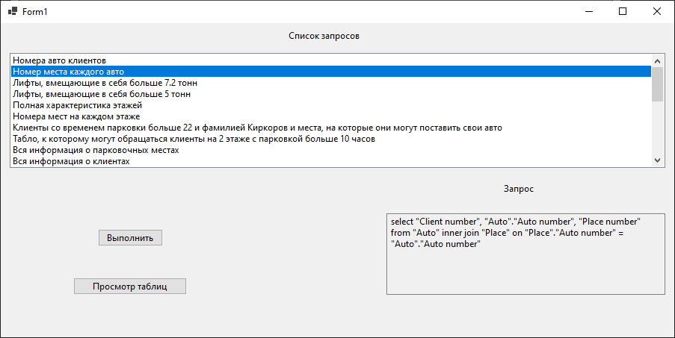

Рисунок 1.2 – окно выбора операции

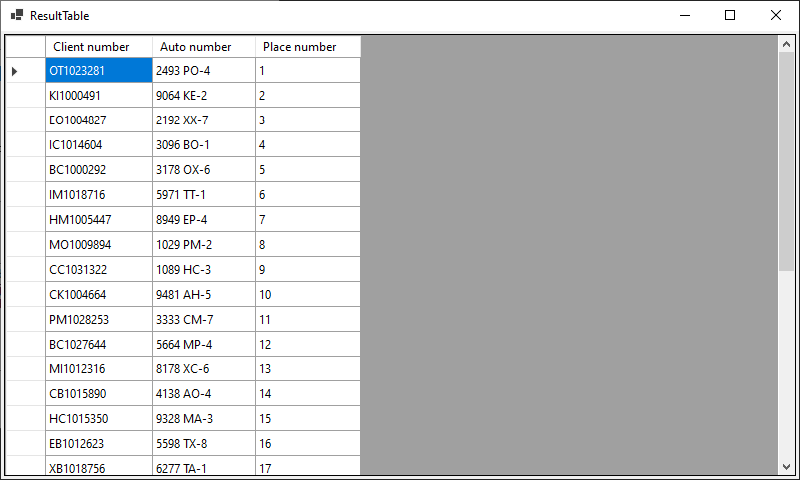

Рисунок 1.3 – окно вывода результата операции

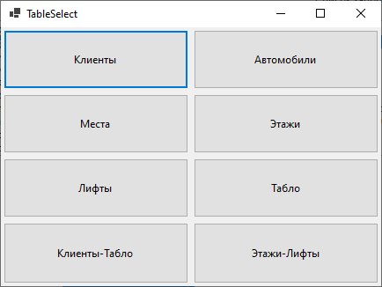

Рисунок 1.4 – Выбор таблицы для просмотра

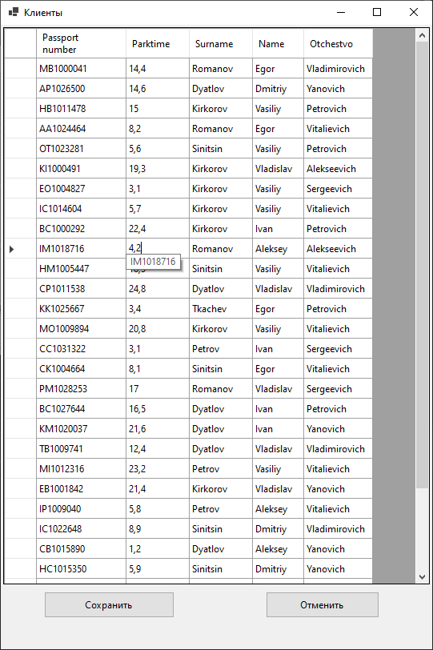

Рисунок 1.5 – окно для работы с таблицей

## Извлечение данных из базы и запись изменений

Для получения данных из базы использовался класс NpgsqlDataAdapter с последующей их записью в DataSet для передачи в графическую форму.

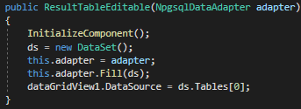

Рисунок 1.6 – извлечение данных из бд

Для записи изменений в базу данных использовался метод адаптера Update и автоматический конструктор CRUD-операций.

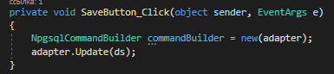

Рисунок 1.7 – сохранение внесенных изменений

В адаптер данные записываются на основе информации о подключении к бд и sql запросе.

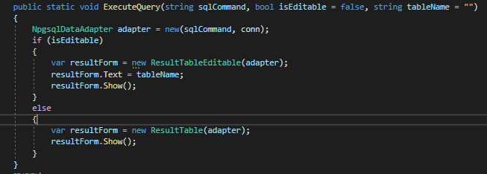

Рисунок 1.8 – создание адаптера

Собственно сами запросы представлены на рисунке 1.9.

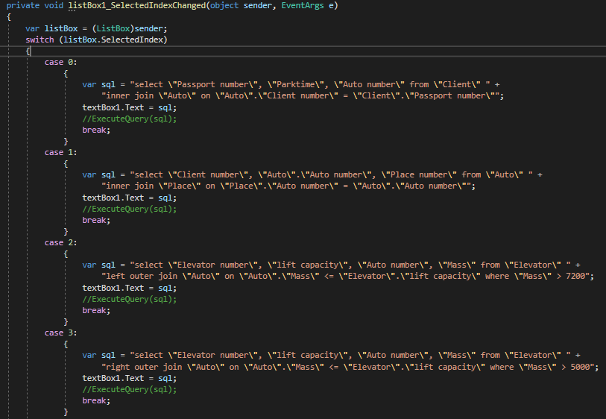

Рисунок 1.9 – sql-запросы

# ЗАКЛЮЧЕНИЕ

В ходе данной лабораторной работы было создано простое серверное приложение на базе .NET Core 5. Был реализован функционал SQL-запросов из лабораторных работ 4 и 5. Создано графическое приложение для работы с таблицами базы данных.

# ПРИЛОЖЕНИЕ А

Листинг кода

namespace WinFormsApp1

{

public partial class Form1 : Form

{

public Form1()

{

InitializeComponent();

conn.Open();

}

public static ApplicationContext db = new ApplicationContext();

public static NpgsqlConnection conn = new NpgsqlConnection("Server=127.0.0.1;User Id=postgres;Password=1;Port=5432;Database=Parking;");

public static void ExecuteQuery(string sqlCommand, bool isEditable = false, string tableName = "")

{

NpgsqlDataAdapter adapter = new(sqlCommand, conn);

if (isEditable)

{

var resultForm = new ResultTableEditable(adapter);

resultForm.Text = tableName;

resultForm.Show();

}

else

{

var resultForm = new ResultTable(adapter);

resultForm.Show();

}

}

private void listBox1_SelectedIndexChanged(object sender, EventArgs e)

{

var listBox = (ListBox)sender;

switch (listBox.SelectedIndex)

{

case 0:

{

var sql = "select \"Passport number\", \"Parktime\", \"Auto number\" from \"Client\" " +

"inner join \"Auto\" on \"Auto\".\"Client number\" = \"Client\".\"Passport number\"";

textBox1.Text = sql;

break;

}

case 1:

{

var sql = "select \"Client number\", \"Auto\".\"Auto number\", \"Place number\" from \"Auto\" " +

"inner join \"Place\" on \"Place\".\"Auto number\" = \"Auto\".\"Auto number\"";

textBox1.Text = sql;

break;

}

case 2:

{

var sql = "select \"Elevator number\", \"lift capacity\", \"Auto number\", \"Mass\" from \"Elevator\" " +

"left outer join \"Auto\" on \"Auto\".\"Mass\" <= \"Elevator\".\"lift capacity\" where \"Mass\" > 7200";

textBox1.Text = sql;

break;

}

case 3:

{

var sql = "select \"Elevator number\", \"lift capacity\", \"Auto number\", \"Mass\" from \"Elevator\" " +

"right outer join \"Auto\" on \"Auto\".\"Mass\" <= \"Elevator\".\"lift capacity\" where \"Mass\" > 5000";

textBox1.Text = sql;

break;

}

case 4:

{

var sql = "select \"Table\".\"Floor number\", \"Floor\".\"Height\", \"Place type\", \"Place numbers\" from \"Floor\"" +

" right outer join \"Table\" on \"Floor\".\"Floor number\" = \"Table\".\"Floor number\"";

textBox1.Text = sql;

break;

}

case 5:

{

var sql = "select \"Table\".\"Floor number\", \"Floor\".\"Height\", \"Place type\", \"Place numbers\" from \"Floor\"" +

" left outer join \"Table\" on \"Floor\".\"Floor number\" = \"Table\".\"Floor number\"";

textBox1.Text = sql;

break;

}

case 6:

{

var sql = "select * from \"Client\" cross join \"Place\" where \"Parktime\" > 22 and \"Surname\" = 'Kirkorov'";

textBox1.Text = sql;

break;

}

case 7:

{

var sql = "select * from \"Table\" cross join \"Client\" where \"Floor number\" = 2 and \"Parktime\" > 10";

textBox1.Text = sql;

break;

}

case 8:

{

var sql = "select * from \"Auto\" full outer join \"Place\" on \"Auto\".\"Auto number\" = \"Place\".\"Auto number\" order by \"Auto\".\"Auto number\" desc";

textBox1.Text = sql;

break;

}

case 9:

{

var sql = "select * from \"Client\" full outer join \"Auto\" on \"Passport number\" = \"Client number\"";

textBox1.Text = sql;

break;

}

case 10:

{

var sql = "select \"Client\".\"Surname\", \"Name\", \"Parktime\", \"Auto\".\"Auto number\" from \"Client\" " +

"join \"Auto\" on \"Passport number\" = \"Client number\" " +

"join \"Place\" on \"Auto\".\"Auto number\"=\"Place\".\"Auto number\" " +

"group by \"Name\", \"Surname\", \"Parktime\", \"Auto\".\"Auto number\" " +

"having \"Parktime\" > (select avg(\"Parktime\") from \"Client\") " +

"order by \"Auto\".\"Auto number\"";

textBox1.Text = sql;

break;

}

case 11:

{

var sql = "select sum(\"Mass\") as \"Summary auto mass\", min(\"Parktime\") as \"Minimum parktime\",max(\"Table\".\"Table number\") as \"Maximum Table number\"," +

"(select count(*) from \"Client\" where \"Surname\" = 'Kirkorov') as \"Kirkorov count\"from \"Client\" " +

"join \"Auto\" on \"Passport number\" = \"Auto\".\"Client number\" " +

"join \"Client_Table\" on \"Client_Table\".\"Client number\" = \"Passport number\" " +

"join \"Table\" on \"Client_Table\".\"Table number\" = \"Table\".\"Table number\"";

textBox1.Text = sql;

break;

}

case 12:

{

var sql = "with ClientAuto as (" +

"select \"Passport number\" from \"Client\" " +

"union select \"Auto\".\"Client number\" from \"Auto\"), " +

"AutoPlace as (" +

"select \"Auto\".\"Auto number\" from \"Auto\" " +

"union select \"Place\".\"Auto number\" from \"Place\")" +

"select \"Surname\", \"Passport number\", \"Auto number\" from \"Client\" " +

"join \"Auto\" on \"Passport number\" = \"Client number\" " +

"where \"Passport number\" in (select * from ClientAuto) and \"Auto number\" in (select * from AutoPlace)";

textBox1.Text = sql;

break;

}

case 13:

{

var sql = "with ClientAuto as (" +

"select \"Passport number\" from \"Client\" " +

"union all select \"Auto\".\"Client number\" from \"Auto\"), " +

"AutoPlace as ( " +

"select \"Auto\".\"Auto number\" from \"Auto\" " +

"union all select \"Place\".\"Auto number\" from \"Place\")" +

"select \"Surname\", \"Passport number\", \"Auto number\" from \"Client\" " +

"join \"Auto\" on \"Passport number\" = \"Client number\" " +

"where \"Passport number\" not in (select * from ClientAuto where \"Passport number\" = 'AA1024464') and \"Auto number\" in (select * from AutoPlace);";

textBox1.Text = sql;

break;

}

case 14:

{

var sql = "with ClientAuto as (" +

"select \"Passport number\" from \"Client\" " +

"except select \"Auto\".\"Client number\" from \"Auto\"), " +

"AutoPlace as ( " +

"select \"Auto\".\"Auto number\" from \"Auto\" " +

"intersect select \"Place\".\"Auto number\" from \"Place\")select \"Surname\", \"Passport number\", \"Auto number\" from \"Client\" " +

"join \"Auto\" on \"Passport number\" = \"Client number\" " +

"where \"Passport number\" not in (select * from ClientAuto) and \"Auto number\" in (select * from AutoPlace);";

textBox1.Text = sql;

break;

}

case 15:

{

var sql = "select \"Surname\", \"Name\", \"Parktime\", \"Auto\".\"Auto number\"from \"Client\" join \"Auto\" on \"Passport number\" = \"Client number\"join \"Place\" on \"Auto\".\"Auto number\"=\"Place\".\"Auto number\"where exists (select * from \"Client\" where \"Surname\" = 'Kirkorov')order by \"Surname\" asc;";

textBox1.Text = sql;

break;

}

case 16:

{

var sql = "select \"Surname\", \"Name\", \"Parktime\", \"Auto\".\"Auto number\"from \"Client\" join \"Auto\" on \"Passport number\" = \"Client number\"join \"Place\" on \"Auto\".\"Auto number\"=\"Place\".\"Auto number\"where \"Parktime\" > any(select \"Parktime\" from \"Client\" where \"Surname\" = 'Sinitsin')order by \"Auto\".\"Auto number\";";

textBox1.Text = sql;

break;

}

case 17:

{

var sql = "select \"Surname\", \"Name\", \"Parktime\", \"Auto\".\"Auto number\", \"Mass\" from \"Client\" join \"Auto\" on \"Passport number\" = \"Client number\" join \"Place\" on \"Auto\".\"Auto number\"=\"Place\".\"Auto number\" group by \"Surname\", \"Name\", \"Mass\", \"Parktime\", \"Auto\".\"Auto number\" having \"Parktime\" > (select avg(\"Parktime\") from \"Client\") and \"Mass\" between min(\"Mass\") and max(\"Mass\") order by \"Auto\".\"Auto number\";";

textBox1.Text = sql;

break;

}

case 18:

{

var sql = "select \"Client\".\"Surname\", \"Name\", \"Parktime\", \"Auto\".\"Auto number\" from \"Client\" join \"Auto\" on \"Passport number\" = \"Client number\" join \"Place\" on \"Auto\".\"Auto number\"=\"Place\".\"Auto number\" where \"Name\" <> 'Vasiliy' order by \"Name\" asc;";

textBox1.Text = sql;

break;

}

case 19:

{

var sql = "select \"Surname\", \"Passport number\", \"Auto number\" from \"Client\" join \"Auto\" on \"Passport number\" = \"Client number\" where \"Passport number\" like '%B%' order by \"Passport number\";";

textBox1.Text = sql;

break;

}

case 20:

{

var sql = "select \"Passport number\", \"Floor\".\"Floor number\", \"Place type\", \"Height\" from \"Client\" join \"Client_Table\" on \"Client number\" = \"Passport number\" join \"Table\" on \"Table\".\"Table number\" = \"Client_Table\".\"Table number\" join \"Floor\" on \"Table\".\"Floor number\" = \"Floor\".\"Floor number\";";

textBox1.Text = sql;

break;

}

case 21:

{

var sql = "select avg(\"Mass\") as \"Average auto mass\", avg(\"Parktime\") as \"Average parktime\", (select count(*) from \"Client\" where \"Surname\" = 'Kirkorov') as \"Kirkorov count\" from \"Client\" join \"Auto\" on \"Passport number\" = \"Auto\".\"Client number\" join \"Client_Table\" on \"Client_Table\".\"Client number\" = \"Passport number\";";

textBox1.Text = sql;

break;

}

case 22:

{

var sql = "select * from \"Client\" join \"Client_Table\" on \"Client number\" = \"Passport number\" join \"Table\" on \"Table\".\"Table number\" = \"Client_Table\".\"Table number\" join \"Floor\" on \"Table\".\"Floor number\" = \"Floor\".\"Floor number\";";

textBox1.Text = sql;

break;

}

case 23:

{

var sql = "select \"Surname\", \"Passport number\", \"Auto\".\"Auto number\", \"Place number\" from \"Client\" join \"Auto\" on \"Passport number\" = \"Client number\" join \"Place\" on \"Auto\".\"Auto number\" = \"Place\".\"Auto number\" where \"Passport number\" not in (select \"Passport number\" from \"Client\" where \"Passport number\" like '%4%');";

textBox1.Text = sql;

break;

}

case 24:

{

var sql = "select \"Surname\", \"Passport number\", \"Auto\".\"Auto number\", \"Place number\" from \"Client\" join \"Auto\" on \"Passport number\" = \"Client number\" join \"Place\" on \"Auto\".\"Auto number\" = \"Place\".\"Auto number\" where \"Passport number\" in (select \"Passport number\" from \"Client\" where \"Passport number\" like '%13%') order by \"Surname\";";

textBox1.Text = sql;

break;

}

default: break;

}

}

private void ExecuteButton_Click(object sender, EventArgs e)

{

ExecuteQuery(textBox1.Text);

}

private void ShowTablesButton_Click(object sender, EventArgs e)

{

TableSelect form = new();

form.Show();

}

}

}

namespace WinFormsApp1

{

public partial class ResultTableEditable : Form

{

private DataSet ds;

private NpgsqlDataAdapter adapter;

public ResultTableEditable(NpgsqlDataAdapter adapter)

{

InitializeComponent();

ds = new DataSet();

this.adapter = adapter;

this.adapter.Fill(ds);

dataGridView1.DataSource = ds.Tables[0];

}

private void CanselButton_Click(object sender, EventArgs e)

{

this.Close();

}

private void SaveButton_Click(object sender, EventArgs e)

{

NpgsqlCommandBuilder commandBuilder = new(adapter);

adapter.Update(ds);

}

}

}