**Esports**

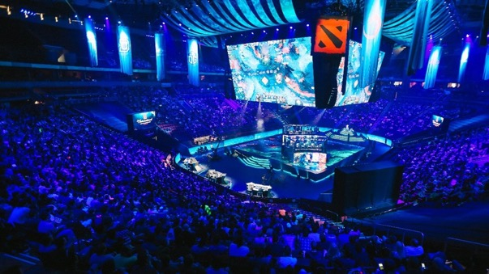

Picture taken from: <https://www.thetimes.co.uk/raconteur/business/why-esports-is-attracting-global-brands-and-what-it-has-to-do-to-get-more/> (last access: May 14, 2019)

**Task 1**

In groups of 4-5, create a **mind map** collecting all the information you have on esports.

What is it, which games are played, (how) does it affect your personal life?

Include the following aspects:

* Motivation for esports
* Dangers
* Ways of playing
* Requirements
* Famous players
* Etc.

You might want to use *Venngage* in order to create your mind map and also to collaborate on the design with your whole team: <https://venngage.com/mind-map-maker/>   
Just register for a free account with an email address.

**Task 2**

**Esports – a big business**

In pairs, watch the YouTube video (https://www.youtube.com/watch?v=F_GxPXXLc-w) and answer the following questions by taking notes:

* 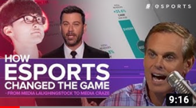**How did esports evolve?**
* **What is it exactly?**
* **In which way is it controversial?**
* **How has it become big business?**

**Task 3**

**Esports – an infographic**

Watch the video again and in a group of 4 **create an infographic** about esports.

Include the information you consider essential in order to **make somebody invest in esports**.

Again, use *Venngage* to create your infographic. Keep in mind, you can collaborate online if you like.

Here are **8 tips** in order to create a good infographic:

1. Collect all the relevant data.
2. Use a sheet of paper (or your tablet and pen) and group the information using  
    relevant sub-headings.
3. Think about how you will structure your infographic.
4. Sketch out your ideas.
5. Go to Venngage.
6. Choose a design or create a new one.
7. Store your infographic as a .png or .jpg file.
8. Share your infographic (OneDrive, Dropbox, Google Drive, etc.).

*Exemplary infographic:*

This is an infographic on how to customize your template. For a larger view, go to:



<https://venngage.com/templates/infographics/how-to-customize-your-infographic-template-578de64d-9086-4e61-847b-df88c0e38543>

**Follow-up Task 4**

**Individual writing task**

Esports have become more and more recognized as a “real” sport. Therefore, it is being discussed whether these games should become Olympic.

**Watch this TED Talk** with Jonathan Pan (a professional US gamer) in order to get a general idea on this issue.



<https://www.youtube.com/watch?v=xPxZTqRkvCc>



**Write a short text (100 words)** discussing the following question:

***“Should esports be part of the Olympic Games in L.A. in 2028?”***

(picture taken from: Wikipedia.com)