Tetbury Woolsack Races

- give general information about this sport (rules, number of players/participants, place, equipment, target group)

You get a woolsack and you have to carry it up the Gumstool Hill in Tetbury.

Each event there are around of 5000 people watching. They also close down roads for this event.

The course starts at the pub on the bottom of Gumstool Hill, which is called: Royal Oak Tetbury.
It ends at the pub on the top of the hill, which is called: The Crown.
The course is 240 yard long.

You can either run alone or in a team.
A team consists of 4 people and you take turns running with the sack.

The weight of the sack:

Men: 60lbs
Woman: 35lbs
Youth (14-17 y/o): 35lbs

Prices:
Team: £50
Youth-Team: £30
Individual: £20
Primary School: Free (running with pillow cases)

Entertainment park:
They also have an entertainment park at the event.
Sponsored by the Feoffees of Tetbury (how tf do you pronounce that??)
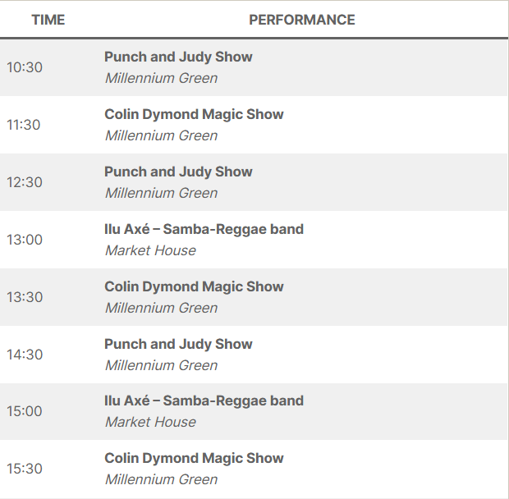

History:

In the 17h Century Tetbury was one of the best-known wool market in the country.
It said that the drovers drank a beer in the pub (name: Royal Oak Tetbury), at the bottom of Gumstool Hill.
Then they would run up the hill with a sheep or a woolsack on their back.
And then drink another beer at the pub on the top of Gumstool Hill (name: The Crown).

- suggest what could be done to make this type of sport more popular

If you didn’t have to pay to take part in this sport.
They should do more marketing.
More events but in different places, because nobody wants to travel the world to run around with a woolsack.

- discuss whether this activity should be considered a sport

I feel like everything that is physically challenging can be considered a sport.
But I also feel like, if it is a sport, then there should be training sessions. There should be tournaments. You should be able to compete against others, on more occasions. This woolsack race is only a few times in one year.

Video: https://www.youtube.com/watch?v=NnMacVUxNM8

