**Dokumentasi Quiz & Tugas**

**PEMROGRAMAN DESKTOP**

# 124111021-Lucky Fauzi

|  |  |
| --- | --- |
| NIM | 124111021 |
| NAMA MAHASISWA | Lucky Fauzi |
| FOTO |  |
|  |

# MINGGU 1 – PENGANTAR PEMROGRAMAN DESKTOP

NAMA : Lucky Fauzi

NPM : 124111021

NO ABSEN : 01

KELAS : IF1B

A. STRUKTUR PROJECT

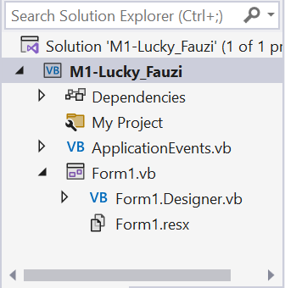

B. DESAIN FORM

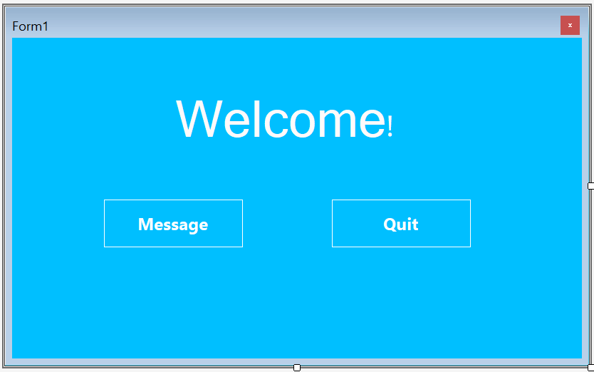

C. KODE PROGRAM

Public Class frmUtama

Private Sub btnPesan_Click(sender As Object, e As EventArgs) Handles btnPesan.Click

MsgBox("Hello World!" & vbCrLf &

"My Name is Lucky Fauzi, from Bandung.", MsgBoxStyle.Information,

"Attention")

End Sub

Private Sub btnQuit_Click(sender As Object, e As EventArgs) Handles btnQuit.Click

Me.Close()

End Sub

End Class

D. RUN PROGRAM

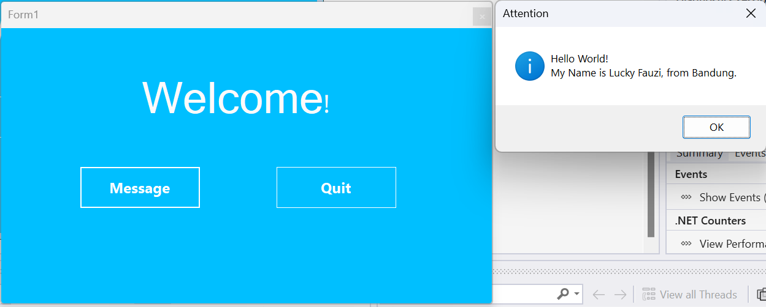

# MINGGU 2 – TYEPE DATA & VARIABLE VB.NET

NAMA :

NPM :

NO ABSEN :

KELAS :

A. STRUKTUR PROJECT

B. DESAIN FORM

C. KODE PROGRAM

D. RUN PROGRAM

# MINGGU 3 – MDI (MULTIPLE DOCUMENT INTERFACE)

NAMA :

NPM :

NO ABSEN :

KELAS :

A. STRUKTUR PROJECT

B. DESAIN FORM

C. KODE PROGRAM

D. RUN PROGRAM