UNIVERSITÀ STUDI DEL SANNIO



Dipartimento di Ingegneria

Corso di Laurea in Ingegneria Informatica

Pre-trained models reuse: a case-study in precision farming ​

Table of Contents
1. Introduction 3
1.1 Background 3
1.2 Research Methodology 3
2. Relevant Models 4
2.1 IBM Granite - General Overview 4
2.1.1 Granite TinyTimeMixers 4
2.1.2 Granite TSPulse 8
2.1.3 Grasnite PatchTST 11
2.1.4 Granite PatchTSMixer 13
2.1.5 Granite FlowState 15
2.1.6 Granite Geospatial Biomass 17
2.2 Smart Farming Disease Detection Transformer 18
2.3 Fruits and Vegetables Detector 36 20
2.4 Plant leaf Detection and Classification 21
2.5 Plant Leaf Diseases Detection 22
2.6 Keras Timeseries Anomaly Detection 23
2.7 AdaptLLM Remote Sensing 24
2.8 CropSeek LLM 26
3. Models reusability 27
4. Non-relevant Models 30
4.1 OpenMed NER 30
4.2 PlanTL models 30
4.3 Plant Genome Analysis 31
4.4 Others 31
References 32

1. Introduction
TODO
Paper su riuso di modelli > https://arxiv.org/pdf/2404.16688
Model reusability is a practice in which pre-trained machine learning models are reused in new tasks, datasets, or environments rather than building solutions from scratch. This practice reduces development time and cost, both in the training process and in data collection, as instead of collecting a large corpus of data for training from scratch, developers may instead gather a smaller amount of samples for an eventual fine-tuning of the models.
Important care has to be put in evaluating the effectiveness of the model in the new field, as it may present bias towards the original training data; as such, fine-tuning may be a necessary step before the deployment of the models in a production environment.
In this thesis, we will analyze the reusability of several pre-trained models applied in the field of precision farming, localized in the FARM-TECH project.

Background
TODO
FARM-TECH is a research project developed by Smart Shaped and Trace Technologies, financed by Ministry of University and Research, with University of Sannio involved as external consultant.
We have been tasked with identifying the best practices for creating a ML model and correspondent MLOps pipeline to perform analysis and forecasting based on the data produced by sensors and drone analysis involved in the project

1.2 Research Methodology
Dr. Federica Pepe, in an on-going work related to FARM-TECH, compiled a list of pre-trained models for her research on bias developed in AI models. The models were collected from HuggingFace if they contained, either in the repo name or readme, any of the terms listed below. Any models with less than 100 downloads were discarded.
[lista dei termini tipo in una tabella boh]
Building upon this list, they will be considered in this work only if they follow these following requirements: 1. must be properly documented, and 2. must be relevant to the field of application.
A Google Spreadsheet has been compiled to keep track of all the models cited in this work.
The models that satisfy both requirements, labeled as “accepted”, will be analyzed in-depth in chapter two; models that satisfy only requirement 2, labeled as “discarded (not relevant)”, will receive a brief overview, alongside their reason for exclusion, in chapter three; models that do not satisfy the first requirement will not be considered for this work.

[TODO] it is important to note that all the models analyzed were retrieved from HuggingFace, which may present a bias: the large amount of IBM models may very well be due to this restricted sampling base. This research may be expanded by considering other sources

2. Relevant Models
This chapter will analyse all the models deemed relevant to the FARM-TECH project. Out of 100 models originally retrieved, 14 have been deemed as relevant: 6 of these models are general-purpose, time-series forecasting models which, while not trained specifically on relevant data, can be re-trained or fine-tuned to better fit the intended purposes. All of the genera-purpose models are part of the IBM Granite suite, while the remaining 9 models were trained to perform image analysis.

2.1 IBM Granite - General Overview
IBM Granite is a family of enterprise-grade AI foundation models developed by IBM, designed to deliver high performance, safety, and efficiency across a wide range of business tasks. These multimodal models support language, vision, speech, and time-series forecasting. Within the Granite suite, these last time-series forecasting models can be of particular importance to FARM-TECH, for example in estimating weather pattern, crop yield and anomaly detection, which may be useful in detecting malfunctioning sensors.

2.1.1 Granite TinyTimeMixers
Granite TinyTimeMixers (TTM) are lightweight, efficient time-series forecasting models within the IBM Granite suite. They are designed to handle large-scale, multivariate time-series data, making them suitable for applications such as sensor data analysis and predictive maintenance in smart farming.
TTM is based on the light-weight TSMixer architecture [https://arxiv.org/abs/2303.06053], which allows a rapid training and fine-tuning for TTM, thanks to the replacement of heavier self-attention blocks in Transformers with MLPMixer blocks. TSMixer will not be analyzed any further in this work, please refer to the original paper for more information. TTM is pre-trained using multiple public datasets, totaling in around a billion of samples; all the datasets used can be found on the HuggingFace page.
TSMixer is further enhanced in the TTM training process by adding the following features.
- Adaptive patching (AP): given the different sampling rates and context lengths present in the various datasets, patching (that is, the process of grouping consecutive time steps into tokens) cannot be performed at a specific patch length; as such, the patching length and number patches changes depending on the backbones layer.
- Diverse resolution sampling (DRS): high-resolution datasets (that is, datasets where sampling is performed very frequently) will account for a larger fraction of the total samples compared to lower-resolution ones, which can lead to a bias towards finer resolution data; the solution is to resample these datasets at lower resolutions, for example, by averaging $k$ samples into a single one, or outright retaining only the $k$-th sample; the following example is presented in the paper: “from a 4-second resolution dataset, we derive multiple datasets at minutely ($k$=15) and hourly resolutions ($k$=900) […] increasing the number of datasets for each resolution which greatly improves the model performance”.
- Resolution prefix tuning (RPT): the purpose of this technique is to explicitly embed resolution information in the first patch, facilitating resolution-conditioned modeling while training on diverse datasets. * multi-level modeling strategy: TTMs are first pre-trained in a channel-independent way, and then fine-tuned with channel mixing to incorporate correlations across targets and exogenous channels in the target domain.
In the next page, an overview of TTM’s architectures is presented.
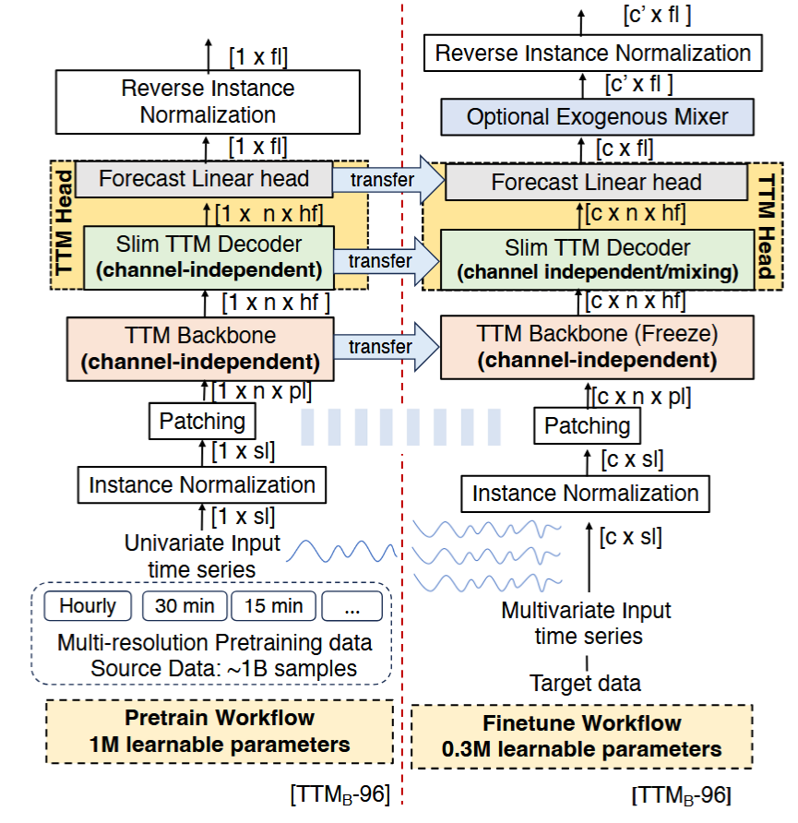

TTM operates in two stages, pre-training and fine-tuning: as you can see from the image, both workflows share the normalization and patching blocks; each time series is normalized per instance to have zero mean and unit standard deviation, the reverse is done at the end of the workflows before computing loss; the data is then patched (this process is different from AP) into $n$ non-overlapping windows of length $pl$, which are then fed to the TTM Backbone. Following is an overview of the TTM backbone.
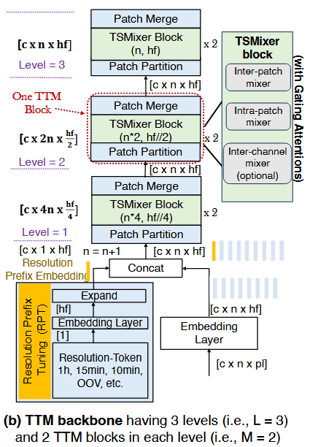
While the backbone will not be seen in detail in this work, you can see the three separate layers that each make use of a TSMixer block, with the AP interfacing each layer with the next. At the start of the backbone there is the RPT, which explicitly learns and incorporates a new patch embedding as a learnable prefix into the input data based on the input resolution. For more information on the backbone’s structure, please refer to the original paper [].
In the pretrain workflow, the backbone utilizes the processed data to perform multi-resolution training on a single channel of the timeseries; the backbone’s output will then be used by the decoder and forecast head to produce the forecast. The functioning of the Decoder and Forecast head will not be discussed in this work, please refer to the original paper for more information [].
In the fine-tuning workflow, the pre-trained model will be working with data from the target domain, which has no overlap with the pre-training datasets. Forecasting can be performed in three ways: * zero-shot: the pre-trained model is directly used to perform forecasting; * few-shot: a tiny portion (5-10%) of the training part of the target dataset is used to update the pre-trained weights in the TTM Head; * full-shot: the entire training part is used to update the pre-trained weights.

While the backbone will still perform channel-independent computing, the following decoder is able to be fine-tuned utilizing channel mixing or channel independence for multivariate or univariate target data, respectively. Again, for more information on the exact functioning of both, please refer to the original paper [].

Granite TTMs are available in two main revisions, named as r1 and r2. While architecturally identical, TTM r2 models have been pre-trained on larger datasets (~700M samples) than r1 models (~250M); IBM reports that with a larger training set, performances have increased by over 15% on average, although they still advise to experiment with both r1 and r2 models to pick the best-suited for the intended application. Additionally, both r1 and r2 models come in different sizes of context and prediction length: on the HuggingFace repo, each model can be found on separate branches with the naming convention cl-pl-rn, where cl is the context length, pl the prediction length and rn is either r1 or r2.
While general-purpose, Granite TinyTimeMixers provide a valid solution for time-series forecasting in smart farming, and the vast documentation and guides provided by IBM would greatly simplify and speed up the process of introducing these models in a live application.

2.1.2 Granite TSPulse
Also part of the IBM Granite suite are the TSPulse models, ultra-compact pre-trained models developed for tasks such as classification, anomaly detection, imputation, and similarity search in multivariate time-series. Their main strength comes from their very limited size, totaling at 1 million parameters, compared to other multivariate time-series analysis models such as Google’s TimesFM (200M parameters) [], Amazon’s Chronos models (20M for the smallest) [] and even Lag-LLaMA (2.49M) [], allowing these models to perform GPU-free inference.
Like TTMs, TSPulse is also built on top of the TSMixer architecture, while also introducing several enhancements:
- Dual-space masked reconstruction strategy: masked inputs are simultaneously reconstructed in both time and frequency domains, leveraging the intuition that certain patterns are easier to detect in the time domain while others are more salient in the frequency domain. By learning to mix, attend and reconstruct across both spaces, TSPulse is able to build richer and robust representations.
- Dual-embedding disentanglement: TSPulse generates two types of embeddings during pre-training, that is detailed embeddings for fine-grained analysis, and high-level semantic embeddings for broader task understanding. By capturing both levels of information during pre-training, TSPulse enables faster and more robust generalization across tasks.
- TSLens: a neural component which enables effective attention during fine-tuning by learning to focus on the most informative regions within and across the dual embeddings, allowing the model to prioritize task and data-relevant signals.
- Hybrid masking pre-train strategy: by combining point-wise and block-wise masking with varying ratios per sample, the model is able to reconstruct irregular masking structures, mimicking realistic scenarios.
Below is an overview of the models’ architecture; please note that in this work, the model’s architecture will be considered at a high level: for more information, please refer to the original paper [].
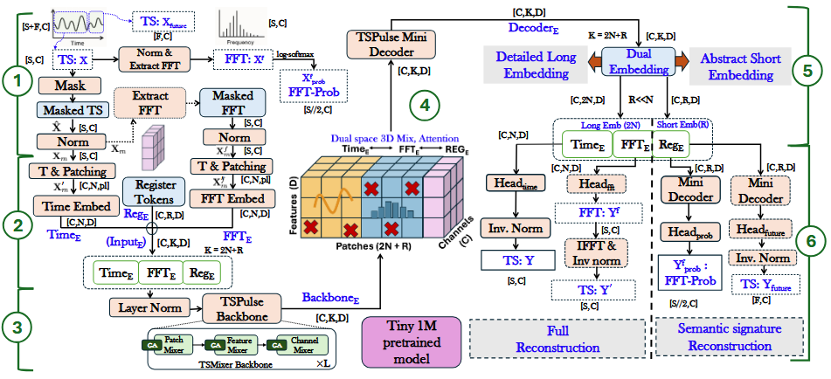
- TSPulse masks the input sequence, that is it hides portions of the input which the model will then have to reconstruct. Masking can be done using two strategies: block and hybrid masking. In block masking, entire input patches are randomly replaced with learnable tokens, while hybrid masking is able to mask individual tokens inside of a patch, while still capable of masking full patches. The masked timeseries is then normalized, but do note that the mean and variance are computed from the unmasked values.
The normalized and masked values are fed directly into Torch’s Fast Fourier Transform (FFT) to produce the frequency-domain representation of the timeseries, ensuring that data is consistently hidden both in time and frequency domains.
- Both time and frequency representation are patched into $N$ non-overlapping patches of length $pl$; these are then projected into an embedding space and then concatenated, alongside $R$ learnable register tokens (as suggested by [https://arxiv.org/abs/2309.16588]) shared across all channels, to be used as input for the TSPulse Backbone. Note that the patching length $pl$ used in this process is the same as the patching used during the masking stage.
- Here, there is the Backbone which, as said earlier, is itself based upon the TSMixer Backbone; its goal is to transform the input into semantically rich, task-robust representations. Since the input already integrates time and frequency information, TSMixer is able to mix these views, learning dual-space representations that capture temporal and spectral correlation. For more information, refer to the original paper [], as well as TSMixer’s paper [].
- The backbone output is passed through a lightweight mini-decoder, described as a mirror of the backbone but 10-20% of its size; its purpose is to refine and adapt the learned representations during fine-tuning.
- The decoder’s output is disentangled in two separate embedding types: (1) long embeddings, corresponding to the time and frequency domains, and are used for detailed reconstruction; (2) short embeddings, which correspond to the remaining register embeddings, used for semantic reconstruction tasks such as short-horizon forecasting and global frequency signature prediction.
- Long embeddings are used by the reconstruction heads: the patch embeddings related to the time domain are passed through a linear layer called the Time Head, and are inverse-normalized to obtain the reconstruction of the timeseries; the frequency-domain patches, similarly, are projected through the FTT Head to reconstruct the input frequency spectrum, although, other than reconstructing the input frequency-domain timeseries, the patches are also passed through Torch’s inverse Fourier transform (torch.ifft) to reconstruct an alternative time-domain timeseries.
Short Embeddings are used by the semantic heads: one head outputs a predicted softmax distribution over the log-magnitude frequency spectrum to capture global spectral semantics; a second head predicts a short-horizon forecast to model high-level temporal dynamics.
Three variants of pre-trained TSPulse models are released, each specialized in a different task: tspulse-hybrid-allhead-512-p8-r1, recommended for anomaly detection; tspulse-hybrid-dualhead-512-p8-r1, recommended for imputation and search; tspulse-block-dualhead-512-p16-r1, recommended for classification.
The terms “hybrid” and “block” represent the type of masking used during pre-training: “allhead” and “dualhead” specify which heads were enabled during pre-training, with “dualhead” meaning that only time and prob heads were enabled (prob head, while not explicitly stated, most likely refers to the first semantic head as the paper names its output as $Y_{prob}^{f}$); 512 is the base context length of each model; the number following “p” represents the timeseries patches’ length during training.
The released models were trained on a collection of datasets which span from weather tracking to electricity demands; the full list of datasets used can be found both on the model’s HuggingFace repo [] and the paper’s appendix [].
In conclusion, thanks to their compact architecture and strong benchmark performance, TSPulse models represent a valid choice for anomaly detection tasks in smart farming. Their small parameter count enables efficient, resource-light deployment, while maintaining a high degree of efficiency compared to state-of-the-art models.

2.1.3 Granite PatchTST
Like TTMs, PatchTST [] is a transformer-based model for tasks related to multivariate time-series, such as forecasting, regression and classification.
PatchTST makes use of two techniques: Patching, like the previous models, consists in aggregating several time steps into subseries-level short contiguous segments; Channel-independence, a multivariate time series is a multi-channel signal, which can be aggregated into a single data point to serve as input token for the Transformer; channel-independence, instead, means that each input token contains information from a single channel.
The purpose of these two ideas are mainly three: (i) a reduction on time and space complexity, since patching will reduce the amount of input tokens fed to the Transformer, this will be seen more in detail later; (ii) increased locality and capture of comprehensive semantic information that would be missed in point-level evaluation, and (iii) the separate per-channel attention would increase adaptability across heterogeneous series, reducing overfitting while still allowing cross-series weight sharing for transferability.
Below is an image of the model’s architecture.
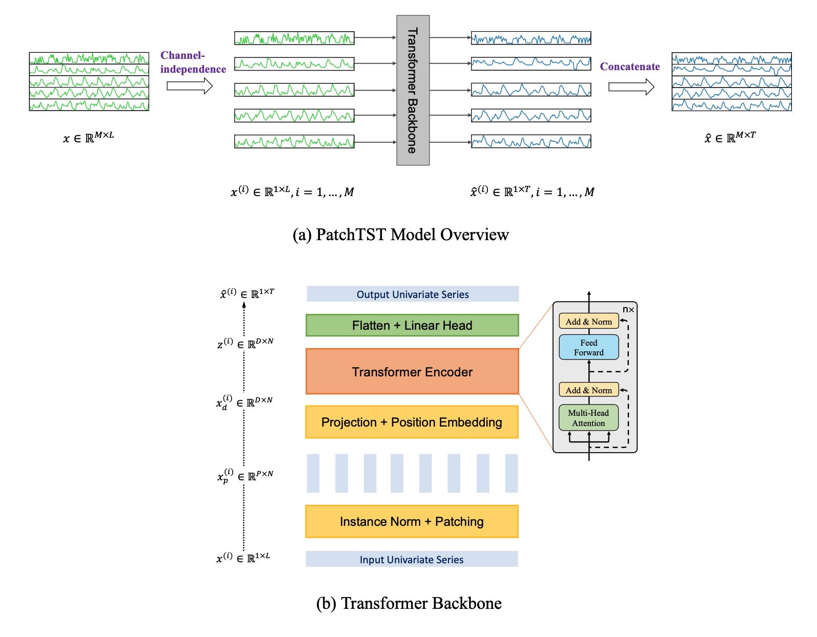
Where $x$ is the matrix containing data of all $M$ channels, with lookback window of length $L$.
The first step is applying channel-independence on $x$, breaking it down in $M$ vectors $x^{(i)}$, where $i=1,...,M$. At this point, for each $i$ the Transformer backbone will produce a forecast of T future values, that is to say ${\hat{x}}^{(i)}=({\hat{x}}_{L+1}^{(i)},...{\hat{x}}_{L+T}^{(i)})$.

b) shows in detail the transformer’s behavior: each $x^{\left(i\right)}$ is divided into patches, which can be either overlapped or not. Given $P$ as patch length and $S$ as stride (that is, the non-overlapping region between two consecutive patches), the patching process will generate a sequence of $x_{p}^{(i)}∈R^{P×N}$
patches, where $N=⌊\frac{L-P}{S}⌋+2$ is the number of patches.
This is a significant improvement, since through the patching process we reduce the amount of input tokens to the transformer, from $L$ to $N≈L/S$: since the vanilla transformer’s complexity is $O(N^{2})$, the memory usage and computational complexity of the attention map are quadratically reduced by a factor of $S$.
The model, trained on a dataset containing several parameters sampled from an electrical transformer every hour over the span of two years, achieved a training loss of 0.3 and validation loss of 0.81, while a mean square error of 0.39 on the evaluation dataset. Training hyperparameters can be found on the model’s page.
While the model has been trained on non-relevant data, IBM has provided a guided demo to train a model on a custom dataset.
[conclusion TODO]

2.1.4 Granite PatchTSMixer
PatchTSMixer is yet another model designed for multivariate time-series analysis. As the name suggests, this model still makes use of the patching process introduced with PatchTST, while its main feature is the swap of the Transformer backbone with an MLP modules, allowing it to be much lighter than it’s Transformer-based counterpart: through empirical testing on 7 different datasets, IBM has found that, while TSMixer outperforms PatchTST by just 1-2%, it shows a reduction in training time and memory usage by a factor of 2-3X.
Below is an overview of the architecture.
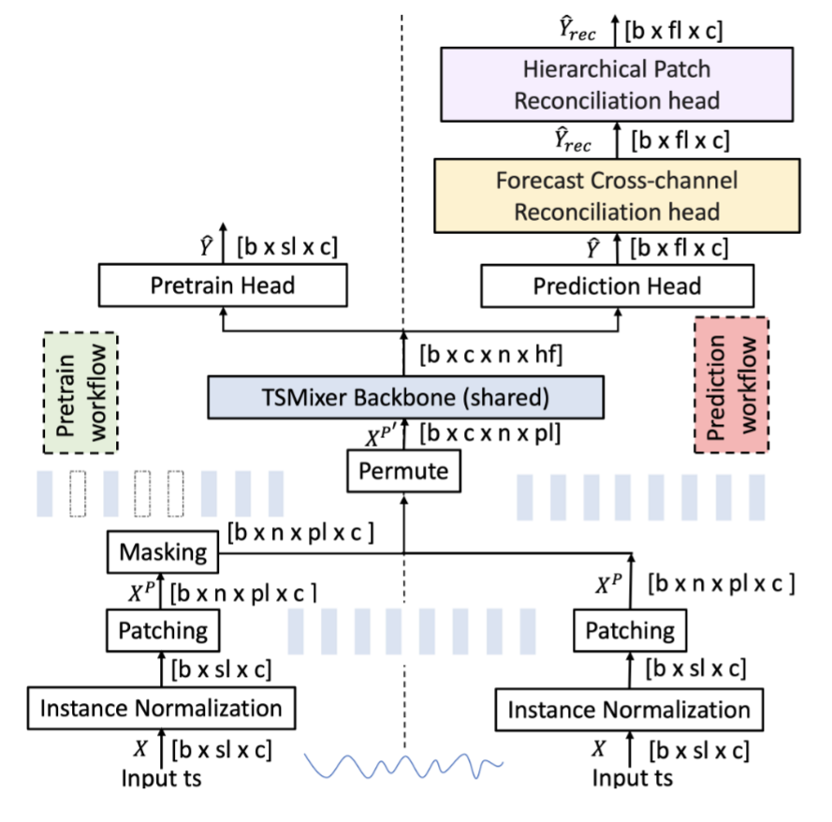
Where $X_{c×L}$ is a multivariate time series of length $L$ and $c$ channels, $sl≤L$ the input sequence length, $fl$ the forecast length, $b$ the batch size, $n$ and $pl$ respectively the number of parches and a patch’s length, and $Μ$ the DNN model; the forecasting task is defined as predicting the future values:
$${\hat{Y}}_{fl×c}=Μ(X_{sl×c})$$
The actual future values are named as $Y_{fl×c}$.

Training can be performed in two ways: supervised (following “prediction” workflow) and self-supervised (“pretrain” workflow).
- supervised training: the input sequence is normalized, patched and processed through a permutation process. Then, the result enters the TSMixer backbone, responsible for the training process. The backbone’s output embedding is then converted into the base forecast $\hat{Y}$ by the prediction head; at this point, the model is trained to minimise the loss between $\hat{Y}$ and $Y$. The extra online forecast reconciliation heads, if activated, can tune the base forecasts and produce more accurate forecasts by leveraging cross-channel and patch-aggregation information. For more details on their functioning, refer to IBM’s original paper.
- self-supervised training: while the normalization and patching processes are nearly identical, a masking process randomly masks a fraction of the input patches. The model is then trained to recover these missing patches. Afterwards, the pretrained model is finetuned through the “prediction” workflow.
The patching process is identical to PatchTST, although the self-supervised training, in contrast to supervised, needs patches to be strictly non-overlapping.
The TSMixer backbone will take in the several patches and produce an output embedding, which will then be used by either the prediction or pretrain head to forecast the future values (or missing patches); it’s inner working will not be discussed in this work, please refer to IBM’s paper for more information.
[conclusion TODO]

2.1.5 Granite FlowState
FlowState [] is a Time Series foundation model designed to perform zero-shot forecasting independently of the data’s sampling rate. To achieve this, FlowState makes use of an encoder-decoder architecture, combining a state space model encoder with a functional basis decoder.
A state space model (SSM) [lookForSource?] is a kind of model trained to perform predictions on a system based on its internal state evolution over time; in particular, FlowState utilizes several state space layers, namely S5 layers [], which, thanks to their architecture, allow FlowState to perform sampling rate-independent forecasting.
Below is an overview of the model’s architecture.
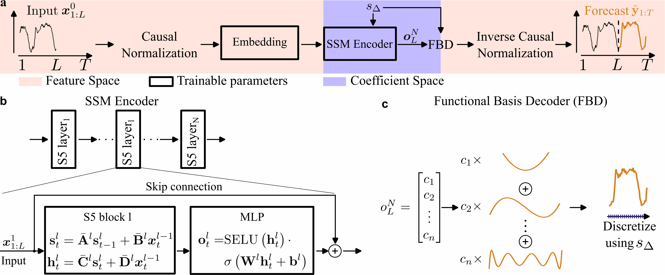
The model’s inner workings are quite complex, in the following section a high-level overview will be presented; for more information, consult IBM’s paper [].
a) is a complete overview of the model’s architecture: the input time series of length L is normalized and then fed to the embedding module; the embedding is then fed to the encoder without any patching, in contrast to previous models; the SSM encodes the data into a coefficient space, that is to say the input series is processed into coefficients of a continuous basis function, allowing the Functional Basis Decoder (FBD) to produce a continuous output function; lastly, the decoder’s output is inverse-normalized, using the inverse process of the input normalization; the result of this last process form the forecast of the model.
b) is a close-in of the SSM encoder: it is composed by a series of S5 layers, each consisting of an S5 block followed by an MLP; each S5 layer is connected by a skip connection to the later layers, and through the matrixes ${\overset{‾}{A}}^{l}$, ${\overset{‾}{B}}^{l}$, ${\overset{‾}{C}}^{l}$ and ${\overset{‾}{D}}^{l}$ (which represent, respectively, the state transition, input, output and skip connections); the final output of the SSM encoder is fed into the Functinal Basis Decoder.
c) the FBD will interpret the SSM’s final output as coefficients of a functional basis, and will generate a continuous output function as forecast. The advantage of the output being continuous lays in the fact that we will be able to sample it with any desired sample rate. Again, for more information on how the FBD works, consult the original paper [].
Note that, in the image above, the value $s_{Δ}$ is a parameter called scale factor, which is used both in the encoder and decoder to adjust for unseen sampling rates. On FlowState’s model page, these values are suggested for common sampling rates:

Sampling Rate | Recommended Scale Factor
15min | 0.25
30min | 0.5
hourly | 1.0
daily | 3.43 if data has a weekly cycle, else 0.0656
weekly | 0.46
monthly | 2

IBM compared FlowState in zero-shot forecasting to several state-of-the-art models, such as NXAI’s TiRex, Amazon’s Chronos and Google’s TimesFM, using the Gift-Eval benchmark []: two variants of different sizes (2.6M and 9.1M params) were trained on the benchmark data, and, as of July 31, 2025, both variants outperformed other state-of-the-art models at a fraction of their size. Below is an extract of the testing done by IBM, utilizing MASE (mean absolute scaled error) as a metric:

Model | #Param | MASE
FlowState-9.1M | 9.1M | 0.728
TiRex | 35M | 0.733
FlowState-2.6M | 2.6M | 0.733
TimesFM-2.0 | 500M | 0.764
Chronos-bolt-b | 205M | 0.832

At the time of writing, the model published on Hugging Face has been trained on a subset of data from both Gift-Eval Pretrain [] and Chronus Pretraining Data Corpus; additionally, the current model does not support more than one input channel, rendering this model unable to perform forecasting on multivariate time series.
[conclusion TODO]

2.1.6 Granite Geospatial Biomass
Granite Geospatial Biomass (GGB) [] has been developed for the purpose of predicting the total amount of aboveground biomass utilizing satellite imagery. The model has been trained using Terratorch [], a toolkit intended for simplifying fine-tuning, evaluation and deployment of Geospatial Foundation models; TerraTorch’s architecture will not be discussed in this work, please refer to their paper for more information.
GGB was fine-tuned from a model similar to Prithvi [https://arxiv.org/pdf/2310.18660], a model created to test the proposed training framework for Geospatial Foundation models, which will not be discussed in detail in this work; GGB switches the proposed Vision Transformer (ViT) for the Swin-B Transformer backbone [https://arxiv.org/abs/2103.14030] as an encoder, as it enables the model to process at higher effective resolutions while also improving computational efficiency thanks to the use of windowed self-attention. Swin-B will also not be discussed in this work, as such please consult the original paper for more information [https://arxiv.org/abs/2103.14030]; more information regarding the fine-tuning process performed by IBM can be found here [https://arxiv.org/abs/2406.19888].
Pretraining was performed using SimMIM [https://arxiv.org/abs/2111.09886], a self-supervised learning strategy based on masking a part of the input data which will then be reconstructed by the model.
Two datasets were used for the training process, Harmonized Landsat-Sentinel 2 (HLS) and Global Ecosystem Dynamics Investigation (GEDI), both provided by NASA. Both training and testing require a cloud-free snapshot of an area: starting from HLS data gathered during the leaf-on season for each hemisphere, pixels not contaminated with clouds were selected; the mean value of each cloud-free pixel is computed during the leaf-on season for each spectral band, which is then assembled into a composite image representative for that area; the corresponding GEDI data obtained during the same leaf-on season are interpolated to the HLS grid (CRS:4326) such that the measured biomass points are aligned with HLS data.
GGB can be very useful in relation to FARM-TECH, first and foremost in enabling continuous monitoring of fields and yield estimation; while originally trained on data retrieved from forests, IBM has provided a notebook on how to perform few-shot forecasting on an unseen biome: perhaps by performing few-shot fine-tuning on crop imagery the model could generalize fairly well, although testing is needed.

2.2 Smart Farming Disease Detection Transformer
This model [https://huggingface.co/wambugu71/crop_leaf_diseases_vit] has been developed to detect diseases in crops based on a picture. It is a Vision Transformer model, finetuned from Google’s “vit-tiny-patch16-224” []; it should be noted that the HuggingFace repo is a [reupload?] from the timm repository [], which contains a large number of models and utilities for image processing.
While the exact dataset has not been shared, the model’s page describes it as a “diverse dataset of plant images, including different disease categories affecting crops such as corn, potato, rice, and wheat […] includes images captured under various lighting conditions, from both controlled and uncontrolled environments and angles”; the exact number of pictures is not shared, but a table of all the classes present in the dataset is:
Crop | Class
Corn | Common Rust
 | Gray Leaf Spot
 | Healthy
 | Leaf Blight
Potato | Early Blight
 | Healthy
 | Late Blight
Rice | Brown Spot
 | Healthy
 | Leaf Blast
Wheat | Brown Rust
 | Healthy
 | Yellow Rust
It should be noted that in the above table the class “rice_hispa” is not present, but is printed in the confusion matrix later in the model’s page:
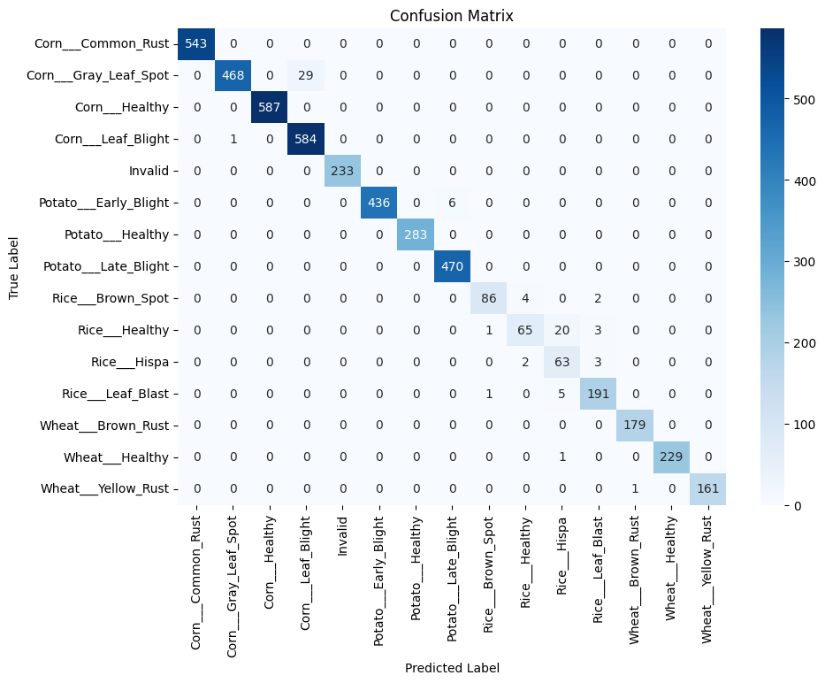
While it’s not clear if the confusion matrix above is the one being referenced, testing was performed on a validation set consisting of 20% of the original dataset; if the confusion matrix is the result of this testing, then the original dataset was composed of ≈23k images. Testing resulted in the following metrics: * Accuracy: 98% * Precision: 97% * Recall: 97% * F1 Score: 96%
The author reports that the model may not generalise to unseen crops; as such, fine-tuning on relevant crops (that is, crops expected to be processed) is strongly suggested.
[conclusion TODO]

2.3 Fruits and Vegetables Detector 36
This model [] is a fine-tuned version of ResNet-50 [], a deep neural network developed by Microsoft for the purpose of image classification; 50 represents the depth of the network.
The main takeaway from ResNet is the use of Shortcut Connections, which allow the input of a layer to be passed directly to the next layer’s input, effectively acting as an identity mapping; in the paper, it is demonstrated that these shortcut connections allow a deep network to not degrade any worse than a shallower counterpart. More information can be found in the original paper []. Below is an overview of its architecture compared to other DNNs, where the shortcut connections are connecting each layer’s input to the next’s.
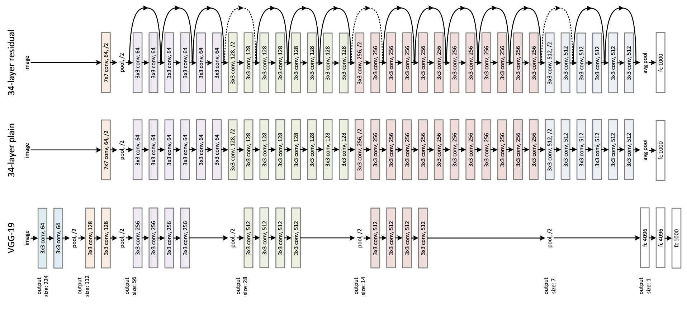
Going back to Fruits and Vegetables detectors, it is not well documented: the model was trained on a dataset containing 3825 images of 36 different fruits; testing on the evaluation set found it achieves an accuracy of 0.97 and a loss of 0.0014; other than this, the training hyperparameters were provided, they can be found on the model’s HuggingFace Repo.
[conclusion TODO]

2.4 Plant leaf Detection and Classification
This model [] has been trained using YOLOv8 to detect and classify plant leaves: YOLOv8 [] is a computer vision model architecture developed by Ultralytics, which allows to train models at performing detection and classification of images and real-time video feeds.
While Ultralytics has provided no proper documentation on YOLO’s internal architecture nor inner workings, it has uploaded a vast amount of tutorials and guided examples on how to train a model with it, which would speed up the process of building a system ourselves if needed. This paper [] describes YOLOv8’s architecture, although it is unclear if was written by an affiliate of Ultranalytics, or at least in cooperation with them.
The model was trained by FOODU, an Indian company specialised in Web Designing. On the model’s HuggingFace page, not much information about the training process is shared: the dataset utilised was not shared, but it is stated that it’s composed by “hundreds of images of 46 different plants, including both disease-infected and healthy leaves”; training was ran for 50 epochs, and, worringly, the terms “testing” nor “evaluation” have appeared on the page, but it is claimed that “The model has achieved a precision (mAP@0.5) of 0.946 on the object detection task”.
[conclusion] something something the model page is smelly, wouldn’t trust it

2.5 Plant Leaf Diseases Detection
https://huggingface.co/YuchengShi/LLaVA-v1.5-7B-Plant-Leaf-Diseases-Detection
This model was trained for the purpose of evaluating the SelfSynthX framework [], a framework developed to fine-tune large multimodal models (LMMs) to improve their ability of performing fine-grained visual reasoning and increase explanation quality. We will see a brief overview of SelfSynthX, for more information please consult the original paper [].
Below is an overview of the framework’s architecture: 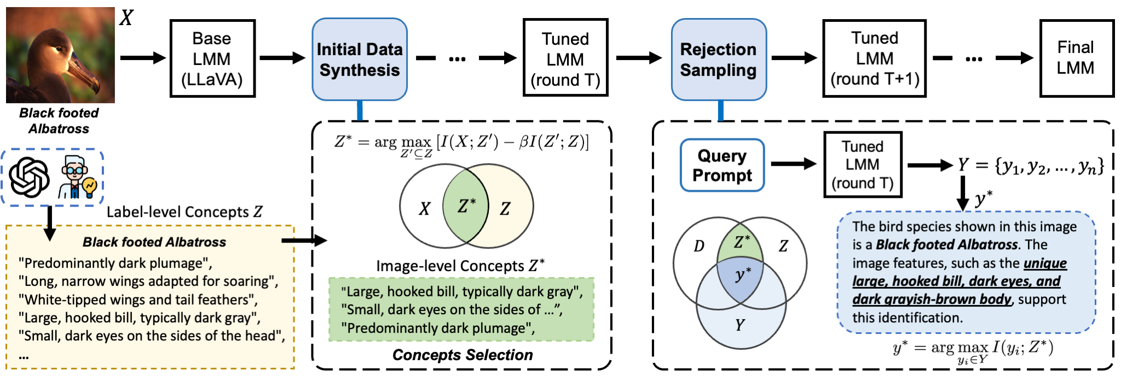 Given an image, $X$ represents it’s true contents and $c$ it’s class label, each $c$ is associated with a set of visual concepts $Z$, which can either be defined by domain experts or by an LLM; the base LMM we wish to fine-tune (LLaVa in the paper) will now be prompted to describe the image, generating a set of descriptions $D$; the model is then tuned to maximise the mutual information between $X,D$ and $Z$, and to select a set of $Z^{*}⊆Z$ which maximises the relevance of $D$ to $X$. Once $Z^* $ is found, it’s possible to generate an explainable answer for a classification on each image by prompting the base LMM, such as “What is this bird’s species? Explain your reasoning.”; the pairs image and query-answer are later used to fine-tune the LMM. The question reported above was asked to the evaluation model trained on a dataset of birds
After the above steps, the tuned model goes through the Rejection Sampling process: for each image and query, several candidate answers are generated, scoring each by how well it aligns with the image-specific $Z^* $; the highest scoring candidate is accepted for successive fine-tuning only if it also correctly predicts the image’s class label.
As we stated earlier, the model [] was trained to evaluate SelfSynthX: as such, it is a fine-tuned version of LLaVa trained on the Plant Diseases Dataset [https://www.kaggle.com/datasets/vipoooool/new-plant-diseases-dataset]; other than this model, others were trained on different datasets to evaluate the framework on different domains.

2.6 Keras Timeseries Anomaly Detection
This model was trained as part of a tutorial for the Keras library in order to perform anomaly detection in timeseries. Keras is a high‑level deep learning API for building, training, and deploying neural networks.

2.7 AdaptLLM Remote Sensing
These models have been trained in the context of this paper [https://arxiv.org/abs/2411.19930], which aims at adapting general multimodal large language models (MLLMs) to specific domains: the domains considered in the paper are biomedicine, food, and remote sensing, while the models analysed are Qwen2-VL-2B, LLaVA-v1.6-8B, and Llama-3.2-VL-11B; the two models retrieved for our research are the models adapted from Llama and Qwen2 for the remote sensing domain.
Below is an overview of the training process:
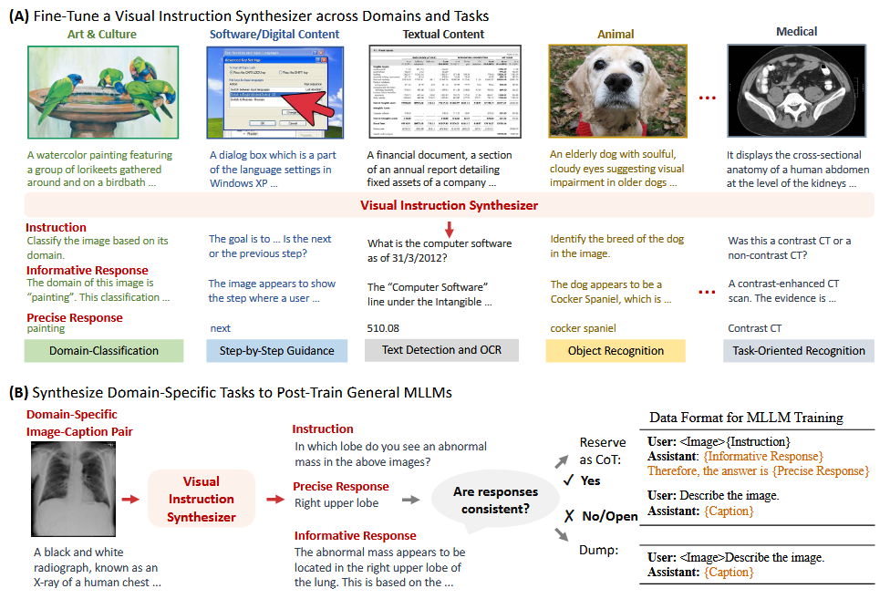
The process to fine-tune the original MLLMs is quite simple: A) a base model is fed a corpus of image-caption pairs plus a few triplets composed by an instruction (a natural‑language task prompt derived from the image and caption), informative reasoning (chain‑of‑thought style steps supporting the answer) and precise answer (the concise final response), and fine-tuned to generate more of these triplets given an image and caption pair, as such it is now called Synthesizer; B) the synthesizer now goes through an open-source language model which classifies each triplet as consistent or not, that is whether the precise and informative responses align, dumping the inconsistent triplets; lastly, the consistent triplets generated by the synthesizer are used to post-train the MLLM model on the domain of interest. Do note that this last step showcased in this work has been simplified, more information can be found in the original paper [].
To experiment the proposed fine-tuning, a synthesizer based on LLaVa-v1.6-8B was used to generate triplets relevant to three domains, that is biomedicine, food and remote sensing (of course, three separate synthesizers were developed); Qwen2, LLaVa and Llama were then trained on the synthesizer data and then compared to several baselines (different for each domain), resulting in the models trained with the proposed method consistently outperforming the baselines.
The two models retrieved in this work were trained for the remote-sensing domain, one trained from Qwen2.5 and the other from Llama 3.2; the third model trained on LLaVa was not retrieved as it had less than 100 downloads on HuggingFace. These two models may be useful to provide a natural language analysis of drone or satellite imagery, which can be either be used for further analysis by other LLM models or to provide information to farmers regarding their crop’s current status.

2.8 CropSeek LLM
This model was trained to answer question related to agriculture, such as a certain crop’s optimal planting season and recommendations for crop optimization. It’s based on DeepSeek R1, fine-tuned on this dataset: DARJYO/sawotiQ29_crop_optimization dataset, finetuned using LoRa.

3. Models reusability
In this chapter, we propose a scoring of each model’s reusability in regards to farmtech. In the following paragraph, the scoring method is presented.
Each model has been evaluated on several categories with a score from 1 to 3; following are the proposed categories, alongside the meaning for each value:
- Project alignment (PA), how relevant the model is to the project, both in purpose and training dataset; 1 represents a general affinity to FARM-TECH’s field of application, 2 an immediate correlation to a task relevant to FARM-TECH, 3 satisfies 2’s condition plus the use of data immediately related to the field during the model’s training.
- Quality of documentation (QD), how much the documentation provided is useful in the implementation of the model in a production-ready environment; 1 the documentation is enough for the sole scope of running the model, 2 an overview of the architecture is provided, 3 satisfies 2’s condition plus a significant number of guides and examples.
- Ease of evaluation (EE), how simple it is to evaluate the model’s output; 1 requires significant testing, 2 is idk good enough lol, 3 is immediately verifiable.
The total score is evaluated by performing the weighted sum $TS= 0.3*PA+0.4*QD+0.3*EE$, rounded to the lower integer if below 0.5 and to the higher if above and equal to 0.5; QD was given more importance compared to the other categories as it is assumed that abundant and clear documentation, alongside use cases and guided examples, would greatly improve a model’s reusability.
In the following page, a table reporting each model’s score, both total and for each category, is presented; each score will be explained in the next paragraph. For models that share a similar name, the relevant chapter is reported to improve readability.

Model | PA | QD | EE | Total
TTM | 2 | 3 | 2 | 2.4
TSPulse | 2 | 3 | 2 | 2.4
PatchTST | 2 | 3 | 2 | 2.4
PatchTSMixer | 2 | 3 | 2 | 2.4
FlowState | 1* | 3 | 2 | 2.1
Geospatial Biomass | 2 | 3 | 2 | 2.4
Disease Detection Transformer (2.2) | 3 | 2 | 3 | 2.6
Fruits and Vegetables Detector (2.3) | 1* | 2 | 3 | 2.0
Plant and Leaf Detector (2.4) | 1* | 2 | 3 | 2.0
Plant Leaf Diseases Detection (2.5) | 3 | 2 | 1 | 2.0
Keras Timeseries Anomaly Detection | 2 | 2 | 2 | 2.0
AdaptLLM Remote Sensing | 3 | 2 | 1 | 2.0
CropSeek LLM | 3 | 3 | 1 | 2.4
The asterisks (*) represent an exception to the scoring rules defined above; they will be explained in the following section.
All IBM Granite models identical scoring: timeseries forecasting, anomaly detection and pattern classification are all functions that are highly relevant to a smart farming application, but, being general purpose models, they were trained on non-relevant data, thus getting a 2 in the PA category. FlowState has a score of 1 in this category since, as of time of writing, it is limited to work with timeseries composed by a single channel, reducing its utility in a live application. Having a large documentation backing them, these models all get the maximum score in the QD category, while the scoring in the EE category is set at 2 since, in order to properly evaluate them, proper data has to be produced.
Disease Detection Transformer: 3 because finding diseases based on leaves is highly relevant to this field; 2 because while a single usage example is presented it is a fine-tuning of Google’s vit, of which the architecture is known, 3 because plant leaves images can be easily collected
Fruits and Vegetables Detector: 1 has been given since the purpose of this model is to detect plants and vegetables in a picture, which in a smart farming application is not a necessity (penso idk, lo so già cosa tengo piantato); other scores same as above
Plant and Leaf Detector: same as above
Plant Leaf Diseases Detection: same as Disease Detection Transformer, with the difference of EE getting a 1 since, using an LLM to describe images, it may require further testing to ensure the model doesn’t hallucinate
Keras Timeseries Anomaly Detection: 2 because it does anomaly detection; 2 because it was trained as part of a framework so you know it’s background; 2 cause requires appropriate data
AdaptLLM Remote Sensing: same as Plant Leaf Diseases Detection
CropSeek LLM: 3 it was trained specifically to answer farming related questions, as such the data used is appropriate; 3 because it’s a fine-tuning of DeepSeek, so you have its documentation underneath, and being a chatbot not many usage examples are needed; 1 because it may need intensive testing to make sure it isn’t crazy

4. Non-relevant Models
A significant amount of the retrieved models have been deemed non-relevant to the projects’ objective, these will be listed in this chapter alongside their reason of exclusion.

4.1 OpenMed NER
OpenMed Named-entity recognition (NER) [] is a suite of open-source transformer models, developed by OpenMed for the purpose of identifying biomedical entities contained in clinical texts, research papers and other healthcare-related documents.
The various models have been trained on the same dataset, but all differ in parameter size (~60M to ~570M) and underlying architecture: in their paper, it is stated that the main architectures used during the training process were DeBERTa-v3-large, PubMedBERT-large and BioELECTRA-large, all models based on Google’s BERT.
Of all non-relevant models, 29 of them were part of the OpenMed NER suite; they have been collected by the script due to the presence of the word “organism” in the model card. It should be noted that OpenMed NER suite contains 475+ models, as stated on OpenMed’s site [], but only these 29 have been retrieved as they were the only ones containing the term “organism”.
Being a collection of healthcare-related models, they have been deemed not relevant to FARM-TECH.

4.2 PlanTL models
Plan de Tecnologías del Lenguaje (PlanTL) is a government-owned Spanish company which has developed several models with different intended purposes, all unrelated to FARM-TECH: 8 of their models have been retrieved since their hugging-face page contains the abbreviation “PlanTL”, where “Plant” was one of the searched terms; they are all listed below.
- Anominization Core LG, whose purpose is to detect personal information contained in plain-text documents written in Spanish and Catalan. It is developed to work in conjunction with the Anonymization Pipeline [], which will either remove or randomize the detected information from the documents
- Biomedical-clinical language model for Spanish, these are a group of models trained with the purpose of performing fill-mask tasks on medical documents written in Spanish. They differ in their underlying architectures; they will not be described in more detail as they are not relevant to this work.
- RoBERTa base trained with Spanish Legal Domain Corpora, similar to the above model but the target documents are of legal nature.
- roberta-base-es-wikicat-es, is a model trained with the purpose of classifying documents written in Spanish.
All of these models have been deemed not relevant since their intended purposes are outside of FARM-TECH’s scope.

4.3 Plant Genome Analysis
5 retrieved models were trained to perform modeling of genomic sequences of plants, they are listed below.
- kuleshov-group/PlantCaduceus_l32
- kuleshov-group/PlantCaduceus_l20
- zhangtaolab/plant-dnamamba-singlebase
- zhangtaolab/plant-dnabert-BPE
- yangheng/PlantRNA-FM
All of these models were retrieved due to the presence of the term “Plant” in their name; being out of scope for farm-tech, they were discarded.

4.4 Others
All the remaining models have been discarded for providing little to no documentation, they are listed below.
- muhammad-atif-ali/fine_tuned_vit_plant_disease
- textattack/roberta-base-rotten-tomatoes
- textattack/bert-base-uncased-rotten-tomatoes
- Diginsa/Plant-Disease-Detection-Project
- hyrinmansoor/text2frappe-s2-flan-field
- KevinCha/dinov2-vit-large-remote-sensing
- TomatoMTL/bert-mini-finetuned-ner-chinese-onnx
- votepurchase/plantMilkModelSuite_walnut
- misri/plantMilkModelSuite_walnut
- denxxs/soil-gemini
- plantingspace/nl-yezo-ivy-metric-model
- SanketJadhav/PlantDiseaseClassifier-Resnet50
- Thalirajesh/Aerial-Drone-Image-Segmentation
- kashif/time-series-transformer-mv-traffic-hourly
- Abhiram4/PlantDiseaseDetectorVit2
- surprisedPikachu007/tomato-disease-detection
- A2H0H0R1/swin-tiny-patch4-window7-224-plant-disease-new
- Two models, developed by BlackHat404, have been excluded as pornographic in nature. They were retrieved since the word “Soil” was present in their model page.

References
TODO
[] Yuqi Nie, Nam H. Nguyen, Phanwadee Sinthong, and Jayant Kalagnanam. A time series is worth 64 words: Long-term forecasting with transformers, 2023. URL https://arxiv.org/abs/2211.14730
[] Smart Farming Disease Detection Transformer, https://huggingface.co/wambugu71/crop_leaf_diseases_vit
[] Chronos, https://arxiv.org/abs/2403.07815
[] TimesFM, https://arxiv.org/abs/2310.10688
[] Lag-LLaMA, https://arxiv.org/abs/2310.08278
[] Maziyar Panahi. Openmed ner: Open-source, domain-adapted state-of-the- art transformers for biomedical ner across 12 public datasets, 2025. URL https://arxiv.org/abs/2508.01630
[] Michal Muszynski, Levente Klein, Ademir Ferreira da Silva, Anjani Prasad Atluri, Carlos Gomes, Daniela Szwarcman, Gurkanwar Singh, Kewen Gu, Ma- ciel Zortea, Naomi Simumba, Paolo Fraccaro, Shraddha Singh, Steve Melik- setian, Campbell Watson, Daiki Kimura, and Harini Srinivasan. Fine-tuning of geospatial foundation models for aboveground biomass estimation, 2024. URL https://arxiv.org/abs/2406.19888
[S5] Jimmy T. H. Smith, Andrew Warrington, and Scott W. Linderman. Simplified state space layers for sequence modeling, 2023. URL https://arxiv.org/abs/2208.04933
[Swin B] Ze Liu, Yutong Lin, Yue Cao, Han Hu, Yixuan Wei, Zheng Zhang, Stephen Lin, and Baining Guo. Swin transformer: Hierarchical vision transformer using shifted windows, 2021. URL https://arxiv.org/abs/2103.14030
[simMIM] Zhenda Xie, Zheng Zhang, Yue Cao, Yutong Lin, Jianmin Bao, Zhuliang Yao, Qi Dai, and Han Hu. Simmim: A simple framework for masked image mod- eling, 2022. URL https://arxiv.org/abs/2111.09886

