Data Science Project
Disagreements in Hate Interpretation

Report
Students Name |  | ID
Section #80657 | Shahad alotaibi | 444201168
Section #80657 | Raghad AL-Qwaider | 444200109
Section #80657 | Zuhd Ibrahim | 444201206
Section #80657 | Renad Alowais | 444200530
Section #80657 | Ghada AlQahtani | 444200371

Instructor: Dr. Abeer Aldayel

Contents
1. EDA Results 3
1.1 Reddit 3
1.2 Twitter 7
1.3 YouTube 10
5. Summary of New Insights and Hypotheses 13
6. Raw Data File(s) 13
7. Jupyter Notebook 13
8. Logbook 14

1. EDA Results

1.1 Reddit
Reddit posts are largely non-hate, with hate content making up only about 11% of the dataset. Toxicity levels are generally low, and while a few outliers exist, most posts remain non-toxic. Hate posts also tend to be shorter than non-hate ones, and toxicity shows little connection to engagement, suggesting toxic content does not gain more visibility.
Distributions (Histograms)
- Toxicity Score: heavily right-skewed; most posts are non-toxic with only a few high-toxicity outliers.
- Word Count: sharply right-skewed; most posts are extremely short, only a handful are long.
- Engagement: also right-skewed; most posts gain little interaction, only a few receive high visibility.
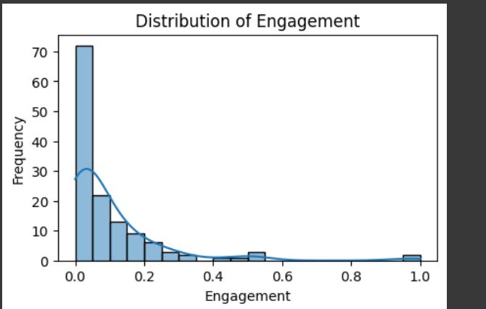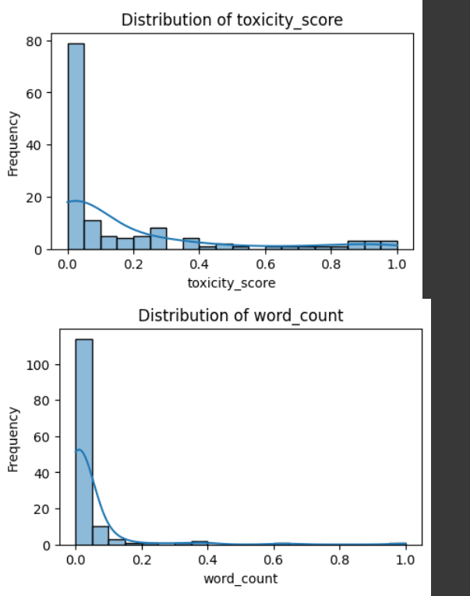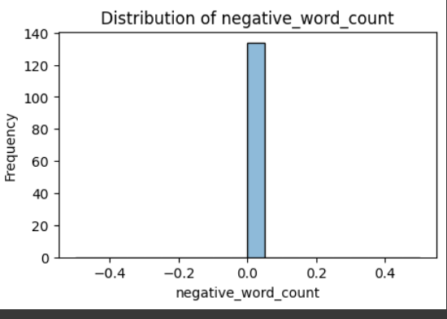

Label Distribution (Bar Chart)
- Vast majority of posts are non-hate (≈119) compared to only 15 hate posts.
- This confirms a strong class imbalance, with hate speech underrepresented.
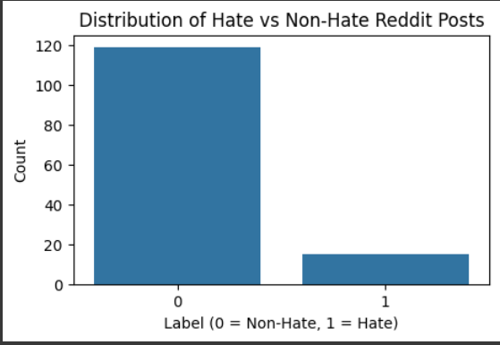

Correlation Heatmap
- Engagement and toxicity score correlation is −0.11 → a very weak negative relationship.
- Word count also has very weak correlation with both engagement (−0.067) and toxicity (−0.097).
- Overall, no strong linear relationships between numeric features.
- Implication: toxicity and engagement behave independently in this dataset.
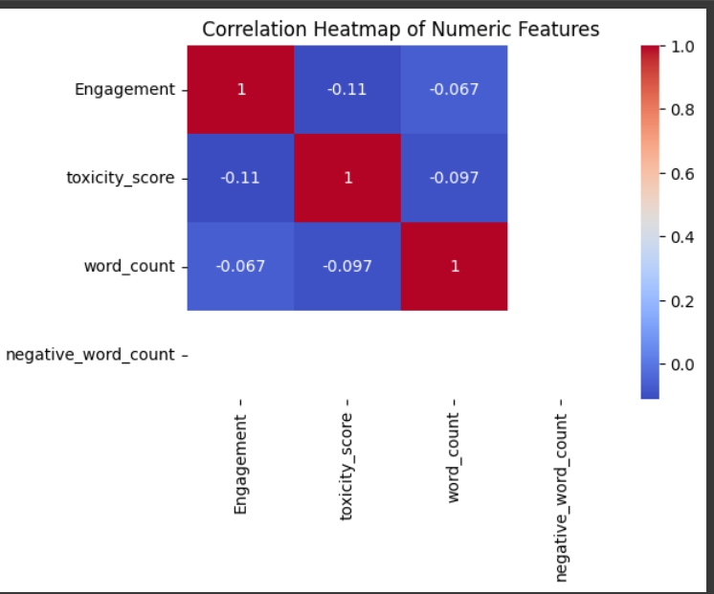

Boxplots (Word Count, Engagement, Toxicity Score, Negative Word Count)
- Word Count: distribution heavily skewed toward very short posts, with a few outliers (longer discussions).
- Engagement: mostly clustered near 0–0.1, but some outliers with very high engagement exist.
- Toxicity Score: concentrated around 0–0.2, with a long right tail up to 1.0, showing rare extreme toxicity outliers.
- Negative Word Count: essentially zero across all posts → negativity lexicon did not pick up words.
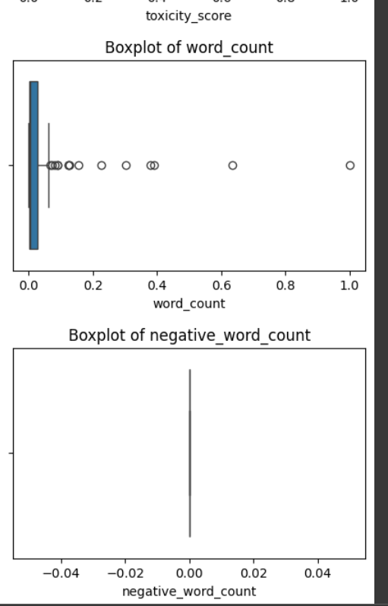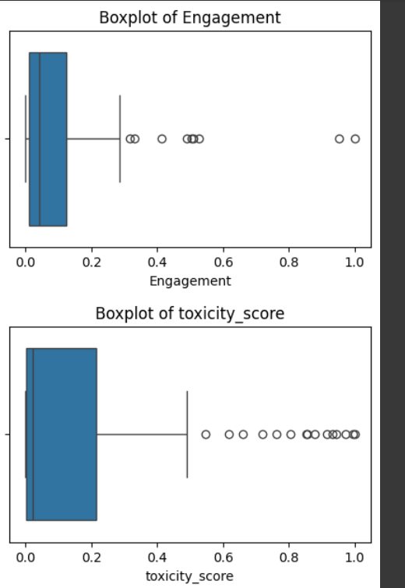

Word Count by Label (Boxplot)
- Both hate and non-hate posts have low word counts.
- Non-hate posts show more variability (a few longer posts), while hate posts are generally shorter.
- Suggests that hate comments tend to be concise compared to discussions in non-hate posts.

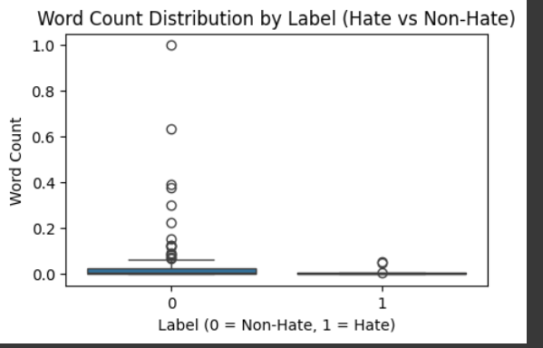

Summary Statistics (Table)
- Engagement: mean = 0.099, but max = 1.0 → confirms presence of outliers with very high engagement.
- Toxicity: mean = 0.161, but median = 0.023 → most posts are low-toxicity, with skew from a few high scores.
- Word Count: mean = 0.039, median = 0.006 → typical post is extremely short.
- Negative Word Count: mean = 0.0 → none of the lexicon words were flagged.
- Labels: 119 non-hate, 15 hate → ≈11% toxic content.
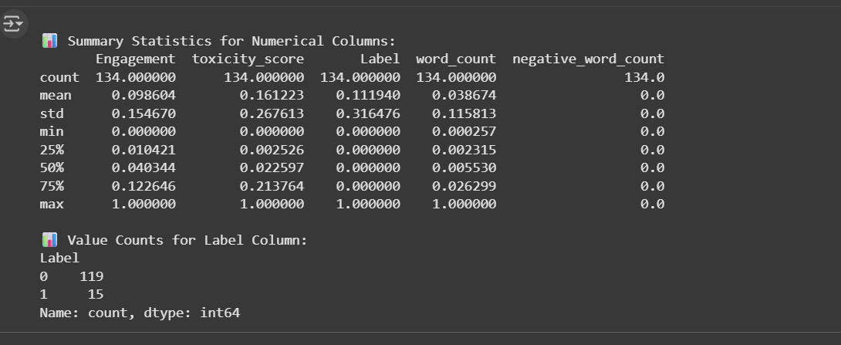

1.2 Twitter
Twitter data shows a clearer presence of hate speech compared to Reddit, with about 27% of tweets labeled as hate. Toxicity levels are more spread out, with a higher average than Reddit, though most tweets still cluster at lower values. Hate and non-hate tweets have similar lengths, and toxicity shows almost no relationship with engagement, suggesting toxic tweets are not necessarily more visible.
Distributions (Histograms)
- Toxicity Score: right-skewed but flatter than Reddit; many tweets fall at low values, though some reach high toxicity (up to 1.0).
- Word Count: centered around the mid-range (0.3–0.5), with more spread than Reddit.
- Engagement: heavily skewed toward zero; most tweets get minimal interaction.
- Negative Word Count: mostly zero, but a few tweets show high values, unlike Reddit.
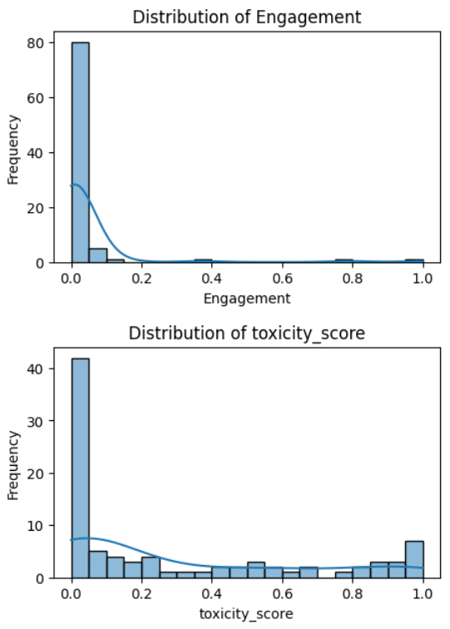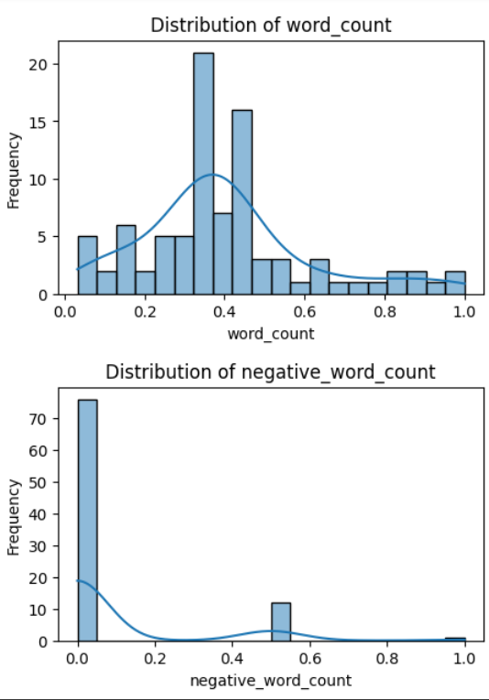

Label Distribution (Bar Chart)
- 65 non-hate tweets vs 24 hate tweets.
- Hate content is underrepresented but at a higher rate (27%) compared to Reddit.
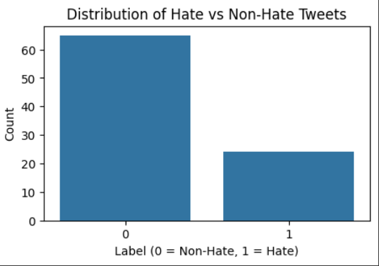

Correlation Heatmap
- Toxicity vs. Engagement: −0.056 → very weak negative relationship.
- Toxicity vs. Negative Word Count: 0.27 → moderate positive correlation (tweets with more flagged negative words also tend to have higher toxicity).
- Other correlations are negligible.
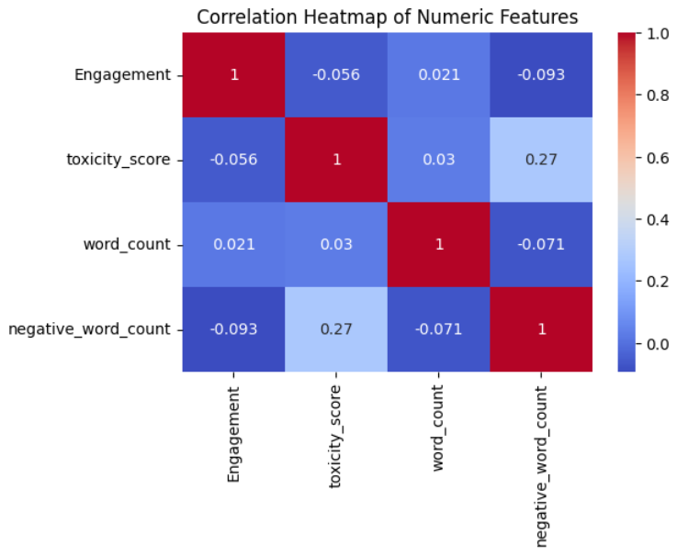
Boxplots (Word Count, Engagement, Toxicity Score, Negative Word Count)
- Word Count: most tweets are in the mid-range, with a few very short and long outliers.
- Engagement: almost all clustered at 0, with rare outliers reaching high engagement.
- Toxicity Score: widely spread across the range, unlike Reddit where most clustered near 0.
- Negative Word Count: mostly zero, but a few tweets with higher values pull the distribution upward.

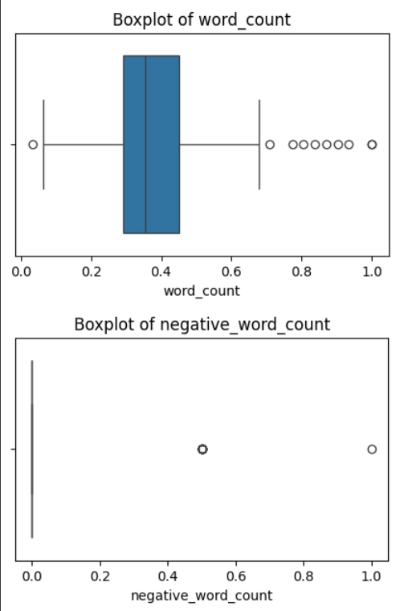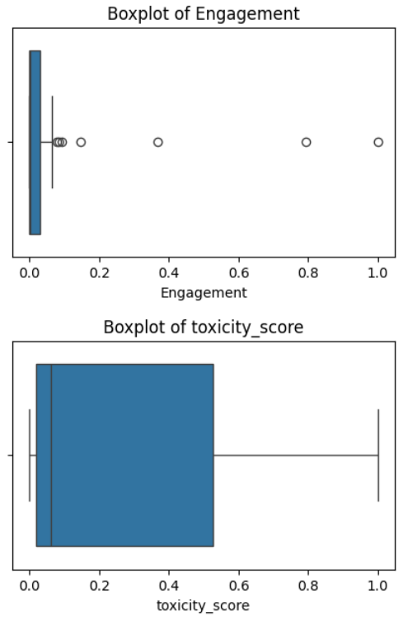

Word Count by Label (Boxplot)
- Hate and non-hate tweets have similar word counts.
- Suggests that tweet length is not a distinguishing factor for hate content.
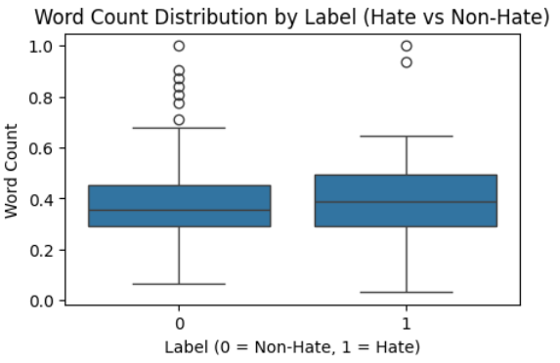

Summary Statistics (Table)
- Engagement: mean = 0.038, max = 1.0 → confirms most tweets have low interaction, a few outliers drive the range.
- Toxicity: mean = 0.284, median = 0.061 → average toxicity is higher than Reddit.
- Word Count: mean = 0.397, median = 0.355 → tweets are generally short but longer than Reddit posts.
- Negative Word Count: mean = 0.079, with some values reaching 1.0 → some tweets flagged strongly for negativity.
- Labels: 65 non-hate, 24 hate → ≈27% toxic content.
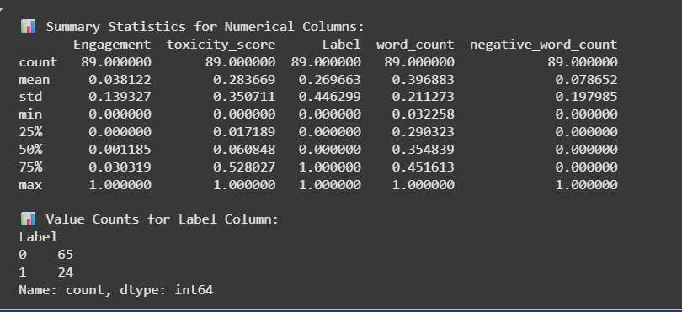

1.3 YouTube
YouTube comments are mostly non-hate, with about 20% labeled as hate, similar to Twitter but less than Reddit. Toxicity levels are generally low, though a few comments reach the maximum score of 1.0. Hate comments are often slightly shorter than non-hate ones, and there’s no clear link between toxicity and engagement, indicating that toxic content does not drive visibility.
Distributions (Histograms)
- Toxicity Score: right-skewed; most comments near zero, a small number at very high values.
- Word Count: sharply skewed toward short comments, with only a few longer ones.
- Engagement: extremely skewed; almost all comments have no engagement, rare outliers reach maximum.
- Negative Word Count: mostly zero, with very few comments registering higher negativity.
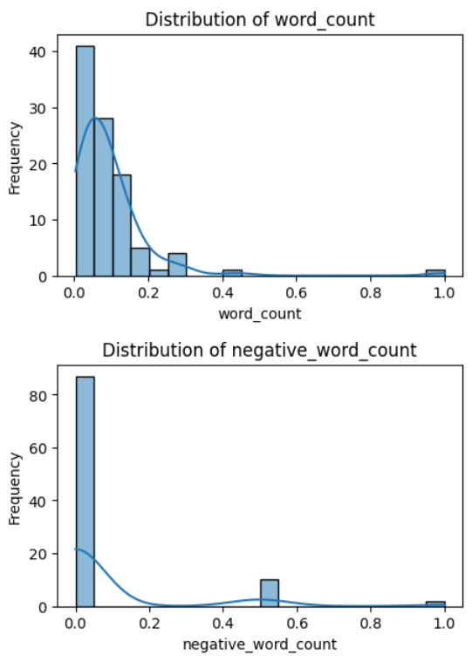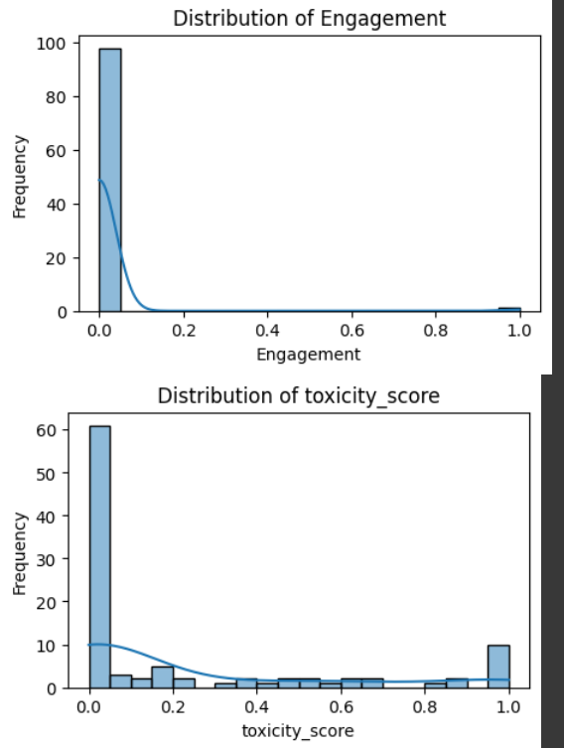

Label Distribution (Bar Chart)
- 79 non-hate vs 20 hate comments.
- Hate content makes up about 20%, higher than Reddit (11%) but lower than Twitter (27%).
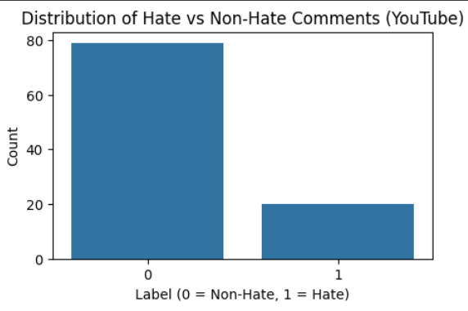

Correlation Heatmap
- Engagement vs. Negative Word Count: 0.22 → weak positive correlation (toxic words slightly linked to higher engagement).
- Toxicity vs. Negative Word Count: 0.12 → weak positive relationship.
- Other correlations are negligible (<0.1).
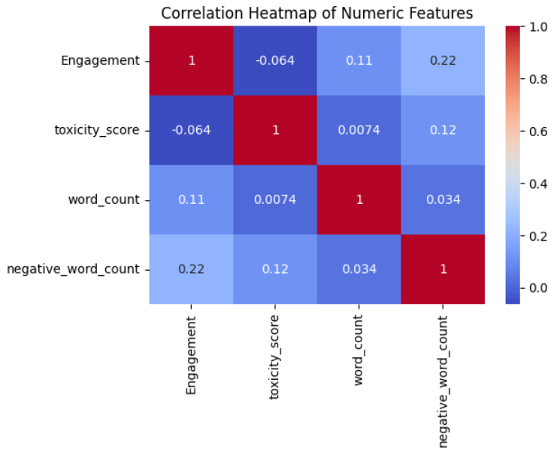

Boxplots (Word Count, Engagement, Toxicity Score, Negative Word Count)
- Word Count: highly concentrated at very short lengths; some outliers are longer.
- Engagement: nearly all at zero, with one or two extreme outliers.
- Toxicity Score: mostly below 0.2, but with several outliers approaching 1.0.
- Negative Word Count: nearly always zero, but a couple of comments show higher values.
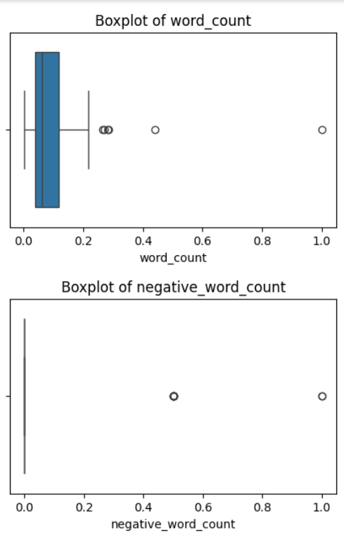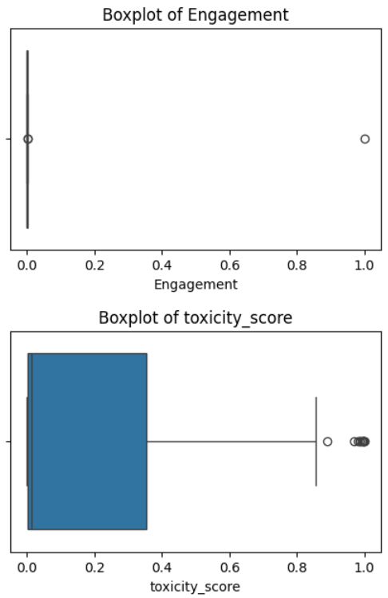

Word Count by Label (Boxplot)
- Hate and non-hate comments both tend to be very short.
- Non-hate comments show slightly more spread, while hate comments remain more concise.
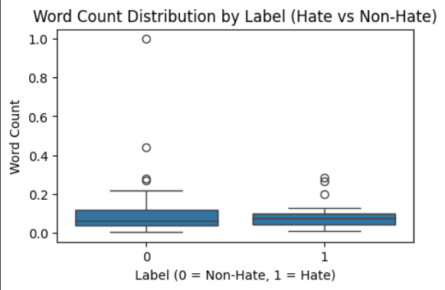
Summary Statistics (Table)
- Engagement: mean = 0.010, max = 1.0 → nearly all comments ignored, few extreme outliers.
- Toxicity: mean = 0.217, median = 0.013 → most comments low-toxicity, skew from a few highly toxic ones.
- Word Count: mean = 0.093, median = 0.061 → confirms comments are very short.
- Negative Word Count: mean = 0.071, mostly zeros with a couple of high scorers.
- Labels: 79 non-hate, 20 hate → ≈20% toxic content.
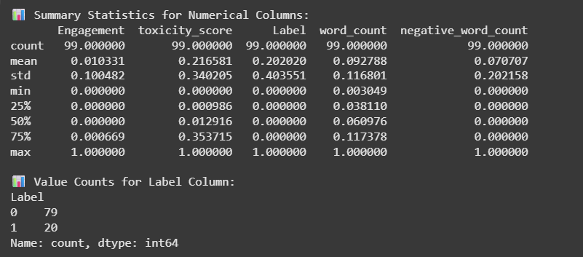

5. Summary of New Insights and Hypotheses
New Insights
- Prevalence of Hate Speech: Hate content varies across platforms — lowest on Reddit (~11%), moderate on YouTube (~20%), and highest on Twitter (~27%). This suggests platform differences in moderation practices or community norms.
- Toxicity Distribution: All platforms are skewed toward low toxicity, but Twitter and YouTube show more mid- to high-toxicity posts than Reddit.
- Comment/Tweet Length: Hate posts and comments tend to be shorter than non-hate across all three platforms, with Twitter showing less difference than Reddit and YouTube.
- Engagement Patterns: Engagement is heavily skewed toward zero across platforms. Toxicity does not strongly correlate with engagement, meaning hateful content is not necessarily more visible.
- Negative Lexicon Usage: Negative word counts are low on all platforms, but show a weak positive relationship with toxicity, particularly on Twitter and YouTube.
Hypotheses Generated
- Platform Moderation Hypothesis: Platforms with stricter moderation policies (e.g., Reddit) will show lower proportions of hate speech compared to more open platforms (e.g., Twitter).
- Conciseness of Hate Speech Hypothesis: Hate speech is more concise than non-hate content, reflecting the tendency for hateful comments to be short and direct.
- Engagement Independence Hypothesis: Toxicity and engagement are independent; hateful content does not inherently drive higher visibility or interaction.
- Lexical Cue Hypothesis: While lexicon-based negativity measures are sparse, their positive correlation with toxicity on Twitter and YouTube suggests they may serve as partial indicators for detecting hate speech.

6. Structured and Clean Data File(s)
Standardized:
-reddit_standardized.csv
-twitter_standardized.csv
-youtube_standardized.csv

Cleaned, Processed, & Standardized:
-reddit_cleaned.csv
-twitter_cleaned.csv
-youtube_cleaned.csv

7. Jupyter Notebook
Contains notebooks for Data cleaning and EDA
- Unifying Datasets before cleaning
https://colab.research.google.com/drive/1f22ZDKucAqNsKnQaV5aqgW_j2qhO2Su6?usp=sharing
- Data Cleaning & Processing + EDA
Twitter: https://colab.research.google.com/drive/1FKM3oouI7nl4290IqEs9AbZibGdEBAa9?usp=sharing
Reddit: https://colab.research.google.com/drive/1j_YcTgukaWLdZLW09P6JSs8Ej8a0PIlo?usp=sharing
YouTube: https://colab.research.google.com/drive/16ztdImwC3wRkSFdW8bBxVoNHAJLhj0Jf?usp=sharing

8. Logbook
Provided in a separate document.

