**Lock&Key**

Projekat iz Web programiranja 1

<https://lthechubbyl.github.io/lock_key/>

Miloš Čubrak 35/21

Internet Tehnologije

Table of Contents

1 Uvod 2

1.1 Korišćeni programski jezici 2

1.2 Opis funkcionalnosti 2

1.3 Template 2

2 Organizacija 3

2.1 Organizaciona šema 3

2.2 Mapa sajta 3

2.3 Slike stranica i opisi funkcionalnosti 4

3 Kodovi 10

3.1 HTML 10

3.1.1 index.html 10

3.1.2 contact.html 19

3.2 CSS 27

3.2.1 my-style.css 27

3.3 JavaScript 28

3.3.1 main.js 28

3.3.2 custom-jquery.js 41

3.3.3 template-main.js - (TEMPLATE) 42

LOCK&KEY

# Uvod

## Korišćeni programski jezici

* HTML5, CSS3, Bootstrap 5.2, JavaScript, JQuery, Swiper, FontAwesome
* Visual Studio Code

## Opis funkcionalnosti

* Dinamicko kreiranje navigacije
* Dinamicko kreiranje elemenata pomocu nizova i matrica putem javascripta
* Slideri koji prikazuju slike ili neki sadrzaj pomocu Swiper.js
* Filtriranje elemenata preko tastera u zavisnosti od odabranih opcija unutar padajucih lista
* Filtriranje elementa preko dugmica
* Ispisivanje dodatnog tekstualnog sadrzaja preko dugmeta
* Dinamicko kreiranje footer-a
* Sticky navigacija
* Back to top dugme
* Validacija forme, koriscenje regularnih izraza i ispisivanje gresaka
* Pracenje broja karaktera unutar textarea polja

## Template

* <https://htmlcodex.com/real-estate-html-template-free/>

# Organizacija

## Organizaciona šema

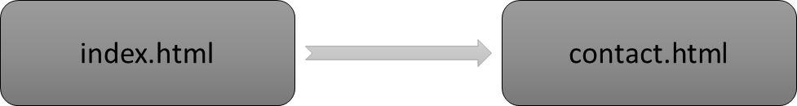

## Mapa sajta

<?xml version="1.0" encoding="UTF-8"?>

<urlset xmlms="http://www.sitemaps.org/schemas/sitemap/0.9">

    <url>

        <loc>https://lthechubbyl.github.io/lock_key/index.html</loc>

        <lastmod>2022-12-14</lastmod>

        <changefreq>daily</changefreq>

        <priority>1.0</priority>

    </url>

    <url>

        <loc>https://lthechubbyl.github.io/lock_key/contact.html</loc>

        <lastmod>2022-12-14</lastmod>

        <changefreq>weekly</changefreq>

        <priority>0.8</priority>

    </url>

</urlset>

## Slike stranica i opisi funkcionalnosti

* **Funkcionalnosti koje nisu napravljene od strane mene su: “sticky navbar” prilikom skrolovanja i “back to top” dugme**

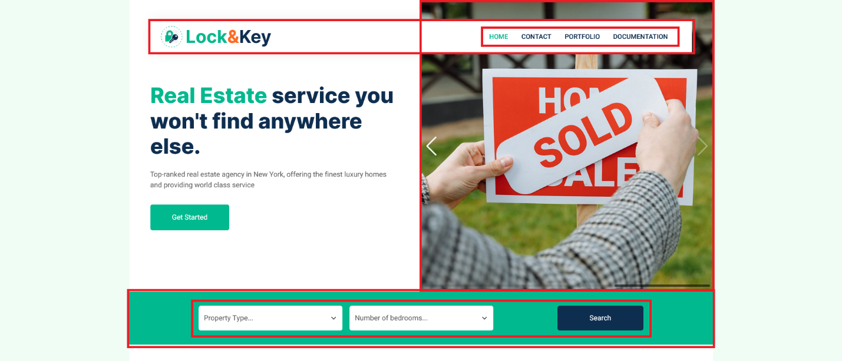

**1.**

* Linkovi unutar navigacionog menija su dinamicki kreirani
* Dodeljivanje active klase ispitivanjem sadrzaja title taga kroz javascript

**2.**

* Slider koji se nalazi unutar header-a je kreiran pomocu Swiper.js, automatski se menja, a moze i rucno pomocu strelica ili povlacenja

**3.**

* Omoguceno pretrazivanje iliti filtriranje kroz “Property Type” padajucu listu i “Number of bedrooms” padajucu listu, obe liste su dinamicki kreirane koristeci jednu funkciju
* Unutar “Property Type” DDL se bira tip objekta od ponudjenih “Apartment, Building, Home, Villa”
* Unutar “Number of bedrooms” DDL se bira broj soba od ponudjenih “3 bedroom/s, 6 bedroom/s”
* Klikom na taster “Search” se poziva funkcija koja filtira elemente koji se prikazuju u sledecoj sekciji “Property Listing” prema uputstvima bilo koje kombinacije odabira unutar obe liste
* Ukoliko se izabere kombinacija opcija unutar padajucih lista za koju ne odgovara nijedan element, prikazuje se poruka umesto elemenata koja skrece paznju na to

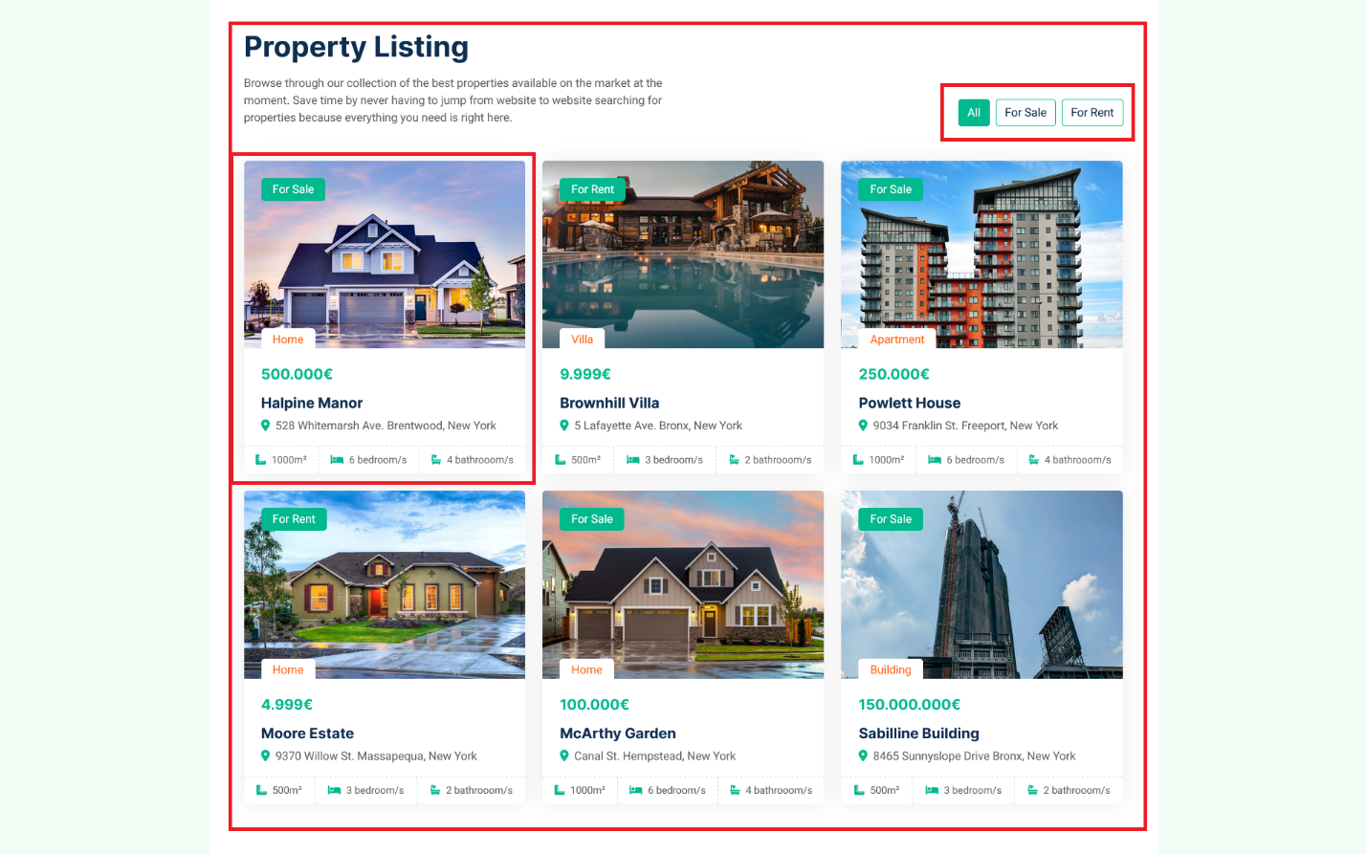

**4.**

* U gornjem desnom uglu sekcije se nalaze opcije filtriranja elemenata unutar same sekcije
* Opcije nestaju ukoliko ne postoje elementi koji se poklapaju sa zahtevima iz prethodnih padajucih lista
* Opcija “All” – prikaz svih elemenata
* Opcija “For Sale” – prikaz samo onih elemenata sa oznakom “For Sale”, odnosno koji se prodaju
* Opcija “For Rent” – prikaz samo onih elemenata sa oznakom “For Rent”, odnosno koji se iznajmljuju

**5.**

* Dinamicki kreirani elementi zajedno sa svim sadrzajem koristeci dvodimenzionalni niz podataka iliti matricu
* Prelaskom preko bilo kog elementa, slika se zoom-ira

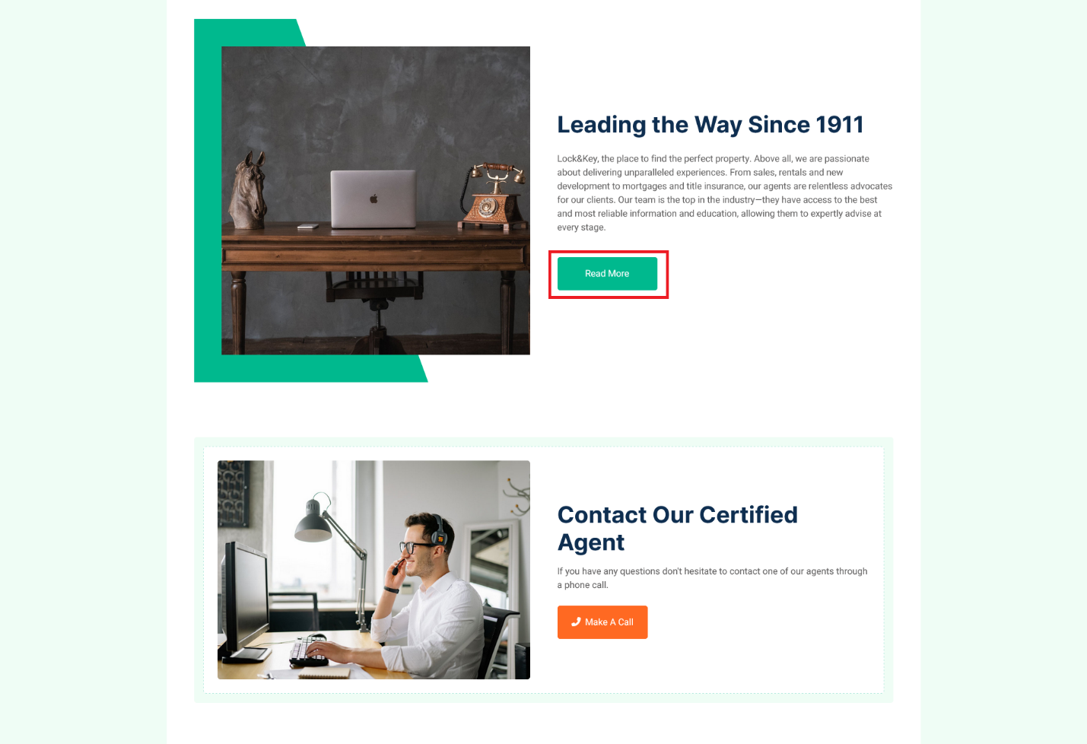

**6.**

* Klikom na taster “Read More” se dinamicki prikazuje dodatni tekst u obliku paragrafa pomocu jquery metode .slideToggle(‘slow’)

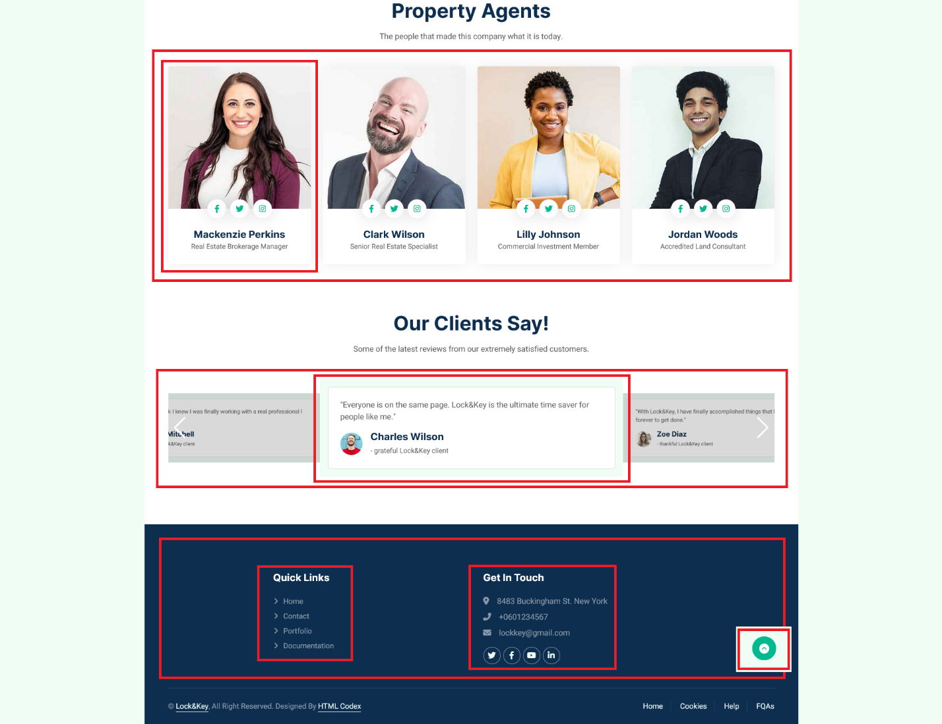

**7.**

* Elementi sekcije “Property Agents” su dinamicki kreirani iz javascripta

**8.**

* Sadrzaj slider-a formiran kroz javascript iz matrice, a funkcionalnost slider-a pomocu Swiper.js, automatski se menja, a moze i rucno pomocu strelica ili povlacenja

**9.**

* Linkovi unutar “Quick Links” kreirani iz niza
* Sadrzaj unutar “Get in touch” zajedno sa ikonicama kreiran iz niza

**9.**

* Takozvano back to top dugme koje vodi nazad na vrh stranice

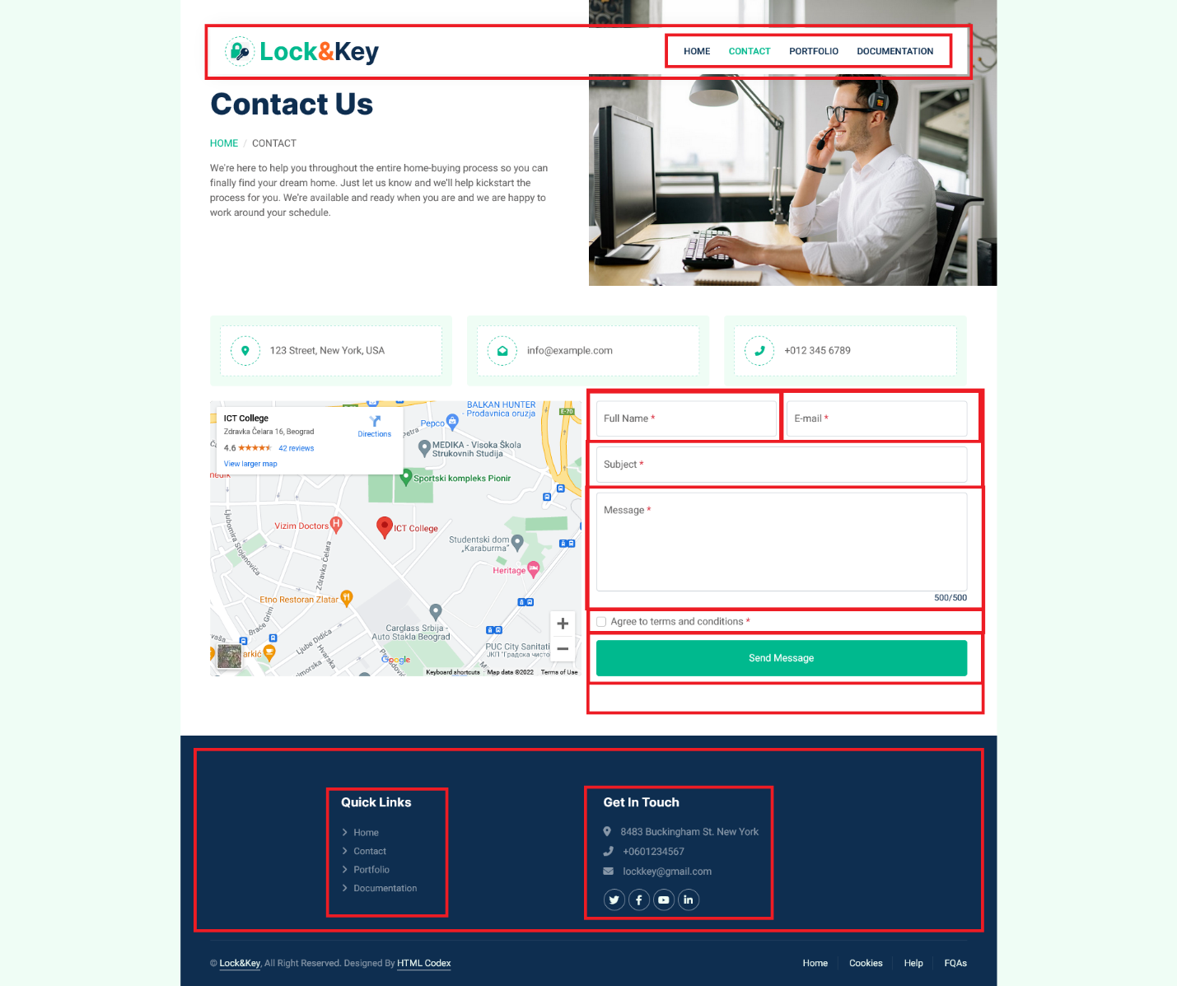

**1.**

* Linkovi unutar navigacionog menija su dinamicki kreirani
* Dodeljivanje active klase ispitivanjem sadrzaja title taga kroz javascript

**2.**

* Klikom na taster “Send message” se poziva funkcija koja proverava ispravnost unetih podataka u svako polje forme
* Validacija forme pomocu regularnih izraza i preko DOM atributa
* Ukoliko postoji greska prilikom unosa ili se neko polje koje je obavezno ne popuni, svaki deo forme koji nije popunjen ili je pogresno popunjen dobija crvenu borduru i ima zaseban element odmah ispod polja, koje ce se prikazati i u kome ce biti ispisana greska, sta se podrazumeva za unos u polje zajedno sa pravilnim primerom unosa
* Sva polja su obavezna zajedno sa checkbox-om
* Ispod textarea polja se nalazi counter koji odbrojava pri svakom unosu nekog karaktera unutar njega
* Ukoliko ne postoji greska prilikom unosa, forma se resetuje, prikazuje se sakriveni element ispod forme sa porukom o uspesnom popunjavanju forme i poslatom porukom

**3.**

* Linkovi unutar “Quick Links” kreirani iz niza
* Sadrzaj unutar “Get in touch” zajedno sa ikonicama kreiran iz niza

**4.**

* Takozvano back to top dugme koje vodi nazad na vrh stranice

# Kodovi

## HTML

### index.html

<!DOCTYPE html>

<html lang="en">

    <head>

        <meta charset="utf-8">

        <title>Lock&Key | Home</title>

        <meta content="width=device-width, initial-scale=1.0" name="viewport">

        <meta content="" name="keywords">

        <meta content="" name="description">

*<!-- Favicon -->*

        <link href="img/favicon.ico" rel="icon"/>

*<!-- _*-*_ CSS _*-*_ -->*

        <link href="https://cdn.jsdelivr.net/npm/bootstrap@5.2.3/dist/css/bootstrap.min.css" rel="stylesheet" integrity="sha384-rbsA2VBKQhggwzxH7pPCaAqO46MgnOM80zW1RWuH61DGLwZJEdK2Kadq2F9CUG65" crossorigin="anonymous"/>

        <link rel="stylesheet" href="https://cdn.jsdelivr.net/npm/swiper@8/swiper-bundle.min.css"/>

        <link href="assets/css/my-style.css" rel="stylesheet"/>

*<!-- Google Web Fonts -->*

        <link rel="preconnect" href="https://fonts.googleapis.com"/>

        <link rel="preconnect" href="https://fonts.gstatic.com" crossorigin/>

        <link href="https://fonts.googleapis.com/css2?family=Heebo:wght@400;500;600&family=Inter:wght@700;800&display=swap" rel="stylesheet">

*<!-- Customized Bootstrap Stylesheet -->*

        <link href="css/bootstrap.min.css" rel="stylesheet"/>

*<!-- Template Stylesheet -->*

        <link href="css/style.css" rel="stylesheet"/>

    </head>

    <body>

        <div class="container-xxl bg-white p-0">

*<!-- Navbar Start -->*

            <div class="container-fluid nav-bar bg-transparent">

                <nav class="navbar navbar-expand-lg bg-white navbar-light py-0 px-4">

                    <a href="index.html" class="navbar-brand d-flex align-items-center text-center">

                        <div class="icon p-2 me-2">

                            <img class="img-fluid" src="assets/img/lock_key_logo.png" alt="lock_key_logo"/>

                        </div>

                        <h1 class="m-0 text-primary">Lock<span class="text-secondary">&</span><span class="text-dark">Key</span></h1>

                    </a>

                    <button class="navbar-toggler" type="button" data-bs-toggle="collapse" data-bs-target="#navbarCollapse" aria-controls="navbarCollapse" aria-expanded="false" aria-label="Toggle navigation">

                        <i class="fa-solid fa-bars-staggered"></i>

                    </button>

                    <div class="collapse navbar-collapse" id="navbarCollapse">

                    </div>

                </nav>

            </div>

*<!-- Navbar End -->*

*<!-- Header Start -->*

            <div class="container-fluid header bg-white p-0">

                <div class="row g-0 align-items-center flex-column-reverse flex-md-row">

                    <div class="col-md-6 p-5 mt-lg-5">

                        <h1 class="display-5 mb-4"><span class="text-primary">Real Estate</span> service you won't find anywhere else.</h1>

                        <p class=" mb-4 pb-2">Top-ranked real estate agency in New York, offering the finest luxury homes and providing world class service</p>

                        <a href="#property-section" class="btn btn-primary py-3 px-5 me-3">Get Started</a>

                    </div>

                    <div class="col-md-6">

                        <div class="swiper swiperHeader">

                            <div class="swiper-wrapper">

                                <div class="swiper-slide">

                                    <img class="img-fluid" src="assets/img/key_in_lock.jpg" alt="key_in_lock"/>

                                </div>

                                <div class="swiper-slide">

                                    <img class="img-fluid" src="assets/img/moving_in.jpg" alt="moving_in"/>

                                </div>

                                <div class="swiper-slide">

                                    <img class="img-fluid" src="assets/img/sold_sign.jpg" alt="sold_sign"/>

                                </div>

                            </div>

                            <div class="swiper-button-prev text-light"></div>

                            <div class="swiper-button-next text-light"></div>

                            <div class="swiper-scrollbar mb-2"></div>

                        </div>

                    </div>

                </div>

            </div>

*<!-- Header End -->*

*<!-- Search Start -->*

            <div id="search-section" class="container-fluid bg-primary mb-5">

                <div class="container">

                    <div class="row g-2 justify-content-center">

                        <div class="col-md-8">

                            <div class="row g-3">

                                <div class="col-md-5 search-form-item">

                                </div>

                                <div class="col-md-5 search-form-item">

                                </div>

                            </div>

                        </div>

                        <div class="col-md-2">

                            <a id="search-btn" href="#search-btn" class="btn btn-dark border-0 w-100 py-3">Search</a>

                        </div>

                    </div>

                </div>

            </div>

*<!-- Search End -->*

*<!-- Property List Start -->*

            <div class="container-xxl py-5" id="property-section">

                <div class="container">

                    <div class="row g-0 gx-5 align-items-end">

                        <div class="col-lg-6">

                            <div class="text-start mx-auto mb-5">

                                <h1 class="mb-3">Property Listing</h1>

                                <p>Browse through our collection of the best properties available on the market at the moment. Save time by never having to jump from website to website searching for properties because everything you need is right here.</p>

                            </div>

                        </div>

                        <div class="col-lg-6 text-start text-lg-end">

                            <ul class="nav nav-pills d-inline-flex justify-content-end mb-5" id="property-filters">

                                <li class="nav-item me-2">

                                    <a class="btn btn-outline-primary active" data-bs-toggle="pill" href="#property-section-content">All</a>

                                </li>

                                <li class="nav-item me-2">

                                    <a class="btn btn-outline-primary" data-bs-toggle="pill" href="#property-section-content">For Sale</a>

                                </li>

                                <li class="nav-item me-0">

                                    <a class="btn btn-outline-primary" data-bs-toggle="pill" href="#property-section-content">For Rent</a>

                                </li>

                            </ul>

                        </div>

                    </div>

                    <div class="tab-content">

                        <div id="tab-1" class="tab-pane fade show p-0 active">

                            <div class="row g-4" id="property-section-content">

                            </div>

                            <p id="no-property" class="alert alert-info text-center h5 p-5 hide"></p>

                        </div>

                    </div>

                </div>

            </div>

*<!-- Property List End -->*

*<!-- About Start -->*

            <div class="container-xxl py-5">

                <div class="container">

                    <div class="row g-5 align-items-center">

                        <div class="col-lg-6">

                            <div class="about-img position-relative overflow-hidden p-5 pe-0">

                                <img class="img-fluid w-100" src="assets/img/about-us.jpg" alt="about_us"/>

                            </div>

                        </div>

                        <div class="col-lg-6">

                            <h1 class="mb-4">Leading the Way Since 1911</h1>

                            <p class="mb-4">Lock&Key, the place to find the perfect property. Above all, we are passionate about delivering unparalleled experiences. From sales, rentals and new development to mortgages and title insurance, our agents are relentless advocates for our clients. Our team is the top in the industry—they have access to the best and most reliable information and education, allowing them to expertly advise at every stage.

                            <p id="read-more" class="mb-4">We are backed by over a century's worth of insights and expertise We represent owners and tenants of all sizes across all industries, our goal is to achieve your objectives more easily. As the most trusted brand with the largest global network, Lock&Key is a genuine home for agents. By helping agents to be exceptional at what they do, we are ensuring that our customers receive the best level of service.</p></p>

                            <button id="read-more-btn" class="btn btn-primary py-3 px-5 mt-3">Read More</button>

                        </div>

                    </div>

                </div>

            </div>

*<!-- About End -->*

*<!-- Call to Action Start -->*

            <div class="container-xxl py-5">

                <div class="container">

                    <div class="bg-light rounded p-3">

                        <div class="bg-white rounded p-4 green-dashed-border">

                            <div class="row g-5 align-items-center">

                                <div class="col-lg-6">

                                    <img class="img-fluid rounded w-100" src="assets/img/call-to-action.jpg" alt="call-to-action"/>

                                </div>

                                <div class="col-lg-6">

                                    <div class="mb-4">

                                        <h1 class="mb-3">Contact Our Certified Agent</h1>

                                        <p>If you have any questions don't hesitate to contact one of our agents through a phone call.</p>

                                    </div>

                                    <a href="tel:0601234567" class="btn btn-secondary py-3 px-4 me-2"><i class="fa fa-phone-alt me-2"></i>Make A Call</a>

                                </div>

                            </div>

                        </div>

                    </div>

                </div>

            </div>

*<!-- Call to Action End -->*

*<!-- Team Start -->*

            <div class="container-xxl py-5">

                <div class="container">

                    <div class="text-center mx-auto mb-5">

                        <h1 class="mb-3">Property Agents</h1>

                        <p>The people that made this company what it is today.</p>

                    </div>

                    <div id="agent-section" class="row g-4">

                    </div>

                </div>

            </div>

*<!-- Team End -->*

*<!-- Testimonial Start -->*

            <div class="container-xxl py-5">

                <div class="container">

                    <div class="text-center mx-auto mb-5">

                        <h1 class="mb-3">Our Clients Say!</h1>

                        <p>Some of the latest reviews from our extremely satisfied customers.</p>

                    </div>

                    <div>

                        <div class="swiper swiperTestimonials">

                            <div id="testimonials" class="swiper-wrapper">

                                <div class="swiper-slide">

                                </div>

                                <div class="swiper-slide">

                                </div>

                                <div class="swiper-slide">

                                </div>

                            </div>

                            <div class="swiper-button-prev text-white"></div>

                            <div class="swiper-button-next text-white"></div>

                        </div>

                    </div>

                </div>

            </div>

*<!-- Testimonial End -->*

*<!-- Footer Start -->*

            <div class="container-fluid bg-dark text-white-50 footer pt-5 mt-5">

                <div class="container py-5">

                    <div class="row g-5 justify-content-center">

                        <div id="footer-quick-link" class="col-md-4">

                            <h5 class="text-white mb-4">Quick Links</h5>

                        </div>

                        <div id="footer-info" class="col-md-4">

                            <h5 class="text-white mb-4">Get In Touch</h5>

                        </div>

                    </div>

                </div>

                <div class="container">

                    <div class="copyright">

                        <div class="row">

                            <div class="col-md-6 text-center text-md-start mb-3 mb-md-0">

                                &copy; <a class="border-bottom" href="index.html">Lock&Key</a>, All Right Reserved.

*<!--/*** This template is free as long as you keep the footer author’s credit link/attribution link/backlink. If you'd like to use the template without the footer author’s credit link/attribution link/backlink, you can purchase the Credit Removal License from "https://htmlcodex.com/credit-removal". Thank you for your support. ***/-->*

                                Designed By <a class="border-bottom" href="#">HTML Codex</a>

                            </div>

                            <div class="col-md-6 text-center text-md-end">

                                <div class="footer-menu">

                                    <a href="index.html">Home</a>

                                    <a href="index.html">Cookies</a>

                                    <a href="index.html">Help</a>

                                    <a href="index.html">FQAs</a>

                                </div>

                            </div>

                        </div>

                    </div>

                </div>

            </div>

*<!-- Footer End -->*

*<!-- Back to Top -->*

            <a href="#" class="btn btn-lg btn-primary btn-lg-square back-to-top"><i class="fa-solid fa-circle-chevron-up"></i></a>

        </div>

*<!-- _*-*_ JS _*-*_ -->*

        <script src="https://cdnjs.cloudflare.com/ajax/libs/jquery/3.6.2/jquery.min.js" integrity="sha512-tWHlutFnuG0C6nQRlpvrEhE4QpkG1nn2MOUMWmUeRePl4e3Aki0VB6W1v3oLjFtd0hVOtRQ9PHpSfN6u6/QXkQ==" crossorigin="anonymous" referrerpolicy="no-referrer"></script>

        <script src="https://cdn.jsdelivr.net/npm/bootstrap@5.2.3/dist/js/bootstrap.bundle.min.js" integrity="sha384-kenU1KFdBIe4zVF0s0G1M5b4hcpxyD9F7jL+jjXkk+Q2h455rYXK/7HAuoJl+0I4" crossorigin="anonymous"></script>

        <script src="https://cdn.jsdelivr.net/npm/swiper@8/swiper-bundle.min.js"></script>

        <script src="https://kit.fontawesome.com/270460494f.js" crossorigin="anonymous"></script>

        <script src="assets/js/main.js"></script>

        <script src="assets/js/custom-jquery.js"></script>

*<!-- Template Javascript -->*

        <script src="js/template-main.js"></script>

    </body>

</html>

### contact.html

<!DOCTYPE html>

<html lang="en">

    <head>

        <meta charset="utf-8">

        <title>Lock&Key | Contact</title>

        <meta content="width=device-width, initial-scale=1.0" name="viewport">

        <meta content="" name="keywords">

        <meta content="" name="description">

*<!-- Favicon -->*

        <link href="img/favicon.ico" rel="icon">

*<!-- _*-*_ CSS _*-*_ -->*

        <link href="https://cdn.jsdelivr.net/npm/bootstrap@5.2.3/dist/css/bootstrap.min.css" rel="stylesheet" integrity="sha384-rbsA2VBKQhggwzxH7pPCaAqO46MgnOM80zW1RWuH61DGLwZJEdK2Kadq2F9CUG65" crossorigin="anonymous"/>

        <link rel="stylesheet" href="https://cdn.jsdelivr.net/npm/swiper@8/swiper-bundle.min.css"/>

        <link href="assets/css/my-style.css" rel="stylesheet"/>

*<!-- Google Web Fonts -->*

        <link rel="preconnect" href="https://fonts.googleapis.com"/>

        <link rel="preconnect" href="https://fonts.gstatic.com" crossorigin/>

        <link href="https://fonts.googleapis.com/css2?family=Heebo:wght@400;500;600&family=Inter:wght@700;800&display=swap" rel="stylesheet">

*<!-- Customized Bootstrap Stylesheet -->*

        <link href="css/bootstrap.min.css" rel="stylesheet"/>

*<!-- Template Stylesheet -->*

        <link href="css/style.css" rel="stylesheet"/>

    </head>

    <body>

        <div class="container-xxl bg-white p-0">

*<!-- Navbar Start -->*

            <div class="container-fluid nav-bar bg-transparent">

                <nav class="navbar navbar-expand-lg bg-white navbar-light py-0 px-4">

                    <a href="index.html" class="navbar-brand d-flex align-items-center text-center">

                        <div class="icon p-2 me-2">

                            <img class="img-fluid" src="assets/img/lock_key_logo.png" alt="lock_key_logo">

                        </div>

                        <h1 class="m-0 text-primary">Lock<span class="text-secondary">&</span><span class="text-dark">Key</span></h1>

                    </a>

                    <button class="navbar-toggler" type="button" data-bs-toggle="collapse" data-bs-target="#navbarCollapse" aria-controls="navbarCollapse" aria-expanded="false" aria-label="Toggle navigation">

                        <i class="fa-solid fa-bars-staggered"></i>

                    </button>

                    <div class="collapse navbar-collapse" id="navbarCollapse">

                    </div>

                </nav>

            </div>

*<!-- Navbar End -->*

*<!-- Header Start -->*

            <div class="container-fluid header bg-white p-0">

                <div class="row g-0 align-items-center flex-column-reverse flex-md-row">

                    <div class="col-md-6 p-5 mt-lg-5">

                        <h1 class="display-5 mb-4">Contact Us</h1>

                            <nav aria-label="breadcrumb">

                                <ol class="breadcrumb text-uppercase">

                                    <li class="breadcrumb-item"><a href="index.html">Home</a></li>

                                    <li class="breadcrumb-item text-body active" aria-current="page">Contact</li>

                                </ol>

                            </nav>

                        <p>We're here to help you throughout the entire home-buying process so you can finally find your dream home.  Just let us know and we'll help kickstart the process for you. We're available and ready when you are and we are happy to work around your schedule.</p>

                    </div>

                    <div class="col-md-6">

                        <img class="img-fluid" src="assets/img/call-to-action.jpg" alt="call-to-action">

                    </div>

                </div>

            </div>

*<!-- Header End -->*

*<!-- Contact Start -->*

            <div class="container-xxl py-5">

                <div class="container-fluid">

                    <div class="row g-4">

                        <div class="col-12">

                            <div class="row gy-4">

                                <div class="col-md-6 col-lg-4">

                                    <div class="bg-light rounded p-3">

                                        <div class="d-flex align-items-center bg-white rounded p-3 green-dashed-border">

                                            <div class="icon me-3">

                                                <i class="fa fa-map-marker-alt text-primary"></i>

                                            </div>

                                            <span>123 Street, New York, USA</span>

                                        </div>

                                    </div>

                                </div>

                                <div class="col-md-6 col-lg-4">

                                    <div class="bg-light rounded p-3">

                                        <div class="d-flex align-items-center bg-white rounded p-3 green-dashed-border">

                                            <div class="icon me-3">

                                                <i class="fa fa-envelope-open text-primary"></i>

                                            </div>

                                            <span>info@example.com</span>

                                        </div>

                                    </div>

                                </div>

                                <div class="col-md-6 col-lg-4">

                                    <div class="bg-light rounded p-3">

                                        <div class="d-flex align-items-center bg-white rounded p-3 green-dashed-border">

                                            <div class="icon me-3">

                                                <i class="fa fa-phone-alt text-primary"></i>

                                            </div>

                                            <span>+012 345 6789</span>

                                        </div>

                                    </div>

                                </div>

                            </div>

                        </div>

                        <div class="col-md-6">

                            <iframe id="maps" class="position-relative rounded w-100 h-100"

                            src="https://www.google.com/maps/embed?pb=!1m18!1m12!1m3!1d2830.3586717145054!2d20.482226115733457!3d44.81425718459493!2m3!1f0!2f0!3f0!3m2!1i1024!2i768!4f13.1!3m3!1m2!1s0x475a7a9609031735%3A0xc17ed71f59ac4725!2sICT%20College!5e0!3m2!1sen!2srs!4v1671078028178!5m2!1sen!2srs"

                                frameborder="0" loading="lazy" allowfullscreen="" aria-hidden="false"

                                tabindex="0"></iframe>

                        </div>

                        <div class="col-md-6">

                            <div>

                                <form name="form-contact" id="form-contact">

                                    <div class="row g-3">

                                        <div class="col-md-6">

                                            <div class="form-floating">

                                                <input type="text" class="form-control" id="form-name" placeholder="Your Full Name"/>

                                                <label for="form-name">Full Name<span class="text-danger ms-1">*</span></label>

                                            </div>

                                            <p class="error-message alert alert-danger mt-1 p-2 hide"></p>

                                        </div>

                                        <div class="col-md-6">

                                            <div class="form-floating">

                                                <input type="email" class="form-control" id="form-email" placeholder="Your Email"/>

                                                <label for="form-email">E-mail<span class="text-danger ms-1">*</span></label>

                                            </div>

                                            <p class="error-message alert alert-danger mt-1 p-2 hide"></p>

                                        </div>

                                        <div class="col-12">

                                            <div class="form-floating">

                                                <input type="text" class="form-control" id="form-subject" placeholder="Subject"/>

                                                <label for="form-subject">Subject<span class="text-danger ms-1">*</span></label>

                                            </div>

                                            <p class="error-message alert alert-danger mt-1 p-2 hide"></p>

                                        </div>

                                        <div class="col-12">

                                            <div class="form-floating">

                                                <textarea class="form-control" placeholder="Leave a message here" id="form-message"></textarea>

                                                <label for="form-message">Message<span class="text-danger ms-1">*</span></label>

                                                <small id="char-count" class="d-block text-end text-dark">500/500</small>

                                            </div>

                                            <p class="error-message alert alert-danger mt-1 p-2 hide"></p>

                                        </div>

                                        <div class="col-12">

                                            <div class="form-check">

                                                <input class="form-check-input" type="checkbox" id="form-terms-conditions"/>

                                                <label class="form-check-label" for="form-terms-conditions">Agree to terms and conditions<span class="text-danger ms-1">*</span></label>

                                            </div>

                                            <p class="error-message alert alert-danger mt-1 p-2 hide"></p>

                                        </div>

                                        <div class="col-12">

                                            <input type="button" id="form-btn" class="btn btn-primary w-100 py-3" value="Send Message"/>

                                        </div>

                                    </div>

                                    <p id="no-error-message" class="alert alert-success mt-3 p-3 text-center hide"></p>

                                </form>

                            </div>

                        </div>

                    </div>

                </div>

            </div>

*<!-- Contact End -->*

*<!-- Footer Start -->*

            <div class="container-fluid bg-dark text-white-50 footer pt-5 mt-5">

                <div class="container py-5">

                    <div class="row g-5 justify-content-center">

                        <div id="footer-quick-link" class="col-md-4">

                            <h5 class="text-white mb-4">Quick Links</h5>

                        </div>

                        <div id="footer-info" class="col-md-4">

                            <h5 class="text-white mb-4">Get In Touch</h5>

                        </div>

                    </div>

                </div>

                <div class="container">

                    <div class="copyright">

                        <div class="row">

                            <div class="col-md-6 text-center text-md-start mb-3 mb-md-0">

                                &copy; <a class="border-bottom" href="index.html">Lock&Key</a>, All Right Reserved.

*<!--/*** This template is free as long as you keep the footer author’s credit link/attribution link/backlink. If you'd like to use the template without the footer author’s credit link/attribution link/backlink, you can purchase the Credit Removal License from "https://htmlcodex.com/credit-removal". Thank you for your support. ***/-->*

                                Designed By <a class="border-bottom" href="#">HTML Codex</a>

                            </div>

                            <div class="col-md-6 text-center text-md-end">

                                <div class="footer-menu">

                                    <a href="index.html">Home</a>

                                    <a href="index.html">Cookies</a>

                                    <a href="index.html">Help</a>

                                    <a href="index.html">FQAs</a>

                                </div>

                            </div>

                        </div>

                    </div>

                </div>

            </div>

*<!-- Footer End -->*

*<!-- Back to Top -->*

            <a href="#" class="btn btn-lg btn-primary btn-lg-square back-to-top"><i class="fa-solid fa-circle-chevron-up"></i></a>

        </div>

*<!-- _*-*_ JS _*-*_ -->*

         <script src="https://cdnjs.cloudflare.com/ajax/libs/jquery/3.6.2/jquery.min.js" integrity="sha512-tWHlutFnuG0C6nQRlpvrEhE4QpkG1nn2MOUMWmUeRePl4e3Aki0VB6W1v3oLjFtd0hVOtRQ9PHpSfN6u6/QXkQ==" crossorigin="anonymous" referrerpolicy="no-referrer"></script>

         <script src="https://cdn.jsdelivr.net/npm/bootstrap@5.2.3/dist/js/bootstrap.bundle.min.js" integrity="sha384-kenU1KFdBIe4zVF0s0G1M5b4hcpxyD9F7jL+jjXkk+Q2h455rYXK/7HAuoJl+0I4" crossorigin="anonymous"></script>

         <script src="https://cdn.jsdelivr.net/npm/swiper@8/swiper-bundle.min.js"></script>

         <script src="https://kit.fontawesome.com/270460494f.js" crossorigin="anonymous"></script>

         <script src="assets/js/main.js"></script>

         <script src="assets/js/custom-jquery.js"></script>

*<!-- Template Javascript -->*

         <script src="js/template-main.js"></script>

    </body>

</html>

## CSS

### my-style.css

* Najveci deo stilizovanja koji sam ja dodavao je uradjen preko Bootstrap klasa unutar samog HTML-a
* Ostatak je iz posebnog CSS fajla koji se dobije uz sam template

.hide {

    display: none !important;

}

.error-message {

    font-size: 0.8rem;

}

.icon {

    width: 3rem;

    height: 3rem;

}

.green-dashed-border {

    border: 1px dashed rgba(0, 185, 142, .3);

}

#search-section {

    padding: 2rem;

}

#maps {

    min-height: 400px;

}

#form-message {

    height: 10rem;

    resize: none;

}

## JavaScript

### main.js

*// if (location.pathname == '/lock_key/index.html' || location.pathname == '/lock_key/') {*

*if* (location.pathname == '/index.html' || location.pathname == '/') {

*/* _*-*_ BEGIN|DYNAMIC "PROPERTY LISTING" CONTENT _*-*_ */*

    var propertySectionContent = document.getElementById('property-section-content');

    const contentPropertyMatrix = [

        ['For Sale', 'Home', '500.000', 'Halpine Manor', '528 Whitemarsh Ave. Brentwood, New York', 'blue_house'],

        ['For Rent', 'Villa', '9.999', 'Brownhill Villa', '5 Lafayette Ave. Bronx, New York', 'villa'],

        ['For Sale', 'Apartment', '250.000', 'Powlett House', '9034 Franklin St. Freeport, New York', 'apartment'],

        ['For Rent', 'Home', '4.999', 'Moore Estate', '9370 Willow St. Massapequa, New York', 'green_house'],

        ['For Sale', 'Home', '100.000', 'McArthy Garden', 'Canal St. Hempstead, New York', 'brown_house'],

        ['For Sale', 'Building', '150.000.000', 'Sabilline Building ', '8465 Sunnyslope Drive Bronx, New York', 'building_construction']

    ];

    const contentPropertyDetails = [[1000, 6, 4], [500, 3, 2], [1000, 6, 4], [500, 3, 2], [1000, 6, 4], [500, 3, 2]];

    const contentPropertyDivClasses = ['property-list-part col-lg-4 col-md-6', 'property-item rounded overflow-hidden', 'position-relative overflow-hidden', 'sale-or-rent bg-primary rounded text-white position-absolute start-0 top-0 m-4 py-1 px-3', 'bg-white rounded-top text-primary position-absolute start-0 bottom-0 mx-4 pt-1 px-3', 'p-4 pb-0', 'd-flex border-top'];

    const contentPropertyIconClasses = ['fa fa-ruler-combined text-primary me-2', 'fa fa-bed text-primary me-2', 'fa fa-bath text-primary me-2'];

*for* (let index = 0; index < 6; index++) {

*for*(let index = 1; index <= 7; index++) {

            window['propertyDiv' + index] = document.createElement('div');

            window['propertyDiv' + index].setAttribute('class', contentPropertyDivClasses[index-1]);

        }

        let propertyAnchor1 = document.createElement('a');

        propertyAnchor1.setAttribute('href', '#property-section');

        propertyAnchor1.setAttribute('disabled', 'disabled');

        let propertyImage = document.createElement('img');

        Object.assign(propertyImage, {

            className: 'img-fluid',

            src: `assets/img/${contentPropertyMatrix[index][5]}.jpg`,

            alt: contentPropertyMatrix[index][5]

        });

        let propertyHeader5 = document.createElement('h5');

        propertyHeader5.setAttribute('class', 'text-primary mb-3');

        let propertyAnchor2 = document.createElement('a');

        propertyAnchor2.setAttribute('class', 'd-block h5 mb-2');

        propertyAnchor2.setAttribute('href', '#property-section');

        let propertyParagraph = document.createElement('p');

        let propertyIcon = document.createElement('i');

        propertyIcon.setAttribute('class', 'fa fa-map-marker-alt text-primary me-2');

*for* (let index = 1; index <= 3; index++) {

            window['propertySmall' + index] = document.createElement('small');

            window['propertySmall' + index].setAttribute('class', 'flex-fill text-center border-end py-2');

            window['propertyIcon' + index] = document.createElement('i');

            window['propertyIcon' + index].setAttribute('class', contentPropertyIconClasses[index - 1]);

            window['propertySmall' + index].appendChild(window['propertyIcon' + index]);

            propertyDiv7.appendChild(window['propertySmall' + index]);

        }

        propertyDiv5.classList.add('text-secondary');

        propertySmall2.classList.add('bedroom-num');

        propertySmall3.classList.remove('border-end');

        propertyDiv1.appendChild(propertyDiv2);

            propertyDiv2.appendChild(propertyDiv3);

                propertyDiv3.append(propertyAnchor1, propertyDiv4, propertyDiv5);

                    propertyAnchor1.appendChild(propertyImage);

                    propertyDiv4.textContent += contentPropertyMatrix[index][0];

                    propertyDiv5.textContent += contentPropertyMatrix[index][1];

            propertyDiv2.appendChild(propertyDiv6);

                propertyDiv6.append(propertyHeader5, propertyAnchor2, propertyParagraph);

                    propertyHeader5.innerHTML += contentPropertyMatrix[index][2] + '&#x20AC;';

                        propertyAnchor2.innerHTML += contentPropertyMatrix[index][3];

                        propertyParagraph.appendChild(propertyIcon);

                        propertyParagraph.innerHTML += contentPropertyMatrix[index][4];

            propertyDiv2.appendChild(propertyDiv7);

                    propertySmall1.innerHTML += contentPropertyDetails[index][0] + 'm&#178;';

                    propertySmall2.innerHTML += contentPropertyDetails[index][1] + ' bedroom/s';

                    propertySmall3.innerHTML += contentPropertyDetails[index][2] + ' bathrooom/s';

    propertySectionContent.append(propertyDiv1);

    }

*/* _*-*_ END|DYNAMIC "PROPERTY LISTING" CONTENT _*-*_ */*

*/* _*-*_ BEGIN|DYNAMIC "PROPERTY LISTING" FILTER _*-*_ */*

    var propertyFilters = document.querySelectorAll('#property-filters li a');

    var propertySaleOrRent = document.querySelectorAll('.sale-or-rent');

    var propertyListPart = document.querySelectorAll('.property-list-part');

*for* (const element of propertyFilters) {

        element.addEventListener('click', function() {

            document.querySelector('#property-filters li a.active').classList.remove('active');

            element.classList.add('active');

*for* (let index = 0; index < propertyListPart.length; index++) {

*if*((element.innerHTML != 'All') && !(element.innerHTML == propertySaleOrRent[index].innerHTML)) {

                    propertyListPart[index].classList.add('hide');

                }

*else* {

                    propertyListPart[index].classList.remove('hide');

                }

            }

        })

    }

*/* _*-*_ END|DYNAMIC "PROPERTY LISTING" FILTER _*-*_ */*

*/* _*-*_ BEGIN|DYNAMIC "SEARCH" CONTENT _*-*_ */*

    var searchFields = document.querySelectorAll(".search-form-item");

    var searchPropertySort = ['3 bedroom/s', '6 bedroom/s'];

    var searchPropertyTypes = ['Apartment', 'Building', 'Home', 'Villa'];

    var typeSelect, typeOption, sortSelect, sortOption;

    function CreateSearchDDL(*ddlName*, *ddlId*, *defaultValue*, *valueArray*, *optionName*, *position*) {

        ddlName = document.createElement('select');

        ddlName.setAttribute('class', 'form-select border-0 py-3 search-form-ddl');

        ddlName.setAttribute('id', ddlId);

        searchFields[position].append(ddlName);

        var typeDefaultOption = document.createElement('option');

        typeDefaultOption.setAttribute('value', 0);

        typeDefaultOption.innerHTML += defaultValue;

        ddlName.append(typeDefaultOption);

*for* (let index = 0; index < valueArray.length; index++) {

            optionName = document.createElement('option');

            optionName.setAttribute('value', valueArray[index]);

            optionName.innerHTML += valueArray[index];

            ddlName.append(optionName);

        }

    }

    CreateSearchDDL(typeSelect, 'search-type', 'Property Type...', searchPropertyTypes, typeOption, 0);

    CreateSearchDDL(sortSelect, 'search-sort', 'Number of bedrooms...', searchPropertySort, sortOption, 1);

    var searchFieldType = document.querySelector('#search-type');

    var searchFieldSort = document.querySelector('#search-sort');

    var searchFieldBtn = document.querySelector('#search-btn');

    var propertyBedroom = document.getElementsByClassName('bedroom-num');

    searchFieldBtn.addEventListener('click', function() {

*for* (let index = 0; index < propertyListPart.length; index++) {

            propertyListPart[index].classList.remove('hide');

*if* (!(searchFieldType.value == '0') && !(searchFieldSort.value == '0')) {

*if* ((!(searchFieldType.value == propertySaleOrRent[index].nextElementSibling.innerHTML)) || (!(searchFieldSort.value == propertyBedroom[index].textContent))) {

                    propertyListPart[index].classList.add('hide');

                }

            }

*else* *if* (!(searchFieldType.value == '0') && !(searchFieldType.value == propertySaleOrRent[index].nextElementSibling.innerHTML)) {

                propertyListPart[index].classList.add('hide');

            }

*else* *if* (!(searchFieldSort.value == '0') && !(searchFieldSort.value == propertyBedroom[index].textContent)) {

                propertyListPart[index].classList.add('hide');

            }

*else* {

                propertyListPart[index].classList.remove('hide');

            }

        }

    });

*/* _*-*_ END|DYNAMIC "SEARCH" CONTENT _*-*_ */*

*/* _*-*_ BEGIN|DYNAMIC "PROPERTY AGENTS" CONTENT _*-*_ */*

    var agentSection = document.getElementById('agent-section');

    const contentAgentDetails = [['Mackenzie Perkins', 'Real Estate Brokerage Manager', 'mackenzie'], ['Clark Wilson', 'Senior Real Estate Specialist', 'clark'], ['Lilly Johnson', 'Commercial Investment Member', 'lily'],['Jordan Woods', 'Accredited Land Consultant', 'jordan']];

    const contentAgentDivClasses = ['col-lg-3 col-md-6 wow fadeInUp', 'team-item rounded overflow-hidden', 'position-relative', 'position-absolute start-50 top-100 translate-middle d-flex align-items-center', 'text-center p-4 mt-3'];

    const contentAgentIconClasses = ['fab fa-facebook-f', 'fab fa-twitter', 'fab fa-instagram'];

*for* (let index = 0; index < 4; index++) {

*for* (let index = 1; index <= 5; index++) {

            window['agentDiv' + index] = document.createElement('div');

            window['agentDiv' + index].setAttribute('class', contentAgentDivClasses[index-1]);

        }

        let agentImage = document.createElement('img');

        Object.assign(agentImage, {

            className: 'img-fluid',

            src: `assets/img/${contentAgentDetails[index][2]}.jpg`,

            alt: contentAgentDetails[index][2]

        });

*for* (let index = 0; index < 3; index++) {

            window['agentAnchor' + index + 1] = document.createElement('a');

            window['agentAnchor' + index + 1].setAttribute('class', 'btn btn-square mx-1');

            window['agentAnchor' + index + 1].setAttribute('href', '#agent-section');

            window['agentIcon' + index + 1] = document.createElement('i');

            window['agentIcon' + index + 1].setAttribute('class', contentAgentIconClasses[index]);

            window['agentAnchor' + index + 1].appendChild(window['agentIcon' + index + 1]);

            agentDiv4.appendChild(window['agentAnchor' + index + 1]);

        }

        let agentHeader5 = document.createElement('h5');

        agentHeader5.setAttribute('class', 'fw-bold mb-0');

        let agentSmall = document.createElement('small');

        agentDiv1.appendChild(agentDiv2);

            agentDiv2.appendChild(agentDiv3);

                agentDiv3.append(agentImage, agentDiv4);

            agentDiv2.appendChild(agentDiv5);

                agentDiv5.append(agentHeader5, agentSmall);

                    agentHeader5.innerHTML += contentAgentDetails[index][0]

                    agentSmall.innerHTML += contentAgentDetails[index][1]

    agentSection.append(agentDiv1);

    }

*/* _*-*_ END|DYNAMIC "PROPERTY AGENTS" CONTENT _*-*_ */*

*/* _*-*_ BEGIN|DYNAMIC "TESTIMONIALS" CONTENT _*-*_ */*

    var testimonialsSection = document.querySelectorAll('#testimonials .swiper-slide');

    const contentTestimonialsDetails = [

        ['"When I found Clark I knew I was finally working with a real professional I could rely on."' ,'Naomi Mitchell', '- happy Lock&Key client', 'naomi'],

        ['"Everyone is on the same page. Lock&Key is the ultimate time saver for people like me."' ,'Charles Wilson', '- grateful Lock&Key client', 'charles'],

        ['"With Lock&Key, I have finally accomplished things that have been waiting forever to get done."' ,'Zoe Diaz', '- thankful Lock&Key client', 'zoe']

    ];

    const contentTestimonialsDivClasses = ['testimonial-item bg-light rounded p-3', 'bg-white border rounded p-4', 'd-flex align-items-center', 'ps-3'];

*for* (let index = 0; index < 3; index++) {

*for* (let index = 1; index <= 4; index++) {

            window['testimonialDiv' + index] = document.createElement('div');

            window['testimonialDiv' + index].setAttribute('class', contentTestimonialsDivClasses[index-1]);

        }

        let testimonialParagraph = document.createElement('p');

        let testimonialImage = document.createElement('img');

        Object.assign(testimonialImage, {

            className: 'img-fluid flex-shrink-0 rounded-circle',

            src: `assets/img/${contentTestimonialsDetails[index][3]}.jpg`,

            alt: contentTestimonialsDetails[index][3]

        });

        testimonialImage.style.width = '45px';

        testimonialImage.style.height = '45px';

        let testimonialHeader6 = document.createElement('h5');

        testimonialHeader6.setAttribute('class', 'fw-bold mb-1');

        let testimonialSmall = document.createElement('small');

        testimonialDiv1.appendChild(testimonialDiv2);

            testimonialDiv2.append(testimonialParagraph, testimonialDiv3);

                testimonialParagraph.innerHTML += contentTestimonialsDetails[index][0];

                testimonialDiv3.append(testimonialImage, testimonialDiv4);

                    testimonialDiv4.append(testimonialHeader6, testimonialSmall);

                        testimonialHeader6.innerHTML += contentTestimonialsDetails[index][1];

                    testimonialSmall.innerHTML += contentTestimonialsDetails[index][2];

    testimonialsSection[index].append(testimonialDiv1);

    }

*/* _*-*_ END|DYNAMIC "TESTIMONIALS" CONTENT _*-*_ */*

}

*// else if (location.pathname == '/lock_key/contact.html') {*

*else* *if* (location.pathname == '/contact.html') {

*/* _*-*_ BEGIN|CONTACT FORM VALIDATION _*-*_ */*

    var formSubmit = document.querySelector('#form-btn');

    formSubmit.addEventListener('click', formValidation);

    var errors = 0;

    function regExValidation(*formPart*, *regEx*, *errorMessage*) {

*if*(!regEx.test(formPart.value)) {

            formPart.classList.add('border-2', 'border-danger', 'rounded');

            formPart.parentElement.nextElementSibling.innerHTML = errorMessage;

            formPart.parentElement.nextElementSibling.classList.remove('hide');

            errors++;

        }

*else*{

            formPart.classList.remove('border-2', 'border-danger', 'rounded');

            formPart.parentElement.nextElementSibling.innerHTML = '';

            formPart.parentElement.nextElementSibling.classList.add('hide');

        }

    }

    function formValidation() {

        errors = 0;

        let formFullName, formEmail, formSubject, formMessage, formTerms, formSuccess;

        let regExFullName, regExEmail, regExSubject;

        formFullName = document.querySelector('#form-name');

        formEmail = document.querySelector('#form-email');

        formSubject = document.querySelector('#form-subject');

        formMessage = document.querySelector('#form-message');

        formTerms = document.querySelector('#form-terms-conditions');

        formSuccess = document.querySelector('#no-error-message');

        regExFullName = /*^*[A-ZČĆŠĐŽ][a-zčćđšž]{2,14}([\s][A-ZČĆŠĐŽ][a-zčćđšž]{2,14})+*$*/;

        regExEmail = /*^*[a-z0-9+_.-]+@[a-z0-9.-]+\.[a-z]{2,3}*$*/;

        regExSubject = /*^*[A-ZČĆŠĐŽa-zčćđšž0-9\s\.,!?""-]{3,}*$*/;

        regExValidation(formFullName, regExFullName, 'Field "Full name" accepts only letters. </br><em><small> - example: John Doe</small></em>');

        regExValidation(formEmail, regExEmail, 'Field "E-mail" is invalid. </br><em><small> - example: john.doe@gmail.com</small></em>');

        regExValidation(formSubject, regExSubject, 'Field "Subject" accepts letter, numbers and (!?.,-")');

*if*(!formTerms.checked) {

            formTerms.classList.add('border-2', 'border-danger', 'rounded');

            formTerms.nextElementSibling.classList.add('text-danger');

            errors++;

        }

*else* {

            formTerms.classList.remove('border-2', 'border-danger', 'rounded');

            formTerms.nextElementSibling.classList.remove('text-danger');

        }

*if*(formMessage.textLength < 10) {

            formMessage.classList.add('border-2', 'border-danger', 'rounded');

            formMessage.parentElement.nextElementSibling.innerHTML = 'Field "Message" must contain at least 10 characters.';

            formMessage.parentElement.nextElementSibling.classList.remove('hide');

            errors++;

        }

*else*{

            formMessage.classList.remove('border-2', 'border-danger', 'rounded');

            formMessage.parentElement.nextElementSibling.innerHTML = '';

            formMessage.parentElement.nextElementSibling.classList.add('hide');

        }

*if*(errors==0) {

            formSuccess.classList.remove('hide');

            formSuccess.innerHTML = 'Thank you for contacting us. We will reply to your message ASAP!';

            document.getElementById("form-contact").reset();

        }

    }

*/* _*-*_ END|CONTACT FORM VALIDATION _*-*_ */*

}

*/* _*-*_ BEGIN|DYNAMIC "NAVBAR" LINKS _*-*_ */*

var navPart = document.getElementById('navbarCollapse');

const navMatrix = [

    ['index.html', 'nav-item nav-link', 'Home'],

    ['contact.html', 'nav-item nav-link', 'Contact'],

    ['https://lthechubbyl.github.io/portfolio/', 'nav-item nav-link', 'Portfolio'],

    ['documentation.pdf', 'nav-item nav-link', 'Documentation']

];

let navDiv = document.createElement('div');

navDiv.setAttribute('class', 'navbar-nav ms-auto');

*for* (let index = 1; index <= 4; index++) {

    window['navAnchor' + index] = document.createElement('a');

    window['navAnchor' + index].setAttribute('href', navMatrix[index - 1][0])

    window['navAnchor' + index].setAttribute('class', navMatrix[index - 1][1]);

    window['navAnchor' + index].innerHTML += navMatrix[index - 1][2];

    navDiv.append(window['navAnchor' + index]);

}

navAnchor4.setAttribute('target', '_blank');

navPart.append(navDiv);

*/* - BEGIN|"NAVBAR" ACTIVE LINK - */*

*if* (document.title == 'Lock&Key | Home') {

    navAnchor1.classList.add('active');

}

*else* *if* (document.title == 'Lock&Key | Contact') {

    navAnchor2.classList.add('active');

}

*/* - END|"NAVBAR" ACTIVE LINK - */*

*/* _*-*_ END|DYNAMIC "NAVBAR" LINKS _*-*_ */*

*/* _*-*_ BEGIN|DYNAMIC "FOOTER" CONTENT _*-*_ */*

var footerQuickLink = document.getElementById('footer-quick-link');

const footerQuickLinkMatrix = [['Home', 'index.html'], ['Contact', 'contact.html'], ['Portfolio', 'https://lthechubbyl.github.io/portfolio/'], ['Documentation', 'documentation.pdf']];

var footerInfo = document.getElementById('footer-info');

const footerInfoMatrix = [

    ['fa fa-map-marker-alt me-3', '8483 Buckingham St. New York'],

    ['fa fa-phone-alt me-3', '+0601234567'],

    ['fa fa-envelope me-3', 'lockkey@gmail.com']

];

const footerIconPartArray = ['fab fa-twitter', 'fab fa-facebook-f', 'fab fa-youtube', 'fab fa-linkedin-in'];

*for* (let index = 0; index < footerQuickLinkMatrix.length; index++) {

    footerQuickLink.innerHTML += `<a class="btn btn-link text-white-50" href="${footerQuickLinkMatrix[index][1]}">${footerQuickLinkMatrix[index][0]}</a>`

}

*for* (let index = 0; index < footerInfoMatrix.length; index++) {

    footerInfo.innerHTML += `<p class="mb-2"><i class="${footerInfoMatrix[index][0]}"></i>${footerInfoMatrix[index][1]}</p>`

}

let footerInfoTemp = `<div class="d-flex pt-2">`;

*for* (let index = 0; index < footerIconPartArray.length; index++) {

    footerInfoTemp += `<a class="btn btn-outline-light btn-social" href="#"><i class="${footerIconPartArray[index]}"></i></a>`;

}

footerInfoTemp += `</div>`;

footerInfo.innerHTML += footerInfoTemp;

*/* _*-*_ END|DYNAMIC "FOOTER" CONTENT _*-*_ */*

var swiperHeader = new Swiper('.swiperHeader', {

    effect: "fade",

    autoplay: {

        delay: 3000,

        disableOnInteraction: false,

        pauseOnMouseEnter: true,

    },

    navigation: {

      nextEl: '.swiper-button-next',

      prevEl: '.swiper-button-prev',

    },

    scrollbar: {

      el: '.swiper-scrollbar',

      draggable: true,

    },

});

var swiperTestimonials = new Swiper('.swiperTestimonials', {

    loop: true,

    slidesPerView: 2,

    centeredSlides: true,

    effect: "creative",

    creativeEffect: {

        prev: {

          shadow: true,

          translate: ["-120%", 0, -500],

        },

        next: {

          shadow: true,

          translate: ["120%", 0, -500],

        },

    },

    autoplay: {

        delay: 4000,

        disableOnInteraction: false,

        pauseOnMouseEnter: true,

    },

    navigation: {

      nextEl: '.swiper-button-next',

      prevEl: '.swiper-button-prev',

    },

    pagination: {

        el: ".swiper-pagination",

        dynamicBullets: true,

      },

});

### custom-jquery.js

$(document).ready(function(){

    $('#read-more').hide();

    $('#read-more-btn').click(() => {

        $('#read-more').slideToggle('slow');

    });

    $('#search-btn').click(() => {

*if* ($('#property-section-content').height() == 0) {

            $('#no-property').removeClass('hide');

            $('#no-property').html('<i class="fa-solid fa-house-circle-xmark"></i></br></br>There are no properties that match your search criteria!');

            $('#property-filters').parent().addClass('hide');

        }

*else* {

            $('#no-property').addClass('hide');

            $('#property-filters').parent().removeClass('hide');

        }

    });

    $("#form-message").keyup(function(){

        $("#char-count").text("500/" + (500 - $(this).val().length));

    });

});

### template-main.js - (TEMPLATE)

(function (*$*) {

    "use strict";

*// Sticky Navbar*

    $(window).scroll(function () {

*if* ($(this).scrollTop() > 45) {

            $('.nav-bar').addClass('sticky-top');

        } *else* {

            $('.nav-bar').removeClass('sticky-top');

        }

    });

*// Back to top button*

    $(window).scroll(function () {

*if* ($(this).scrollTop() > 300) {

            $('.back-to-top').fadeIn('slow');

        } *else* {

            $('.back-to-top').fadeOut('slow');

        }

    });

    $('.back-to-top').click(function () {

        $('html, body').animate({scrollTop: 0}, 1000, 'linear');

*return* false;

    });

})(jQuery);