Nicholas Orriols

Statistical Learning

Homework 5

1. 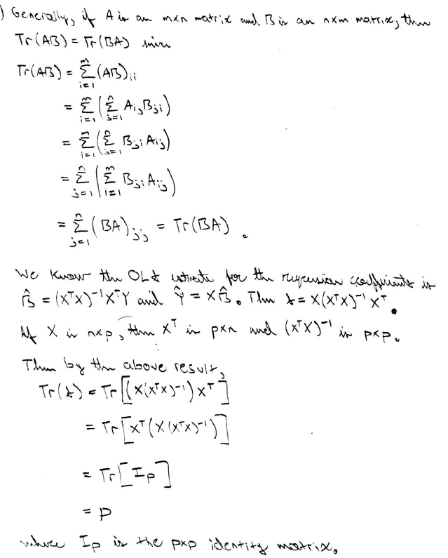
2. a) As $λ→∞$, the integral of the square of $\hat{f}$ must decrease in order to minimize the argument. If $\hat{f}$ is not identically 0 then the integral term is positive, and so multiplying by $λ$ makes the argument positively unbounded (so not minimized) as $λ→∞$. Hence, we require that $\hat{f}≡0$.

b) Similar to part a), minimizing the argument requires that the derivative of $\hat{f}$ be equivalent to the zero function, which implies $\hat{f}$ must be constant. In this case the integral term is (minimized to) 0, and to minimize the RSS term, we choose $\hat{f}≡\overline{Y}$, which is equivalent to the intercept-only least squares model.

c) Similar to parts a) and b), minimizing the argument requires that the second derivative of $\hat{f}$ be equivalent to the zero function, which implies $\hat{f}$ must be linear. In this case the integral term is (minimized to) 0, and to minimize the RSS term we choose $\hat{f}$ to be equivalent to the linear least squares model (since we know the linear LS model minimizes the RSS over linear functions).

d) If $λ= 0$, then there is no smoothness constraint for minimizing the argument. Then minimizing the argument is equivalent to choosing $\hat{f}$ such that RSS = 0; in this case, $\hat{f}\left(X_{i}\right)=Y_{i}$ for each $i = 1,…,n$, and $\hat{f}$ will likely not be very smooth.

1. a) The following code fits a regression tree, uses CV to determine the tree size, prunes the tree according to the size chosen by CV, and prints the pruned tree’s testing MSE and the following graph.

> library(tree)

> library(randomForest)

>

> train = read.csv("Problem3train.csv", header=T)

> test = read.csv("Problem3testing.csv", header=T)

> set.seed(exp(-pi / 2))

>

> fit = tree(y~., data=train)

> cv.fit = cv.tree(fit)

> cv.size = cv.fit$size[which.min(cv.fit$dev)]\*1

> prune.fit = prune.tree(fit, best=cv.size)

>

> plot(prune.fit)

> text(prune.fit)

>

> fit.pred = predict(prune.fit, newdata = test)

> mean((fit.pred - test[,1])^2)

[1] 3.74206

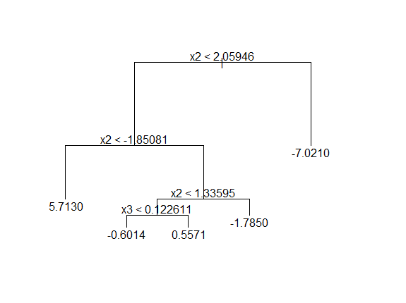

b) The following code uses bagging with 1000 trees to fit a find a final regression tree. The final regression tree’s testing MSE is printed.

> fit.bag = randomForest(y~., data=train, mtry=10, ntree=1000)

> mean((predict(fit.bag, newdata=test)-test[,1])^2)

[1] 3.089651

c) The following code fits a GAM as described and outputs the testing MSE of the GAM.

> gam.fit=gam(y~s(x1,k=5,fx=T)+s(x2, k=5,fx=T)+

+ s(x3,k=5,fx=T)+s(x4, k=5,fx=T)+

+ s(x5,k=5,fx=T)+s(x6, k=5,fx=T)+

+ s(x7,k=5,fx=T)+s(x8, k=5,fx=T)+

+ s(x9,k=5,fx=T)+s(x10,k=5,fx=T),

+ data=train)

>

> gam.pred = predict(gam.fit, newdata=test)

> mean((gam.pred - test[,1])^2)

[1] 2.896434