Name: Online toll to improve degree planning for BSc students.

Description of project: Improving degree planning for science students, students could select courses by major and form pdf rather than change at the pdf version. For new students, they can choose any pathway they want and find the favourite one.

Jingyuan Kang and Xinchen Lin -- backend

Yuwen Ye and Yutong Zhou --front end

Chole Wang -- database

Yuanchen Mao --design

Xinchen Lin also --Integration of the code

Description of project package and how to startup:

api -- backend

api -- backend

api -- background

pc -- front end

script -- the environment required for background startup

api/db/cs.sql -- data file required by the system

api/docs/requirements.txt -- the toolkits required in the background startup environment

course.py -- code to process course data

direction.py -- code to handle professional direction data

pc/node_modules -- the environment required for front-end startup (equivalent to the environment required for background startup)

When the program starts, there is no sequence in the front-end and back-end. It depends on your habits, but both must be started before the main page can run. If only the back-end is started, only the back-end system can start normally.

-- How to start the background system

Click on the background start address

Add /admin after the address bar

-- Front-end startup method

Click on the front-end start address

Technologies used: Python 3.10.8, vue(Node.js 16.0), django, mysql 8.0.31.

[Download Python | Python.org](https://www.python.org/downloads/)

<https://vuejs.org/guide/quick-start.html#creating-a-vue-application>

<https://www.mysql.com/downloads/>

All the coed is run on the ‘PyCharm 2022.2.1’

<https://www.jetbrains.com/zh-cn/pycharm/download/>

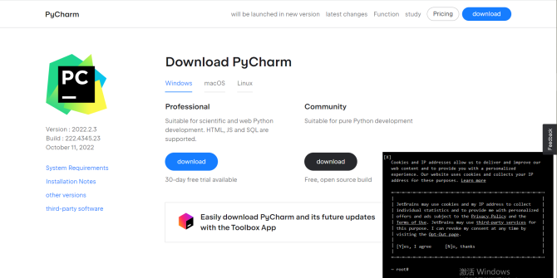

We should download the professional hence it is for 30days free and if you are a student it all free

Management system:

http://127.0.0.1:8000/admin

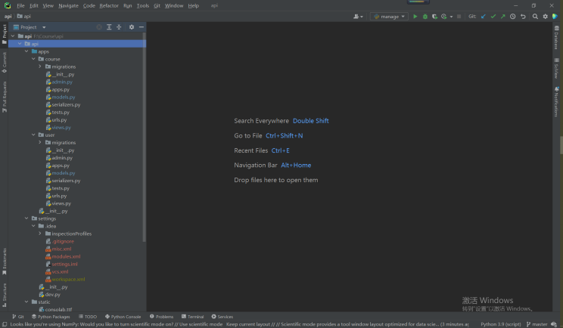

Open api and then click the ‘run manage’ or use ‘shift+f10’ to run the code

Make sure ‘mysql’ is open or it show like this one

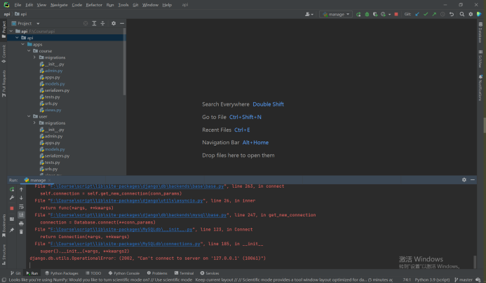

If all network environments are configured， it will show like that one and it have the website.

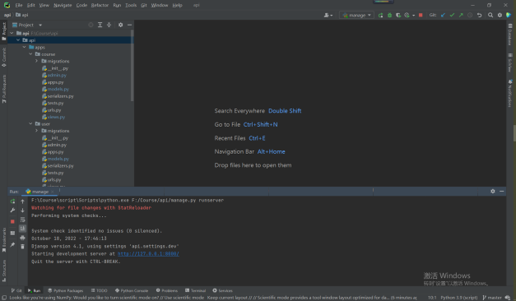

Then when we open the website is shows me page not found dont worry you are right beceuse we just need add ‘\admin’

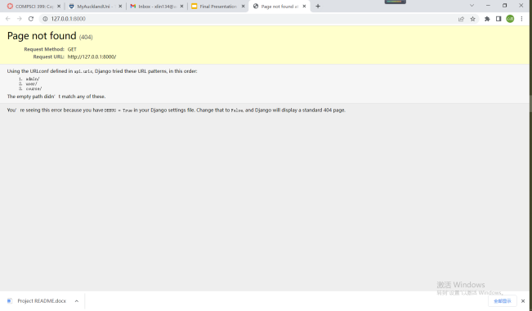

Hecne management page is open.

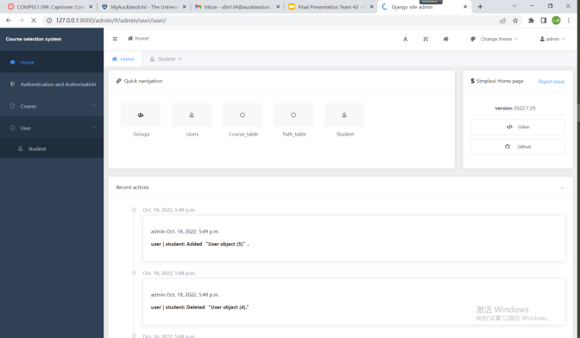

Main programming website:

<http://localhost:8080>

Remember open management page first

Open the file named ‘pc’ and then click the ‘run manage’ or use ‘shift+f10’ to run the code

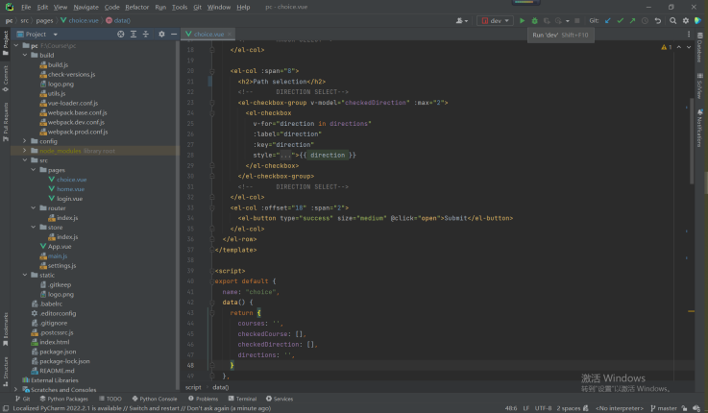

Waiting for 30-60 seconds (depend on computer) it will show the website

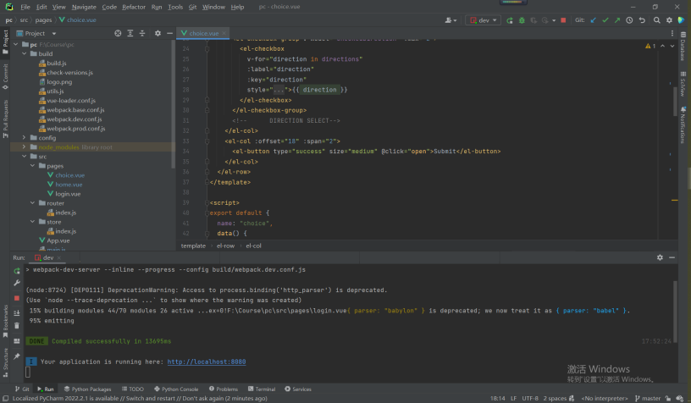

Then just click it

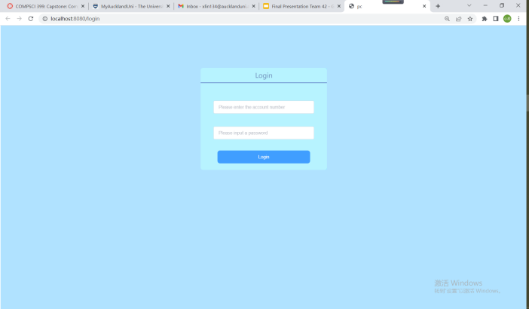

Note:If the network environment is not configured it will show up like this:

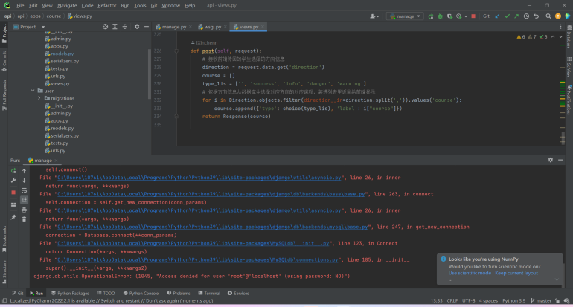

Future plan: Move down the path recommendation and students can select courses by years. The courses on the web page are moveable. Further beautify the design of the web page.

Acknowledgements:

Thanks to the University of Auckland for letting us get to know each other. Thanks to tutor Qiming gives us lots of suggestions. Thanks to YouTube and Bilibili which provide lots of video let us to learn vue and django. Thanks to all lecctuer and tutor in cs399. Thanks to team 12!