CMIFilter Plugin Usage

This document describes the CMIFilter plugin, its purpose, installation, and usage.

Introduction
The CMIFilter plugin is one member of the WildPackets Lawful Intercept Support Package (LISP) bundle. This suite of analysis modules provides powerful tools in support of lawful intercept and targeted packet capture. The CMIFilter plugin serves to “filter” packets by revealing an encapsulateed “packet within a packet”. This is done by intelligently removing wrapper ip information from an input packet.

Console and Engine Versions of CMIFilter
CMIFilter plugin versions are available to run on both the OmniPeek and OmniEngine platforms. The two plugin versions are referred to as the console (OmniPeek) version and the engine (OmniEngine) version. The two versions have identical behavior and results. Both are dll files. Both are filter type plugins (see below) whose results show in the packet display screen of OmniPeek. Both have an identical options setting dialog as well as About box. Thus the decision regarding which plugin version to install is strictly driven by whether your capture is via OmniEngine or OmniPeek.

5

Although both the console and engine versions of CMIFilter come as a single dll, the engine plugin dll is actually installed on both on the OmniEngine computer and also on any OmniPeek computer that will be accessing CMIFilter on the engine it connects to. This console, or OmniPeek, side install is required in order to create the required analysis module filter as well as to set user options via a dialog window.

Interim instructions for installing the plugin engine version, December 2010.
This installation is in advance of an install package for the CMIFilter engine version. This is a manual install until an automated install package becomes available.
It must be noted that the CMIFilter engine plugin must be installed on both OmniEngine and additionally on any OmniPeek computer that will be accessing the OmniEngine for CMIFilter usage.
- Rename the CMIFilter.zip.blob file to remove the “.blob” suffix.
- Unzip CMIFilter.zip: this will create two files, CMIFilter.dll and CMIFilter.he.
- On the computer on which OmniEngine is installed, copy the two CMIFilter files directly into the OmniEngine directory. For example, this might be :
C:\Program Files\WildPackets\OmniEngine
- Restart the OmniEngine for the plugin to become active.
- For any OmniPeek computer that will be accessing CMIFilter on a remote OmniEngine, copy the two CMIFilter files directly into the OmniPeek directory. This might be:
C:\Program Files\WildPackets\OmniPeek
- If OmniPeek is running, it must be restarted for the plugin to be active.

CMIFilter Dynamics
There are known network situations whereby packets are “wrapped” with an outer IP layer and sent over the network in this embedded fashion. The circumstances under which this wrapping occurs are not discussed in this document. That said, on the network monitoring end we want to unwrap the packets and present the inner encapsulated data. This is the function of the CMIFilter plugin.

The IP wrapper in question actually produces an IPv4 UDP packet with a known source and/or destination IP address. Thus the first function of a CMIFilter plugin would be to filter on IP address information (and optionally port information as well), and to throw out all packets that do not meet this criterion. Secondly, the filter would remove the UDP header to reveal its Data Area, which is in fact the encapsulated packet. The resulting packet is displayed in OmniPeek and/or saved to file.

Another dynamic at play is that an original packet may have been fragmented into two or even three separate UDP-encapsulated packets before sending. Thus a further work of the plugin is to internally stage packet fragments until all pieces are received, then to reassemble them into their single / original state. Once a packet is reassembled it will be displayed or saved to file.

Possible CMI Configurations
All packets that we are referring to here as “CMI packets” are UDP packets. As noted, they may be captured (filtered) with reference to a particular IP address and optionally as well to a particular port. In full, the targeting possibilities allow specifying that the source and/or destination may be a particular IP address or “any address”, with a constraint that at least one address (i.e. the source or the destination) must be a specific IP address. This again with the optional addition of a port number specification for targeting.

Regarding the internal, or encapsulated, packet, there are a couple of possibilities. The encapsulated packet may be found to lack an ethernet header. In this case the plugin can add an ethernet header onto the packet before presenting the filtered result back to the engine for display. The ethernet information that will be added (source address, destination address, and protocol type) are specified by the user as plugin options.

Optionally as well, a VLAN tag may be added to the displayed packets, indicating that the captured packets pertain to a particular virtual lan. This also is configurable via the user options dialog box.

Terminology Pertinent to the CMIFilter Plugin
Fragment - this is the customary reference to an IP fragment, that is, a portion of a full source packet that will be combined with other fragment(s) to re-create the original packet. This concept needs to be noted because an “age limit” for fragments is an option that needs to be specified (see below).

Orphan – we refer to orphaned packet fragments as fragments that have not been successfully reassembled within the acceptable age limit timeframe. In this case there is a user option to save off orphaned packet fragments to file.

Using the CMIFilter Plugin
For both OmniPeek and OmniEngine, using the plugin requires firstly creating an analysis module type filter for the CMIFilter plugin, then setting the appropriate options for usage. Both of these procedures will be described below. Following that, whenever a capture is started on OmniEngine or OmniPeek with the CMIFilter analysis module filter selected, the plugin will be operative.

Creating a Filter for CMIFilter

Creating a filter is necessary before the CMIFilter plugin can be used in a capture. The type of filter to be created, as mentioned, is the “analysis module” type of filter, which is one of the choices in the Insert Filter dialog box. The word “filter” in the “CMIFilter” plugin name, which describes its functionality as a plugin, should not be confused here with the analysis module filter we need to create in order to use the plugin.

The dialogs for creating a filter are quite similar for console and engine captures. In both cases the filter can be created from the Capture Options dialog box that is invoked when starting a new capture or when changing capture options. A detailed example will be given for an engine type capture, but it is quite analogous for a console type capture. Also, it will be noted that there are alternative ways of invoking the dialog for filter creation, but only one will be detailed to exemplify the process.

For an engine type capture it is of course necessary from within OmniPeek to connect to a remote OmniEngine. This will not be explicated here. In this example we have connected to an engine and are about to create a new capture. There is not yet any filter for CMIFilter.

Click on “New Capture” under “Captures” on the Home tab for OmniEngines to invoke the Capture Options dialog.

From the Capture Options dialog click on Filters; the display will appear somewhat like the following:
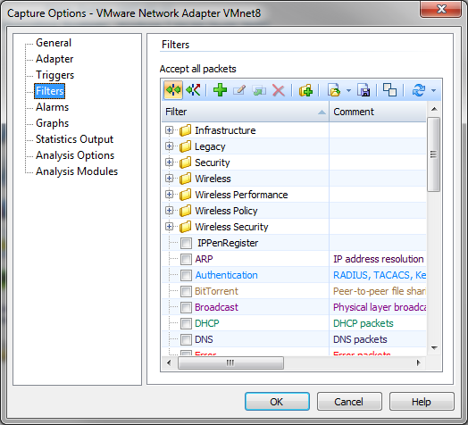

We note in this example case that no filter yet exists for CMIFilter so we will create one. Click on the green “+” icon to invoke a dialog for creating the filter. This will bring up the Insert Filter dialog:
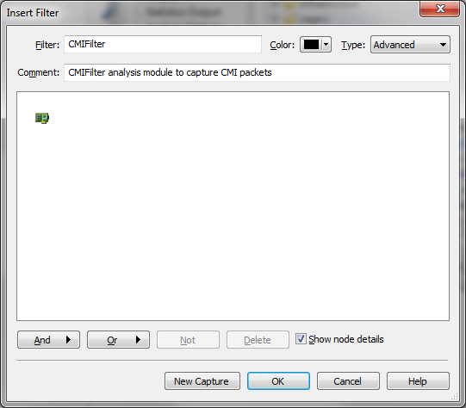
Enter a name for the filter and optionally a comment. Select “Advanced” for the type of filter and press the “And” button, then select “Analysis Module” from the selection list that comes up.

You will get an Analysis Module Filter dialog:
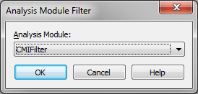

In the drop down list box, select “CMIFilter”. You will have created the needed filter:
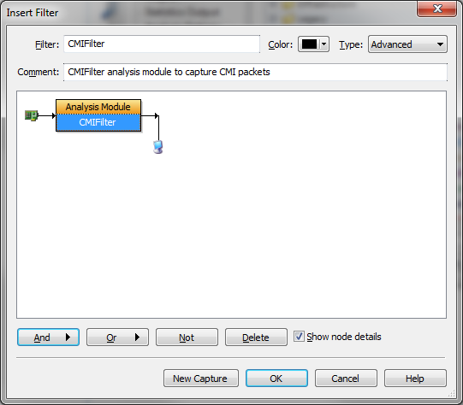
Press OK to accept the new filter settings.

Back on the Capture Options dialog, make sure that the new filter (in this example case called “CMIFilter”) is checked, and for engine plugins only click on “Click here to send changes”:
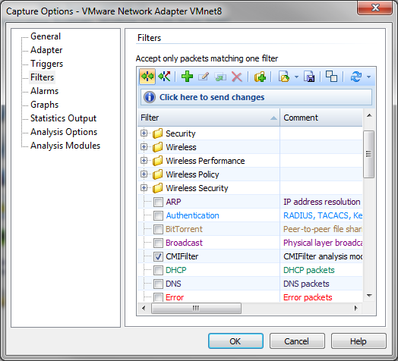
Alternative Ways of Invoking the Insert Filter Dialog
From the Filters tab along the left side of the window (this example from an engine plugin):
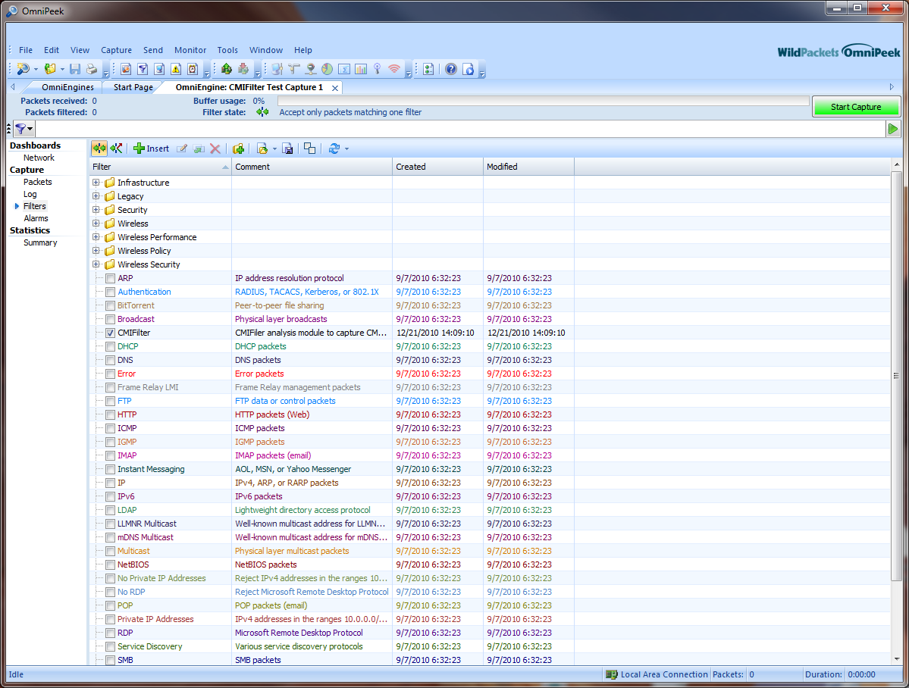
For an engine plugin, from the OmniEngine Filters tab:
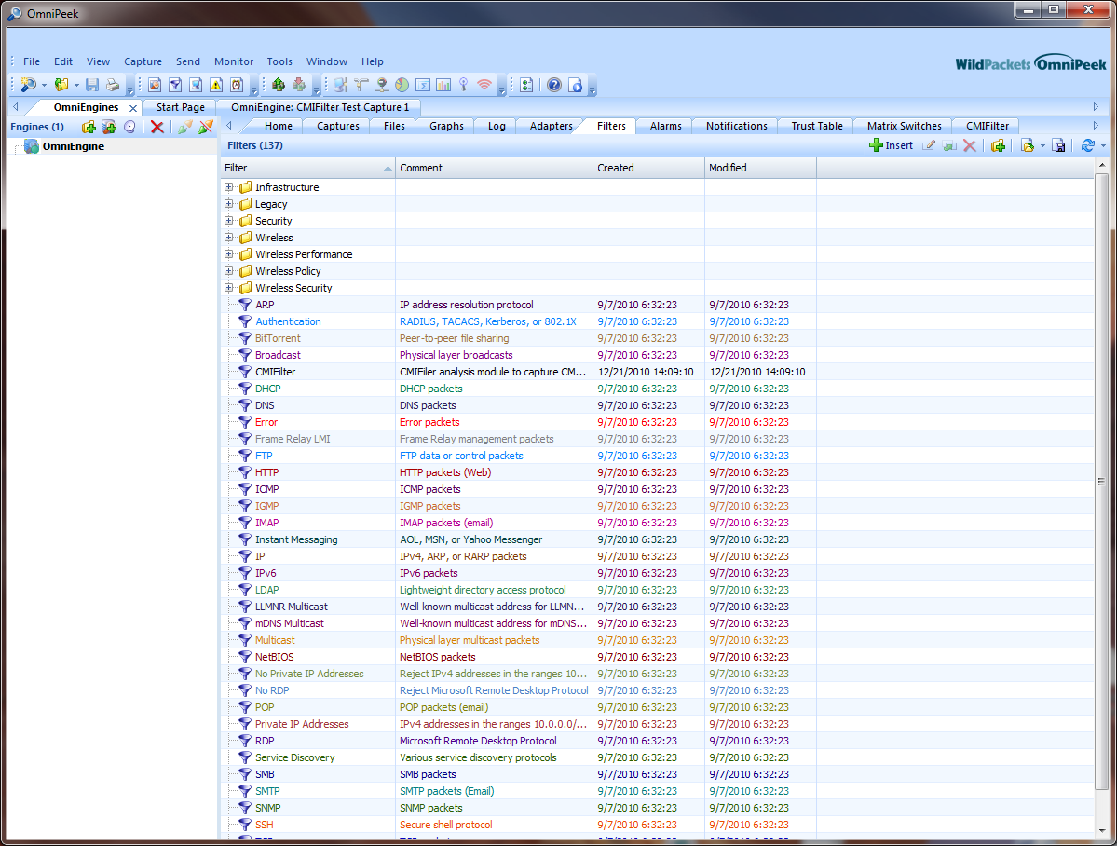

For a console plugin, by clicking the View menu in OmniPeek, then clicking Filters to create a Filters tab:
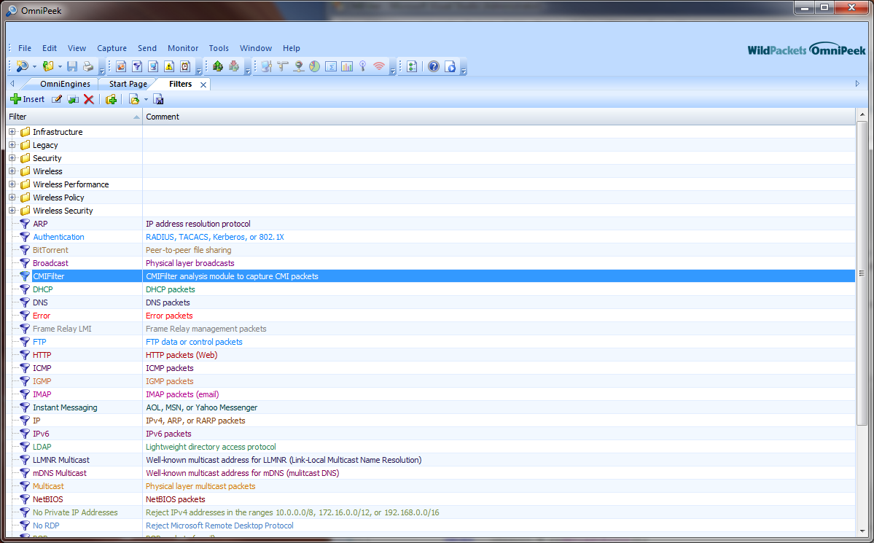

]

Invoking the CMIFilter Options Dialog

Considerations to Resolve in Advance of Setting the Options

It is expected that the user of this plugin will know the network configuration that is at play. The following CMI and network-related considerations should be resolved beforehand:
- What IP address should we filter on, i.e. what source and/or destination address will the UDP packets be sent from/to?
- Is there an UDP port number that we should filter on in addition to the IP address?
- Will this configuration require that we add back an ethernet header in order to create a properly formatted reassembled packet? If so, what source and destination ethernet addresses should we use?
- If an ethernet header is to be added, what protocol type will this be?
- Is this a virtual lan configuration, and if so should a VLAN tag be added while reassembling the packets?

Additionally, the following two capture-related considerations should be decided on:
- How many seconds should the plugin save fragments waiting to be reassembled before they are considered “orphaned” and either discarded or saved off to file (the default is 5 seconds)?
- Should orphaned packets be saved to file, and if so to what file and path name and at what frequency?

Note that more information regarding the above considerations will be given with the specific options setting instructions below.

Invoking the Options Dialog on the Console (OmniPeek) Side

Following are various ways that the CMIFilter options dialog window can be invoked:
- From the menu bar at top of the OmniPeek window select Tools and the Options. You will get the following dialog box:

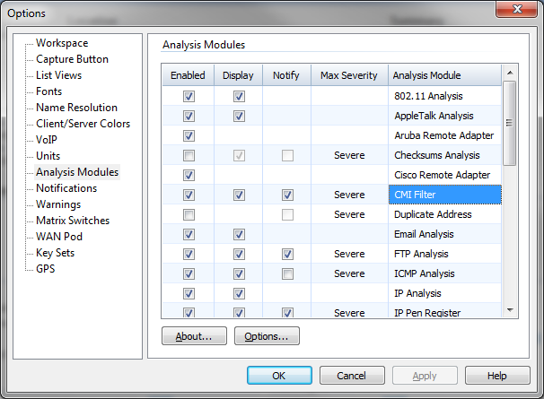

Select “Analysis Modules” on the left pane, then either double click on “CMI Filter” or select “CMI Filter” and press “Options”.

- When creating a new capture - from the Capture Options dialog select “Analysis Modules” on the left pane, then either double click on “CMI Filter” or select it and press “Options”:

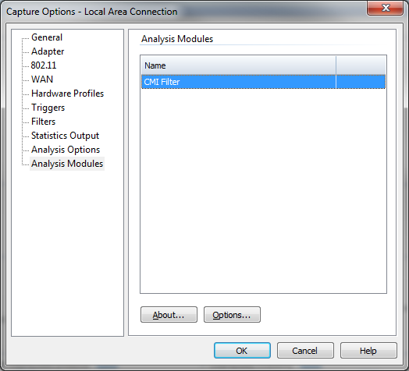
- Once a new capture window has been created, on the left pane select “CMI Filter” to display a tab view of the selections, then press the “Modify” button:

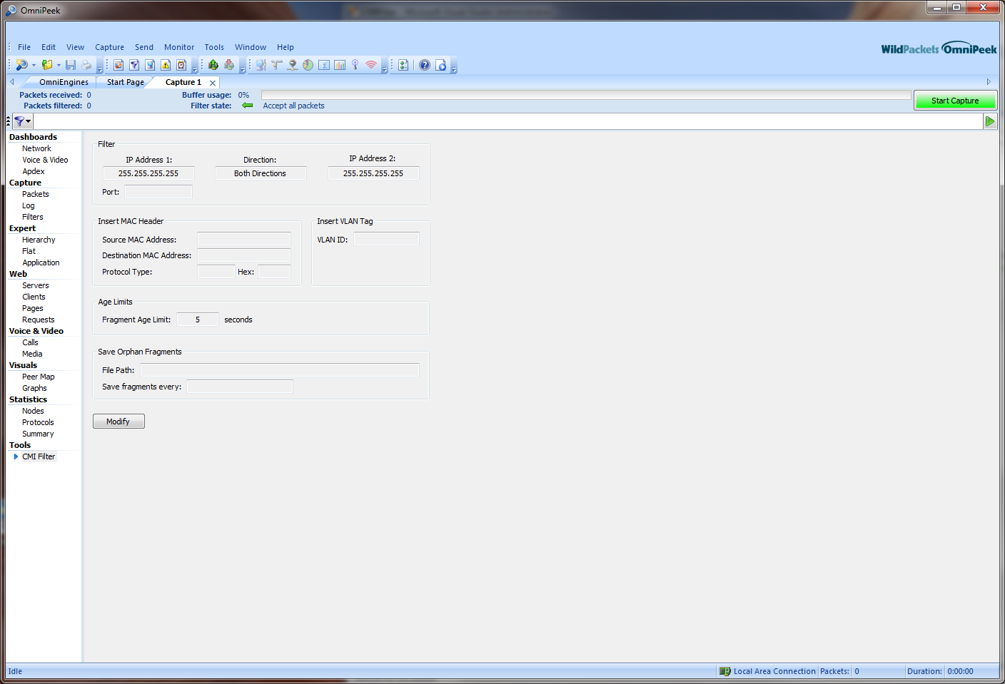

Invoking the Options Dialog on the Engine (OmniEngine) Side
- When starting a new engine capture from the “Home” tab on the OmniEngines window, from the Capture Options dialog select “Analysis Modules” on the left pane, then either double click on “CMIFilter” on the right pane or select “CMIFilter” and then press “Options”:

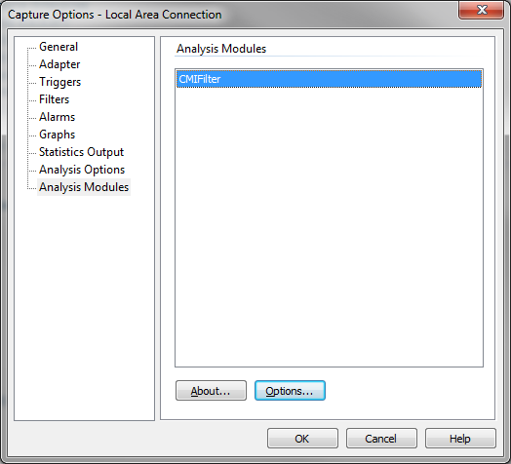

- From the Captures tab in the OmniEngines window – if starting a new capture click “Insert” (with the green plus sign), or if changing options to an existing capture select the CMIFilter entry and press the icon for editing Capture Options (or double click on the entry):

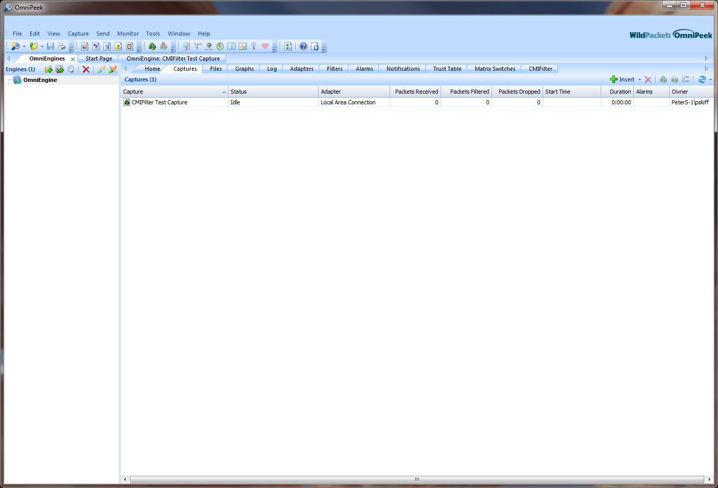

These actions will invoke the same dialog box as in #1 above, and the same actions should be taken from there.

Setting the Options

Below is the CMIFilter options dialog as it first comes up:

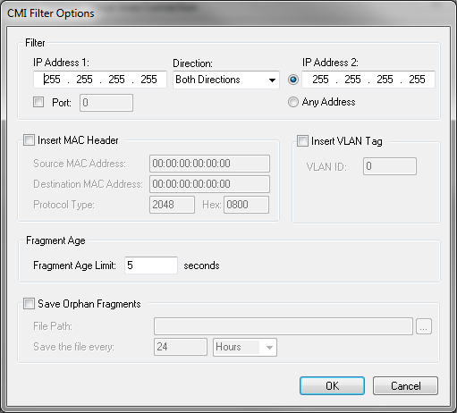

From here the various fields can be set according to the needs of the capture:

Filter Section
The fields in this section delineate the from/to IP addresses, and optionally port, that should be filtered on. If an address / port specification is not met by a given input packet then the packet will be rejected by CMIFilter. A minimally required entry might be a specific address in IP Address 1, “Address 1 to 2” selected, and “Any Address” for IP Address 2.

IP Address 1:

IP Address 1 should be set as a specific IPv4 address. This can be either a source or a destination address, or either one, according to the Direction identification.

Direction:

The selection possibilities are Both Directions, Address 1 to 2, and Address 2 to 1.

IP Address 2:

This can either be a specific address if the edit box is checked, or “Any Address” if that item is checked.

Port:

This optional field relates to UDP port number and if selected stipulates that the given port be filtered on (i.e. packets not having that UDP port number will be rejected). Note that the port number reference is to the destination port.

Insert Mac Header

In some network configurations wherein CMI packets are used the encapsulated packet does not have an ethernet header. In this case the “Insert MAC Header” check box should be checked and the three fields should be filled in. This will insure that the OmniPeek analysis functionality appropriately interprets the packet. The source and destination ethernet addresses should be provided as well as the Protocol Type. Note that the protocol type can be entered as a decimal value (the left edit box) or as a hexadecimal value (the right edit box), and the values for the edit box not being entered into will auto-fill with the equivalent corresponding value.

Insert VLAN Tag

In some network configurations that have an implementation of an 802.1Q virtual lan, the VLAN Tag can be added into the destination packet just as is done with the MAC header. To do this, select the “Insert VLAN Tag” check box, then enter the decimal value into the VLAN ID field. This will result in a VLAN ID being added to the packet for display.

Fragment Age

Fragment age is a required field, with a default value of 5 seconds. Internally, the plugin temporarily stages any fragmented packets (i.e. incomplete packets) that will need to be reassembled. In the event that reassembly cannot be completed due to never receiving all the packet portions, the fragments must be deleted from their internal buffer. The Fragment Age option stipulates the number of seconds that fragments should be buffered before being removed.

Save Orphan Fragments

This optional parameter allows for saving orphaned packets in a disk file. The orphaned packets are fragments that could not be reassembled within the stipulated Fragment Age limits. If “Save Orphan Fragments” is selected, then every time the Fragment Age limit is exceeded for a fragment, this fragment will be internally staged (buffered) in preparation for being stored to disk file. The “File Path” stipulates the path / file name identifier to save the packets to, and “Save the file every” stipulates the frequency in seconds, minutes, or hours that a file should be saved and a new file created.

Note that a date/time string will be created to be used as part of the unique file name. For example, if

C:\Program Files\WildPackets\Packet Files\CMI\Orphans

is the File Path and “Save the file every” is 3 Hours, then every 3 hours a new packet file will be created with all orphans captured since the last file refresh in it, and saved to the stipulated path. The file name identifier (in this case “Orphans”) will be combined with the timestamp string to produce the unique file name. A possible auto-created file name in this example might be:

“Orphans 2010-12-21T19.49.59.041Z.pkt”.

Running a CMIFilter Capture
Always make sure that the CMIFilter analysis module filter is selected on the Filters tab under “Capture” on the left pane on the capture window. Press the green Start Capture button, which will turn red.

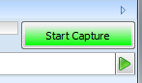

Example Packet Capture

This example show an OmniEngine capture using the CMIFilter plugin. The data is test data. The example shows a situation where all of the options criteria are selected, as shown in the options dialog:

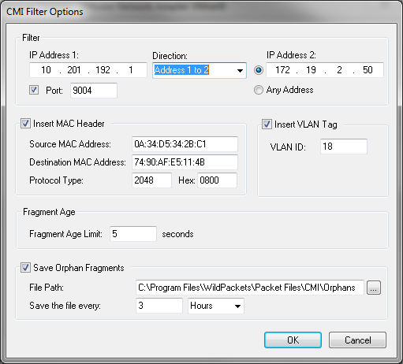

Test input file, not yet CMI filtered, comprised of CMI / UDP packets:

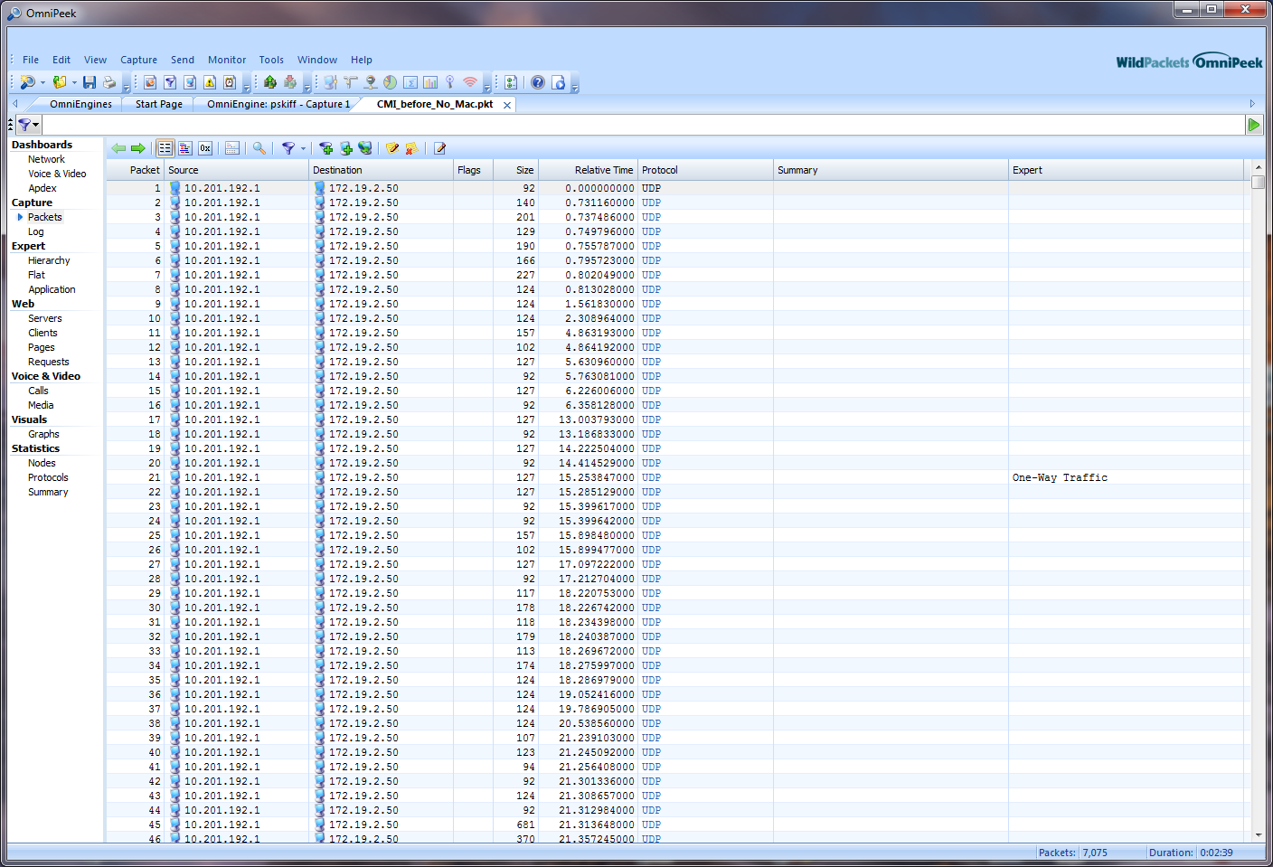

Note that in the test display above all the input packets are UDP packets with the same source and destination address. These are all CMI packets, which would presumably not be the case on a live network.

Sample test input packet (packet number one in the list above):

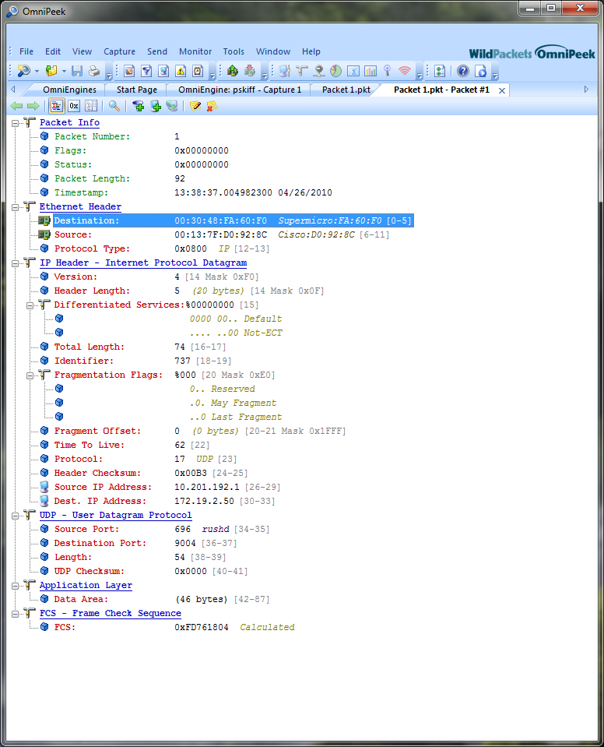

Capture result using the CMIFilter plugin:

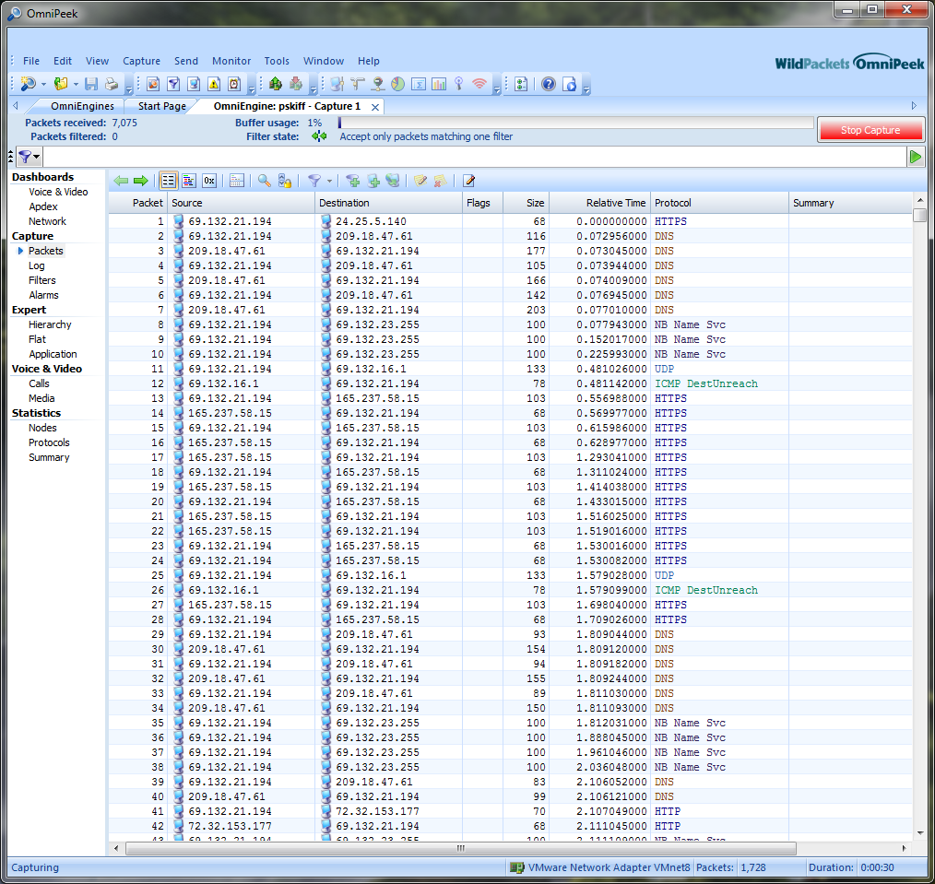

Note here that the UDP header has been removed. Any packet fragments have been reassembled into the original packet.

Example packet test result after CMI processing:

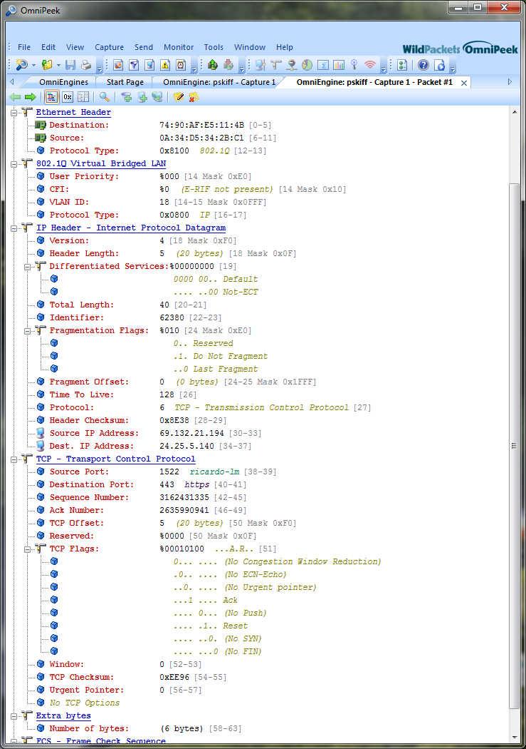
VLAN Id of 18 as entered in options
Ethernet addresses as entered in options

Note that the source ethernet address of 0A:34:D5:34:2B:C1 and the destination ethernet address of 74:90:AF:E5:11:4B that we had entered into the “Insert MAC Header” section in the options dialog appears in this packet decode. Also that it is properly interpreted as an IP packet, in this case as a TCP packet. The VLAN id of 18 that we had stipulated also appears in the decode.

