Domain Name Capture Plugin Usage

This document describes the Domain Name plugin, its purpose, installation, and usage.

Introduction
The Domain Name plugin is a Lawful Intercept type of plugin. This means that its utility is in support of monitoring the internet for packets that are “of interest” to law enforcement or similar agencies in need of capturing data for enforcement purposes.

What the Domain Name plugin does is to watch for DNS (Domain Name System) packets have domain names matching items in a user-specified list (the list may include a wildcard character). If a domain name match is found then statistical information is logged, and optionally relevant IP packets are captured as well. In order to perform this operation the Domain Name plugin must parse the DNS packets in a manner that is analogous to what DNS servers must do.

Console and Engine Versions of the Domain Name Plugin
Domain Name plugin versions are available to run on both the OmniPeek and OmniEngine platforms. The two plugin versions are referred to as the console (OmniPeek) version and the engine (OmniEngine) version. The two versions have nearly identical behavior and results. Both are dll files. Both are filter type plugins (see below) whose results show in the packet display screen of OmniPeek. Both have a nearly identical options setting dialog as well as About box. Thus the decision regarding which plugin version to install is strictly driven by whether your capture is via OmniEngine or OmniPeek.

5

Although both the console and engine versions of Domain Name come as a single dll (on the engine side it is available as 32 bit or 64 bit), the engine plugin dll is actually installed on both on the OmniEngine computer and also on any OmniPeek computer that will be accessing Domain Name Capture on the engine it connects to. This console, or OmniPeek, side install is required in order to create the required analysis module filter as well as to set user options via a dialog window.

Interim instructions for installing the plugin engine version, November 2011.
It must be noted that the Domain Name engine plugin must be installed on an OmniEngine and additionally on any OmniPeek computer that will be accessing the OmniEngine for Domain Name usage.
- A zip file will be available with the name DomainNameCaptureOE.<Version #>(such as DomainNameCaptureOE.1.0.0.1).
- Unzip DomainNameCaptureOE.1.0.0.1.zip: this will create a directory structure such as:
DomainNameCaptureOE.1.0.0.1
        - DomainNameCaptureOE.he
      - Win32
        - DomainNameCaptureOE.dll (32 bit version)
      - X64
        - DomainNameCaptureOE.dll (64 bit version)

- On the computer on which OmniEngine is installed, copy DomainNameCaptureOE.he as well as the correct version (32 bit or 64 bit) of DomainNameCaptureOE.dll directly into the OmniEngine directory. For example, this might be :
C:\Program Files\WildPackets\OmniEngine\
- Restart the OmniEngine for the plugin to become active.
        - For any OmniPeek computer that will be accessing Domain Name Capture on a remote OmniEngine, copy DomainNameCaptureOE.he and the 32 bit version of DomainNameCaptureOE.dll directly into the OmniPeek directory. This might be:
C:\Program Files\WildPackets\OmniPeek\
- Or -
C:\Program Files (x86)\WildPackets\OmniPeek\

- If OmniPeek is running, it must be restarted for the plugin to be active.

A DNS Overview
DNS (Domain Name System) is a hierarchical naming system for the internet. It translates human readable domain names to internet addresses. This functions as a “phone book” for the internet in that it allows a domain name such as www.wildpackets.com to be translated into an internet address which will be needed in order to create an IP connection and to perform data interactions with that address.

DNS packets are UDP packets and are sent over port 53. The essential interactions between a requesting client and a DNS server involve questions to a DNS server and responses. The questions are the domain names sent by the client for resolution, and the responses include various aliases and resources, but importantly, resolution to IP addresses.

Law Enforcement Usage of the Domain Name Plugin
It may be of advantage to monitor particular domain names that are “of interest” to note their activity and perhaps further to ascertain their IP addresses and to capture any traffic to and from those addresses. Both of these levels of monitoring are available from the Domain Name Capture plugin.

The first, or “lower”, level of usage will only display each of the domain names configured for monitoring, along with a count of how many questions and how many answers were performed during traffic to and from each domain name. The only packets captured will be the DNS packets that were parsed to get the displayed data.

The second, or “higher”, level of usage will display, in addition to the counts of questions and responses, a list of all the domain names that were discovered along with their associated IP addresses. Additionally, all the IP traffic to and from those addresses will be captured.

Using the Domain Name Plugin
For both OmniPeek and OmniEngine, using the plugin requires firstly creating an analysis module type filter for the Domain Name plugin, then setting the appropriate options for usage. Both of these procedures will be described below. Following that, whenever a capture is started on OmniEngine or OmniPeek with the Domain Name analysis module filter selected, the plugin will be operative.

Creating a Filter for Domain Name Capture

Creating a filter is necessary before the Domain Name plugin can be used in a capture. The type of filter to be created, as mentioned, is the Analysis Module type of filter, which is one of the choices in the Insert Filter dialog box.

The dialogs for creating a filter are quite similar for console and engine captures. In both cases the filter can be created from the Capture Options dialog box that is invoked when starting a new capture or when changing capture options. A detailed example will be given for an engine type capture, but it is quite analogous for a console type capture. Also, it will be noted that there are alternative ways of invoking the dialog for filter creation, but only one will be detailed to exemplify the process.

For an engine type capture it is of course necessary from within OmniPeek to connect to a remote OmniEngine. This will not be explicated here. In this example we have connected to an engine and are about to create a new capture. There is not yet any filter for Domain Name Capture.

Click on “New Capture” under “Captures” on the Home tab for OmniEngines to invoke the Capture Options dialog.

From the Capture Options dialog click on Filters; the display will appear somewhat like the following:
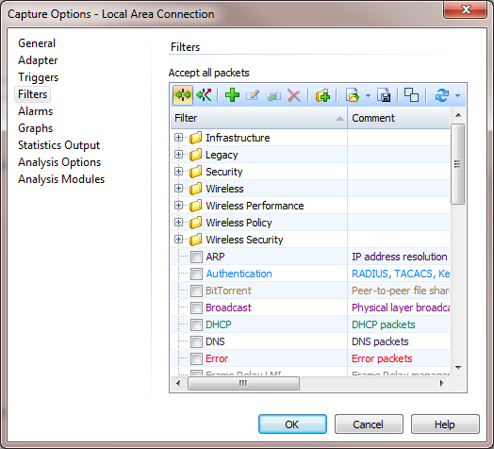

We note in this example case that no filter yet exists for Domain Name so we will create one. Click on the green “+” icon to invoke a dialog for creating the filter. This will bring up the Insert Filter dialog:
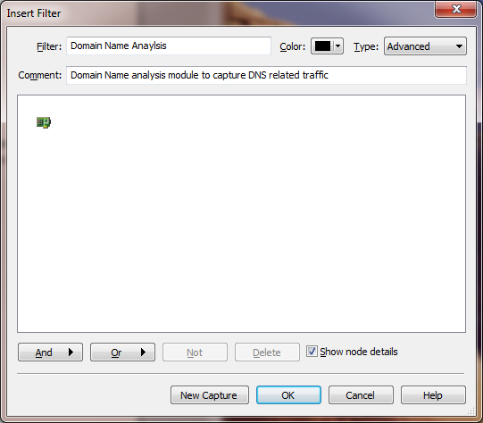

Enter a name for the filter and optionally a comment. Select “Advanced” for the type of filter and press the “And” button, then select “Analysis Module” from the selection list that comes up.

You will get an Analysis Module Filter dialog:
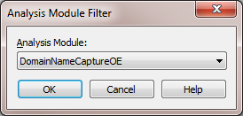

In the drop down list box, select “DomainNameCaptureOE” (for console plugins it will be “Domain Name Capture”). You will have created the needed filter:
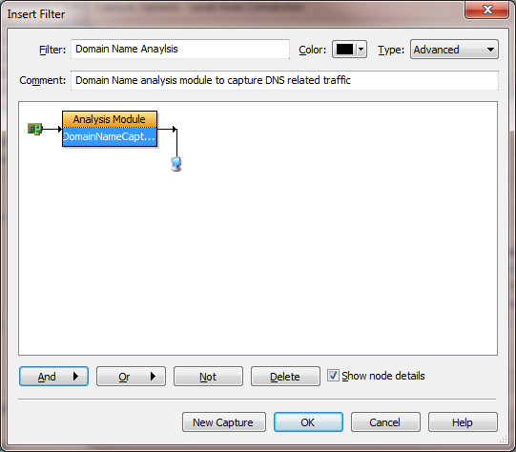
Press OK to accept the new filter settings.

Back on the Capture Options dialog, make sure that the new filter (in this example case called “Domain Name Analysis”) is checked and for engine plugins only, click on “Click here to send changes” (if that text appears):
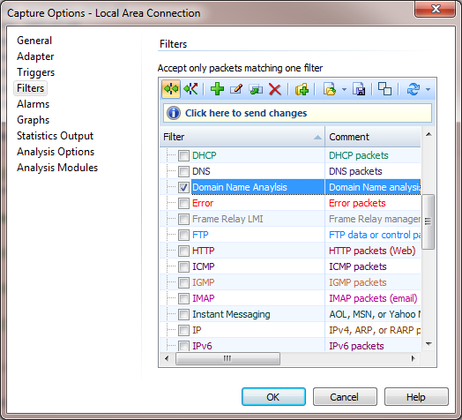
Alternative Ways of Invoking the Insert Filter Dialog
From the Filters tab along the left side of the window (this example from an engine plugin):
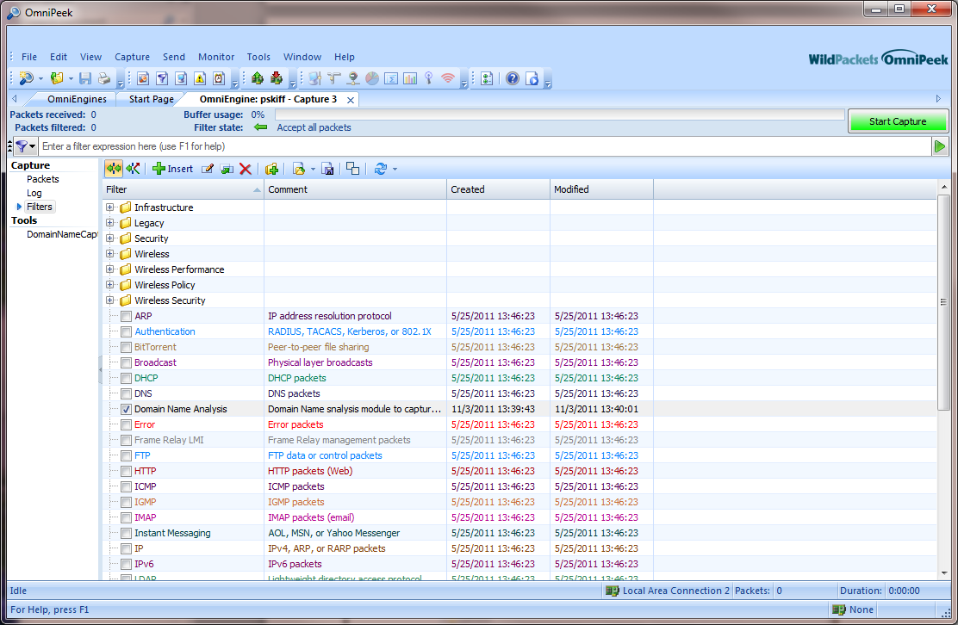

For an engine plugin, from the OmniEngine Filters tab:
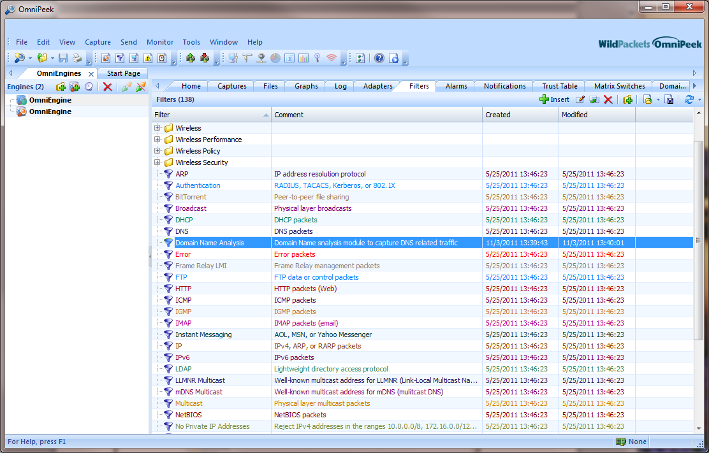

For a console plugin, by clicking the View menu in OmniPeek, then clicking Filters to create a Filters tab:

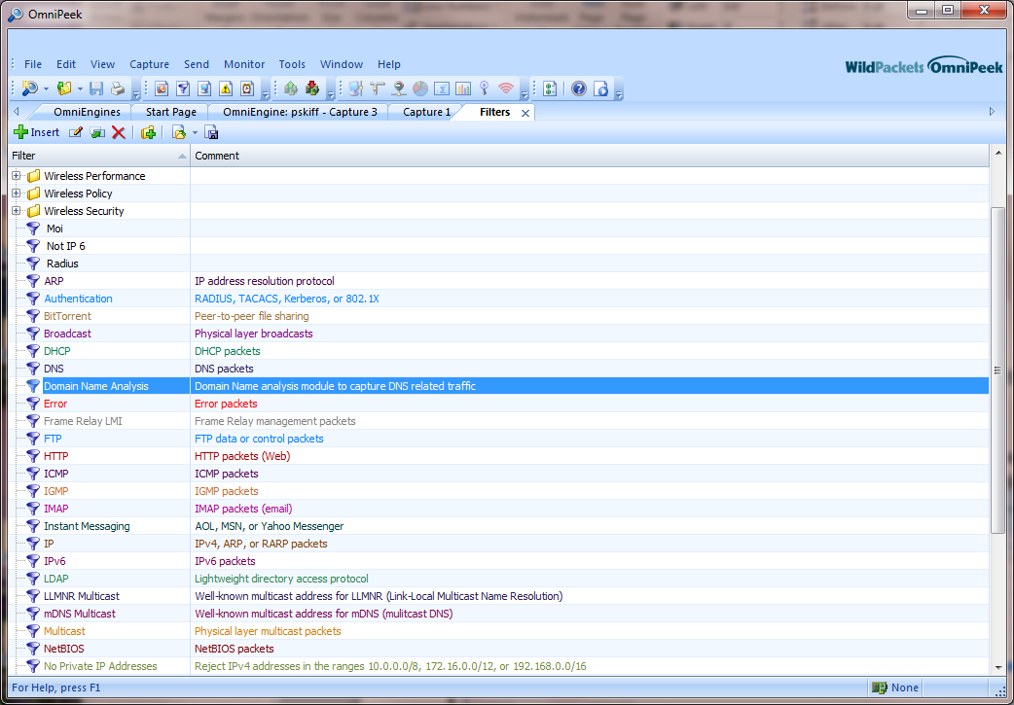

Invoking the Domain Name Options Dialog

Considerations to Resolve in Advance of Setting the Options
- Firstly it must be resolved whether or not IP traffic associated with domain names is to be captured. Not capturing the associated traffic may be a legal constraint.
- Secondly you must compile a list of domain names to be monitored. Any number of domain names can be specified, and wildcards can be used.

Note that more information regarding the above considerations will be given with the specific options setting instructions below.

Invoking the Options Dialog on the Console Version of the Plugin

For the console version of Domain Name Capture, following are various ways that the options dialog window can be invoked:
- From the menu bar at top of the OmniPeek window select Tools and then Options. You will get the following dialog box:

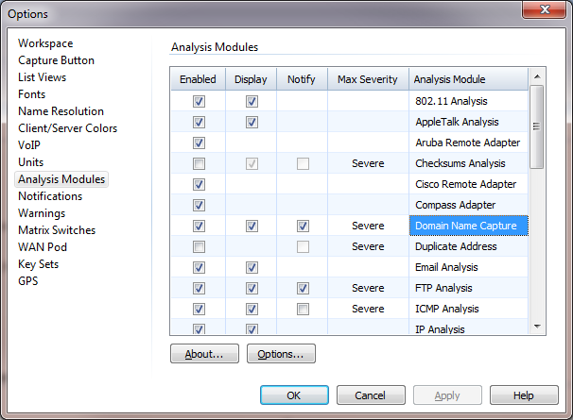

Select “Analysis Modules” on the left pane, then either double click on “Domain Name Capture” or select “Domain Name Capture” and press the Options button.

This will invoke a Domain Name Capture Options dialog box:

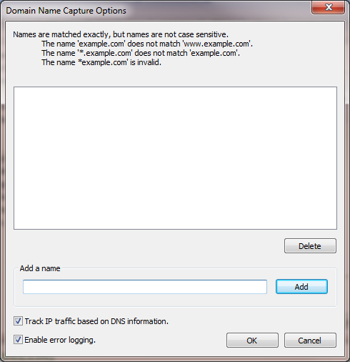

One thing is to be noted at this point, and this is the check box in the lower left hand corner, “Enable error logging”. This check box is only found on this dialog and should be selected if you want error messages to be logged to a file. This is a global setting for all captures (and only applies to console plugins, not engine plugins).

See the section towards the end of this document on Error Logging for more detail.

Other than setting the error logging, other options need not be set in this dialog, but rather in the options dialog for each individual capture. This will be described below.

- When creating a new capture: from the Capture Options dialog select “Analysis Modules” on the left pane, then either double click on “Domain Name Capture” or select it and press “Options”:
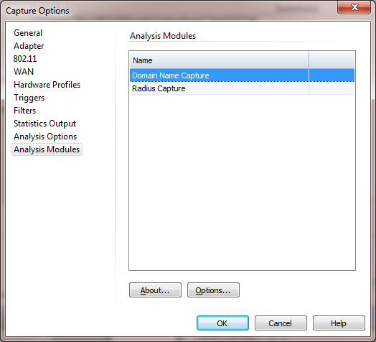
Once a new capture window has been created, on the left pane select “Domain Name” to display a tab view of the selections, then press the “Modify” button:

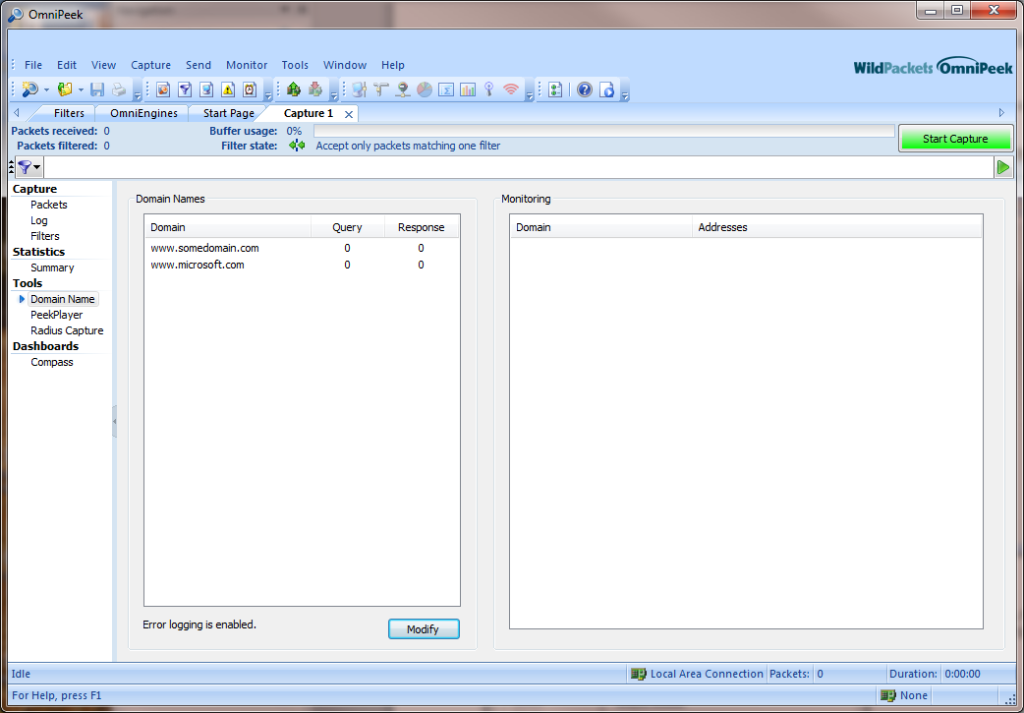

Invoking the Options Dialog on the Engine Version of the Plugin
- When starting a new engine capture from an instance of OmniPeek that is connected to an engine: from the Home tab on the OmniEngines window click on “New Capture”, then from the Capture Options dialog that appears select “Analysis Modules” on the left pane. Now either double click on “DomainNameCaptureOE” on the right pane, or select “DomainNameCaptureOE” and then press the Options button:

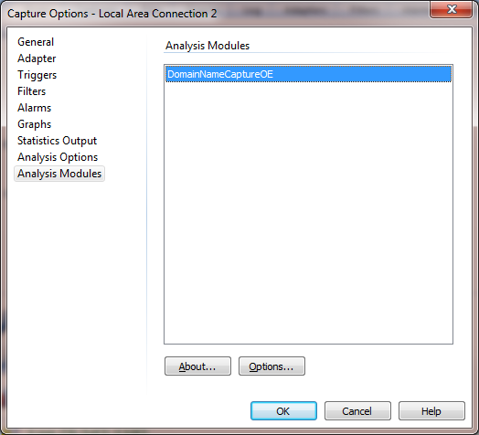
- From the Captures tab in the OmniEngines window: if starting a new capture click “Insert” (with the green plus sign), or if changing options to an existing capture select the capture entry and press the icon for editing Capture Options (or double click on the entry):

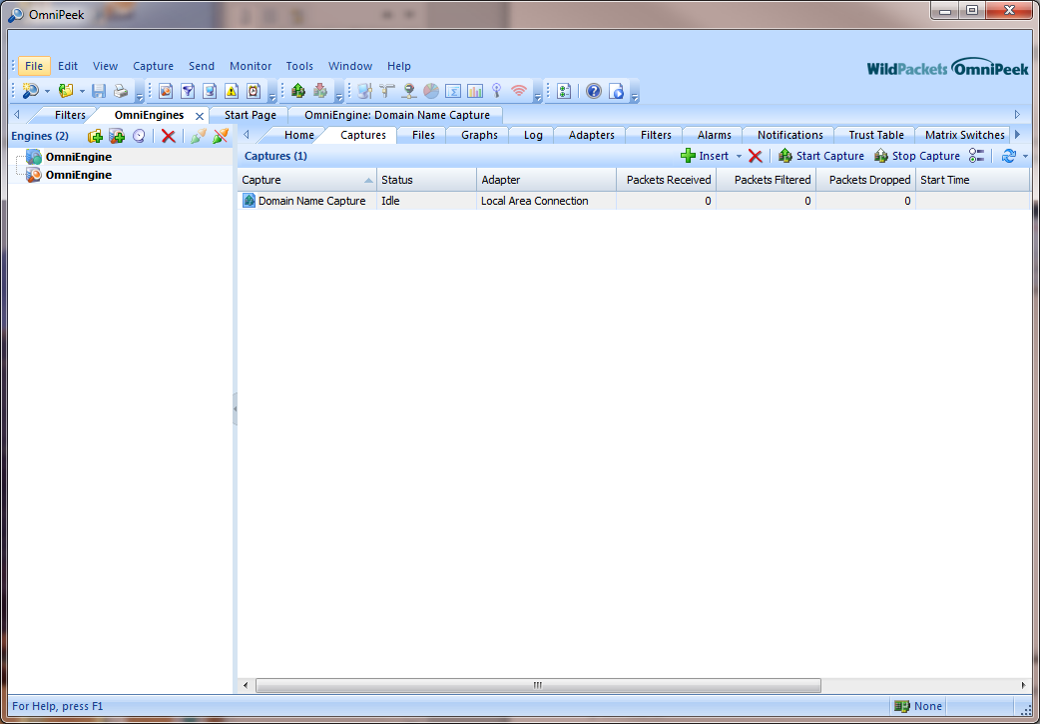

These actions will invoke the same dialog box as in #1 above, and the same actions should be taken from there.

Setting the Options

Below is the Domain Name Capture options dialog as it first comes up:

Engine:

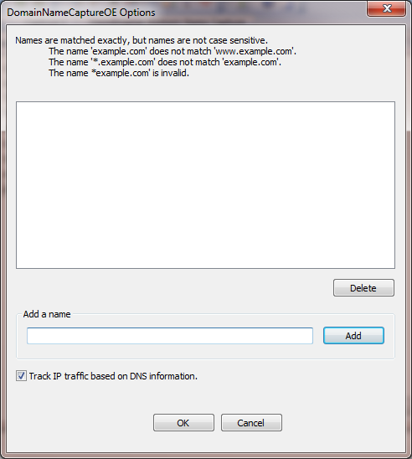

Console:

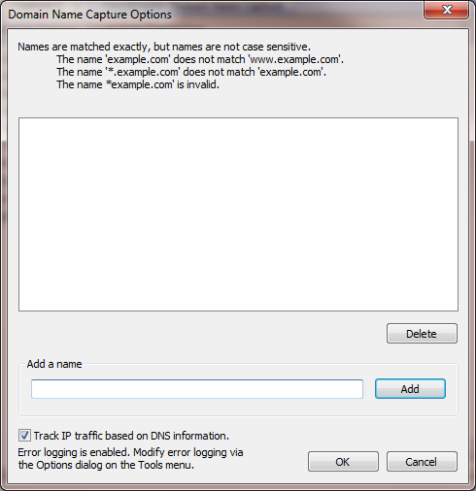

In the options dialog you will add any domain names for which you would like the plugin to perform a watch during a capture. Type a domain name into the “Add a name” edit box and click the Add button. The domain name will then appear in the list box above. Note that removing any name from the list is done by selecting it and pressing the Delete button.

In this example www.wildpackets.com and www.somecompany.com have been added to the list, and additionally an entry with using a wildcard, *.anothercompany.com. This third example entry demonstrates the use of wildcards as an alternative way of specifying names, in which the “*.” on the left will indicate that any domain name matching the right hand part of the specified name will be accepted. Note that only “*” can be used as a wildcard, “.” must immediately follow it, and only one asterisk in the name is permitted. Case is ignored in domain name entries.

Engine:

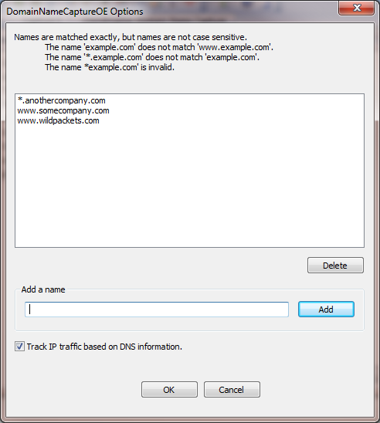

Console:

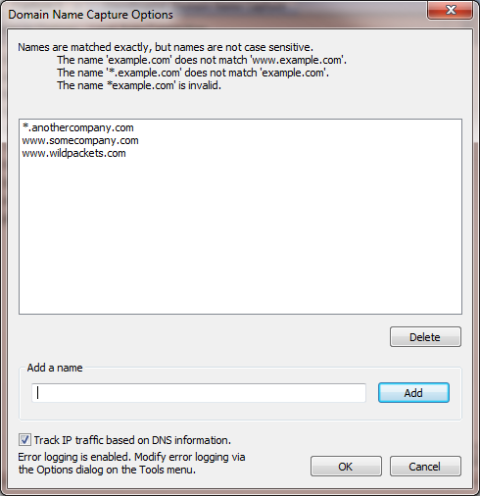

If “*.com” or “*.net” are entered as domain entries then they are truly global and no other “.com” or “.net” entry is needed at all. All domain names will be accepted.

The lower left is a check box “Track IP traffic based on DNS information”. This option has a significant impact on the capture results. If this option is unchecked then no IP address information will be displayed, and only DNS packets will be captured. If the option is checked then IP addresses for any of the domain names configured will be displayed, and all packets to and from those addresses will be captured.

Running a Domain Name Capture
Always make sure that the Domain Name analysis module filter is selected on the Filters tab under “Capture” on the left pane on the capture window. On the engine this will be “DomainNameCaptureOE” and on the console it will be “Domain Name Analysis”. To start the capture press the green Start Capture button, which will turn red.
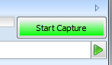

Example Packet Capture

This example will show a live capture in which the domain names configured in the options are:

“*.wildpackets.com” and “*.google.com”

Note that for this example “Track IP traffic based on DNS information” is checked. In both the engine and the console plugin, results are seen by selecting the tab on the left pane, under Tools, which will say DomainNameCaptureOE for the engine and Domain Name for the console.

After running a capture for a while, here are some results.

Engine:

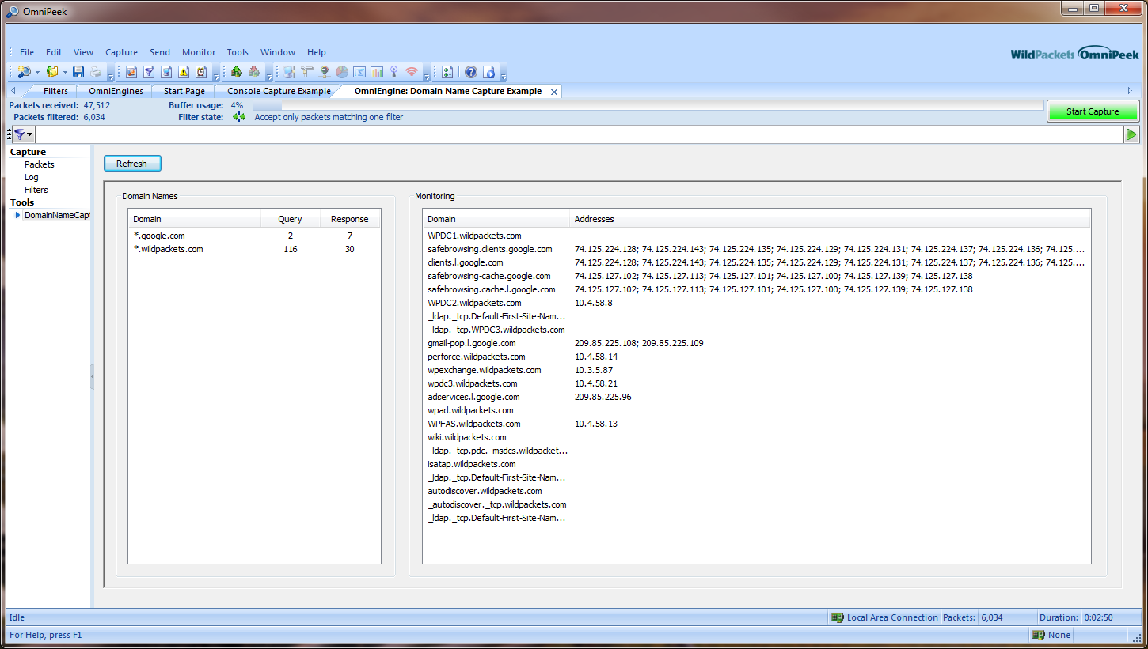

Note regarding the engine view: you must press the “Refresh” button to update the results.

Console:

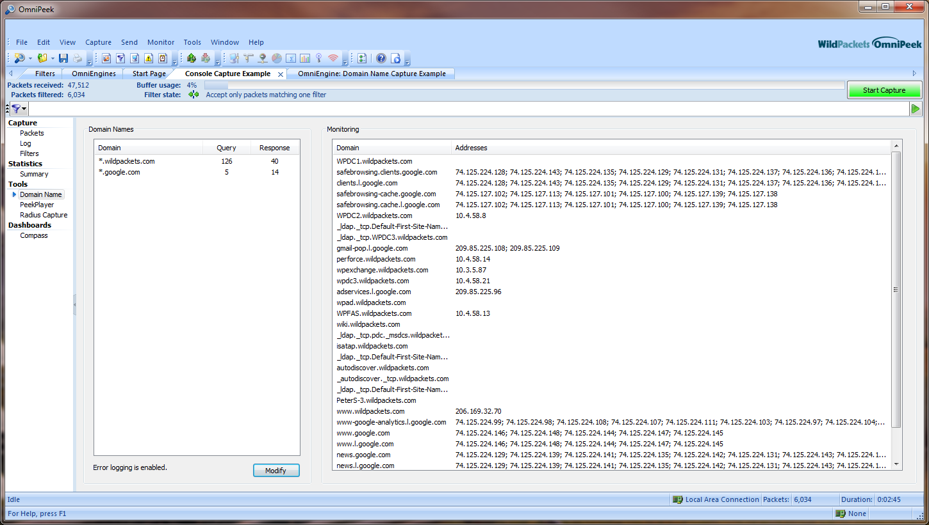

Note regarding the console view: it is a live view and updates continuously. Also, it is possible to modify the options by pressing the Modify button.

Error Logging

Error logging is implemented differently in the console version of the plugin than in the engine version.

Console

As noted prior, error logging can be activated in the console plugin only from the options dialog that is available from the OmniPeek Tools menu. From the Tools menu item, select Options, then highlight Analysis Modules in the left hand pane. In the right hand pane select “Domain Name Capture” and either press the Options button or double click on the selection.

From the Domain Name Capture Options dialog that will come up either check or uncheck “Enable error logging”. This selection will be global for any console capture.

Console only:

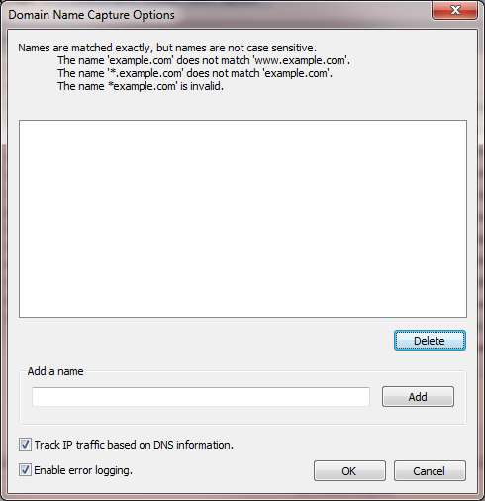

If Enable error logging is selected, any error messages will be logged to the following file:

C:\Users\<user>\AppData\Roaming\WildPackets\OmniPeek\Plugins\DomainNameCaptureErrorLog.txt

Engine:

There is no configuration for error logging in the engine version of the plugin, as errors will always be logged on screen if any occur. Thus there is no file logging in the engine plugin. In the engine version of the plugin any DNS errors are displayed when you select the Log tab under Capture in the left hand pane.

Here is an example error message in the engine:

