IP Pen Register Plugin Usage

This document describes the IP Pen Register plugin, its purpose, installation, and usage.

Introduction
The IP Pen Register plugin is one member of the WildPacket’s Lawful Intercept Support Package (LISP) bundle. This suite of analysis modules provides powerful tools in support of lawful intercept and targeted packet capture. The IP Pen Register plugin serves to filter network traffic and provide addressing and some other meta packet information without revealing packet content. Due to this non inclusion of payload / packet data content, the IP Pen Register plugin finds itself in a legally straightforward category of lawful network interception tools.

The Pen Register Concept
"Pen Register" is historically a term that relates to recording telephone numbers dialed out from a telephone. This has been amended in the 2001 US Patriot Act to be more general:

''...a device or process which records or decodes dialing, routing, addressing, or signaling information transmitted by an instrument or facility from which a wire or electronic communication is transmitted, provided, however, that such information shall not include the contents of any communication, but such term does not include any device or process used by a provider or customer of a wire or electronic communication service for billing, or recording as an incident to billing, for communications services provided by such provider or any device or process used by a provider or customer of a wire communication service for cost accounting or other like purposes in the ordinary course of its business.''

Thus “pen register” now encompasses lawful internet capture as an extension of the legacy telephone concept. This term, together with the related ''trap and trace device'' term, describes capturing traffic from and/or to a device in such a way that addressing and related data are captured without revealing message contents.

The WildPackets IP Pen Register Plugin
The IP Pen Register plugin, as an analysis module, supports the pen register concept with respect to network traffic. This plugin uses the filtering capability of OmniPeek and OmniEngine such that:
- Only IP and ICMP traffic is captured.
- All IP header information, including addressing, packet size, and so on, are captured. This more specifically includes protocol, intercept time and date, source and destination IP addresses, TCP and ICMP ports, packets and bytes transmitted by each IP address, and total packet and byte numbers of payload transmitted.
- All information beyond IP / UDP / TCP / ICMP headers is removed from packet display. This data is thus ''sliced'', or put another way, payload data is removed from the packet. The slicing is intelligent; that is, a packet will be sliced relative to its protocol header such that its own payload is specifically removed.

Sample Packet Display
As an example of the result from an IP Pen Register plugin capture, below is a screen print from a sample https packet that has been filtered through this plugin. Note that the actual packet length is 213 but that it has been sliced at byte 54. We know from the tcp port number that this is an https packet, but no https data is actually displayed:

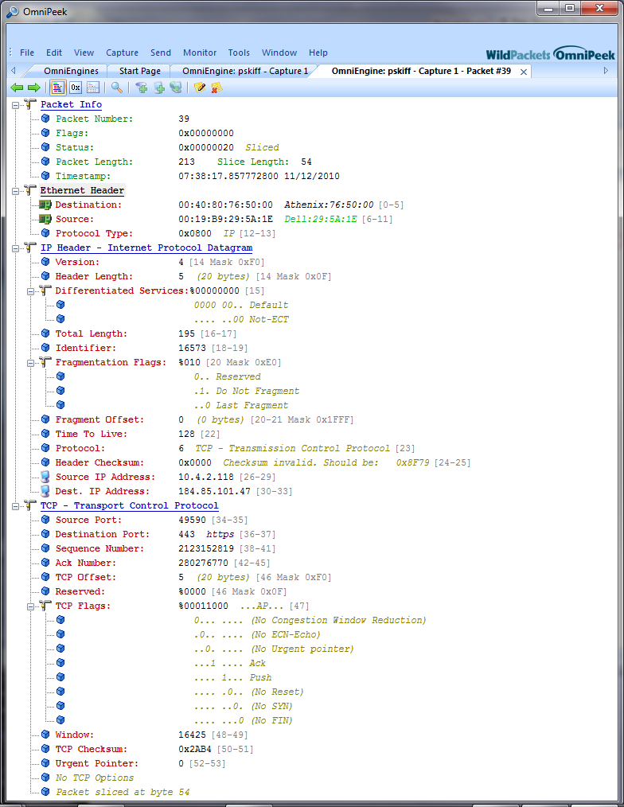
In fact, the data not displayed has been discarded and is not available. This is just what is required for a pen register capture.

Console and Engine Versions of IP Pen Register
IP Pen Register plugin versions are available to run on both the OmniPeek and OmniEngine platforms. The two plugin versions are referred to as the console (OmniPeek) version and the engine (OmniEngine) version. The two versions have identical behavior and results. Both are dll files. Both are filter type plugins (see below) whose results show in the packet display screen of OmniPeek. There is no options setting for either plugin, so no options dialog is available. Both do, however, have an About dialog box that is available. In the About box for the engine version of the plugin it is noted that this is an engine plugin.

Installing the IP Pen Register Plugin
Although both the console and engine versions of IP Pen Register come as a single dll, the engine plugin dll is actually installed on both on the OmniEngine computer and also on any OmniPeek computer that will be accessing IP Pen Register on the engine it connects to. The reason for requiring a dll install on the OmniPeek computer running an engine plugin is that the plugin dll is required by OmniPeek in order to create a filter (discussed below) for IP Pen Register. Also, its presence on OmniPeek allows display of the About dialog box.

Interim instructions for installing the plugin engine version, November 2010.
This installation is in advance of an install package for the IP Pen Register engine version. This is a manual install until an automated install package becomes available.
It must be noted that the IP Pen Register engine plugin must be installed on both OmniEngine and additionally on any OmniPeek computer that will be accessing the OmniEngine for IP Pen Register usage. The reason for this is that a filter must be created on OmniPeek (see below) .
- Rename the IpPenRegister.zip.blob file to remove the “.blob” suffix.
- Unzip IpPenRegister.zip: this will create two files, IpPenRegister.dll and IpPenRegister.he.
- On the computer on which OmniEngine is installed, copy the two IpPenRegister files directly into the OmniEngine directory. For example, this might be :
C:\Program Files\WildPackets\OmniEngine
- Restart the OmniEngine for the plugin to become active.
- For any OmniPeek computer that will be accessing IP Pen Register on a remote OmniEngine, copy the two IP Pen Register files directly into the OmniPeek directory. This might be:
C:\Program Files\WildPackets\OmniPeek
- If OmniPeek is running, it must be restarted for the plugin to be active.

Using the IP Pen Register Plugin
For both OmniPeek and OmniEngine, using the plugin simply involves creating a capture that uses the plugin as an analysis module filter. How to create the filter is covered in the next section. As there is no options setting involved, that’s really all there is to it: create a filter (if one does not already exist), select it, and start the capture. Functionally, to OmniPeek and OmniEngine, the IP Pen Register plugin itself is acting as the filter, and this filter tells the executable which packets to accept and where to slice the accepted packets (in order to remove packet content information) before display.

Creating a Filter for IP Pen Register

Creating a filter is necessary before the IP Pen Register plugin can be used in a capture. The type of filter to be created, as mentioned, is the “Analysis Module” type of filter, which is one of the choices in the Insert Filter dialog box. The dialogs for creating a filter are quite similar for console and engine captures. In both cases the filter can be created from the Capture Options dialog box that is invoked when starting a new capture or when changing capture options. A detailed example will be given for an engine type capture, but it is quite analogous for a console type capture. Also, it will be noted that there are alternative ways of invoking the dialog for filter creation, but only one will be detailed to exemplify the process.
For an engine type capture, of course it is necessary from within OmniPeek to connect to a remote OmniEngine. This will not be explicated here. In this example we have connected to an engine and are about to create a new capture. There is not yet any filter for IP Pen Register.

Click on “New Capture” under “Captures” on the Home tab for OmniEngines to invoke the Capture Options dialog.

From the Capture Options dialog click on Filters, as shown below:
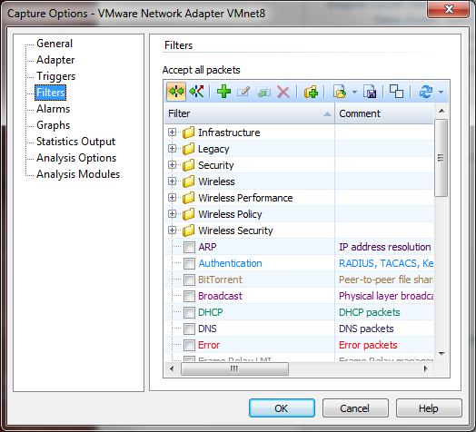

We note (in this example case) that no filter yet exists for IP Pen Register so we will create one. Click on the green “+” icon to invoke a dialog for creating the filter. This will bring up the Insert Filter dialog:

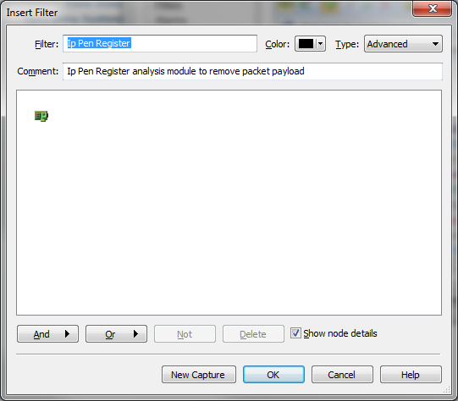
Enter a name for the filter and optionally a comment. Select “Advanced” for the type of filter and press the “And” button, then select “Analysis Module” from the selection list that comes up.

You will get an Analysis Module Filter dialog:

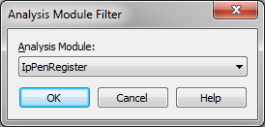

In the drop down list box, select “IpPenRegister” for an engine plugin or “IP Pen Register” for a console plugin. You will have created the needed filter:

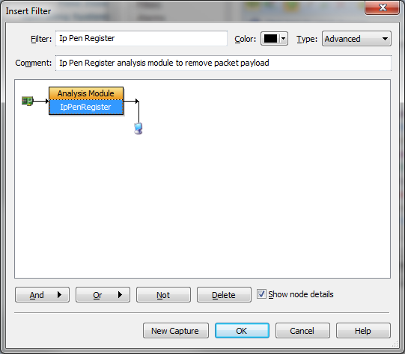

Press OK to accept the new filter settings.
Back on the Capture Options dialog, make sure that the new filter (in this example case called “Ip Pen Register”) is checked:
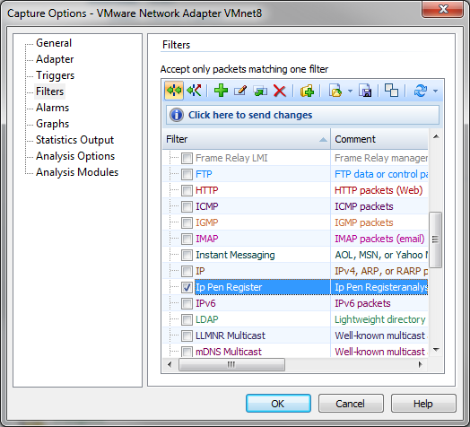

For engine plugins you need to click on “Click here to send changes” as is shown in the example. This is not required for console plugin configuration.

Alternative Ways of Invoking the Insert Filter Dialog
From the Filters tab along the left side of the window (this example from an engine plugin):
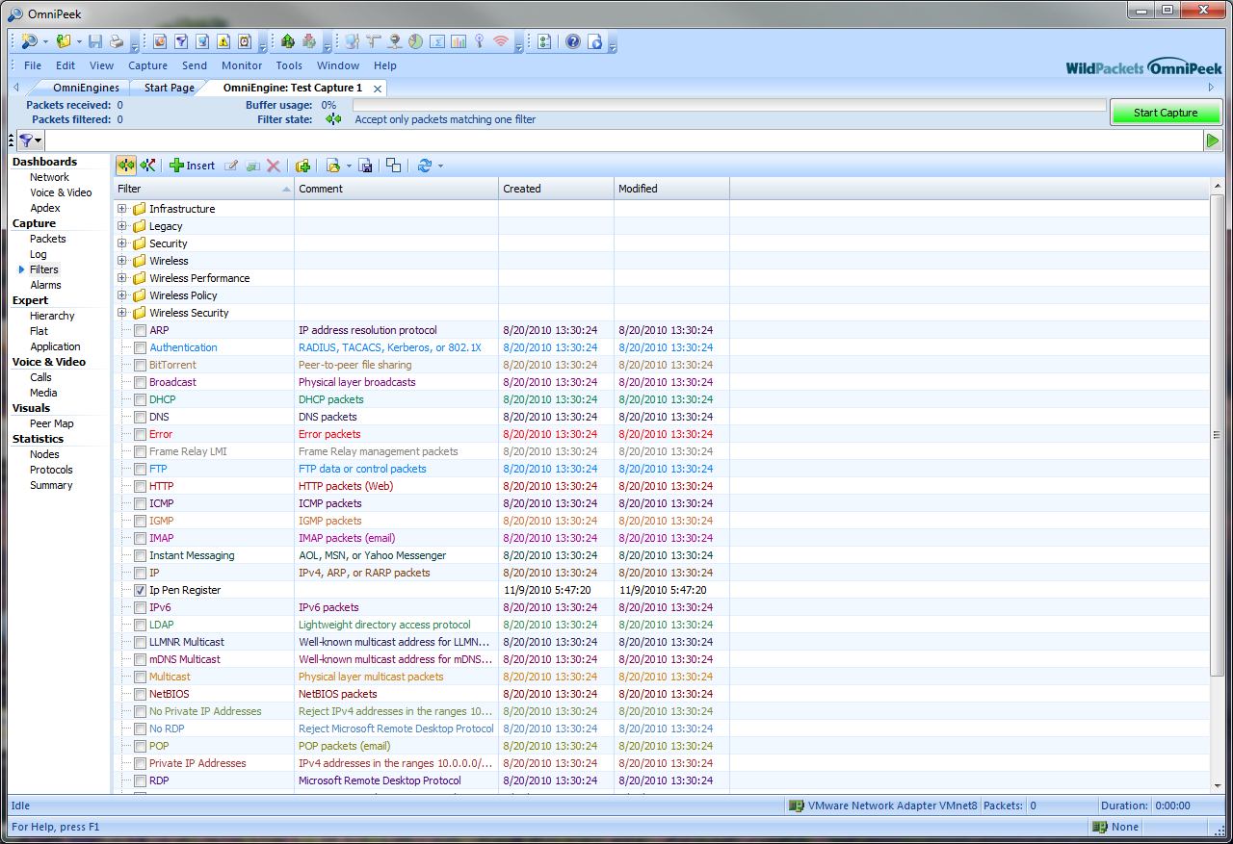

For an engine plugin, from the OmniEngine Filters tab:
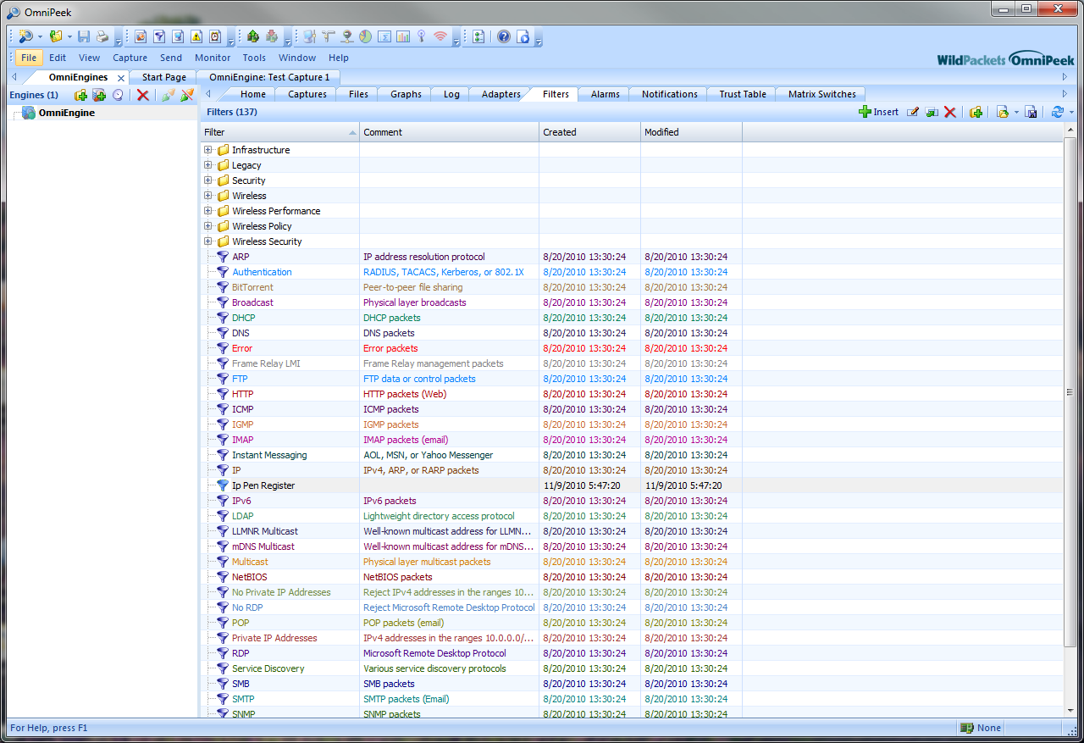

For a console plugin, by clicking the View menu in OmniPeek, then clicking Filters to create a Filters tab:
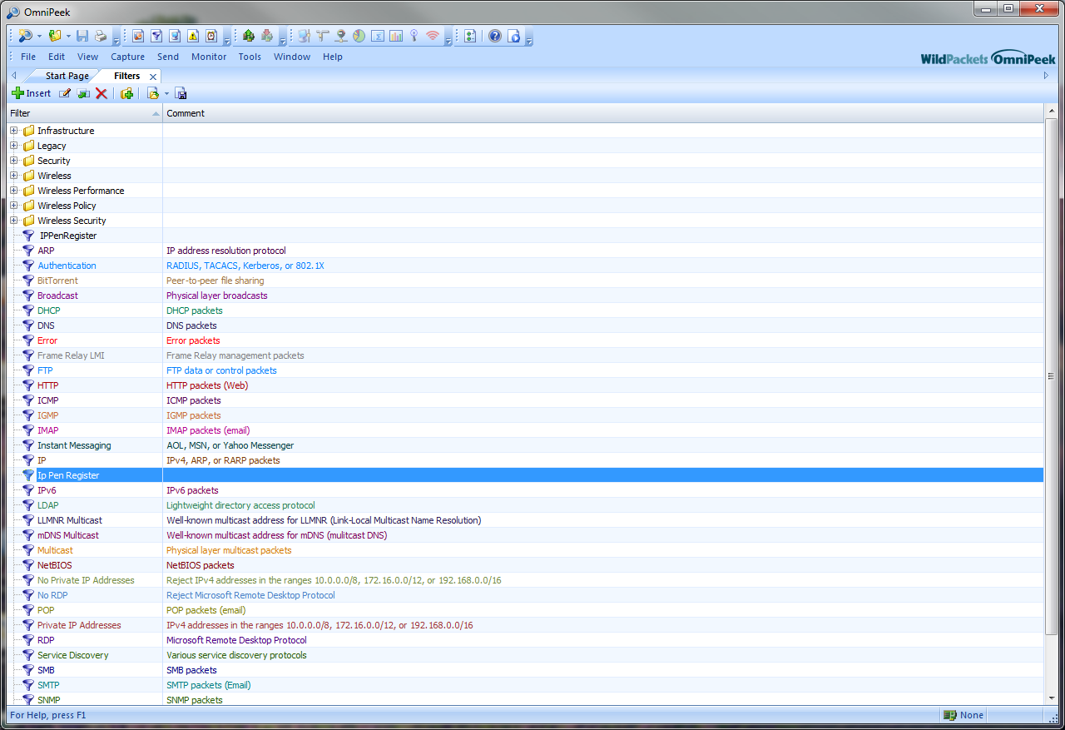

Complex Filters for Targeted Captures

The needs for a capture session may well be that only certain targeted addresses, only certain ports, and so on, are desired. This is all possible using complex filters. A full discussion of filter creation and options setting in general can be found in the OmniPeek help system. Here, however, an example extension from the above filter creation will be shown.

In this example the IP Pen Register analysis module will be used for capturing data to and from two IP addresses, 10.4.2.118 and 10.4.2.44. This is accomplished with a combination of “And” and “Or” filter selections . The combined effect will be to capture only packets for the two selected addresses, and to utilize the IP Pen Register analysis module to remove payload information from the packets:

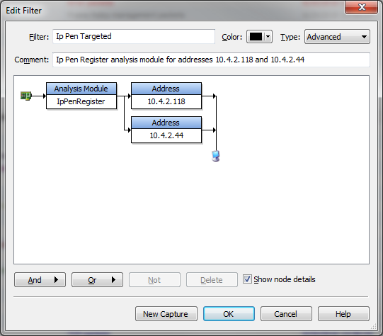

Running an IP Pen Register Capture
Always make sure that the Ip Pen Register filter is selected on the Filters tab under “Capture” on the left pane on the screen. Press the green Start Capture button, which will turn red. Note in the example capture below that only traffic to and from the specified addresses has been captured. Furthermore, all packet data for these targets has been “scrubbed” by the IP Pen Register plugin.

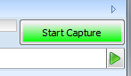

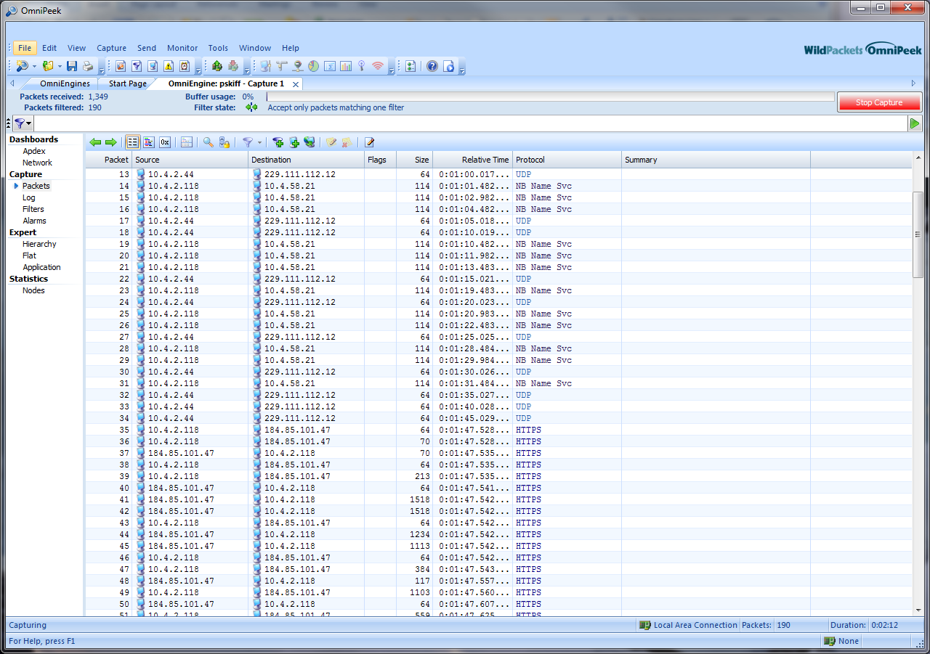

Packet number 32 detail is below

Packet number 32 detail. Note that any payload data has been removed:

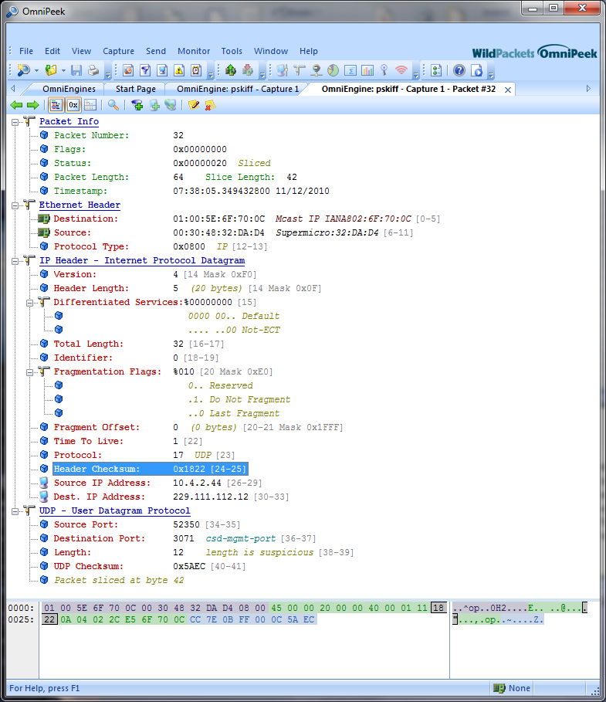

Saving the Configuration to a Capture Template
The configuration for a capture session, either console or engine, can be saved to a template file. This is worth mentioning with respect to the Ip Pen Register plugin, which does not have an unique options setting dialog, but for which it would still be helpful to save off configuration options for capture sessions. Saving the configuration for an Ip Pen Register capture session, including the filter configuration as explicated above plus any trigger options, saving to disk options, and so on, can be accomplished with capture templates. This allows easily replicating the capture options each time the plugin is used, with insurance that identical settings are used for each capture session. Furthermore, it opens up the possibility of automating captures.

Capture templates are well covered in the OmniPeek documentation available from the Help menu and will not be exhaustively discussed in this document. However, the process for creating a capture template for an Ip Pen Register session on an engine will be described, with comments regarding performing this process in other contexts added as well.

In this example I would like an OmniEngine capture that is filtered by the IP Pen Register analysis module for the two IP addresses 10.4.2.118 and 10.4.2.44. Furthermore, I would like the packets to be saved to disk on a periodic basis. I would like the capture to terminate at 5:00 pm on 12/20/2010.

From the General tab of the Capture Options dialog I select ”Continuous capture” and “Capture to disk” (with its settings). I will also check “Save as template” so as to have the system save off my configuration:

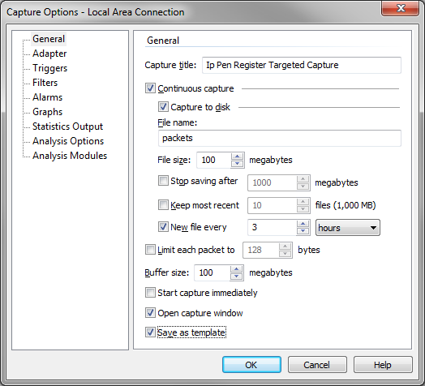
Note that in my case the packets will be saved to “C:\ProgramData\WildPackets\OmniEngine\Ip Pen Register Targeted Capture”. Files will be constructed with names such as “packets2010-11-12T09.28.10.235.pkt”.

From the Filters tab I select my “Ip Pen Register Targeted” filter:
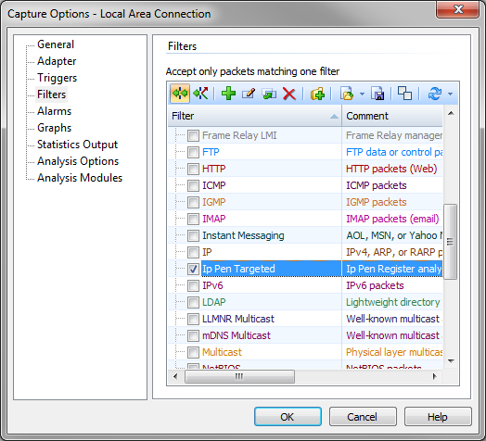
From the Triggers tab I select “Stop trigger”:
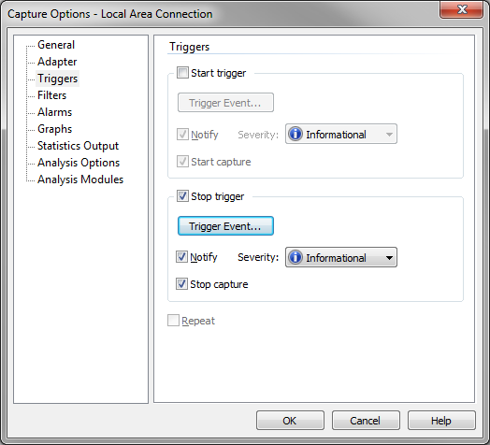

Then I press Trigger Event to bring up the Stop Trigger Event dialog, which I fill in as follows:
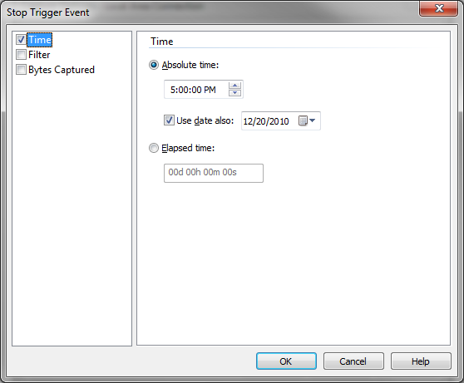

For Analysis Options I have chosen to deselect all but Analysis Modules for efficiency. This makes sense because I am simply capturing packets and not performing any analysis.

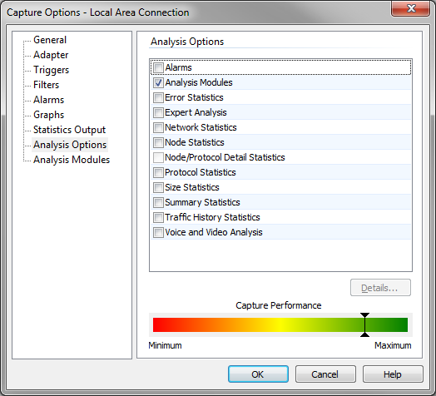

I now press OK to save off my configuration as well as establish the current capture session. If prompted, choose “Continue with current settings”. Also, it is prudent to close and the re-open OmniPeek to insure that the settings are saved. This is because the saving of capture templates does not occur until OmniPeek is closed.

To use the saved options at a later time
When starting a fresh capture, when “New Capture” is clicked on from the OmniEngine Home tab, you should see your capture template as a selection option. Selecting your template will bring up all the options for you IP Pen Capture just as you configured them!

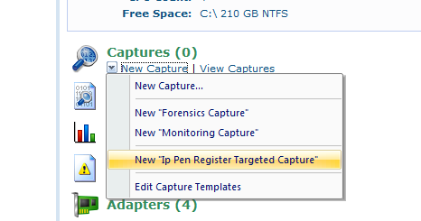

Other Ways of Creating / Editing Capture Templates

On the Engine
From the Captures tab, click the down arrow attached to the Insert button, then select “Edit Capture Templates”:

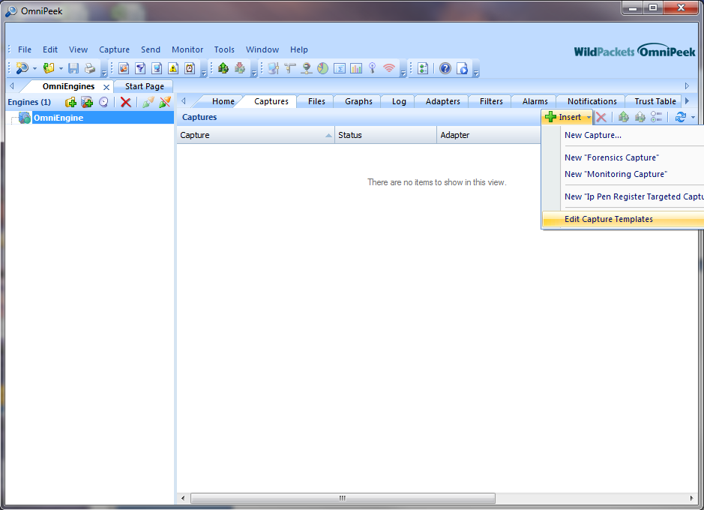

On the Console
From the File menu on the OmniPeek console you can save or select capture templates.
“Save as Capture Template” allows you to save off the current capture session to a template file.
“New Capture From Template” allows you to select from a list of existing templates in order to create a capture with the configuration you wish.

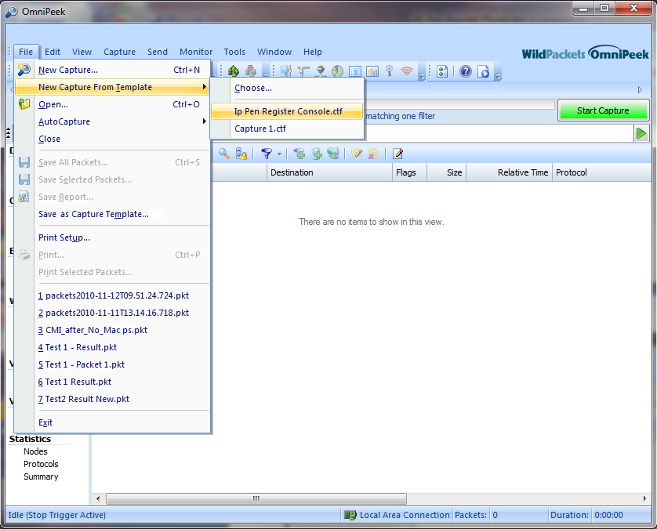

Automating Captures
Capture automation is beyond the scope of this document, but it should be at least mentioned that this is possible. Regarding console captures, it is possible to create autocapture files. Autocapture files are documented in the OmniPeek Help system. Automation is also possible using OmniScript in collaboration with capture templates.

