Welcome to the data management system! I am here to help you record and update your processing activities. The following activities have already been assigned to you:

1. Correspondence & invoices
2. Payroll
3. Document destruction
4. Copy - correspondence & invoices
5. Email delivery
6. Email archiving
7. Customer file
8. Email Sent Receipt

Please simply enter the appropriate number with which you would like to start updating the processing activities.

**Dialogue between employee and chatbot:**

Employees: 1

Chatbot: You have selected “Correspondence & Invoices”.   
I have the following information about this:

Process manager Dirk Janthur

Application / Storage Ms-Office (Excel and Word)

Information object address data contact person

Purpose of correspondence with customers and partners

Legal basis for business transactions

Is this information still correct or have there been any changes?

Employees:

There have been changes in the application. I now use Open Office.

Chatbot: Thank you.

Then I note the change on OpenOffice.

Chatbot:

We will then check the further information.

are noted as affected persons :



Have there been any changes to this?

Employee: No

Chatbot. Great, then let's check the entries for the data category:

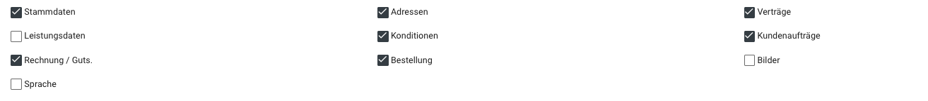

Have there been any changes to this?

Employee: Yes, no, maybe

Chatbot: *response to information*

Chatbot. Great, then let's check the entries for the special data category:



Have there been any changes to this?

Employee: Yes, no, maybe

Chatbot: *response to information*

Chatbot. Great, then let's check the entries for internal recipients / recipient category:



Have there been any changes to this?

Employee: Yes, no, maybe

Chatbot: *Answer to information*

Chatbot. Great, then we will check the entries for external recipients / recipient categories:

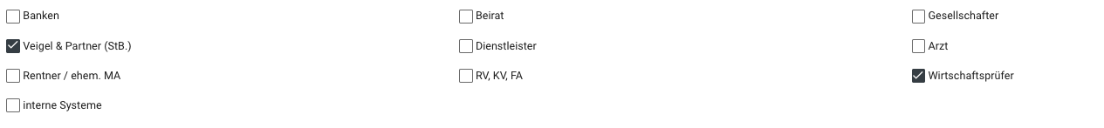

Have there been any changes to this?

Employee: Yes, our tax advisor is now called ???

Chatbot: *Thanks for the info. I'll change the entry then.*

Chatbot. Great, then we will check the entries for standard deadlines for deletion of data / note if only blocked:



Have there been any changes to this?

Employee: Yes, no, maybe

Chatbot: *Answer to information*

Chatbot. Great, then we'll check the entries for planned data transfer to third countries:



Have there been any changes to this?

Employee: Yes, no, maybe

Chatbot: *response to information*

Chatbot. Great, then we'll check the entries for additional information



Have there been any changes to this?

Employee: Yes, no, maybe

Chatbot: *response to information*

Chatbot. Great, then we'll check the entries for risk assessment

Ein Bild, das Screenshot enthält.

Have there been any changes to this?

Employee: Yes, no, maybe

Chatbot: *response to information*

Chatbot: Thank you very much, then let's move on to the next processing activity. Please select again:

1. Correspondence & invoices
2. Payroll
3. Document destruction
4. Copy - correspondence & invoices
5. Email delivery
6. Email archiving
7. Customer file
8. Email Sent Receipt

Or do you want to record a new processing activity?

*QUERY starts again from the beginning*

Chatbot: Thank you for using the data management system. For further information do not hesitate to contact me. Have a nice day!