

Housing costs demand a significant investment from both consumers and developers. And when it comes to planning a budget—whether personal or corporate—the last thing anyone needs is uncertainty about one of their biggest expenses. Sberbank, Russia’s oldest and largest bank, helps their customers by making predictions about realty prices so renters, developers, and lenders are more confident when they sign a lease or purchase a building.

Although the housing market is relatively stable in Russia, complex interactions between housing features such as number of bedrooms and location are enough to make pricing predictions complicated.

In this project, you are challenged to develop models which use a broad spectrum of features to predict realty prices. An accurate prediction model will allow Sberbank to provide more certainty to their customers and value to their shareholders. There are two goals:

1. We would like to build a useful model to predict the **price** of an individual property given some or all of the variables in the data dictionary and in the dataset *train.csv*. You will make predictions using the model you develop using *predictionData.csv* which contains 7662 properties that sold between July 2015 and May 2016. Your goal is to minimize the RMSLE as defined below.

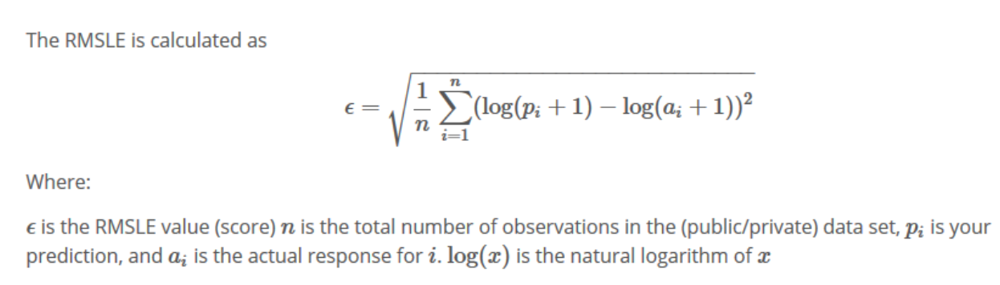

1. We would like to build a useful model to forecast the **mean** price of properties from July 2015 to July 2016. We would also like to provide a table and a plot of these forecasts complete with 95% confidence intervals. This analysis will entail extensive data wrangling. In addition, the analysis should test for serial correlation in the data and make necessary adjustments to the model if there is evidence of significant serial correlation.

More details on both of these goals are below:

**Goal 1: $≤$ 8 Pages (*60 pts*)**

This should take 8 or less pages to address Goal 1. Your analysis should include the following:

1. Introduction (Brief introduction to the problem … 2 to 3 sentences).
2. Description of the data with a table or a reference to a table.
3. Data Cleaning / Wrangling (any renaming of variables or standardizing of values.)
4. Exploratory Data Analysis (EDA).

(Complete with summary statistics, descriptions, tables and/or plots etc.)

* 1. **Outlier Identification** and Handling
  2. **Missing value identification**, summary and possible imputation (mean, median, regression.) This may also be considered “Data Wrangling”.
  3. **Multicollinearity** (is there reason to believe it is present? You don’t have to address every potential pair of variables that may be collinear. Just provide a plot and or other evidence of a single occurrence of multicollinearity if at least one exists and then mention possible other occurrences.
  4. **Checking assumptions**: homoscedasticity, normal distributions of the response for fixed values of the explanatory variable(s), linear relationship between the mean of the response and each explanatory variable, etc. This is where you would apply transformation (log, square root, etc.)
  5. **High level variable selection** would be included in the EDA. (Example: There are many potential explanatory variables. Running stepwise variable selection with a high entry and exit threshold will not provide a plausible final model, but may leave you with a smaller set of potential explanatory to work with.)
  6. Anything else that might be appropriate in learning about the data before getting started. (Example: You might **try interactions between explanatory variables in the EDA**.)

*Note: For a refresher on the EDA, review the Exploratory Data Analysis Unit in

Doing Data Science.

1. Modeling
   1. You must **fit at least 3 candidate models**.
      1. **A model with OLS parameter estimates.** You may choose the variables with or without the use of a variable selection technique (forward, backward, stepwise) (You may have done this already in the EDA.)
      2. **A model with LASSO** estimation and selection.
      3. **A model of your choice**. This may be using another OLS or LASSO model or custom model, etc.

\***Note: in at least one of the models above, or in the EDA, you should test the significance of at least one term that involves an interaction**.

* 1. You need to **address the assumptions with respect to the residuals**. (Normally distributed around 0 with constant standard deviation.)
  2. **For each model** you need to conduct an **internal and external cross validation**.
  3. You should **compare the models using the AIC, SBC, Interval k-fold cross validation (you pick k), external cross validation**. For external cross validation you will have to subset the train data set into modeling and test data sets.

1. Prediction
   1. Identify which model you feel is the best and discuss why.
   2. Use this model to predict the price of each of the 7662 properties in the prediction data set (*predictionData.csv*).
   3. Submit these predictions in the zip file with your final paper. Please see the sample submission file. *SampleSubmission.csv*

**\*Note: It is understood that all the material above should supported with plots, tables, charts, discussions, etc. where appropriate**. All plots and tables should be clearly labeled and referenced in the discussion and all tables referenced in the discussion should exist in the paper. It is never appropriate to have a plot or table in the paper that it not described / referenced in the writing. *Your team could lose points or gain points depending on how well your professor feels you described research / findings.*

**Goal 2: $≤$ 3 Pages (*30 pts*)**

1. Introduction (Brief introduction to the problem … 2 to 3 sentences).
2. Data Wrangling: Here you will have to manipulate/wrangle the data to produce the data you will use in this analysis. Your goal is to **get the mean price for each month/year combination**. Hints:

Data Wrangling Use SAS, Python or R (hint: dplyr and tidyr packages) to separate the timestamp column into 3 columns. These three columns should be called “Day”, “Month” and “Year” respectively (any order is fine). To be clear, your task is to turn:

 into 

**USE R, Python or SAS to aggregate the data by year and month**. This means that the new dataset should have the mean of all the properties for a given month in a given year. You may do this using any method you like. The “aggregate” function in R is one way of doing this. As a reference, the first four months should match the values below.



1. **Plot the time series** of the price_doc versus the numbers 1 – 47 on the x-axis. You should simply name the x-axis “months”.
2. **Model the residual series**.
   1. Fit a simple linear regression model with price_doc as the response variable and Month_Number as the explanatory variable.
   2. Obtain the residuals from this model and plot them against the month number. Make sure this plot is a series rather than a scatter plot. This simply means make sure the points on the plot are connected by a line. Keep the x-axis label: “Month”.
   3. Fit the residual and time data using proc autoreg and investigate the autocorrelation structure based on the Durbin-Watson statistic, partial autocorrelation plots, AIC and SBC. You studied the AR(1) model in depth in Unit 4, it is possible you may find that an AR(p) with p > 1 is a better fit to this data. Explore what this means in terms of intuition, model construction and forecasting.
   4. Use your model from part c to forecast the residual for the next year (June 2015 – June 2016) with 95% confidence intervals.
3. Using your model from the last question and the series of residuals, forecast the next year: July 2015 – June 2016 and of course include 95% confidence intervals. You can do this by obtaining an estimate from the model in part b for the mean price and then add to it the forecast residuals from the model in part e. The confidence interval won’t be exact but a very conservative estimate will be to add the upper and lower bound from each model.
4. Submit your forecasts (with confidence intervals) as well as your final csv data set you used in the analysis (wrapped in a zip file.)

**Appendix 1: Data Dictionary *3 pts***

1. This Appendix does not count against your page count.
2. You should “prettify” the data dictionary you have received. Add color, add examples, add data types, change the formatting. Just do something to improve the look and/or readability.

**Appendix 2: Code *7pts***

(Well commented … Remember: Reproducible Research!)

1. This Appendix does not count against your page count.
2. Simply cut and paste your well commented code here.

**Submissions:**

What to submit 2 DS in a single zip file:

1. Prediction from Goal 1. (csv file)
2. Wrangled data set from Goal 2. (48 rows including title row. / csv file)
3. Predictions from Goal 2. (csv file)
4. Line plot of predictions from Goal 2 with 95% confidence intervals. Image or cut and pasted into something like a word doc.
5. Final paper (No longer than 11 pages without appendix.) LaTex/Word/ etc.

**Note: Data Wrangling:**

*Wrangling = having a long and complicated dispute.*

Part of this project is meant to have a significant data wrangling component. As an example, you will more than likely need to work with R or SAS or both to change data from character/string to integer/numeric so your models make the predictions that are required. This is only an example of the data wrangling you will need to conduct. It will help to start early and bring these issues up in live session and/or office hours.

**Due Date:**

**All submissions are due no later than 11:59pm Saturday October 6th.**