Application of Classification Models

for Predicting Shooting Performance

in the NBA

A Case Study of Kobe Bryant

Allen Crane

Brock Friedrich

Examiner: Dr. Anthony Tanaydin

Southern Methodist University

Data Science

Applied Statistics

December 1th, 2018

Writing period

10. 24. 2018 – 12. 1. 2018

Abstract

In a world with continuously increasing techological capabilities, the demand for answers increases alongside it. The domain of professional sports in particular is no exception to this trend. The very essence of competitive sports is rooted in a desire to optimize and gain every advantage over competitors. In this paper, we describe classification methodologies for predicting the performance of professional athletes through a scoped analysis of the long-time NBA allstar, Kobe Bryant. We detail three simulations modelling shooting accuracy over Bryant’s 20 year career, using logistic regression and discriminant analyses to yield predictions about Bryant’s theoretical future performance. We show that Bryant’s potential to score is strongly dependent on his distance from the basket when shooting. We also show that Bryant’s scoring performance in the post-season, as compared to that of the regular season, is consistent with his performance at any other point in the season.

i

Contents

1 | Introduction |  |  | 1
2 | Approach |  |  | 3
 | 2.1 | Problem Definition . . . . . . . . . . . . . . . . . . . . . . . . . . . . |  | 3
 | 2.2 | Exploratory Analysis . . . . . . . . . . . . . . . . . . . . . . . . . . . |  | 5
 |  | 2.2.1 | Data Overview . . . . . . . . . . . . . . . . . . . . . . . . . . | 5
 |  | 2.2.2 | Multicollinearity . . . . . . . . . . . . . . . . . . . . . . . . . | 8

3 | Methodoloy |  | 11
 | 3.1 | Feature Selection . . . . . . . . . . . . . . . . . . . . . . . . . . . . . | 11
 | 3.2 | Model Selection . . . . . . . . . . . . . . . . . . . . . . . . . . . . . . | 11
 | 3.3 | Evaluation . . . . . . . . . . . . . . . . . . . . . . . . . . . . . . . . . | 14
4 | Conclusion |  | 15
5 | Limitations and Future Directions |  | 19
6 | Appendix |  | 21
 | 6.1 | Github Repository . . . . . . . . . . . . . . . . . . . . . . . . . . . . | 21
 | 6.2 | Appendix A . . . . . . . . . . . . . . . . . . . . . . . . . . . . . . . . | 21
 |  | 6.2.1 Model Comparison - Continued . . . . . . . . . . . . . . . . . | 21
 |  | 6.2.2 Data Dictionary . . . . . . . . . . . . . . . . . . . . . . . . . | 21
 | 6.3 | SAS Code . . . . . . . . . . . . . . . . . . . . . . . . . . . . . . . . . | 22
 | 6.4 | Python Code . . . . . . . . . . . . . . . . . . . . . . . . . . . . . . . | 41

iii

List of Figures

1 | Market Analysis . . . . . . . . . . . . . . . . . . . . . . . . . . . . . | 4
2 | Plots of y_loc . . . . . . . . . . . . . . . . . . . . . . . . . . . . . . . | 7
3 | Boxplot of Shot Distance . . . . . . . . . . . . . . . . . . . . . . . . | 7
4 | Correlation Matrix - All features . . . . . . . . . . . . . . . . . . . . | 9

Correlation Matrix - Candidate Model . . . . . . . . . . . . . . . . . 12

6 Model Composition Chart . . . . . . . . . . . . . . . . . . . . . . . . 13

7 | Predicted Shot Probability over Distance to Hoop . . . . . . . . . . | 16
8 | Performance in Regular and Post Season . . . . . . . . . . . . . . . . | 17

v

List of Tables

1 | Feature Summary . . . . . . . . . . . . . . . . . . . . . . . . . . . . . | 5
2 | Key Feature Descriptions . . . . . . . . . . . . . . . . . . . . . . . . | 6
3 | Variance Inflation Factors . . . . . . . . . . . . . . . . . . . . . . . . | 8
4 | Logistic Model Summary . . . . . . . . . . . . . . . . . . . . . . . . | 11

- Log-odds with Respect to Distance . . . . . . . . . . . . . . . . . . . 15

6 Odds with Respect to Distance . . . . . . . . . . . . . . . . . . . . . 18 7 Percent Change over Distance . . . . . . . . . . . . . . . . . . . . . . 18

vii

1 Introduction

With modern computers and the popularity of the budding disciple of data science, there are numerous predictive technologies readily available. In professionl sports alone, a host of disparate entities, players, ogranizations, and gamblers alike are hungry for new insights. Each bears an economic imperative to seek advantages and optimizations that will give them an edge over their peers. Technology, however, does not predicate useful and eﬀective models. It is the rigorous application of sound statistical theory that yields actionable conclusions. Unfortunately, the appeal of novel algorithms and the sparkles of big data detract from the importance of a strong statistical foundation. Thus, we seek to right the ship of this rampant malpractice as it applies to this problem domain. In what follows, we explore insights we have garnered from the application of linear discriminant analysis and logistic regression, then leveraging those insights to appropriately tune the final predictive model.

Kobe Bryant marked his retirement from basketball by scoring 60 points in his final game as a member of the Los Angeles Lakers team on Wednesday, April 13, 2016. Starting to play professional basketball at the age of 17, Kobe earned the sport’s highest accolades throughout his long career. Using 20 years of data on Kobe’s shots made and shots missed, we wish to predict which shots will be successful.
2 Approach

2.1 Problem Definition

Sports analytics is, as many previously low-tech markets are, poised to boom as sports organizations are increasingly able to generate more data. Recent research

"The Sports Analytics market is expected to grow from USD 123.7 Million in 2016 to USD 616.7 Million by 2021, at a Compound Annual Growth Rate (CAGR) of 37.9

The increasing volume of on-field and oﬀ-field data generated among various sports organizations has led to an increase in managing these data to analyze them. This need is driving the adoption of sports analytics solutions. Analytics and big data technologies have found huge potential in various industries, including sports. The increasing demand of coaches, mentors, and other management oﬃcials for real-time access to the insights of relevant information presents huge potential for sports analytics market. The demand for cloud-based sports analytics solutions is also expected to increase due to the lack of budget allocation for hiring technical skills and experts to analyze data for sports organization. These are some of the major factors expected to augment the growth of the market. Moreover, in order to remain competitive, organizations are adopting sports analytics solutions."

[1]

This study was birthed out of a need to reliably quantify three key metrics specifically, each used in assessing a professional basketball player’s shooting ability. Those metris are:

3

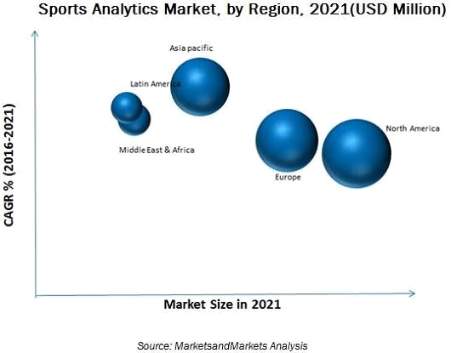

Figure 1: Market Analysis

- Odds of making a shot as distance from the basket increases.

- Linearity of the decline rate of the probability of making a shot with respect to the distance the shot was taken from the basket.

- The relationship between the distance from the shooter to the basket and the odds of the shot being made is diﬀerent when in the regular season verses the post-season.

Rephrasing those metrics as questions helps clarify the focus of the analysis as it relates to Kobe Bryant. Those questions are as follows:

- Do the odds of Kobe making a shot decrease with respect to distance he is from the hoop?

- Does the probability of Kobe making a shot descrease linearly with respect to the distance he is from the hoop?

- Is the relationship between the distance Kobe is from the basket and the odds of him making the shot diﬀerent if they are in the playoﬀs.

To appropriately answer the questions of interest above, we must fit a series of classifier models to the training portion of our dataset, iteratively scoring and comparing the various models against one another so that we can tune their parameters and hone in on a final feature set.

The entirity of the analysis is implemented side-by-side in Python and SAS. Below, we set the stage for conducting our analysis through an exploratory analysis of the dataset.

4

2.2 Exploratory Analysis

2.2.1 Data Overview

The NBA has provided a comprehensive dataset of every shot Kobe Bryant took throughtout his career. Accompanying each shot record are a number of supplemen-tary features that provide context to the positioning and environment in which a given shot was taken. Generally, the data was remarkably clean and readily manipulable. The majority of the wrangling eﬀort was focused on synthesizing new predictors. A brief summary of the features is below.

 | count | mean | std | min | 25% | 50% | 75% | max
game_event_id | 25697 | 249 | 150 | 2 | 111 | 253 | 367 | 653
game_id | 25697 | 24741091 | 7738108 | 20000012 | 20500064 | 20900337 | 29600270 | 49900088
lat | 25697 | 34 | 0 | 33 | 34 | 34 | 34 | 34
loc_x | 25697 | 7 | 110 | -250 | -67 | 0 | 94 | 248
loc_y | 25697 | 91 | 88 | -44 | 4 | 74 | 160 | 791
lon | 25697 | -118 | 0 | -119 | -118 | -118 | -118 | -118
minutes_remaining | 25697 | 5 | 3 | 0 | 2 | 5 | 8 | 11
period | 25697 | 3 | 1 | 1 | 1 | 3 | 3 | 7
playoﬀs | 25697 | 0 | 0 | 0 | 0 | 0 | 0 | 1
seconds_remaining | 25697 | 28 | 18 | 0 | 13 | 28 | 43 | 59
shot_distance | 25697 | 13 | 9 | 0 | 5 | 15 | 21 | 79
shot_made_flag | 25697 | 0 | 0 | 0 | 0 | 0 | 1 | 1
team_id | 25697 | 1610612747 | 0 | 1610612747 | 1610612747 | 1610612747 | 1610612747 | 1610612747
shot_id | 25697 | 15328 | 8860 | 2 | 7646 | 15336 | 22976 | 30697
attendance | 25697 | 15041 | 1076 | 11065 | 14314 | 15048 | 15738 | 20845
arena_temp | 25697 | 70 | 2 | 64 | 69 | 70 | 71 | 79
avgnoisedb | 25697 | 95 | 2 | 89 | 93 | 95 | 96 | 102

Table 1: Feature Summary

From the available features, the variable "shot_made_flag" indicates whether a

5

particular shot was made (1) or missed (0), and is the feature that acts as our endogenous variable. The remainder of the features are the potential predictors, or exogenous variables. Since there are a managable number of them, we can simply generate descriptive plots for each exogenous feature. Univariate distribution or frequency plots are ideal for vizualizing the underlying distristribution of each variable. In addition, boxplots for each exogenous feature against each level of the endogenous variable allowed us to develop our intuition about the variance within each level of the target feature.

Most of the features show no signs of skewness or severe departures from normality, however, there are some exceptions.

It’s clear that outliers are prevalent in some of the features, particularly those representing the distance to the hoop and the time remaining, as represented in figures 2b and 2a. Several solutions were explored to mitigate the potential impact of the outliers, none of which yielded a model with better results. Thus, all outliers were included in the final models on their original scale.

 | Table 2: Key Feature Descriptions
Game_event_id | Identification variable
Game_id | Identification variable
Lat and loc_y | Appear to be the same data (y-axis), based on location on the court.
Lat and loc_y | The tall bar indicates the frequency of shots taken at the location near the basket
Loc_x and lon | Appear to be the same data (x-axis), based on location on the court.
Loc_x and lon | The tall bar indicates the frequency of shots taken at the location near the basket
Minutes_remaining | Suggests that there is evidence that Kobe took more shots as the period
Minutes_remaining | progressed (higher shot counts closer to the end of the period)
Period | Indicates similar shot frequency across periods
Playoﬀs | Playoﬀs were a rare event in the season, hence the lower shot frequency overall
Season | Shot frequency was lower in 2 seasons
 | Suggests that there is evidence that Kobe took more shots in the final seconds
Seconds_remaining | (higher shot counts closer to the end of the last minute in the period, correlates
 | with shot frequency in the minutes_remaining variable above)
 | High shot frequency at the basket, at the top of the key (field goals),
Shot_distance | and the three-point line. Shot frequency was comparatively rarer
 | beyond the three-point line

6

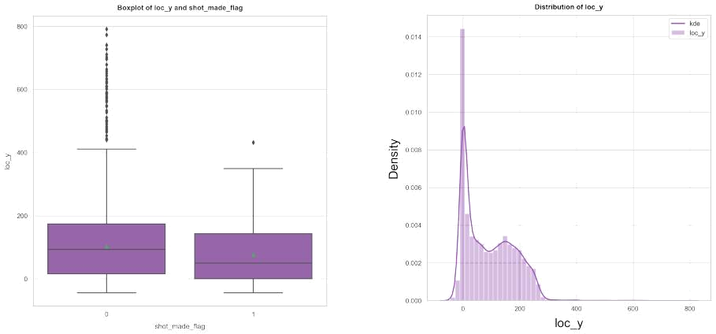

(a) Boxplot of Shot Y Location (b) Distplot of Shot Y Location

Figure 2: Plots of y_loc
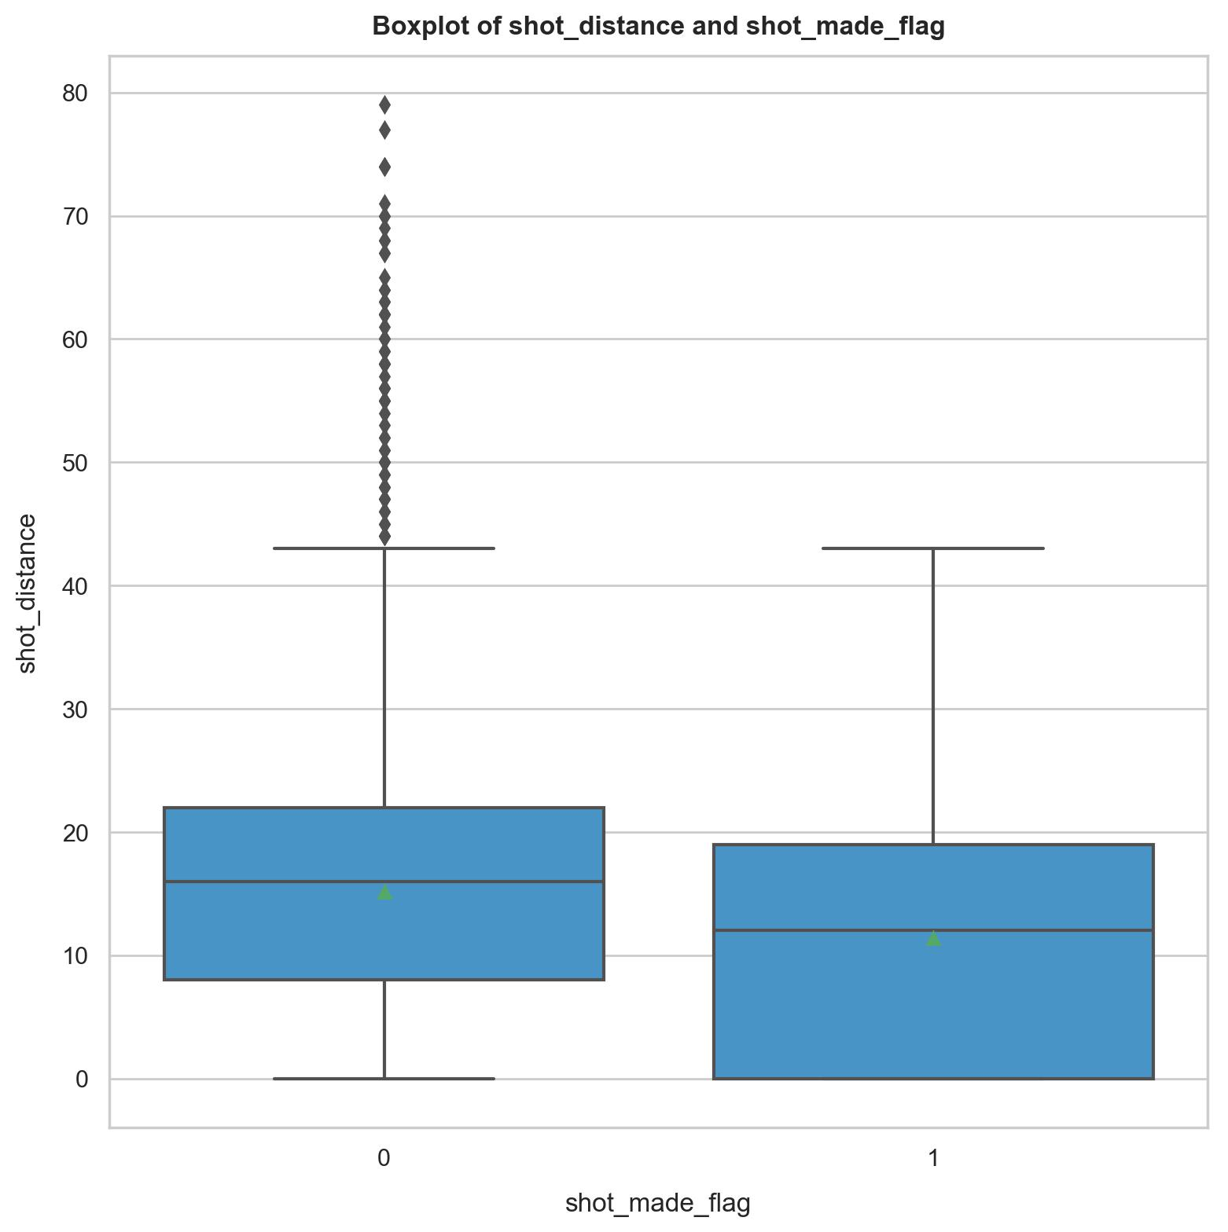

Figure 3: Boxplot of Shot Distance

7

The exploratory boxplot of shot_distance (figure 3) already hints at a potential relationship between a shot’s likelyhood of being made verses the distance the shot was taken from the hoop.

2.2.2 Multicollinearity

The base feature set was wrought with violations of independent variability. As noted in the table and it’s accompanying correlation matrix, approximately half of the features showed a collinear relationship with other features in the data set. This caused our approach to feature selection vary from the normal methods. We chose to ignore the more nuanced stepwise / LASSO / LarsCV methods and instead implemented a procedure to recursively drop a feature with an exorbitant variance inflation factor on each iteration until reaching a feature set that showed no multicollinearity violations. We used an elimination cutoﬀ of the initial median VIF

- 2 standard deviations. Variance inflation factors for the original features can be seen in table 3. A correlation matrix of the same feature set is displayed in figure 4.

Figure 4: Correlation Matrix - All features

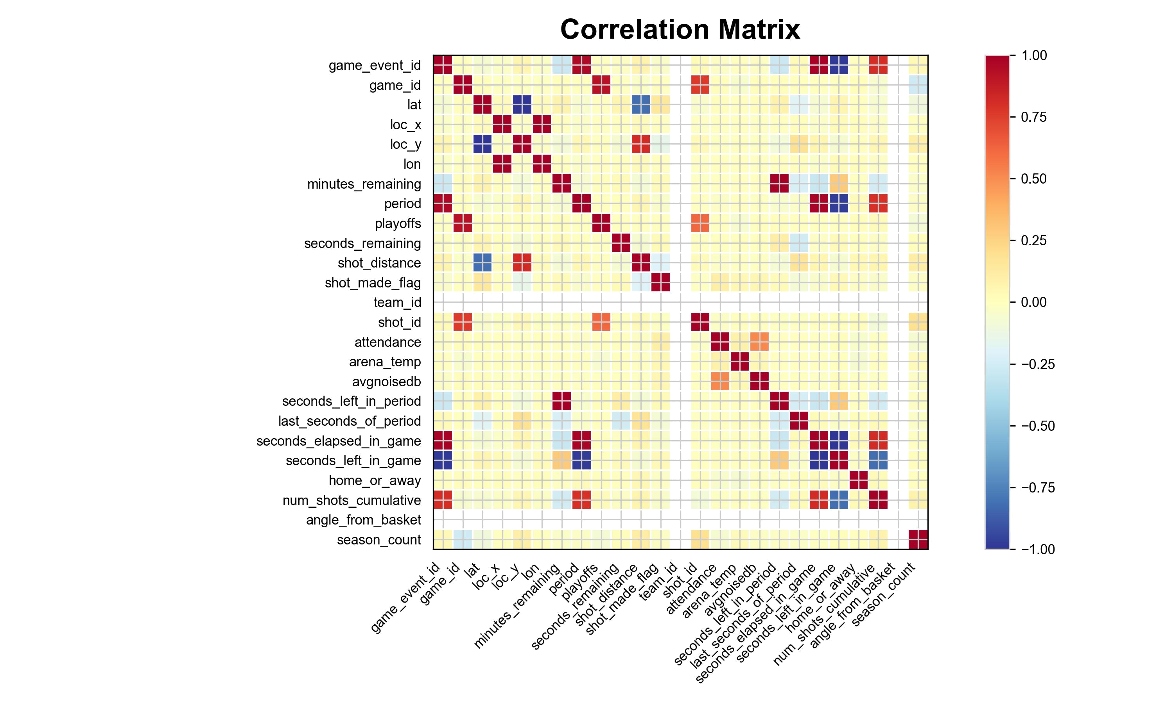
[2]

VIF Factor features

- 0 Intercept

- 35 game_event_id

- 68 game_id

- inf lat

- inf loc_x

- inf loc_y

- inf lon

- inf minutes_remaining

- inf period

- 29 playoﬀs

- inf seconds_remaining

- 3 shot_distance

- 0 team_id

- 14 shot_id

Table 3: Variance Inflation Factors

8

3 Methodoloy

3.1 Feature Selection

As mentioned in the previous section, the feature selection process was dominated by the prevalent mulicollinearity between many of the features. As example, collinearity was reduced to a tolerable range in the featureset of one candidate model pictured in figure 5.

3.2 Model Selection

Our key observation during model selection arose in diﬀerentiating the preformance of Fisher’s linear discriminant and binary logistic regression. While both procedures are common choices for two-level classification, and often yield simiar results, there aa few critical assumptions that diﬀer between them. The linear discriminant analysis (LDA) mandates the within-group covariance between each level of the endogenous variable be equal. Additionally, the LDA model is susceptible to the influence of extreme observations, and will potentially yield inconsistent results when outliers are not accounted for. Conversely, the logarithmic analysis has no exigence on the form of the model’s predictors. The prevalence of outliers in the dataset, exposed during the exploratory analysis, was suﬃcient enough cause to move forward with the logistic regression as a conservative base on which we could build our predictions. Beta models using LDA can be found in the appendix (6.2).

Several iterations of model selection concluded on a final model that yielded a 0.615 AUC, with exceptional sensitivity (true positive rate) and moderate specificity (true negative rate). (table 4). Categorical predictors in the final model were substituted for dummied predictors for estimate. (See regression formula - 4)

Model 5

Log Loss | 0.6664
AUC | 0.6155
Sensitivity | 0.744
Specificity | 0.425

Table 4: Logistic Model Summary

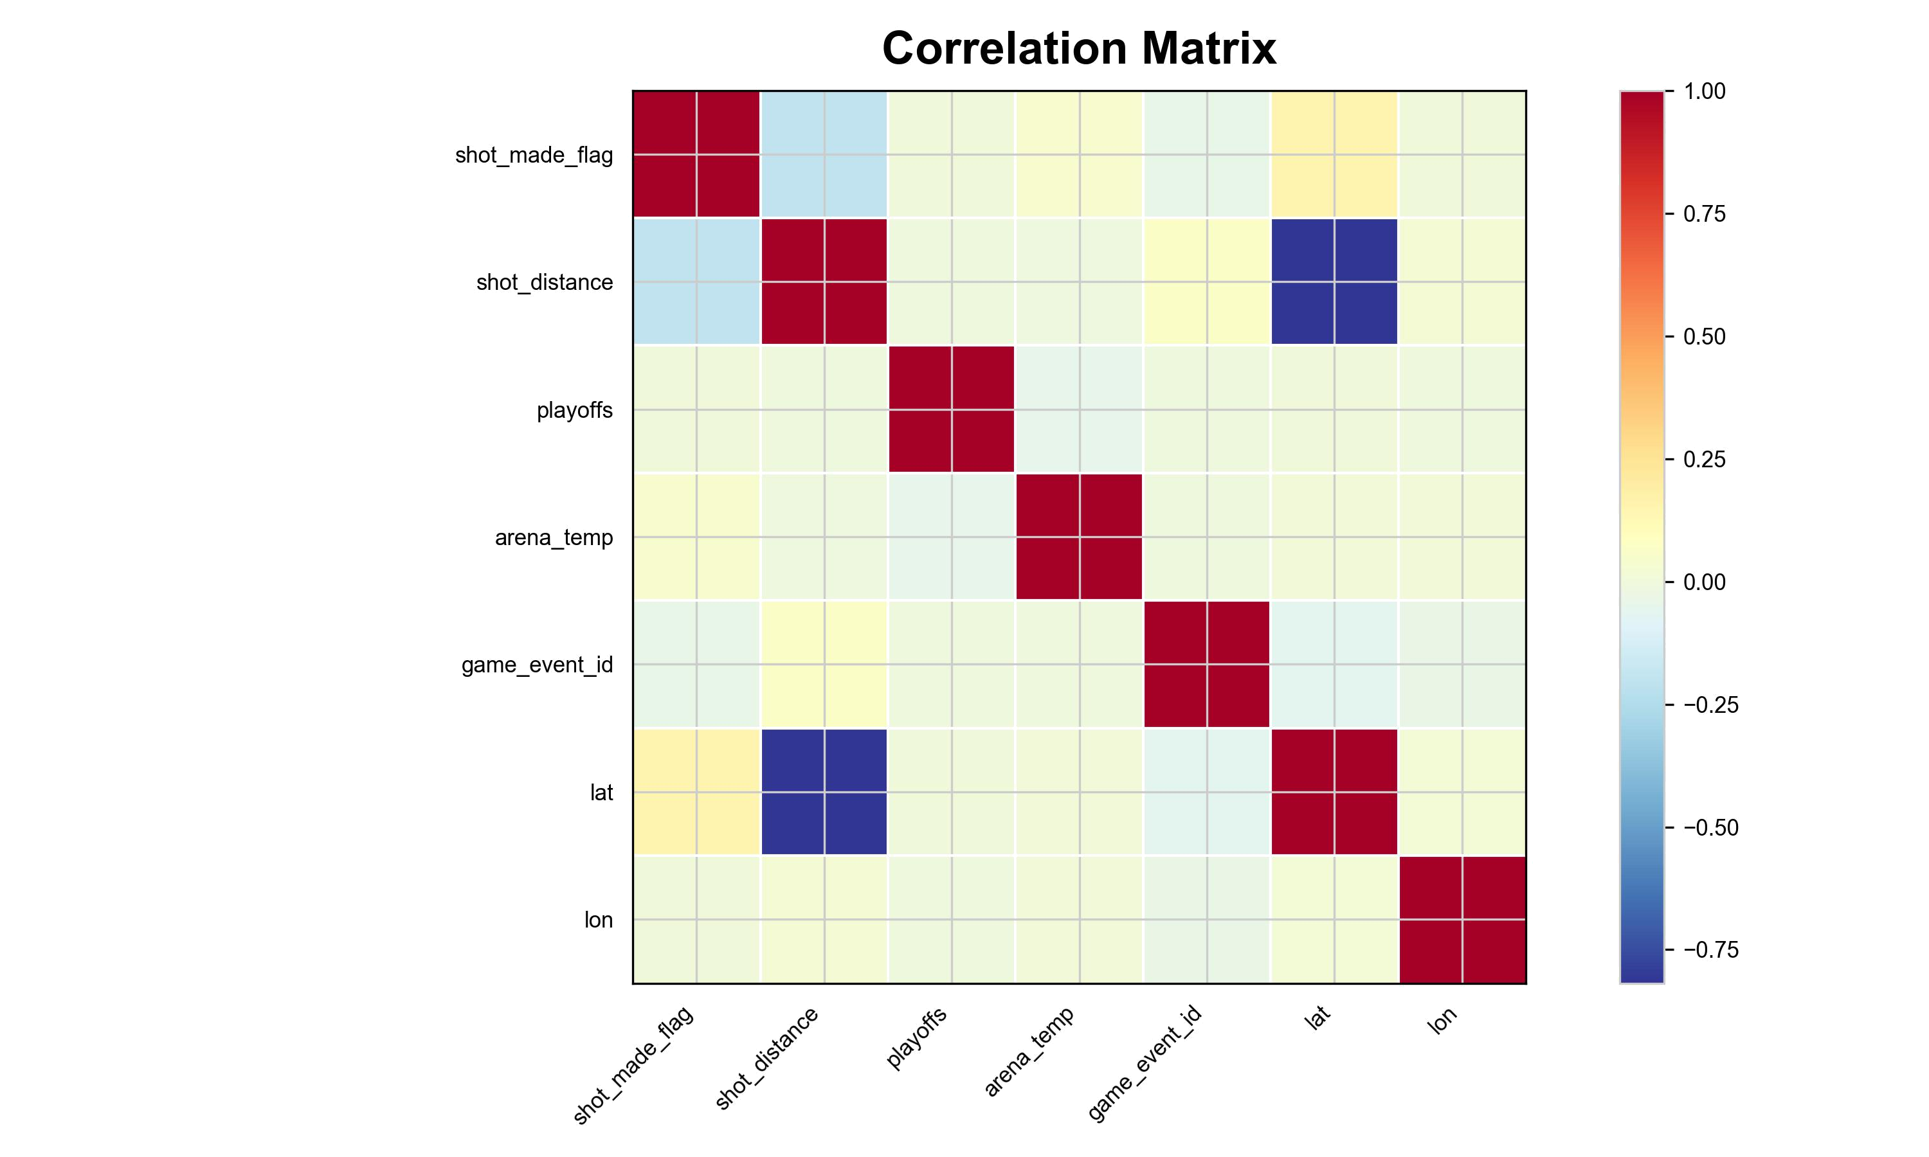

Figure 5: Correlation Matrix - Candidate Model

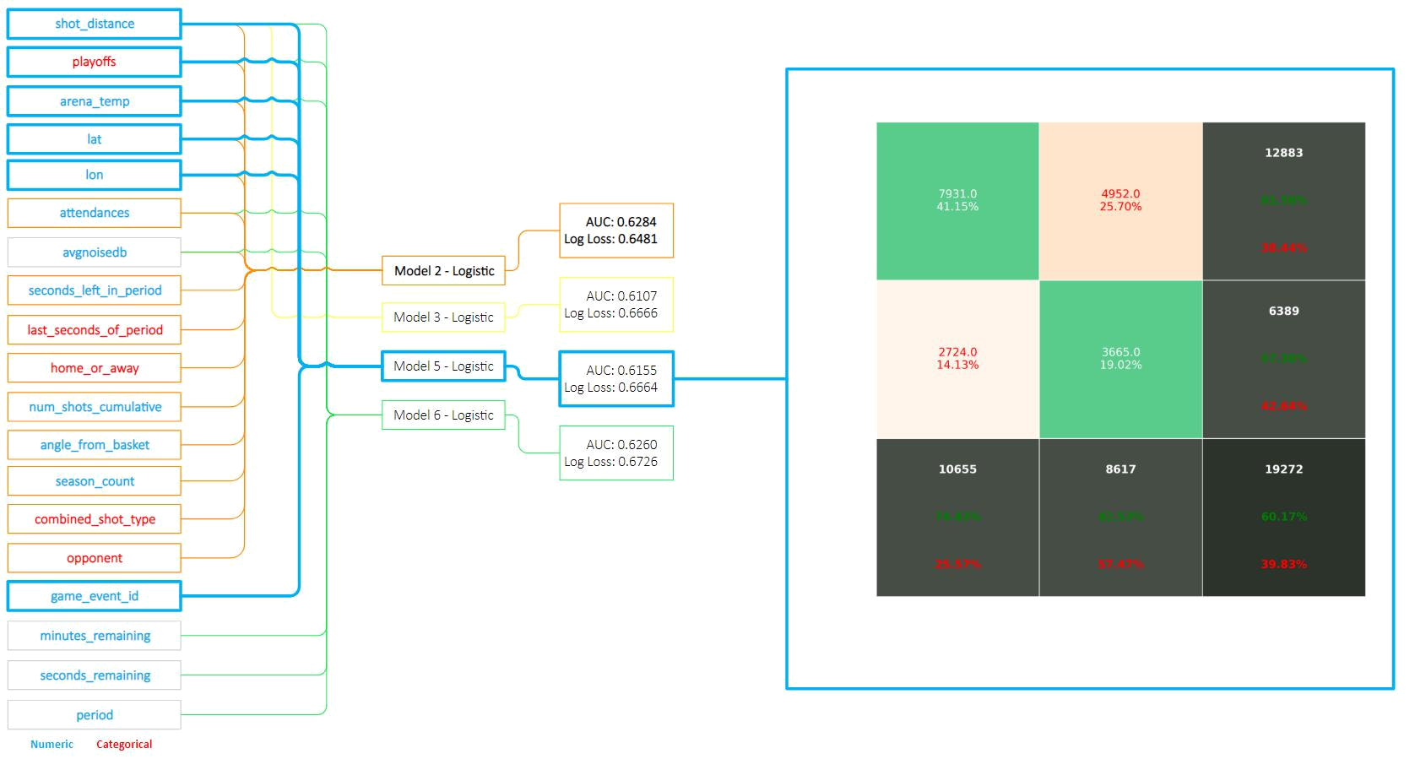

Figure 6: Model Composition Chart

π
Logit( ₁ ₋ _{π} ) = β₀ + β₁shot_distance + β₂playoﬀs₀ + β₃playoﬀs₁ + β₄arena_temp + β₅game_event_id + β₆lat + β₇lon

Regular Season (playoﬀs = 0)

- β₀ + β₁shot_distance + β₂(1) + β₃(0) + β₄arena_temp + β₅game_event_id + β₆lat + β₇lon

- β₀ + β₁shot_distance + β₂ + β₄arena_temp + β₅game_event_id + β₆lat + β₇lon

Logit( |  | π | ) = β₀ + β₁x₁ + β₂x₂ + β₄x₄ + β₅x₅ + β₆x₆ + β₇x₇ | (1)
Logit( |  | − π | ) = β₀ + β₁x₁ + β₂x₂ + β₄x₄ + β₅x₅ + β₆x₆ + β₇x₇ | (1)
1 |  | − π

Playoﬀs (playoﬀs = 1)

β₀ + β₁shot_distance + β₂(0) + β₃(1) + β₄arena_temp + β₅game_event_id + β₆lat + β₇lon

β₀ + β₁shot_distance + β₃ + β₄arena_temp + β₅game_event_id + β₆lat + β₇lon

π
^{Logit(} ₁ ₋ _{π} ⁾ ⁼ ^{β}0 ⁺ ^{β}1^{x}1 ⁺ ^{β}3^{x}3 ⁺ ^{β}4^{x}4 ⁺ ^{β}5^{x}5 ⁺ ^{β}6^{x}6 ⁺ ^{β}7^{x}7

A model composition chart, displayed in figure 6 shows the features selected in the champion model, along with the model’s confusion matrix.

[2]

13

A full listing of candidate models can be seen in the appendix (6.2).

3.3 Evaluation

Goodness of fit measured by logarithmic loss function, where:

LogLoss = −(y log(p) + (1 − y)log(1 − p))

Logarithmic loss (related to cross-entropy) measures the performance of a classifica-tion model where the prediction input is a probability value between 0 and 1. Log Loss takes into account the uncertainty of a prediction based on how much it varies from the actual label, insead of simply counting if the predicted value exactly equals the true value, as is the case with accuracy. This gave us a more nuanced view into the performance of our model.

4 Conclusion

Finally, now that we’ve demonstrated the process of applying binary classification techniques to NBA shooting data, we can return to the original questions of interest. Our findings show a −1.87%±0.85% (−2.72%, −1.01%) step change in Kobe Bryant’s shot making ability, measured with a p-value of < 0.001 at α = 0.05 (figure 7). That is to say, for every additional foot between Bryant and the basket, his accuracy is reduced by just under 2%. Another, perhaps more familiar way to put it is in terms of odds. Kobe’s odds of making a basket are

0.9813 ± 0.0084 (0.9728, 0.9899)

with respect to his distance from the basket.

Additionally, the model indicates a 4.25% ± 9.9% (−4.77%, 14.15%) increase in shooting ability during the playoﬀs, however, the result was not statistically significant, with a p-value of 0.3671 at an α level of 0.05 on the χ² distribution. There is not suﬃcient evidence to reject the null hypothesis that Kobe’s performance shows no notable diﬀerence between regular and post season. (table 8)

Figure tables of Log-odds, odds, and percentage change in shooting ability with respect to distance:

15

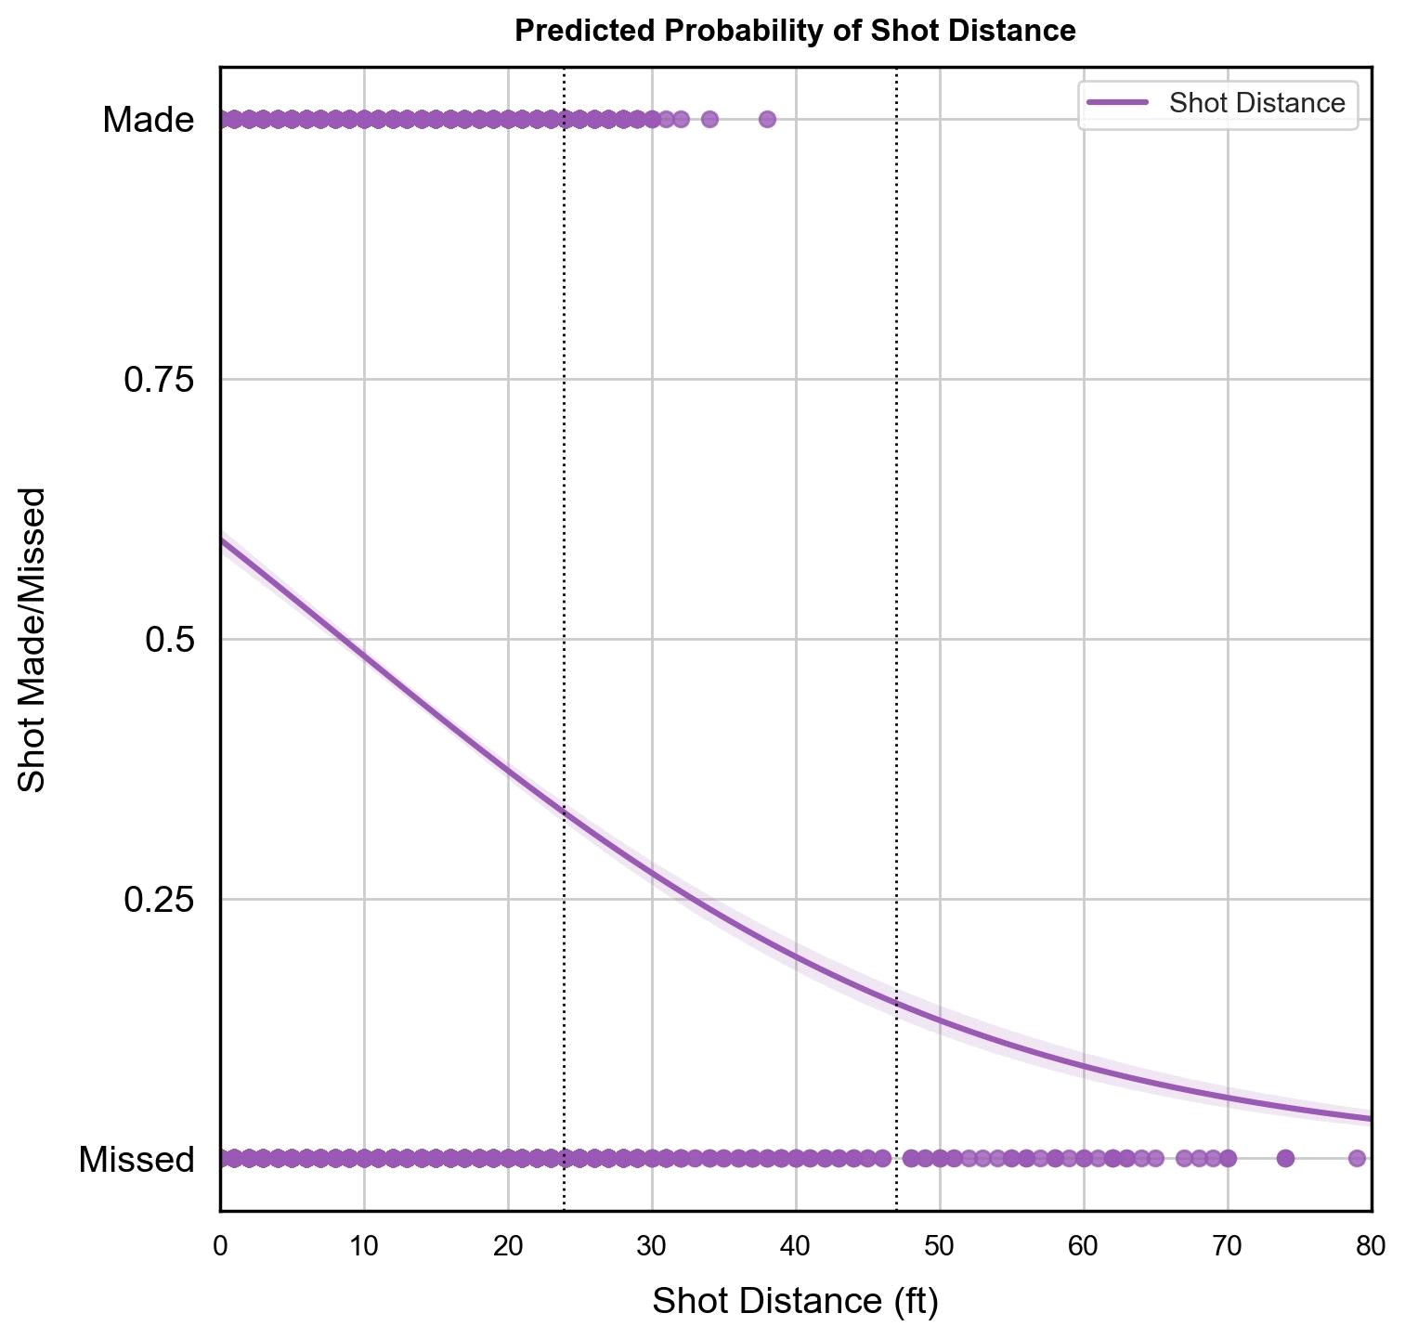

Figure 7: Predicted Shot Probability over Distance to Hoop

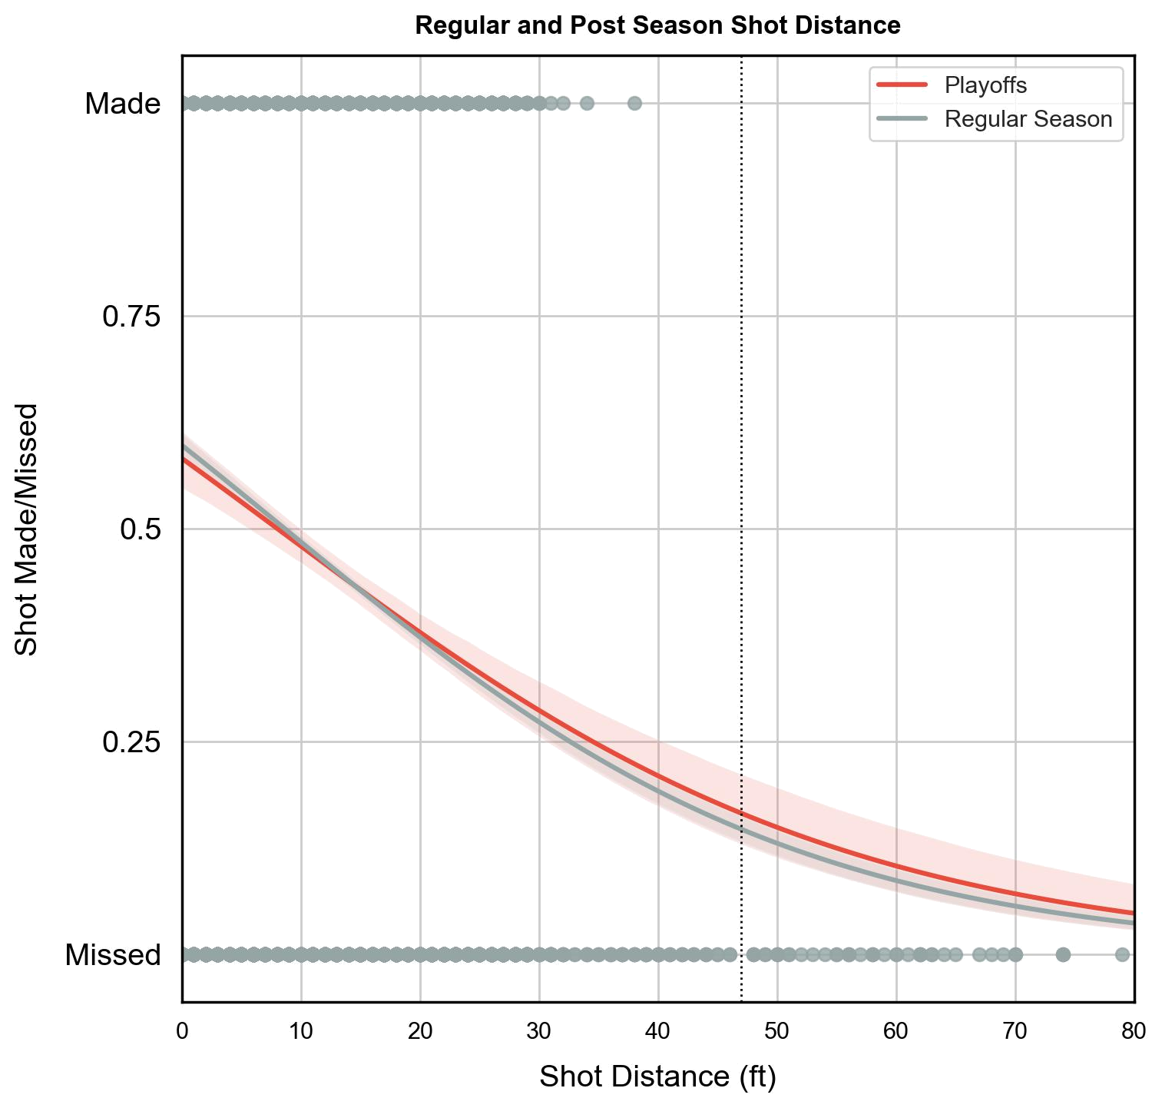

Figure 8: Performance in Regular and Post Season

 | Coef. | Std.Err. | z | P>|z| | [0.025 | 0.975]
lat | 0 | 0 | -2 | 0 | 0 | 0
lon | 0 | 0 | -0 | 1 | 0 | 153130194710622
playoﬀs | 71 | 0 | 1 | 0 | 0 | 1400174
seconds_remaining | 1 | 0 | 2 | 0 | 1 | 1
shot_distance | 0 | 0 | -4 | 0 | 0 | 0
attendance | 1 | 0 | 10 | 0 | 1 | 1
arena_temp | 28 | 0 | 4 | 0 | 6 | 133
avgnoisedb | 1 | 0 | 0 | 1 | 0 | 6
seconds_left_in_period | 1 | 0 | 1 | 0 | 1 | 1
last_seconds_of_period | 0 | 0 | -7 | 0 | 0 | 0
seconds_left_in_game | 1 | 0 | 2 | 0 | 1 | 1
home_or_away | 0 | 0 | -1 | 0 | 0 | 32
num_shots_cumulative | 1 | 0 | 0 | 1 | 0 | 2
angle_from_basket | 1 | 0 | 0 | 1 | 1 | 1
season_count | 3 | 0 | 3 | 0 | 1 | 5

Table 5: Log-odds with Respect to Distance

 | Coef. | Std.Err. | z | P>|z| | [0.025 | 0.975]
lat | 0 | 0 | -2 | 0 | 0 | 0
lon | 0 | 0 | -0 | 1 | 0 | 153130194710622
playoﬀs | 71 | 0 | 1 | 0 | 0 | 1400174
seconds_remaining | 1 | 0 | 2 | 0 | 1 | 1
shot_distance | 0 | 0 | -4 | 0 | 0 | 0
attendance | 1 | 0 | 10 | 0 | 1 | 1
arena_temp | 28 | 0 | 4 | 0 | 6 | 133
avgnoisedb | 1 | 0 | 0 | 1 | 0 | 6
seconds_left_in_period | 1 | 0 | 1 | 0 | 1 | 1
last_seconds_of_period | 0 | 0 | -7 | 0 | 0 | 0
seconds_left_in_game | 1 | 0 | 2 | 0 | 1 | 1
home_or_away | 0 | 0 | -1 | 0 | 0 | 32
num_shots_cumulative | 1 | 0 | 0 | 1 | 0 | 2
angle_from_basket | 1 | 0 | 0 | 1 | 1 | 1
season_count | 3 | 0 | 3 | 0 | 1 | 5

Table 6: Odds with Respect to Distance

5 Limitations and Future Directions

The primary (and obvious) limitation to this study is the narrow subject pool from which the data was gathered. The data, being observational in nature and from a single athlete’s history, allows us no ability to draw conclusions that accurately reflect a causal relationship between the predictors and the outcome variable. Additionaly, the absence of a random sampling mechanism would make any inferrening our conclusions to any population, other than Kobe Bryant himself, highly suspect. Even with such a limited scope, the conclusions produced from our study serves an important purpose.

Our conclusions, presented in the previous section, yielded strong evidence of Kobe’s ability to make shots dwindling as his distance from the basket grew. The general principle behind this conclusion seems obvious, and it is. Of course an athlete is going to see diminished shooting accuracy as they take longer shots. What is significant about our results is not even the quantification of that relationship between accuracy and distance directly, but it is the proof that such a relationship is reliably quantifiable and, holding all other variables constant, interpretable in a 2-dimensional space. These findings build a foundation on which future studies will be able to design experiments and investiagte broader populations. Future directions for our work may be investigating similar trends across NBA players of diﬀerent vintages, skill levels, positions, and team compositions. Such an experiment, with the appropriate design, would provide definitive insight into the extensibility of our findings in this analysis.
21
6 Appendix

6.1 Github Repository

We are on Github! (https://github.com/la-mar/Applied-Stats-Project-2) All code used in our analysis is included in the appendix below, but we recommend viewing it in its original form in our github repository.

6.2 Appendix A

6.2.1 Model Comparison - Continued
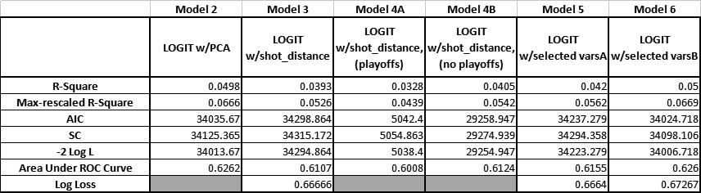
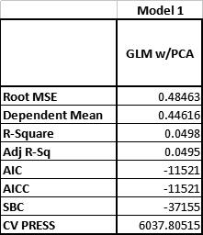

6.2.2 Data Dictionary

23

6.3 SAS Code

MSDS 6371 - Applied Statistics */

2 Allen Crane and Brock Friedrich */

3 | Kobe Bryant Shot Selection | */
4 | November 2018 | */

5

import data */

7 oc import datafile="c:\users\allen\documents\smu data science\MSDS ,→ 6372 - Applied Statistics\project 2\project2Data.csv"

dbms=dlm out=train replace;

delimiter=',';

getnames=yes;

n;

12

print data */

oc print data=train (obs=10);

n;

16

investigate data for variable types*/

oc contents data=train;

n;

20

look for missing numeric data - may need to impute */

oc means data = train n nmiss;

var _numeric_;

n;

25

investigate means of training data and any missing values */

oc means data = train n nmiss;
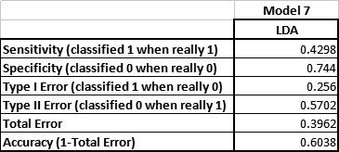

24

n;

29

univariate data analysis */

oc univariate data = train;

r season;

n;

34

note that certain "season" fields are missing */

ta _season;

set train;

where missing (season);

n;

40

print "season" data, where "season" is missing */

oc print data=_season (obs=200);

n;

44

45

more univariate data analysis */

s graphics on;

oc univariate data = train plot;

r recId

me_event_id

me_id

t

c_x

c_y

n

nutes_remaining

riod

ayoffs

ason

conds_remaining

ot_distance

ot_made_flag

am_id

25

me_date

ot_id

tendance

ena_temp

gnoisedb

69

n;

s graphics off;

72

create a time-based variable, concatenating Period, minutes

,→ remaining, and seconds remaining, in descending order. This one ,→ is for Periods remaining... */

74 ta train2;

75 set train;

if period = 1 then periods_remaining2 = "14";

else if period = 2 then periods_remaining2 = "28";

else if period = 3 then periods_remaining2 = "42";

else if period = 4 then periods_remaining2 = "57";

else if period = 5 then periods_remaining2 = "71";

else if period = 6 then periods_remaining2 = "85";

else if period = 7 then periods_remaining2 = "99";

else periods_remaining2 = period;

n;

85

print data */

oc print data=train2 (obs=10);

n;

89

Minutes remaining... */

ta train2;

set train2;

if minutes_remaining = 11 then minutes_remaining2 = "99";

else if minutes_remaining = 10 then minutes_remaining2 = "90";

else if minutes_remaining = 9 then minutes_remaining2 = "81";

else if minutes_remaining = 8 then minutes_remaining2 = "72";

else if minutes_remaining = 7 then minutes_remaining2 = "63";

26

else if minutes_remaining = 6 then minutes_remaining2 = "54";

else if minutes_remaining = 5 then minutes_remaining2 = "45";

else if minutes_remaining = 4 then minutes_remaining2 = "36";

else if minutes_remaining = 3 then minutes_remaining2 = "27";

else if minutes_remaining = 2 then minutes_remaining2 = "18";

else if minutes_remaining = 1 then minutes_remaining2 = "09";

else if minutes_remaining = 0 then minutes_remaining2 = "00";

else minutes_remaining2 = minutes_remaining;

n;

107

print data */

oc print data=train2 (obs=10);

n;

111

Seconds remaining... */

ta train2;

set train2;

if seconds_remaining = 59 then seconds_remaining2 = "99";

else if seconds_remaining = 58 then seconds_remaining2 = "97.3";

else if seconds_remaining = 57 then seconds_remaining2 = "95.6";

else if seconds_remaining = 56 then seconds_remaining2 = "94";

else if seconds_remaining = 55 then seconds_remaining2 = "92.3";

else if seconds_remaining = 54 then seconds_remaining2 = "90.6";

else if seconds_remaining = 53 then seconds_remaining2 = "88.9";

else if seconds_remaining = 52 then seconds_remaining2 = "87.3";

else if seconds_remaining = 51 then seconds_remaining2 = "85.6";

else if seconds_remaining = 50 then seconds_remaining2 = "83.9";

else if seconds_remaining = 49 then seconds_remaining2 = "82.2";

else if seconds_remaining = 48 then seconds_remaining2 = "80.5";

else if seconds_remaining = 47 then seconds_remaining2 = "78.9";

else if seconds_remaining = 46 then seconds_remaining2 = "77.2";

else if seconds_remaining = 45 then seconds_remaining2 = "75.5";

else if seconds_remaining = 44 then seconds_remaining2 = "73.8";

else if seconds_remaining = 43 then seconds_remaining2 = "72.2";

else if seconds_remaining = 42 then seconds_remaining2 = "70.5";

else if seconds_remaining = 41 then seconds_remaining2 = "68.8";

27

else if seconds_remaining = 40 then seconds_remaining2 = "67.1";

else if seconds_remaining = 39 then seconds_remaining2 = "65.4";

else if seconds_remaining = 38 then seconds_remaining2 = "63.8";

else if seconds_remaining = 37 then seconds_remaining2 = "62.1";

else if seconds_remaining = 36 then seconds_remaining2 = "60.4";

else if seconds_remaining = 35 then seconds_remaining2 = "58.7";

else if seconds_remaining = 34 then seconds_remaining2 = "57.1";

else if seconds_remaining = 33 then seconds_remaining2 = "55.4";

else if seconds_remaining = 32 then seconds_remaining2 = "53.7";

else if seconds_remaining = 31 then seconds_remaining2 = "52";

else if seconds_remaining = 30 then seconds_remaining2 = "50.3";

else if seconds_remaining = 29 then seconds_remaining2 = "48.7";

else if seconds_remaining = 28 then seconds_remaining2 = "47";

else if seconds_remaining = 27 then seconds_remaining2 = "45.3";

else if seconds_remaining = 26 then seconds_remaining2 = "43.6";

else if seconds_remaining = 25 then seconds_remaining2 = "41.9";

else if seconds_remaining = 24 then seconds_remaining2 = "40.3";

else if seconds_remaining = 23 then seconds_remaining2 = "38.6";

else if seconds_remaining = 22 then seconds_remaining2 = "36.9";

else if seconds_remaining = 21 then seconds_remaining2 = "35.2";

else if seconds_remaining = 20 then seconds_remaining2 = "33.6";

else if seconds_remaining = 19 then seconds_remaining2 = "31.9";

else if seconds_remaining = 18 then seconds_remaining2 = "30.2";

else if seconds_remaining = 17 then seconds_remaining2 = "28.5";

else if seconds_remaining = 16 then seconds_remaining2 = "26.8";

else if seconds_remaining = 15 then seconds_remaining2 = "25.2";

else if seconds_remaining = 14 then seconds_remaining2 = "23.5";

else if seconds_remaining = 13 then seconds_remaining2 = "21.8";

else if seconds_remaining = 12 then seconds_remaining2 = "20.1";

else if seconds_remaining = 11 then seconds_remaining2 = "18.5";

else if seconds_remaining = 10 then seconds_remaining2 = "16.8";

else if seconds_remaining = 9 then seconds_remaining2 = "15.1";

else if seconds_remaining = 8 then seconds_remaining2 = "13.4";

else if seconds_remaining = 7 then seconds_remaining2 = "11.7";

else if seconds_remaining = 6 then seconds_remaining2 = "10.1";

else if seconds_remaining = 5 then seconds_remaining2 = "08.4";

28

else if seconds_remaining = 4 then seconds_remaining2 = "06.7";

else if seconds_remaining = 3 then seconds_remaining2 = "05";

else if seconds_remaining = 2 then seconds_remaining2 = "03.4";

else if seconds_remaining = 1 then seconds_remaining2 = "01.7";

else if seconds_remaining = 0 then seconds_remaining2 = "00";

se seconds_remaining2 = seconds_remaining;

n;

177

print data */

oc print data=train2 (obs=10);

n;

181

concatenante data */

ta train2;

t train2;

s_remaining = cat(periods_remaining2, minutes_remaining2, ,→ seconds_remaining2);

n;

187

print data */

oc print data=train2 (obs=10);

n;

191

make field numeric (some components contained leading zeroes */

ta train2;

t train2;

n_pms_remaining = input(pms_remaining,8.);

n;

197

drop original non-numeric concetenanted data field */

ta train2;

t train2 (drop = pms_remaining);

n;

ta train2;

203

204 rename new numeric concatenated data field */

29

205 t train2 (rename=(

_pms_remaining'n='pms_remaining'n));

n;

208

print data */

oc print data=train2 (obs=10);

n;

212

213

214

215

216

check data - histogram */

s graphics on;

oc univariate data = train2;

r pms_remaining;

stogram;

n;

s graphics off;

224

check data - scatter plot */

oc sgplot data=train2;

scatter x=pms_remaining y=shot_made_flag / group=shot_made_flag;

n;

229

230

231

transform data - log transformation on shot distance and time ,→ remaining */

ta train3;

t train2;

shot_distance = log(shot_distance);

pms_remaining = log(pms_remaining);

n;

238

239

30

check data - scatter plot */

s graphics on;

oc univariate data = train3 plot;

r l_shot_distance l_pms_remaining;

n;

s graphics off;

246

247

248

249

correlation analysis */

s graphics on;

oc corr data=train2 plots=matrix(histogram);

r recId

me_event_id

me_id

t

c_x

c_y

n

nutes_remaining

riod

ayoffs

ason

conds_remaining

ot_distance

ot_made_flag

am_id

me_date

ot_id

tendance

ena_temp

gnoisedb;

n;

s graphics off;

275

31

276

277

principal component analysis */

s graphics on;

oc princomp plots=all data=train2 cov out=pca;

r recId

me_event_id

me_id

t

c_x

c_y

n

nutes_remaining

riod

ayoffs

ason

conds_remaining

ot_distance

ot_made_flag

am_id

me_date

ot_id

tendance

ena_temp

gnoisedb;

n;

s graphics off;

303

304

correlation analysis using train2 data vs shot made flag */

oc corr data=train2 plots=matrix(histogram);

var shot_made_flag game_event_id lat loc_y minutes_remaining

,→ period seconds_remaining shot_distance attendance arena_temp ,→ avgnoisedb;

run;

309

32

310

correlation analysis using pricipal components vs shot made flag */

oc corr data=pca plots=matrix(histogram);

var shot_made_flag prin1 - prin10;

run;

315

316

model 1 - GLM select using PCA */

oc glmselect data=pca plots=all seed=3;

del shot_made_flag =prin1-prin10 / selection = stepwise(choose=CV ,→ select=CV stop=CV);

n;

321

322

model 2 - Logistic using PCA */

s graphics on;

oc logistic data=pca plots(only)=(roc(id=obs) effect);

model shot_made_flag (event='1') =prin1-prin10 / scale=none

327 | clparm=wald
328 | clodds=pl
329 | rsquare
330 | lackfit
331 | ctable;
332 | output out = model_2_results p = Predict;

n;

s graphics off;

335

336

model 3 - Logistic using train2 dataset (not PCA) only by distance ,→ */

s graphics on;

oc logistic data=train2 plots(only)=(roc(id=obs) effect);

model shot_made_flag (event='1') = shot_distance / scale=none

341 | clparm=wald
342 | clodds=pl
343 | rsquare

33

344 | lackfit
345 | ctable;
346 | output out = model_3_results p = Predict;

n;

s graphics off;

349

350

create data for model 4 - data sets for playoffs and not at playoffs

,→ */

352

353 ta train2_playoffs;

354 t train2;

355 ere playoffs = 1;

n;

357

358 ta train2_no_playoffs;

359 t train2;

360 ere playoffs = 0;

n;

362

363

model 4A - Logistic using train2 dataset (not PCA) during playoffs ,→ */

365

366 s graphics on;

367 oc logistic data=train2_playoffs plots(only)=(roc(id=obs) effect);

368 model shot_made_flag (event='1') = shot_distance / scale=none

369

370

371

372

373

clparm=wald

clodds=pl

rsquare

lackfit

ctable;

374 output out = model_4A_results p = Predict;

n;

s graphics off;

377

34

378

model 4B - Logistic using train2 dataset (not PCA) during playoffs

,→ */

380

381 s graphics on;

382 oc logistic data=train2_no_playoffs plots(only)=(roc(id=obs) effect);

383 model shot_made_flag (event='1') = shot_distance / scale=none

384

385

386

387

388

clparm=wald

clodds=pl

rsquare

lackfit

ctable;

389 output out = model_4B_results p = Predict;

n;

s graphics off;

392

393

model 5 - Logistic using train2 dataset (not PCA) during playoffs ,→ */

s graphics on;

oc logistic data=train2 plots(only)=(roc(id=obs) effect);

model shot_made_flag (event='1') = shot_distance playoffs arena_temp ,→ game_event_id lat lon / scale=none

398 | clparm=wald
399 | clodds=pl
400 | rsquare
401 | lackfit
402 | ctable;
403 | output out = model_5_results p = Predict;

n;

s graphics off;

406

407

model 6 - Logistic using train2 dataset (not PCA) for all variables ,→ that had corr p < 0.0001 */

s graphics on;

35

410 | oc logistic data=train2 plots(only)=(roc(id=obs) effect);
411 | model shot_made_flag (event='1') = shot_distance playoffs period
 | ,→minutes_remaining seconds_remaining attendance arena_temp
 | ,→avgnoisedb / scale=none
412 | clparm=wald
413 | clodds=pl
414 | rsquare
415 | lackfit
416 | ctable;
417 | output out = model_6_results p = Predict;

n;

s graphics off;

420
421
422 | Model 7 - LDA Model */
423
424 | oc discrim data=train2 outstat=LDAstat method=normal pool=yes
425 | list crossvalidate;
426 | class shot_made_flag;
427 | priors prop;
428 | var shot_distance playoffs period minutes_remaining
 | ,→seconds_remaining attendance arena_temp avgnoisedb;
run;

430

431

432

433

434

435

436

437

438

Import test data for prediction model */

440

441 import test data */

36

442 oc import datafile="c:\users\allen\documents\smu data science\MSDS ,→ 6372 - Applied Statistics\project 2\project2pred.csv"

dbms=dlm out=test replace;

delimiter=',';

getnames=yes;

n;

447

print data */

oc print data=test (obs=10);

n;

451

investigate data for variable types*/

oc contents data=test;

n;

455

look for missing numeric data - may need to impute */

oc means data = test n nmiss;

var _numeric_;

n;

460

investigate means of training data */

oc means data = test n nmiss;

n;

464

univariate data analysis */

oc univariate data = test;

r season;

n;

469

note that certain "season" fields are missing */

ta _seasontest;

set test;

where missing (season);

n;

475

476 print "season" data, where "season" is missing */

37

477 oc print data=_seasontest (obs=200);

n;

479

add empty predicted response field */

ta test2;

t test;

ot_made_flag = .;

484

485

print data */

oc print data=test2 (obs=200);

n;

489

490

Create TRAIN and TEST fields to distinguish test vs train data.

,→ Combine data, predict missing values, create final data set */

492

493 ta train2b;

494 t train2;

495 le = "TRAIN";

n;

497

498 oc print data=train2b (obs=10);

n;

500

501 ta test2b;

502 t test2;

503 le = "TEST";

n;

505

506 oc print data=test2b (obs=10);

n;

508

509

510

511

38

make a numeric shot_made_flag variable in test data */

513

514 ta test2c;

515 t test2b;

n_shot_made_flag = input(shot_made_flag,8.);

n;

518

drop original non-numeric shot_made_flag */

ta test2c;

t test2c (drop = shot_made_flag);

n;

523

rename numeric shot_made_flag */

ta test2c;

t test2c (rename=(

_shot_made_flag'n='shot_made_flag'n));

n;

529

drop the n_shot_made_flag variable */

ta test2c;

t test2c (drop = shot_made_flag);

n;

534

rename rannum variable to recId */

ta test2c;

t test2c (rename=(

annum'n='recId'n));

n;

540

541

542

combine data sets */

544

545 ta test3;

546 t train2b test2c;

n;

39

548

549 oc print data=test3 (obs=10);

n;

551

552 oc contents data=test3;

n;

554

555

predict response field (shot_made_flag) using desired method */

s graphics on;

oc logistic data=test3 plots(only)=(roc(id=obs) effect);

model shot_made_flag (event='1') = shot_distance playoffs period

 | ,→minutes_remaining seconds_remaining attendance arena_temp
 | ,→avgnoisedb / scale=none
560 | clparm=wald
561 | clodds=pl
562 | rsquare
563 | lackfit
564 | ctable;
565 | tput out = model_test_results p = Predict;

n;

s graphics off;

568

569

check data for completeness */

571

572 oc means data = results n nmiss;

573 var _numeric_;

n;

575

576 oc print data=results (obs=10);

577 ere file = "TEST";

n;

579

580 oc contents data=results;

n;

40

582

583 oc means data=results

Mean Std Min Q1 Median Q3 Max;

n;

586

This is the final step that maps the predicted value into the ,→ shot_made_flag variable

d then drops all variables except shot_id and shot_made_flag. */

589

590 ta results_final;

591 tain shot_id shot_made_flag;

592 t model_test_results;

shot_made_flag < 1 then shot_made_flag = predict;

ep shot_id shot_made_flag;

ere file = "TEST";

n;

597

598 oc print data=results_final (obs=100);

n;

600

601 oc contents data=results_final;

n;

603

604

605

606

607

608

609

610

611

612

613

614

615 s graphics on;

616 oc logistic data=test3 plots(only)=(roc(id=obs) effect);

41

626
627
628

621
622
623 output out = model_test3_results p = Predict;

618
619
620
617 model shot_made_flag (event='1') = shot_distance / scale=none

clparm=wald clodds=pl rsquare

lackfit ctable;

n;

s graphics off;

model 5 - Logistic using train2 dataset (not PCA) during playoffs ,→ */

s graphics on;

oc logistic data=test3 plots(only)=(roc(id=obs) effect);

model shot_made_flag (event='1') = shot_distance playoffs arena_temp ,→ game_event_id lat lon / scale=none

633 | clparm=wald
634 | clodds=pl
635 | rsquare
636 | lackfit
637 | ctable;
638 | output out = model_test5_results p = Predict;

n;

s graphics off;

641

642

model 6 - Logistic using train2 dataset (not PCA) for all variables ,→ that had corr p < 0.0001 */

s graphics on;

oc logistic data=test3 plots(only)=(roc(id=obs) effect);

model shot_made_flag (event='1') = shot_distance playoffs period

,→ minutes_remaining seconds_remaining attendance arena_temp ,→ avgnoisedb / scale=none

647 clparm=wald

42

648 | clodds=pl
649 | rsquare
650 | lackfit
651 | ctable;
652 | output out = model_test6_results p = Predict;

n;

s graphics off;

655

656

657 ta results_final_6;

658 tain shot_id shot_made_flag;

659 t model_test6_results;

shot_made_flag < 1 then shot_made_flag = predict;

ep shot_id shot_made_flag;

ere file = "TEST";

n;

6.4 Python Code

# MSDS 6371 - Applied Statistics #

2# Allen Crane and Brock Friedrich #

3 | # | Kobe Bryant Shot Selection | #
4 | # | November 2018 | #
5
6

7 port warnings

rnings.filterwarnings("ignore")

9

10 port os

11 port sys

12 port seaborn as sns

13 port matplotlib.pyplot as plt

14 port pandas as pd

15 port numpy as np

16 port statsmodels.api as sm

43

17 | om | statsmodels.stats.outliers_influence import
 | ,→variance_inflation_factor
18 | om sklearn.feature_selection import RFE
19 | om sklearn.discriminant_analysis import LinearDiscriminantAnalysis
20 | om sklearn.model_selection import train_test_split
21 | om sklearn.metrics import confusion_matrix, log_loss, roc_auc_score
22 | om sklearn.linear_model import LogisticRegression
23
24 | port statsmodels.formula.api as smf
25 | om scipy import stats
26 | port matplotlib.pyplot as plt
27 | port numpy as np
28 | port pandas as pd
29 | om pandas.plotting import (lag_plot,
30 |  | autocorrelation_plot,
31 |  | table, scatter_matrix,
32 |  | boxplot)
33
34 | om patsy import dmatrices
35 | om math import degrees, acos
36 | om scipy.spatial import distance

37

38

os.chdir(os.path.dirname(__file__))

s.path.insert(0, os.getcwd()+'/src')

om eda import *

om confusion_matrix_pretty import *

from plotting import *

om logistic_regression import *

om linear_discriminant_analysis import *

46

47 f cols(df: pd.DataFrame) -> list:

"""Extract list of columns from input DataFrame and removing the ,→ dependent variable."""
49

50 return [x for x in df.columns.tolist() if x not in [DEPENDENT]]

44

51

52 f get_dummies(df: pd.DataFrame, drop_first = False):

"""Replace catagorical varables with indicators"""

54

df = pd.get_dummies(df, dtype = float)

df.columns = df.columns \

57 | .str.lower() \
58 | .str.replace(" | ", "_")

return df

60

61 f LogRegModel(data: pd.DataFrame, add_constant = False):

if add_constant:

data = sm.add_constant(data)

model = LogR(data, DEPENDENT)

model.sm = model.statsmodel()

66

model.yhat = model.sm.predict(model.test_x)

print("\n Predicted Log Loss: {}\n".format(

round(

log_loss(model.test_y, model.yhat)

, 4)))

return model

73

74 f summarize_model(model: LogR):

print(model.describe_features())

print(model.sm.summary())

print(model.sm.summary2())

print(model.sm.wald_test_terms())

79

80 Import Data

81 TA = pd.read_excel('data/project2Data.xlsx', index_col = 'recId')

82 R_PREDICTION = pd.read_excel('data/project2Pred.xlsx', index_col =

,→ 'rannum')

83 PENDENT = "shot_made_flag"

84

85 DUNDANT_FEATURES = [

45

86 'team_id', # constant term

87 'team_name', # constant term

'season',

'game_id', # violates independence

'matchup',

'shot_id',

'recId',

'shot_zone_area',

'shot_zone_basic',

'shot_zone_range',

'minutes_remaining',

'seconds_elapsed_in_game',

'game_event_id', # violates independence

'game_date', # violates independence

'action_type',

'loc_x', # collinear with lat

'loc_y', # collinear with lon

103

104

105

106

107

108

109 f to_latex(df):

pd.set_option('display.float_format', lambda x: '%.0f' % x)

with open('temp.txt', 'w') as f:

f.write(r'\resizebox{\textwidth}{!}{'+

df.to_latex()

+ r'}\captionof{table}{Feature

,→ Summary}\label{tbl:featuresummary}')

pd.set_option('display.float_format', lambda x: '%.4f' % x)

116

117

118 f desc(df: pd.DataFrame):

119 ""Produces a summary of the input DataFrame

120

46

rguments:

df {pd.DataFrame} -- [description]

123

eturns:

pd.DataFrame -- DataFrame of summary statistics

""

127

128 esc = df.describe(percentiles = None).T

129 esc['missing'] = len(df.index) - desc['count']

desc = desc.astype('int')

esc['median'] = df.median()

esc['missing %'] = desc.missing / len(df.index) * 100

eturn desc.T

134

135 "############# Model 0 - Predicted Log Loss: 0.6552 #############"""

136

137

138 "Dataset: d0 | Prediction set: d0_pred

- Full Model

"

141

= prepare_data(DATA.drop(columns = ['action_type']))

.game_date = d0.game_date.apply(lambda x: x.toordinal())

= get_dummies(d0).fillna(0) # Get dummy variables for categoricals

_pred = wrangle_features(FOR_PREDICTION)

_pred.game_date = d0_pred.game_date.apply(lambda x: x.toordinal())

_pred = get_dummies(d0_pred).fillna(0) # Get dummy variables for

,→ categoricals

148 _pred = d0_pred[cols(d0)]

149

150 "Fit d2"""

151

152 del0 = LogRegModel(d0)

mmarize_model(model0)

del0.roc_plot()

155

47

156 "############# Model 1 - Predicted Log Loss: 0.6652 #############"""

157

158

159 "Dataset: d1 | Prediction set: d1_pred

- No categorical features

"

= prepare_data(DATA, drop_categorical = True) # Wrangle Data

.game_date = d1.game_date.apply(lambda x: x.toordinal())

= d1.fillna(0)

d1_pred = wrangle_features(FOR_PREDICTION)

d1_pred.game_date = d1_pred.game_date.apply(lambda x: x.toordinal())

d1_pred = d1_pred[cols(d1)].fillna(0)

168
169 | "Fit d1"""
170 | del1 = LogRegModel(d1)
171 | mmarize_model(model1)
172 | del1.roc_plot()
173
174 | "############# Model 2 - Predicted Log Loss: 0.6479 #############"""
175
176 | "Dataset: d2 | Prediction set: d2_pred
177 | - Categorical features as indicators
178 | - Drop redundant features
179 | "
180

= prepare_data(DATA, drop_columns= REDUNDANT_FEATURES)

d2.game_date = d2.game_date.apply(lambda x: x.toordinal())

d2.last_seconds_of_period = d2.last_seconds_of_period.astype(int)

= get_dummies(d2).fillna(0) # Get dummy variables for categoricals

_pred = wrangle_features(FOR_PREDICTION)

_pred = get_dummies(d2_pred).fillna(0) # Get dummy variables for

,→ categoricals

187 _pred = d2_pred[cols(d2)]

188

189 "Fit d2"""

190 del2 = LogRegModel(d2)

48

mmarize_model(model2)

del2.sm2 = model2.statsmodel_()

del2.sm2.fitted = model2.sm2.fit()

model2.sm.summary2()

del2.sm2.fitted.predict(model2.test_x)

pd.Series(model2.predict_labels(d2_pred)).set_index(d2_pred.sho)

model2.roc_plot()

198

199 f_train_x = model2.sm2.pdf(model2.train_x)

200 f_train_x = model2.sm2.cdf(model2.train_x)

201

202 sult = model2.sm.summary2()

203 godds = result.tables[1]

204 ds[['Coef.','[0.025', '0.975]']] = np.exp(logodds[['Coef.','[0.025', ,→ '0.975]']])

205 t_change = (odds[['Coef.','[0.025', '0.975]']] - 1) * 100

206

207

208 rr_matrix(wrangle_features(DATA.drop(columns = ['action_type'])))

ot_proba(model2)

ot_regular_vs_post_season(model2)

ot_confusion_matrix(model2)

212

213

"

215

logOdds

-----------------------------------------------------------------------------------------

218 |  |  | Coef. | Std.Err. | z | P>|z|
 | ,→ | [0.025 | 0.975]
219 | t |  | -0.6565 | 0.3081 | -2.1307 | 0.0331
 | ,→ | -1.2604 | -0.0526
220 | n |  | -0.0526 | 0.1710 | -0.3076 | 0.7584
 | ,→ | -0.3879 | 0.2826
221 | ayoffs |  | 0.0417 | 0.0462 | 0.9019 | 0.3671
 | ,→ | -0.0489 | 0.1324

49

222 | conds_remaining |  |  |  | 0.0014 | 0.0009 | 1.5626 | 0.1182
 | ,→ | -0.0004 |  | 0.0031
223 | ot_distance |  |  |  | -0.0189 | 0.0044 | -4.2505 | 0.0000
 | ,→ | -0.0275 |  | -0.0102
224 | tendance |  |  |  | 0.0002 | 0.0000 | 10.3586 | 0.0000
 | ,→ | 0.0001 |  | 0.0002
225 | ena_temp |  |  |  | 0.0328 | 0.0076 | 4.3008 | 0.0000
 | ,→ | 0.0178 |  | 0.0477
226 | gnoisedb |  |  |  | 0.0025 | 0.0078 | 0.3175 | 0.7509
 | ,→ | -0.0128 |  | 0.0177
227 | conds_left_in_period |  |  |  | 0.0001 | 0.0001 | 0.7850 | 0.4325
 | ,→ | -0.0001 |  | 0.0002
228 | st_seconds_of_period |  |  |  | -0.8629 | 0.1282 | -6.7335 | 0.0000
 | ,→ | -1.1141 |  | -0.6117
229 | conds_left_in_game |  |  |  | 0.0001 | 0.0000 | 2.2041 | 0.0275
 | ,→ | 0.0000 |  | 0.0001
230 | me_or_away |  |  |  | -0.0259 | 0.0305 | -0.8465 | 0.3973
 | ,→ | -0.0857 |  | 0.0340
231 | m_shots_cumulative |  |  |  | 0.0005 | 0.0042 | 0.1257 | 0.9000
 | ,→ | -0.0077 |  | 0.0087
232 | gle_from_basket |  |  |  | 0.0002 | 0.0004 | 0.3873 | 0.6985
 | ,→ | -0.0006 |  | 0.0009
233 | ason_count |  |  |  | 0.0093 | 0.0034 | 2.7567 | 0.0058
 | ,→ | 0.0027 |  | 0.0159
234
235 | Odds
236
237 |  |  |  |  | Coef. | Std.Err. | z | P>|z| | [0.025
 | ,→ | 0.975]
238
239 | lat |  |  |  | 0.5175 | 0.3082 -2.1377 0.0325
 | ,→ | 0.2829 | 0.9467
240 | n |  |  |  | 0.9476 | 0.1711 -0.3144 0.7532 |  |  | 0.6777
 | ,→ | 1.3251
241 | ayoffs |  |  |  | 1.0214 | 0.0586 | 0.3602 0.7187 |  | 0.9105
 | ,→ | 1.1458

50

242 | conds_remaining |  |  | 1.0014 | 0.0009 |  | 1.5652 | 0.1175 | 0.9996
 | ,→ | 1.0031
243 | shot_distance |  |  | 0.9813 | 0.0044 -4.2570 0.0000
 | ,→ | 0.9728 | 0.9899
244 | me_date |  |  | 1.0002 | 0.0003 |  | 0.5708 | 0.5681 | 0.9995
 | ,→ | 1.0008
245 | attendance |  |  | 1.0002 | 0.0000 10.3607 0.0000
 | ,→ | 1.0001 | 1.0002
246 | arena_temp |  |  | 1.0331 | 0.0076 |  | 4.2622 0.0000
 | ,→ | 1.0177 | 1.0486
247 | gnoisedb |  |  | 1.0025 | 0.0078 |  | 0.3238 | 0.7461 | 0.9873
 | ,→ | 1.0180
248 | conds_left_in_period |  |  | 1.0001 | 0.0001 |  | 0.7873 | 0.4311 | 0.9999
 | ,→ | 1.0002
249 | last_seconds_of_period |  |  | 0.4220 | 0.1282 -6.7317 0.0000
 | ,→ | 0.3283 | 0.5425
250 | seconds_left_in_game |  |  | 1.0001 | 0.0000 |  | 2.2072 0.0273
 | ,→ | 1.0000 | 1.0001
251 | me_or_away |  |  | 0.9739 | 0.0306 | -0.8659 0.3865 |  |  | 0.9173
 | ,→ | 1.0340
252 | m_shots_cumulative |  |  | 1.0005 | 0.0042 |  | 0.1242 | 0.9011 | 0.9923
 | ,→ | 1.0088
253 | gle_from_basket |  |  | 1.0002 | 0.0004 |  | 0.3880 | 0.6980 | 0.9994
 | ,→ | 1.0009
254 | ason_count |  |  | 0.9419 | 0.1212 | -0.4942 0.6212 |  |  | 0.7427
 | ,→ | 1.1944

255

Percent Changes

257 |  |  | Coef. | Std.Err. | z | P>|z|
 | ,→ | [0.025 | 0.975]
258 | lat |  | -48.1343 | 0.3081 -2.1307 0.0331
 | ,→ | -71.6464 -5.1247
259 | n |  | -5.1247 | 0.1710 | -0.3076 | 0.7584
 | ,→-32.1487 32.6623
260 | ayoffs |  | 4.2596 | 0.0462 | 0.9019 | 0.3671
 | ,→ | -4.7756 | 14.1521

51

261 | conds_remaining |  |  | 0.1395 | 0.0009 | 1.5626 | 0.1182
 | ,→ | -0.0354 | 0.3147
262 | shot_distance |  |  | -1.8678 | 0.0044 -4.2505 0.0000
 | ,→-2.7173 -1.0109
263 | attendance |  |  | 0.0173 | 0.0000 10.3586 0.0000
 | ,→ | 0.0141 | 0.0206
264 | arena_temp |  |  | 3.3317 | 0.0076 | 4.3008 0.0000
 | ,→ | 1.7998 | 4.8866
265 | gnoisedb |  |  | 0.2476 | 0.0078 | 0.3175 | 0.7509
 | ,→ | -1.2714 | 1.7900
266 | conds_left_in_period |  |  | 0.0061 | 0.0001 | 0.7850 | 0.4325
 | ,→ | -0.0092 | 0.0215
267 | last_seconds_of_period |  |  | -57.8070 | 0.1282 -6.7335 0.0000
 | ,→ | -67.1786 -45.7595
268 | seconds_left_in_game |  |  | 0.0070 | 0.0000 | 2.2041 0.0275
 | ,→ | 0.0008 | 0.0132
269 | me_or_away |  |  | -2.5519 | 0.0305 -0.8465 0.3973
 | ,→ | -8.2134 | 3.4588
270 | m_shots_cumulative |  |  | 0.0527 | 0.0042 | 0.1257 | 0.9000
 | ,→ | -0.7654 | 0.8775
271 | gle_from_basket |  |  | 0.0150 | 0.0004 | 0.3873 | 0.6985
 | ,→ | -0.0610 | 0.0911
272 | ason_count |  |  | 0.9308 | 0.0034 | 2.7567 | 0.0058
 | ,→ | 0.2681 | 1.5979

273

Significant features

275 |  | Coef. | Std.Err. | z | P>|z| | [0.025 | 0.975]
276 | t | 0.5175 | 0.3082 | -2.1377 0.0325 |  | 0.2829 | 0.9467
277 | ot_distance | 0.9813 | 0.0044 | -4.2570 0.0000 |  | 0.9728 | 0.9899
278 | tendance | 1.0002 | 0.0000 | 10.3607 | 0.0000 | 1.0001 | 1.0002
279 | ena_temp | 1.0331 | 0.0076 | 4.2622 | 0.0000 | 1.0177 | 1.0486
280 | st_seconds_of_period | 0.4220 | 0.1282 | -6.7317 0.0000 |  | 0.3283 | 0.5425
281 | conds_left_in_game | 1.0001 | 0.0000 | 2.2072 | 0.0273 | 1.0000 | 1.0001

282

"

284

52

285

286

287 " #! Interpretation

288 e p value is calculated based on the assumption that the null ,→ hypothesis is true.
289

290 think about it this way: “assuming the null hypothesis is true, the ,→ probability of the observed test statistic occurring is 0.02. ,→ That’s not very probable. But the observed test statistic

,→ definitely occurred, because it was observed. Therefore, it seems ,→ more likely that the null hypothesis is not true, i.e. It should ,→ be rejected.”

291

292 suming the null hypothesis is true, the probability of measuring at ,→ least the observed test occurring is 0.02.”
293

"

295

296 f_test_x = sm2.pdf(model2.test_x)

297

298 " Refine Model 2 """

299

300 ld = model2.sm.wald_test_terms()

301 ld.df = wald.summary_frame()

302 ld.significant = wald.df[wald.df['P>chi2'] < 0.1].index.tolist()

303

304 " Refined Fit - Predicted Log Loss: 0.6634 """

305

306 del2r = LogRegModel(d2[wald.significant + [DEPENDENT]])

307

"

309 | t | -0.1393
310 | ot_distance | -0.0447
311 | tendance | 0.0002
312 | ena_temp | 0.0337
313 | conds_left_in_game | 0.0001

53

314 st_seconds_of_period -0.8275

"

316

317

318

319

Interpret: http://www-hsc.usc.edu/~eckel/biostat2/notes/notes14.pdf

321

322 "############# Model 3 - Predicted Log Loss: 0.669 #############"""

323

324 "Dataset: d3 | Prediction set: d3_pred

- Allen's Model

"

cols = [

'shot_distance',

'playoffs',

'arena_temp',

'game_event_id',

'lat',

'lon',

'shot_made_flag'

]

= DATA[d3cols]

_pred = FOR_PREDICTION[d3cols].drop(columns = [DEPENDENT]).fillna(0)

338

339 "Fit d3"""

340 del3 = LogRegModel(d3)

mmarize_model(model3)

342

343

344

345 "############# Model 4 - LDA - Predicted Log Loss: 9.351 ,→ #############"""

346

347 a = LinearDiscriminantAnalysis()

348 a = lda.fit(model2.train_x, model2.train_y)

54

349 a_x = lda.transform(model2.train_x)

350 = lda.transform(model2.test_x)

351 labels = lda.predict(model2.test_x)

352

353 g_loss(model2.test_y, z)

354

355

356 "############# Model 5 #############"""

357

358 "Dataset: d5 | Prediction set: d5_pred

- shot_distance only predictor

"

361

= DATA[[DEPENDENT, 'shot_distance']]

d3_pred = FOR_PREDICTION[d3cols].drop(columns =

,→ [DEPENDENT]).fillna(0)

364

365 "Fit d5"""

= sm.add_constant(d5)

del5 = LogR(d5, DEPENDENT)

del5.sm = model5.statsmodel()

369

370 del5.yhat = model5.sm.predict(model.test_x)

371

372 del5 = LogRegModel(d5)

= model5.sm.summary2()

374

= np.exp(s5.tables[1]['Coef.'])

376

377

378 "############# Model 6 - Log Loss: 0.669 #############"""

379

380 "Dataset: d6 | Prediction set: d6_pred

- Allen's model 5

"

383

55

= DATA[[DEPENDENT, 'shot_distance', 'playoffs', 'arena_temp',

,→ 'game_event_id', 'lat', 'lon']]

385

386 "Fit d6"""

387 d5 = sm.add_constant(d5)

388 model5 = LogR(d5, DEPENDENT)

389

390

391 del6 = LogRegModel(d6)

= model6.sm.summary2()

393

394

= np.exp(s6.tables[1]['Coef.'])

396

ot_confusion_matrix(model6)

398

del6.sensitivity()

del6.specificity()

401

402

Data Overview

404

405 TODO: Add Univariate Plots

# QQ

# Hist

408

409

410

411

412 = d6 .select_dtypes(np.number)

413

414

415 cNoFocus = "red"

416

417

418 Correlation Matrix

56

435

433

427

419
420
421 TA.shape
422

better model was at the cost of explainability and violation of

,→ parsimony

424
425 | "
426 | The | __odds of Kobe | making a shot | decrease with respect to | the
 | ,→ | distance he is | from the hoop__. If there is evidence |  | of this,
 | ,→ | quantify this relationship. |  | (CIs, plots, etc.)

Yes. His odds go down by -1.87% +-.85 % (-2.72% -1.01%) for every ,→ additional foot away from the basket.

"

430
431 | "
432 | The | __probability of Kobe making a shot decreases linearly with
 | ,→ | respect to the distance he is from the hoop__. | If there is
 | ,→ | evidence of this, quantify this relationship. | (CIs, plots,
 | ,→ | etc.)

It doesn't. Show pdf plot.

436 near up to 23ft, but is not at zero at 23ft, so probability curve ,→ must be curved.

437

438

"

440

441

442

"

57

457
458 's overlap and contain zero. zome evidence but not enough to conclude ,→ there is a difference.
459
460
461 om sklearn.linear_model import LogisticRegression
462 om sklearn.model_selection import train_test_split 463 om sklearn.feature_selection import chi2
464 om sklearn.metrics import (
465
classification_report,
466
roc_curve,
467
auc
468
469
)
470 port pandas as pd
471 om confusion_matrix_pretty import *
58

,→

456

The model indicates a 4.25% increase in shooting ability during the playoffs, however, the result was not statistically significant.

444 The relationship between the __distance Kobe is from the basket and ,→ the odds of him making the shot is different if they are in the ,→ playoffs__. Quantify your findings with statistical evidence one ,→ way or the other. (Tests, CIs, plots, etc.)
445
446
447
448 "
449
450
451 " Odds Ratios
452 ds ratios that are greater than 1 indicate that the event is more ,→ likely to occur as the predictor increases. Odds ratios that are ,→ less than 1 indicate that the event is less likely to occur as ,→ the predictor increases.
453
454 tps://www.predictiveanalyticsworld.com/patimes/on-variable-importance-in-logistic-re
455

472 port statsmodels.api as sm

473 om sklearn.metrics import confusion_matrix

474

475 ass LogR(LogisticRegression):

""" Sparse extension of sklearn.linear_model.LogisticRegression.

477

"""

479

def __init__(self,

data: pd.DataFrame,

dependent_name: None,

store_covariance: bool = True,

test_size: float = 0.25,

fit_intercept = False):

super().__init__(solver = 'lbfgs',

487 | fit_intercept = fit_intercept
488 | )

self.yhat = None

490

self.train_x, self.test_x, self.train_y, self.test_y = ,→ train_test_split(data.drop(columns = [dependent_name]),

,→ data[dependent_name], test_size = test_size, random_state = 0)

492

def __repr__(self):

return super().__repr__()

495

def __str__(self):

return super().__str__()

498

def describe_features(self):

500

501

502

503

504

505

print(f"""

X: features: {len(self.train_x)}

dtypes:

-------""")

59

506

507

508

509

510

511

512

513

for k, v in self.train_x.dtypes.sort_index().items():

print(f'''\t\t{k:<30}{v.name:} ''')

print(f"""

{self.train_y.name}: {self.train_y.dtype}

""")

def confusion_matrix(self, test = False, plot = True):

""" Generate, and optionally plot, a confusion matrix for the ,→ test or train datasets

516

Keyword Arguments:

plot {bool} -- optionally plot the confusion matrix ,→ (default: {True})
519

520

521

522

523

524

525

526

527

528

529

Returns:

pd.DataFrame -- confusion matrix

"""

if test:

x = self.test_x

y = self.test_y

else:

x = self.train_x

y = self.train_y

# if y is not None and x is not None:

self.cm = pd.DataFrame(confusion_matrix(y,

,→ self.sm2.fitted.predict(x)), index = [0, 1], columns = [0, 1])

if plot:

pretty_plot_confusion_matrix(self.cm, cmap='PuRd')

return self.cm

# else:

#print('X or Y is empty. Check parameters.')

#return None

538

60

def score(self) -> float:

""" Wrapper for parent class method using xy's stored in child

,→ class object. Scores model fit using test data.

541

542

543

544

545

546

547

548

549

Returns:

float -- model score

"""

x = self.test_x

y = self.test_y

550

551

552

553

554

score = super().score(x, y)

print(f'''

Features:

{' | '.join([x for x in x.columns])}

Accuracy: {score:.2%}

556

557

558

559

''')

return score

def plot_separability() -> None:

""" Plots a heatmap of fitted coefficients, highlighting

,→ features that are more likely seperable by a linear hyperplane.

562

563

564

565

566

567

568

569

570

"""

x = self.train_x

if len(x.columns.tolist()) == len(self.coef_[0]): fig, ax = plt.subplots(1, 1, figsize=(12, 10)) sns.heatmap(pd.DataFrame(self.coef_[0],

columns=[1],

index=x.columns.tolist()),

ax=ax, cmap='RdBu', annot=True)

571
572 | plt.title('LDA Feature Separability')

61

plt.tight_layout()

else:

print('Length of input "x" does not match number of

,→ coefficients. Refit the model using the dependents in x.')

return None

577

def fit(self):

""" Wrapper for parent class method using xy's stored in child

,→ class object.

580

Fit the model.

582

Returns:

pd.Series -- array of x values projected to maximize ,→ seperation
585

586

587

588

"""

super().fit(self.train_x, self.train_y)

def predict(self, x):

590

591

592

593

self.yhat = super().predict(x)

return self.yhat

def transform(self):

""" Wrapper for parent class method using xy's stored in child ,→ class object.

596

597

598

Transform x to maximize seperation.

Returns:

pd.Series -- array of x values projected to maximize ,→ seperation
601

602

603

"""

return super().transform(self.x)

62

604

605 def log_loss(self, x = None):

606

607

608

609

610

611

if self.yhat is not None:

self.yhat = self.sm.predict(x or self.test_x)

return round(log_loss(self.test_y, self.yhat), 2)

def _decision_function(self):

#TODO: Implement, time permitting

raise NotImplementedError()

615

def classification_report(self):

""" Class wrapper for sklearn.metrics.classification_report

"""

619

620

621

622

623

624

classification_report(

self.test_y,

self.yhat,

target_names=self.classes_.astype(str).tolist())

def statsmodel(self):

""" Model using statsmodels library.

627

628

629

630

Returns:

statsmodels result object

"""

632

633

634

return sm.Logit(self.train_y, self.train_x).fit()

def statsmodel_(self):

""" Model using statsmodels library.

637

638

639

Returns:

statsmodels result object

63

640

"""

642

643

644

645

return sm.Logit(self.train_y, self.train_x)

646 def roc_plot(self, sm = True):

647

648

649

"""

Referenced from:

,→ https://scikit-learn.org/stable/auto_examples/model_selection/plot_roc_cro

"""

651

652

653

y_score = self.predict_labels(self.test_x)

654

655

656

657

658

659

fpr, tpr, _ = roc_curve(self.test_y, y_score)

roc_auc = auc(fpr, tpr)

plt.plot(fpr, tpr, lw=1, alpha=1,

label='ROC fold %d (AUC = %0.2f)' % (1, roc_auc))

660

661

662

663

664

665

666

667

668

669

670

671

672

673

674

g = plt.plot([0, 1], [0, 1], linestyle='--', lw=2, color='r', label='Chance', alpha=.8)

plt.xlim([-0.05, 1.05])

plt.ylim([-0.05, 1.05])

plt.xlabel('False Positive Rate')

plt.ylabel('True Positive Rate')

plt.title('Receiver operating characteristic example')

plt.legend(loc="lower right")

g.set_title(f'Distribution of {y}', color = cNoFocus)

g.set_xlabel(f'{y}', size = 'xx-large', color = cNoFocus)

g.set_ylabel(f'Density', size = 'xx-large', color = cNoFocus)

g.set_xticklabels(g.get_xticklabels(), size = 'xx-large')

g.set_yticklabels(g.get_yticklabels(), size = 'xx-large')

g.tick_params(colors=cNoFocus)

64

675

676

677

678

679

680

681

682

683

g.spines['bottom'].set_color(cNoFocus)

g.spines['top'].set_color(cNoFocus)

g.spines['left'].set_color(cNoFocus)

g.spines['right'].set_color(cNoFocus)

g.xaxis.label.set_color(cNoFocus)

g.yaxis.label.set_color(cNoFocus)

return

def predict_labels(self, x, thresh = 0.5):

""" Predict class labels"""

686

687

688

689

690

691

self.yhat = self.sm.fitted.predict(x)

pc = np.zeros(len(self.yhat))

pc[self.yhat > thresh] = 1

return pc

def sensitivity(self):

"""Sensitivity - TP/(TP+FN)"""

694

695

696

697

698

699

700

cm = self.sm.pred_table()

sens = cm[0,0]/(cm[0,0]+cm[0,1])

print('Sensitivity : ', sens )

return sens

def specificity(self):

"""Specificity = TN/(TN+FP)"""

703

704

705

706

707

708

709

710

cm = self.sm.pred_table()

spec = cm[1,1]/(cm[1,0]+cm[1,1])

print('Specificity : ', spec)

return spec

65

711

712 f RecursiveFeatureSelection(X, y):

logreg = LogisticRegression()

rfe = RFE(logreg, 20)

rfe = rfe.fit(X.fillna(0), y.values.ravel())

return rfe

717

718

719 Evaluate Model

https://www.r-bloggers.com/evaluating-logistic-regression-models/

721

722

723

http://blog.yhat.com/posts/logistic-regression-and-python.html

725

Dont use r-sq

https://stats.stackexchange.com/questions/3559/which-pseudo-r2-measure-is-the-one-to

728

729 TODO: Kobe last minute shots are outliers

730

731

732

733

734

735 X_train, X_test, y_train, y_test = train_test_split(

d3.drop(columns=[DEPENDENT]),

d3[DEPENDENT], test_size=0.3, random_state=0)

logreg = LogisticRegression(fit_intercept = True, C = 1e9)

logreg.fit(X_train, y_train)

y_pred = logreg.predict(X_test)

print('Accuracy of logistic regression classifier on test set: ,→ {:.2f}'.format(logreg.score(X_test, y_test)))

log_loss(y_test, y_pred)

logreg.coef_

744

745 # sm

66

746 | logit = sm.Logit(y_train, X_train)
747 | logit.fit().params
748
749 | port os
750 | port sys
751 | port seaborn as sns
752 | port matplotlib.pyplot as plt
753 | port pandas as pd
754 | port numpy as np
755 | port statsmodels.api as sm
756 | om statsmodels.stats.outliers_influence import
 | ,→variance_inflation_factor
757 | om sklearn.discriminant_analysis import LinearDiscriminantAnalysis
758 | om sklearn.model_selection import train_test_split
759 | om sklearn.metrics import confusion_matrix, log_loss
760 | om sklearn.linear_model import LogisticRegression
761
762 | port statsmodels.formula.api as smf
763 | om scipy import stats
764 | port matplotlib.pyplot as plt
765 | port numpy as np
766 | port pandas as pd
767 | om pandas.plotting import (lag_plot,
768 | autocorrelation_plot,
769 | table, scatter_matrix,
770 | boxplot)
771
772 | om patsy import dmatrices
773 | om math import degrees, acos
774 | om scipy.spatial import distance

775

776

os.chdir(os.path.dirname(__file__))

s.path.insert(0, os.getcwd()+'/src')

om eda import *

om confusion_matrix_pretty import *

67

781 from plotting import *

782

783 ass LDAB(LinearDiscriminantAnalysis):

"""Sparse extension of

,→ sklearn.discriminant_analysis.LinearDiscriminantAnalysis for ,→ handling binary class cases.

785

"""

787

def __init__(self,

data: pd.DataFrame,

dependent_name: None,

store_covariance: bool = True,

solver = 'eigen',

test_size: float = 0.25):

super().__init__(

795 | # n_components = | 2,
796 | solver = solver,
797 | store_covariance | = store_covariance
798 | )

self.yhat = None

800

self.train_x, self.test_x, self.train_y, self.test_y = ,→ train_test_split(

802 | data.drop(columns = [dependent_name]),
803 | data[dependent_name],
804 | test_size = test_size,
805 | random_state = 0)

806

def __repr__(self):

return super().__repr__()

809

def __str__(self):

return super().__str__()

812

813 def explained_variance(self) -> float:

68

814

815

""" Get variance explained per discriminant.

816

817

818

819

Returns:

float -- explained variance ratio

"""

820

821

822

823

print(f'''Explained variance ratio:

Discriminant 1: {self.explained_variance_ratio_[0]: .2f}''')

# return self.explained_variance_ratio_[0]

def describe_features(self):

825

826

827

828

829

830

831

print(f"""

X: features: {len(self.train_x)}

dtypes:

-------""")

832

833

834

835

836

837

838

for k, v in self.train_x.dtypes.sort_index().items():

print(f'''\t\t{k:<30}{v.name:} ''')

print(f"""

{self.train_y.name}: {self.train_y.dtype}

""")

def confusion_matrix(self, test = False, plot = True):

""" Generate, and optionally plot, a confusion matrix for the ,→ test or train datasets

841

Keyword Arguments:

plot {bool} -- optionally plot the confusion matrix

,→ (default: {True})

844

845

846

847

Returns:

pd.DataFrame -- confusion matrix

"""

69

848

849

850

851

852

853

854

if test:

x = self.test_x

y = self.test_y

else:

x = self.train_x

y = self.train_y

# if y is not None and x is not None:

self.cm = pd.DataFrame(confusion_matrix(y, self.predict(x)), ,→ index = [0, 1], columns = [0, 1])

if plot:

pretty_plot_confusion_matrix(self.cm, cmap='PuRd')

return self.cm

# else:

#print('X or Y is empty. Check parameters.')

#return None

863

def score(self, x, y) -> float:

""" Wrapper for parent class method using xy's stored in child ,→ class object. Scores model fit using test data.

866

867

868

869

870

871

872

873

874

875

876

877

878

879

880

Returns:

float -- model score

"""

x = self.test_x

y = self.test_y

score = super().score(x, y)

print(f'''

Features:

{' | '.join([x for x in x.columns])}

Accuracy: {score:.2%}

881

70

882

883

884

''')

return score

def plot_separability() -> None:

""" Plots a heatmap of fitted coefficients, highlighting

,→ features that are more likely seperable by a linear hyperplane.

"""

888

889

890

891

892

893

894

895

896

x = self.train_x

if len(x.columns.tolist()) == len(self.coef_[0]): fig, ax = plt.subplots(1, 1, figsize=(12, 10)) sns.heatmap(pd.DataFrame(self.coef_[0],

columns=[1],

index=x.columns.tolist()),

ax=ax, cmap='RdBu', annot=True)

plt.title('LDA Feature Separability')

plt.tight_layout()

else:

print('Length of input "x" does not match number of

,→ coefficients. Refit the model using the dependents in x.')

return None

902

def fit(self):

""" Wrapper for parent class method using xy's stored in child

,→ class object.

905

906

907

Fit the model.

Returns:

pd.Series -- array of x values projected to maximize

,→ seperation

910

911

912

"""

super().fit(self.train_x, self.train_y)

913

71

def predict(self, x):

915

916

917

918

self.yhat = super().predict(x)

return self.yhat

def transform(self, x):

""" Wrapper for parent class method using xy's stored in child ,→ class object.

921

Transform x to maximize seperation.

923

Returns:

pd.Series -- array of x values projected to maximize ,→ seperation
926

927

928

"""

return super().transform(x)

929

930 def log_loss(self, x = None):

931

932

933

934

935

936

if self.yhat is not None:

self.yhat = self.predict(x or self.test_x)

return round(log_loss(self.test_y, self.yhat), 2)

def _decision_function(self):

#TODO: Implement, time permitting

raise NotImplementedError()

940

def classification_report(self):

""" Class wrapper for sklearn.metrics.classification_report

"""

944

945

946

947

classification_report(

self.test_y,

self.yhat,

72

948

949

target_names=self.classes_.astype(str).tolist())

def roc_plot(self):

951

952

953

"""

Referenced from:

,→ https://scikit-learn.org/stable/auto_examples/model_selection/plot_roc_crossval

"""

955

956

957

y_score = self.decision_function(self.test_x)

958

959

960

961

962

963

fpr, tpr, _ = roc_curve(self.test_y, y_score)

roc_auc = auc(fpr, tpr)

plt.plot(fpr, tpr, lw=1, alpha=1,

label='ROC fold %d (AUC = %0.2f)' % (1, roc_auc))

964

965

966

plt.plot([0, 1], [0, 1], linestyle='--', lw=2, color='r', label='Chance', alpha=.8)

plt.xlim([-0.05, 1.05])

plt.ylim([-0.05, 1.05])

plt.xlabel('False Positive Rate')

plt.ylabel('True Positive Rate')

plt.title('Receiver operating characteristic example')

plt.legend(loc="lower right")

plt.show()

974

975

976

977

"

sumptions:

- Each class must be:

- normally distributed

- identical cov matrices

73

- independent

984

"

986

987 __name__ == "__main__":

988

989

990

991

992

993

994

995

996

997

998

999

1000

1001

1002

1003

1004

1005

1006

1007

1008

1009

1010

#! Try full model

model = LDAB(data.fillna(0), DEPENDENT)

model.fit()

model.explained_variance()

model.score()

model.get_confusion_matrix()

model.plot_separability()

model_fi = model.feature_importance()

model.log_loss()

#! Try reduced model

data_reduced = data[model_fi.index]

ldab_reduced = LDAB(data_reduced, DEPENDENT)

ldab_reduced.fit()

ldab_reduced.explained_variance()

ldab_reduced.score_()

ldab_reduced.get_confusion_matrix()

ldab_reduced.plot_separability()

ldab_reduced.log_loss()

1011

1012

1013

1014

1015

1016

1017

disc1 = ldab_reduced.fit_transform(train_x_reduced, train_y)

Plot single discriminant sns.distplot(disc1)

TODO: Add plots

1018

74

,→
"""
1019

1020

1021

1022

1023

1024

1025

1026

1027

1028

1029

1030

1031

1032

1033

1034

1035

1036

1037

1038

#! Yes! Shows no seperation

sns.pairplot(temp_x,

hue="shot_made_flag",

palette="husl",

markers = ['<', '>'],

plot_kws = {

'alpha': 0.5,

},

diag_kws = {

},

)

"""

Conclusion:

Reduced model, with only 2 features, yields results effectively

equivalent to those of the full model that uses 13 features.

1039 | import os
1040 | import seaborn as sns
1041 | import matplotlib.pyplot as plt
1042 | import pandas as pd
1043 | import numpy as np
1044 | import statsmodels.api as sm
1045 | from statsmodels.stats.outliers_influence import
,→variance_inflation_factor
1046 | from sklearn.discriminant_analysis import
,→ | LinearDiscriminantAnalysis
1047 | from sklearn import linear_model
1048 | import statsmodels.formula.api as smf
1049 | from scipy import stats
1050 | import matplotlib.pyplot as plt
1051 | import numpy as np

75

1052

1053

1054

1055

1056

1057

1058

1059

1060

1061

1062

1063

1064

1065

1066

1067

1068

1069

1070

1071

1072

1073

1074

1075

1076

1077

1078

1079

1080

1081

1082

1083

1084

1085

1086

1087

import pandas as pd

from pandas.plotting import (lag_plot,

autocorrelation_plot,

table, scatter_matrix,

boxplot)

from patsy import dmatrices

from math import degrees, acos

from scipy.spatial import distance

pd.options.display.max_rows = None

pd.set_option('display.float_format', lambda x: '%.3f' % x)

pd.set_option('large_repr', 'truncate')

pd.set_option('precision',2)

Matplotlib global config plt.rcParams.update({'legend.fontsize': 'x-large',

'figure.figsize': (10, 6), 'axes.labelsize': 'large', 'axes.titlesize':'xx-large', 'xtick.labelsize':'small', 'ytick.labelsize':'small', 'savefig.dpi' : 300, 'savefig.format' : 'png', 'savefig.transparent' : True, 'axes.labelpad' : 10, 'axes.titlepad' : 10, 'axes.titleweight': 'bold' })

plt.style.use('seaborn-deep')

Define Contants

76

1088

1089

1090

1091

1092

1093

1094

1095

1096

1097

1098

1099

1100

1101

1102

1103

1104

1105

1106

1107

1108

1109

1110

1111

1112

1113

1114

1115

1116

1117

1118

1119

1120

1121

1122

1123

DEPENDENT = "shot_made_flag"

PERIODS_IN_GAME = 4

MIN_IN_PERIOD = 12

MIN_IN_GAME = MIN_IN_PERIOD * PERIODS_IN_GAME SECONDS_IN_PERIOD = MIN_IN_PERIOD * 60 SECONDS_IN_GAME = MIN_IN_GAME * 60

"""

LOGISTIC MODEL:

Dependent: shot_made: bool

"""

"""

LDA MODEL:

Dependent: shot_made: bool

"""

"""

EDA:

Potential Mulicolinearity:

  - Court Position: lat/log x/y

shot_zone_area (cat) shot_zone_basic (cat) shot_zone_range (cat)

  - (maybe) game_date:

77

1124
1125
1126 | - Add Features:
1127
1128 | - game_count: cumulative number of games
1129 | - "distance" between games is more or less equivalent

,→ (except between seasons), so representation as an

,→ ordinal continuous value is appropriate. The effects of ,→ season changes will still be captures by season_count.

1130

1131

1132

- home_or_away: home ("vs.") or away ("@")

1133

1134

- seconds_left_in_game: apply function

1135 | - seconds_left_in_period: min_remaining * 60 +
 | ,→ | seconds_remaining
1136
1137 | - season_count: cumulative number of seasons
1138 |  | - "distance" between seasons is more or less equivalent, so
 |  | ,→representation as an ordinal continuous value is
 |  | ,→appropriate.
1139
1140 | - num_shots_cumulative: running total of number of shots up to
 | ,→ | the current point in the game
1141

1142

1143

- (NotYetImplemented) shot_difficulty

1144 Stretch Features:

1145

1146

1147

- altitude: obtain from lat/long

1148

1149

1150

1151

1152

central_angle_to_basket: instead of x/y

vector_length_to_basket: instead of x/y Drop Features:

78

1153

1154

1155

1156

1157

team_id: constant

team_name: constant

1158

1159

1160

1161

1162

1163

1164

1165

1166

1167

1168

1169

1170

1171

1172

1173

1174

season: replace with season_count

game_id: replace with game_count

matchup: redundant with opponent

"""

def desc(df: pd.DataFrame):

Produces a summary of the input DataFrame

Arguments:

df {pd.DataFrame} -- [description]

1175

1176

1177

1178

Returns:

pd.DataFrame -- DataFrame of summary statistics

"""

1179

1180

1181

1182

1183

1184

1185

desc = df.describe().T

desc['missing'] = len(df.index) - desc['count']

desc = desc.astype('int') desc['median'] = df.median()

desc['missing %'] = desc.missing / len(df.index) * 100 return desc.T

1186 def vif(df: pd.DataFrame, dependent: str) -> pd.DataFrame:

1187 """ Get Variance Inflation Factor for each feature in df via a ,→ simple, multiple regression.

79

1188

1189

1190

1191

1192

Arguments:

df {pd.DataFrame} -- dataset

dependent {str} -- column name of dependent feature in df

1193 | Returns:
1194 | pd.DataFrame -- DataFrame containing feature names and VIF
 | ,→measures.
1195 | """
1196

1197

1198

1199

1200

https://etav.github.io/python/vif_factor_python.html df = df.dropna()

df = df._get_numeric_data() #drop non-numeric cols

1201

1202

#gather features

features = "+".join(df.columns.drop(dependent).tolist())

1203

1204 # get y and X dataframes based on this regression:

1205 y, X = dmatrices('{} ~'.format(dependent) + features, df, ,→ return_type='dataframe')
1206

1207 # For each X, calculate VIF and save in dataframe

1208 vif = pd.DataFrame()

1209 vif["VIF Factor"] = [variance_inflation_factor(X.values, i) for ,→ i in range(X.shape[1])]

1210 vif["features"] = X.columns

1211

1212

1213

return vif.round(1)

1214 | def angle(a: float, | b: float, c: float) -> float:
1215 | """ Calculate central angle for three known side lengths using
 | ,→Law of Cosines
1216 | Arguments:
1217 | a {Side} -- | A side length
1218 | b {Side} -- | B side length
1219 | c {Side} -- | C side length

80

1220

1221

1222

1223

1224

1225

1226

Returns:

Angle {float} -- central angle of A in degrees

"""

return degrees(acos((c**2 - b**2 - a**2)/(-2.0 * a * b)))

1227 def central_angle(x: float, y:float) -> float:

1228 """ Calculate central angle of shot using NBA court grid ,→ coordinates.

1229

1230

1231

1232

1233

1234

1235

1236

1237

1238

1239

1240

1241

1242

1243

1244

1245

1246

1247

1248

1249

1250

1251

1252

1253

1254

Arguments:

x {float} -- X coordinate of shot

y {float} -- Y coordinate of shot

Returns:

float -- angle in degrees of shot

"""

# Hack

if (y == 0) & (x < 0):

return -90

if (y == 0) & (x > 0):

return 90

if (y == 0) & (x == 0):

return 0

# Vertices

vc_a = (x, y) # shot loation

vc_b = (0,0) # origin

vc_c = (0, y) # reference point (0, y)

side_a = distance.euclidean(vc_b, vc_c)

side_b = distance.euclidean(vc_a, vc_c)

81

1255

1256

1257

1258

1259

1260

1261

1262

1263

1264

1265

1266

1267

1268

1269

1270

1271

1272

1273

1274

1275

1276

1277

1278

1279

1280

1281

1282

1283

1284

1285

1286

1287

1288

1289

1290

side_c = distance.euclidean(vc_a, vc_b)

A = angle(side_a, side_b, side_c)

C = angle(side_c, side_a, side_b) B = angle(side_b, side_c, side_a)

return B if x > 0 else -B

def wrangle_features(data: pd.DataFrame) -> pd.DataFrame:

feats = pd.Series(

data = False,

index = ['recId',

'action_type',

'combined_shot_type',

'game_event_id',

'game_id',

'lat',

'loc_x',

'loc_y',

'lon',

'minutes_remaining',

'period',

'playoffs',

'season',

'seconds_remaining',

'shot_distance',

'shot_made_flag',

'shot_type',

'shot_zone_area',

'shot_zone_basic',

'shot_zone_range',

'team_id',

'team_name',

'game_date',

'matchup',

'opponent',

82

1291

1292

1293

1294

1295

1296

1297

'shot_id',

'attendance',

'arena_temp',

'avgnoisedb'],

dtype = bool

)

1298 | # Flag features that were passed to the function
1299 | feats.loc[feats.index.isin(data.columns)] = True
1300 | try:
1301 | if feats.minutes_remaining & feats.seconds_remaining:
1302 | data['seconds_left_in_period'] = data.minutes_remaining
,→ | * 60 + data.seconds_remaining
1303 | except Exception as e:
1304 | print('Failed to add feature: seconds_left_in_period.
,→ | ({})'.format(e))
1305
1306 | try:
1307 | data['last_seconds_of_period'] =
,→ | data.seconds_left_in_period < 2
1308 | data.last_seconds_of_period =
,→data.last_seconds_of_period.astype(int)
1309 | except Exception as e:
1310 | print('Failed to add feature: last_seconds_of_period.
,→ | ({})'.format(e))
1311
1312
1313 | try:
1314 | if feats.period:
1315 | data['seconds_elapsed_in_game'] = SECONDS_IN_PERIOD *
,→ | data.period - data.seconds_left_in_period
1316 | except:
1317 | print('Failed to add feature: seconds_elapsed_in_game')
1318

1319

1320

try:

if True:

83

1321

,→

1322

1323

1324

1325

1326

1327

,→

1328

1329

1330

1331

1332

1333

,→

1334

1335

1336

1337

1338

1339

,→

1340

1341

1342

1343

1344

1345

1346

,→

1347

1348

1349

1350

1351

data['seconds_left_in_game'] = SECONDS_IN_GAME - data.seconds_elapsed_in_game

except:

print('Failed to add feature: seconds_left_in_game')

try:

if feats.matchup:

data['home_or_away'] =

data.matchup.str.contains("@").astype(int)

except:

print('Failed to add feature: home_or_away')

try:

if feats.game_id:

data['num_shots_cumulative'] =

data.groupby(['game_id']).cumcount()

except:

print('Failed to add feature: num_shots_cumulative')

try:

if feats.loc_x & feats.loc_y:

data['angle_from_basket'] = data.apply(lambda row:

central_angle(row.loc_x, row.loc_y), axis = 1)

except:

print('Failed to add feature: angle_from_basket')

try:

if feats.season:

Convert season to ordered Categorical (Factor) type data.season = pd.Categorical(data.season,

data.season.sort_values().unique().tolist(), ordered = True) data['season_count'] = data.season.cat.codes

except:

print('Failed to add feature: season_count')

try:

84

1352 | if len(data.select_dtypes('object').columns):
1353 | # Convert other string fields to unordered Categorical
1354 | data[data.select_dtypes('object').columns.tolist()] =
 | ,→data.select_dtypes('object').astype('category')
1355 | except:
1356 | print('Failed to convert objects to categories')
1357

1358

1359

return data

1360 def drop_features(data, columns):

1361

1362 # Remove columns in the 'remove' list if they are present in ,→ the dataset

1363 data = data.drop(columns = [x for x in columns if x in ,→ data.columns])

1364 return data

1365

1366

1367

1368

1369

def eigen_solver():

""" Assess using Eigen values and vectors

,→ https://stackoverflow.com/questions/25676145/capturing-high-multi-collinearity-

1370

1371 An almost zero eigen value shows a direction with zero ,→ variation, hence collinearity.

1372

1373

1374

1375

1376

"""

TODO: Implement, time permitting raise NotImplementedError()

1377

1378

1379

1380

1381

1382

def check_collinearity(data: pd.DataFrame):

return vif(data, DEPENDENT) \

.set_index('features') \

.rename(columns = {'VIF Factor' : 'VIF'}) \

.sort_values(by = 'VIF', ascending = False) \

.drop('Intercept')

85

1383

1384 def check_collinearity_recursive(data: pd.DataFrame, vifs = None):

1385 """ Recursively check the multicollinearity (MC) associated

,→ with each feature. Each iteration, the feature with the largest

,→ MC is dropped if the MC is infinite or if MC > x, where x is the

,→ standard deviation of the finite VIFs of the original features. A

,→ matrix containing VIFs for each iteration is returned once an

,→ iteration is reached where MC <= x.

1386
1387 | Arguments:
1388 | data {pd.DataFrame} -- Matrix or DataFrame with
 | ,→ | shape(n_obs, n_features)
1389
1390 | Keyword Arguments:
1391 | vifs {None} -- Recursive control parameter (default:
 | ,→ | {None})
1392
1393 | Returns:
1394 | [pd.DataFrame] -- Matrix of VIFs per iteration. Nan (not a
 | ,→ | number) values represent features dropped from the

,→

,→
assessment in either a previous or the current

iteration.

1395 | """
1396

1397

1398

1399

1400

1401

1402

1403

1404

1405

prev_vifs = vifs

vifs = vif(data, DEPENDENT) \

.set_index('features') \

.rename(columns = {'VIF Factor' : 'VIF'}) \

.sort_values(by = 'VIF', ascending = False) \

.drop('Intercept') # Drop intercept term

1406 vif0_name, vif0_val = vifs.iloc[0].name, ,→ vifs.iloc[0].values[0]
1407

86

1408

1409

1410

,→

1411

1412

1413

1414

1415

1416

1417

1418

1419

1420

1421

1422

1423

1424

1425

1426

1427

,→

1428

drop_feature = False

limit = None

thresh = prev_vifs.VIF[np.isfinite(prev_vifs.VIF)].max() if prev_vifs is not None else 0

If inflated feature VIF is infinite, drop the feature if vif0_val == float('inf'):

drop_feature = True else:

# Otherwise, drop feature if VIF within 2.5 stds.

limit = (vifs[vifs != float('inf')].std()*2.5).values[0] if vif0_val > limit > thresh:

drop_feature = True

if prev_vifs is not None:

print('\n\nprev_vifs')

print(prev_vifs)

vifs = prev_vifs.join(vifs, rsuffix = '_'+str(len(vifs)))

print(f'VIF: Dropping: {vif0_name} | limit: {limit or 0:.2f} |

thresh: {thresh or 0:.2f}')

1429

1430

1431

1432

1433

1434

if drop_feature:

return check_collinearity_recursive( data.drop(columns = [vif0_name]), vifs = vifs

)

1435

1436

1437

1438

1439

1440

print('\n\nvifs')

print(vifs)

return vifs

def fix_mulitcollinearity(data: pd.DataFrame):

87

1441 """ Remove multicollinear variables by assessing variance ,→ inflation factors.
1442

1443

1444

1445

1446

1447

1448

1449

1450

1451

1452

1453

1454

1455

1456

1457

Arguments:

data {pd.DataFrame} -- (n_obs, n_features)

Returns:

pd.DataFrame -- data

"""

print('\n\n')

vifs = check_collinearity_recursive(data)

# vifs = check_collinearity(data)

vifs = vifs.iloc[:, -1] # Get last column (the last iteration)

# remove features with high MC from data set

data = data.drop(columns = vifs[vifs.isna()].index)

return data

1458 def prepare_data(data: pd.DataFrame, drop_categorical = False,

,→ drop_columns: list = None) -> pd.DataFrame:

1459 """ Template procedue to ingest new dataset.

1460

1461

1462

Arguments:

data {pd.DataFrame} -- new dataset

1463

1464

1465

1466

1467

1468

1469

1470

1471

1472

1473

1474

Returns:

pd.DataFrame -- dataset for further prep or analysis

"""

data = wrangle_features(data)

if drop_columns is not None:

data = drop_features(data, drop_columns)

data = fix_mulitcollinearity(data)

Drop remaining categoricals if drop_categorical:

88

1475 | data = data.select_dtypes(exclude = ['object',
,→ | 'category'])
1476

1477

1478

return data

1479

1480

1481

1482

1483

def identify_outliers(data):

pass

1484 # action_counts =

,→ DATA['action_type'].value_counts().sort_values(ascending = ,→ False)

1485

1486

1487

1488

1489

1490

from scipy import stats

d2[(np.abs(stats.zscore(d2)) < 3).any(axis=1)]

d2[np.abs(d2-d2.mean()) <= (3*d2.std())]

stats.trimb

1491

1492

1493

1494

1495

1496

1497

1498

1499

1500

1501

data = data.drop(columns = [

'minutes_remaining',

'seconds_remaining',

'seconds_elapsed_in_game',

'lat',

'lon',

'game_event_id',

'period',

'seconds_left_in_period',]

)

1502 # Sort features by VIF

1503

1504 # NOTE: PLOTS

1505

1506 # fig, ax = plt.subplots(figsize=(12,8))

89

1507 # ax = sns.scatterplot('loc_x', 'loc_y', hue = 'shot_made_flag', ,→ data = data)

1508 # ax.set_title('Shot Location')

1509 # ax.set_xlabel('X')

1510 # ax.set_ylabel('Y')

1511 # ax.set_ylim(0, 400)

1512 # fig.savefig('figs/p2-3_price-v-months.png')

1513

1514

1515

1516

1517

1518

1519

1520

1521

1522

fig, ax = plt.subplots(figsize=(12,8))

ax = data.boxplot()

ax.set_xticklabels(data.columns, rotation=90)

fig.tight_layout()

fig, ax = plt.subplots(figsize=(12,8))

ax = data.select_dtypes(include=[np.number]).hist()

# ax.set_xticklabels(data.columns, rotation=90)

fig.tight_layout()

1523

1524 # import time

1525 # from sklearn.linear_model import LassoCV

1526 # print("Computing regularization path using the coordinate descent ,→ lasso...")

1527 # t1 = time.time()

1528 # model = LassoCV(cv=5).fit(X, y)

1529 # t_lasso_cv = time.time() - t1

1530

1531

1532

1533

# Display results

m_log_alphas = -np.log10(model.alphas_)

1534

1535

1536

1537

1538

1539

1540

plt.figure()

ymin, ymax = 2300, 3800

plt.plot(m_log_alphas, model.mse_path_, ':')

plt.plot(m_log_alphas, model.mse_path_.mean(axis=-1), 'k',

label='Average across the folds', linewidth=2)

plt.axvline(-np.log10(model.alpha_), linestyle='--', color='k',

# label='alpha: CV estimate')

90

1541

1542

1543

1544

1545

1546

1547

1548

1549

1550

1551

plt.legend()

plt.xlabel('-log(alpha)')

plt.ylabel('Mean square error')

plt.title('Mean square error on each fold: coordinate descent '

'(train time: %.2fs)' % t_lasso_cv)

plt.axis('tight')

plt.ylim(ymin, ymax)

1552 # def correct_multicollinearity(data: pd.DataFrame) -> ,→ pd.DataFrame:

1553

1554

1555

print('Anterior VIF')

print(vif(data, DEPENDENT))

1556

1557

1558

1559

1560

1561

1562

1563

1564

1565

1566

# Drop multicolinear features

data = data.drop(columns = [

# 'minutes_remaining',

# 'seconds_remaining',

# 'seconds_elapsed_in_game',

# 'lat',

# 'lon',

# 'game_event_id',

# 'period',

# 'seconds_left_in_period',

1567

1568

1569

1570

1571

1572

1573

1574

1575

])

print('Posterior VIF')

v = vif(data, DEPENDENT)

print(v)

return data

"""

plot a pretty confusion matrix with seaborn

91

1576 Created on Mon Jun 25 14:17:37 2018

1577 @author: Wagner Cipriano - wagnerbhbr - gmail - CEFETMG / MMC

1578 @repository:

,→ https://github.com/wcipriano/pretty-print-confusion-matrix/blob/master/confusi 1579 References:

1580 https://www.mathworks.com/help/nnet/ref/plotconfusion.html

1581

,→ https://stackoverflow.com/questions/28200786/how-to-plot-scikit-learn-classi

1582

,→ https://stackoverflow.com/questions/5821125/how-to-plot-confusion-matrix-wit

1583 https://www.programcreek.com/python/example/96197/seaborn.heatmap

1584

,→ https://stackoverflow.com/questions/19233771/sklearn-plot-confusion-matrix-w

1585

,→ http://scikit-learn.org/stable/auto_examples/model_selection/plot_confusion_

1586 """

1587

1588

1589

1590

1591

1592

1593

1594

1595

1596

#imports

from pandas import DataFrame

import numpy as np

import matplotlib.pyplot as plt

import matplotlib.font_manager as fm

from matplotlib.collections import QuadMesh import seaborn as sns

1597

1598

1599

1600

1601

1602

1603

1604

def _get_new_fig(fn, figsize=[9,9]):

""" Init graphics """

fig1 = plt.figure(fn, figsize)

ax1 = fig1.gca() #Get Current Axis

ax1.cla() # clear existing plot

return fig1, ax1

#

1605 def _configcell_text_and_colors(array_df, lin, col, oText, ,→ facecolors, posi, fz, fmt, show_null_values=0):

92

1606

1607

1608

1609

1610

1611

1612

1613

1614

1615

1616

1617

1618

1619

1620

1621

1622

1623

1624

1625

1626

1627

1628

1629

1630

1631

1632

1633

1634

1635

1636

1637

1638

1639

1640

1641

"""

config cell text and colors

and return text elements to add and to dell @TODO: use fmt
"""

text_add = []; text_del = [];

cell_val = array_df[lin][col]

tot_all = array_df[-1][-1]

per = (float(cell_val) / tot_all) * 100 curr_column = array_df[:,col] ccl = len(curr_column)

#last line and/or last column

if(col == (ccl - 1)) or (lin == (ccl - 1)):

#tots and percents

if(cell_val != 0):

if(col == ccl - 1) and (lin == ccl - 1):

tot_rig = 0

for i in range(array_df.shape[0] - 1):

tot_rig += array_df[i][i]

per_ok = (float(tot_rig) / cell_val) * 100 elif(col == ccl - 1):

tot_rig = array_df[lin][lin]

per_ok = (float(tot_rig) / cell_val) * 100 elif(lin == ccl - 1):

tot_rig = array_df[col][col]

per_ok = (float(tot_rig) / cell_val) * 100 per_err = 100 - per_ok

else:

per_ok = per_err = 0

per_ok_s = ['%.2f%%'%(per_ok), '100%'] [per_ok == 100]

#text to DEL

text_del.append(oText)

93

1642 | #text to ADD
1643 | font_prop = fm.FontProperties(weight='bold', size=fz)
1644 | text_kwargs = dict(color='w', ha="center", va="center",
,→ | gid='sum', fontproperties=font_prop)
1645 | lis_txt = ['%d'%(cell_val), per_ok_s, '%.2f%%'%(per_err)]
1646 | lis_kwa = [text_kwargs]
1647 | dic = text_kwargs.copy(); dic['color'] = 'g';
,→lis_kwa.append(dic);
1648 | dic = text_kwargs.copy(); dic['color'] = 'r';
,→lis_kwa.append(dic);
1649 | lis_pos = [(oText._x, oText._y-0.3), (oText._x, oText._y),
,→ | (oText._x, oText._y+0.3)]
1650 | for i in range(len(lis_txt)):
1651 | newText = dict(x=lis_pos[i][0], y=lis_pos[i][1],
,→ | text=lis_txt[i], kw=lis_kwa[i])
1652 | #print 'lin: %s, col: %s, newText: %s' %(lin, col,
,→ | newText)

1653

1654

1655
text_add.append(newText)

#print '\n'

1656 | #set background color for sum cells (last line and last
,→ | column)
1657 | carr = [0.27, 0.30, 0.27, 1.0]
1658 | if(col == ccl - 1) and (lin == ccl - 1):
1659 | carr = [0.17, 0.20, 0.17, 1.0]
1660 | facecolors[posi] = carr
1661

1662

1663

1664

1665

1666

1667

1668

1669

1670

else:

if(per > 0):

txt = '%s\n%.2f%%' %(cell_val, per)

else:

if(show_null_values == 0):

txt = ''

elif(show_null_values == 1):

txt = '0'

else:

94

1671

1672

1673

1674

1675

1676

1677

1678

1679

1680

1681

1682

txt = '0\n0.0%'

oText.set_text(txt)

#main diagonal

if(col == lin):

#set color of the textin the diagonal to white oText.set_color('w')

set background color in the diagonal to blue facecolors[posi] = [0.35, 0.8, 0.55, 1.0]

else:

oText.set_color('r')

1683 return text_add, text_del

1684 #

1685

1686

1687

1688

1689

1690

1691

1692

1693

1694

1695

1696

1697

1698

1699

def _insert_totals(df_cm):

""" insert total column and line (the last ones) """

sum_col = []

for c in df_cm.columns:

sum_col.append( df_cm[c].sum() )

sum_lin = []

for item_line in df_cm.iterrows():

sum_lin.append( item_line[1].sum() )

df_cm['sum_lin'] = sum_lin

sum_col.append(np.sum(sum_lin))

df_cm.loc['sum_col'] = sum_col

#print ('\ndf_cm:\n', df_cm, '\n\b\n')

#

1700 | def pretty_plot_confusion_matrix(df_cm, annot=True, cmap="Oranges",
,→ | fmt='.2f', fz=11,
1701 | lw=0.5, cbar=False, figsize=[8,8], show_null_values=0,
,→pred_val_axis='y'):
1702 | """
1703 | print conf matrix with default layout (like matlab)
1704 | params:

95

1705 | df_cm |  | dataframe (pandas) without totals
1706 | annot |  | print text in each cell
1707 | cmap |  | Oranges,Oranges_r,YlGnBu,Blues,RdBu, ...
 | ,→ | see:
1708 | fz |  | fontsize
1709 | lw |  | linewidth
1710 | pred_val_axis |  | where to show the prediction values (x or y
 | ,→ | axis) | 'col' or 'x': show predicted values in
1711 |  |  | 'col' or 'x': show predicted values in
 |  |  | ,→columns (x axis) instead lines
1712 |  |  | 'lin' or 'y': show predicted values in
 |  |  | ,→lines (y axis)

1713

1714

1715

1716

1717

1718

1719

1720

1721
"""

if(pred_val_axis in ('col', 'x')):

xlbl = 'Predicted'

ylbl = 'Actual'

else:

xlbl = 'Actual'

ylbl = 'Predicted'

df_cm = df_cm.T

1722

1723

1724

1725

1726

1727

1728

1729

,→

1730

1731

1732

1733

,→

create "Total" column _insert_totals(df_cm)

#this is for print allways in the same window

fig, ax1 = _get_new_fig('Conf matrix default', figsize)

#thanks for seaborn

ax = sns.heatmap(df_cm, annot=annot, annot_kws={"size": fz}, linewidths=lw, ax=ax1,

cbar=cbar, cmap=cmap, linecolor='w', fmt=fmt)

#set ticklabels rotation

ax.set_xticklabels(ax.get_xticklabels(), rotation = 45, fontsize = 10)

96

1734

,→

1735

1736

1737

1738

1739

1740

1741

1742

1743

1744

1745

1746

1747

1748

1749

1750

1751

1752

1753

1754

1755

1756

,→

1757

1758

1759

,→

1760

1761

1762

1763

1764

1765

1766

ax.set_yticklabels(ax.get_yticklabels(), rotation = 25, fontsize = 10)

# Turn off all the ticks

for t in ax.xaxis.get_major_ticks():

t.tick1On = False

t.tick2On = False

for t in ax.yaxis.get_major_ticks():

t.tick1On = False

t.tick2On = False

#face colors list

quadmesh = ax.findobj(QuadMesh)[0] facecolors = quadmesh.get_facecolors()

#iter in text elements

array_df = np.array( df_cm.to_records(index=False).tolist() ) text_add = []; text_del = [];

posi = -1 #from left to right, bottom to top.

for t in ax.collections[0].axes.texts: #ax.texts: pos = np.array( t.get_position()) - [0.5,0.5] lin = int(pos[1]); col = int(pos[0]);

posi += 1

#print ('>>> pos: %s, posi: %s, val: %s, txt: %s' %(pos, posi, array_df[lin][col], t.get_text()))

#set text

txt_res = _configcell_text_and_colors(array_df, lin, col, t, facecolors, posi, fz, fmt, show_null_values)

text_add.extend(txt_res[0])

text_del.extend(txt_res[1])

#remove the old ones

for item in text_del:

item.remove()

97

1767

1768

1769

1770

1771

1772

1773

1774

1775

1776

1777

1778

1779

#append the new ones

for item in text_add:

ax.text(item['x'], item['y'], item['text'], **item['kw'])

#titles and legends

ax.set_title('Confusion matrix')

ax.set_xlabel(xlbl)

ax.set_ylabel(ylbl)

plt.tight_layout() #set layout slim

plt.show()

return ax

1780 | def plot_confusion_matrix_from_data(y_test, predictions,
,→ | columns=None, | annot=True, cmap="Oranges",
1781 | fmt='.2f', fz=11, lw=0.5, cbar=False, figsize=[8,8],
,→ | show_null_values=0, pred_val_axis='lin'):
1782 | """
1783 | plot confusion matrix function with y_test (actual values)
 | ,→and | predictions (predic),
1784 | whitout | a confusion matrix yet
1785 | """
1786 | from sklearn.metrics import confusion_matrix
1787 | from pandas | import DataFrame
1788
1789 | #data
1790 | if(not columns):
1791 | #labels | axis integer:
1792 | ##columns = range(1, len(np.unique(y_test))+1)
1793 | #labels | axis string:
1794 | from string import ascii_uppercase
1795 | columns | = ['class %s' %(i) for i in

,→ list(ascii_uppercase)[0:len(np.unique(y_test))]]

1796

1797

1798

confm = confusion_matrix(y_test, predictions)

cmap = 'Oranges';

98

1799 | fz = 11;
1800 | figsize=[9,9];
1801 | show_null_values = 2
1802 | df_cm = DataFrame(confm, index=columns, columns=columns)
1803 | pretty_plot_confusion_matrix(df_cm, fz=fz, cmap=cmap,
,→ | figsize=figsize, show_null_values=show_null_values,
,→pred_val_axis=pred_val_axis)
1804 | #
1805
1806
1807

1808

1809

1810

1811

1812

1813

1814

1815

1816

1817

1818

1819

1820

1821

1822

1823

1824

1825

#
#TEST functions
#
def _test_cm():
#test function with confusion matrix done
array = np.array( [[13, |  | 0, | 1, | 0, | 2, | 0],
[ | 0, | 50, | 2, | 0, 10, |  | 0],
[ | 0, | 13, | 16, | 0, | 0, | 3],
[ | 0, | 0, | 0, | 13, | 1, | 0],
[ | 0, | 40, | 0, | 1, 15, |  | 0],

0, 0, 0, 0, 0, 20]])

#get pandas dataframe

df_cm = DataFrame(array, index=range(1,7), columns=range(1,7)) #colormap: see this and choose your more dear

cmap = 'Oranges'

pretty_plot_confusion_matrix(df_cm, cmap=cmap)

#

1826 def _test_data_class():

1827 """ test function with y_test (actual values) and predictions ,→ (predic) """

1828 #data

99

1829 | y_test = np.array([1,2,3,4,5, 1,2,3,4,5, 1,2,3,4,5, 1,2,3,4,5,
,→ | 1,2,3,4,5, 1,2,3,4,5, 1,2,3,4,5, 1,2,3,4,5, 1,2,3,4,5, 1,2,3,4,5,
,→ | 1,2,3,4,5, 1,2,3,4,5, 1,2,3,4,5, 1,2,3,4,5, 1,2,3,4,5, 1,2,3,4,5,
,→ | 1,2,3,4,5, 1,2,3,4,5, 1,2,3,4,5, 1,2,3,4,5, 1,2,3,4,5,
,→ | 1,2,3,4,5])
1830 | predic = np.array([1,2,4,3,5, 1,2,4,3,5, 1,2,3,4,4, 1,4,3,4,5,
,→ | 1,2,4,4,5, 1,2,4,4,5, 1,2,4,4,5, 1,2,4,4,5, 1,2,3,3,5, 1,2,3,3,5,
,→ | 1,2,3,4,4, 1,2,3,4,1, 1,2,3,4,1, 1,2,3,4,1, 1,2,4,4,5, 1,2,4,4,5,
,→ | 1,2,4,4,5, 1,2,4,4,5, 1,2,3,4,5, 1,2,3,4,5, 1,2,3,4,5,
,→ | 1,2,3,4,5])
1831 | """
1832 | Examples to validate output (confusion matrix plot)
1833 | actual: 5 and prediction 1 | >> | 3
1834 | actual: 2 and prediction 4 | >> | 1
1835 | actual: 3 and prediction 4 | >> | 10
1836 | """
1837 | columns = []
1838 | annot = True;
1839 | cmap = 'Oranges';
1840 | fmt = '.2f'
1841 | lw = 0.5
1842 | cbar = False
1843 | show_null_values = 2
1844 | pred_val_axis = 'y'
1845 | #size::
1846 | fz = 12;
1847 | figsize = [9,9];
1848 | if(len(y_test) > 10):
1849 | fz=9; figsize=[14,14];
1850 | plot_confusion_matrix_from_data(y_test, predic, columns,
1851 | annot, cmap, fmt, fz, lw, cbar, figsize, show_null_values,
,→pred_val_axis)
1852 | #
1853
1854
1855 | #

100

1856 |  | #MAIN function
1857 |  | #
1858 |  | if(__name__ == '__main__'):
1859 |  | print('__main__')
1860 |  | print('_test_cm: test function with confusion matrix done\nand
 | ,→ | pause')
1861 |  | _test_cm()
1862 |  | plt.pause(5)
1863 |  | print('_test_data_class: test function with y_test (actual
 | ,→ | values) and predictions (predic)')
1864 |  | _test_data_class()

101

Bibliography

Sports Analytics MarketSports Analytics Market. Market Research Firm, www.marketsandmarkets.com/Market-Reports/sports-analytics-market-35276513.html.

[2] Confusion Matrix Pretty Print: Wagner Cipri-

ano, https://github.com/wcipriano/pretty-print-confusion-

matrix/blob/master/confusion_{m}atrix_{p}retty_{p}rint.py

103

