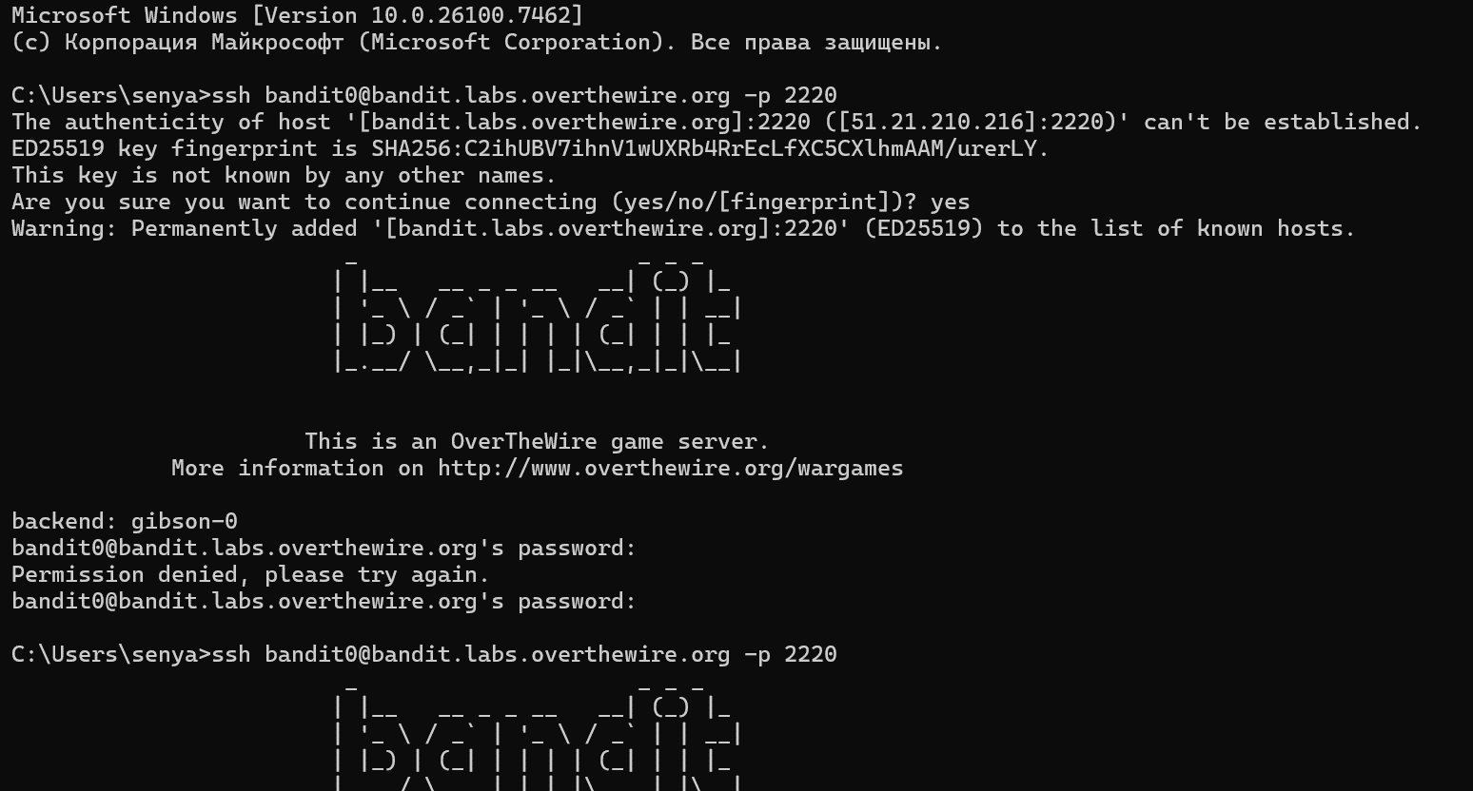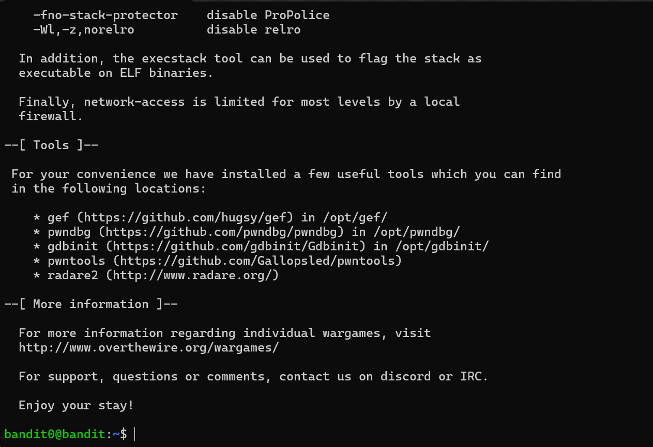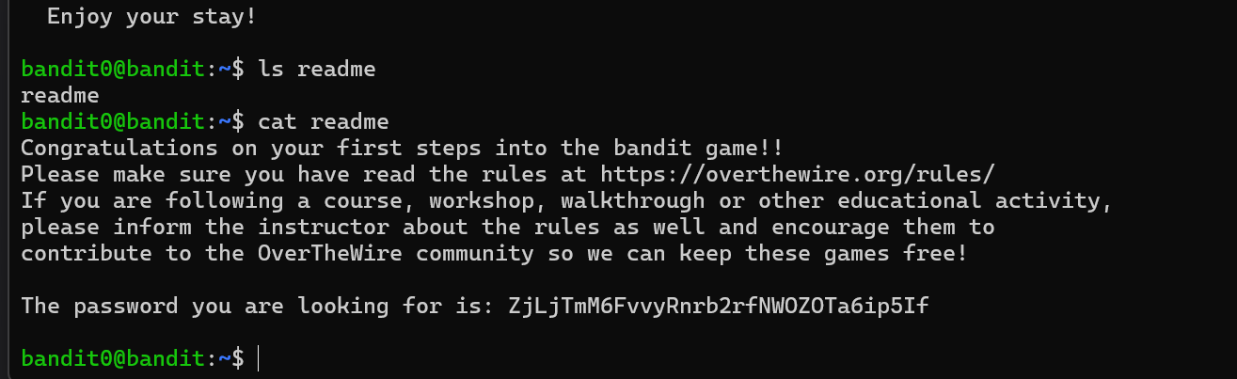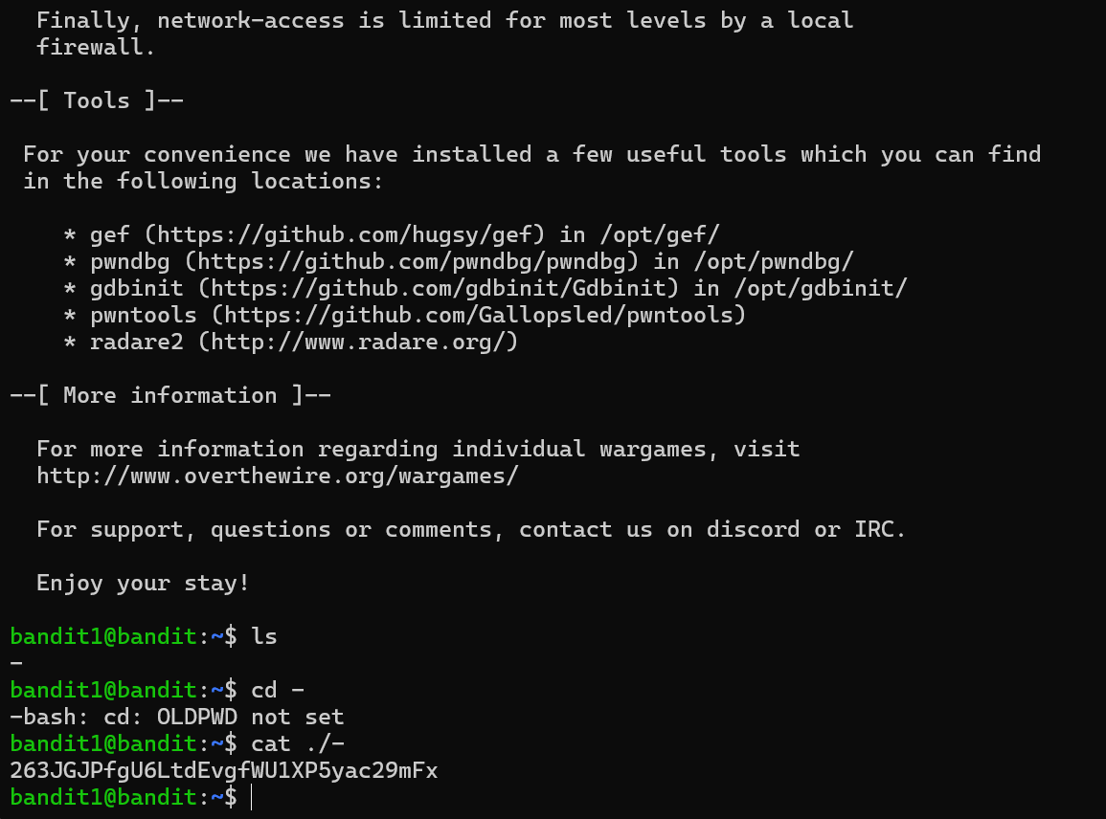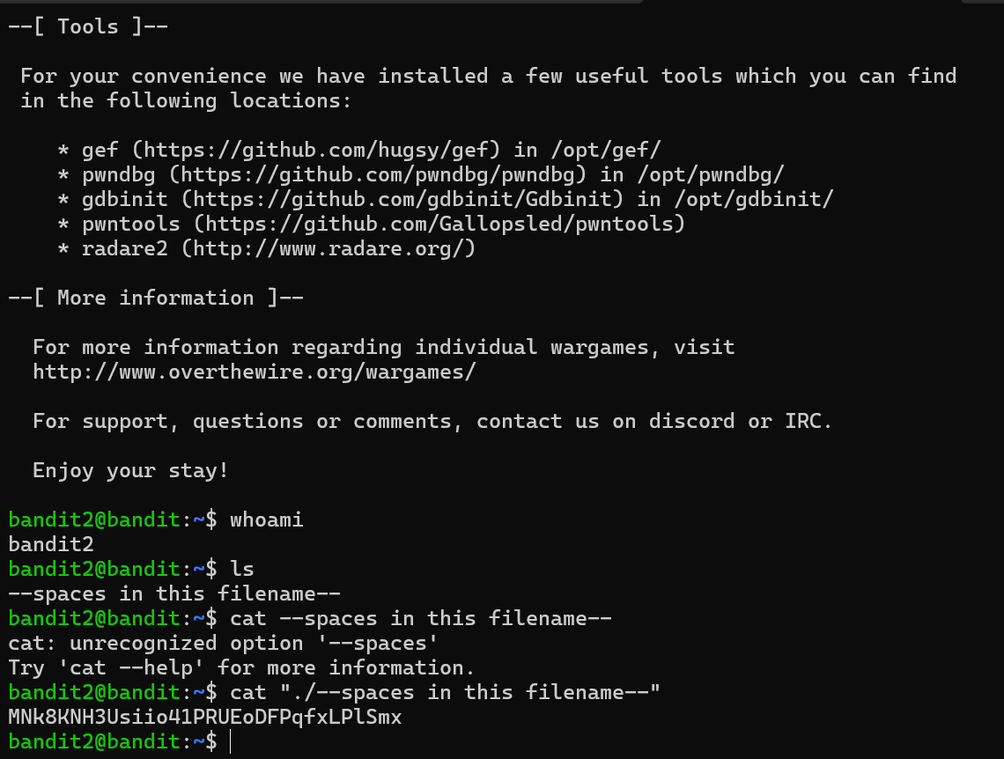
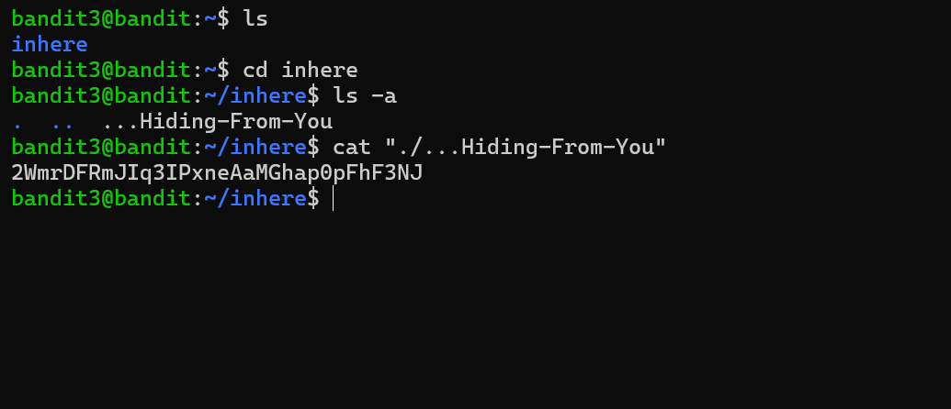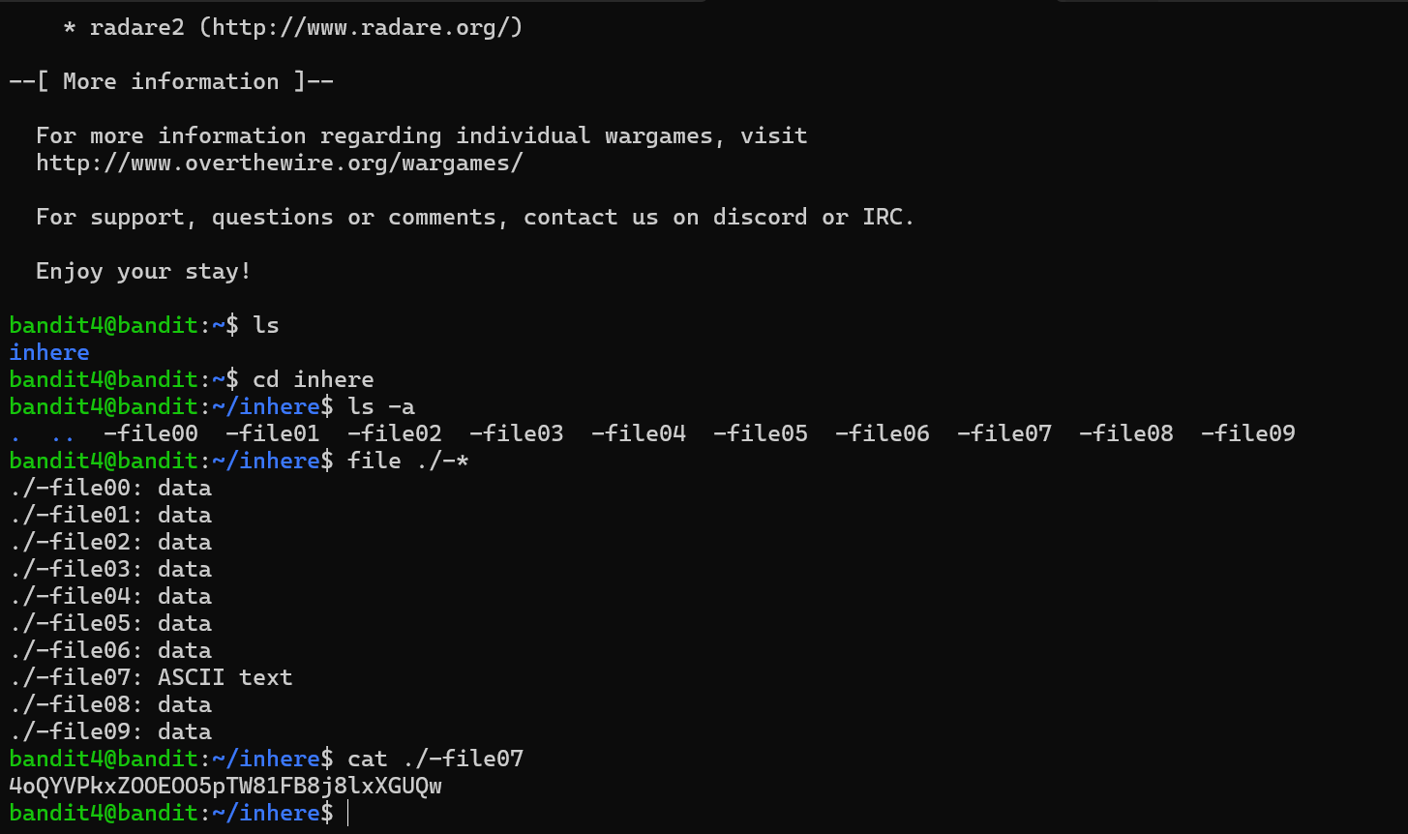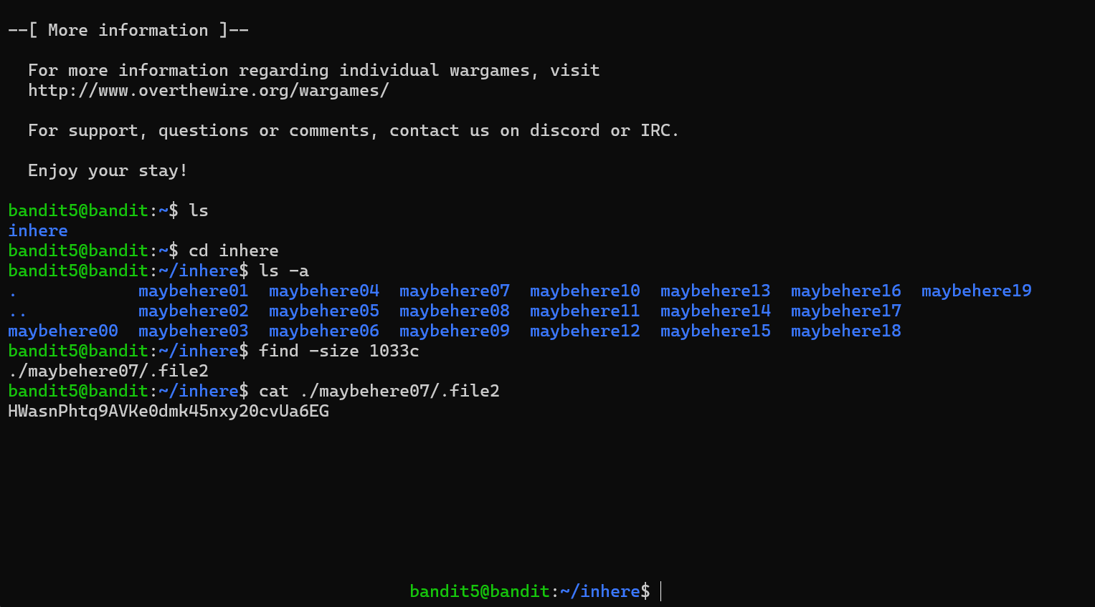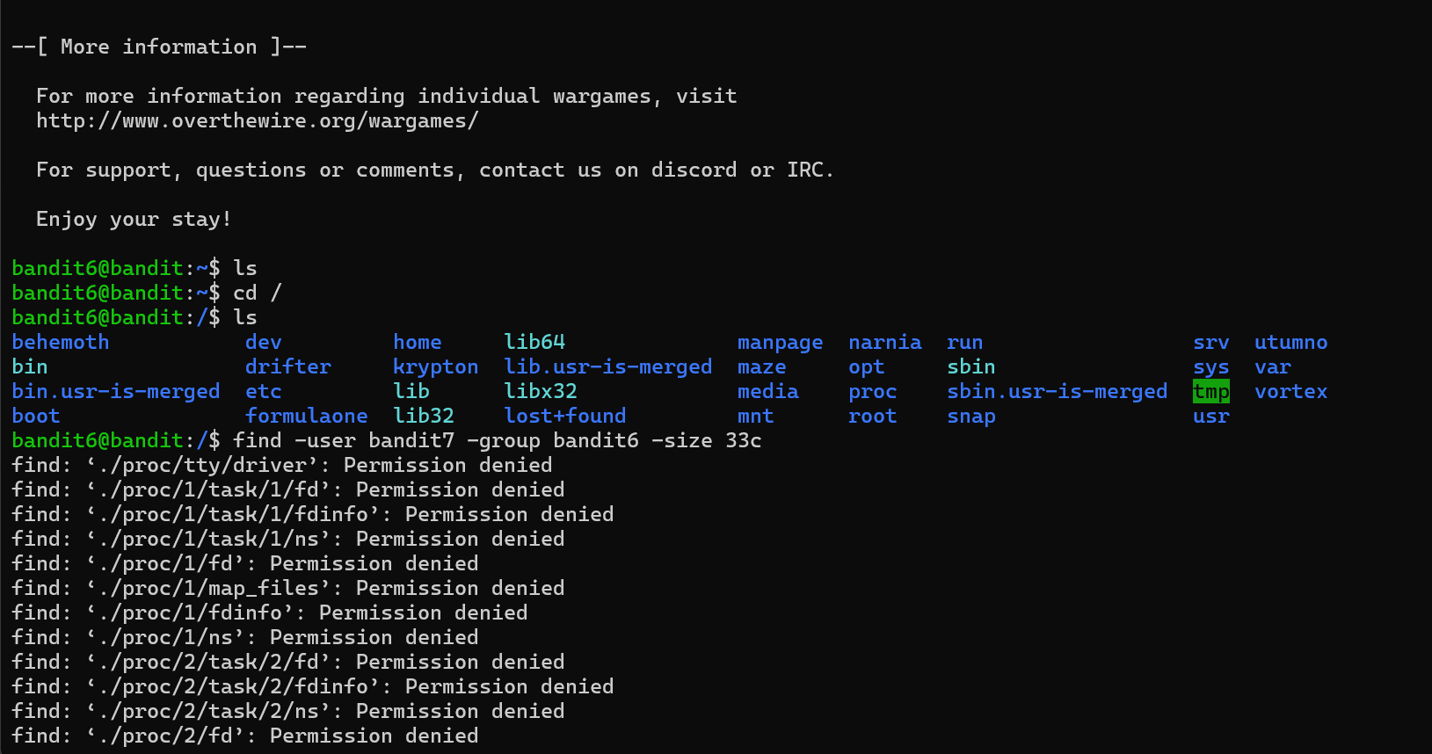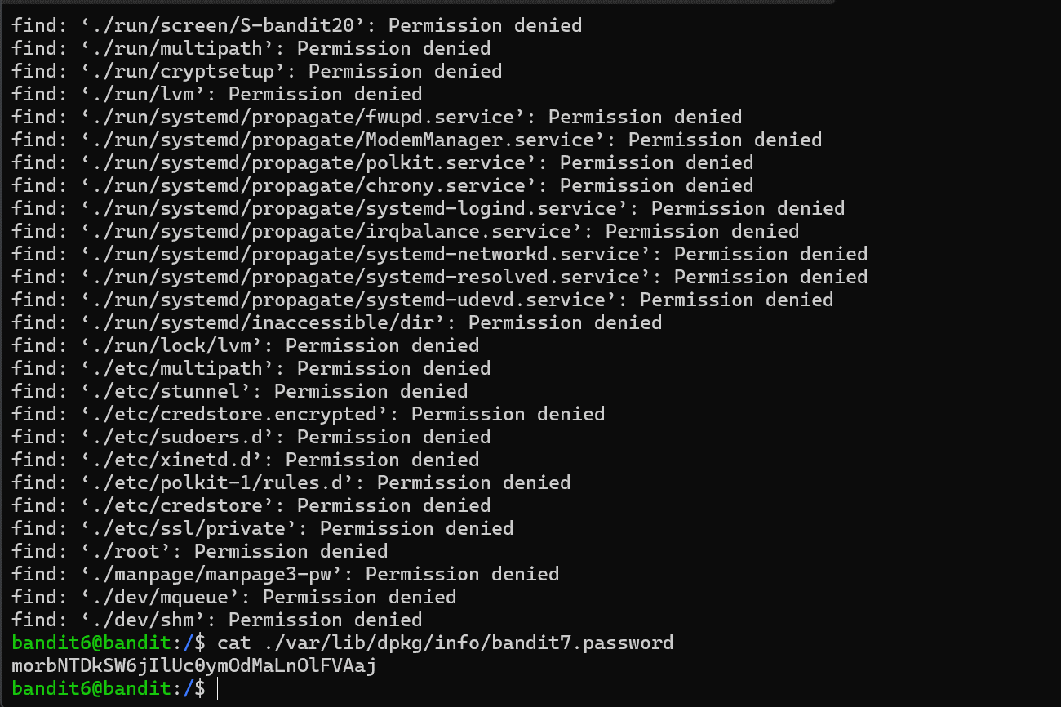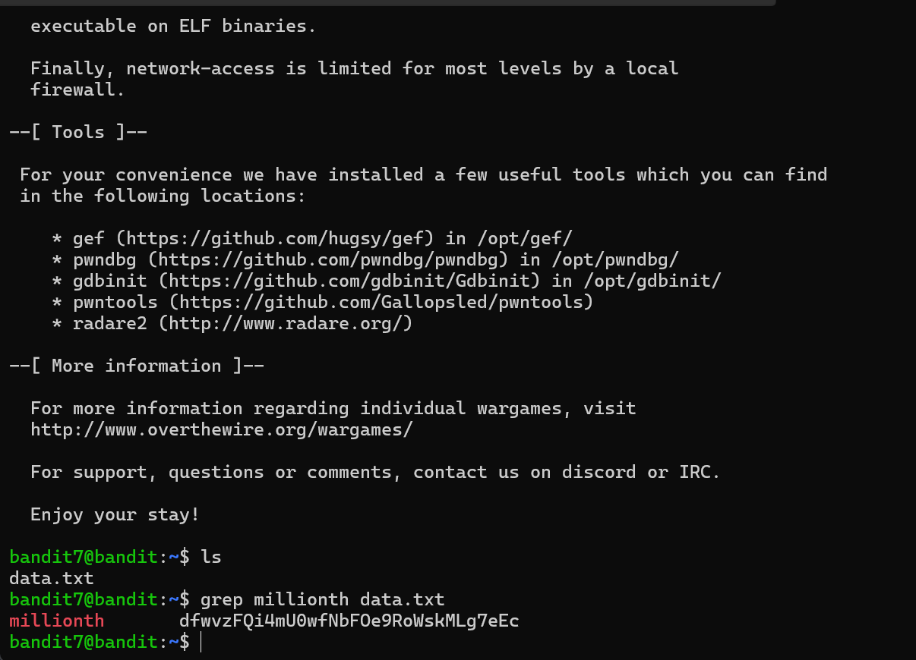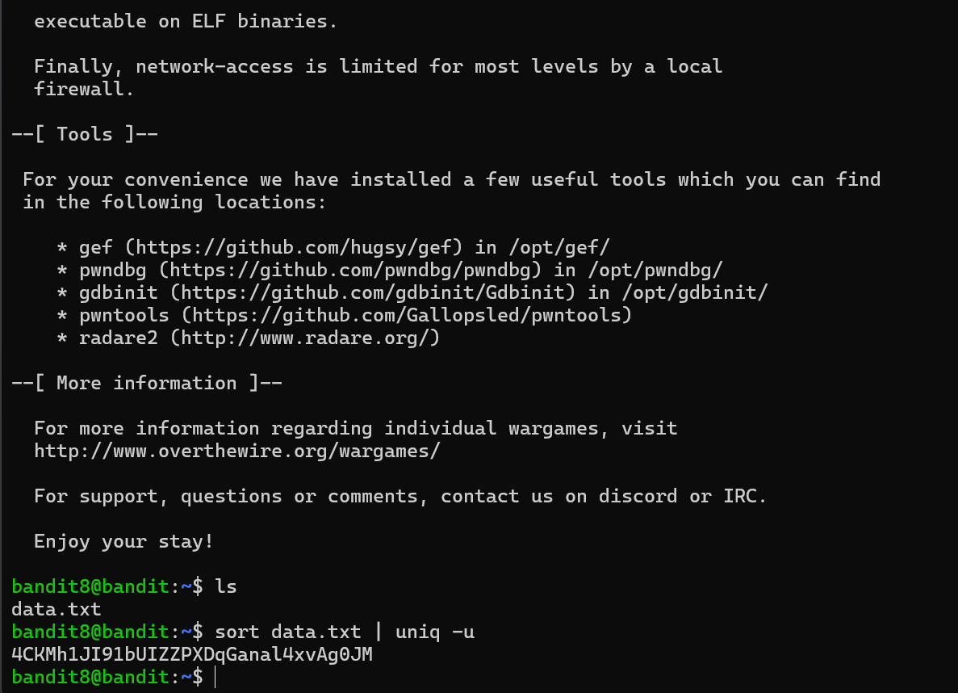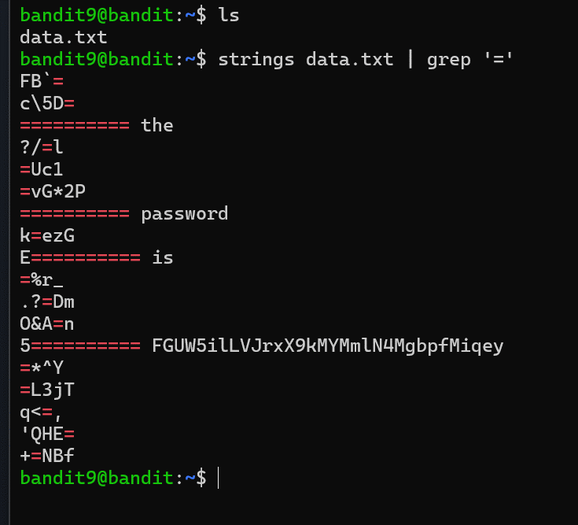
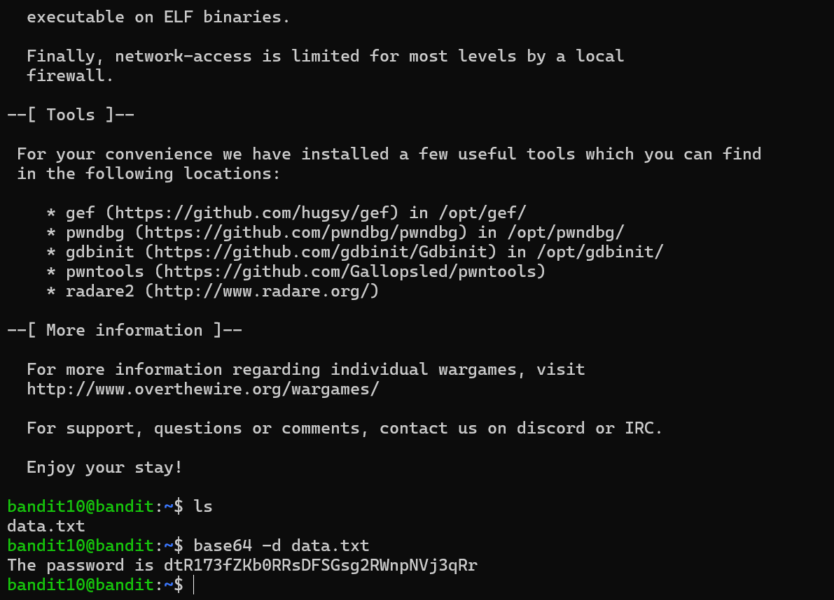
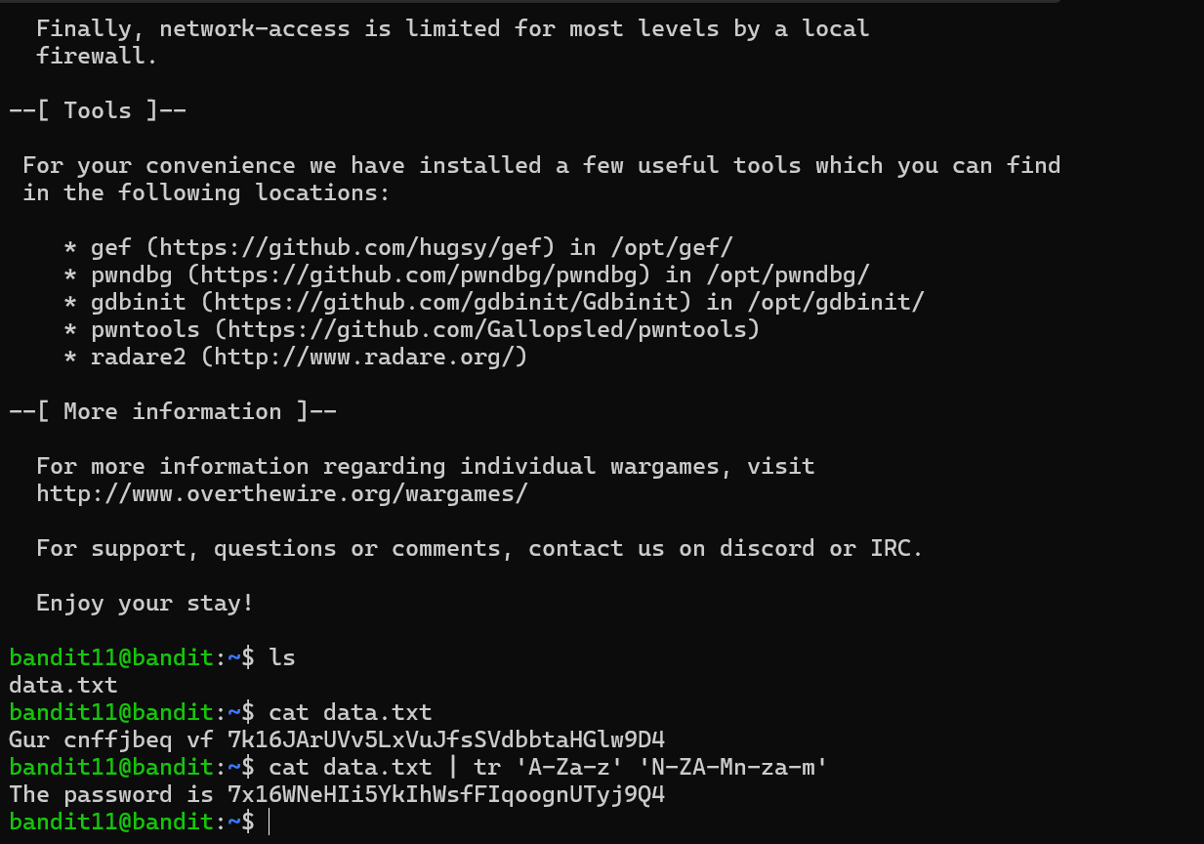
Список паролей:
1. ZjLjTmM6FvvyRnrb2rfNWOZOTa6ip5If
2. 263JGJPfgU6LtdEvgfWU1XP5yac29mFx
3. MNk8KNH3Usiio41PRUEoDFPqfxLPlSmx
4. 2WmrDFRmJIq3IPxneAaMGhap0pFhF3NJ
5. 4oQYVPkxZOOEOO5pTW81FB8j8lxXGUQw
6. HWasnPhtq9AVKe0dmk45nxy20cvUa6EG
7. morbNTDkSW6jIlUc0ymOdMaLnOlFVAaj
8. dfwvzFQi4mU0wfNbFOe9RoWskMLg7eEc
9. 4CKMh1JI91bUIZZPXDqGanal4xvAg0JM
10. FGUW5ilLVJrxX9kMYMmlN4MgbpfMiqey
11. dtR173fZKb0RRsDFSGsg2RWnpNVj3qRr
12. 7x16WNeHIi5YkIhWsfFIqoognUTyj9Q4

