1.3. Give the definitions of the terms.

1. cloud computing – There are 2 definitions. 1 – solution to running workloads remotely over the internet in a com- mercial provider’s data center. 2 - a virtualized pool of resources, from raw compute power to application functionality, available on demand.

2. IaaS – Infrastructure as a service  
3. PaaS – platform as a service  
4. SaaS – software as a service

5. Service provider – A company which provide some service such as software, platform, integration platform and so on

6. AWS API – API of the Amazon Web Services, which offers online services to other websites, or clients.   
7. ARPANET - Advanced Research Projects Agency Network), a “very” primi- tive version of the Internet.   
8. IBM - The International Business Machines Corporation, it specializes in computer [hardware](https://en.wikipedia.org/wiki/Computer_hardware), [middleware](https://en.wikipedia.org/wiki/Middleware), and [software](https://en.wikipedia.org/wiki/Computer_software), and provides hosting and [consulting services](https://en.wikipedia.org/wiki/Consultant) in areas ranging from [mainframe computers](https://en.wikipedia.org/wiki/Mainframe_computer) to [nanotechnology](https://en.wikipedia.org/wiki/Nanotechnology)

9. Amazon - **Amazon.com, Inc.**[[1]](https://en.wikipedia.org/wiki/Amazon_(company)#cite_note-10K-1) ([/ˈæməzɒn/](https://en.wikipedia.org/wiki/Help:IPA/English) [*AM-ə-zon*](https://en.wikipedia.org/wiki/Help:Pronunciation_respelling_key)) is an American [multinational](https://en.wikipedia.org/wiki/Multinational_corporation) [technology company](https://en.wikipedia.org/wiki/Technology_company) focusing on [e-commerce](https://en.wikipedia.org/wiki/E-commerce), [cloud computing](https://en.wikipedia.org/wiki/Cloud_computing), [online advertising](https://en.wikipedia.org/wiki/Online_advertising), [digital streaming](https://en.wikipedia.org/wiki/Digital_streaming), and [artificial intelligence](https://en.wikipedia.org/wiki/Artificial_intelligence)

10. private cloud - Private Clouds – it’s a system designed for business needs which store, and can share, sensitive data. These Private Clouds are basically data centers, using many of the basic Cloud technologies. Private Clouds offer technologies of controlling security and privacy concerns.

1.4

Funding - финансирование

Simultaneously - одновременно

Reels - катушки

Precursor - предшественник

Accessing - доступ

Promoted - продвигаемый

Shifting - меняться

Rentable – доступный к аренде

Stages - этапы

Boundaries - границы

Ponderous – тяжелое к восприятию

Purchase - покупка

on-demand – по требованию

retail - розничный

launched – запущенный

supporting - поддержка

arrangement - соглашение

distributing - распространение

expectations - ожидания

troubleshooting – устранение проблем

primary - основной

leakage - утечка

1.5

Technology vendors – поставщики технологий

Decline - снижение

hybrid cloud provider –провайдер гибридного облака

fastest-growing - быстрорастущий

different route – другой маршрут

billing - биллинг

software - ПО

concept of delivering – концепция доставки

accessing programs – доступ к программам

grid computing -

major player – крупный игрок

to be reckoned – важный

cloud equivalents – облачные альтернативы

IT departments – ИТ отделы

shift away – отход/переход от

increasingly accustomed – все более привычные

vendors - поставщики

small companies and individuals – небольшие компании и частные лица

according to – согласно чем-то

IT market – ИТ рынок

networking equipment – сетевое оборудование

maintenance - обслуживание

longer-established – давно существующий

focusing on – фокусироваться на

general release – общий/полноценный релиз

analyst community – аналитическое сообщество

frequently - часто

bundle – комплект/набор

expectations - ожидания

perceived - восприятие

security – безопасность

1.6

|  |  |
| --- | --- |
| Текущий рынок | Current market |
| концепция облачных вычислений | The concept of cloud computing |
| впервые появилась | first emerged |
| приверженный | committed |
| технологии развиваются | technology evolve |
| годы опыта | years of experience |
| адаптированные к облаку | adapted to the cloud |
| предоставлять | provide |
| насыщенные событиями | eventful |
| производят большие данные | produce big data |
| компьютерные приложения | computer applications |
| почти | almost |
| в целом | generally |
| стремиться увеличить | seek to increase |
| ежегодные расходы | annual costs |
| уменьшить зависимость | reduce dependency |
| стремиться предотвратить | seek to prevent |
| преимущество | advantage |
| принятие | adopting |
| ряд других услуг | a number of other services |
| руководство | guide |
| Сеть | Network |
| Подписываться | Sign up |
| Предприятие | Company |
| Предложение | Offer |
| устаревшие поставщики программного обеспечения | Legacy software vendors |
| облачные технологии | cloud technology |
| арендовать компьютеры | rent computers |
| пользователи программного обеспечения | software users |
| первый этап | first phase |
| доступный для пользователей | available to users |
| обеспечение | provisioning |
| покупки | purchases |
| влияние | impact |
| компания | company |
| прогноз | forecast |
| в частности | in particular |

1.7

1. In what year did DARPA submit $ 2 million for the MAC project?

It was in 1963

2. Who was the forerunner of cloud computing?

It was J. C. R. Licklider

3. What situation was the word "virtualization" used to describe?

It was a computer which worked as a cloud for 2-3 people

4. In what year did J. K. R. Licklider develop ARPANET?

He did it in 1969

5. How did the meaning of virtualization change in the 1970s?

In the 1970s, creating a virtual machine which was a copy of a real computer became known as virtualization

6. What did Professor Ramnath Chellappa of Emory University do in 1997?

He defined Cloud Computing as the new “computing paradigm”, where the boundaries of computing will be determined by economic rationale, rather than technical limits alone.”

7. What was Salesforce used for in 1999?

They used Cloud computing to pioneer the idea of using the Internet to de- liver software programs to the end users. The program (or application) could be accessed and downloaded by anyone with Inter- net access. Businesses could purchase the software in an on- demand, cost-effective manner, without leaving the office.

8. In what year did Amazon introduce its retail web services?

In 2002

9. What did IBM, Google, and several other universities do in 2007?

In 2007, IBM, Google, and several universities joined forces to develop a server farm for research projects needing both fast processors and huge data sets.

10. What are the two types of public clouds?

One serves individuals for personal use, and one serves businesses.

1.9

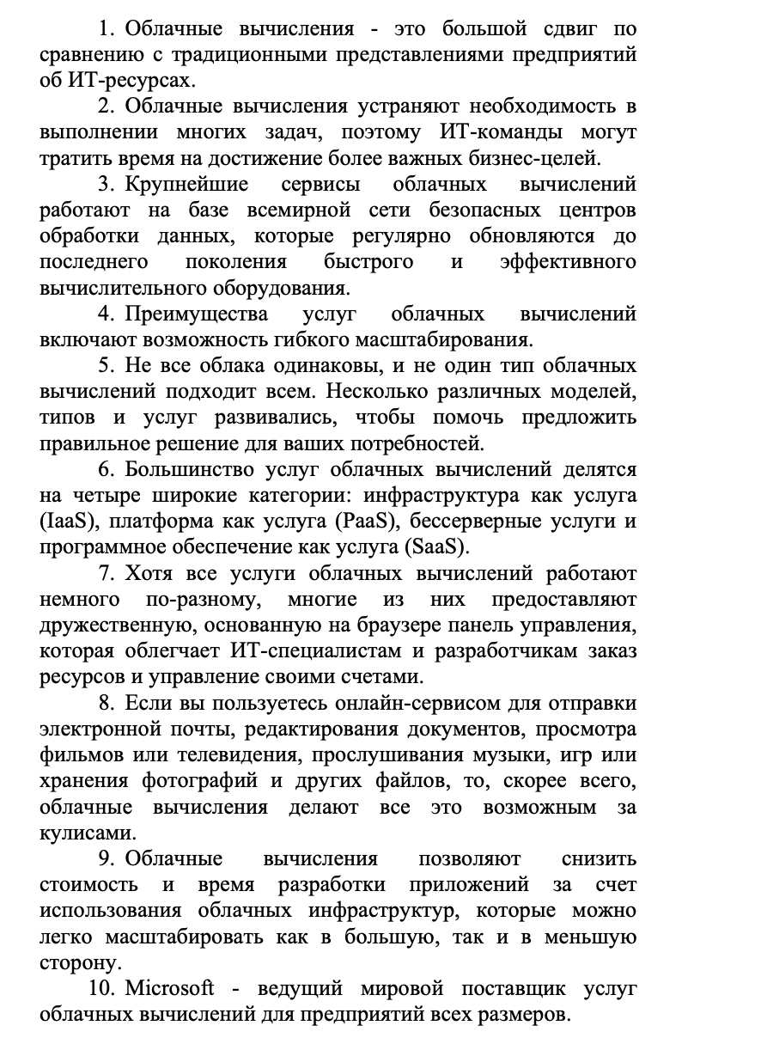

1.10

1. The user defines his/her own network needs, such as server time, download and processing speeds, etc., without interaction with a service provider representative.

2. Cloud technology services are available to consumers via the Data Transfer Network regardless of the terminal device used.

3. automation of procedures and modification of cloud computing resource allocation enables to significantly reduce the cost of subscriber service.

4. Many cloud computing services provide a convenient browser-based monitoring panel, which allows IT professionals and developers to order resources and manage their accounts.

5. Software as a Service - a model in which the consumer is provided with the possibility to use the application software of a cloud-based provider, which is accessible from various client devices, via a browser or a program interface.

6. By using cloud computing, information technology consumers can significantly reduce expenses on data processing center construction.

7. Since its introduction in 2006, the concept of cloud computing has been deeply penetrating into various IT spheres and taking more and more weight.

8. Many experts believe that advantages and convenience outweigh possible risks of using cloud services.

9. Although companies sometimes migrate outdated applications to the cloud, the real benefits come from new applications that take advantage of cloud services.

10. Cloud computing has become the ideal way to deliver enterprise applications and the preferred solution for companies expanding their infrastructure.