COMAVI: complex-aware structural mechanism profiles for prioritizing missense variants
Short title: Complex-aware structural mechanism profiles for missense variants
[AUTHOR LIST TO BE SUPPLIED]
[AFFILIATIONS TO BE SUPPLIED]
* Corresponding author: [EMAIL TO BE SUPPLIED]

Abstract
Pathogenicity predictors rank missense variants by how likely they are to cause disease, but they rarely name the structural process a variant disrupts or the experiment that would test it. COMAVI (COMplex-Aware Variant Impact scoring) uses FoldX to score each substitution twice, in the isolated subunit and in the assembled complex, and reports three predicted energy changes: isolated-subunit stability, assembled-complex stability and binding to each partner. With a structural-context tier, these yield two outputs: a priority score that ranks variants for structural follow-up, and a mechanism profile that names the disrupted process and therefore the experiment. We evaluated both against a literature-curated benchmark of 61 variants in 14 protein systems, experimental or predicted with AlphaFold 3, in which every expected effect carries a written evidence basis and a citation. Scoring the assembled complex is what made most lesions visible: at the 2.5 kcal/mol reference threshold the isolated-subunit axis alone detected 7 of the 29 variants with a committed structural mechanism, and the three axes together detected 20, at a cost of three further calls among 27 no-lesion variants. The mechanism-pattern score was 37.0 of 56 graded variants (0.661) against 0.482 for the strongest trivial strategy, but the axis the literature implicates fired for only 14 of the 29. Across the prespecified range of 1.0 to 2.5 kcal/mol, stringency left detection nearly unchanged, lowered attribution and raised correct rejection. Predicted energies ranked measured effects (Spearman ρ = 0.48, n = 63) but compressed their size (slope 0.42). The priority score placed 17 of 21 structural mechanisms in the top 20 of 46 ranked variants. Use the priority score to choose variants, then the mechanism profile to choose a stability, assembly or binding experiment. A silent result means that the supplied model shows no lesion, not that the variant is benign.

Author summary
Genetic testing finds far more changes to single protein building blocks than any laboratory can study. Computer tools estimate which changes cause disease but rarely say how, which is what decides the next experiment. Most proteins work while bound to partners. A change can make the protein itself unstable, or leave it folded but weaken its grip on a partner, and the two are tested differently. Our method evaluates each change twice, in the protein alone and in the assembled group, to tell them apart. We tested it on 61 changes in 14 protein systems whose effects published experiments have already established. Judging the protein alone found the damage in 7 of 29 disruptive changes; judging the assembled group found 20. Of the 56 we could grade, its predictions fully matched the published evidence for 32 and partly for 10 more, and in a ranked list of 46 it placed 17 of the 21 truly disruptive ones in the top 20. Its main weakness was naming the wrong problem: it often blamed the stability of the assembled group where the evidence pointed to a weakened grip. We describe how to choose experiments with it, and when not to trust it.

Introduction
Sequencing now identifies far more missense variants than can be studied experimentally. Variant effect predictors such as AlphaMissense and GPN-Star rank these variants by predicted pathogenicity or functional constraint [1,2]. AlphaMissense reads sequence, evolutionary signal and structural context, but that context is a predicted single chain, so its view of a residue is the view from one subunit. A pathogenicity score does not say how a variant acts. Similar scores can describe a variant that destabilizes a folded domain, one that weakens an interface and one that alters catalysis, and each calls for a different experiment.
Many proteins function in complexes, and assembly changes the structural context of a residue. A site exposed in an isolated chain may be buried once partners bind. A substitution tolerated by the isolated subunit may destabilize the assembly or weaken one interaction, and an interface substitution can change affinity while leaving the fold intact. Experiments that measure folding and binding separately find distinct energetic effects [3]. A method meant to guide follow-up should therefore keep the isolated and assembled contexts apart instead of merging them into one impact score. AlphaFold 3 and the Boltz models now predict complex structures for most pairs of interest, which makes this comparison possible at scale where no experimental complex exists [4–6]; how much the source of the model matters is itself a result reported below.
Several tools place variants on experimental or predicted structures [7–13]. Two frameworks consider both the monomeric and the assembled context. ELASPIC assigns each substitution to the core or to an interface and predicts the corresponding quantity [14]. MAVISp computes folding and local-interaction free energies in separate modules for more than a thousand proteins [15]. Neither scores the same substitution in the isolated subunit and in the assembled complex and compares the two, and that comparison carries mechanistic information. A substitution that destabilizes the isolated subunit predicts a protein that folds poorly and is depleted; one that leaves the subunit intact but weakens an interaction predicts a protein that is present but fails to engage its partner. The first calls for a stability or turnover assay, the second for an affinity measurement against the named partner. A single energy cannot separate the two, because a residue buried in an interface can destabilize the fold without weakening binding. Stability and interface predictors have been benchmarked against measured energies and deep mutational scans [16–23], but such benchmarks score energies, not the identification of the disrupted process.
Here we describe COMAVI (COMplex-Aware Variant Impact scoring), a pipeline that scores each substitution in both contexts and keeps its fold and binding predictions separate (Fig 1). COMAVI returns two linked outputs: a priority score, which ranks variants for structural follow-up, and a mechanism profile, which names the process predicted to be disrupted. To test both, we curated a benchmark of 61 variants in 14 protein systems in which every expected effect is tied to a written evidence basis and a citation. We asked four questions of it. What does the assembled complex add over the isolated subunit alone? Does the mechanism profile recover the literature-defined mechanism, and how far does that answer depend on the energy threshold that turns a continuous prediction into a call? How do the predicted energies compare with direct measurements? And does the threshold-free priority score concentrate structural mechanisms at the top of a ranking? We then compared the priority score with a pathogenicity predictor.
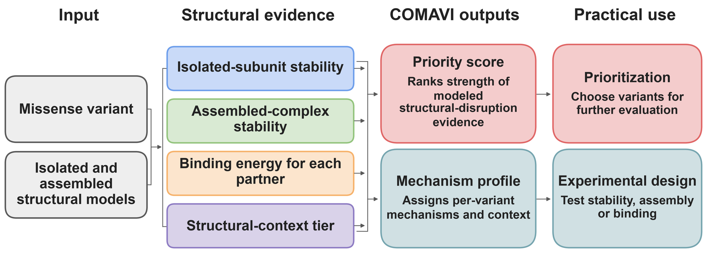
Fig 1. COMAVI workflow. A missense variant and isolated and assembled structural models yield four lines of structural evidence: predicted stability changes in the isolated subunit and in the assembled complex, the binding-energy change for each partner, and the structural-context tier. These combine into two outputs. The priority score ranks the strength of modeled structural disruption and is used to choose variants for further study; the mechanism profile assigns each variant its predicted mechanisms and context and indicates whether to test stability, assembly or binding. Pathogenicity evidence is not an input to either output.

Results

Every expectation in the benchmark carries its evidence
The benchmark contains 61 missense variants in 14 protein systems (Table 1): 49 variants in 13 multi-chain complexes and 12 in the tandem BRCA1 C-terminal (BRCT) domain, a single-chain system with measured unfolding free energies [24]. We chose systems in which published experiments establish how each variant acts, and all energies throughout are FoldX 5.1 predictions (Methods). Together they span the mechanisms COMAVI is meant to separate: loss and gain of function, fold-driven and binding-driven disruption, and variants with ambiguous biology. For each variant, the primary literature defines the expected direction on each applicable axis [25–58]. Each of the 99 committed expectations is recorded with its evidence class, a one-line basis and a citation (S1 Table).
Table 1. Benchmark composition.
System | Gene | Variants | Graded | Pathogenic | Structure
BRCA1 BRCT tandem domain | BRCA1 | 12 | 10 | – | PDB 1JNX
BRCA1–BARD1 RING heterodimer | BRCA1 | 4 | 4 | 2 | PDB 1JM7
Calmodulin–CaV1.2 IQ domain | CALM1 | 3 | 3 | 3 | AlphaFold 3 model
Complement factor H–C3b | CFH | 3 | 3 | 2 | PDB 2WII
Hemoglobin α–β dimer | HBB | 1 | 1 | 1 | PDB 2HHB
Hemoglobin tetramer | HBB | 5 | 5 | 5 | PDB 2HHB
KRAS–RAF1 RAS-binding domain | KRAS | 3 | 3 | 3 | PDB 6XI7
MLH1–PMS2 C-terminal heterodimer | MLH1/PMS2 | 7 | 7 | 3 | AlphaFold 3 model
MSH2–MSH6 heterodimer | MSH2 | 5 | 4 | 3 | AlphaFold 3 model
PI3K p110α–p85α | PIK3CA/PIK3R1 | 5 | 5 | 4 | AlphaFold 3 model
SMAD4–SMAD3 MH2 complex | SMAD4 | 4 | 4 | 4 | AlphaFold 3 model
Troponin I–troponin C | TNNI3 | 4 | 3 | 3 | AlphaFold 3 model
VHL–elongin C | VHL | 3 | 2 | 3 | AlphaFold 3 model
VWF A1–GPIbα | VWF | 2 | 2 | 1 | PDB 1SQ0
Total |  | 61 | 56 | 37
Graded variants carry a committed expectation on at least one modeled axis or, for five no-lesion variants, at the whole-variant level. Pathogenic counts clinical annotations, which are independent of the mechanism ground truth and are not used in any mechanism metric; the BRCT variants carry no clinical label (–). Experimental structures are identified by their Protein Data Bank (PDB) entries [59–64]; the other systems used AlphaFold 3 models.
Three nested populations serve different claims. All 61 variants receive COMAVI outputs. Of these, 56 are graded against an expected mechanism: 29 carry a committed structural mechanism and 27 are curated to carry no lesion on the modeled axes, which we call no-lesion variants. Five variants are not graded. The mechanism of BRCA1 R1699L and R1699Q, loss of phosphopeptide recognition, cannot be represented by the supplied structure, and TNNI3 R162W, VHL W117R and MSH2 G674R have no committed expectation on any modeled axis (S2 Table, model_scope sheet). Of the 56 graded variants, the 46 in complexes also carry a structural-context tier and form the prioritization population of 21 structural-mechanism and 25 no-lesion variants. The 21 are a subset of the 29; the other eight are BRCT fold mechanisms, which have no partner chain and therefore no tier.
Four graded no-lesion variants carry no committed expectation on any individual axis: CALM1 D96V, N98S and F142L, which act through altered calcium binding [29,30], and SMAD4 I500T, which acts through impaired monoubiquitination [44]. Their mechanisms lie outside the modeled axes, so they are graded at the whole-variant level as no-lesion variants. S1 Table lists their basis and sources, and the analyses below report the effect of removing them.
Evidence quality differs by direction, because a disruptive effect attracts a dedicated biophysical measurement far more often than a normal one does. Of the 42 expectations supported by quantitative evidence (classes E1 and E2; Methods), 28 are destabilizing; of the 57 supported by qualitative, population or inferred evidence (E3 to E5), 8 are. All 9 population-supported and all 18 inferred expectations are neutral. Restricting the benchmark to the best-evidenced expectations would therefore remove most of the no-lesion class instead of raising the standard evenly. We retained every evidence class and report evidence-restricted analyses as sensitivity analyses (S1 Text).

Scoring the assembled complex is what makes most lesions visible
COMAVI's premise is that one calculation on the isolated subunit is not enough, so we first measured what the assembled complex adds on the same variants at the same threshold. At the 2.5 kcal/mol reference the isolated-subunit axis alone reached the threshold for 7 of the 29 variants carrying a committed structural mechanism; with the assembled-complex and binding axes the figure is 20. The 13 variants found only through the assembled axes are 6 of the 12 pure interface variants, 5 of the 6 mixed expectations and 2 fold mechanisms, drawn from 7 of the 13 complexes. Among the 21 structural mechanisms that sit in a complex the contrast is starker, 2 against 15. The cost is three further calls on no-lesion variants: correct rejection falls from 25 of 27 to 22. At the 1.0 kcal/mol screening default the same comparison gives 12 against 24 detected and 17 against 12 rejected, so the assembled axes carry most of the detection at every threshold and most of the false calls at permissive ones (Table 2).
Two variants show both what the second context adds and the error it introduces. Complement factor H R78G barely changes isolated-subunit stability (0.93 kcal/mol) but is predicted to weaken binding to C3b by 6.12 kcal/mol, consistent with a measured rise in dissociation constant from 10–14 μM to more than 35 μM [51]. Von Willebrand factor R1334Q leaves the isolated A1 domain unchanged (0.01 kcal/mol) but weakens binding to GPIbα by 4.11 kcal/mol; the purified A1 domain is natively folded, binds GPIbα weakly and supports little platelet adhesion [52]. A calculation on the isolated subunit alone would call both variants silent. In both, however, the assembled-complex stability axis also fires (4.88 and 4.73 kcal/mol) where the literature implies an intact fold, so both are graded partial rather than consistent.

COMAVI recovers literature-defined mechanisms but localizes them less reliably than it detects them
Each graded variant received a three-level grade: 1 when COMAVI recovered the expected combination of effects, 0.5 when it partly recovered a multi-axis pattern, and 0 otherwise. Table 2 defines this mechanism-pattern score and every other metric reported below. At the 2.5 kcal/mol (10.5 kJ/mol) reference threshold, the mechanism-pattern score was 37.0 of 56 (0.661). To judge this value, we graded every trivial fixed strategy on the same variants. The strongest, calling every variant silent, scores 0.482 by accepting all no-lesion variants and missing every mechanism. Calling every variant destabilized on both the assembled-complex and binding axes scores 0.438, and permuting the ground truth gives a mean of 0.464 (standard deviation 0.051; p = 0.0005; S2 Text). COMAVI exceeds the best trivial strategy by 0.179. Because the strongest trivial strategy scores exactly the no-lesion fraction of the cohort, this margin, rather than the raw score, is the quantity that can be compared across cohorts of different composition.
Table 2. Metrics, populations and values at each energy threshold.
Metric | Population | What it counts | 1.0 | 1.5 | 2.0 | 2.5 | Bound
Mechanism-pattern score | 56 graded variants | Mean whole-variant grade | 0.562 | 0.616 | 0.652 | 0.661 | 0.652
Structural arm | 29 structural-mechanism variants | Mean grade of variants expected to carry a lesion | 0.672 | 0.638 | 0.569 | 0.517 | 0.466
No-lesion arm | 27 no-lesion variants | Mean grade of variants expected to be silent | 0.444 | 0.593 | 0.741 | 0.815 | 0.852
Detection | 29 structural-mechanism variants | Any axis reaches the threshold | 0.828 | 0.724 | 0.724 | 0.690 | 0.621
Detection, isolated subunit only | 29 structural-mechanism variants | The isolated-subunit axis alone reaches the threshold | 0.414 | 0.345 | 0.310 | 0.241 | 0.172
Attribution | 29 structural-mechanism variants | The axis the literature implicates reaches the threshold | 0.621 | 0.586 | 0.552 | 0.483 | 0.414
Correct rejection | 27 no-lesion variants | No axis reaches the threshold | 0.444 | 0.593 | 0.741 | 0.815 | 0.852
Correct rejection, isolated subunit only | 27 no-lesion variants | The isolated-subunit axis alone does not reach the threshold | 0.630 | 0.741 | 0.852 | 0.926 | 0.926
Direction agreement, energy axes | 77 axis expectations | Call matches the committed direction | 0.675 | 0.714 | 0.727 | 0.727 | 0.701
Direction agreement, tier | 46 variants | Tier 1–2 matches the committed structural class | 0.652 | 0.652 | 0.652 | 0.652 | 0.652
Measured destabilizations recovered | 42 measured comparisons | Measured ≥ 1.0 kcal/mol; predicted ≥ threshold with the same sign | 0.643 | 0.548 | 0.429 | 0.286 | 0.262
Prioritization ROC AUC | 46 prioritization variants | A structural mechanism outranks a no-lesion variant | 0.834 | 0.834 | 0.834 | 0.834 | 0.834
Values at the four uniform thresholds (kcal/mol) and at the per-axis prediction-interval bound (2.9, 2.9 and 3.5 kcal/mol for isolated-subunit stability, assembled-complex stability and binding). The two isolated-subunit rows recount detection and correct rejection on that axis alone, which is what a calculation on the subunit without its partners would report. Detection, attribution and correct rejection use every computed axis; the rubric grades use only axes that pass confidence gating, the rule that discards an axis whose variant site falls below the AlphaFold confidence band (Methods). ROC AUC (area under the receiver operating characteristic curve) uses no threshold and takes one value.
The pooled score combines two capabilities that behave differently. The grade averaged 0.517 over the 29 structural-mechanism variants and 0.815 over the 27 no-lesion variants. Asked as binary questions, the same calls give three rates. At least one axis reached the threshold for 20 of the 29 mechanisms (detection, 0.690), and the axis the literature implicates reached it for 14 (attribution, 0.483). No axis reached it for 22 of the 27 no-lesion variants (correct rejection, 0.815). Binary attribution agrees with the graded structural arm to within 0.052 at every uniform threshold, so partial credit does not inflate the structural arm. COMAVI therefore detects structural disruption more reliably than it localizes it, and this gap is its principal limitation.
The localization errors concentrate in one class. Among the eleven variants curated as pure interface destabilizers, the binding axis fired for 4 and the assembled-complex stability axis for 7. The lesion was found but placed in the fold of the complex instead of in the interaction (S2 Text), the same error that costs CFH R78G and VWF R1334Q a consistent grade above. An interface substitution can genuinely raise the folding energy of the assembled coordinates, so the two axes are not independent; what the benchmark shows is that the larger of the two is often the wrong one to report.
Direction agreement was similar on the three axes: 19 of 26 expectations for isolated-subunit stability, 17 of 22 for assembled-complex stability and 20 of 29 for binding (56 of 77 overall), rates within 0.042 of one another. The 46 complex variants and the 10 BRCT variants scored similarly (0.652 and 0.700), so neither subset determines the pooled result.
No single protein system carries the result. Resampling whole systems gave a 95% interval of 0.573–0.755 for the mechanism-pattern score, and leaving out one system at a time gave values from 0.641 to 0.679 (S1 Fig). Without the four whole-variant no-lesion variants, the score is 33.0 of 52 (0.635). Because the 56 variants come from 14 clustered systems, 0.661 measures agreement on this benchmark, not general accuracy.
Performance was lower on predicted than on experimental complexes. Seven systems use an experimental complex structure and seven an AlphaFold 3 model; the mechanism-pattern score was 20.0 of 28 (0.714) on the experimental systems and 17.0 of 28 (0.607) on the predicted ones, and the prioritization AUC was 1.000 against 0.911. Resampling whole systems within each source puts a 95% interval of −0.080 to 0.257 on the difference of 0.107, so the benchmark does not resolve it. With seven systems on each side, the source of the model also cannot be separated from the difficulty of the systems. The split is not a clean comparison of model quality in any case: isolated-subunit stability is calculated on a single-chain AlphaFold 3 model in 11 of the 14 systems, including systems whose complex is experimental.
A silent result has two meanings that the benchmark keeps apart. For a variant whose mechanism the supplied model can represent, silence on every applicable axis is an informative negative. When the mechanism acts through a state absent from the model, silence cannot test it. HBB E6V is the clearest case: it acts through polymerization of deoxygenated hemoglobin [53], so COMAVI silence points to the missing assembly state, not to a benign variant. A model-scope screen separates the two situations (S2 Table, model_scope sheet).

Stringency costs attribution, not detection
Every graded result depends on the energy threshold that turns a continuous prediction into a call (Fig 2). Over the prespecified uniform thresholds of 1.0, 1.5, 2.0 and 2.5 kcal/mol and the per-axis prediction-interval bound (Methods), the mechanism-pattern score was 0.562, 0.616, 0.652, 0.661 and 0.652. The 2.5 kcal/mol reference is the highest of the five on this cohort, as it is for the unweighted mean of the two arms. The system-resampling intervals overlap at every threshold, however (Fig 2C), so the benchmark does not establish it as an optimum.
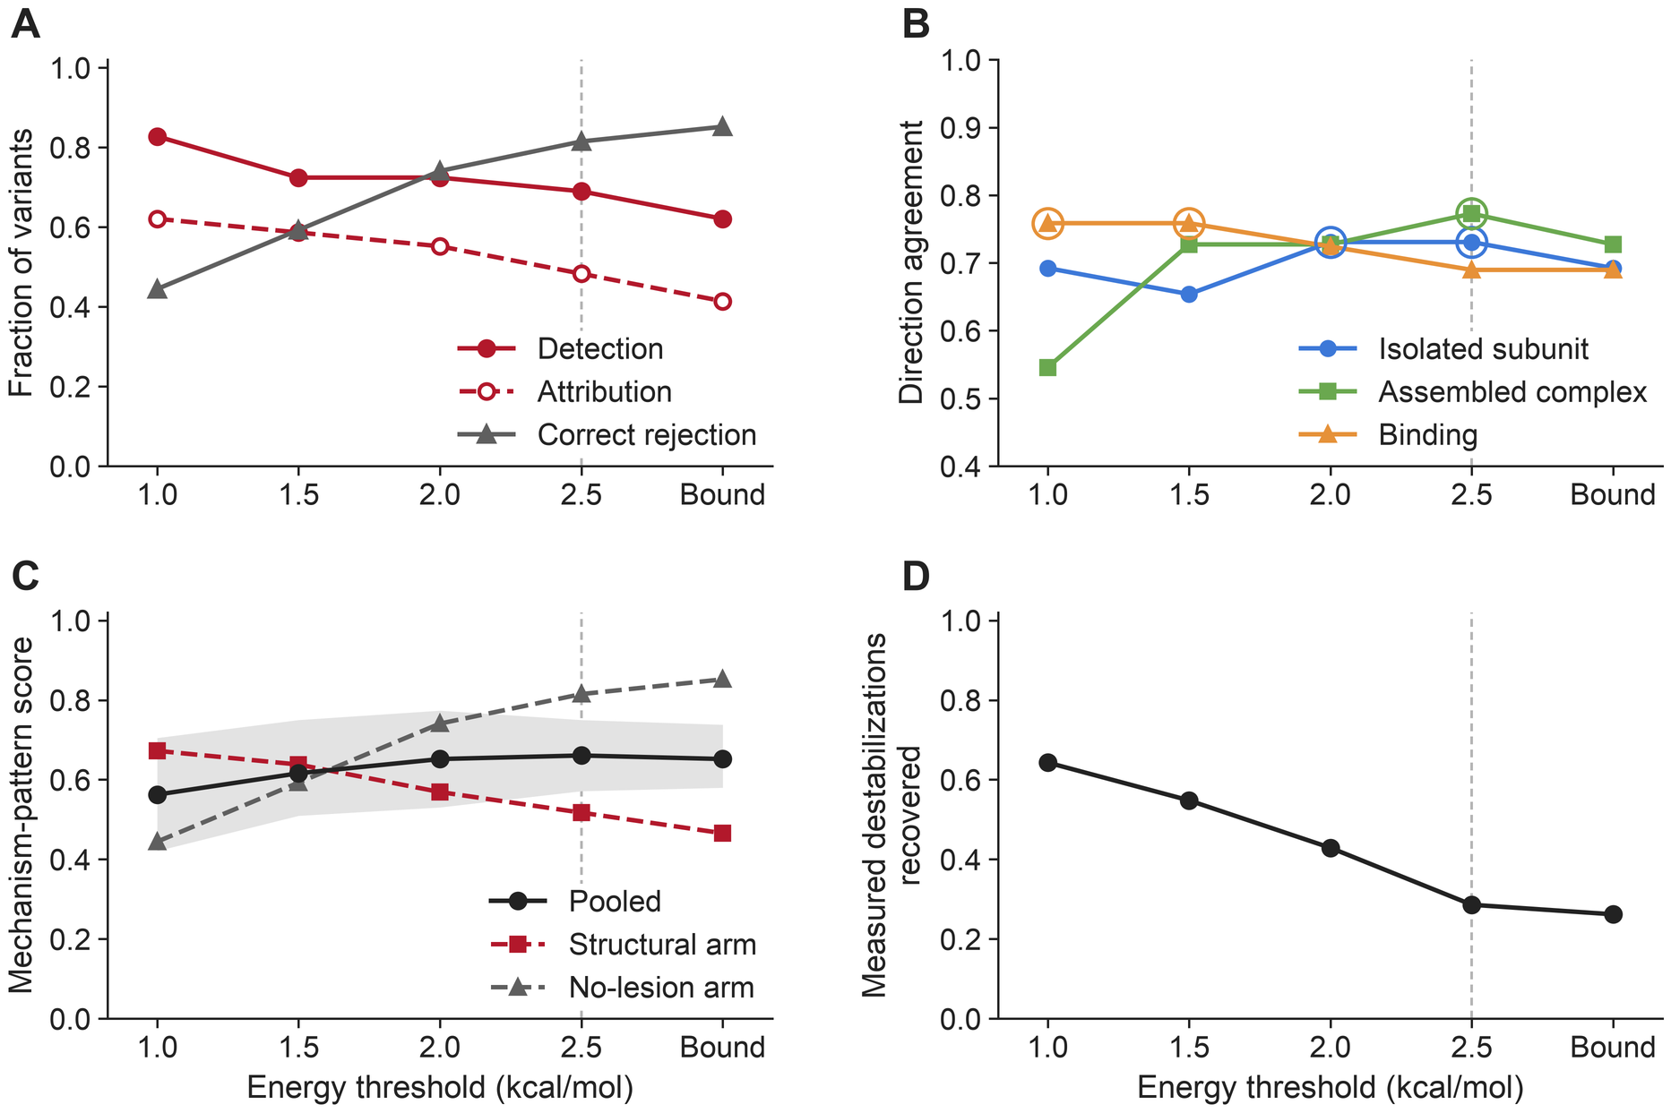
Fig 2. Every graded result depends on the energy threshold. Values at the four uniform thresholds and at the per-axis prediction-interval bound (Bound); the dashed line marks the 2.5 kcal/mol reference. (A) Detection, attribution and correct rejection for the 29 structural-mechanism and 27 no-lesion variants. (B) Direction agreement on each axis (26 isolated-subunit, 22 assembled-complex and 29 binding expectations); open circles mark the best value for each axis. (C) Mechanism-pattern score, pooled (gray band, 95% interval from resampling the 14 systems) and for each arm. (D) Measured destabilizations of at least 1.0 kcal/mol (n = 42) predicted at or above the threshold with the same sign.
Raising the threshold changed the three binary rates in different ways. Detection was nearly flat: at least one axis fired for 24 of the 29 mechanisms at 1.0 kcal/mol, for 21 at 1.5 and 2.0, for 20 at 2.5 and for 18 at the bound. Attribution fell at every step, from 18 to 17, 16, 14 and 12. Correct rejection rose at every step, from 12 of 27 to 16, 20, 22 and 23. Stringency therefore buys rejection by losing the correct axis, not by missing the lesion. The structural arm fell from 0.672 to 0.466 and the no-lesion arm rose from 0.444 to 0.852, and the two cross between 1.5 and 2.0 kcal/mol (Fig 2A and 2C).
The three axes prefer different thresholds (Fig 2B). Binding agreement was highest at 1.0 and 1.5 kcal/mol (22 of 29) and fell to 20 at the reference. Assembled-complex agreement rose from 12 of 22 at 1.0 kcal/mol to 17 at the reference, and isolated-subunit agreement peaked at 2.0 and 2.5 kcal/mol (19 of 26). The denominators do not change across thresholds. A single global threshold is therefore set where the two stability axes perform best, and binding gives up 0.069 relative to its own optimum. Per-axis thresholds are therefore the most promising single change to the calling layer, although whether they recover part of the interface shortfall has not been tested.
Measured effects show the same cost of stringency. We counted the 42 comparisons with a measured destabilization of at least 1.0 kcal/mol, 13 from benchmark variants and 29 from external measurements, and asked whether FoldX predicted a destabilization of at least the threshold with the same sign. It did for 27 at 1.0 kcal/mol, 12 at 2.5 kcal/mol and 11 at the bound (Fig 2D). A stringent threshold can therefore miss a real effect even when the measured destabilization is large.

Predicted energies rank measured effects but compress their size
The thresholds act on predicted free-energy changes (ΔΔG), so we compared predictions with direct measurements wherever they exist (Fig 3). The pooled set contains 63 comparisons from four systems: 48 binding energies for barnase–barstar and TEM1–BLIP from SKEMPI 2.0 [65], 10 unfolding free energies for the BRCA1 BRCT domain [24] and 5 hemoglobin assembly energies [54–56]. Predicted and measured values were rank-correlated (Spearman ρ = 0.48, p = 5.6 × 10⁻⁵), but the fitted slope was 0.42, and the prediction error became more negative as the measured effect grew (ρ = −0.66). A measured destabilization of 2.5 kcal/mol corresponds to a predicted 1.43 kcal/mol. FoldX therefore orders effects but compresses large ones, which accounts for part of the loss of measured effects at stringent thresholds.
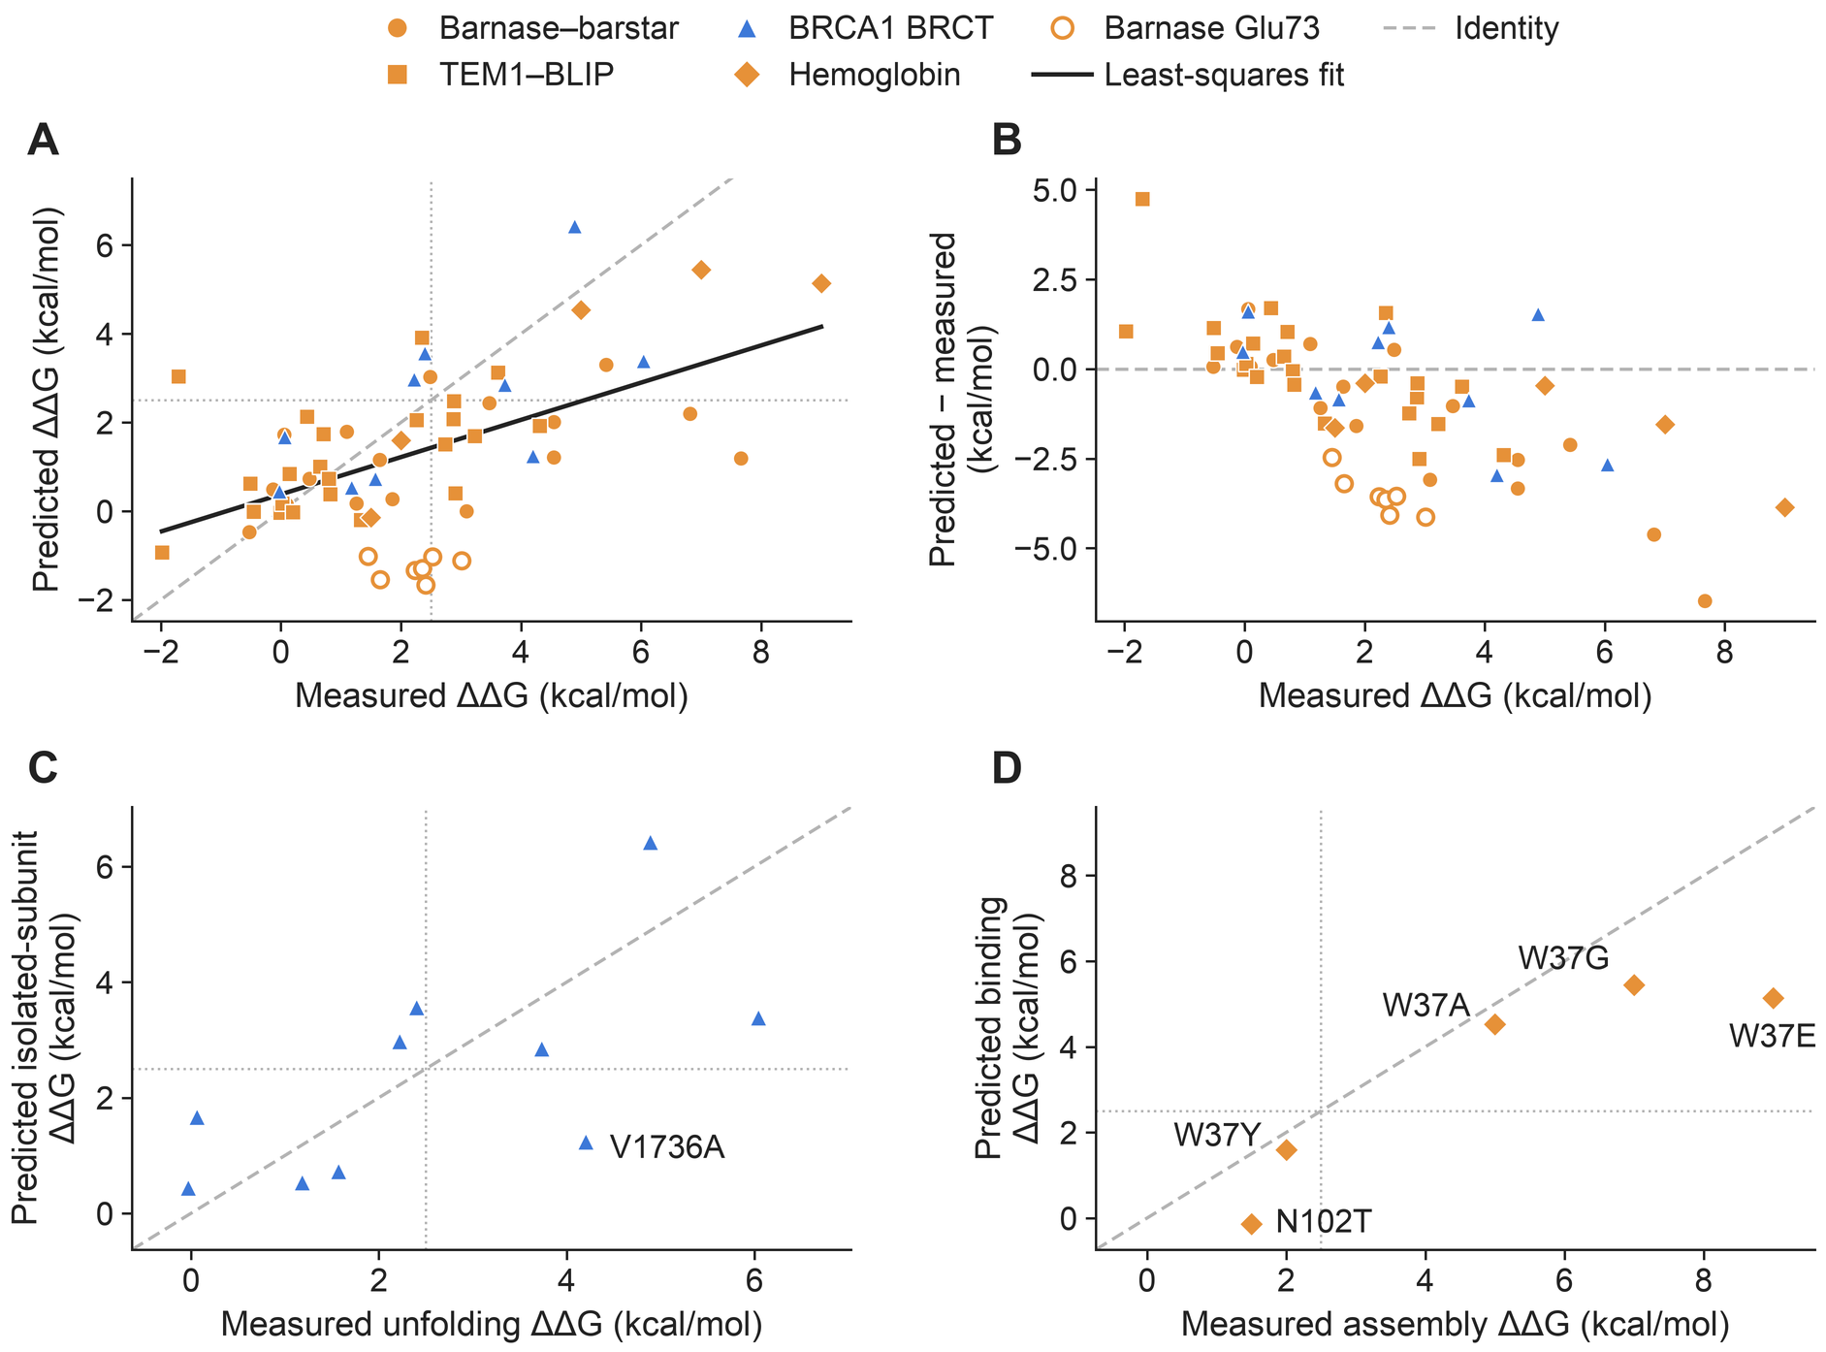
Fig 3. Predicted energies rank measured effects but compress their magnitude. (A) Predicted against measured ΔΔG for 63 comparisons from four systems, with the least-squares fit (slope 0.42) and the identity line; open symbols mark the seven barnase Glu73 substitutions. (B) Prediction error (predicted minus measured) against measured ΔΔG. (C) Isolated-subunit stability for the 10 graded BRCA1 BRCT variants against measured unfolding free energy. (D) Binding energy against measured assembly free energy for the five hemoglobin β-chain benchmark variants at the α1β2 interface. Dotted lines mark 2.5 kcal/mol; positive values are destabilizing.
Seven barnase substitutions at Glu73 behave differently from the rest. All are measured as destabilizing (1.45 to 3.01 kcal/mol) and all are predicted as stabilizing (−1.66 to −1.01 kcal/mol), a systematic sign inversion at a single site. They are included in every primary statistic. Without them the rank correlation rises to 0.63 (n = 56) while the slope barely changes (0.43), so the compression does not depend on this cluster. For the SKEMPI binding comparisons alone, ρ = 0.34 (p = 0.019, n = 48), and the predicted sign was correct for 30 of 40 measured destabilizations. Without Glu73, ρ = 0.55 (p = 0.0002, n = 41), and the sign was correct for 30 of 33 (S2 Fig). At the 2.5 kcal/mol reference, measured and predicted calls agreed for 43 of the 63 comparisons (S3 Fig).
Two axes also have direct anchors within the benchmark's own systems. Predicted isolated-subunit stability tracked measured unfolding free energy across the 10 graded BRCT variants (ρ = 0.72; Fig 3C). The only one measured above 2.5 kcal/mol but predicted below it is V1736A (measured 4.20, predicted 1.24 kcal/mol). Predicted binding tracked measured hemoglobin assembly energies (ρ = 0.90, n = 5; Fig 3D). The largest measured penalty, HBB W37E at 9.00 kcal/mol, was predicted at 5.14 kcal/mol, so magnitude is underestimated without changing any call at 2.5 kcal/mol. The benchmark contains no direct measurement of assembled-complex stability, so that axis is tested only against literature-defined directions.
These comparisons support reporting the sign, rank and continuous value of each predicted energy with its replicate spread and threshold. They do not support treating a FoldX ΔΔG as a measured energy.

The priority score concentrates structural mechanisms at the top of the ranking
The priority score combines a context component and an energy component (Methods), and we first tested each alone on the 46-variant prioritization population. The structural-context tier uses no energy. It placed 17 of the 21 structural-mechanism variants in Tier 1 or 2 (sensitivity 0.810, 95% confidence interval 0.581–0.946) together with 12 of the 25 no-lesion variants (specificity 0.520, 0.313–0.722; Fisher p = 0.032, within-system permutation p = 0.165). The tier is therefore permissive and, on this cohort, not separated from chance once system membership is held fixed. Because it cannot identify which process is affected, it never overrides an axis energy. Interface status alone was comparably specific (0.720) and recovered 15 of the 21 mechanisms, and the interface bonus is what promotes those 15 (S2 Table, context_comparators sheet; S4 Fig). On the 26 variants whose every committed axis has E1 to E3 support, sensitivity was unchanged at 0.812 and specificity was 0.600 (S1 Text).
We measured ranking quality by the ROC AUC, the probability that a randomly chosen structural-mechanism variant outranks a randomly chosen no-lesion variant. The energy component alone reached an AUC of 0.779 and placed 15 of the 21 mechanisms in the top 20, and 16 by rank 25. The context component alone reached 0.785 and recovered 11 mechanisms in the top 20 and 13 by rank 25. The two components fail on different variants. Crossing the energy calls with the tier gives four descriptive evidence states, according to whether an axis fires and whether the tier is 1–2: convergent, energy only, context only and neither. At 2.5 kcal/mol, 15 mechanisms are convergent, 2 are context-only and 4 fall in the neither state, while the energy-only state holds 3 no-lesion variants and no mechanism. At 1.0 kcal/mol the energy-only state holds 6 no-lesion variants and 2 mechanisms (S3 Table, evidence_states sheet). At the reference threshold, an energy call without supporting structural context marks a no-lesion variant in this cohort, but that separation does not hold at the screening default.
Combining the two components recovered what neither reaches alone (Fig 4). The priority score placed 9 of the 21 structural mechanisms in the top 10 and 17 in the top 20, with no further recovery by rank 25. Its ROC AUC was 0.834 and its average precision 0.779, against a positive rate of 21 in 46; without the four whole-variant no-lesion variants, the AUC was 0.837. The ranking applies no energy threshold, and its positive class comes from the curated mechanism class, so none of these values depends on the threshold.
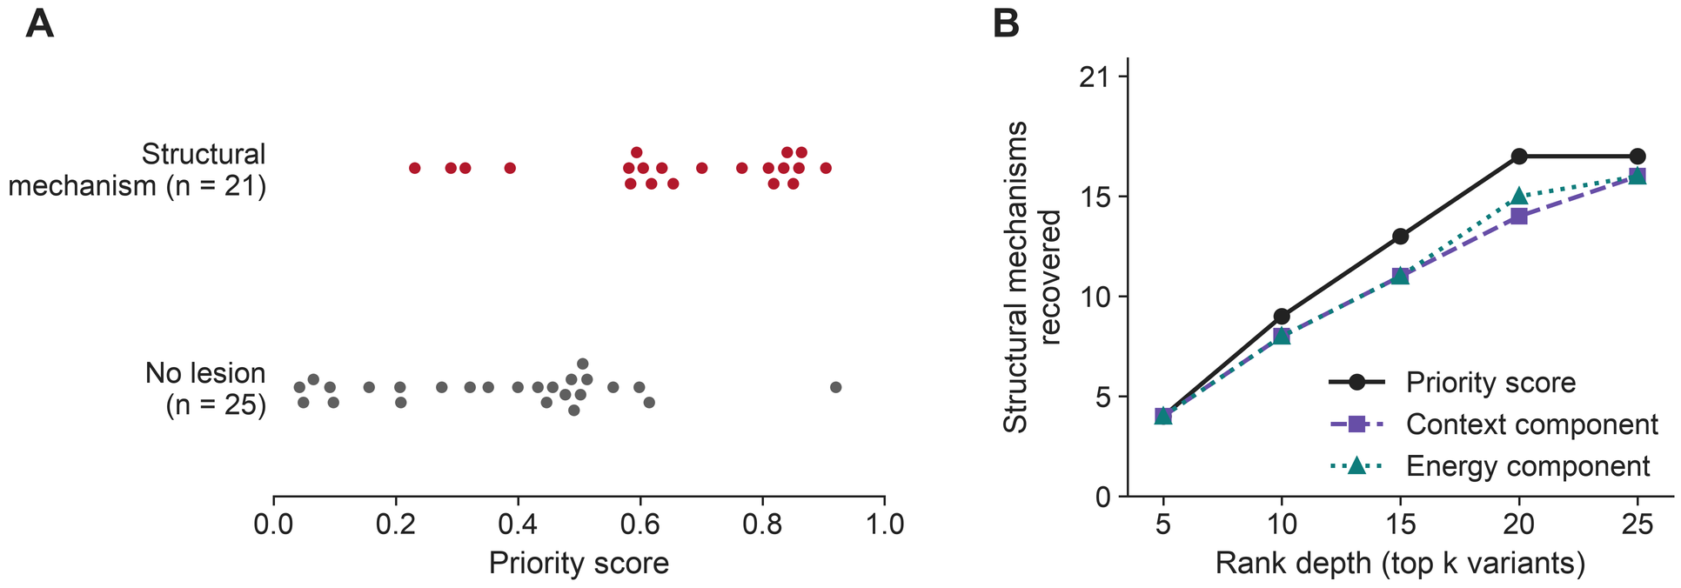
Fig 4. The priority score concentrates structural mechanisms at the top of the ranking. (A) Priority scores of the 21 structural-mechanism and 25 no-lesion variants in the 46-variant prioritization population. (B) Structural mechanisms recovered as a function of rank depth for the priority score and for its context and energy components ranked alone.
A high rank does not guarantee a correct mechanism. Of the 17 structural mechanisms in the top 20, 5 are graded consistent, 10 partial and 2 inconsistent. The four outside it are KRAS G12D and G12V, MLH1 H718Y and SMAD4 I500V, at ranks 32 to 38 — the four expectations whose measured magnitudes are smallest, none reaching the 2.5 kcal/mol reference. The two inconsistent cases, MLH1 R755W and PIK3CA E545K, fail the same way. FoldX returns a large favorable interaction energy for each (−9.7 and −4.6 kcal/mol), which COMAVI reads as strengthened binding. For E545K the axis is right but the direction is wrong, because releasing the inhibitory contact with p85 is energetically favorable [40]. For R755W the literature reports reduced abundance with binding preserved [32,36], and neither stability prediction reaches the threshold (0.97 kcal/mol for the isolated subunit and −0.94 in the complex). These two variants would send a user to the right protein with the wrong experiment (S3 Text).

Structural prioritization and pathogenicity prediction answer different questions
Clinical annotation and modeled structural disruption come apart inside this cohort. Of the 36 pathogenic variants in the 47 that carry both a clinical label and an AlphaMissense score, 14 are curated to carry no lesion on any modeled axis and 19 carry a structural mechanism; the remaining 3 are ungraded. Two fifths of the pathogenic class is therefore invisible to a structural method by construction, which is the strongest statement the benchmark makes about the two properties being distinct.
Rank-based comparison with a pathogenicity predictor is correspondingly limited. All 11 benign variants in this set entered the benchmark as curated no-lesion controls, so any structural score separates them from pathogenic structural mechanisms partly by construction, and a pathogenicity AUC computed here measures the cohort as much as the method. With that caveat, AlphaMissense ranked pathogenicity better (ROC AUC 0.903) than the priority score (0.851) or its energy (0.836) and context (0.769) components (Fig 5). The populations also differ: this set includes TNNI3 R162W and VHL W117R, which are not graded, and lacks VWF R1334Q and A1381T, for which no AlphaMissense score was retrieved, so none of these values is comparable with the structural AUC of 0.943.
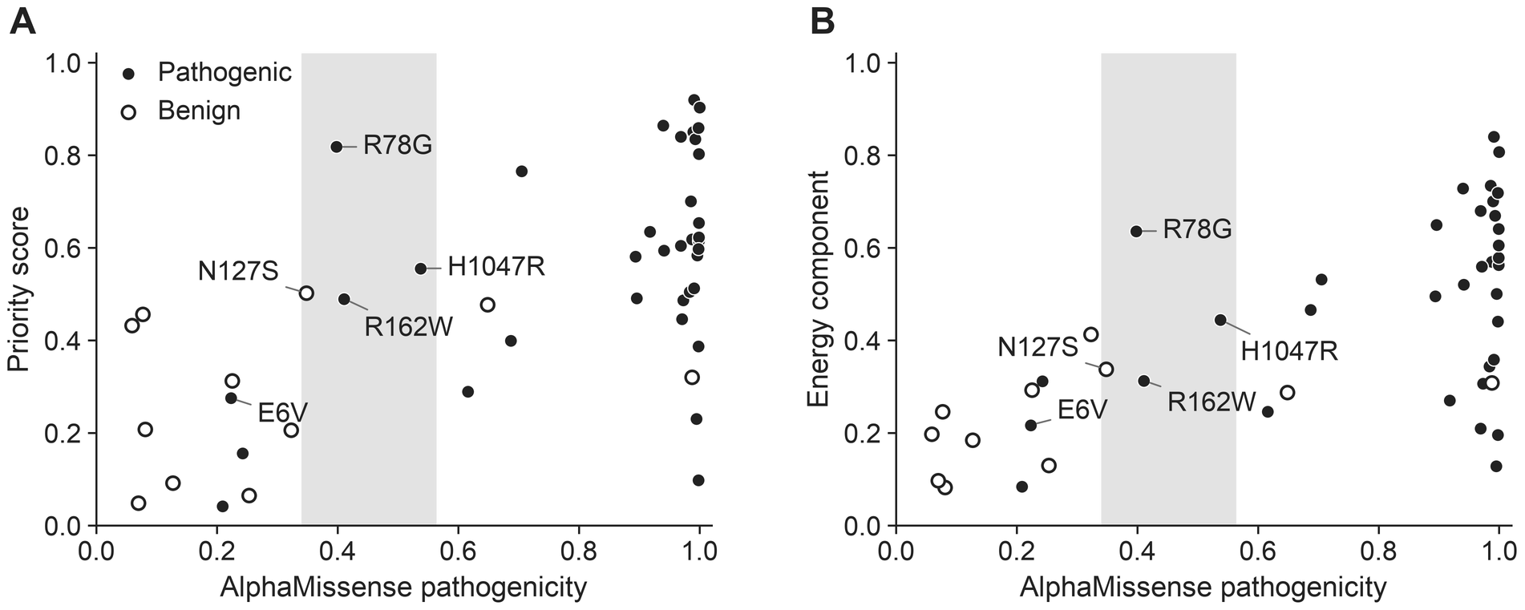
Fig 5. Pathogenicity prediction and structural prioritization rank different properties. AlphaMissense pathogenicity against (A) the priority score and (B) its energy component for the 47 complex variants with a clinical label and an AlphaMissense score. Filled circles, pathogenic (including gain of function); open circles, benign; gray band, the AlphaMissense ambiguous range (0.34–0.564). Labelled variants are discussed in the text.
Discordant variants show what each view adds. HBB E6V is pathogenic but scores low on both AlphaMissense (0.223) and the priority score (0.275), because its mechanism is absent from the supplied model. CFH R78G has a high priority score (0.818) and a named binding lesion. PIK3CA H1047R and TNNI3 R162W sit in Tier 2 context, but neither has an energy call on any axis at the reference threshold, so COMAVI ranks them on context alone and names no mechanism. All three of these clinically pathogenic variants, R78G, H1047R and R162W, fall in the AlphaMissense ambiguous range (0.398, 0.538 and 0.411), as does one benign variant, MSH2 N127S. Where the pathogenicity score is least decided, the structural profile supplies a named mechanism for one variant and a place to look for two.
The two views are therefore asymmetric in use: a structural call supplies a testable hypothesis, whereas a silent result constrains nothing about pathogenicity (S3 Text).

Discussion

Using the two outputs
COMAVI answers two practical questions: which variants deserve structural follow-up, and which experiment should test the predicted effect. Its two outputs fail differently: the priority score carries no threshold, whereas the mechanism profile depends on the one at which a continuous energy becomes a call. A practical workflow therefore has two steps. The priority score allocates experimental effort. The signed energies for isolated-subunit stability, assembled-complex stability and binding to each partner, read with their uncertainty, threshold, tier and model limitations, then select a stability, assembly or binding experiment. A high score without an energy call is a reason to examine a site, not a named lesion.
The threshold should follow the cost of error. The 1.0 kcal/mol default suits screening, where a missed mechanism costs more than extra follow-up; 2.5 kcal/mol is the benchmark reference; and the prediction-interval bound suits settings where a false mechanistic claim is costly. These thresholds separate curated mechanisms from no-lesion variants, a different question from the 3 kcal/mol cut-off that MAVISp and related MLH1 studies use to predict cellular degradation [15,66,67]. Because each call is reported with its continuous energy, a user can re-read it at another threshold; 17 of the 56 graded variants change grade within the prespecified range (S2 Table, benchmark_variants sheet). A silent result means that the supplied static model shows no lesion at the stated threshold. It does not mean that a variant is benign, nonfunctional or unworthy of study.
COMAVI complements pathogenicity predictors, population data, functional assays and clinical interpretation tools such as Franklin [68]. Shown side by side, a pathogenicity score and the COMAVI outputs disagree in interpretable ways (Fig 5). Combining them into one score would reintroduce the conflation that separating structure from pathogenicity is meant to remove.

Relation to existing frameworks
MAVISp is the closest existing framework [15]. Both use FoldX BuildModel for stability and AnalyseComplex for interaction energy, averaged over replicates, and both report fold and binding effects separately; MAVISp also runs a consensus of predictors and covers more than a thousand proteins. COMAVI differs in three ways. First, it scores each substitution in both the isolated subunit and the assembled complex and contrasts the two, whereas the MAVISp stability module uses one structure per target and its interaction module treats interfaces separately. Second, it evaluates mechanism attribution against literature-defined expectations for each axis and against measured energies. MAVISp is validated against functional assays and clinical labels, and its authors note that interaction data are too scarce and heterogeneous to benchmark its binding module. The two designs trade scale against the availability of a measured answer. Third, COMAVI is a pipeline that runs on a user's own structures and variants, whereas MAVISp is a curated database to which new proteins are added.
Two of these differences stand on their own, independently of the pipeline. The first is the benchmark itself: every expectation carries a written basis and a citation, and an automated check enforces their agreement. The second is the comparison of predictions with measured energies rather than with other predictors.

Limitations and next tests
FoldX preserves the direction and rank of an effect better than its size, here and in the literature. Published correlations with measured stability changes range from 0.19 to 0.81, and the uncertainty of a single prediction is large [69]; evaluations report qualitative agreement more often than quantitative agreement [16]. Large destabilizations are therefore understated, stringent thresholds miss real effects, and the priority score cannot be read in experimental energy units.
A related caution applies to small effects. A variant below the threshold is reported as carrying no modeled lesion on that axis, not as having no effect. Modest destabilizations can matter where a small change in stability or affinity alters assembly or turnover, and the measured-recovery counts above show how many of them a stringent threshold discards. A study concerned with mild perturbations should therefore use the lower threshold and accept more false calls.
The benchmark is small and clustered: 56 graded variants in 14 systems, with the variants of a system sharing structures and curation. Resampling whole systems addresses this dependence but cannot replace prospective validation. The same benchmark informed the development of the priority score, so its ranking figures, including the AUC of 0.943, are in-sample estimates; the formula is frozen, which is what makes an out-of-sample test possible, but this benchmark cannot provide one. Performance was also lower on predicted than on experimental complexes, by an amount this cohort cannot resolve. Evidence is uneven as well: isolated-subunit stability and binding have direct energy anchors, assembled-complex stability has none, and five no-lesion variants are graded only at the whole-variant level.
COMAVI evaluates static coordinates. It cannot capture catalytic, dynamic, aggregative, regulatory, post-translational, ligand-dependent or other state-dependent mechanisms, so model limitations must be assessed before a silent result is interpreted.
The most informative next tests are external panels that separate folding from binding and include both disruptive and function-retaining variants. More variants in the VWF A1–GPIbα and complement factor H–C3b systems would strengthen the evidence on fold-neutral binding lesions, and SOD1, transthyretin and the dense PDZ and SH3 landscapes can test coupled tertiary, quaternary and allosteric effects [3,70,71]. The priority-score formula is frozen and should be evaluated on such panels without retuning. Extending the tier and the priority score to monomer-only systems would require a prespecified formula and prospective validation.

Conclusion
COMAVI turns a list of missense variants into a fixed priority for structural follow-up and a mechanism profile that proposes the disrupted process and the experiment to test it. On this benchmark it recovered most literature-defined mechanisms, ranked structural mechanisms near the top, and failed most often by placing a detected lesion on the wrong axis. Its value lies in directing experiments, not in predicting pathogenicity.

Materials and methods

COMAVI outputs
COMAVI takes a missense variant and a structural model of its complex and calculates three FoldX energy changes: the stability of the isolated subunit, the stability calculated on the assembled coordinates and the interaction energy with each partner. A structural-context tier summarizes the local environment of the site without using energy. From these, COMAVI returns the priority score, which ranks variants by the strength of modeled structural disruption, and the mechanism profile, which keeps the signed energies, the tier, their uncertainty, the threshold and the model limitations. A profile may support an isolated-subunit effect, an assembled-complex effect, a binding effect, more than one of these, or none. The energies, the tier and the priority score are continuous. A threshold is needed only to turn the energies into the discrete calls that are graded against categorical literature expectations, so the threshold belongs to this evaluation, not to the method.

Structures and energy calculations
COMAVI scores a variant on a supplied model of a complex whose composition is known; it does not discover partners. Seven systems used experimental complex structures and seven used models from the AlphaFold 3 server (Table 1) [4]. The isolated subunit is a separate single-chain model, not a chain extracted from the complex. Eleven of the 14 systems use a single-chain AlphaFold 3 model of the relevant gene, including systems whose complex is experimental; the BRCT, VWF A1 and complement factor H systems use the experimental chain. The two stability axes are therefore calculated on different coordinates. That difference is what makes the contrast between them informative, and it is also a source of error. Energies were calculated with FoldX 5.1 [72,73] using default energy-function parameters. Energies are reported in kcal/mol, the convention of the stability literature; 1 kcal/mol is 4.184 kJ/mol. Each structure was repaired once with RepairPDB. BuildModel was run five times per variant on the isolated subunit and on the assembled complex, and AnalyseComplex was applied to each mutant complex to obtain the change in interaction energy with each partner. ΔΔG is mutant minus wild type in kcal/mol, so positive values are destabilizing; the axis value is the mean over replicates, and the replicate standard deviation is kept. Summary outputs use the most disruptive partner, and partner-level values remain available. Running BuildModel and AnalyseComplex separately keeps an interface-localized fold signal from being read as a binding change. S1 Text gives the commands.

Structural confidence
FoldX calculates ΔΔG from the supplied coordinates, and the predicted local distance difference test (pLDDT) of an AlphaFold model does not rescale these energies. Instead pLDDT decides whether a predicted axis is used at all, using the confidence bands of the AlphaFold database [74]. Two thresholds act at once rather than defining alternative settings. An axis is admitted when the pLDDT at the variant site reaches 50. The isolated-subunit axis follows the site pLDDT in the single-chain model, and each partner's axes follow the site pLDDT in the complex. An axis below 50 contributes neither a mechanism call nor a term to the priority score, and that partner adds no contacts, interface occupancy or burial to the tier. At 70 the derived confidence of a variant's energies is upgraded from medium to high, which the concordance analyses use. Independently of either, the tier's context score is multiplied by 0.7 when the best site pLDDT lies between 50 and 70 and by 0.4 below 50; experimental structures are not attenuated.

Structural-context tier and priority score
The structural-context tier describes how strongly a site is embedded in features that make it sensitive to substitution. It contains no energy and is not a mechanism call. It combines substitution severity, scored by the Grantham distance [75], with local contacts, interface occupancy, burial and model confidence. The fixed total maps to Tier 1 (strongest context) through Tier 4 (weakest), and S1 Text gives the weights and cut-offs. Because interface occupancy contributes directly to the tier, we compared the full tier with interface status alone and with the tier recalculated without its interface bonus (S2 Text).
The integrated structural-disruption score (ISDS-v1), called the priority score here, combines energy and context with a fixed formula: the same reference values and tier mapping apply to every variant set, and no coefficient is fitted to the cohort. For each confidence-passing energy j, |ΔΔG_{j}| is divided by a reference value τ_{j} of 2.9 kcal/mol for the two stability axes and 3.5 kcal/mol for binding. These are the upper bounds of the published FoldX 95% prediction intervals [69]. Here they serve as divisors that put the three axes on one scale, not as cut-offs, so an energy below τ_{j} still contributes. The largest ratio represents the strongest reliable energetic signal without summing correlated stability effects:
$$R = \max_{j} \frac{|{ΔΔG}_{j}|}{τ_{j}}$$
R is compressed so that a single extreme prediction cannot dominate the ranking:
$$E = \frac{R}{1 + R}$$
The tier T is converted to a context component C, which maps Tiers 1 to 4 to 1, 2/3, 1/3 and 0:
$$C = \frac{4 − T}{3}$$
The priority score weights the two components equally:
$$S = \frac{E + C}{2}$$
The priority score does not change with the threshold used for mechanism calls, and the prioritization results below therefore hold at every threshold. It is not a pathogenicity probability, it does not identify the disrupted process, and no binary cut-off on it has been validated. The Tier 1–2 cut-off is used only in the descriptive comparator analyses.

Energy thresholds and evidence states
A predicted energy becomes a call on an axis when its absolute value reaches the threshold. Five operating points were fixed before scoring: uniform thresholds of 1.0, 1.5, 2.0 and 2.5 kcal/mol, and the prediction-interval bound. The bound takes, separately for each axis, the upper limit of the 95% prediction interval fitted to FoldX folding and binding predictions [69]: 2.9 kcal/mol for isolated-subunit stability, 2.9 for assembled-complex stability and 3.5 for binding. A call that survives the bound is unlikely to arise from prediction error alone. The released software uses 1.0 kcal/mol as a screening default, and 2.5 kcal/mol is the benchmark reference. S3 Table (threshold_sweep sheet) reports post hoc points above the bound. Crossing the energy calls with the tier (Tier 1–2 against Tier 3–4) defines four descriptive evidence states: convergent, energy only, context only and neither (S2 Text).

Benchmark curation
The primary literature defined the expected direction on each applicable axis, and each expectation was classified by what its source measured. Class E1, quantitative energetic, is a reported thermodynamic or kinetic quantity for the substitution, such as a melting-temperature shift, an unfolding free energy or a dissociation constant. E2, quantitative functional, is a numerical assay readout that stands in for one of these, such as a deep-mutational-scanning abundance or interaction score. E3, qualitative experimental, is a direct observation reported without a number, such as loss of co-immunoprecipitation. E4, population frequency, is inference from allele frequency or constraint without an assay of the variant. E5, inferred, is an expectation implied by an established mechanism without a measurement of that axis; a variant shown to bind normally while losing catalytic activity, for example, implies a neutral binding axis. The absence of an assay was never treated as evidence: without a published result implying the axis state, the axis was left uncommitted. S1 Table gives the class, basis and citation of all 99 committed expectations, and an automated check enforces agreement between each committed direction and its written basis (S3 Text). Expectations were curated from the primary literature; during development, expectations found to contradict their own written basis were corrected, and every correction is recorded with its reason (S3 Text).
For each variant, we asked whether the supplied structure contains the context its known mechanism needs: the relevant partner, ligand, modification, oligomeric state and conformation. When the context was absent, a silent result could not test the mechanism and was treated as a limitation of the model, not as negative evidence. The isolated BRCT structure, for example, represents fold energetics but not phosphopeptide recognition by R1699L and R1699Q; HBB E6V requires the deoxygenated polymerization state; VHL Y98H lacks the bound hypoxia-inducible factor peptide; and CALM1 N98S depends on calcium-linked dynamics. S2 Table (model_scope sheet) gives the rules.

Outcomes and statistics
The mechanism-pattern score is the mean of a three-level grade (Table 3): 1 for a fully consistent whole-variant pattern, 0.5 for a partly correct multi-axis pattern and 0 for an inconsistent pattern. It is a weighted mechanism consistency, not exact-match accuracy, and unknown or inapplicable axes are omitted. Direction agreement counts, for each axis, the expectations whose call matches the committed direction, irrespective of the size of the predicted energy. Detection, attribution and correct rejection ask the same question as binary rates (Table 2).
Table 3. Whole-variant grading rubric.
Condition | Grade | Score
No-lesion variant, and no modeled energy effect at the threshold | Consistent | 1.0
All expected effects recovered in the correct direction, with no unsupported effect | Consistent | 1.0
All expected effects recovered, but an axis expected to be neutral also reaches the threshold | Partial | 0.5
One of several expected effects missed, without an unsupported effect | Partial | 0.5
Predicted change opposite in direction to the expected effect | Inconsistent | 0.0
No-lesion variant with an energy call; expected effect missed entirely; or a missed effect with a wrong call | Inconsistent | 0.0
Structure unusable, required context absent, mechanism not established or no applicable axis | Not graded | –
Each graded variant receives one grade at each threshold; the mechanism-pattern score is the mean grade.
Variants are named as their primary literature names them. For 53 of the 61 that is the numbering of the UniProt reference sequence; the six HBB variants use mature-chain numbering, so HBB E6V is p.Glu7Val. Two benign controls are named in the reverse direction, because the deposited structure each was modeled on carries the substituted residue rather than the reference one. 2WII carries Ile where the reference sequence has Val62, and 1SQ0 carries Ala where it has Thr1381. The calculations labelled CFH I62V and VWF A1381T are therefore the reverse of p.Val62Ile and p.Thr1381Ala. Both are curated no-lesion controls, and on each of the three axes both predict below 0.72 kcal/mol, under the lowest threshold considered, so the direction of the calculation affects no reported result.
A measured destabilization counts as recovered at a threshold when the predicted energy reaches that threshold with the same sign; the population is every comparison with a measured destabilization of at least 1.0 kcal/mol. Calibration used Spearman correlation and least-squares regression of predicted on measured ΔΔG.
For prioritization, the positive class is the 21 structural-mechanism variants and the negative class the 25 no-lesion variants in the 46-variant population. Average precision summarizes precision over the recall curve, and top-k recovery counts the structural mechanisms among the k highest-ranked variants. Alternative formulas, score bands and component analyses are internal sensitivity analyses, because the same benchmark informed the development of the score (S2 Text; S5 Fig). Within-system permutation tests for the tier screens used exact convolved hypergeometric distributions.
Variants in a system share structures and curation, so the main uncertainty analysis resampled whole systems (2,000 draws). We also report leave-one-system-out values, variant-level bootstrap intervals, label permutations and replicate noise; S1 Text lists the seeds and draw counts. Confidence intervals for proportions are exact binomial intervals.

Software and code
Scoring and statistics used Python 3.11 with pandas 2.3.3, NumPy 2.4.6, SciPy 1.17.1 and scikit-learn 1.9.0. Code, reference outputs, figure sources and regression tests are available at https://github.com/la424/comavi. The priority score is implemented once in a shared engine, so benchmark and external runs receive the same versioned fields. FoldX, which is licensed separately, and the large collections of structural inputs are not redistributed.

Acknowledgments
[ACKNOWLEDGMENTS TO BE SUPPLIED]

References
1. Cheng J, Novati G, Pan J, Bycroft C, Žemgulytė A, Applebaum T, et al. Accurate proteome-wide missense variant effect prediction with AlphaMissense. Science. 2023;381(6664):eadg7492. doi:10.1126/science.adg7492
2. Ye C, Benegas G, Albors C, Li JC, Prillo S, Fields PD, et al. Predicting genome-wide functional constraints with GPN-Star. Nature. 2026. doi:10.1038/s41586-026-11005-5
3. Faure AJ, Domingo J, Schmiedel JM, Hidalgo-Carcedo C, Diss G, Lehner B. Mapping the energetic and allosteric landscapes of protein binding domains. Nature. 2022;604(7904):175–183. doi:10.1038/s41586-022-04586-4
4. Abramson J, Adler J, Dunger J, Evans R, Green T, Pritzel A, et al. Accurate structure prediction of biomolecular interactions with AlphaFold 3. Nature. 2024;630(8016):493–500. doi:10.1038/s41586-024-07487-w
5. Wohlwend J, Corso G, Passaro S, Getz N, Reveiz M, Leidal K, et al. Boltz-1: democratizing biomolecular interaction modeling. bioRxiv [Preprint]. 2024. doi:10.1101/2024.11.19.624167
6. Passaro S, Corso G, Wohlwend J, Reveiz M, Thaler S, Somnath VR, et al. Boltz-2: towards accurate and efficient binding affinity prediction. bioRxiv [Preprint]. 2025. doi:10.1101/2025.06.14.659707
7. Arnaudi M, Utichi M, Tiberti M, Papaleo E. Predicting the structure-altering mechanisms of disease variants. Curr Opin Struct Biol. 2025;91:102994. doi:10.1016/j.sbi.2025.102994
8. Khanna T, Hanna G, Sternberg MJE, David A. Missense3D-DB web catalogue: an atom-based analysis and repository of 4M human protein-coding genetic variants. Hum Genet. 2021;140(5):805–812. doi:10.1007/s00439-020-02246-z
9. Woodard J, Zhang C, Zhang Y. ADDRESS: a database of disease-associated human variants incorporating protein structure and folding stabilities. J Mol Biol. 2021;433(11):166840. doi:10.1016/j.jmb.2021.166840
10. Philipp M, Moth CW, Ristic N, Tiemann JKS, Seufert F, Panfilova A, et al. MutationExplorer: a webserver for mutation of proteins and 3D visualization of energetic impacts. Nucleic Acids Res. 2024;52(W1):W132–W139. doi:10.1093/nar/gkae301
11. Moth CW, Sheehan JH, Al Mamun A, Sivley RM, Gulsevin A, Rinker DC, et al. VUStruct: a compute pipeline for high throughput and personalized structural biology. PLoS Comput Biol. 2026;22(5):e1014183. doi:10.1371/journal.pcbi.1014183
12. Kwon S, Safer J, Nguyen DT, Hoksza D, May P, Arbesfeld JA, et al. Genomics 2 Proteins portal: a resource and discovery tool for linking genetic screening outputs to protein sequences and structures. Nat Methods. 2024;21(10):1947–1957. doi:10.1038/s41592-024-02409-0
13. Stephenson JD, Totoo P, Burke DF, Jänes J, Beltrao P, Martin MJ. ProtVar: mapping and contextualizing human missense variation. Nucleic Acids Res. 2024;52(W1):W140–W147. doi:10.1093/nar/gkae413
14. Witvliet DK, Strokach A, Giraldo-Forero AF, Teyra J, Colak R, Kim PM. ELASPIC web-server: proteome-wide structure-based prediction of mutation effects on protein stability and binding affinity. Bioinformatics. 2016;32(10):1589–1591. doi:10.1093/bioinformatics/btw031
15. Arnaudi M, Utichi M, Degn K, Tiberti M, Beltrame L, Krzesińska K, et al. MAVISp: a modular structure-based framework for protein variant effects. Protein Sci. 2026;35(5):e70548. doi:10.1002/pro.70548
16. Buß O, Rudat J, Ochsenreither K. FoldX as protein engineering tool: better than random based approaches? Comput Struct Biotechnol J. 2018;16:25–33. doi:10.1016/j.csbj.2018.01.002
17. Rodrigues CHM, Myung Y, Pires DEV, Ascher DB. mCSM-PPI2: predicting the effects of mutations on protein–protein interactions. Nucleic Acids Res. 2019;47(W1):W338–W344. doi:10.1093/nar/gkz383
18. Montanucci L, Capriotti E, Frank Y, Ben-Tal N, Fariselli P. DDGun: an untrained method for the prediction of protein stability changes upon single and multiple point variations. BMC Bioinformatics. 2019;20(Suppl 14):335. doi:10.1186/s12859-019-2923-1
19. Livesey BJ, Marsh JA. Using deep mutational scanning to benchmark variant effect predictors and identify disease mutations. Mol Syst Biol. 2020;16(7):e9380. doi:10.15252/msb.20199380
20. Blaabjerg LM, Kassem MM, Good LL, Jonsson N, Cagiada M, Johansson KE, et al. Rapid protein stability prediction using deep learning representations. eLife. 2023;12:e82593. doi:10.7554/eLife.82593
21. Sora V, Laspiur AO, Degn K, Arnaudi M, Utichi M, Beltrame L, et al. RosettaDDGPrediction for high-throughput mutational scans: from stability to binding. Protein Sci. 2023;32(1):e4527. doi:10.1002/pro.4527
22. Degn K, Utichi M, Sánchez-Izquierdo Besora P, Tiberti M, Papaleo E. In-silico stability predictors: investigation of performance towards balanced experimental data. bioRxiv [Preprint]. 2025. doi:10.1101/2025.03.28.645695
23. Vliora A, Tiberti M, Papaleo E. Evaluating FoldX 5.1 for MAVISp stability data collection. bioRxiv [Preprint]. 2026. doi:10.64898/2026.03.31.715598
24. Rowling PJE, Cook R, Itzhaki LS. Toward classification of BRCA1 missense variants using a biophysical approach. J Biol Chem. 2010;285(26):20080–20087. doi:10.1074/jbc.M109.088922
25. Clark KA, Paquette A, Tao K, Bell R, Boyle JL, Rosenthal J, et al. Comprehensive evaluation and efficient classification of BRCA1 RING domain missense substitutions. Am J Hum Genet. 2022;109(6):1153–1174. doi:10.1016/j.ajhg.2022.05.004
26. Starita LM, Young DL, Islam M, Kitzman JO, Gullingsrud J, Hause RJ, et al. Massively parallel functional analysis of BRCA1 RING domain variants. Genetics. 2015;200(2):413–422. doi:10.1534/genetics.115.175802
27. Brzovic PS, Meza J, King MC, Klevit RE. The cancer-predisposing mutation C61G disrupts homodimer formation in the NH2-terminal BRCA1 RING finger domain. J Biol Chem. 1998;273(14):7795–7799. doi:10.1074/jbc.273.14.7795
28. Roehm PC, Berg JM. Sequential metal binding by the RING finger domain of BRCA1. Biochemistry. 1997;36(33):10240–10245. doi:10.1021/bi970863d
29. Crotti L, Johnson CN, Graf E, De Ferrari GM, Cuneo BF, Ovadia M, et al. Calmodulin mutations associated with recurrent cardiac arrest in infants. Circulation. 2013;127(9):1009–1017. doi:10.1161/CIRCULATIONAHA.112.001216
30. Nyegaard M, Overgaard MT, Søndergaard MT, Vranas M, Behr ER, Hildebrandt LL, et al. Mutations in calmodulin cause ventricular tachycardia and sudden cardiac death. Am J Hum Genet. 2012;91(4):703–712. doi:10.1016/j.ajhg.2012.08.015
31. Hunter JC, Manandhar A, Carrasco MA, Gurbani D, Gondi S, Westover KD. Biochemical and structural analysis of common cancer-associated KRAS mutations. Mol Cancer Res. 2015;13(9):1325–1335. doi:10.1158/1541-7786.MCR-15-0203
32. Kosinski J, Hinrichsen I, Bujnicki JM, Friedhoff P, Plotz G. Identification of Lynch syndrome mutations in the MLH1-PMS2 interface that disturb dimerization and mismatch repair. Hum Mutat. 2010;31(8):975–982. doi:10.1002/humu.21301
33. Raevaara TE, Korhonen MK, Lohi H, Hampel H, Lynch E, Lönnqvist KE, et al. Functional significance and clinical phenotype of nontruncating mismatch repair variants of MLH1. Gastroenterology. 2005;129(2):537–549. doi:10.1053/j.gastro.2005.06.005
34. Drost M, Tiersma Y, Thompson BA, Frederiksen JH, Keijzers G, Glubb D, et al. A functional assay-based procedure to classify mismatch repair gene variants in Lynch syndrome. Genet Med. 2019;21(7):1486–1496. doi:10.1038/s41436-018-0372-2
35. Thompson BA, Spurdle AB, Plazzer JP, Greenblatt MS, Akagi K, Al-Mulla F, et al. Application of a 5-tiered scheme for standardized classification of 2,360 unique mismatch repair gene variants in the InSiGHT locus-specific database. Nat Genet. 2014;46(2):107–115. doi:10.1038/ng.2854
36. Larsen-Ledet S, Panfilova A, Stein A. Disentangling the mutational effects on protein stability and interaction of human MLH1. PLoS Genet. 2025;21(4):e1011681. doi:10.1371/journal.pgen.1011681
37. Ollila S, Sarantaus L, Kariola R, Chan P, Hampel H, Holinski–Feder E, et al. Pathogenicity of MSH2 missense mutations is typically associated with impaired repair capability of the mutated protein. Gastroenterology. 2006;131(5):1408–1417. doi:10.1053/j.gastro.2006.08.044
38. Ollila S, Dermadi Bebek D, Jiricny J, Nyström M. Mechanisms of pathogenicity in human MSH2 missense mutants. Hum Mutat. 2008;29(11):1355–1363. doi:10.1002/humu.20893
39. Jia X, Burugula BB, Chen V, Lemons RM, Jayakody S, Maksutova M, et al. Massively parallel functional testing of MSH2 missense variants conferring Lynch syndrome risk. Am J Hum Genet. 2021;108(1):163–175. doi:10.1016/j.ajhg.2020.12.003
40. Zhao L, Vogt PK. Helical domain and kinase domain mutations in p110α of phosphatidylinositol 3-kinase induce gain of function by different mechanisms. Proc Natl Acad Sci USA. 2008;105(7):2652–2657. doi:10.1073/pnas.0712169105
41. Mandelker D, Gabelli SB, Schmidt-Kittler O, Zhu J, Cheong I, Huang CH, et al. A frequent kinase domain mutation that changes the interaction between PI3Kα and the membrane. Proc Natl Acad Sci USA. 2009;106(40):16996–17001. doi:10.1073/pnas.0908444106
42. Jaiswal BS, Janakiraman V, Kljavin NM, Chaudhuri S, Stern HM, Wang W, et al. Somatic mutations in p85α promote tumorigenesis through class IA PI3K activation. Cancer Cell. 2009;16(6):463–474. doi:10.1016/j.ccr.2009.10.016
43. De Bosscher K, Hill CS, Nicolás FJ. Molecular and functional consequences of Smad4 C-terminal missense mutations in colorectal tumour cells. Biochem J. 2004;379(Pt 1):209–216. doi:10.1042/bj20031886
44. Le Goff C, Mahaut C, Abhyankar A, Le Goff W, Serre V, Afenjar A, et al. Mutations at a single codon in Mad homology 2 domain of SMAD4 cause Myhre syndrome. Nat Genet. 2012;44(1):85–88. doi:10.1038/ng.1016
45. Lanauze CB, Sehgal P, Hayer K, Torres-Diz M, Pippin JA, Grant SFA, et al. Colorectal cancer-associated Smad4 R361 hotspot mutations boost Wnt/β-catenin signaling through enhanced Smad4-LEF1 binding. Mol Cancer Res. 2021;19(5):823–833. doi:10.1158/1541-7786.MCR-20-0721
46. Elliott K, Watkins H, Redwood CS. Altered regulatory properties of human cardiac troponin I mutants that cause hypertrophic cardiomyopathy. J Biol Chem. 2000;275(29):22069–22074. doi:10.1074/jbc.M002502200
47. Frazier A, Judge DP, Schulman SP, Johnson N, Holmes KW, Murphy AM. Familial hypertrophic cardiomyopathy associated with cardiac β-myosin heavy chain and troponin I mutations. Pediatr Cardiol. 2008;29(4):846–850. doi:10.1007/s00246-007-9177-9
48. Takahashi-Yanaga F, Morimoto S, Harada K, Minakami R, Shiraishi F, Ohta M, et al. Functional consequences of the mutations in human cardiac troponin I gene found in familial hypertrophic cardiomyopathy. J Mol Cell Cardiol. 2001;33(12):2095–2107. doi:10.1006/jmcc.2001.1473
49. Stebbins CE, Kaelin WG Jr, Pavletich NP. Structure of the VHL-ElonginC-ElonginB complex: implications for VHL tumor suppressor function. Science. 1999;284(5413):455–461. doi:10.1126/science.284.5413.455
50. Ohh M, Park CW, Ivan M, Hoffman MA, Kim TY, Huang LE, et al. Ubiquitination of hypoxia-inducible factor requires direct binding to the β-domain of the von Hippel-Lindau protein. Nat Cell Biol. 2000;2(7):423–427. doi:10.1038/35017054
51. Pechtl IC, Kavanagh D, McIntosh N, Harris CL, Barlow PN. Disease-associated N-terminal complement factor H mutations perturb cofactor and decay-accelerating activities. J Biol Chem. 2011;286(13):11082–11090. doi:10.1074/jbc.M110.211839
52. Tischer A, Moon-Tasson L, Auton M. Structure-resolved dynamics of type 2M von Willebrand disease. J Thromb Haemost. 2025;23(4):1215–1228. doi:10.1016/j.jtha.2024.12.026
53. Eaton WA, Hofrichter J. Sickle cell hemoglobin polymerization. Adv Protein Chem. 1990;40:63–279. doi:10.1016/S0065-3233(08)60287-9
54. Kiger L, Klinger AL, Kwiatkowski LD, De Young A, Doyle ML, Holt JM, et al. Thermodynamic studies on the equilibrium properties of a series of recombinant βW37 hemoglobin mutants. Biochemistry. 1998;37(13):4336–4345. doi:10.1021/bi970868a
55. Kwiatkowski LD, Hui HL, Wierzba A, Noble RW, Walder RY, Peterson ES, et al. Preparation and kinetic characterization of a series of βW37 variants of human hemoglobin A: evidence for high-affinity T quaternary structures. Biochemistry. 1998;37(13):4325–4335. doi:10.1021/bi970866q
56. Bonaventura J, Riggs A. Hemoglobin Kansas, a human hemoglobin with a neutral amino acid substitution and an abnormal oxygen equilibrium. J Biol Chem. 1968;243(5):980–991. doi:10.1016/S0021-9258(18)93612-4
57. Karczewski KJ, Francioli LC, Tiao G, Cummings BB, Alföldi J, Wang Q, et al. The mutational constraint spectrum quantified from variation in 141,456 humans. Nature. 2020;581(7809):434–443. doi:10.1038/s41586-020-2308-7
58. Landrum MJ, Lee JM, Benson M, Brown GR, Chao C, Chitipiralla S, et al. ClinVar: improving access to variant interpretations and supporting evidence. Nucleic Acids Res. 2018;46(D1):D1062–D1067. doi:10.1093/nar/gkx1153
59. Williams RS, Green R, Glover JN. Crystal structure of the BRCT repeat region from the breast cancer-associated protein BRCA1. Nat Struct Biol. 2001;8(10):838–842. doi:10.1038/nsb1001-838
60. Brzovic PS, Rajagopal P, Hoyt DW, King MC, Klevit RE. Structure of a BRCA1-BARD1 heterodimeric RING-RING complex. Nat Struct Biol. 2001;8(10):833–837. doi:10.1038/nsb1001-833
61. Wu J, Wu YQ, Ricklin D, Janssen BJC, Lambris JD, Gros P. Structure of complement fragment C3b-factor H and implications for host protection by complement regulators. Nat Immunol. 2009;10(7):728–733. doi:10.1038/ni.1755
62. Fermi G, Perutz MF, Shaanan B, Fourme R. The crystal structure of human deoxyhaemoglobin at 1.74 Å resolution. J Mol Biol. 1984;175(2):159–174. doi:10.1016/0022-2836(84)90472-8
63. Tran TH, Chan AH, Young LC, Bindu L, Neale C, Messing S, et al. KRAS interaction with RAF1 RAS-binding domain and cysteine-rich domain provides insights into RAS-mediated RAF activation. Nat Commun. 2021;12(1):1176. doi:10.1038/s41467-021-21422-x
64. Dumas JJ, Kumar R, McDonagh T, Sullivan F, Stahl ML, Somers WS, et al. Crystal structure of the wild-type von Willebrand factor A1-glycoprotein Ibα complex reveals conformation differences with a complex bearing von Willebrand disease mutations. J Biol Chem. 2004;279(22):23327–23334. doi:10.1074/jbc.M401659200
65. Jankauskaitė J, Jiménez-García B, Dapkūnas J, Fernández-Recio J, Moal IH. SKEMPI 2.0: an updated benchmark of changes in protein–protein binding energy, kinetics and thermodynamics upon mutation. Bioinformatics. 2019;35(3):462–469. doi:10.1093/bioinformatics/bty635
66. Abildgaard AB, Stein A, Nielsen SV, Schultz-Knudsen K, Papaleo E, Shrikhande A, et al. Computational and cellular studies reveal structural destabilization and degradation of MLH1 variants in Lynch syndrome. eLife. 2019;8:e49138. doi:10.7554/eLife.49138
67. Nielsen SV, Stein A, Dinitzen AB, Papaleo E, Tatham MH, Poulsen EG, et al. Predicting the impact of Lynch syndrome-causing missense mutations from structural calculations. PLoS Genet. 2017;13(4):e1006739. doi:10.1371/journal.pgen.1006739
68. Franklin by Genoox [Internet]. Genoox; c2026 [cited <ACCESS DATE>]. Available from: https://franklin.genoox.com
69. Sapozhnikov Y, Patel JS, Ytreberg FM, Miller CR. Statistical modeling to quantify the uncertainty of FoldX-predicted protein folding and binding stability. BMC Bioinformatics. 2023;24:426. doi:10.1186/s12859-023-05537-0
70. Vassall KA, Stathopulos PB, Rumfeldt JAO, Lepock JR, Meiering EM. Equilibrium thermodynamic analysis of amyotrophic lateral sclerosis-associated mutant apo Cu,Zn superoxide dismutases. Biochemistry. 2006;45(23):7366–7379. doi:10.1021/bi0600953
71. Hurshman Babbes AR, Powers ET, Kelly JW. Quantification of the thermodynamically linked quaternary and tertiary structural stabilities of transthyretin and its disease-associated variants: the relationship between stability and amyloidosis. Biochemistry. 2008;47(26):6969–6984. doi:10.1021/bi800636q
72. Schymkowitz J, Borg J, Stricher F, Nys R, Rousseau F, Serrano L. The FoldX web server: an online force field. Nucleic Acids Res. 2005;33(Web Server issue):W382–W388. doi:10.1093/nar/gki387
73. Delgado J, Radusky LG, Cianferoni D, Serrano L. FoldX 5.0: working with RNA, small molecules and a new graphical interface. Bioinformatics. 2019;35(20):4168–4169. doi:10.1093/bioinformatics/btz184
74. Tunyasuvunakool K, Adler J, Wu Z, Green T, Zielinski M, Žídek A, et al. Highly accurate protein structure prediction for the human proteome. Nature. 2021;596(7873):590–596. doi:10.1038/s41586-021-03828-1
75. Grantham R. Amino acid difference formula to help explain protein evolution. Science. 1974;185(4154):862–864. doi:10.1126/science.185.4154.862

Supporting information
S1 Table. Committed structural expectations with their evidence basis and citation. All 99 committed axis expectations, and the four no-lesion variants graded at the whole-variant level, with evidence class, one-line basis and reference.
S2 Table. Benchmark cohort, evidence and comparator tables. Per-variant benchmark record with graded calls at every threshold, evidence composition, model scope, structural-context comparators, denominator sensitivity and fold–binding disagreements, one sheet each.
S3 Table. Operating points, evidence states and robustness tables. Threshold sweep including post hoc points, measured-effect recovery, call relationships, tier distribution, evidence states, detection metrics, pathogenicity ranking, robustness and SKEMPI 2.0 validation.
S1 Text. Implementation details, statistical conventions and evidence provenance. FoldX commands, tier weights and cut-offs, seeds and draw counts, and the evidence-restricted sensitivity analyses.
S2 Text. Sensitivity analyses, mechanism-class decomposition and operating-point diagnostics. Trivial strategies and the permutation null, grades by mechanism class, the interface-class localization error, interface ablation of the tier, evidence states and alternative priority-score formulas.
S3 Text. Pathogenicity comparison, robustness and independent validation. Silent results by clinical label, stress tests, the SKEMPI 2.0 binding check and the crossing of rank with grade.
S1 Fig. Stress tests of the mechanism-pattern score. (A) Score under 2,000 permutations of the ground-truth labels, permuted as a block; the vertical line marks the observed 0.661. (B) Score over 2,000 resamples of the 14 systems; dashed lines mark the 95% interval (0.625–0.821). (C) Score with each system left out in turn; the dashed line marks the full-cohort value. (D) Score over 500 draws that add Gaussian noise at the standard error of each FoldX replicate mean.
S2 Fig. Binding-axis validation on SKEMPI 2.0. Predicted against measured binding ΔΔG for (A) 24 barnase–barstar substitutions, with the seven at barnase Glu73 as open circles, and (B) 24 TEM1–BLIP substitutions. Over all 48, ρ = 0.34; without Glu73, ρ = 0.55 (n = 41).
S3 Fig. Call relationships between predicted and measured energies at 2.5 kcal/mol. Absolute prediction error for the 63 comparisons, grouped by whether the measured and predicted calls agree (n = 43), disagree with both values within 1.0 kcal/mol of the threshold (borderline, n = 7) or disagree by more (substantive, n = 13). Gray bars mark medians; open circles, barnase Glu73.
S4 Fig. Structural-context comparators on the 46-variant prioritization population. Sensitivity on the 21 structural-mechanism variants and specificity on the 25 no-lesion variants for interface status alone, the tier without its interface bonus and the full tier (Tier 1–2).
S5 Fig. Priority-score transformation and component ranking. (A) The energy component E = R/(1 + R) as a function of the largest energy ratio R. (B) ROC curves for the priority score and its energy and context components on the 46-variant prioritization population.

