Appendix for RWU Model Instructions

This appendix will have example input files for the models used. A table of contents should be placed on this first page for accessibility.

10/21/14: need to update this document for the new input format of root_param.h5 and pflotran.in for the said parameter.

11/26/2014: Just added in information regarding the output files, but information regarding some of the post-processing and the types of graphs generated would be useful. Also, consider adding in the RSWMS format for reference.

Contents

RootTyp Input: param.txt 2

RootTyp Input: sol.txt 4

RootTyp Output: noeud.txt 5

RootBox Runtime Script: generic_name.m 6

PFLOTRAN-Root Input: pflotran.in 8

PFLOTRAN-Root Input: RootSystem.h5 13

PFLOTRAN-Root Input: root_param.h5 14

PFLOTRAN-Root Input: precipitation.dat 15

PFLOTRAN-Root Input: potential_transpiration.dat 16

PFLOTRAN-Root Output: .vtk format 17

PFLOTRAN-Root Output: .h5 format 21

# RootTyp Input: param.txt

==============================================

PARAMETERS OF SIMULATION FOR ROOT TYP - Simple Primary Root System

==============================================

50 # Simulation time [days]

1 # Number of axes

1 # Number of reiterations

200 # Date of reiteration [day]

0.8 # Coefficient to augment diameter

TYPE 0 (SEED)

0 0 # Insertion angle (avg, std dev) [rad]

0 0 # Insertion angle at reiteration (avg, std dev)

5 # Time before emergence [days]

1.2 0.3 # Max length, Initial growth rate (avg) [cm/day]

0 0 # Max length, Growth rate (std dev)

0.41 0 # Interbranch Distance (avg, std dev)

1 # Type of tropism (0 plagio, +1 and -1 geo, -2 and +2 exo)

0 # Intensity of tropism

0 # Sensitivity to mechanical constraint

0.10 # Root tip diameter [cm]

8000 # Time before necrosis begins [days]

0 # Probability of reiteration

0 0 # Min/Max number of axes for reiteration

1000 # Age at which transformation possible [days]

0 # Daily probability of transformation

-1 # Sense of transformation (-1 decrease in order, +1 increase in order)

0 1.0 0 0 0 0 0 0 # Proportion of child root 0-7

TYPE 1 (TAP)

0 0 # Insertion angle (avg, std dev) [rad]

0 0 # Insertion angle at reiteration (avg, std dev)

5 # Time before emergence [days]

300 1.5 # Max length, Initial growth rate (avg) [cm/day]

0 0 # Max length, Growth rate (std dev)

.600 0 # Interbranch Distance (avg, std dev)

1 # Type of tropism (0 plagio, +1 and -1 geo, -2 and +2 exo)

0.15 # Intensity of tropism

0.15 # Sensitivity to mechanical constraint

0.13 # Root tip diameter [cm]

8000 # Time before necrosis begins [days]

0 # Probability of reiteration

0 0 # Min/Max number of axes for reiteration

1000 # Age at which transformation possible [days]

0 # Daily probability of transformation

-1 # Sense of transformation (-1 decrease in order, +1 increase in order)

0 0 0.35 0.40 0.25 0 0 0 # Proportion of child root 0-7

TYPE 2 (LONG LATERALS)

1.8 0.04 # Insertion angle (avg, std dev) [rad]

0 0 # Insertion angle at reiteration (avg, std dev)

8 # Time before emergence [days]

300 2.500 # Max length, Initial growth rate (avg) [cm/day]

0 0 # Max length, Growth rate (std dev)

7.000 0 # Interbranch Distance (avg, std dev)

0 # Type of tropism (0 plagio, +1 and -1 geo, -2 and +2 exo)

0.04 # Intensity of tropism

0.06 # Sensitivity to mechanical constraint

0.13 # Root tip diameter [cm]

8000 # Time before necrosis begins [days]

0 # Probability of reiteration

0 0 # Min/Max number of axes for reiteration

1000 # Age at which transformation possible [days]

0 # Daily probability of transformation

-1 # Sense of transformation (-1 decrease in order, +1 increase in order)

0.4 0.0 0.4 0.2 0.40 0 0 0 # Proportion of child root 0-7

TYPE 3 (AVG LATERALS)

1.70 0.07 # Insertion angle (avg, std dev) [rad]

0 0 # Insertion angle at reiteration (avg, std dev)

8 # Time before emergence [days]

6.0 .450 # Max length, Initial growth rate (avg) [cm/day]

0 0 # Max length, Growth rate (std dev)

20.000 0 # Interbranch Distance (avg, std dev)

1 # Type of tropism (0 plagio, +1 and -1 geo, -2 and +2 exo)

0.06 # Intensity of tropism

0.4 # Sensitivity to mechanical constraint

0.07 # Root tip diameter [cm]

8000 # Time before necrosis begins [days]

0 # Probability of reiteration

0 0 # Min/Max number of axes for reiteration

1000 # Age at which transformation possible [days]

0 # Daily probability of transformation

-1 # Sense of transformation (-1 decrease in order, +1 increase in order)

0.2 0.0 0.4 0.2 0.40 0 0 0 # Proportion of child root 0-7

TYPE 4 (SHORT LATERALS)

1.30 0.07 # Insertion angle (avg, std dev) [rad]

0 0 # Insertion angle at reiteration (avg, std dev)

10 # Time before emergence [days]

1.8 0.2 # Max length, Initial growth rate (avg) [cm/day]

0 0 # Max length, Growth rate (std dev)

150.0 0 # Interbranch Distance (avg, std dev)

2 # Type of tropism (0 plagio, +1 and -1 geo, -2 and +2 exo)

0.05 # Intensity of tropism

0.4 # Sensitivity to mechanical constraint

0.03 # Root tip diameter [cm]

8000 # Time before necrosis begins [days]

0 # Probability of reiteration

0 0 # Min/Max number of axes for reiteration

1000 # Age at which transformation possible [days]

0 # Daily probability of transformation

-1 # Sense of transformation (-1 decrease in order, +1 increase in order)

1.0 0.0 0 0 1.0 0 0 0 # Proportion of child root 0-7

=========================================================

# RootTyp Input: sol.txt

Croiss Ramif ICMeca Direction contr. (0 : isotrope, 1 verticale) Sorgho

0.5 1.0 1.0 0

0.7 1.0 1.0 0

0.9 1.0 1.0 0

1.0 1.0 1.0 0

1.0 1.0 1.0 1

1.0 1.0 1.5 1

1.0 1.0 2.0 1

1.0 1.0 2.0 1

1.0 1.0 2.5 1

1.0 1.0 2.5 1

1.0 1.0 2.5 1

1.0 1.0 2.5 1

1.0 1.0 2.5 1

1.0 1.0 2.5 1

1.0 1.0 2.5 1

1.0 1.0 2.5 1

1.0 1.0 2.5 1

1.0 1.0 2.5 1

1.0 1.0 2.5 1

1.0 1.0 2.5 1

1.0 1.0 2.5 1

1.0 1.0 2.5 1

1.0 1.0 2.5 1

1.0 1.0 2.5 1

1.0 1.0 2.5 1

1.0 1.0 2.5 1

1.0 1.0 2.5 1

1.0 1.0 2.5 1

1.0 1.0 2.5 1

1.0 1.0 2.5 1

1.0 1.0 2.5 1

1.0 1.0 2.5 1

1.0 1.0 2.5 1

1.0 1.0 2.5 1

1.0 1.0 2.5 1

# RootTyp Output: noeud.txt

Sample output from the RootTyp model. The variable definitions are as follows:

|  |  |
| --- | --- |
| NumNd | Root node’s identification number |
| Jour | Simulation day root node was created |
| Type | Root functional type as defined in param.txt (tap, lateral, etc) |
| Nec | Root dead? false=0, true=1 |
| NumAxe | Number of axes branching from node |
| SuivSF | Node ID of child node (subsequent node which connects to this node via straight line) |
| SuivSP | Node ID of brother node (a root node which originates from the same parent root node), 0 if none |
| Pere | Parent root node, points to -9 when not branching |
| Diam | Diameter of root at this point |
| X | x coordinate of node |
| Y | y coordinate of node |
| Z | z coordinate of node |

NumNd Jour Type Nec NumAxe SuivSF SuivSP Pere Diam X Y Z

1 0 0 0 1 2 0 -9 5.23 0.00 0.00 2.00

2 6 0 0 1 3 0 -9 5.23 0.00 0.00 2.24

3 8 0 0 1 5 0 -9 5.23 0.00 0.00 2.38

5 10 1 0 1 9 4 1 5.23 0.00 0.00 2.41

4 10 0 0 1 6 0 -9 0.10 0.00 0.00 2.47

6 12 0 0 1 7 0 -9 0.10 0.00 0.00 2.52

7 14 0 0 1 16 0 -9 0.10 0.00 0.00 2.55

16 16 0 0 1 25 0 -9 0.10 0.00 0.00 2.57

25 18 0 0 1 0 0 -9 0.10 0.00 0.00 2.58

5 10 1 0 2 9 4 1 5.23 0.00 0.00 2.41

9 14 4 0 2 80 10 2 5.23 -0.03 0.00 2.61

10 14 3 0 2 60 11 2 5.23 -0.06 0.01 2.81

11 14 3 0 2 61 12 2 5.23 -0.09 0.01 3.00

12 14 2 0 2 62 13 2 5.23 -0.11 0.01 3.20

13 14 2 0 2 63 14 2 5.19 -0.14 0.01 3.40

14 14 2 0 2 64 15 2 5.11 -0.17 0.02 3.60

15 14 2 0 2 65 8 2 5.05 -0.20 0.02 3.80

8 14 1 0 2 18 0 -9 4.96 -0.21 0.02 3.89

18 16 4 0 2 115 19 2 4.96 -0.21 0.01 3.99

19 16 2 0 2 91 20 2 4.96 -0.21 -0.01 4.19

20 16 3 0 2 92 21 2 4.94 -0.20 -0.02 4.39

21 16 4 0 2 119 22 2 4.93 -0.20 -0.04 4.59

# RootBox Runtime Script: generic_name.m

clear all;

set(0, 'RecursionLimit', 10000);

% i is the index of the type definition; these parameters need to be set for each

% type. Any parameters left blank will be set to default by the function

% “completeParameters”

p{i}.lb = [mean, std] %length of the basal zone (default = [0,0]) (the

length of branch at the base which produces no lateral offshoots

p{i}.la = [mean, std] %length of the apical zone (default = [10,0])

p{i}.ln = [mean, std] %inter-branch distance (default = [0,0])

p{i}.nob = [mean, std] %number of branches (default = [0,0])

p{i}.r = [mean, std] %initial growth speed (cm/day) (default = [1,0])

p{i}.a = [mean, std] %root radius (constant along axis)

(default = [1e-2,0])

p{i}.color = [r,g,b] %color of this root type

(default = [150/255,150/255,50/255])

p{i}.tropism = [t,N,s] %t is the type (0=Plagio-, 1=Gravi-, 2=Exo-,

3=Chemotropism), N is the maximal angular

deviation in root heading (default=[1 1 pi/20])

p{i}.dx %axial resolution (default = 0.1)

p{i}.successor = [I,P] %I indices of successive types, P probability

(default = [])

p{i}.theta = [mean, std] %angle between type i and predecessor

(default = [70/180*pi,0])

p{i}.rlt = [mean, std] %root life time (default = [inf,0])

p{i}.gf %type of the growth function (default = 1)

p{i}.name %name of the root type (default = 'unknown')

p = completeParameters(p);

%%%%%%%%%%%%%%%%%%%%%%%%%%%%%%%%%%%%%%%%%%%%%%

% SIMULATION

%%%%%%%%%%%%%%%%%%%%%%%%%%%%%%%%%%%%%%%%%%%%%%

days = 100;

root = createRootSystem();

str = applyRules(root, days);

plotTubes(str);

%Runs RootBox model and calculates the macrohydraulic parameters.

ROOTBOX_DIR='/home/lizagee/RootBox'

path(path,'/home/lizagee/RootBox/test')

cd(ROOTBOX_DIR);

ROOTBOX_INPUT='A00_primary_root'

CONDROOT='CondRoot_1.in'

%run(ROOTBOX_INPUT)

load('str.mat')

[Krs, Kcomp, SUF, coordinates,seg_info]=macro_hydraulic_parms(CONDROOT,1,str)

save('root_system.mat','str')

save('hydro_params.mat','Krs','Kcomp','SUF','coordinates','seg_info')

exit

# Couvreur Hydraulic Parameters: CondRoot.in

***ROOT HYDRAULIC CHARACTERISTICS**

* Radial root conductivity in function of root age

Number of axes types; Number of couples for each axe type

5 2 2 2 2 2

List of (age;Lr)- points (T;[L/T/L]):line 1: principal axes/line 2 secondary axes/ line 3 3ry axes

.0 0.00000000173 300.0 0.00000000173

.0 0.00000000432 300.0 0.00000000432

.0 0.00000000864 300.0 0.00000000864

.0 0.0000000173 300.0 0.0000000173

.0 0.0000000864 300.0 0.0000000864

* Axial root conductance in function of root age

Number of axes types; Number of couples for each axe type

5 2 2 2 2 2

List of (age;Kh)- points (T;[L4/T/L]):line 1: principal axes/line 2 secondary axes/ line 3 3ry axes

.0 172800 300.0 172800

.0 86400 300.0 86400

.0 1728 300.0 1728

.0 8640 300.0 8640

.0 173 300.0 173

****AVERAGING METHOD*****

* incorporate one large root (yes=1) or (no=2)

2

* incorporate equivalent Distance (eqDis) approach, only if dx=dy (yes=1) or (no=2) -> radius equal (r=1/2d0*sqrt((dx)/noNodes_voxel**(1/3d0))); position changed

2

****STRESS FUNCTIONS*****

* stresfun: no stress (0) / stress value (1)/ linear function (2) /Tuzet function (3) /Additional signaling (4)

1

* values: stresfun=1: hlim / stresfun=2: hlim1 and hlim2 / strsfun=3: sf and hf /

stresfun=4: min & max stomatal conductance (gs_min, gs_max), sensitivity of stomatal conductance (beta, delta from Tardieu&Davies,1993, Eq.1),

signal production per root tip [microMole/d] --> 5 values in case (4)

-15000

****XYLEM CAVITATION*****

* incorporate Weibull cavitation function (yes=1) or (no=2)

2

* b (hPa) and c (-) Weibull curve parameters

17000 2.7

****AIR GAP / RHYZOSPHERE HYDROPHOBICITY*****

* incorporate air gap / rhyzosphere hydrophobicity effect on radial conductivity (yes=1) or (no=2)

2

* g1 and g2 [hPa] parameters (default conductivity above g1, linear decrease from default to default*10^-9 between g1 and g2 and default*10^-9 below g2)

-500 -15000

****AQUAPORIN CONTROL*****

* incorporate change in aquaporin status' effect on radial conductivity (yes=1) or (no=2)

1

* number of couples (interface matric potential; multiplying factor on radial conductivity)

5

* List of (PHs;AQPc)- points ([hPa];[-]), from high matric potentials to low matric potentials; constant value above and below extreme points, linear interpolation between points

100.0 0.0 -100.0 1.0 -1000.0 2.0 -5000.0 2.0 -15000.0 0.0

# PFLOTRAN-Root Input: pflotran.in

:Description: Input file with a soil domain 100m x 100m x 2m,

: need to update sink terms according to spatial distribution soil moisture

:=========================== flow mode ========================================

MODE RICHARDS

:=========================== solver options ===================================

TIMESTEPPER

TS_ACCELERATION 8

:NUM_STEPS_AFTER_CUT 10

MAX_SATURATION_CHANGE 5

MAX_TS_CUTS 30

/

:=========================== discretization ===================================

GRID

TYPE structured

ORIGIN 0.d0 0.d0 0.d0

:NXYZ 100 100 20

:NXYZ 2000 2000 400

NXYZ 20 20 40

BOUNDS

0.d0 100.d0

0.d0 100.d0

0.d0 2.d0

/

END

:=========================== fluid properties =================================

FLUID_PROPERTY

DIFFUSION_COEFFICIENT 1.d-9

/

:=========================== material properties ==============================

MATERIAL_PROPERTY soil1

ID 1

POROSITY 0.37d0

TORTUOSITY 1.d0

SATURATION_FUNCTION sf1

PERMEABILITY

: PERM_X 8.84d-12 ![m2] k=K(mu/rho/g)=350/1000/3600*0.000891/1000/9.8, dynamic viscosity of 0.000891kg/(ms) at 25C

PERM_X 1.3d-11 ![m2] k=K(mu/rho/g)=350/1000/3600*0.0013/1000/9.8, dynamic viscosity of 0.0013kg/(ms) at 10C

PERM_Y 1.3d-11

PERM_Z 1.3d-11

/

/

MATERIAL_PROPERTY soil2

ID 2

POROSITY 0.37d0

TORTUOSITY 1.d0

SATURATION_FUNCTION sf1

PERMEABILITY

PERM_X 1.3d-11

PERM_Y 1.3d-11

PERM_Z 1.3d-11

/

/

MATERIAL_PROPERTY soil3

ID 3

POROSITY 0.37d0

TORTUOSITY 1.d0

SATURATION_FUNCTION sf1

PERMEABILITY

PERM_X 1.3d-11

PERM_Y 1.3d-11

PERM_Z 1.3d-11

/

/

:=========================== saturation functions =============================

SATURATION_FUNCTION sf1

SATURATION_FUNCTION_TYPE VAN_GENUCHTEN

RESIDUAL_SATURATION 0.0 !(0.04-0.04)/(0.37-0.04)=0

LAMBDA 0.404d0 !VG m=1-1/n=1-1/1.68=0.404

ALPHA 5.3d-4 !alpha=-0.0052 1/mm --> 0.0052/9.806= 5.3d-41/pa

END

:=========================== output options ===================================

OUTPUT

:MASS_BALANCE

: TIMES h 1d0 5d0 9d0

PERIODIC TIME 1.0 h

: FORMAT TECPLOT BLOCK

: FORMAT HDF5

FORMAT VTK

: VELOCITIES

/

:=========================== times ============================================

TIME

FINAL_TIME 1990.d0 h

INITIAL_TIMESTEP_SIZE 1.0d0 h

MAXIMUM_TIMESTEP_SIZE 1.0d0 h

/

:=========================== regions ==========================================

REGION all

COORDINATES

0.d0 0.d0 0.d0

100.d0 100.d0 2.d0

/

END

REGION RootSystem1

FILE Rootsystem.h5

END

REGION RootSystem2

FILE Rootsystem.h5

END

REGION Soil

FILE Rootsystem.h5

END

REGION west

FACE WEST

COORDINATES

0.d0 0.d0 0.d0

0.d0 100.d0 2.d0

/

END

REGION east

FACE EAST

COORDINATES

100.d0 0.d0 0.d0

100.d0 100.d0 2.d0

/

END

REGION north

FACE NORTH

COORDINATES

0.d0 100.d0 0.d0

100.d0 100.d0 2.d0

/

END

REGION south

FACE SOUTH

COORDINATES

0.d0 0.d0 0.d0

100.d0 0.d0 2.d0

/

END

REGION top

FACE TOP

COORDINATES

0.d0 0.d0 2.d0

100.d0 100.d0 2.d0

/

END

REGION bottom

FACE BOTTOM

COORDINATES

0.d0 0.d0 0.d0

100.d0 100.d0 0.d0

/

END

REGION top_layer

COORDINATES

0.d0 0.d0 0.d0

100.d0 100.d0 1.d0

/

END

REGION bottom_layer

COORDINATES

0.d0 0.d0 1.d0

100.d0 100.d0 2.d0

/

END

:=========================== flow conditions ==================================

: source/sink, need to be update at each time step, according to spatial SM condition

: and it's different for each soil elements

FLOW_CONDITION source_RootSystem1

TYPE

RATE heterogeneous_mass_rate

/

SYNC_TIMESTEP_WITH_UPDATE

RATE file Trans_RootSystem1.dat

/

FLOW_CONDITION source_RootSystem2

TYPE

RATE heterogeneous_mass_rate

/

SYNC_TIMESTEP_WITH_UPDATE

RATE file Trans_RootSystem2.dat

/

FLOW_CONDITION initial

TYPE

PRESSURE hydrostatic

/

: PRESSURE 1956741.84 ! 200 meter piezometric head (200*997.32*9.81)

DATUM 0.d0 0.d0 0.d0 ! Initial pressure at the bottom, assume water table at the bottom

PRESSURE 101325.d0 ! 1 meter piezometric head (1*997.32*9.81)

/

FLOW_CONDITION bottom_darcy_flux

TYPE

PRESSURE unit_gradient

/

PRESSURE 101325.d0 ! likely still need a dummy pressure, but you could try without.

END

FLOW_CONDITION NetPPT

TYPE

FLUX neumann

/

:FLUX 0.317098d-7 ! 1 m/y

:FLUX 1.5855d-9 ! 5 cm/y

FLUX file UMBS_NetPPT_file_hourly.dat :mm/hr-->m/s

/

:=========================== data sets ========================================

DATASET overlapped_root_param

FILENAME root_param.h5

/

:=========================== root properties ==============================

ROOT_PROPERTY root1

ID 1

COMPENSATORY_CONDUCATNACE 1.4d-7

STANDARD_WATER_UPDATE_DENISTY DATASET overlapped_root_param

COLLAR_WATER_POT_THRESHOLD -250.d0

/

ROOT_PROPERTY root2

ID 2

COMPENSATORY_CONDUCATNACE 1.4d-7 ! Kcomp

STANDARD_WATER_UPDATE_DENISTY DATASET overlapped_root_param

COLLAR_WATER_POT_THRESHOLD -250.d0

/

ROOT_PROPERTY no_root

ID 3

COMPENSATORY_CONDUCATNACE 1.4d-7

STANDARD_WATER_UPDATE_DENISTY 0.d0

COLLAR_WATER_POT_THRESHOLD -250.d0

/

:=========================== condition couplers ===============================

: source/sink

SOURCE_SINK RootSystem1

FLOW_CONDITION source_RootSystem1

REGION RootSystem1

END

SOURCE_SINK RootSystem2

FLOW_CONDITION source_RootSystem2

REGION RootSystem2

END

: initial condition

INITIAL_CONDITION initial

FLOW_CONDITION initial

REGION all

END

: bottom boundary condition

BOUNDARY_CONDITION bottom

FLOW_CONDITION bottom_darcy_flux

REGION bottom

END

BOUNDARY_CONDITION NetPPT

FLOW_CONDITION NetPPT

REGION top

END

:=========================== stratigraphy couplers ============================

STRATA

REGION RootSystem1

MATERIAL soil1

ROOT_MATERIAL root1

END

STRATA

REGION RootSystem2

MATERIAL soil2

ROOT_MATERIAL root2

END

STRATA

REGION Soil

MATERIAL soil3

ROOT_MATERIAL no_root

END

# PFLOTRAN-Root Input: pflotran.in (updated)

!Description: Input file for domain 21x21x2m, single root, 720 hours (1month)

!=========================== flow mode ========================================

MODE RICHARDS

**ROOT_SYSTEM**

!=========================== solver options ===================================

TIMESTEPPER

TS_ACCELERATION 8

!NUM_STEPS_AFTER_CUT 10

MAX_SATURATION_CHANGE 5

MAX_TS_CUTS 30

/

!=========================== discretization ===================================

GRID

TYPE structured

ORIGIN 0.d0 0.d0 0.d0

NXYZ 21 21 20

BOUNDS

0.d0 0.d0 0.d0

21.d0 21.d0 2.d0

/

END

!=========================== fluid properties =================================

FLUID_PROPERTY

DIFFUSION_COEFFICIENT 1.d-9

/

!=========================== material properties ==============================

MATERIAL_PROPERTY soil1

ID 1

POROSITY 0.37d0

TORTUOSITY 1.d0

SATURATION_FUNCTION sf1

PERMEABILITY

! PERM_X 8.84d-12 ![m2] k=K(mu/rho/g)=350/1000/3600*0.000891/1000/9.8, dynamic viscosity of 0.000891kg/(ms) at 25C

PERM_X 1.3d-11 ![m2] k=K(mu/rho/g)=350/1000/3600*0.0013/1000/9.8, dynamic viscosity of 0.0013kg/(ms) at 10C

PERM_Y 1.3d-11

PERM_Z 1.3d-11

/

/

!=========================== saturation functions =============================

SATURATION_FUNCTION sf1

SATURATION_FUNCTION_TYPE VAN_GENUCHTEN

RESIDUAL_SATURATION 0.0 !(0.04-0.04)/(0.37-0.04)=0

LAMBDA 0.404d0 !VG m=1-1/n=1-1/1.68=0.404

ALPHA 5.3d-4 !alpha=-0.0052 1/mm --> 0.0052/9.806= 5.3d-41/pa

END

!=========================== output options ===================================

OUTPUT

!MASS_BALANCE

! TIMES h 1d0 5d0 9d0

PERIODIC TIME 1.0 h

! FORMAT TECPLOT BLOCK

**FORMAT HDF5 MULTIPLE_FILES**

**ROOT_SYSTEMS ALL**

! FORMAT VTK

! VELOCITIES

/

!=========================== times ============================================

TIME

FINAL_TIME 719.d0 h

INITIAL_TIMESTEP_SIZE 1.0d0 h

MAXIMUM_TIMESTEP_SIZE 1.0d0 h

/

!=========================== regions ==========================================

REGION all

COORDINATES

0.d0 0.d0 0.d0

21.d0 21.d0 2.d0

/

END

REGION RootSystem1

FILE Rootsystem.h5

END

REGION Soil

FILE Rootsystem.h5

END

REGION west

FACE WEST

COORDINATES

0.d0 0.d0 0.d0

0.d0 21.d0 2.d0

/

END

REGION east

FACE EAST

COORDINATES

21.d0 0.d0 0.d0

21.d0 21.d0 2.d0

/

END

REGION north

FACE NORTH

COORDINATES

0.d0 21.d0 0.d0

21.d0 21.d0 2.d0

/

END

REGION south

FACE SOUTH

COORDINATES

0.d0 0.d0 0.d0

21.d0 0.d0 2.d0

/

END

REGION top

FACE TOP

COORDINATES

0.d0 0.d0 2.d0

21.d0 21.d0 2.d0

/

END

REGION bottom

FACE BOTTOM

COORDINATES

0.d0 0.d0 0.d0

21.d0 21.d0 0.d0

/

END

REGION top_layer

COORDINATES

0.d0 0.d0 0.d0

21.d0 21.d0 1.d0

/

END

REGION bottom_layer

COORDINATES

0.d0 0.d0 1.d0

21.d0 21.d0 2.d0

/

END

!=========================== flow conditions ==================================

! source/sink, need to be update at each time step, according to spatial SM condition

! and it's different for each soil elements

FLOW_CONDITION source_RootSystem1

TYPE

RATE heterogeneous_mass_rate

/

SYNC_TIMESTEP_WITH_UPDATE

RATE file Trans_RootSystem1.dat

/

FLOW_CONDITION initial

TYPE

PRESSURE hydrostatic

/

! PRESSURE 1956741.84 ! 200 meter piezometric head (200*997.32*9.81)

DATUM 0.d0 0.d0 0.d0 ! Initial pressure at the bottom, assume water table at the bottom

PRESSURE 101325.d0 ! 1 meter piezometric head (1*997.32*9.81)

/

FLOW_CONDITION bottom_darcy_flux

TYPE

PRESSURE unit_gradient

/

PRESSURE 101325.d0 ! likely still need a dummy pressure, but you could try without.

END

FLOW_CONDITION NetPPT

TYPE

FLUX neumann

/

FLUX FILE PPT_5dayfreq_1month.dat

/

!=========================== data sets ========================================

DATASET root_param_1

FILENAME root_param_vhe.h5

/

!=========================== root properties ==============================

ROOT_PROPERTY root1

ID 1

COMPENSATORY_CONDUCATNACE 4.42e-9

STANDARD_WATER_UPDATE_DENISTY DATASET root_param_1

COLLAR_WATER_POT_THRESHOLD -150.d0

/

ROOT_PROPERTY no_root

ID 13

COMPENSATORY_CONDUCATNACE 0

STANDARD_WATER_UPDATE_DENISTY 0.d0

COLLAR_WATER_POT_THRESHOLD -150.d0

/

!=========================== condition couplers ===============================

! source/sink

SOURCE_SINK RootSystem1

FLOW_CONDITION source_RootSystem1

REGION RootSystem1

END

! initial condition

INITIAL_CONDITION initial

FLOW_CONDITION initial

REGION all

END

! bottom boundary condition

BOUNDARY_CONDITION bottom

FLOW_CONDITION bottom_darcy_flux

REGION bottom

END

BOUNDARY_CONDITION NetPPT

FLOW_CONDITION NetPPT

REGION top

END

!=========================== stratigraphy couplers ============================

STRATA

REGION RootSystem1

MATERIAL soil1

ROOT_MATERIAL root1

END

STRATA

REGION Soil

MATERIAL soil1

ROOT_MATERIAL no_root

END

# PFLOTRAN-Root Input: RootSystem.h5

This input file describes the spatial location of root systems and plain soil grid cells. Each grid cell is denoted by a unique number (1, 2, 3, …, N grid cells). For each region, there is an array which identifies the grid cell numbers which reside within that region.

For now: see the below screenshot. Later: a script which generates these files will be documented here.

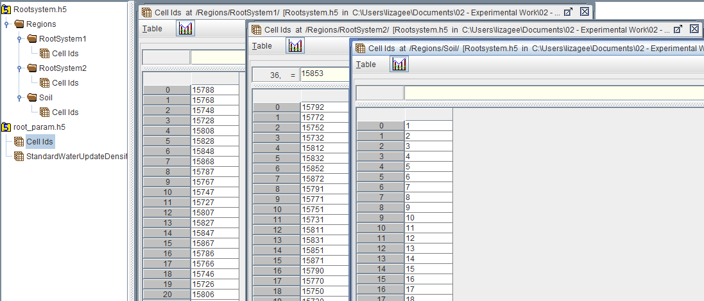

# PFLOTRAN-Root Input: root_param.h5

This input file contains the standard water uptake density for each grid cell. The first array, “Cell Ids”, contains the numerical identifier for each grid cell (n=1, 2, 3, …, N grid cells). The second array contains the standard water uptake density, with each column representing the different regions represented in the model domain. In this example, three regions are represented: two root systems (columns 1 and 2) and the soil (column 3). Values may exist in more than one column, as this would represent the situation where root systems overlap. The sum of these values represents the cumulative water uptake density for that grid cell.

For now: a screenshot of the input file is presented. Later: a script which generates these files will be documented here.

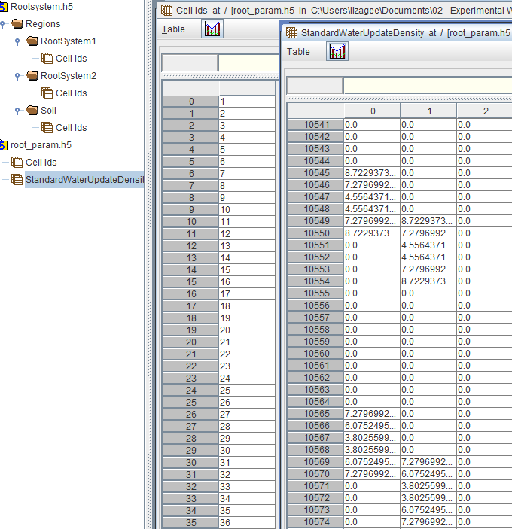

# PFLOTRAN-Root Input: precipitation.dat

This file contains the hourly precipitation rates for the domain. Time is measured in seconds [s] and the rate is meters/second [m/s]. The following is from the example input, UMBS_NetPPT_file_hourly.dat:

: Source File - D:\aRoot\mRootRhizo\tRIBSVEGGIE_files\UMBS_NetPPT_file_hourly.dat

:

: Start Date -

: End Date -

: Time Increment - 1hr

:

: Data - Time(seconds) Recharge (m/s)

: Time[s] m/s

0 0

3600 0

7200 0

10800 0

14400 0

18000 0

21600 0

25200 0

28800 0

32400 0

36000 0

39600 0

43200 3.04672E-07

46800 0

50400 0

54000 0

57600 0

61200 0

64800 0

68400 0

72000 0

75600 0

79200 0

82800 0

86400 0

90000 0

93600 0

97200 0

100800 0

104400 0

108000 0

111600 0

115200 0

118800 0

122400 0

126000 0

129600 0

133200 0

136800 0

140400 0

144000 0

147600 0

151200 0

154800 0

158400 0

162000 3.04672E-07

165600 4.94854E-07

# PFLOTRAN-Root Input: potential_transpiration.dat

This input file needs to be generated for every root structure in the domain. It represents the hourly potential transpiration in kilograms per second [kg/s]. The following example is from the benchmark input, Trans_RootSystem1.dat:

TIME_UNITS h

DATA_UNITS kg/s

0 -0.000001

1 -0.000003

2 -0.000003

3 -0.000001

4 -0.000001

5 -0.000000

6 -0.000004

7 -0.000060

8 -0.000370

9 -0.000766

10 -0.001221

11 -0.001690

12 -0.001866

13 -0.002002

14 -0.002135

15 -0.002183

16 -0.002134

17 -0.001930

18 -0.001576

19 -0.000997

20 -0.000345

21 -0.000039

22 -0.000004

23 -0.000002

24 -0.000002

25 -0.000001

26 -0.000001

27 -0.000001

28 0.000000

29 0.000000

30 0.000000

31 0.000000

32 -0.000276

33 -0.000892

34 -0.001567

35 -0.002068

36 -0.002281

37 -0.002390

38 -0.002167

39 -0.001722

40 -0.001475

41 -0.000621

42 -0.000298

43 -0.000218

44 -0.000057

# PFLOTRAN-Root Output: .vtk format

GENERAL FILE FORMAT

* POINTS
* CELLS
* CELL_TYPES
* CELL_DATA
  + Liquid_Pressure
  + Liquid_Saturation
  + Actual_Transpiration
  + Representative Root Information (repeats for # rep. root systems)
    - T_RootSystem
    - Root_ID
  + Material_ID

# vtk DataFile Version 2.0

PFLOTRAN output

ASCII

DATASET UNSTRUCTURED_GRID

POINTS **NUM_POINTS** float

The **POINTS** section is a three column array which gives the X Y Z coordinates in the model. It cycles through X coordinates for a given Y, then increments Y and repeats the process until all X Y points for a given Z are accounted for. It then increments the Z value and the above process repeats.

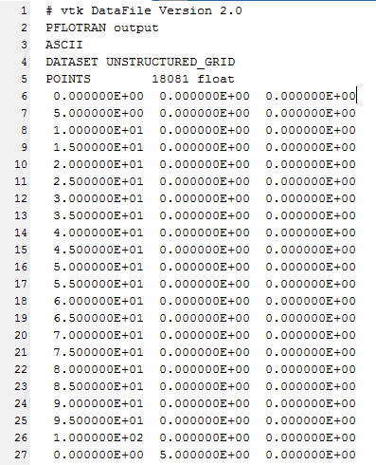

Following the **POINTS** section is the **CELLS** section which identifies cell IDs in a ? x 9 matrix where (:, 1) is the number 8.

CELLS **NUM_CELLS** 144000

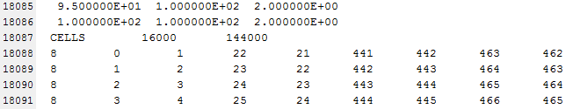

The **CELLS** section is followed by the **CELL_TYPES** section which is a single column vector with one value. This is skipped over in the processing scripts.

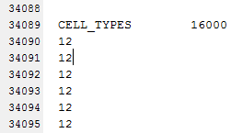

The **CELL_TYPES** section is followed by the **CELL_DATA** section which includes the output variables. The first output variable is **Liquid_Pressure** and is given as a (?, 10) array.

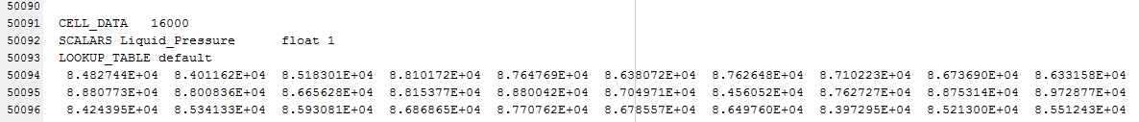

This data is followed by a two line break and then the header and values for **Liquid_Saturation**



The process is repeated for **Actual_Transpiration**



And then designated individual root system transpiration (truncating columns for readability), **T_RootSystemX**.

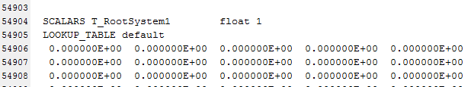

The transpiration of the root system is followed by a single column vector for **Root_ID_RootSystemX**. This gives location (if root is located in indexed cell, it gives that root system number in the cell) of the previously reported root system transpiration.

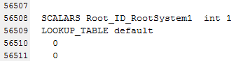

Process repeats for all representative root systems.

Following the Actual_Transpiration and Root_ID information, a single column vector is given for the **Material_ID** variable which identifies the soil type used.

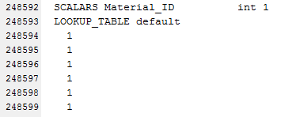

This concludes the file. The following information gives insight to the relative size of the data blocks within the file (pasted from the **read_PFLOTRAN_VTK.m** function):

cell_range=['A',num2str(6+point_number+1),'..I',num2str(6+point_number+1+cell_number-1)];

cells=dlmread(vtkfile,'',cell_range);

cell_P_range=['A',num2str(8+point_number+2*cell_number+5),'..J',num2str(8+point_number+2*cell_number+cell_number/10+5-1)];

cell_P=dlmread(vtkfile,'',cell_P_range);

cell_S_range=['A',num2str(12+point_number+2*cell_number+cell_number/10+5),'..J',num2str(12+point_number+2*cell_number+2*cell_number/10+5-1)];

cell_S=dlmread(vtkfile,'',cell_S_range);

Total_T_range=['A',num2str(16+point_number+2*cell_number+2*cell_number/10+5),'..J',num2str(16+point_number+2*cell_number+3*cell_number/10+5-1)];

Total_T=dlmread(vtkfile,'',Total_T_range);

T1_range=['A',num2str(20+point_number+2*cell_number+3*cell_number/10+5),'..J',num2str(20+point_number+2*cell_number+4*cell_number/10+5-1)];

T1=dlmread(vtkfile,'',T1_range);

T2_range=['A',num2str(24+point_number+2*cell_number+4*cell_number/10+5),'..J',num2str(24+point_number+2*cell_number+5*cell_number/10+5-1)];

T2=dlmread(vtkfile,'',T2_range);

# PFLOTRAN-Root Output: .h5 format

The HDF5 format reduces the file size and writing time dramatically and is the preferred format for saving simulation information.

|  |  |
| --- | --- |
|  | The data is represented as a 3-D array. |

**Useful MATLAB commands for handling the hdf5 file format** (<http://www.mathworks.com/help/matlab/hdf5-files.html>):

**hinfo = hdf5info(filename);**

Gives file information including the dataset names.

**data = hdf5read(filename, dataset_name);**

Reads in the specified dataset.