**Personal Fitness Tracker**

A Project Report

submitted in partial fulfillment of the requirements

of

AICTE Internship on AI: Transformative Learning

with

TechSaksham – A joint CSR initiative of Microsoft & SAP

by

**C.LaahariKalyani**

**laaharikalyani2004@gmail.com**

Under the Guidance of

**Soamya Chowdary**

**ACKNOWLEDGEMENT**

Firstly, we would like to thank my supervisor**, Soamya Chowdary** for being a great mentor and the best adviser I could ever have.

"I extend my heartfelt gratitude to all those who have contributed to the successful completion of my project, Personal Fitness Tracker. I am deeply thankful for insights and expertise that have been invaluable in shaping this endeavor. I also appreciate the unwavering support and encouragement from my friends and family, which has been instrumental in bringing this vision to life. His talks and lessons not only help in project work and other activities of the program but also make me a good and responsible professional.”

#### **ABSTRACT**

"In today's fast-paced world, maintaining a healthy lifestyle has become increasingly challenging due to hectic schedules and limited access to personalized health insights. This project aims to bridge the gap by developing a Personal Fitness Tracker—a multifunctional platform that integrates user health metrics, calorie tracking, exercise logging, water intake monitoring, Sleep monitoring and visual progress analytics.

The primary objective of this project is to provide users with an interactive and user-friendly application that offers accurate predictions and actionable insights. By employing machine learning techniques, such as Random Forest Regressor, the application predicts calorie burn based on user-specific data, including BMI, age, heart rate, and exercise duration. The project also leverages Python libraries like Streamlit, Pandas, and Plotly for an engaging interface and real-time data visualization..Additionally, the application offers features like exercise logging and water intake tracking to encourage holistic well-being.

In conclusion, this Comprehensive Fitness Tracker serves as a step towards empowering individuals to achieve their fitness goals through technology, bridging the gap between convenience and personalized health management."

**TABLE OF CONTENT**

**Abstract I**

**Chapter 1.**  **Introduction 1**

1.1 Problem Statement 1

1.2 Motivation 1

1.3 Objectives 2

1.4. Scope of the Project 2

**Chapter 2.**  **Literature Survey 4**

**Chapter 3.**  **Proposed Methodology 6**

**Chapter 4.**  **Implementation and Results 8**

**Chapter 5. Discussion and Conclusion 11**

**References** --------------------------------------------------------------------------------------13

**LIST OF FIGURES**

|  |  |  |
| --- | --- | --- |
| **Figure No.** | **Figure Caption** | **Page No.** |
|  | PERSONAL FITNESS TRACKER-USER PROFILE,BMI CALCULATION | **7** |
|  | DAILY TRACKING-CALORIE PREDICTION | **7** |
|  | DAILY TRACKING TAB-EXERCISE TRACKING | **8** |
|  | DAILY TRACKING TAB-WATER INTAKE | **8** |
|  | DAILY TRACKING TAB-SLEEP MONITORING | **8** |
|  | PROGRESS TAB -VISULAIZATION | **9** |
|  | PROGRESS TAB-VISUALIZATION | **9** |
|  |  |  |
|  |  |  |

**LIST OF TABLES**

|  |  |  |
| --- | --- | --- |
| **Table. No.** | **Table Caption** | **Page No.** |
|  |  |  |
|  |  |  |
|  |  |  |
|  |  |  |
|  |  |  |
|  |  |  |
|  |  |  |
|  |  |  |
|  |  |  |

**CHAPTER 1**

**Introduction**

* 1. **Problem Statement:**

Individuals often lack effective tools to monitor and manage crucial aspects of their health, such as physical activity, nutrition, water intake, and overall fitness progress. While numerous fitness applications exist, they often focus on isolated functionalities, leaving users with fragmented solutions that fail to provide a holistic view of their health.

Additionally, personalized insights, such as calorie prediction or customized BMI tracking, are limited in many platforms. As a result, individuals struggle to make informed decisions about their fitness goals and daily routines

* 1. **Motivation:**

A Personal Fitness Tracker project is absolutely worth my time and effort because it brings together meaningful impact, practical learning, and cutting-edge technology. Here’s why it’s great and why i feel inspired:

* Empowerment Through Data: This project helps users take control of their health and fitness by providing them with actionable insights. Tracking and visualizing progress can motivate healthier habits and lead to real, life-changing results.
* Practical Skills Development:

Tech Stack Master: you’re working with Python, Streamlit, machine learning libraries like Scikit-learn, and visualization tools like Plotly. It’s an amazing way to build hands-on expertise in highly marketable skills.

* Problem-Solving: From user profiles to predicting calorie burn and logging activities, you’re tackling real-world challenges. It’s like turning abstract coding knowledge into something tangible and impactful.
* System Thinking: This project integrates data, models, logic, and user interface. You’re practicing design and execution for a complete system—a crucial skill in any tech career.
  1. **Objective:**

Objectives

* BMI Calculation and Categorization: Enable users to calculate their Body Mass Index (BMI) based on their height and weight and categorize BMI into health-related categories (e.g., Underweight, Normal weight, Overweight, Obese) for meaningful insights.
* User Profile Management: Allow users to input and update their profile details, such as age, gender, height, and weight, to personalize the tracking experience.
* Calorie Prediction Using Machine Learning: Use a pre-trained Random Forest Regressor model to predict calories burned based on input features like age, BMI, exercise duration, heart rate, and body temperature.
* Daily Tracking Features: Provide an interface for users to track their daily activities, including:

Calorie Burn: Predict calories burned during specific activities.

Exercise Logging: Allow users to log exercise details such as date, type, and duration.

Water Intake Logging: Record daily water consumption in terms of the number of glasses.

Sleep Monitoring: Record daily sleep duration along with quality of sleep on rating of 0-5

* Data Storage and Retrieval: Store user data for exercises and water intake in CSV files to ensure persistence.
* Progress Visualization: Provide dynamic and interactive visualizations using Plotly.
* Interactive and Intuitive User Interface: Utilize Streamlit to offer an interactive, visually appealing, and easy-to-navigate application layout.
  1. **Scope of the Project:**

#### A. **Features Offered**

* **User Profiling:** Calculate BMI, categorize weight, and personalize fitness suggestions.
* **Daily Tracking:** Log calorie burn, exercise details, water intake, and sleep data.
* **Calorie Prediction:** Use machine learning to predict calorie expenditure based on user-specific inputs.
* **Progress Visualization:** Plot trends over time for calories, exercise, water intake, and sleep metrics.
* **Data Persistence:** Store logged data securely in CSV files for long-term access and progress tracking.

#### B. **Technological Learning**

* **Machine Learning:** Training and applying a Random Forest model for calorie predictions.
* **Data Handling:** Working with pandas for CSV operations and data visualization.
* **Frontend Development:** Using Streamlit for user-friendly interfaces and Plotly for dynamic, interactive charts.
* **Resource Optimization:** Leveraging Streamlit caching for efficient model execution.

#### 

**CHAPTER 2**

**Literature Survey**

**1. Examining user engagement and use of fitness tracking technology through the lens of technology affordances.**

**https://www.tandfonline.com/doi/abs/10.1080/0144929X.2021.1915383**

The promise of fitness tracking technology in promoting positive health behaviours lies in its ability to allow users to track their physical activity, receive personalised feedback, and connect with other users.

**2. A study on privacy and security aspects of personalised apps**

[**https://link.springer.com/article/10.1007/s10207-024-00887-z**](https://link.springer.com/article/10.1007/s10207-024-00887-z)

This paper studies personalised smart apps, from a data protection and security point of view. adopt appropriate data protection techniques, focusing especially on aspects from the data protection by design and by default principles, as well as on their security features.

# 3. Exploring Fitness Tracker Visualisations to Avoid Rumination

**https://dl.acm.org/doi/abs/10.1145/3379503.3405662**

Fitness trackers encourage users to set goals to improve personal wellbeing, but these goals sometimes remain unmet. Understanding how improved ways of communicating failure to meet fitness goals could help prevent negative thought cycles (rumination) and avoid reduced motivation for physical activity.

**Gaps or Limitations in Existing Solutions**

* Customization and Accessibility: Many current systems are either proprietary or require specialized hardware, limiting their accessibility to users who prefer software-based, flexible solutions.
* Data Integration: Few tools seamlessly combine calorie prediction, exercise logging, and hydration tracking in a single, lightweight application.
* Security and Privacy Concerns: Cloud-based platforms can pose risks to personal data security and privacy.
* User Engagement: Existing models often lack dynamic features like tailored recommendations or interactive visualizations.

**How Your Project Addresses These Gaps**

* Open-Source and Lightweight: By leveraging Python and Streamlit, ths project is accessible and doesn’t require specialized hardware.Users can run it locally, mitigating concerns about data privacy.
* Integrated Features: A unified platform that combines calorie prediction, exercise tracking, and water intake monitoring and sleep monitoring.
* User Engagement: Interactive visualizations (e.g., calorie tracking over time, water intake patterns,sleep patterns) and a tab-based design promote ease of use and interaction.
* Focus on Privacy:By storing data locally and offering no mandatory cloud integration, it enhances personal data security.

**CHAPTER 3**

**Proposed Methodology**

**3.1 System Design**

+--------------------------+

| User Interface |

| (Streamlit Frontend) |

+---------------------------+

---------------------------------------------------------

| |

+-------------------------+ +-------------------------+

| User Profile Tab | | Daily Tracking Tab |

| - Input: Gender | | - Log Calorie Burn |

| Age | | - Log Sleep |

| Height, Weight | | - Log Water Intake |

| - Calculate BMI | | - Log Exercise Details |

+--------------------------+ +----------------------------+

|

+---------------------+

| Progress Tab |

| - Visualizations |

| - Calorie, Sleep, |

| Water, Exercise |

+---------------------+

|

+-------------------------------------+

| Backend Logic |

| - Helper Functions: BMI calc, |

| file save/load, predictions |

| - Cached Model: RandomForest |

+----------------------------------------+

|

+--------------------------------+

| Data Storage Layer |

| - CSV Files: Persistent data |

| - calorie_data.csv |

| - exercise_data.csv |

| - water_data.csv |

| - sleep_data.csv |

+------------------------------------+

* 1. **Requirement Specification**

The tools and technologies required to implement the solution.

* + 1. **Hardware Requirements:**
* Local Machine:A computer or laptop with at least:
* Processor: Intel i5/i7 or AMD Ryzen 5 (or higher) for smooth model training and Streamlit execution.
* RAM: 8 GB (minimum); 16 GB or more for handling larger datasets.
* Storage: At least 2 GB free space for storing datasets (exercise.csv, calories.csv, etc.) and user-logged data files.

* + 1. **Software Requirements:**
* Operating System: Windows 10/11, macOS, or Linux-based OS.
* Python Environment: Python Version: Python 3.8 or higher.
* Required Python Libraries: streamlit pandas scikit-learn plotly numpy.

For handling multimedia files or any additional visualization tasks:

opencv-python moviepy matplotlib

* Development Tools: IDE/Text Editor: Visual Studio Code, PyCharm, or Jupyter Notebook for development.

Streamlit: For building the web interface of your application.

* Data Files:Ensure the CSV files (calories.csv, exercise.csv, etc.) are in the project directory.

**CHAPTER 4**

**Implementation and Result**

* 1. **Snap Shots of Result:**

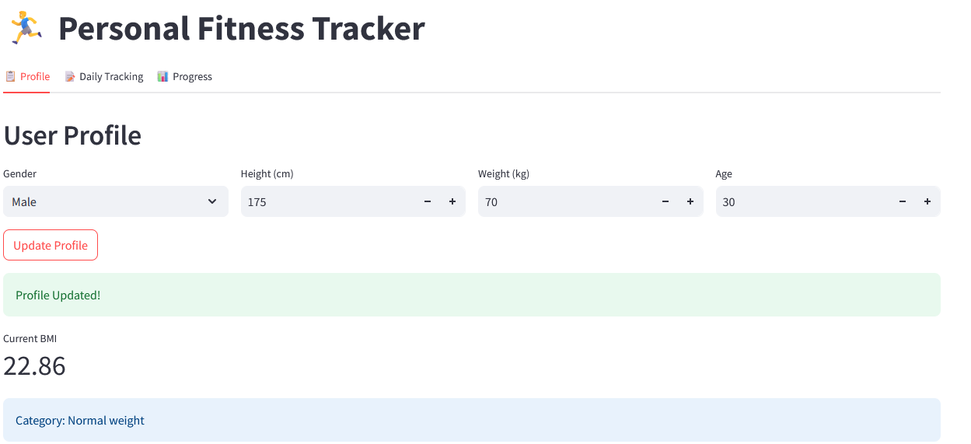

Figure 1 this shows the user profile and BMI calculation.

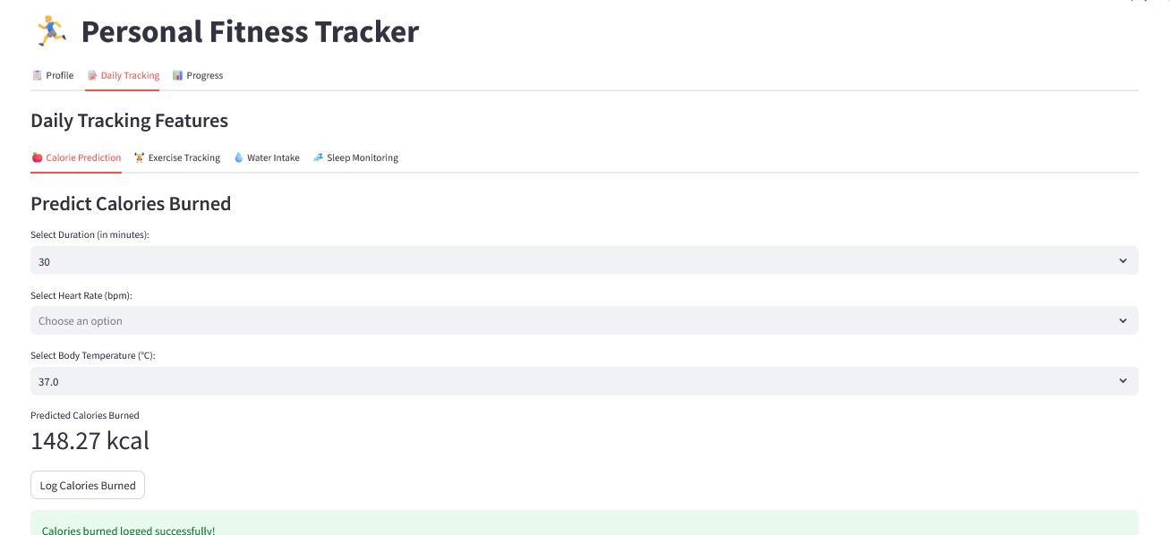

Figure 2 this shows the daily tracking tab –calorie prediction.

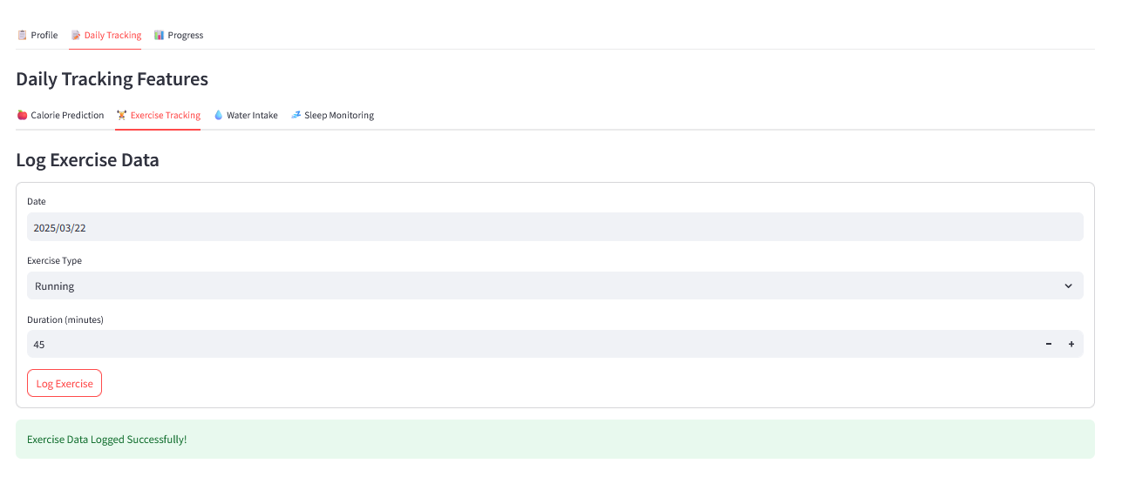

Figure 3 this shows exercise tracking

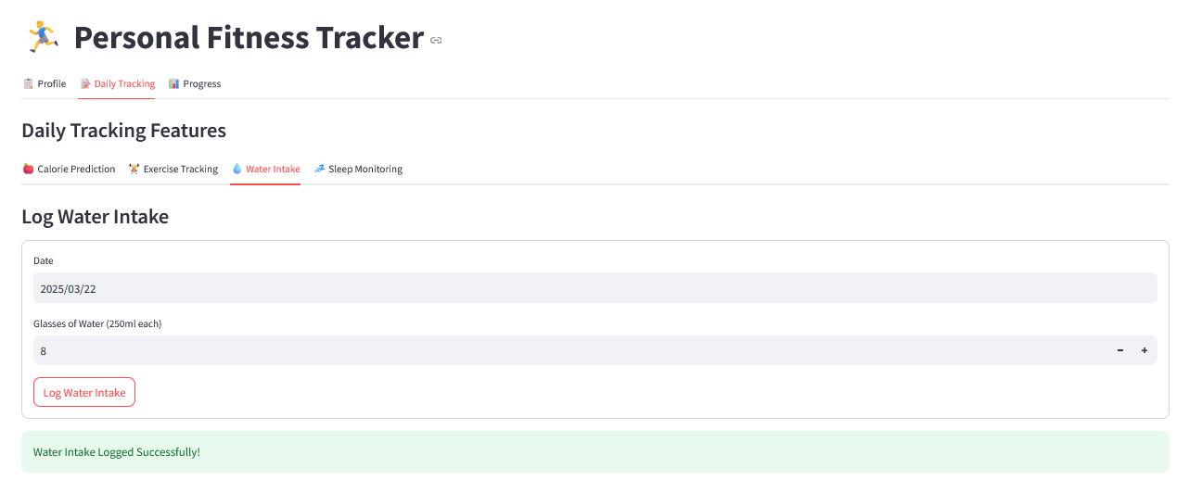

Figure 4 this shows water intake

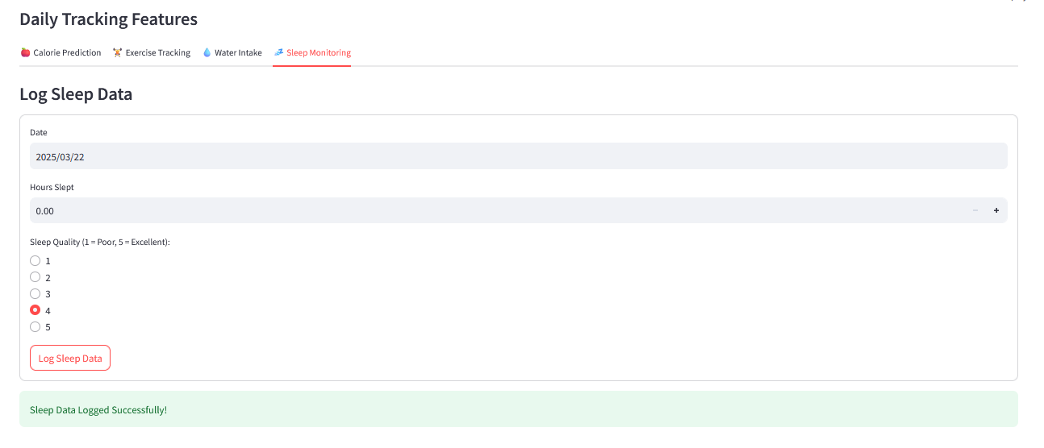

Figure 5 this shows sleep monitoring.

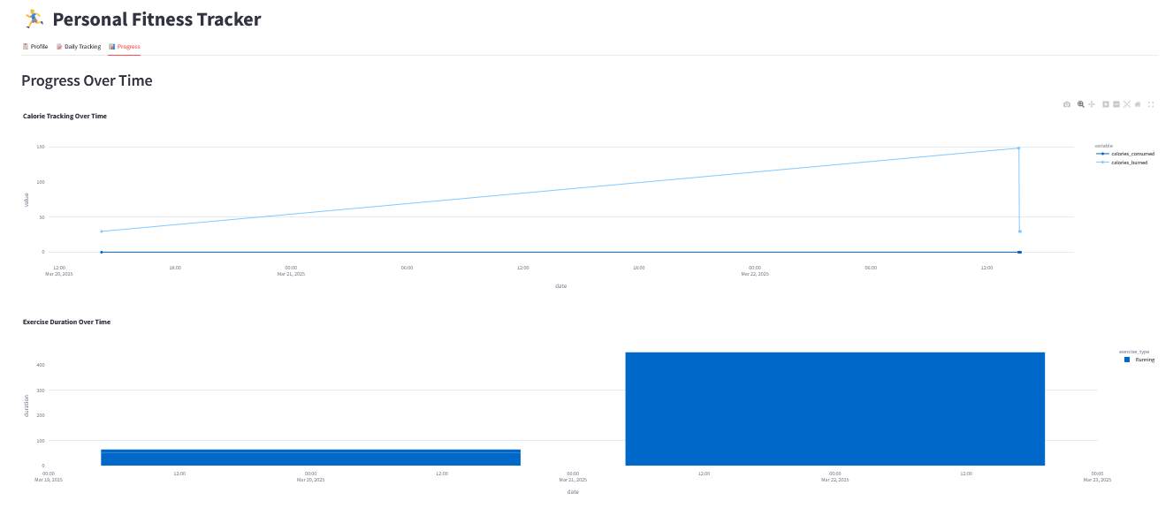

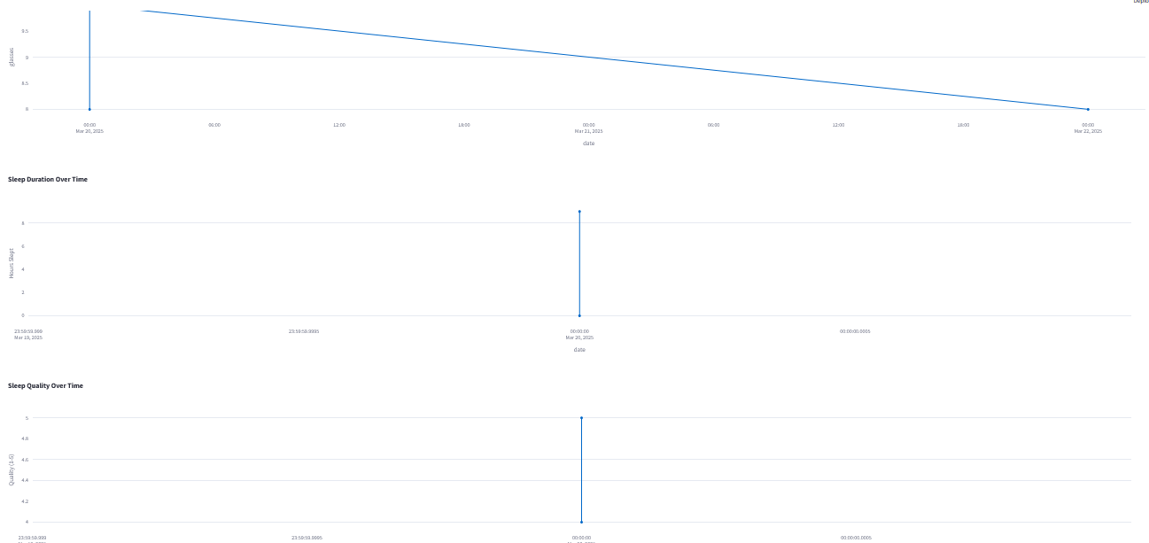

Figure 6,7 –this shows the progress tab visualizations of logged and predicted data

* 1. **GitHub Link for Code:**

[**https://github.com/laaharikalyani/PERSONAL-FITNESSTRACKER**](https://github.com/laaharikalyani/PERSONAL-FITNESSTRACKER)

**CHAPTER 5**

**Discussion and Conclusion**

* 1. **Future Work:**

* **Personalized Recommendations**: Use machine learning to offer tailored fitness and diet recommendations based on user data and progress.
* **Mobile-Friendly Version**: Convert the Streamlit app into a mobile-friendly Progressive Web Application (PWA).
* **Gamification:** Add badges, streaks, and rewards for meeting milestones like daily step goals or consistent water intake.
* **Diet and Nutrition Features**-**Meal Planning**: Incorporate a database of food items to calculate caloric intake and suggest balanced meals.

* 1. **Conclusion:**

The Personal Fitness Tracker is an innovative and user-centric application designed to enhance health and wellness through streamlined tracking and actionable insights. By leveraging Streamlit for a dynamic interface, integrated machine learning for calorie prediction, and robust data visualization with Plotly, the project encapsulates the power of modern technology to empower users in their fitness journeys.

Key accomplishments of this project include:

A comprehensive user profile system with BMI calculation and categorization.

Practical tracking features for exercise, water intake, sleep, and calorie prediction.

Interactive data visualizations that make monitoring progress intuitive and effective.

A scalable design that allows further enhancements and integration of advanced features.

This project demonstrates the potential of technology to bring meaningful change to everyday life. It serves as a testament to the versatility of Python and its libraries for developing functional, data-driven applications. Moving forward, the project could evolve to include advanced analytics, personalized recommendations, and enhanced data security features, further solidifying its impact.

Through this endeavor, it’s evident that meticulous design, combined with technical expertise, can create tools that not only inform but also inspire users to lead healthier, more balanced lives.

**REFERENCES**

1. <https://www.tandfonline.com/doi/abs/10.1080/0144929X.2021.1915383>

Examining user engagement and use of fitness tracking technology through the lens of technology affordances

[2] <https://link.springer.com/article/10.1007/s10207-024-00887->

A study on privacy and security aspects of personalised apps

# [3] <https://dl.acm.org/doi/abs/10.1145/3379503.3405662>

# Exploring Fitness Tracker Visualisations to Avoid Rumination

[4] <https://www.youtube.com/watch?v=4y9BWBkj9Bo>

[5] <https://www.analyticsvidhya.com/blog/2021/11/how-to-use-python-to-analyse-fitness-tracker-market-step-by-step-eda/>