The Results

The purpose of the PW Analysis is to examine the Human Resources Department of Pewlett Harckard that is preparing their employees' retirement. We are encouraged to use the Quick software to analyze the number of eligible people for retirement. We use the ERD schema to build the company retirement program. We are also provided the department data, department employees data, the titles, the managers, and their salaries. The data show the retiring employees were born between January 1, 1952, and December 31, 1955. I use the query editor to retrieve the emp_no, first_name, the last name from the employees' tables. I also retrieved the title and joined both tables as required by the assignment. For the second deliverable, I wrote a query that retrieves columns from the employees and dept_emp table to filter the data of current employees born in 1965.



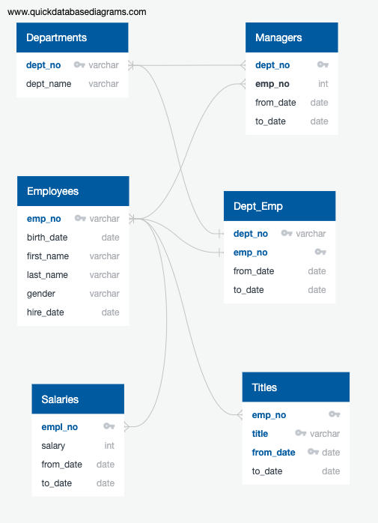

I cannot see the result because the key locks the data output on the emp_no, last_name, first_name, birth_date, titles, from_date, and to-date, preventing me from seeing the output production.