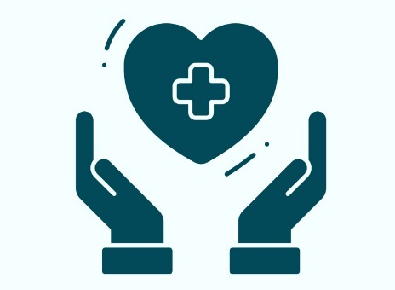
CareSync

Role-Based Hospital Workflow Management System

1. Project Title
CareSync – Enterprise Role-Based Hospital Workflow Management System

2. Description
CareSync is a full-stack hospital workflow management system designed to centralize patient operations and improve coordination across departments.
The platform provides role-based dashboards for Admin, Doctor, Nurse, Laboratory Staff, and Receptionist. It enables structured tracking of patient workflows categorized into Active, Pending, and Delayed states to improve accountability and reduce operational bottlenecks.
Key features include:
- Role-Based Access Control (RBAC)
- Secure authentication using JSON Web Token (JWT)
- Patient lifecycle timeline tracking
- Doctor-specialization-based patient mapping
- Report and diagnostic management
- Multilingual voice-enabled navigation
- Real-time workflow visibility
The system is built using a scalable three-tier architecture and production-ready security practices.

3. Tech Stack Used

Frontend
- React.js (Vite)
- Tailwind CSS
- ShadCN UI
- Framer Motion

Backend
- Node.js
- Express.js

Database
- MongoDB
- Mongoose Object Data Modeling (ODM)

Security
- JSON Web Token (JWT) Authentication
- Role-Based Access Control (RBAC)
- bcrypt Password Hashing

4. How to Run the Project

Clone Repository
git clone https://github.com/your-username/caresync.git
cd caresync

Backend Setup
cd server
npm install

Create .env file inside server:
PORT=5000
MONGO_URI=your_mongodb_connection_string
JWT_SECRET=your_secret_key

Start backend:
npm run dev

5. Dependencies
Major dependencies include:
Frontend:
- react
- react-router-dom
- tailwindcss
- axios
- framer-motion
Backend:
- express
- mongoose
- jsonwebtoken(JWT)
- bcryptjs
- cors
- dotenv
Refer to package.json for full dependency details.

6. Important Instructions
- Ensure MongoDB is running locally or use MongoDB Atlas.
- Configure environment variables correctly before running.
- Seed initial user roles (Admin, Doctor, etc.) before testing dashboards.
- Use HTTPS and secure environment management in production deployment.

7. Demo Video (MVP)
CareSync – Healthcare Dashboard - Personal - Microsoft_ Edge 2026-02-12 18-17-15.mp4 - Google Drive

8. Demo Images (MVP)
If we chose the language the labels will be displayed in the chosen language you can even call the doctor by clicking the call icon
