User manual: toaster_visualizer

Presentation:

toaster_visualizer is a module developed for the framework toaster (Tracking Of Agent and Spatio-TEmporal Reasoning), this device is design to create a simple 3d representation of toaster's physical elements in RVIZ.

Launch:

toaster_visualizer use informations taken form toaster_msgs published on specifics ros topics to create and publish markerArray viewable with RVIZ.
toaster_msgs concerned: AreaList, ObjectList, HumanList
topics concerned: /area_manager/areaList, /pdg/objList, /pdg/humanList

In this context, toaster_visualizer can be launch anytime from your catkin workspace using the classic rosrun command:

$ rosrun toaster_visualization run

Next open rviz:

$ rosrun rviz rviz

Now make sure that the Fixed Frame field is set to “map”
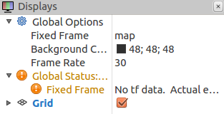

and then, by simply adding a new MarkerArray display for each topic, you should see a 3d representation of current situation in toaster.

If you are not comfortable with RVIZ please follow next steps.
Add a MarkerArray:

While in rviz, add a MarkerArray by clicking on Add in the display menu

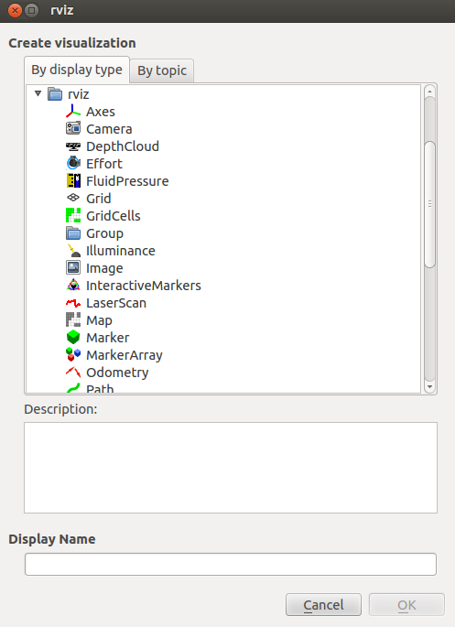
and then select “MarkerArray” in the menu which just opened
Visualize toaster's situation:

Now that your MarkerArray is created set the Marker Topic field to the topic of your choice.
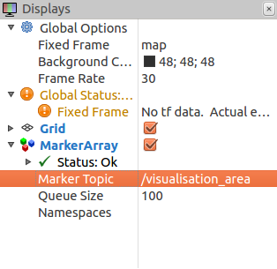
In order to fully see your toaster scene you will need to add 3 MarkerArray (one for each topic)

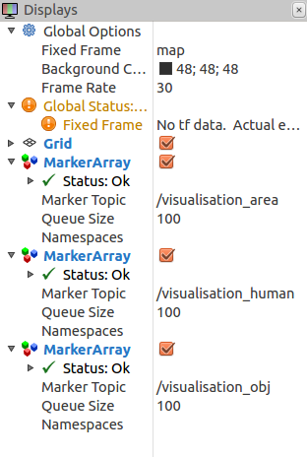
You should now see your toaster stage on RVIZ, if not make sure that you correctly follow all previous steps.

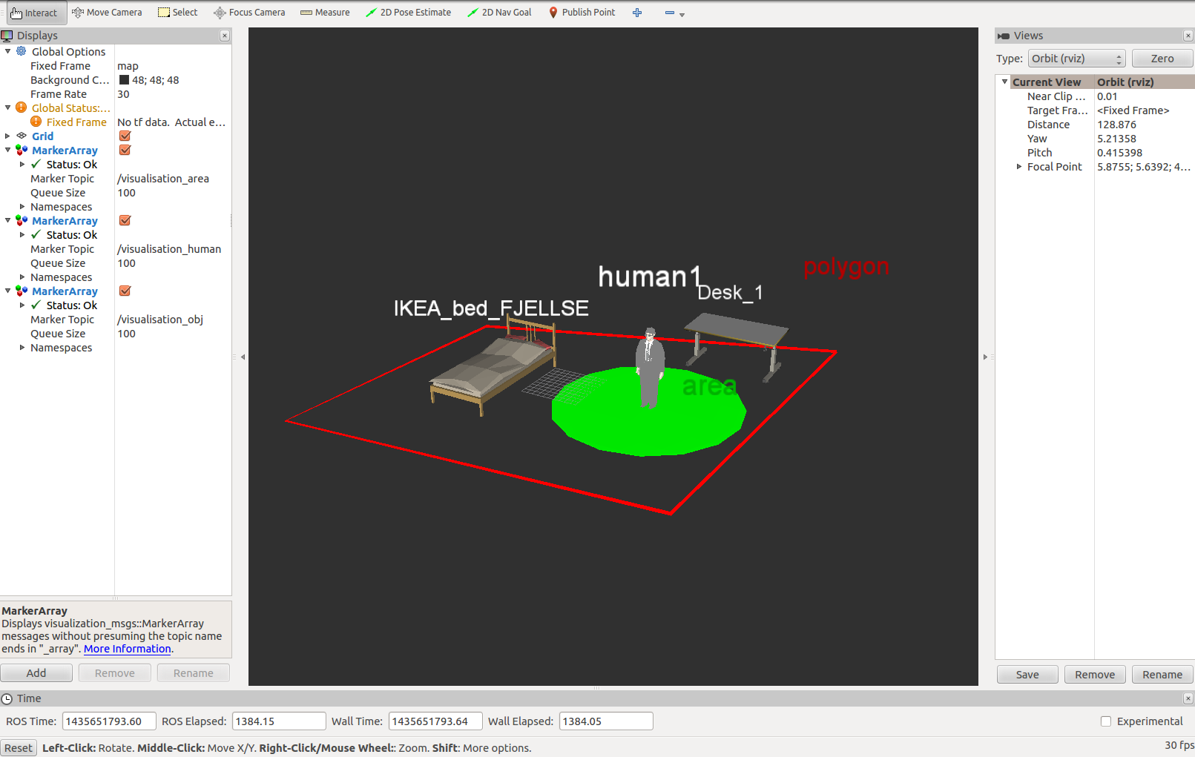
Hide markers:

Sometimes you may need to hide markers, there is two option available to you.

- In one hand you are allowed to hide all markers from a given type, for exemple if you want to hide all humans in the stage just uncheck this orange box
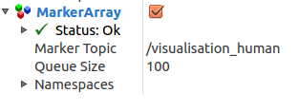
- In the other hand you can hide a specific marker, for this look at the Namespaces menu and in the same way uncheck the box of your choice

example: to only hide the Desk_1 object
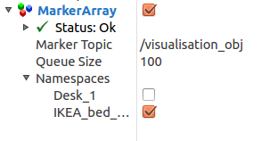
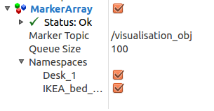
Of course you can restore your markers by doing the inverse operation.

Add new 3d models
In order to improve your representation you may need to add some 3d models of ordinary objects (.dae .3ds ect...).
For that you will need to add your new mesh ressource at
toaster_visualizer/mesh/objets_toaster

and edit the list_obj.xml file located at
toaster_visualizer/src/list_obj.xml

using the following pattern:

<list_obj>

<object name="your_object" mesh_ressource="your_mesh_adress" />

<list_obj>

then create a toaster object with the same name and your 3d model will appear in RVIZ.

