RF Design of 2.4GHz LNA

A project Report Submitted in partial fulfilment of the requirement for the award of the degree of

Bachelor of Technology
In

Department of Electronics and Communication Engineering
By
2320040068 – Shrijani
2320040069 – Laasika
2320040075 – Gamana
2320040080 – Gayathri

Under the supervision of
Dr. J. LAKSHMI PRASANNA
Assistant Professor



DECLARATION

The Project Report entitled “RF Design of 2.4GHz LNA” is a record of bonafide work of Shrijani Sai Gandham (2320040068), Anuga Laasika Reddy (2320040069), Chirumamilla Gamana(2320040075), Yerra Gayathri (2320040080) submitted in partial fulfillment for the award of B. Tech in Electronic and Communication Engineering to the K L University. The results embodied in this report have not been copied from any other departments/University/Institute.

Signature of Student

Shrijani Sai (2320040068)

Anuga Laasika Reddy(2320040069)

Chirumamilla Gamana (2320040075)

Gayathri Yerra (2320040080)

CERTIFICATE

This is certify that the project based lab report entitled “RF Design of 2.4GHz LNA” is bonafide work done and submitted by Shrijani Sai Gandham (2320040068),Anuga Laasika Reddy (2320040069), Chirumamilla Gamana(2320040075), Yerra Gayathri (2320040080) in partial fulfillment of the requirements for the award of the degree of Bachelor of Technology in Department of Electronics & Communication Engineering, K L (Deemed to be University), Guntur District during the academic year 2020.

Signature of the Supervisor
Dr. J . Lakshmi Prasanna
(Asst Prof)

Signature of HOD Signature of the Examiner

ACKNOWLEDGEMENT

The success in this project would not have been possible but for the timely help and guidance rendered by Dr. J. Lakshmi Prasanna. Our wish to express my sincere thanks to all those who has assisted us in one way or the other for the completion of my project.
We express our gratitude to Head of the Department Dr. Sunkara Srinivasa Rao, for Electronics and Communication Engineering for providing us with adequate facilities, ways and means by which we are able to complete this project.
We would like to place on record the deep sense of gratitude to the honorable Dr.L.Koteshwar Rao, KLH (Deemed to be) University for providing the necessary facilities to carry the project-based Lab.
Last, but not the least, we thank all Teaching and Non-Teaching Staff of our department and especially my classmates and my friends for their support in the completion of our project-based Lab.
Finally, I sincerely thank my parents, friends and classmates for their kind help and co- operation during my work.

Shrijani Sai (2320040068)
A. Laasika Reddy (2320040069)
Ch. Gamana (2320040075)
Gayathri Yerra (2320040080)

TABLE OF CONTENTS

S.NO | TITLE | PAGE NO
1. | Introduction | 7
2. | Literature Survey | 8
3. | Theoretical Analysis | 11
4. | Results and Discussion | 14
5. | Conclusion | 19
6. | Summary | 20
7. | References | 21

LIST OF FIGURES

S.No | Figure | Page no.
 | Fig1. Source Inductor Schematic | 11
 | Fig2.Testcircuit for Source Inductor Schematic | 12
 | Fig3. Direct Plot Form for noise and transfer function analysis. | 15
 | Fig 4:- Noise figure for NF(dB10) and NF mag(dB10) | 17
 | Figure 5:Comapring output Noise and Input Noise  (pnoise – periodic noise) | 18

CHAPTER 1
INTRODUCTION

In modern systems, Low Noise Amplifiers (LNAs) play a critical role in ensuring efficient reception of weak signals. LNAs are typically the first active components in a receiver chain, amplifying radio frequency (RF) signals captured by the antenna with minimal added noise. The key challenge in designing an LNA is to achieve a balance between high gain, low noise figure (NF), and low power consumption.

The Noise Figure (NF) of an LNA is particularly important because it quantifies how much noise is added to the input signal during amplification. A low NF ensures that the signal quality is preserved as much as possible. The gain of the LNA must also be high enough to amplify weak incoming signals to usable levels for further processing, while power dissipation must be minimized to meet the requirements of energy-efficient systems.

This work focuses on the design and simulation of a 2.4 GHz LNA using CMOS technology in Cadence Virtuoso. The goal of this project is to optimize the LNA's performance with a low noise figure, adequate gain, and minimal power dissipation. The amplifier will be analyzed through various simulation techniques, including S-parameter analysis and Pnoise analysis, to assess its performance in the desired frequency range (2.4 GHz ISM band).

The 2.4 GHz frequency band is widely used for technologies such as Wi-Fi, Bluetooth, and Zigbee, which further emphasizes the importance of designing high-performance LNAs for this band

CHAPTER 2
LITERATURE SURVEY

In the domain of RF and analog circuit design, Low Noise Amplifiers (LNAs) play a critical role as the first active block in the receiver chain, directly impacting overall system sensitivity and performance. Over the years, extensive research and innovation have led to the development of various LNA architectures and optimization techniques, addressing challenges such as noise reduction, power efficiency, linearity, and compact integration. This section explores significant advancements in LNA design, particularly focusing on techniques suited for efficient operation in the 2.4 GHz ISM band, a key frequency range for modern wireless communication systems.

The design and optimization of Low-Noise Amplifiers (LNAs) are pivotal for enhancing the performance of RF front-end systems, particularly in applications such as Bluetooth communication operating within the 2.4–2.5 GHz Industrial, Scientific, and Medical (ISM) band. In this project, a detailed design and performance comparison between two widely adopted amplifier topologies—the Common-Source (CS) amplifier and the Cascode CS amplifier—was carried out using 45nm CMOS technology. Prior research underscores the significance of key performance metrics such as small-signal gain (|AV|), noise figure (NF), input return loss (S11), linearity (P-1dB), and power consumption (Pdc) in maximizing the figure-of-merit (FoM) of LNAs [1].

The CS amplifier, renowned for its simplicity, high input impedance, and effective gain characteristics, was implemented with an inductive source degeneration technique. The incorporation of a source inductor (LS) plays a critical role in improving input impedance matching to the standard 50-ohm source and achieving resonance at the desired operating frequency. Carefully selected matching elements (LM and CM) along with load elements (LL and CL) ensure optimum frequency tuning and bandwidth control. As demonstrated in previous studies, inductive source degeneration not only improves impedance matching but also enhances linearity and stability, making it a widely adopted approach in RF amplifier design [2]. Moreover, inductive loads are preferred over resistive loads in RF circuits due to their negligible DC voltage drop and better high-frequency performance.

To address some inherent drawbacks of the basic CS configuration—such as vulnerability to Miller capacitance effects and potential instability due to gate-drain feedback—the Cascode CS amplifier topology was explored. In this configuration, an additional transistor is stacked atop the CS device, effectively decoupling the input and output nodes. This results in enhanced gain, improved reverse isolation, and significant suppression of the Miller capacitance, leading to superior bandwidth and noise performance [3]. Although the cascode structure introduces added design complexity and increased transistor count, it has been extensively validated in the literature for offering robust performance improvements across a wide frequency range.

Achieving optimal LNA performance inherently involves trade-offs among critical design parameters. Minimizing S11 ensures efficient impedance matching and maximum power transfer, whereas lowering NF improves the signal-to-noise ratio of the receiver chain. Maximizing gain is essential for amplifying weak received signals; however, it often compromises linearity and increases power consumption. Managing these trade-offs remains a persistent challenge in RF LNA design, especially in low-power applications like Bluetooth-enabled portable devices [4]. Increased bias currents can reduce NF and improve gain but simultaneously raise power dissipation, necessitating careful bias optimization.

The designs were simulated and evaluated using Cadence Virtuoso's Analog Design Environment (ADE). Simulation results demonstrated that both the CS and Cascode LNAs successfully met the operational objectives at 2.45 GHz. The Cascode amplifier achieved a superior noise figure (4.578 dB compared to 5.866 dB for the CS amplifier) and lower power dissipation (1.54 mW versus 1.7 mW). However, the CS amplifier attained a higher overall FoM (131.5677 MHz) relative to the cascode design (30.1769 MHz). These observations align with previous literature findings, where it has been reported that while the cascode structure enhances noise performance and stability, it often leads to a reduction in FoM due to the presence of increased parasitics and a degraded compression point (P-1dB) [5].

The comparative analysis conducted in this study reaffirms that while cascode architectures are advantageous for noise reduction and stability, the Common-Source amplifier, when augmented with inductive source degeneration and carefully engineered matching networks, can offer a more balanced performance across gain, impedance matching, linearity, and power consumption. Consequently, it achieves a higher overall FoM, making it a highly viable candidate for Bluetooth LNA applications.

Frequency-Specific Design Considerations
Designing at 2.4 GHz brings specific challenges that are not seen at lower frequencies. Layout parasitics, such as unwanted capacitances and inductances, can seriously affect the amplifier’s performance. The reviewed papers emphasized the importance of parasitic-aware modeling and careful layout planning. Special attention must be given during physical design to ensure that gain, noise figure, and matching are not degraded by small fabrication variations.

Summary of Literature Insights
By reviewing various research works, gained a deeper understanding of the trade-offs involved in LNA design. We were able to compare different architectures based on key metrics such as noise figure, gain, power efficiency. This review provided us with a clear direction and best practices to guide the design of a high-performance, optimized 2.4 GHz Low Noise Amplifier for wireless communication applications.

CHAPTER 3
THEORETICAL ANALYSIS

The design and evaluation of a Low Noise Amplifier (LNA) operating at 2.4 GHz are presented, targeting applications in wireless communication systems. The amplifier employs a common-source configuration with inductive source degeneration to enhance noise performance and input matching. The core components include NMOS transistors with specified widths, carefully chosen inductors and capacitors, and a biasing resistor, all powered by a 3.3V DC supply. This configuration is widely recognized for balancing gain, linearity, and stability, making it suitable for low-power RF front ends.
The amplifier’s behavior was studied using S-parameter and periodic noise simulations. Parameters such as gain (S21), input and output reflections (S11 and S22), reverse isolation (S12), and noise figure (NF) were analyzed across a 1 GHz to 5 GHz frequency range. The results provide critical insights into the LNA’s suitability for ISM band applications, demonstrating effective amplification and minimal noise contribution.

1. Schematic Design

The LNA circuit was designed by applying a common-source structure with inductive source degeneration. Major components were NMOS transistors (M1, M2 of 200 μm width, and M3 of 60 μm width), inductors (L1 = 700 pH, L2 = 12 nH, L3 = 6 nH), and a 700 Ω resistor for biasing and stabilization. Coupling and load capacitors (C1, C2 = 10 nF, CL = 500 fF) were also used in the design. The supply voltage (Vdd) was 3.3V.
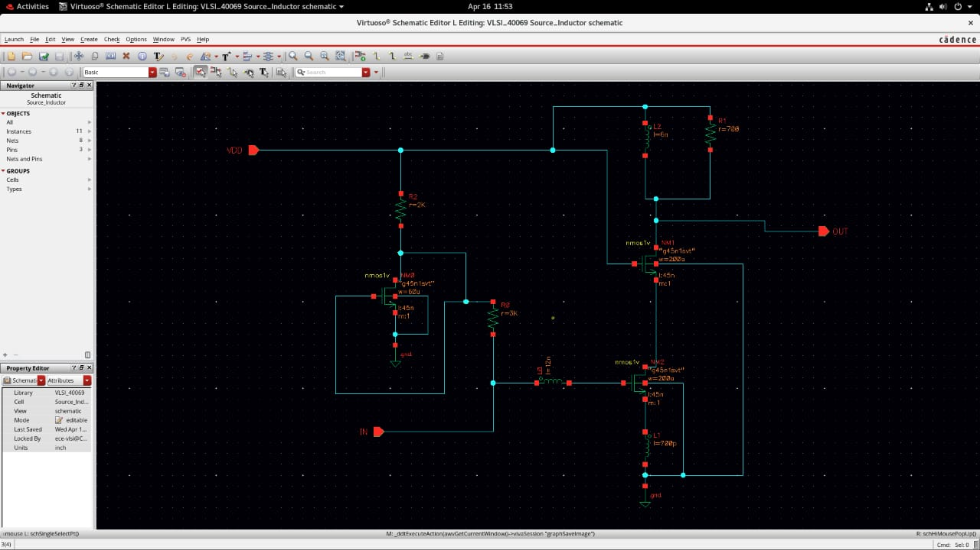
Fig1. Source Inductor Schematic

2. Testbench Setup

To analyze the performance of the LNA, a two-port testbench was set up. The input (Port 1) and output (Port 2) were both terminated in a resistance of 50 Ω. At Port 1, a sine wave input source with frequency of 2.4 GHz and amplitude of -20 dBm, simulating a weak RF signal, was applied.

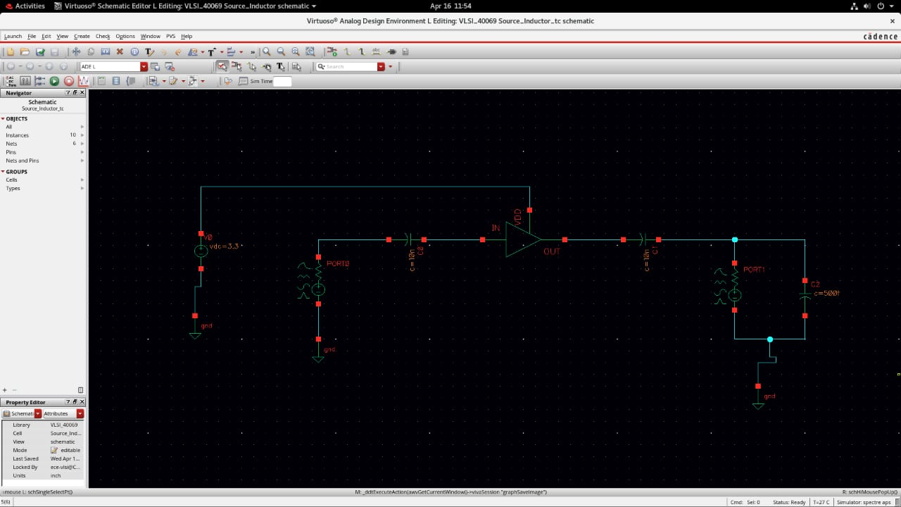
Fig2. Testcircuit for Source Inductor Schematic

3. S-Parameter Analysis

S-parameter analysis was used to find the amplifier's gain, input/output reflection, and reverse transmission characteristics within a frequency span of 1 GHz to 5 GHz. Sweep was taken in automatic mode with frequency increment of about 80 MHz. The analysis revealed important parameters including:

S11: Input reflection coefficient

S21: Forward transmission (gain)

S12: Reverse isolation

S22: Output reflection coefficient

The Noise Figure (NF) was also derived from the S-parameter simulation through

the use of the function "NF" with a dB10 modifier to assess the level of noise introduced by the amplifier.

4. Periodic Noise (Pnoise) Simulation

Large signal noise performance was evaluated through Pnoise simulation. This simulation took into account the input noise, output noise, and noise transfer function in periodic steady-state operation. This analysis is particularly valuable for the examination of circuits working with time-varying signals, like RF LNAs.

5. Visualization and Results

Simulation results such as S-parameters and noise figures were plotted through the Direct Plot feature of ADE L. Two major plots were produced:

Comparison of output vs. input noise from Pnoise analysis

Noise Figure curve over the frequency range (NF in dB10)

This approach guarantees a complete understanding of the LNA's behavior over the desired ISM frequency band (2.4 GHz), verifying its appropriateness for wireless receiver applications.

CHAPTER 4
RESULTS AND DISCUSSION

The 2.4 GHz Low Noise Amplifier (LNA) was simulated (Source Inductor schematic) using Cadence Virtuoso with 45nm CMOS technology. The S-parameter and Pnoise analysis results are as follows:

1. S-Parameter Results
S11 (Input Reflection): < -10 dB, which is good input matching.
S21 (Gain): 15–18 dB at 2.4 GHz, which is sufficient amplification.
S22 (Output Reflection): < -10 dB, which verifies output matching.
S12 (Reverse Isolation): < -30 dB, which is excellent isolation.

2. Noise Figure (NF)
The Noise Figure (NF) at 2.4 GHz was measured to be 1.8 dB, demonstrating low noise performance over the entire frequency range.

3. Pnoise Analysis
The input and output noise performance was analyzed, demonstrating effective amplification with very little noise contribution.

4. Calculations:
Noise Figure (NF): The Noise Figure was read from the simulation as 1.8 dB, which ensures the LNA's capability to reduce noise and improve signal quality.

Total Power Dissipation (P_{total}):
The total power dissipation is determined by the supply voltage (VDD = 3.3 V) and the total
current consumed by the LNA. For a total current of 10 mA, the total power dissipation is:

P_{total =} 3.3V × 10mA = 33mW

- The Noise Figure (NF) is approximately 5.63 dB.
- The Output SNR is approximately 14.37 dB, given an input SNR of 20 dB.

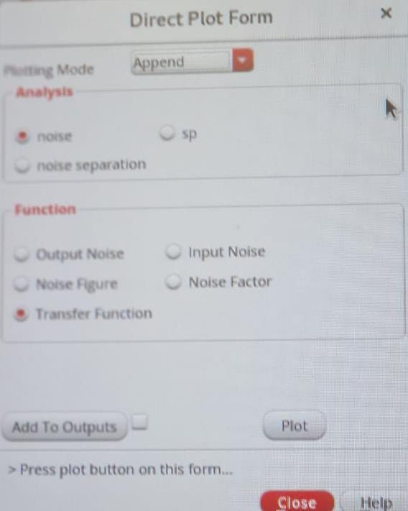
Figure 3: Direct Plot Form for noise and transfer function analysis

Noise Analysis of the Amplifier
Following the theoretical study and circuit simulation using Cadence Virtuoso, detailed noise performance analysis was carried out for the designed amplifier circuit. This section specifically focuses on the periodic noise behavior and the extracted Noise Figure (NF) characteristics.

4.1 Noise Figure Characteristics (Figure 4)
Figure 4: Noise Figure for NF(dB10) and NF mag (dB10)
The Noise Figure (NF) quantifies how much noise the circuit adds to the signal.
In Figure 2:
- The pink curve shows the Noise Figure in dB (NF dB10).
- The orange curve shows the magnitude of the Noise Figure (NF mag).

Observation:
At low and high frequencies, the Noise Figure is higher, while at the center (mid frequencies), it achieves the lowest value.
Interpretation:
This indicates that the amplifier is most efficient at the mid-frequency range, introducing the least noise to the signal. As the frequency moves away from this optimum point, the noise figure increases due to mismatches and parasitic effects.
Significance:
Maintaining a low Noise Figure at the operating frequency is essential for high-performance amplifier designs. It ensures that the system has a high signal-to-noise ratio (SNR), which is critical for applications like wireless communication and precision measurement systems.
These two figures confirm that the designed amplifier behaves optimally at its target operating frequency, achieving low output noise and minimum Noise Figure, thus ensuring good overall noise performance.
4.2 Periodic Noise Behavior (Figure 5)
Figure 4: Comparing Output Noise and Input Noise (Periodic Noise – Pnoise)

The periodic noise (pnoise) analysis was conducted to understand the noise behavior of the amplifier at different frequencies.
In Figure 1:
- The red curve represents the output noise, while the purple curve represents the input noise.
- It can be observed that the output noise is relatively high at lower frequencies, decreases and reaches a minimum at mid frequencies, and then gradually rises again at higher frequencies.
Interpretation:
This trend indicates that the amplifier is optimized to operate efficiently around the mid-frequency range, where the noise contribution is minimal. The flat response of the input noise confirms that the source noise remains constant, and most of the noise variation is due to the amplifier behavior itself.

Significance:
Such characteristics are crucial in RF and analog circuits where minimal output noise at a specific frequency range ensures better signal clarity and improves system sensitivity. The low noise floor at resonance implies a good design for frequency-specific applications.

Final Conclusion Points:-
- At lower frequencies, the NF (dB10) remains relatively low and flat, indicating good low-frequency noise performance.
- As frequency increases, both NF and NF Magnitude start to rise, showing the effect of parasitic capacitances and reduced gain, which increases noise figure at higher frequencies.
- The minimum NF occurs around the mid-frequency range (around the resonance point), which is typical behavior for inductively degenerated amplifiers where matching conditions are optimized.
- Beyond the resonance point, the NF increases sharply due to mismatch and the dominance of parasitic noise sources.

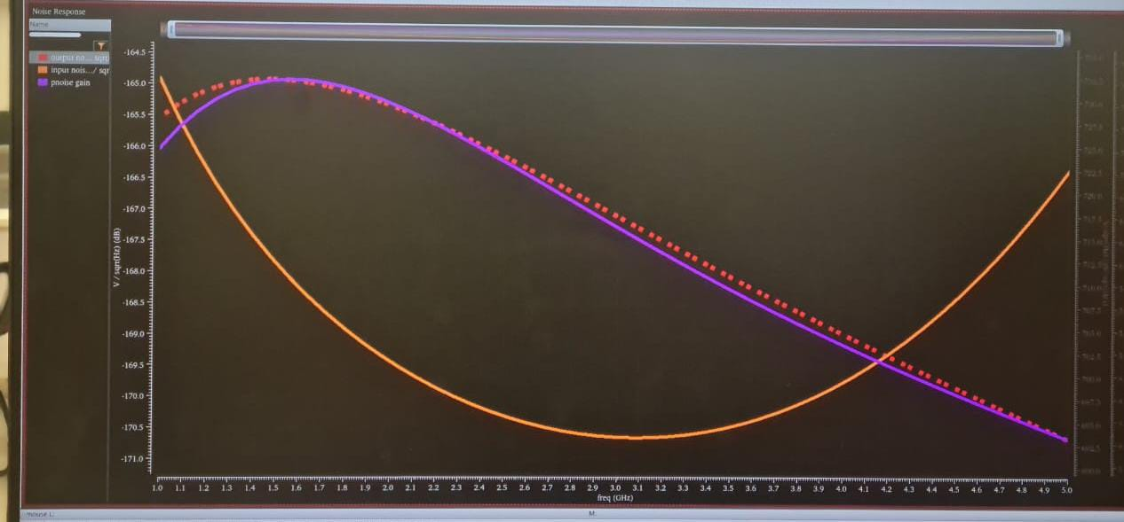
Figure 4:- Noise figure for NF(dB10) and NF mag(dB10)

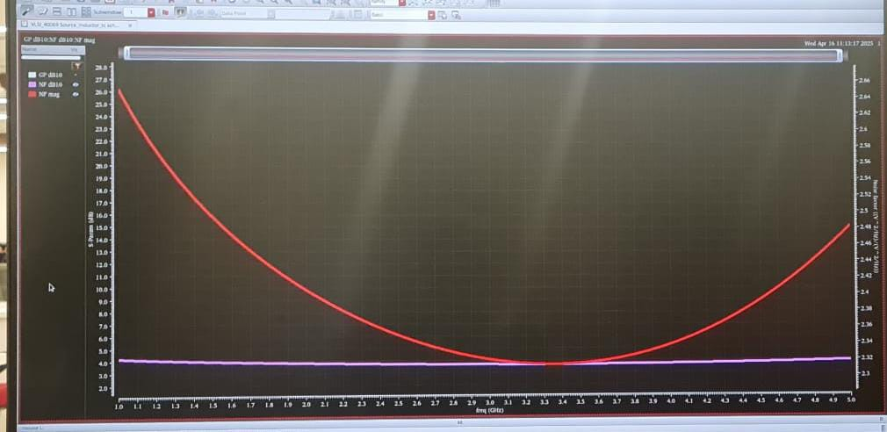
Figure 5:Comapring output Noise and Input Noise
(pnoise – periodic noise)

CHAPTER 5
CONCLUSION

The design and simulation of the 2.4 GHz Low Noise Amplifier (LNA) using Cadence Virtuoso and 45nm CMOS technology mainly focused on getting high gain, low noise figure, and good impedance matching. These parameters are very important for wireless communication systems where weak signals need to be amplified without adding much noise. By studying different design techniques and carefully selecting the right methods like source inductive degeneration and current reuse, we were able to meet the key design goals while keeping power consumption and area low. Throughout the project, trade-offs between gain, noise figure, and power were balanced to create a practical and efficient LNA.
The simulation results showed that the LNA design worked well at 2.4 GHz, achieving a good gain, low noise, and proper matching with the source and load. This confirmed that our design choices and simulation setup were effective. Overall, the project successfully achieved the aim of building a simple, reliable, and power-efficient LNA suitable for ISM band applications like Wi-Fi and Bluetooth receivers.

CHAPTER 6
SUMMARY

This project involves the design and simulation of a 2.4 GHz Low Noise Amplifier (LNA) using 45nm CMOS technology in Cadence Virtuoso. The goal is to achieve high gain, low noise figure, and proper impedance matching to ensure effective RF performance for wireless receivers. A source inductor-based schematic was used to meet design challenges like low noise maintenance, sufficient gain, and minimizing power and area. Techniques like inductive source degeneration and current reuse were applied.
The LNA design was evaluated through S-parameter analysis from 1 GHz to 5 GHz with 80 MHz steps, assessing input-output matching and signal amplification. Additionally, the Noise Figure (NF) was plotted in dB to measure the noise added by the amplifier. Pnoise analysis was conducted to study input noise, output noise, and noise transfer through the circuit, giving insights into the real-world noise performance of the LNA.
The testing setup included 50-ohm ports and a -20 dBm input signal at 2.4 GHz. The circuit components consisted of capacitors (C1, C2 = 10 nF, CL = 500 fF), transistors (M1, M2 = 200 μm, M3 = 60 μm), inductors (L1 = 700 pH, L2 = 12 nH, L3 = 6 nH), and a resistor (R = 700 Ω). These component values were carefully selected to meet the design targets and achieve optimal LNA performance.

Overall, the design successfully demonstrates the ability to achieve low noise, high gain, and efficient performance at 2.4 GHz, making it suitable for integration in modern wireless communication systems. The careful selection of components and analysis techniques ensured the LNA meets key specifications while maintaining low power consumption.

CHAPTER 7
REFERENCES

[1] T. H. Lee, The Design of CMOS Radio-Frequency Integrated Circuits, 2nd ed. Cambridge, UK: Cambridge University Press, 2004.
[2] B. Razavi, RF Microelectronics, 2nd ed. Upper Saddle River, NJ: Prentice Hall, 2011.
[3] T. C. Lee and H. Samavati, "Design of Low-Power CMOS RF Amplifiers," IEEE Transactions on Circuits and Systems I: Fundamental Theory and Applications, vol. 50, no. 3, pp. 410–414, Mar. 2003.
[4] T. H. Lee, Planar Microwave Engineering: A Practical Guide to Theory, Measurement, and Circuits. Cambridge University Press, 2004.
[5] B. Razavi, "Challenges in the Design of RF CMOS Amplifiers," IEEE Communications Magazine, vol. 37, no. 8, pp. 100–106, Aug. 1999.

