quarto_tes
Lauri

Quarto
Quarto enables you to weave together content and executable code into a finished document. To learn more about Quarto see https://quarto.org.

Running Code
When you click the Render button a document will be generated that includes both content and the output of embedded code. You can embed code like this:
1 + 1
[1] 2
data <- read.csv(here::here("Data/forest_inventory_data.csv"))
plot(1:10)
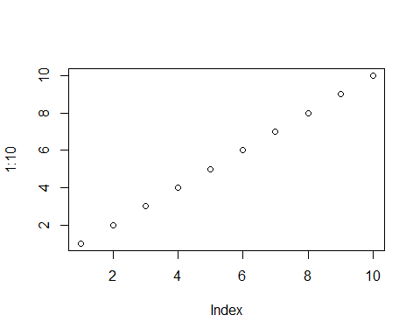
plot(data$age_years, data$height_m)
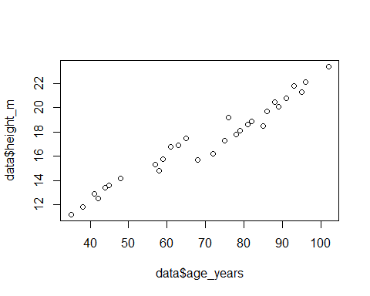
You can add options to executable code like this
[1] 4
The echo: false option disables the printing of code (only output is displayed).

