AI-Based Early Detection of Alzheimer’s Disease Using Speech and Machine Learning
A Mini Project Report Submitted in partial fulfillment of the requirements for the award of the degree of

BACHELOR OF TECHNOLOGY
In

DEPARTMENT OF COMPUTER SCIENCE AND ENGINEERING
By
Krishita Myneni – 2420030443 (Team Lead)
Bhanu Prakash Bhavanam – 2420030209
D.L.S Laasya Priya – 2420030002
Under the Esteemed Guidance of
Dr. Katanguri Swanthana





K L (Deemed to be) University

DEPARTMENT OF COMPUTER SCIENCE AND ENGINEERING

DECLARATION

The mini-project report entitled “AI-Based Early Detection of Alzheimer’s Disease Using Speech and Machine Learning” is a record of bona fide work carried out by Krishita Myneni (2420030443), Bhanu Prakash Bhavanam (2420030209) and D.L.S Laasya Priya (2420030002) in partial fulfillment of the requirements for the award of the B.Tech degree at K L (Deemed to be) University. The work presented in this report is original to the best of our knowledge, and all datasets, tools, code, and external sources used have been appropriately acknowledged.
Krishita Myneni – 2420030443
Bhanu Prakash Bhavanam – 2420030209
D.L.S Laasya Priya – 2420030002

K L (Deemed to be) University

DEPARTMENT OF COMPUTER SCIENCE AND ENGINEERING

CERTIFICATE

This is to certify that the mini-project report entitled “AI-Based Early Detection of Alzheimer’s Disease Using Speech and Machine Learning” is a bona fide work carried out by Krishita Myneni (2420030443), Bhanu Prakash Bhavanam (2420030209) and D.L.S Laasya Priya (2420030002) under the supervision of Dr. Katanguri Swanthana during the academic year 2026–2027, in partial fulfillment of the requirements for the award of the Bachelor of Technology degree at K L (Deemed to be) University.

Signature of the Project Supervisor

Signature of the HOD Signature of the External Examiner

ACKNOWLEDGEMENT
The success in this project would not have been possible but for the timely help and guidance rendered by many people. Our wish to express my sincere thanks to all those who has assisted us in one way or the other for the completion of my project.

Our greatest appreciation to my guide, Dr. Katanguri Swanthana, Department of Computer Science which cannot be expressed in words for his/her tremendous support, encouragement and guidance for this project.

We express our gratitude to Dr. P.Venkateshwar Sir, Head of the Department for Computer Science Engineering for providing us with adequate facilities, ways and means by which we are able to complete this project-based Lab.

We thank all the members of teaching and non-teaching staff members, and also who have assisted me directly or indirectly for successful completion of this project. Finally, I sincerely thank my parents, friends and classmates for their kind help and cooperation during my work.

Krishita Myneni – 2420030443
Bhanu Prakash Bhavanam – 2420030209
D.L.S Laasya Priya – 2420030002

TABLE OF CONTENTS

S.No. | Contents | Page no.
1. | Abstract | 6
2. | Introduction | 7
3. | Literature survey | 11
4. | Problem Statement and Objectives | 16
5. | Hardware and Software requirements | 18
6. | Implementation | 20
7. | Results & Discussion | 27
8. | Conclusion & Future Scope | 35
9. | References | 38

ABSTRACT

Alzheimer’s disease (AD) is a progressive neurodegenerative disorder that can affect language production and connected speech, so automated analysis of speech transcripts offers a low-burden way to detect language patterns linked to cognitive decline. This project performs transcript-based binary classification of Alzheimer’s disease versus healthy controls using a fine-tuned DeBERTa-v3-base model, and examines whether combining learned attention pooling with masked mean pooling improves document-level transcript representations. Cookie Theft picture-description transcripts from the Pitt corpus of DementiaBank were used. After conservative preprocessing and removal of one duplicate, 496 transcripts remained (240 healthy control, 256 Alzheimer’s), split in a stratified manner into 346 training, 75 validation and 75 test samples. Transcripts were tokenized with the DeBERTa-v3 tokenizer (maximum length 256); the attention-pooled and mean-pooled token representations were concatenated and passed through dropout and a linear classifier. On the held-out test set the model achieved 89.33% accuracy, 91.67% precision, 86.84% recall, 89.19% F1 score and 91.89% specificity. Differences in datasets and evaluation protocols make the comparison with published systems indicative rather than conclusive. The classifier is integrated into AlzDx, a web platform for speech recording, transcription, linguistic analysis and PDF reporting; the reported accuracy is transcript-based, not end-to-end speech accuracy.
Team Name: AlzDx
Team Members and Responsibilities:

- Krishita Myneni, 2420030443 – Model development and evaluation (DeBERTa-v3 hybrid pooling, training, metrics)
- Bhanu Prakash Bhavanam, 2420030209 – Web application development (frontend, backend, database, PDF reports)
- D.L.S Laasya Priya, 2420030002 – Dataset preparation, literature survey and report documentation
- Dataset/source and project repository (if applicable): https://dementia.talkbank.org
- Dataset: Pitt corpus (Cookie Theft picture-description transcripts), DementiaBank – https://dementia.talkbank.org (access obtained from DementiaBank on request). Repository: https://github.com/KrishitaMyneni/KLH-CSE-2026-27-2420030443-AlzDx-Alzheimer-s-detection/tree/main

INTRODUCTION

Alzheimer’s disease is a progressive neurodegenerative disorder associated with cognitive and functional decline [Mattson 2004]. Changes in language and connected speech can accompany its progression, which makes spontaneous speech and picture-description tasks useful sources of information for automated cognitive assessment. Earlier research has shown that linguistic characteristics such as lexical diversity, syntactic structure, informativeness and disfluency can help distinguish individuals with Alzheimer’s disease from healthy controls [Fraser et al. 2016, Mueller et al. 2018].
This project applies text classification to Cookie Theft picture-description transcripts. The Cookie Theft picture, developed as part of the Boston Diagnostic Aphasia Examination [Goodglass and Kaplan 1972], elicits spontaneous descriptions around a common stimulus, and the Pitt corpus of DementiaBank [Becker et al. 1994, MacWhinney 2000] is an important source of such transcripts. Transcripts are unstructured text, and reading and comparing them one by one is slow and hard to standardise. Machine learning can learn patterns in word choice, repetition and incomplete descriptions directly from the text; early systems relied on hand-engineered linguistic features [Fraser et al. 2016, de la Fuente Garcia et al. 2020], while recent work uses pretrained transformer models [Vaswani et al. 2017, Devlin et al. 2019].
Target users and intended use. The classifier is intended as a research or triage-support tool rather than an autonomous diagnostic instrument, and is delivered through the AlzDx web platform for researchers and assessment users. Input and output. The input is the text transcript of a Cookie Theft description; the output is a binary prediction (Alzheimer’s disease or healthy control) with a confidence score.
Proposed pipeline. Data collection (Pitt corpus transcripts from DementiaBank) → conservative cleaning and duplicate removal → tokenization with the DeBERTa-v3 tokenizer → contextual encoding with DeBERTa-v3-base [He et al. 2021, He et al. 2023] → parallel attention pooling and masked mean pooling, concatenated → dropout and binary classification → evaluation on a held-out test set → web interface with speech recording, transcription, linguistic analysis, history and PDF reports.
Background: Alzheimer’s Disease and Language
Alzheimer’s disease is a progressive neurodegenerative condition associated with changes in cognition and everyday functioning [Mattson 2004]. In addition to its effects on memory and reasoning, the disease can also affect how people produce language and maintain connected speech. Speakers may take longer to find words, use more general or less informative vocabulary, repeat themselves, abandon sentences part-way through or describe fewer of the important details in a scene. These changes are often subtle, and they can vary considerably from one person to another and from one recording to the next.
For this reason, researchers have investigated spontaneous speech and picture-description tasks as potential sources of information for automated cognitive assessment. Features such as lexical diversity, sentence structure, informativeness and disfluency have been found useful when distinguishing people with Alzheimer’s disease from healthy controls [Fraser et al. 2016, Mueller et al. 2018]. Because speech can be collected with ordinary recording equipment and does not require invasive procedures, language-based analysis is attractive as a low-burden complement to existing assessment methods. It is not a replacement for clinical evaluation, but it can help researchers study how language changes and may support triage in future workflows.
The Cookie Theft Picture-Description Task
Picture-description tasks offer a relatively consistent way to elicit connected speech from different participants. One widely used example is the Cookie Theft picture, developed for the Boston Diagnostic Aphasia Examination [Goodglass and Kaplan 1972]. The picture shows a familiar domestic scene with several events happening at the same time, and participants are asked to describe everything they see. It gives participants a shared visual prompt while still allowing them to describe the scene in their own words.
Because every participant describes the same picture, differences between transcripts are more likely to reflect differences in how people produce language than differences in topic. A speaker who mentions the main characters, their actions and the hazards in the scene produces a more informative description than one who names only a few objects or repeats the same idea. The Pitt corpus in DementiaBank [Becker et al. 1994, MacWhinney 2000] contains clinical recordings and transcripts of this task collected from people with and without dementia, and it has therefore become an established resource for research on automated dementia detection.
From Hand-Crafted Features to Transformers
Earlier computational studies typically relied on manually designed linguistic or acoustic features and conventional machine-learning classifiers [Fraser et al. 2016, de la Fuente Garcia et al. 2020]. Designing such features requires linguistic expertise, and each feature captures only one aspect of the transcript. More recently, pretrained transformer models have made it possible to learn contextual representations directly from text [Vaswani et al. 2017, Devlin et al. 2019]. These models are first trained on large general-purpose text collections and can then be fine-tuned on a smaller labelled dataset for a specific task. Research using BERT and related models has reported competitive results on dementia-classification tasks [Balagopalan et al. 2020, Yuan et al. 2020].
Motivation for Hybrid Attention–Mean Pooling
One design choice remains important when a transformer is used for document classification: how should the model combine token-level information into a single representation of an entire transcript? A transformer produces one contextual vector for every token, but the classifier needs a single vector for the whole description. Evidence related to cognitive change may appear in particular words or short stretches of speech, such as repetitions or incomplete descriptions. At the same time, useful information may be spread across the transcript, for example in its overall vocabulary or in how completely the scene is covered.
Attention pooling can give greater weight to selected tokens, whereas mean pooling summarises all non-padding token representations more uniformly. This project brings the two approaches together. DeBERTa-v3-base first encodes the transcript into contextual token representations. A learned attention layer then forms a weighted summary, while masked mean pooling computes a second summary across the non-padding tokens. The two vectors are concatenated and passed to the classifier, so the classifier can draw on selected token-level signals as well as information distributed across the whole transcript.
Contributions of the Project
- A hybrid transcript representation that combines learned attention pooling and masked mean pooling over the token states produced by DeBERTa-v3-base.
- An evaluation using a range of measures, including accuracy, precision, recall, specificity, F1 score, balanced accuracy, MCC, Cohen’s κ and a Wilson confidence interval, together with a comparison with selected transcript-based studies.
- Integration of the classifier into AlzDx, a web platform with speech recording, automatic transcription, linguistic analysis, assessment history and PDF report generation.
The remaining chapters are organised as follows: Section 3 reviews related work; Section 4 states the problem and objectives; Section 5 lists hardware and software requirements; Section 6 describes the implementation; Section 7 presents results and discussion; Section 8 gives the conclusion and future scope; and Section 9 lists the references.
Organisation of the Report
Section | Chapter | Contents
1 | Abstract | Summary of the problem, dataset, model and main results
2 | Introduction | Background, the Cookie Theft task, motivation for hybrid pooling and contributions
3 | Literature Survey | Review of seven transcript-based systems and the research gap
4 | Problem Statement and Objectives | Problem definition, objectives, scope, assumptions and expected outcomes
5 | Hardware and Software Requirements | Computing resources, software components and system requirements
6 | Implementation | Data, preprocessing, model, mathematical formulation, training and the AlzDx web platform
7 | Results and Discussion | Test metrics, confusion matrix, comparisons, web screenshots and limitations
8 | Conclusion and Future Scope | Summary of findings, reproducibility notes and future work
9 | References | Sources cited in this report
Table 0: Organisation of this report.

LITERATURE SURVEY
Seven representative transcript-based systems for Alzheimer’s disease detection are reviewed below. Accuracy figures are those reported by the cited studies; most were evaluated on the 48-speaker ADReSS test set.
1. [Fraser et al. 2016] Problem: detecting Alzheimer’s disease from narrative speech. Dataset: Pitt corpus (10-fold cross-validation). Method: 370 hand-crafted linguistic features (for example part-of-speech ratios, lexical diversity, syntactic complexity, information-unit coverage and disfluency counts) with conventional learners. Evaluation: accuracy, 81.92%. Finding: the language channel carries substantial discriminative information. Limitation: relies on hand-engineered features, with no pretrained transformer, no component ablation and only partial uncertainty reporting.
2. [Luz et al. 2020] Problem: a standardised benchmark for dementia detection from spontaneous speech (the ADReSS Challenge). Dataset: ADReSS, 48-speaker test set. Method: acoustic and linguistic baseline (LDA for the linguistic baseline). Evaluation: 75.00% accuracy for the linguistic baseline. Finding: provides an important reference point for later systems. Limitation: it is a baseline, with low recall (62.50%), no component ablation and no uncertainty reporting.
3. [Balagopalan et al. 2020] Problem: comparing speech-based and language-based approaches for Alzheimer’s detection. Dataset: ADReSS. Method: BERT fine-tuned end-to-end on transcripts. Evaluation: 83.33% accuracy on the ADReSS test set. Finding: fine-tuned transformers are competitive for this task. Limitation: only partial ablation, no uncertainty reporting and no learned attention pooling over token states.
4. [Searle et al. 2020] Problem: comparing natural-language-processing techniques for dementia prediction from spontaneous speech. Dataset: ADReSS. Method: TF-IDF, SVM, GBDT, CRF and transformer models; the DistilBERT + logistic regression system is the one compared in this report. Evaluation: 81.25% accuracy. Finding: a systematic comparison with component ablation. Limitation: no uncertainty reporting and no learned attention pooling.
5. [Meghanani et al. 2021] Problem: recognising Alzheimer’s dementia from transcriptions of spontaneous speech. Dataset: ADReSS transcripts. Method: fastText embeddings (bi+trigram) and CNN models. Evaluation: 83.33% accuracy. Finding: lightweight word-vector and convolutional models perform competitively. Limitation: no pretrained transformer, only partial ablation and no uncertainty reporting.
6. [Syed et al. 2020] Problem: automated screening for Alzheimer’s dementia from spontaneous speech. Dataset: ADReSS. Method: pooled transformer embeddings and fusion of text-embedding models. Evaluation: 85.42% accuracy. Finding: fusing embeddings improves over single models. Limitation: precision, recall and other per-class metrics are not reported in the comparison used here; ablation is only partial and uncertainty is not reported.
7. [Li et al. 2021] Problem: comparing acoustic and linguistic features for Alzheimer’s detection. Dataset: ADReSS. Method: BERT embeddings with an SVM classifier. Evaluation: 87.50% accuracy (42/48; reported as 0.88). Finding: the strongest published accuracy among the compared ADReSS systems. Limitation: the exact model-specific result should be verified from the primary source, ablation is partial and uncertainty is not reported.
Early Studies of Language in Dementia
Research into language changes associated with dementia began well before modern machine-learning methods. Picture-description studies have reported differences in informativeness, word retrieval, syntax and fluency between healthy older adults and people with cognitive impairment [Mueller et al. 2018]. The Cookie Theft task provides a shared prompt for collecting such speech, and the Pitt corpus preserves clinical recordings and transcripts that researchers can study over time [Becker et al. 1994, MacWhinney 2000].
Early automated systems commonly measured features such as part-of-speech distributions, lexical diversity, syntactic complexity, information-unit coverage and disfluency frequency. These measurements were then supplied to conventional classifiers. Using linguistic features on Pitt data, Fraser et al. reported 81.92% accuracy [Fraser et al. 2016], demonstrating that transcript content can carry useful information for distinguishing the groups.
Shared Benchmarks: ADReSS and ADReSSo
The ADReSS challenge provided a standard benchmark for detecting dementia from spontaneous speech [Luz et al. 2020]. Its linguistic baseline achieved 75.00% accuracy, giving later studies a point of comparison. ADReSSo subsequently explored detection from speech alone, without manual transcripts [Luz et al. 2021], while other work examined acoustic and paralinguistic features [Haider et al. 2020]. Shared benchmarks made results easier to compare, although the small size of the ADReSS test set (48 speakers) means that a single prediction changes accuracy by about two percentage points.
Word Vectors, Transformers and Disfluency
Later studies explored word-vector representations, convolutional neural networks, transformers and multimodal approaches. Mirheidari et al. examined word-vector representations of transcripts for dementia detection [Mirheidari et al. 2018], and Meghanani et al. evaluated fastText and CNN models on ADReSS transcripts [Meghanani et al. 2021]. Balagopalan et al. fine-tuned BERT end to end [Balagopalan et al. 2020]; their subsequent work compared pretrained models with feature-based methods [Balagopalan et al. 2021].
Other work has examined whether disfluencies and pauses should be represented explicitly. Yuan et al. found that speech timing and pause structure can contribute useful information to dementia detection [Yuan et al. 2020, Yuan et al. 2021]. Other studies have addressed speech recognition and acoustic modelling using DementiaBank data [Ye et al. 2021, Liu et al. 2021], which is relevant to systems such as AlzDx that begin from audio rather than from manual transcripts.
DeBERTa and DeBERTa-v3
DeBERTa uses disentangled attention to represent content and positional information separately [He et al. 2021]. DeBERTa-v3 builds on this design with ELECTRA-style pretraining and gradient-disentangled embedding sharing [He et al. 2023, Clark et al. 2020]. These characteristics make it worth evaluating for transcript classification in a small-data setting, where the number of available training examples is limited relative to the model’s parameter count.
Pooling and Explainability
Attention pooling creates a document representation by assigning different weights to different token positions [Lin et al. 2017, Yang et al. 2016]. Mean pooling takes a simpler approach, averaging the contextual states of all non-padding tokens; it is also widely used to form sentence representations [Conneau et al. 2017, Reimers and Gurevych 2019]. The model in this project combines both summaries, allowing the classifier to draw on selected token-level signals as well as information distributed across the transcript.
The learned attention weights can be inspected to see which token positions receive greater weight, but they should not automatically be treated as explanations of a prediction. Jain and Wallace showed that attention distributions may change without changing the output of a model [Jain and Wallace 2019], while Wiegreffe and Pinter argued that attention can still be informative when interpreted carefully [Wiegreffe and Pinter 2019]. Methods such as LIME [Ribeiro et al. 2016] and SHAP [Lundberg and Lee 2017] could provide additional attribution evidence, but such validation is outside the present evaluation.
Summary of the Reviewed Studies
Most published ADReSS results use a fixed test set of 48 speakers, whereas this project uses a stratified test set of 75 transcripts from the Pitt corpus. Because the evaluation samples and protocols differ, the figures in Table 1 are useful for context but do not support a direct head-to-head ranking. Table 1A summarises the main strengths and weaknesses of each family of approaches.
Approach family | Representative studies | Strengths | Weaknesses
Hand-crafted linguistic features | Fraser et al. 2016 | Interpretable features; works with small data | Requires expert feature design; each feature captures one aspect
Benchmark baselines | Luz et al. 2020 | Standard reference point on a shared test set | Low recall (62.50%); simple models
Word vectors and CNNs | Mirheidari et al. 2018; Meghanani et al. 2021 | Lightweight; learn from text directly | No pretrained transformer; partial ablation
Fine-tuned transformers | Balagopalan et al. 2020; Searle et al. 2020 | Contextual representations; competitive accuracy | Usually [CLS] or simple pooling; no uncertainty reporting
Embedding fusion / SVM on embeddings | Syed et al. 2020; Li et al. 2021 | Strong reported accuracy | Limited per-class metrics; partial ablation
This work | DeBERTa-v3 + attention + mean pooling | Learned attention plus global summary; full metric set with Wilson CI | Small test set; single split and seed; speaker overlap unverified
Table 1A: Strengths and weaknesses of the main families of transcript-based approaches.
Comparison and research gap. Table 1 compares these systems with this work. Earlier studies established that pretrained transformers can detect Alzheimer’s disease from transcripts, but most report accuracy alone, rarely isolate which pipeline component produces the gain, and give bare point estimates on small test sets. This mini-project addresses that gap with a DeBERTa-v3 model that combines attention pooling and mean pooling, and reports accuracy, precision, recall, specificity and F1 together with balanced accuracy, MCC, Cohen’s κ and a Wilson confidence interval.
Study | Data | Approach | Accuracy | Ablation | Uncertainty
Fraser et al., 2016 | Pitt | Hand-crafted linguistic features | 81.92% | No | Partial
Luz et al., 2020 | ADReSS | Acoustic + linguistic baseline | 75.00% | No | No
Balagopalan et al., 2020 | ADReSS | Fine-tuned BERT | 83.33% | Partial | No
Searle et al., 2020 | ADReSS | TF-IDF, SVM, GBDT, CRF, transformers | 81.25% | Yes | No
Meghanani et al., 2021 | ADReSS | fastText + CNN | 83.33% | Partial | No
Syed et al., 2020 | ADReSS | Pooled transformer embeddings/fusion | 85.42% | Partial | No
Li et al., 2021 | ADReSS | BERT embeddings + SVM | 87.50% | Partial | No
This work | Pitt (DementiaBank) | DeBERTa-v3 + attention/mean pooling | 89.33% | Partial | Wilson CIs
Table 1: Critical comparison of representative transcript-based studies.

PROBLEM STATEMENT AND OBJECTIVES

Problem Statement:
To classify Cookie Theft picture-description transcripts as Alzheimer’s disease or healthy control using a fine-tuned DeBERTa-v3-base model with hybrid attention–mean pooling, and to evaluate it on a held-out test set.

Problem Description:
Language and connected speech can change as Alzheimer’s disease progresses, so transcripts of picture descriptions carry useful signals. Reviewing such text manually is slow and subjective, and a transcript can contain relevant evidence at many positions (word choice, repetitions, incomplete descriptions). The intended users are researchers and assessment users of triage-support tools; the classifier is not a diagnostic instrument.
Objectives:
- Obtain and inspect a labelled text dataset: Cookie Theft transcripts from the Pitt corpus of DementiaBank, 496 transcripts after duplicate removal (240 healthy control, 256 Alzheimer’s).
- Clean and preprocess the text conservatively, retaining wording, fillers and repetitions, and create a stratified train/validation/test split (346/75/75).
- Convert text into numerical features using the DeBERTa-v3 tokenizer and contextual embeddings, pooled with learned attention pooling and masked mean pooling.
- Fine-tune DeBERTa-v3-base with the hybrid pooling classifier and compare its results with published transcript-based systems.
- Evaluate the model using accuracy, precision, recall, specificity, F1-score, balanced accuracy, MCC, Cohen’s κ, a Wilson confidence interval and a confusion matrix.
- Interpret errors and discuss limitations and possible improvements.
- Build a web interface (AlzDx) that demonstrates predictions with speech recording, transcription, linguistic analysis, history and PDF reports.
Scope of the Project
The project covers two connected parts. The first is a research experiment: training and evaluating a transcript classifier on Cookie Theft transcripts from the Pitt corpus. The second is the AlzDx web platform, which places the trained classifier inside an assessment workflow with speech recording, automatic transcription, linguistic analysis, history and PDF reports. The reported performance figures belong to the first part only; they describe transcript-level classification on the held-out research test set.
Assumptions and Constraints
- The input to the classifier is an English transcript of a Cookie Theft picture description.
- Labels (Alzheimer’s disease or healthy control) are taken from the Pitt corpus and are assumed to be correct.
- Only the Pitt corpus is used for training and evaluation; no other dataset is combined with it.
- The working table does not include participant identifiers, so speaker-disjoint splits cannot be enforced or verified.
- Transcripts longer than 256 tokens are truncated, and shorter transcripts are padded.
- The system is intended for research or triage support and does not provide a clinical diagnosis.
Expected Outcomes
- A fine-tuned DeBERTa-v3-base classifier with hybrid attention–mean pooling, saved at the checkpoint with the highest validation F1 score.
- A complete set of held-out test metrics, a confusion matrix and a descriptive comparison with published transcript-based systems.
- A working web application that demonstrates the classifier and produces a PDF screening report for each assessment.
- A clear statement of limitations and directions for future work.

HARDWARE AND SOFTWARE REQUIREMENTS
Hardware Requirements:
- Computer/laptop with a modern multi-core CPU; recommended 8 GB RAM or more.
- Internet access for downloading datasets and packages; NVIDIA RTX 4070 GPU (CUDA) used for fine-tuning (FP32, mixed precision disabled).
- Sufficient disk space for dataset files, saved models, and result figures.
Software Requirements:
- Python 3.x with PyTorch [Paszke et al. 2019] and Hugging Face Transformers [Wolf et al. 2020].
- scikit-learn [Pedregosa et al. 2011] for evaluation metrics.
- Dataset: Cookie Theft transcripts of the Pitt corpus (DementiaBank); access obtained from DementiaBank on request and used under its access terms.
- Web platform: React with Vite (frontend), FastAPI (backend), Faster-Whisper (speech transcription), PostgreSQL (database) and PDF report generation.
- Git/GitHub for version control: https://github.com/KrishitaMyneni/KLH-CSE-2026-27-2420030443-AlzDx-Alzheimer-s-detection/tree/main
Software Components and Their Roles
Component | Technology | Role in the project
Deep-learning framework | PyTorch | Model definition, training loop and inference
Pretrained model and tokenizer | Hugging Face Transformers (microsoft/deberta-v3-base) | Tokenization and contextual encoding of transcripts
Evaluation | scikit-learn | Accuracy, precision, recall, F1, MCC, Cohen’s κ and confusion matrix
Frontend | React with Vite | Recording/upload, Cookie Theft task, results, history and reports
Backend | FastAPI (HTTP/REST, JSON) | Coordinates transcription, inference, analysis, history and reports
Speech transcription | Faster-Whisper | Converts recorded or uploaded audio into text
Database | PostgreSQL | Stores users, assessments, transcripts, predictions, analysis, history and reports
Reporting | PDF report generation | Produces a downloadable screening report for each assessment
Version control | Git / GitHub | Source-code management and public repository
Table 2A: Software components of the AlzDx project.
Functional Requirements
- The user can record speech in the browser or upload an audio file for the Cookie Theft task.
- The system transcribes the audio automatically and shows the transcript for review.
- The system classifies the transcript as Alzheimer’s disease or healthy control and shows a confidence score.
- The system displays supporting linguistic and temporal indicators such as speech rate, pauses, hesitations and repetitions.
- The system stores each assessment and lets the user view earlier assessments in a history view.
- The system generates a PDF screening report containing the result, the indicators, the transcript and model information.
Non-Functional Requirements
- Clarity: results are accompanied by a research disclaimer, and the report states that the output is not a diagnosis.
- Reproducibility: the training configuration, random seed and data split are fixed and documented.
- Maintainability: the frontend, backend, model module and database are separated, so each can be changed independently.
- Data handling: the Pitt corpus is used only under the DementiaBank access terms, and assessment data are stored in the application database.
- Usability: the assessment screen gives a clear instruction and a simple record-or-upload choice.

IMPLEMENTATION
- Data and task: binary classification of Cookie Theft transcripts (label 1 = Alzheimer’s disease, 0 = healthy control). The data come from the Pitt corpus of DementiaBank [Becker et al. 1994, MacWhinney 2000] and no other dataset was combined with it. The working table held 497 records; one normalised duplicate was removed, leaving 496 transcripts (240 healthy, 256 Alzheimer’s). A stratified split with random_state = 42 gave the partitions in Table 2.
Partition | Total | Healthy | Alzheimer’s
Training | 346 | 167 | 179
Validation | 75 | 36 | 39
Test | 75 | 37 | 38
Table 2: Class distribution across the experimental partitions.
- NLP preprocessing and features: transcript wording was preserved, fillers and repetitions were retained, and no aggressive text cleaning was applied; one normalised duplicate was removed. The microsoft/deberta-v3-base tokenizer was used with a maximum sequence length of 256 tokens, with padding to the maximum length and truncation enabled. No conventional feature selection was applied because the model does not use a fixed handcrafted feature vector; the attention-pooling layer performs a learned, soft selection over token positions. The tokenizer is pretrained, so no preprocessing statistics were fitted on the test data. The working table did not retain participant identifiers, so speaker-disjoint partitioning could not be verified.
- Model training and evaluation: all parameters were fine-tuned [Sun et al. 2019] from microsoft/deberta-v3-base using the settings in Table 3. The checkpoint with the highest validation F1 score was retained and evaluated once on the held-out test partition. Metrics were computed with scikit-learn [Pedregosa et al. 2011] with Alzheimer’s disease as the positive class; a 95% Wilson interval [Wilson 1927] was calculated for accuracy, and MCC [Matthews 1975, Chicco and Jurman 2020] and Cohen’s κ were also reported.
Parameter | Setting
Encoder | DeBERTa-v3-base
Pooling | Attention + masked mean
Maximum sequence length | 256 tokens
Dropout | 0.30
Batch size | 8
Learning rate | 2 × 10⁻⁵
Weight decay | 0.01
Epochs | 8
Warmup steps | 20
Random seed | 42
Precision | FP32 (mixed precision disabled)
Best checkpoint criterion | Validation F1
Table 3: Training configuration of the proposed model.
- Project workflow and modules
  - Data loading and preparation: loading the transcript table, duplicate removal and the stratified split.
  - Text preprocessing: conservative cleaning and DeBERTa-v3 tokenization (maximum length 256).
  - Feature extraction and model training: DeBERTa-v3-base encoder with hybrid pooling classifier, fine-tuned and selected on validation F1.
  - Evaluation: test metrics, confusion matrix and comparison with published systems.
  - Web application: frontend, backend and model inference modules. Source code: https://github.com/KrishitaMyneni/KLH-CSE-2026-27-2420030443-AlzDx-Alzheimer-s-detection/tree/main
- Machine-learning implementation
  - The model is DeBERTa-v3-base [He et al. 2021, He et al. 2023] (12 transformer layers, hidden size 768, 12 attention heads), implemented in PyTorch [Paszke et al. 2019]. DeBERTa-v3 uses disentangled attention and ELECTRA-style pretraining [Clark et al. 2020]. The complete model has 183,933,187 trainable parameters.
    - For each token state h_t an additive scoring function [Yang et al. 2016, Lin et al. 2017] computes e_t = wᵀ tanh(W h_t + b). A masked softmax gives α_t = m_t exp(e_t) / Σ_j m_j exp(e_j), where m_t is the attention mask, and the attention-pooled vector is c_att = Σ_t α_t h_t.
    - Masked mean pooling averages the non-padding states: c_mean = Σ_t m_t h_t / Σ_t m_t. The two 768-dimensional vectors are concatenated, z = [c_att ; c_mean] (1536 dimensions), followed by dropout with probability 0.30 [Srivastava et al. 2014] and a two-class linear classifier: p(y | x) = softmax(W_o Dropout(z) + b_o). The model is trained end-to-end with cross-entropy loss.
    - Baseline and comparison models: no other model was retrained for this report; the proposed model is compared with published systems (Section 7).
Mathematical Formulation of the Model
Let a transcript be represented by a token sequence x = (x₁, …, x_L), with label y ∈ {0, 1}, where 1 denotes Alzheimer’s disease. The encoder returns contextual states H = (h₁, …, h_L) ∈ ℝ^(L×d), with d = 768. For each position t, m_t ∈ {0, 1} indicates whether the token is part of the input rather than padding. An additive scoring function [Yang et al. 2016] assigns an unnormalised relevance score to each token:
e_t = wᵀ tanh(W h_t + b) (1)
A masked softmax is applied to the scores to obtain attention weights. Padding positions receive zero weight, and the weights over valid tokens sum to one:
α_t = m_t exp(e_t) / Σ_j m_j exp(e_j) (2)
The attention-pooled vector is calculated as the weighted sum of the contextual token states:
c_att = Σ_t α_t h_t (3)
Alongside this, masked mean pooling averages the contextual states at all non-padding positions:
c_mean = Σ_t m_t h_t / Σ_t m_t (4)
The attention-pooled and mean-pooled vectors are concatenated to obtain the final transcript representation:
z = [c_att ; c_mean] ∈ ℝ^(2d) (5)
The concatenated representation is passed through dropout and a linear classifier to produce class probabilities:
p(y | x) = softmax(W_o · Dropout(z) + b_o) (6)
Here W, b, w, W_o and b_o denote learnable parameters. The model is trained end to end using cross-entropy loss, so the encoder, the attention scorer and the classifier are all updated together. Weight decay of 0.01 [Loshchilov and Hutter 2019] and dropout of 0.30 are used to reduce overfitting on the small training set.
Step-by-Step Training Procedure
- Load the transcript table, remove the one normalised duplicate and confirm the class counts (240 healthy, 256 Alzheimer’s).
- Create the stratified 346/75/75 train, validation and test split with random_state = 42.
- Tokenize each transcript with the microsoft/deberta-v3-base tokenizer (maximum length 256, padding and truncation enabled), producing token IDs, attention masks, token-type IDs where applicable, and labels.
- Initialise the DeBERTa-v3-base encoder from the pretrained checkpoint and add the attention scorer, mean pooling, dropout and linear classifier.
- Fine-tune all parameters for eight epochs with batch size 8, learning rate 2 × 10⁻⁵, weight decay 0.01 and 20 warmup steps in FP32.
- After each epoch, evaluate on the validation set and keep the checkpoint with the highest validation F1 score.
- Evaluate the retained checkpoint once on the held-out test set and compute all reported metrics.
Evaluation Metrics
With Alzheimer’s disease defined as the positive class, the model was evaluated using accuracy, precision, recall (sensitivity), specificity, F1 score and balanced accuracy. The Matthews correlation coefficient (MCC) [Matthews 1975] and Cohen’s kappa are also reported, since accuracy alone does not capture every aspect of binary classification performance [Chicco and Jurman 2020]. A 95% Wilson score interval was calculated for accuracy [Wilson 1927]. All metrics were computed using scikit-learn [Pedregosa et al. 2011].
Metric | Definition | What it shows
Accuracy | (TP + TN) / N | Share of all transcripts classified correctly
Precision | TP / (TP + FP) | How many predicted Alzheimer’s cases are correct
Recall (sensitivity) | TP / (TP + FN) | How many Alzheimer’s cases are detected
Specificity | TN / (TN + FP) | How many healthy controls are correctly recognised
F1 score | Harmonic mean of precision and recall | Balance between precision and recall
Balanced accuracy | (Recall + Specificity) / 2 | Accuracy adjusted for class balance
MCC | Correlation between predicted and actual labels using all four cells | Overall quality of the binary predictions
Cohen’s κ | Agreement corrected for chance | Agreement beyond what chance alone would give
Wilson interval | 95% score interval for a proportion | Uncertainty of the accuracy estimate
Table 3A: Evaluation metrics (TP, TN, FP and FN refer to the confusion-matrix cells, with Alzheimer’s disease as the positive class).
  - C. Demonstration / API (if implemented)
    - The classifier is the machine-learning component of the AlzDx web platform (Figure 1). The React frontend provides speech recording or upload, the Cookie Theft assessment interface, transcript review, linguistic-metric visualisation, prediction results, assessment history and PDF report access. It communicates with a FastAPI backend over HTTP/REST and JSON. The backend calls Faster-Whisper for transcription, prepares the transcript for model inference, returns the prediction and linguistic analysis, and coordinates report and history operations. A PostgreSQL database stores users, assessments, transcripts, predictions, linguistic-analysis results, history and reports. Speech-level measurements (duration, speech rate, pauses, hesitations and repetitions) are shown as supporting indicators and are not inputs to the reported classifier.
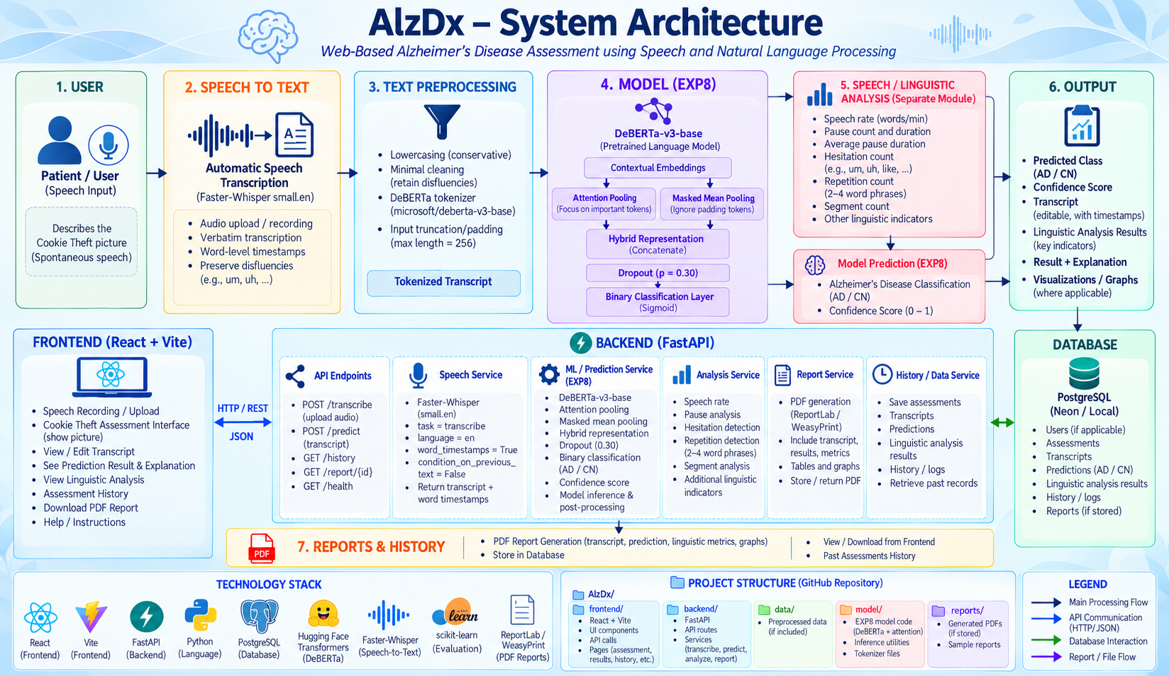
Figure 1: System architecture of the AlzDx web application.
D. Web Application Modules
The model evaluated in this project forms the machine-learning core of the wider AlzDx web platform. The platform separates the user interface, application logic, model inference, data storage and reporting. This allows the classifier to be used within an assessment workflow while keeping the prediction model itself distinct from the surrounding application components.
- Frontend module (React with Vite): supports speech recording or upload, the Cookie Theft task, transcript review, linguistic-metric visualisation, prediction results, assessment history and PDF reports. It exchanges data with the backend through HTTP/REST requests and JSON responses.
- Backend module (FastAPI): coordinates the workflow. It receives audio and assessment details, calls Faster-Whisper for transcription, prepares the resulting transcript for model inference, returns the prediction and linguistic analysis, and manages history and report requests.
- Machine-learning module: contains the DeBERTa-v3-base encoder and the hybrid attention–mean pooling classifier evaluated in this report.
- Linguistic analysis: displays speech-level measurements from the transcription pipeline, including duration, speech rate, pauses, hesitations and repetitions. These are supplementary indicators and are not inputs to the reported classifier.
- Database module (PostgreSQL): stores user records, assessments, transcripts, predictions, linguistic-analysis results, history entries and generated reports.
- Reporting module: produces PDF summaries of assessment results, metrics and visualisations.
E. End-to-End Assessment Workflow
Step | Component | Action
1 | Frontend | The participant views the Cookie Theft picture and the instruction to describe everything in complete sentences.
2 | Frontend | Speech is recorded with the microphone or an audio file is uploaded.
3 | Backend | The audio and assessment details are received through the REST API.
4 | Faster-Whisper | The audio is transcribed into text.
5 | ML module | The transcript is tokenized, encoded and classified; a label and confidence value are returned.
6 | Backend | Speech-level indicators (speech rate, pauses, hesitations, repetitions) are computed for display.
7 | Database | The assessment, transcript, prediction and analysis are stored.
8 | Reporting | A PDF screening report is generated and made available in the history view.
Table 3B: Sequence of operations for one AlzDx assessment.
The web application and the experiment reported in Section 7 should be distinguished. The 89.33% result comes from classifying existing transcripts in the held-out research test set. It is not an end-to-end accuracy figure for the full website, because the effects of automatic speech recognition on downstream predictions were not evaluated in that experiment. End-to-end validation remains future work.

RESULTS AND DISCUSSION
Dataset summary. The evaluated dataset has 496 Cookie Theft transcripts (240 healthy, 256 Alzheimer’s); the class distribution per partition is given in Table 2. The held-out test set has 75 transcripts (37 healthy, 38 Alzheimer’s). Roughly balanced classes mean accuracy is not dominated by one class.
Test performance. On the best validation checkpoint the model correctly classified 67 of 75 test transcripts (Table 4). Precision of 91.67% and specificity of 91.89% show a low false-alarm rate, while recall of 86.84% shows that some Alzheimer’s transcripts were missed. Balanced accuracy (89.37%), MCC (0.788) and Cohen’s κ (0.787) agree with the accuracy figure, so the result is not driven by favouring one class.
Metric | Result
Accuracy | 89.33%
95% Wilson CI (accuracy) | 80.3–94.5%
Precision | 91.67%
Recall / Sensitivity | 86.84%
Specificity | 91.89%
F1 score | 89.19%
Balanced accuracy | 89.37%
MCC | 0.788
Cohen’s κ | 0.787
Table 4: Held-out test performance of the proposed model.
Confusion matrix. The model correctly classified 34 of the 37 healthy-control transcripts and 33 of the 38 Alzheimer’s transcripts (Table 5). It produced three false positives and five false negatives, eight errors in total. More Alzheimer’s cases were missed than healthy transcripts flagged, which is why recall is lower than specificity.
 | Predicted Healthy | Predicted Alzheimer’s
Actual Healthy | 34 | 3
Actual Alzheimer’s | 5 | 33
Table 5: Confusion matrix on the 75-document test partition.
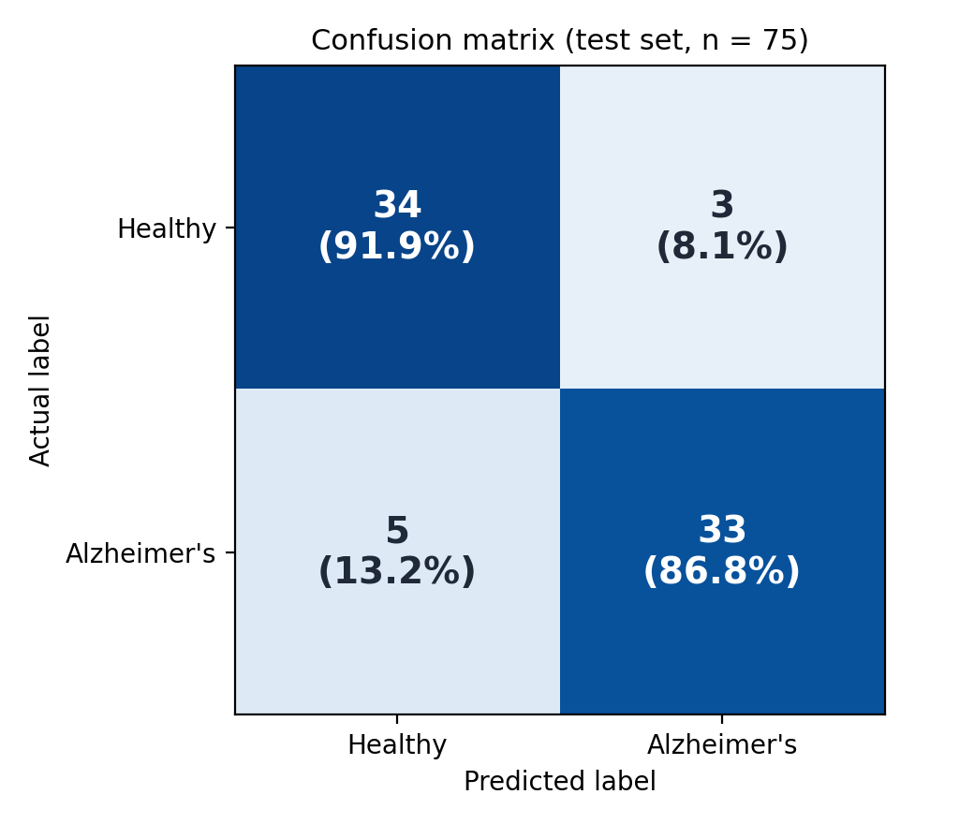
Figure 2: Confusion matrix of the proposed model on the 75-transcript test partition (counts and row-wise percentages).
Figure 2 shows the same matrix as a heatmap. The diagonal cells hold the correct predictions (34 healthy and 33 Alzheimer’s), and the row percentages show that 91.9% of healthy transcripts and 86.8% of Alzheimer’s transcripts were classified correctly. The darker top-left cell reflects the high specificity, while the larger off-diagonal count in the second row (5 missed Alzheimer’s cases versus 3 false alarms) explains why recall is lower than specificity.
Metric-wise Interpretation
The following paragraphs interpret the model’s own principal metrics on the 75-transcript test partition. Since the cited studies do not provide a consistently verified set of directly comparable class-wise metrics, this interpretation does not assign cross-study rankings for precision, recall, F1 score or specificity.
Accuracy
The model achieved 89.33% accuracy, correctly classifying 67 of the 75 test transcripts. The 95% Wilson interval of 80.3–94.5% shows the range of accuracy values that are consistent with this result given the small test set.
Precision
Precision was 91.67%: 33 of the 36 transcripts predicted as Alzheimer’s disease were correctly classified, while three control transcripts were false positives. This is a result for the present test set only.
Recall and Sensitivity
Recall (sensitivity) was 86.84%, with 33 Alzheimer’s transcripts correctly detected and five missed. Missed cases are the most important type of error in a screening context, so recall is the metric where further improvement would be most valuable.
F1 Score
The F1 score was 89.19%, calculated from the test-set precision and recall. It summarises the balance between finding Alzheimer’s cases and avoiding false alarms.
Specificity
Specificity was 91.89%, with 34 of the 37 healthy-control transcripts correctly identified. Together with the precision value, this indicates a low false-alarm rate on the present test set.
Balanced Measures
Balanced accuracy (89.37%), MCC (0.788) and Cohen’s κ (0.787) all agree with the accuracy figure. Because these measures account for both classes, the agreement shows that the result is not driven by favouring one class.
Comparison with published systems. Table 6 and Figure 3 compare the model with published transcript-based systems. For the published ADReSS systems, per-class metrics were reconstructed from reported precision and recall on the 48-speaker test set, so all five metrics are computed on the same basis. The proposed model ranks first on accuracy, precision, F1 score and specificity, and second on recall (Balagopalan et al. report 87.50%). The ranking is indicative only: the 95% Wilson interval for this work (80.3–94.5%) overlaps those of the compared systems, and the test sets differ (ADReSS n = 48 versus Pitt n = 75).
System | Test set | Acc. (%) | Prec. | Recall | Spec. | F1
This work (DeBERTa-v3 + attention + mean pooling) | Pitt, n = 75 | 89.33 | 91.67 | 86.84 | 91.89 | 89.19
Li et al., 2021 (BERT emb. + SVM) | ADReSS, n = 48 | 87.50 | 90.91 | 83.33 | 91.67 | 86.96
Syed et al., 2020 (fused embeddings) | ADReSS, n = 48 | 85.42 | — | — | — | —
Balagopalan et al., 2020 (fine-tuned BERT) | ADReSS, n = 48 | 83.33 | 80.77 | 87.50 | 79.17 | 84.00
Meghanani et al., 2021 (fastText) | ADReSS, n = 48 | 83.33 | 86.36 | 79.17 | 87.50 | 82.61
Fraser et al., 2016 (370 features) | Pitt, 10-fold CV | 81.92 | — | — | — | —
Searle et al., 2020 (DistilBERT + LR) | ADReSS, n = 48 | 81.25 | 80.00 | 83.33 | 79.17 | 81.63
Luz et al., 2020 (linguistic baseline, LDA) | ADReSS, n = 48 | 75.00 | 83.33 | 62.50 | 87.50 | 71.43
Table 6: Metric comparison of this work and published systems (all values in %). “—” means not reported.
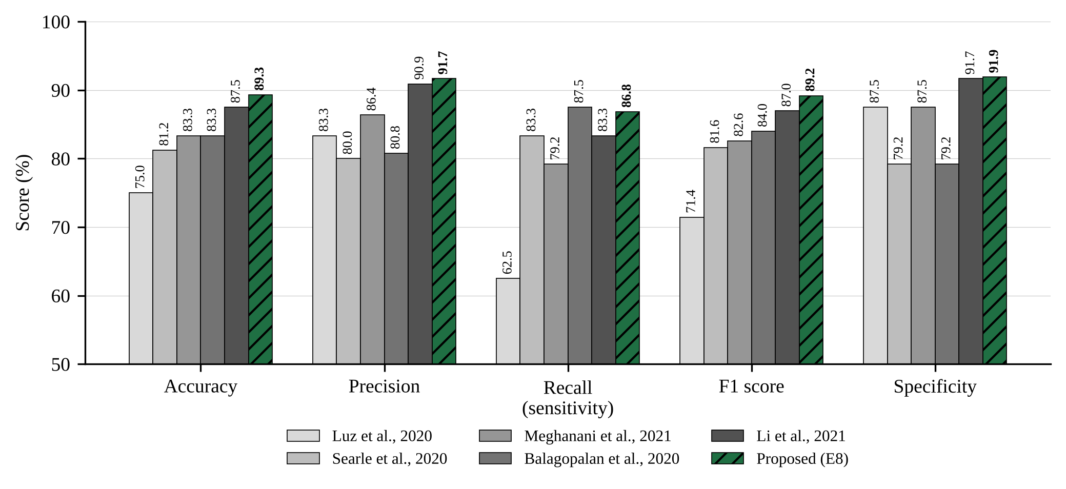
Figure 3: Accuracy, precision, recall, F1 score and specificity of this work versus published systems.
Figure 3 shows the same comparison graphically. The proposed model is highest or close to highest on every metric, with the gap to the next system smallest on recall. Because datasets and splits differ, the figure shows relative position rather than a controlled head-to-head result.
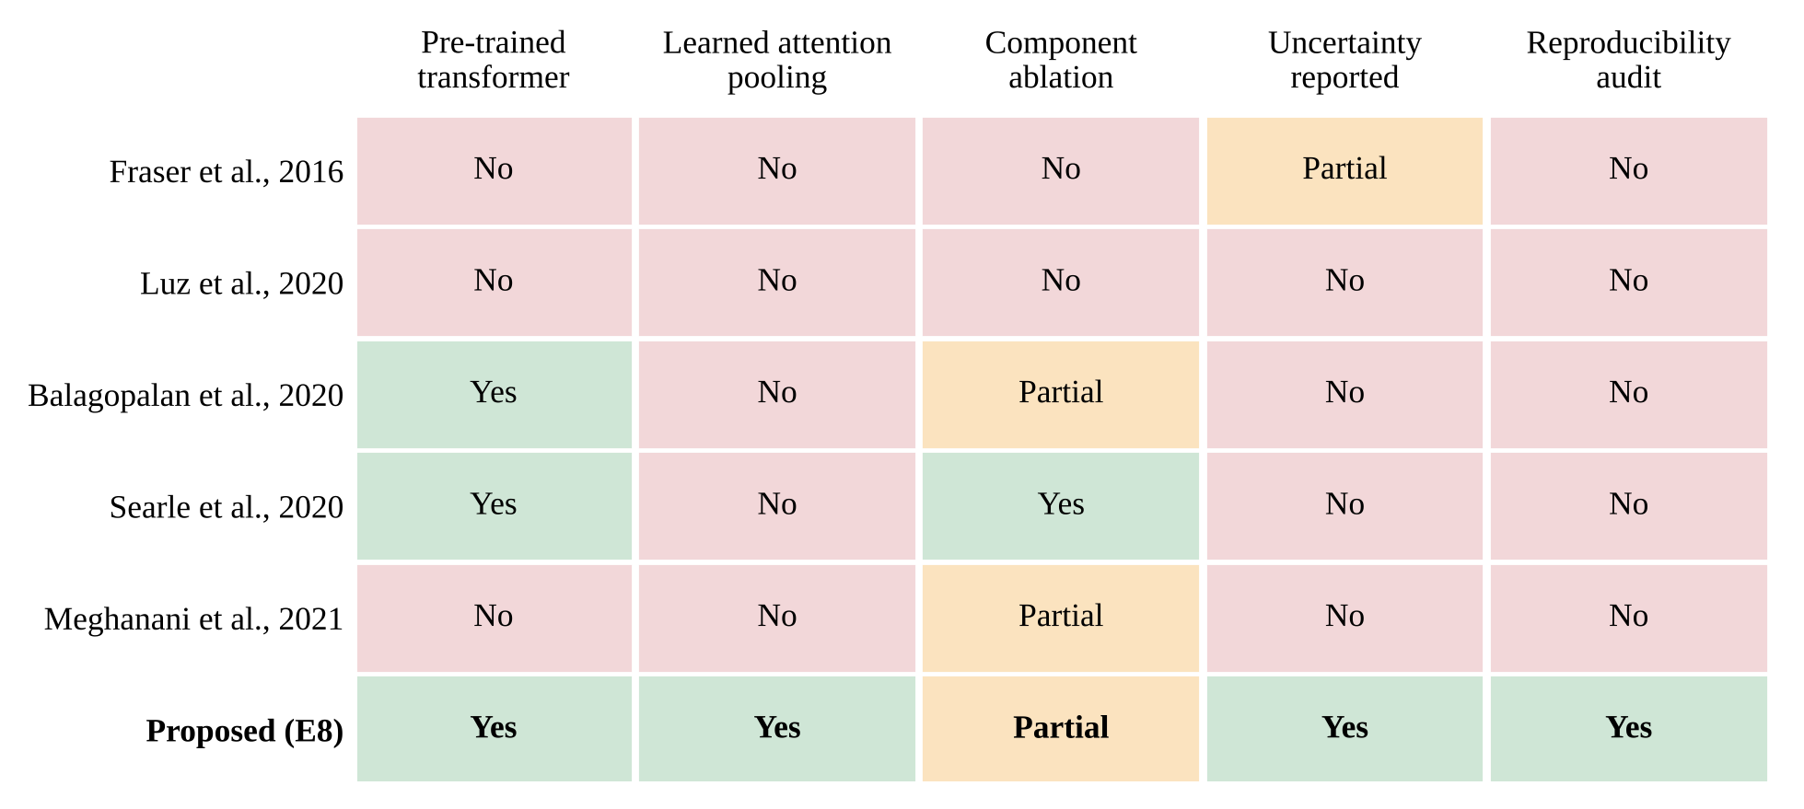
Figure 4: Research gap coverage across representative studies.
Figure 4 summarises what each earlier study reports: use of a pretrained transformer, learned attention pooling, component ablation, uncertainty reporting and a reproducibility audit. This work is the only study in the figure rated “Yes” on learned attention pooling, uncertainty reporting and a reproducibility audit; its component ablation is rated only “Partial”.
Web platform demonstration. Figures 5 and 6 show the AlzDx web application in use. Figure 5 is the Cookie Theft assessment screen, where the participant views the picture, reads the instruction to describe everything in complete sentences, and either records speech with the microphone or uploads an audio file.
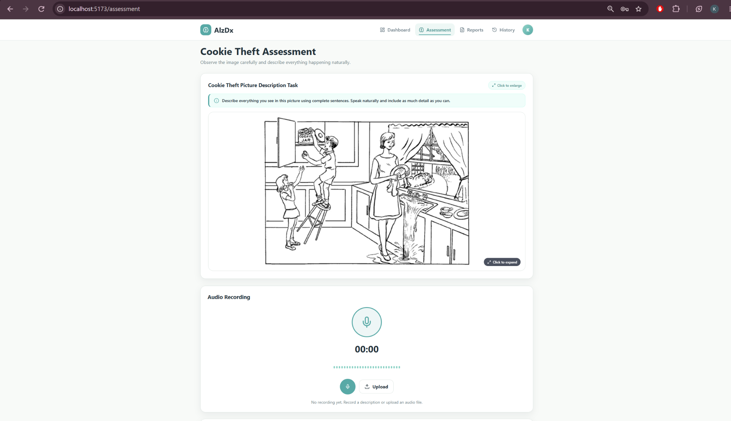
Figure 5: AlzDx Cookie Theft assessment interface with the picture stimulus and audio recording panel.
After the recording is transcribed by Faster-Whisper and passed to the classifier, the platform produces the PDF screening report in Figure 6. The report lists the screening result with a confidence value, a research disclaimer, the supporting linguistic and temporal indicators (speech rate, pause count, total and average pause duration, hesitations and repetitions), the verbatim transcript evaluated by the model, and the model information (microsoft/deberta-v3-base, attention plus mean pooling, test accuracy 89.33%). These speech-timing indicators are supporting information and are not inputs to the classifier. The example is a single demonstration assessment; it illustrates the output format and is not a measure of model performance, which is given by the held-out test results above.
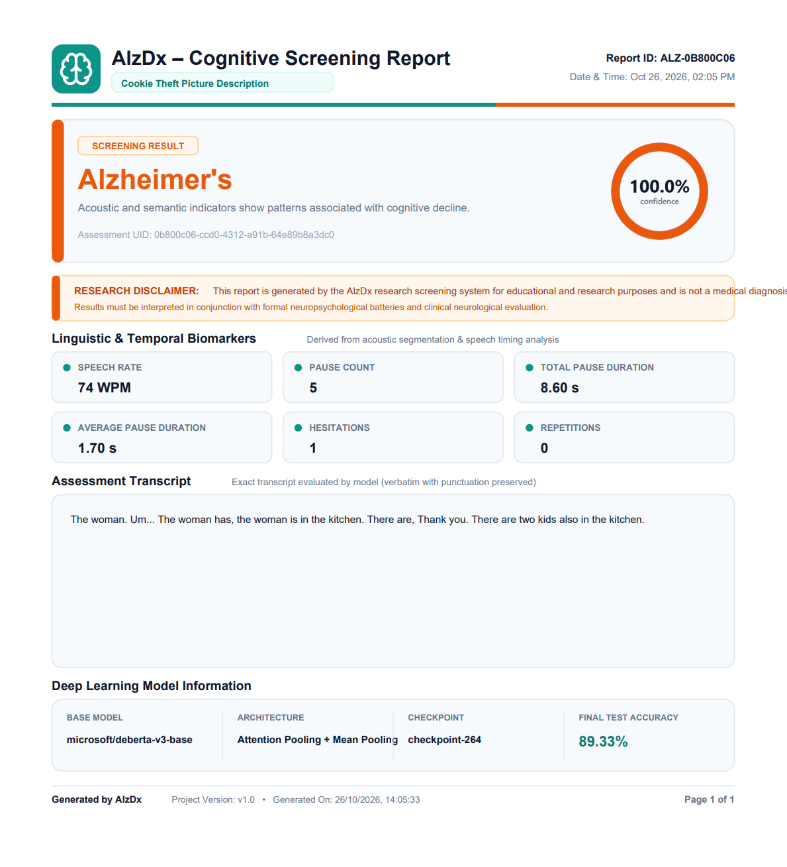
Figure 6: Sample AlzDx cognitive screening report generated for a Cookie Theft assessment.
Model Development History (Ablation Context)
Several configurations were evaluated during development using the same general transcript-classification pipeline. Table 6A lists their test accuracies.
Configuration | Test accuracy
Baseline DeBERTa-v3 | 74.67%
DeBERTa-v3 + attention pooling | 78.67%
Class-weighted loss configuration | 76.00%
Bundled optimisation configuration | 82.67%
Final hybrid attention–mean configuration | 89.33%
Table 6A: Test accuracy of configurations evaluated during development.
The class-weighted loss configuration achieved 76.00% test accuracy despite higher validation accuracy. These experiments document the model-development process, but they do not provide a fully controlled ablation study. The final hybrid configuration changed more than one factor, and it was trained on the 496-record table, whereas some earlier configurations used 497 records. The 89.33% figure is therefore reported as the performance of the final evaluated configuration, not as proof that mean pooling alone caused the improvement.
Interpretation of the Hybrid Representation
The results may reflect the complementary roles of the two pooling methods. Attention pooling can give more weight to selected token positions, while mean pooling summarises information across the full transcript. Combining the two representations gives the classifier access to both kinds of signal. The model’s sensitivity and specificity are consistent with this explanation, but they do not establish it, because the final configuration also used a dropout rate of 0.30 and a training table with one fewer record than some earlier experiments.
Practical Implications
This kind of transcript classifier should be viewed as a research tool or a possible aid to triage, not as a stand-alone diagnostic system. False positives and false negatives both matter in a screening setting. In the test set, the model missed five Alzheimer’s transcripts and incorrectly flagged three control transcripts. The results are encouraging for further research, but they are not sufficient to support clinical deployment.
Relationship to Speech Processing
The classifier evaluated here takes transcripts as input. The wider AlzDx application also includes automatic speech transcription and measurements such as pauses, speech rate, hesitations and repetitions. These features are part of the application workflow, but they were not included in the held-out classification experiment. The reported 89.33% accuracy must therefore not be interpreted as end-to-end accuracy from speech recording to a prediction.
Interpretation of Comparative Findings
The comparison with published systems is descriptive. The studies differ in datasets, sample sizes, partitions and evaluation procedures, and some values come from different model configurations within a paper. Published precision, recall, F1 score and specificity were not consistently verified under directly comparable test protocols, so the comparison should be read as context for the proposed configuration rather than as evidence of superiority.
Discussion, errors and limitations. The balanced rates of false positives and false negatives are consistent with attention pooling (selective evidence) and mean pooling (global evidence) being complementary, but this study does not isolate the independent contribution of mean pooling. The test set has only 75 transcripts, so one prediction changes accuracy by about 1.33 percentage points [Varoquaux 2018]. Participant identifiers were not retained, so speaker-disjoint partitions could not be verified even though the corpus is longitudinal. Only a single split and seed were used, so variability across splits is not measured, and the 256-token limit may truncate longer descriptions. The 89.33% result is transcript-based and is not end-to-end speech-to-diagnosis accuracy. With five missed Alzheimer’s cases and three false alarms, the system suits research or triage support, not clinical deployment.
Summary of Results
- The model correctly classified 67 of the 75 held-out test transcripts (89.33% accuracy, 95% Wilson CI 80.3–94.5%).
- Precision (91.67%) and specificity (91.89%) were higher than recall (86.84%): three false positives and five false negatives.
- Balanced accuracy (89.37%), MCC (0.788) and Cohen’s κ (0.787) agree with the accuracy figure.
- The comparison with published systems is descriptive, because datasets, test sets and protocols differ.
- The AlzDx platform demonstrates the classifier in a complete workflow, but the reported accuracy is transcript-based, not end-to-end.

CONCLUSION AND FUTURE SCOPE
This project investigated a DeBERTa-v3-base approach to transcript-level Alzheimer’s disease detection using a hybrid document representation that combines learned attention pooling with masked mean pooling. On the 75-transcript held-out test partition the model achieved 89.33% accuracy, 91.67% precision, 86.84% recall, 91.89% specificity and 89.19% F1 score, with three false positives and five false negatives.
All objectives were implemented: the Pitt corpus transcripts were obtained and documented, preprocessed and split; text was converted to features with the DeBERTa-v3 tokenizer and pooled representations; the model was trained, evaluated with the listed metrics and compared with published systems; errors and limitations were discussed; and the AlzDx web interface was built. The most important limitation is the small test set together with the unverified speaker-disjoint split, and differences in datasets and protocols mean the comparison with published work is indicative rather than a controlled ranking.
Limitations in Detail
- Small test set: the test set contains only 75 transcripts, so a single prediction changes accuracy by about 1.33 percentage points. Small test sets can produce substantial uncertainty in performance estimates [Varoquaux 2018].
- Speaker separation: the working transcript table did not retain participant identifiers. Since the underlying corpus includes longitudinal data, transcripts from the same participant could potentially appear in more than one partition.
- Single split and seed: the model was evaluated using one stratified split and one random seed, so variation across splits or initialisations is not estimated. This can be important when fine-tuning pretrained transformers on small datasets [Dodge et al. 2020, Mosbach et al. 2021].
- Sequence length: the maximum sequence length of 256 tokens may truncate longer descriptions.
- Transcript-only evaluation: the reported accuracy does not include the effect of automatic speech recognition in the web platform.
Validity and Reproducibility
Several implementation details were recorded to support replication. The main split used random_state = 42, the tokenizer was microsoft/deberta-v3-base with a maximum length of 256 tokens, and the final representation concatenated 768-dimensional attention- and mean-pooled vectors before dropout and binary classification. The test confusion matrix was TN = 34, FP = 3, FN = 5 and TP = 33. These details give other researchers a starting point for reproducing the experiment, although they do not address the uncertainty associated with the small dataset or the unverified participant-level separation.

Future scope. The experiments should be repeated with participant identifiers retained to enforce speaker-disjoint splits, using multiple random seeds and grouped cross-validation to estimate variability. Further work includes separating the effects of mean pooling and dropout, paired significance tests such as McNemar’s test [McNemar 1947, Dietterich 1998], evaluation of the frozen model on an independent dataset such as ADReSS, and explicit pause and disfluency representations [Yuan et al. 2021]. Other extensions are attention-weight analysis validated with LIME or SHAP [Ribeiro et al. 2016, Lundberg and Lee 2017], probability calibration [Guo et al. 2017], longer sequence lengths, ensembling across seeds, multimodal fusion with acoustic features, and end-to-end evaluation of the web platform including the effect of automatic transcription.
Roadmap for Future Work
Priority | Direction | Purpose
1 | Speaker-disjoint splits, multiple seeds, grouped cross-validation | Strengthen reproducibility and estimate variability
2 | Factorial experiments on mean pooling and dropout; McNemar’s test | Isolate the effect of each component
3 | Evaluation on an independent dataset such as ADReSS | Test generalisation beyond the Pitt corpus
4 | Explicit pause and disfluency representations; acoustic fusion | Use temporal speech cues alongside text
5 | LIME/SHAP validation and probability calibration | Make predictions easier to interpret and trust
6 | End-to-end evaluation of the web platform | Measure the effect of automatic transcription
Table 7A: Prioritised directions for future work.
Code Availability
To support reproducibility, the source code of the AlzDx web application, including the frontend, backend and model implementation, is publicly available in the project repository: https://github.com/KrishitaMyneni/KLH-CSE-2026-27-2420030443-AlzDx-Alzheimer-s-detection/tree/main
Data Acknowledgement
The authors acknowledge DementiaBank and TalkBank for providing access to the Pitt Corpus. Use of the Pitt Corpus requires citation of Becker et al. (1994) and acknowledgement of National Institute on Aging grant support AG03705 and AG05133, as specified by the corpus documentation.

REFERENCES

- Balagopalan, A., Eyre, B., Rudzicz, F., and Novikova, J. (2020). To BERT or not to BERT: Comparing speech and language-based approaches for Alzheimer’s disease detection. In Proceedings of Interspeech 2020, pages 2167–2171. https://doi.org/10.21437/Interspeech.2020-2557
- Balagopalan, A., Eyre, B., Robin, J., Rudzicz, F., and Novikova, J. (2021). Comparing pre-trained and feature-based models for prediction of Alzheimer’s disease based on speech. Frontiers in Aging Neuroscience, 13:635945.
- Becker, J. T., Boller, F., Lopez, O. L., Saxton, J., and McGonigle, K. L. (1994). The natural history of Alzheimer’s disease: Description of study cohort and accuracy of diagnosis. Archives of Neurology, 51(6):585–594.
- Chicco, D. and Jurman, G. (2020). The advantages of the Matthews correlation coefficient (MCC) over F1 score and accuracy in binary classification evaluation. BMC Genomics, 21:6.
- Clark, K., Luong, M.-T., Le, Q. V., and Manning, C. D. (2020). ELECTRA: Pre-training text encoders as discriminators rather than generators. In International Conference on Learning Representations.
- Conneau, A., Kiela, D., Schwenk, H., Barrault, L., and Bordes, A. (2017). Supervised learning of universal sentence representations from natural language inference data. In Proceedings of EMNLP 2017, pages 670–680.
- Devlin, J., Chang, M.-W., Lee, K., and Toutanova, K. (2019). BERT: Pre-training of deep bidirectional transformers for language understanding. In Proceedings of NAACL-HLT 2019, pages 4171–4186.
- Dietterich, T. G. (1998). Approximate statistical tests for comparing supervised classification learning algorithms. Neural Computation, 10(7):1895–1923.
- Dodge, J., Ilharco, G., Schwartz, R., Farhadi, A., Hajishirzi, H., and Smith, N. (2020). Fine-tuning pretrained language models: Weight initializations, data orders, and early stopping. arXiv preprint arXiv:2002.06305.
- Fraser, K. C., Meltzer, J. A., and Rudzicz, F. (2016). Linguistic features identify Alzheimer’s disease in narrative speech. Journal of Alzheimer’s Disease, 49(2):407–422. https://doi.org/10.3233/JAD-150520
- Goodglass, H. and Kaplan, E. (1972). The Assessment of Aphasia and Related Disorders. Lea & Febiger, Philadelphia.
- Guo, C., Pleiss, G., Sun, Y., and Weinberger, K. Q. (2017). On calibration of modern neural networks. In Proceedings of ICML 2017, pages 1321–1330.
- Haider, F., de la Fuente, S., and Luz, S. (2020). An assessment of paralinguistic acoustic features for detection of Alzheimer’s dementia in spontaneous speech. IEEE Journal of Selected Topics in Signal Processing, 14(2):272–281.
- He, P., Liu, X., Gao, J., and Chen, W. (2021). DeBERTa: Decoding-enhanced BERT with disentangled attention. In International Conference on Learning Representations.
- He, P., Gao, J., and Chen, W. (2023). DeBERTaV3: Improving DeBERTa using ELECTRA-style pre-training with gradient-disentangled embedding sharing. In International Conference on Learning Representations.
- Jain, S. and Wallace, B. C. (2019). Attention is not explanation. In Proceedings of NAACL-HLT 2019, pages 3543–3556.
- Li, J., Yu, J., Ye, Z., Wong, S., Mak, M., Mak, B., Liu, X., and Meng, H. (2021). A comparative study of acoustic and linguistic features classification for Alzheimer’s disease detection. In Proceedings of ICASSP 2021, pages 6423–6427. https://doi.org/10.1109/ICASSP39728.2021.9414147
- Lin, Z., Feng, M., dos Santos, C. N., Yu, M., Xiang, B., Zhou, B., and Bengio, Y. (2017). A structured self-attentive sentence embedding. In International Conference on Learning Representations.
- Liu, Z., Guo, Z., Ling, Z., and Li, Y. (2021). Detecting Alzheimer’s disease from speech using neural networks with bottleneck features and data augmentation. In Proceedings of ICASSP 2021, pages 7323–7327.
- Loshchilov, I. and Hutter, F. (2019). Decoupled weight decay regularization. In International Conference on Learning Representations.
- Lundberg, S. M. and Lee, S.-I. (2017). A unified approach to interpreting model predictions. Advances in Neural Information Processing Systems, 30.
- Luz, S., Haider, F., de la Fuente, S., Fromm, D., and MacWhinney, B. (2020). Alzheimer’s dementia recognition through spontaneous speech: The ADReSS Challenge. In Proceedings of Interspeech 2020, pages 2172–2176. https://doi.org/10.21437/Interspeech.2020-2571
- Luz, S., Haider, F., de la Fuente, S., Fromm, D., and MacWhinney, B. (2021). Detecting cognitive decline using speech only: The ADReSSo Challenge. In Proceedings of Interspeech 2021, pages 3780–3784.
- MacWhinney, B. (2000). The CHILDES Project: Tools for Analyzing Talk. 3rd edition, Lawrence Erlbaum Associates, Mahwah, NJ.
- Matthews, B. W. (1975). Comparison of the predicted and observed secondary structure of T4 phage lysozyme. Biochimica et Biophysica Acta, 405(2):442–451.
- Mattson, M. P. (2004). Pathways towards and away from Alzheimer’s disease. Nature, 430:631–639.
- McNemar, Q. (1947). Note on the sampling error of the difference between correlated proportions or percentages. Psychometrika, 12(2):153–157.
- Meghanani, A., Anoop, C. S., and Ramakrishnan, A. G. (2021). Recognition of Alzheimer’s dementia from the transcriptions of spontaneous speech using fastText and CNN models. Frontiers in Computer Science, 3:624558. https://doi.org/10.3389/fcomp.2021.624558
- Mirheidari, B., Blackburn, D., Walker, T., Venneri, A., Reuber, M., and Christensen, H. (2018). Detecting signs of dementia using word vector representations. In Proceedings of Interspeech 2018, pages 1893–1897.
- Mosbach, M., Andriushchenko, M., and Klakow, D. (2021). On the stability of fine-tuning BERT: Misconceptions, explanations, and strong baselines. In International Conference on Learning Representations.
- Mueller, K. D., Hermann, B., Mecollari, J., and Turkstra, L. S. (2018). Connected speech and language in mild cognitive impairment and Alzheimer’s disease: A review of picture description tasks. Journal of Clinical and Experimental Neuropsychology, 40(9):917–939.
- Paszke, A., Gross, S., Massa, F., Lerer, A., Bradbury, J., et al. (2019). PyTorch: An imperative style, high-performance deep learning library. Advances in Neural Information Processing Systems, 32.
- Pedregosa, F., Varoquaux, G., Gramfort, A., Michel, V., Thirion, B., et al. (2011). Scikit-learn: Machine learning in Python. Journal of Machine Learning Research, 12:2825–2830. https://scikit-learn.org/stable/
- Reimers, N. and Gurevych, I. (2019). Sentence-BERT: Sentence embeddings using Siamese BERT-networks. In Proceedings of EMNLP-IJCNLP 2019, pages 3982–3992.
- Ribeiro, M. T., Singh, S., and Guestrin, C. (2016). “Why should I trust you?”: Explaining the predictions of any classifier. In Proceedings of the 22nd ACM SIGKDD International Conference on Knowledge Discovery and Data Mining, pages 1135–1144.
- Searle, T., Ibrahim, Z., and Dobson, R. (2020). Comparing natural language processing techniques for Alzheimer’s dementia prediction in spontaneous speech. In Proceedings of Interspeech 2020, pages 2192–2196. https://doi.org/10.21437/Interspeech.2020-2729
- Srivastava, N., Hinton, G., Krizhevsky, A., Sutskever, I., and Salakhutdinov, R. (2014). Dropout: A simple way to prevent neural networks from overfitting. Journal of Machine Learning Research, 15(1):1929–1958.
- Sun, C., Qiu, X., Xu, Y., and Huang, X. (2019). How to fine-tune BERT for text classification? In Chinese Computational Linguistics (CCL 2019), pages 194–206. Springer.
- Syed, M. S. S., Syed, Z. S., Lech, M., and Pirogova, E. (2020). Automated screening for Alzheimer’s dementia through spontaneous speech. In Proceedings of Interspeech 2020, pages 2222–2226. https://doi.org/10.21437/Interspeech.2020-3158
- Varoquaux, G. (2018). Cross-validation failure: Small sample sizes lead to large error bars. NeuroImage, 180:68–77.
- Vaswani, A., Shazeer, N., Parmar, N., Uszkoreit, J., Jones, L., Gomez, A. N., Kaiser, Ł., and Polosukhin, I. (2017). Attention is all you need. Advances in Neural Information Processing Systems, 30.
- Wiegreffe, S. and Pinter, Y. (2019). Attention is not not explanation. In Proceedings of EMNLP-IJCNLP 2019, pages 11–20.
- Wilson, E. B. (1927). Probable inference, the law of succession, and statistical inference. Journal of the American Statistical Association, 22(158):209–212.
- Wolf, T., Debut, L., Sanh, V., Chaumond, J., Delangue, C., Moi, A., et al. (2020). Transformers: State-of-the-art natural language processing. In Proceedings of EMNLP 2020: System Demonstrations, pages 38–45. https://huggingface.co/docs
- Yang, Z., Yang, D., Dyer, C., He, X., Smola, A., and Hovy, E. (2016). Hierarchical attention networks for document classification. In Proceedings of NAACL-HLT 2016, pages 1480–1489.
- Ye, Z., Hu, S., Li, J., Xie, X., Geng, M., Yu, J., Xu, J., Xue, B., Liu, S., Liu, X., and Meng, H. (2021). Development of the CUHK elderly speech recognition system for neurocognitive disorder detection using the DementiaBank corpus. In Proceedings of ICASSP 2021, pages 6433–6437.
- Yuan, J., Bian, Y., Cai, X., Huang, J., Ye, Z., and Church, K. (2020). Disfluencies and fine-tuning pre-trained language models for detection of Alzheimer’s disease. In Proceedings of Interspeech 2020, pages 2162–2166.
- Yuan, J., Cai, X., Bian, Y., Ye, Z., and Church, K. (2021). Pauses for detection of Alzheimer’s disease. Frontiers in Computer Science, 2:624488.
- de la Fuente Garcia, S., Ritchie, C. W., and Luz, S. (2020). Artificial intelligence, speech, and language processing approaches to monitoring Alzheimer’s disease: A systematic review. Journal of Alzheimer’s Disease, 78(4):1547–1574.
- Project repository (AlzDx source code): https://github.com/KrishitaMyneni/KLH-CSE-2026-27-2420030443-AlzDx-Alzheimer-s-detection/tree/main
- FastAPI documentation: https://fastapi.tiangolo.com
- PyTorch documentation: https://pytorch.org/docs

