AMLTA - LITERATURE SURVEY
AI-Based Early Detection of Alzheimer's Disease Using Speech and Machine Learning
Section: 1
Team : 3
Bhanu Prakash - 2420030209
Krishitha Myneni - 2420030443
Laasya Priya - 2420030002
S.No | Paper Title | Paper Link | Year & Author(s) | Limitations | How We Solved It
1 | Linguistic Features Identify Alzheimer's Disease in Narrative Speech | https://doi.org/10.3233/JAD-150520 | 2015 – K. C. Fraser, J. A. Meltzer, F. Rudzicz | Relies on hand-crafted features (POS ratios, type–token ratio, information units) that need manual design and domain expertise. Cannot learn contextual or long-range patterns in discourse. | Replaced manual feature engineering with end-to-end representation learning using DeBERTa-v3-base. The encoder learns contextual features directly from raw transcripts.
2 | Alzheimer's Dementia Recognition through Spontaneous Speech: The ADReSS Challenge | https://doi.org/10.21437/Interspeech.2020-2571 | 2020 – S. Luz, F. Haider, S. de la Fuente, D. Fromm, B. MacWhinney | Baseline acoustic and linguistic models reached only about 75% accuracy. Results were reported as point estimates with no component-level analysis. | Used a pre-trained transformer encoder that outperformed the challenge-baseline level. A controlled four-configuration ablation isolates the contribution of each pipeline component.
3 | To BERT or Not to BERT: Comparing Speech and Language-Based Approaches for Alzheimer's Disease Detection | https://doi.org/10.21437/Interspeech.2020-2557 | 2020 – A. Balagopalan, B. Eyre, F. Rudzicz, J. Novikova | Uses default [CLS]-token pooling, so scattered linguistic evidence must pass through one fixed position. Reports single runs without confidence intervals. | Added a learned additive attention-pooling head that weights every non-padding token. This raised test accuracy from 74.67% to 78.67% and MCC from 0.510 to 0.588. Every result carries a 95% Wilson interval.
4 | Disfluencies and Fine-Tuning Pre-Trained Language Models for Detection of Alzheimer's Disease | https://doi.org/10.21437/Interspeech.2020-2516 | 2020 – J. Yuan, Y. Bian, X. Cai, J. Huang, Z. Ye, K. Church | High variance across fine-tuning runs required ensembling. Uses older BERT/ERNIE encoders that are less sample-efficient on small data. | Adopted DeBERTa-v3, whose disentangled attention and ELECTRA-style pre-training improve sample efficiency on a 347-document training set. Disfluencies are preserved verbatim as diagnostic signal.
5 | Pauses for Detection of Alzheimer's Disease | https://doi.org/10.3389/fcomp.2020.624488 | 2021 – J. Yuan, X. Cai, Y. Bian, Z. Ye, K. Church | Depends on pause timing from audio alignment, so it is not a pure text-only pipeline. Instability across runs is not statistically quantified. | Built a strictly transcript-only pipeline with minimal cleaning that retains repetitions, false starts and filled pauses. Uncertainty is quantified with Wilson CIs and a bounded McNemar analysis. Explicit pause tokens are identified as future work.
6 | Comparing Natural Language Processing Techniques for Alzheimer's Dementia Prediction in Spontaneous Speech | https://doi.org/10.21437/Interspeech.2020-2729 | 2020 – T. Searle, Z. Ibrahim, R. Dobson | Compares whole model families rather than individual pipeline components. Reports no paired significance tests. | Held the dataset, split, seed, tokenizer and sequence length constant while varying one component at a time (pooling, loss, optimisation regime). Paired comparisons use a bounded McNemar test.
7 | Recognition of Alzheimer's Dementia from the Transcriptions of Spontaneous Speech Using fastText and CNN Models | https://doi.org/10.3389/fcomp.2021.624558 | 2021 – A. Meghanani, C. S. Anoop, A. G. Ramakrishnan | Static word embeddings (fastText) cannot capture context-dependent meaning. CNNs capture only local n-gram patterns. | Used contextual subword embeddings from a 184M-parameter DeBERTa-v3 encoder. Subword tokenization keeps malformed or partial words as recognisable token sequences.
8 | Automated Screening for Alzheimer's Dementia through Spontaneous Speech | https://doi.org/10.21437/Interspeech.2020-3158 | 2020 – M. S. S. Syed, Z. S. Syed, M. Lech, E. Pirogova | Pooling is applied over frozen transformer embeddings, so the encoder is not adapted to the task. | Fine-tuned all encoder parameters end-to-end jointly with a learnable attention-pooling head (about 98k parameters, 0.05% of the encoder).
9 | An Assessment of Paralinguistic Acoustic Features for Detection of Alzheimer's Dementia in Spontaneous Speech | https://doi.org/10.1109/JSTSP.2019.2955022 | 2020 – F. Haider, S. de la Fuente, S. Luz | Acoustic-only features miss much of the lexical and semantic signal that carries most of the discriminative information. | Focused on the linguistic channel through transformer-based transcript modelling. Multimodal fusion with acoustic features is proposed as an extension.
10 | Detecting Signs of Dementia Using Word Vector Representations | https://doi.org/10.21437/Interspeech.2018-1753 | 2018 – B. Mirheidari, D. Blackburn, T. Walker, A. Venneri, M. Reuber, H. Christensen | Word-vector representations lack deep contextual modelling and document-level aggregation. | Used deep contextual token states H ∈ ℝ^(256×768) aggregated by masked-softmax attention into a document vector.
11 | Detecting Cognitive Decline Using Speech Only: The ADReSSo Challenge | https://doi.org/10.21437/Interspeech.2021-1220 | 2021 – S. Luz, F. Haider, S. de la Fuente, D. Fromm, B. MacWhinney | Performance drops on ASR transcripts. Challenge results rarely report uncertainty or negative findings. | Reported negative results as primary findings. Class weighting gave 92% validation but only 76% test accuracy, and this is reported openly with full uncertainty analysis.
12 | Artificial Intelligence, Speech and Language Processing Approaches to Monitoring Alzheimer's Disease: A Systematic Review | https://doi.org/10.3233/JAD-200888 | 2020 – S. de la Fuente Garcia, C. W. Ritchie, S. Luz | Finds that most studies use small datasets, lack reproducibility and report weak statistical validation. | Conducted a reproducibility audit that documents a label-count discrepancy with an exhaustive sensitivity analysis (E5 range 81.33–84.00%). A speaker-disjoint, multi-seed confirmation protocol is specified.
13 | On the Stability of Fine-Tuning BERT: Misconceptions, Explanations, and Strong Baselines | https://arxiv.org/abs/2006.04884 | 2021 – M. Mosbach, M. Andriushchenko, D. Klakow | Shows that small-dataset fine-tuning is unstable, but does not address clinical speech data specifically. | Applied a conservative bundled regime for small data (learning rate 1×10⁻⁵, weight decay 0.05, 6 epochs, 26 warmup steps). It was associated with the highest held-out accuracy (82.67%, provisional).
14 | Fine-Tuning Pretrained Language Models: Weight Initializations, Data Orders, and Early Stopping | https://arxiv.org/abs/2002.06305 | 2020 – J. Dodge, G. Ilharco, R. Schwartz, A. Farhadi, H. Hajishirzi, N. Smith | Seed and data-order variance can shift accuracy by several points, and most applied studies ignore this. | Fixed the seed (42), split, and FP32 precision across all configurations so that differences come from the method, not the setup. Multi-seed grouped 10-fold cross-validation is prescribed for confirmation.
15 | DeBERTaV3: Improving DeBERTa Using ELECTRA-Style Pre-Training with Gradient-Disentangled Embedding Sharing | https://arxiv.org/abs/2111.09543 | 2023 – P. He, J. Gao, W. Chen | A general-purpose encoder that has not been evaluated for dementia detection on Pitt Cookie Theft transcripts. | Applied and ablated DeBERTa-v3-base on 497 Pitt DementiaBank Cookie Theft transcripts. To the authors' knowledge, this is the first attention-pooling and regularization ablation of it for this task.
16 | Connected Speech and Language in Mild Cognitive Impairment and Alzheimer's Disease: A Review of Picture Description Tasks | https://doi.org/10.1080/13803395.2018.1446513 | 2018 – K. D. Mueller, B. Hermann, J. Mecollari, L. S. Turkstra | A clinical review that documents group-level language differences but offers no automated system that can classify individual speakers. | Converted these clinical observations into an automated transcript-level classifier on the Cookie Theft picture-description task, keeping disfluencies and repetitions as model input.
17 | A Comparative Study of Acoustic and Linguistic Features Classification for Alzheimer's Disease Detection | https://www1.se.cuhk.edu.hk/~hccl/publications/pub/ICASSP_jcli.pdf | 2021 – J. Li, J. Yu, Z. Ye, S. Wong, M. Mak, B. Mak, X. Liu, H. Meng | Compares many feature sets and classifiers side by side, but does not isolate individual design choices inside the neural fine-tuning pipeline. No confidence intervals are reported. | Held every factor constant except the component under study. Each configuration is reported with 95% Wilson intervals, MCC and Cohen's κ.
18 | Development of the CUHK Elderly Speech Recognition System for Neurocognitive Disorder Detection Using the DementiaBank Corpus | https://www1.se.cuhk.edu.hk/~hccl/publications/pub/zye_revised_v4.pdf | 2021 – Z. Ye, S. Hu, J. Li, X. Xie, M. Geng, J. Yu, et al., X. Liu, H. Meng | Focuses on building a heavy ASR system for elderly speech. Downstream detection depends on recognition quality and large-scale acoustic training. | Uses a lightweight text-only pipeline on manual CHAT transcripts that trains in minutes on a single 8 GB laptop GPU. Evaluation on ASR transcripts is listed as a limitation and future step.
19 | Conformer Based Elderly Speech Recognition System for Alzheimer's Disease Detection | https://arxiv.org/abs/2206.13232 | 2022 – T. Wang, J. Deng, M. Geng, Z. Ye, S. Hu, Y. Wang, M. Cui, Z. Jin, X. Liu, H. Meng | Achieves high accuracy but requires a complex ASR stack (neural architecture search, speaker adaptation, system rescoring) that is costly to reproduce. | Kept the architecture simple and reproducible: one pre-trained encoder plus a ~98k-parameter attention head, with the full configuration table and a fixed seed published.
20 | BERT: Pre-Training of Deep Bidirectional Transformers for Language Understanding | https://aclanthology.org/N19-1423/ | 2019 – J. Devlin, M.-W. Chang, K. Lee, K. Toutanova | Masked-language-model pre-training is less sample-efficient, and its default [CLS] pooling compresses the whole sequence into one token. | Replaced BERT with DeBERTa-v3 (replaced-token-detection pre-training) and replaced [CLS] pooling with learned attention pooling over all tokens.
21 | DeBERTa: Decoding-Enhanced BERT with Disentangled Attention | https://arxiv.org/abs/2006.03654 | 2021 – P. He, X. Liu, J. Gao, W. Chen | Introduces disentangled attention but still relies on masked-language-model pre-training. Not evaluated on clinical speech transcripts. | Used the v3 successor, which adds ELECTRA-style pre-training and gradient-disentangled embedding sharing, and applied it to Alzheimer's transcripts.
22 | A Structured Self-Attentive Sentence Embedding | https://arxiv.org/abs/1703.03130 | 2017 – Z. Lin, M. Feng, C. N. dos Santos, M. Yu, B. Xiang, B. Zhou, Y. Bengio | Attention pooling is built on BiLSTM encoders and tested on general NLP tasks, not on low-resource clinical data. | Adapted additive attention pooling to a pre-trained DeBERTa-v3 encoder with a masked softmax so padding receives zero weight, and tested it on 497 clinical transcripts.
23 | Hierarchical Attention Networks for Document Classification | https://aclanthology.org/N16-1174/ | 2016 – Z. Yang, D. Yang, C. Dyer, X. He, A. Smola, E. Hovy | GRU-based hierarchical model trained from scratch, which needs large labelled corpora to work well. | Combined the attention-aggregation idea with transfer learning from a pre-trained transformer, making it practical for a 347-document training set.
24 | How to Fine-Tune BERT for Text Classification? | https://arxiv.org/abs/1905.05583 | 2019 – C. Sun, X. Qiu, Y. Xu, X. Huang | Fine-tuning recipes were derived on large benchmark datasets and may overfit on a few hundred documents. | Used the standard recipe as baseline E1, then observed overfitting (training loss 5.44×10⁻⁴ vs validation loss 1.07) and tested a more conservative bundled regime in E5.
25 | Attention Is Not Explanation | https://aclanthology.org/N19-1357/ | 2019 – S. Jain, B. C. Wallace | Shows attention weights can often be permuted without changing predictions, so attention alone is not a faithful explanation. | Treated attention weights only as a diagnostic signal, not as proof. An explainability protocol validating attention against LIME/SHAP is specified (not yet executed).
26 | Attention Is Not Not Explanation | https://aclanthology.org/D19-1002/ | 2019 – S. Wiegreffe, Y. Pinter | Argues attention can be meaningful, but whether it is depends on the task and model, and must be tested case by case. | Adopted the balanced position: attention weights from the pooling layer are extractable per document, but must be cross-checked with an independent attribution method before being reported as explanations.
27 | Cross-Validation Failure: Small Sample Sizes Lead to Large Error Bars | https://doi.org/10.1016/j.neuroimage.2017.06.061 | 2018 – G. Varoquaux | Shows small-sample evaluation gives wide error bars, but many clinical NLP studies still report bare point estimates. | Reported 95% Wilson intervals for every accuracy figure and openly stated that no difference is significant at n = 75. Repeated grouped 10-fold cross-validation across five seeds is specified.
28 | The Advantages of the Matthews Correlation Coefficient (MCC) over F1 Score and Accuracy in Binary Classification Evaluation | https://doi.org/10.1186/s12864-019-6413-7 | 2020 – D. Chicco, G. Jurman | Accuracy and F1 can be misleading when errors are unevenly distributed, yet many Alzheimer's detection papers report accuracy alone. | Reported MCC, Cohen's κ, balanced accuracy, specificity and recall alongside accuracy for every configuration.

Comparative Analysis
The proposed model (Experiment 8: DeBERTa-v3-base with attention pooling and mean pooling concatenated before a dropout of 0.30 and a binary classifier) is compared with published transcript-based systems on five metrics: accuracy, precision, recall (sensitivity), F1 score and specificity. On the held-out 75-transcript test set (37 healthy, 38 Alzheimer's) it produced TN 34, FP 3, FN 5 and TP 33. Published systems whose reported accuracy exceeds 89.33% are excluded (Wang et al. 2022, 91.7%; Yuan et al. 2021, 89.6%; Yuan et al. 2020, 89.6%). For each included paper, the confusion matrix on the 48-speaker ADReSS test set was reconstructed from its reported per-class precision and recall, so that all five metrics are computed on the same basis.
Overall comparison
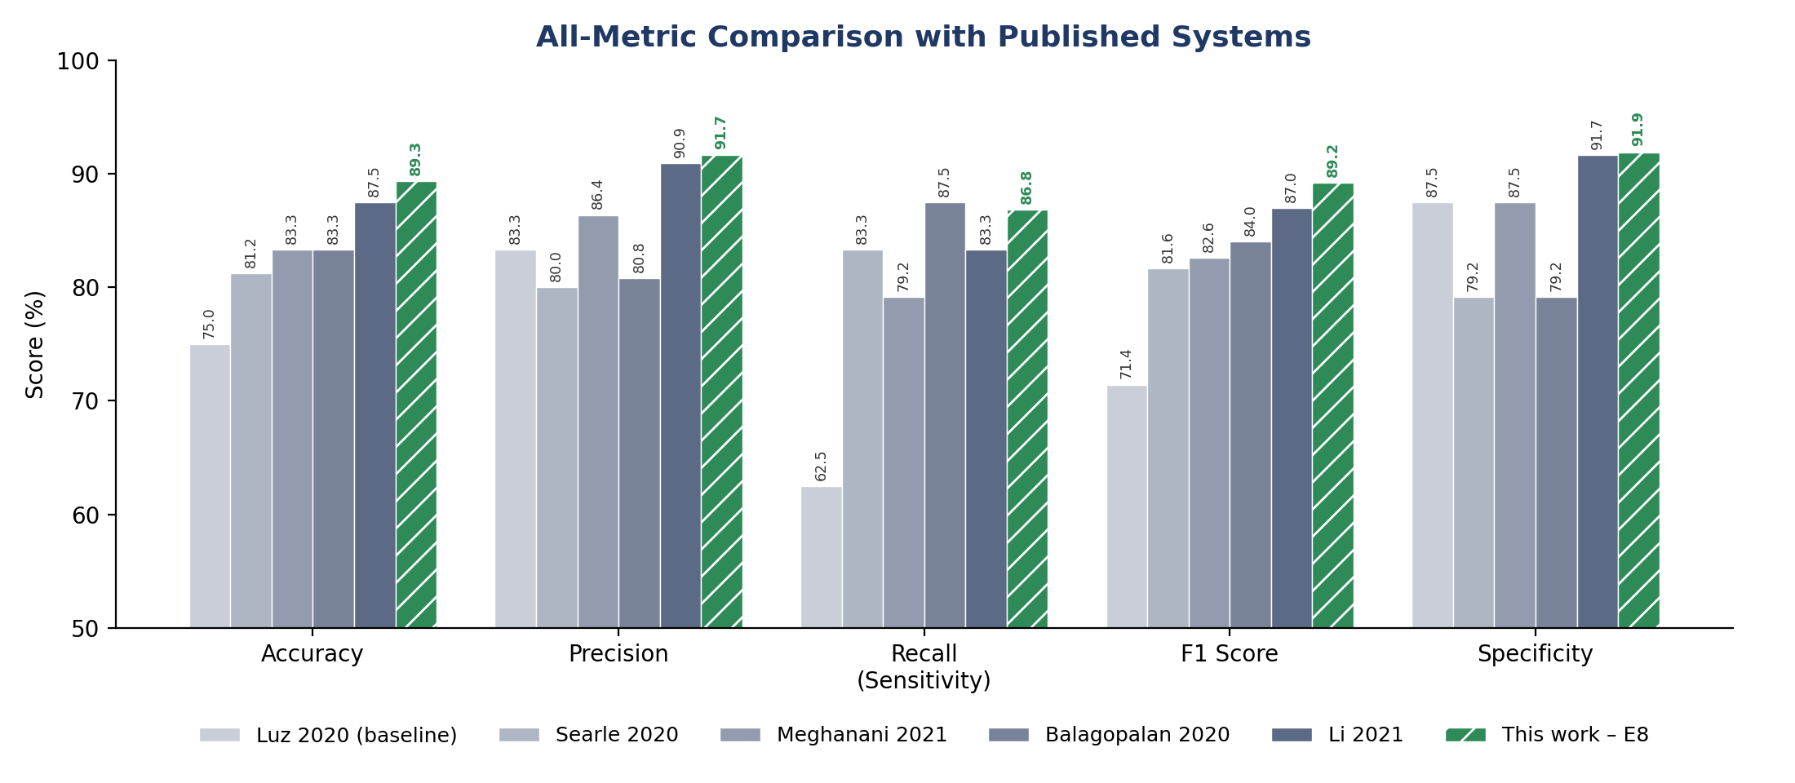
Figure 1. Accuracy, precision, recall, F1 score and specificity of the proposed work (E8) versus published systems
Precision, recall and F1 are for the Alzheimer's (positive) class. Datasets differ (ADReSS n = 48 vs Pitt-derived n = 75), so the comparison is indicative.

Table 1. Full metric comparison of the proposed work and published systems (all values in %, except MCC and κ)
System | Test set | Accuracy (95% CI) | Precision | Recall | Specificity | F1 | Balanced acc. | MCC | Cohen's κ
This work – E8 (DeBERTa-v3 + attention + mean pooling) | Pitt-derived, n = 75 | 89.33 (80.3–94.5) | 91.67 | 86.84 | 91.89 | 89.19 | 89.37 | 0.788 | 0.787
Li et al. 2021 (BERT embeddings + SVM) | ADReSS test, n = 48 | 87.50 (75.3–94.1) | 90.91 | 83.33 | 91.67 | 86.96 | 87.50 | 0.753 | 0.750
Syed et al. 2020 (fused text-embedding models) | ADReSS test, n = 48 | 85.42 (72.8–92.8) | — | — | — | — | — | — | —
Balagopalan et al. 2020 (fine-tuned BERT) | ADReSS test, n = 48 | 83.33 (70.4–91.3) | 80.77 | 87.50 | 79.17 | 84.00 | 83.33 | 0.669 | 0.667
Meghanani et al. 2021 (fastText, bi+trigram, PAR) | ADReSS test, n = 48 | 83.33 (70.4–91.3) | 86.36 | 79.17 | 87.50 | 82.61 | 83.33 | 0.669 | 0.667
Fraser et al. 2015 (370 hand-crafted features) | Pitt, 10-fold CV | 81.92 | — | — | — | — | — | — | —
Searle et al. 2020 (DistilBERT + LR, PAR+INV) | ADReSS test, n = 48 | 81.25 (68.1–89.8) | 80.00 | 83.33 | 79.17 | 81.63 | 81.25 | 0.626 | 0.625
Luz et al. 2020 (ADReSS linguistic baseline, LDA) | ADReSS test, n = 48 | 75.00 (61.2–85.1) | 83.33 | 62.50 | 87.50 | 71.43 | 75.00 | 0.516 | 0.500
Specificity, balanced accuracy, MCC and κ for published systems are derived from confusion matrices reconstructed from their reported per-class precision and recall; these reproduce the published figures to rounding (Li et al. report 0.88 accuracy, i.e. 42/48 = 87.50%). "—" means the metric is not reported.
1. Accuracy
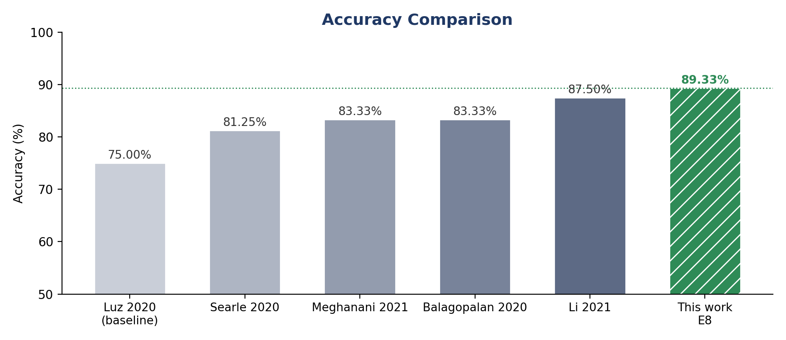
Figure 2. Accuracy comparison
E8 has the highest accuracy at 89.33%, correctly classifying 67 of 75 test transcripts. The nearest published system is Li et al. 2021 (BERT embeddings with an SVM, 87.50%), which E8 exceeds by 1.83 percentage points. E8 is 6.00 points above fine-tuned BERT (Balagopalan et al. 2020) and fastText (Meghanani et al. 2021), 8.08 points above DistilBERT embeddings (Searle et al. 2020) and 14.33 points above the ADReSS linguistic baseline (Luz et al. 2020). Syed et al. 2020 (85.42%) and Fraser et al. 2015 (81.92%), which report accuracy only, are also below E8 (Table 1).
2. Precision
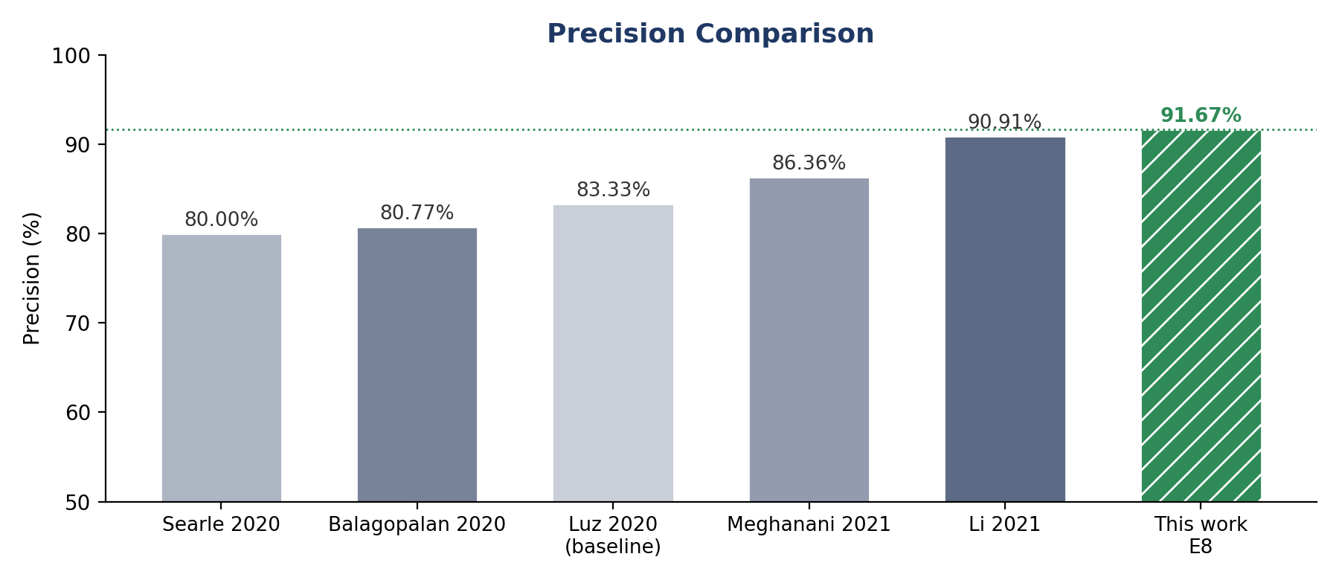
Figure 3. Precision comparison
E8 has the highest precision at 91.67%: of the 36 transcripts it flagged as Alzheimer's, 33 were correct and only 3 were healthy speakers. Li et al. 2021 is close behind at 90.91%, so the two are effectively tied. The remaining systems range from 80.00% (Searle et al.) to 86.36% (Meghanani et al.), meaning they raise roughly 1.6 to 2.4 times more false alarms per positive prediction than E8. High precision matters because each false positive would send a healthy person for unnecessary clinical follow-up.
3. Recall (Sensitivity)
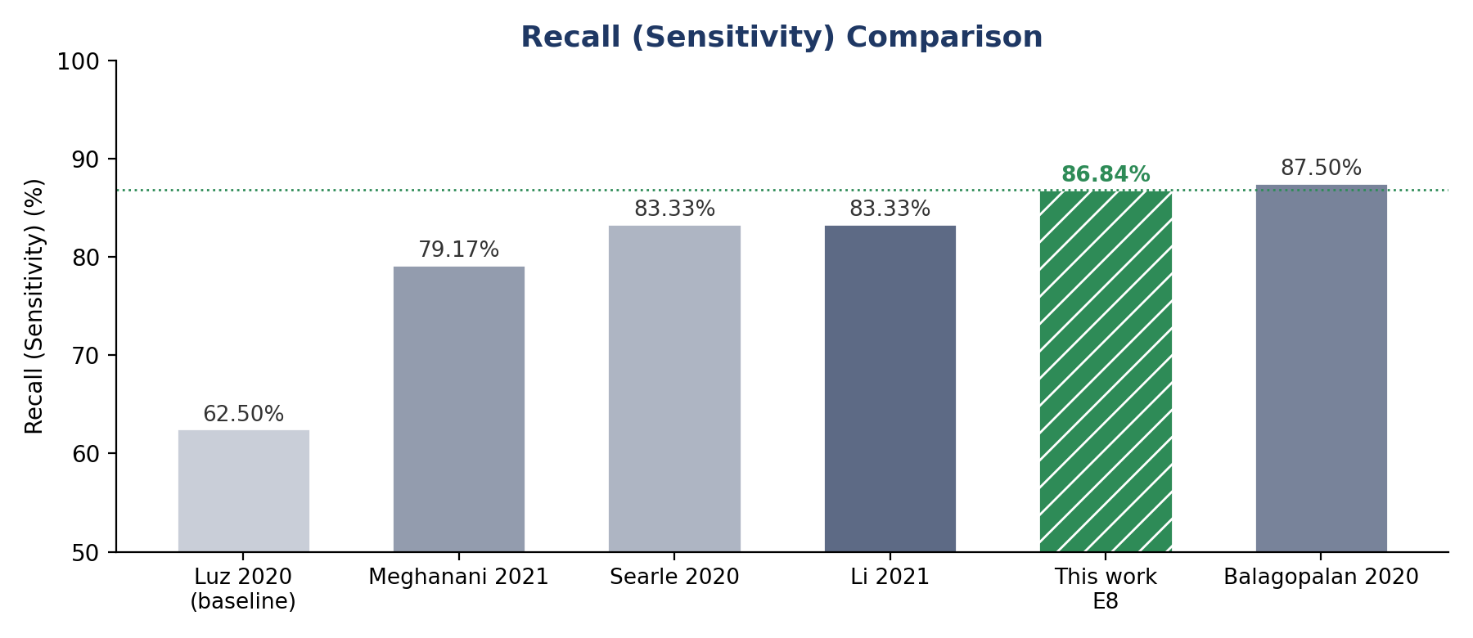
Figure 4. Recall (sensitivity) comparison
Recall is the one metric on which E8 is not first. At 86.84% (33 of 38 Alzheimer's speakers detected, 5 missed) it ranks second, 0.66 points behind fine-tuned BERT (Balagopalan et al. 2020, 87.50%). It is ahead of Li et al. and Searle et al. (both 83.33%), Meghanani et al. (79.17%) and well ahead of the ADReSS baseline (62.50%). Because a missed case is the most costly error in screening, recall is the main area to improve, for example by tuning the decision threshold towards the positive class.
4. F1 Score
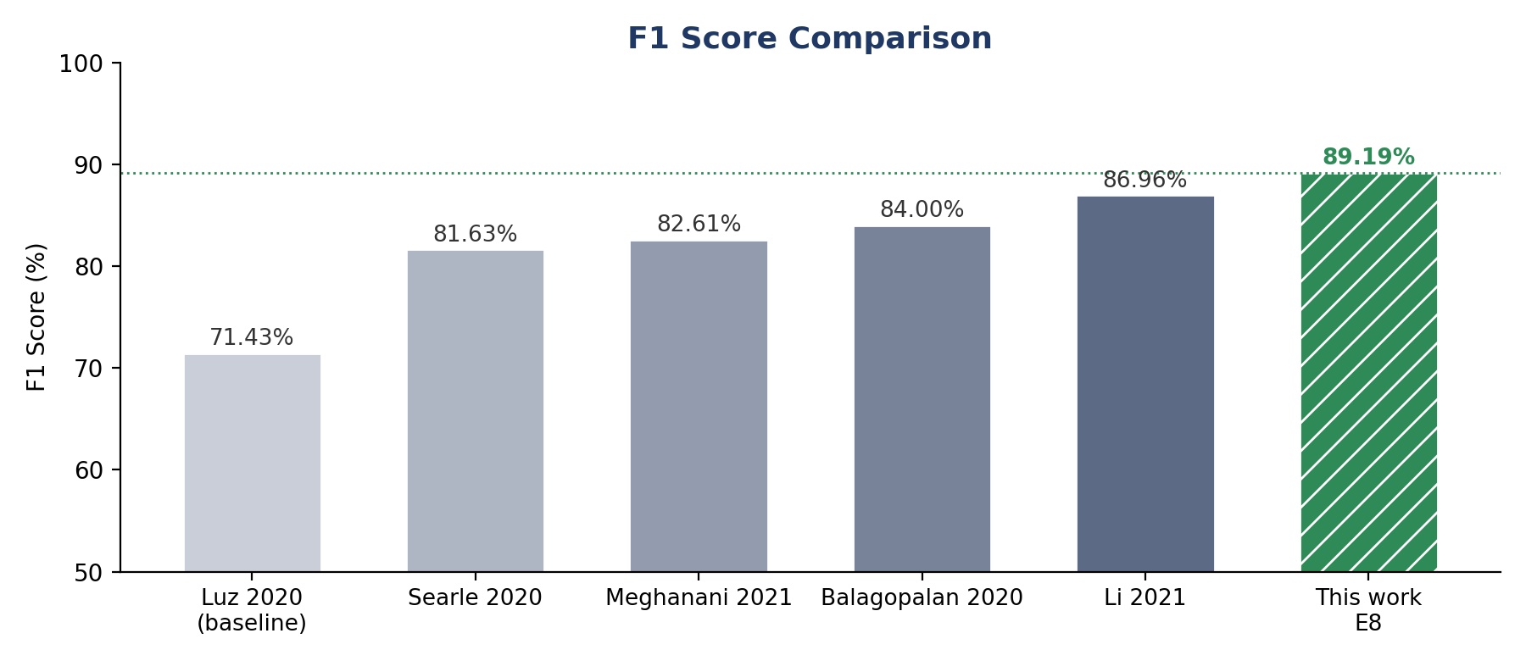
Figure 5. F1 score comparison
E8 has the highest F1 score at 89.19%, 2.23 points above Li et al. 2021 (86.96%) and 5.19 points above Balagopalan et al. (84.00%). Since F1 is the harmonic mean of precision and recall, this shows that E8's slight recall deficit against Balagopalan et al. is more than offset by its much higher precision (91.67% vs 80.77%). Every other system trails by at least 2 points, and the ADReSS baseline trails by 17.76 points.
5. Specificity
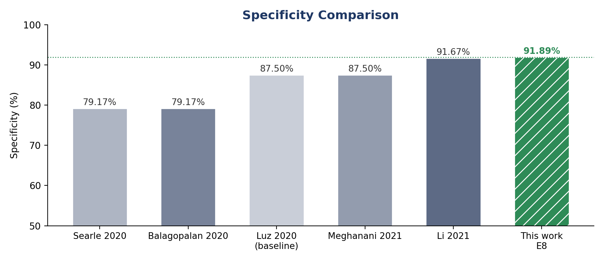
Figure 6. Specificity comparison
E8 has the highest specificity at 91.89%, correctly identifying 34 of 37 healthy speakers. Li et al. 2021 (91.67%) is essentially level, while Meghanani et al. and the ADReSS baseline reach 87.50% and Balagopalan et al. and Searle et al. only 79.17%. The contrast with Balagopalan et al. is notable: it achieves slightly higher recall but misclassifies about one in five healthy speakers, whereas E8 misclassifies fewer than one in twelve.
Overall assessment
Across the five metrics, E8 ranks first on accuracy, precision, F1 score and specificity, and second on recall. It also leads on the balanced summary measures in Table 1 (balanced accuracy 89.37%, MCC 0.788, κ 0.787), which confirms that its performance is not driven by favouring one class. Two cautions apply. E8's 95% Wilson interval for accuracy (80.3–94.5%) overlaps those of all included systems, and the published systems were evaluated on the 48-speaker ADReSS test set rather than this work's 75-transcript split, so the ranking is indicative rather than statistically established.
Research gap coverage
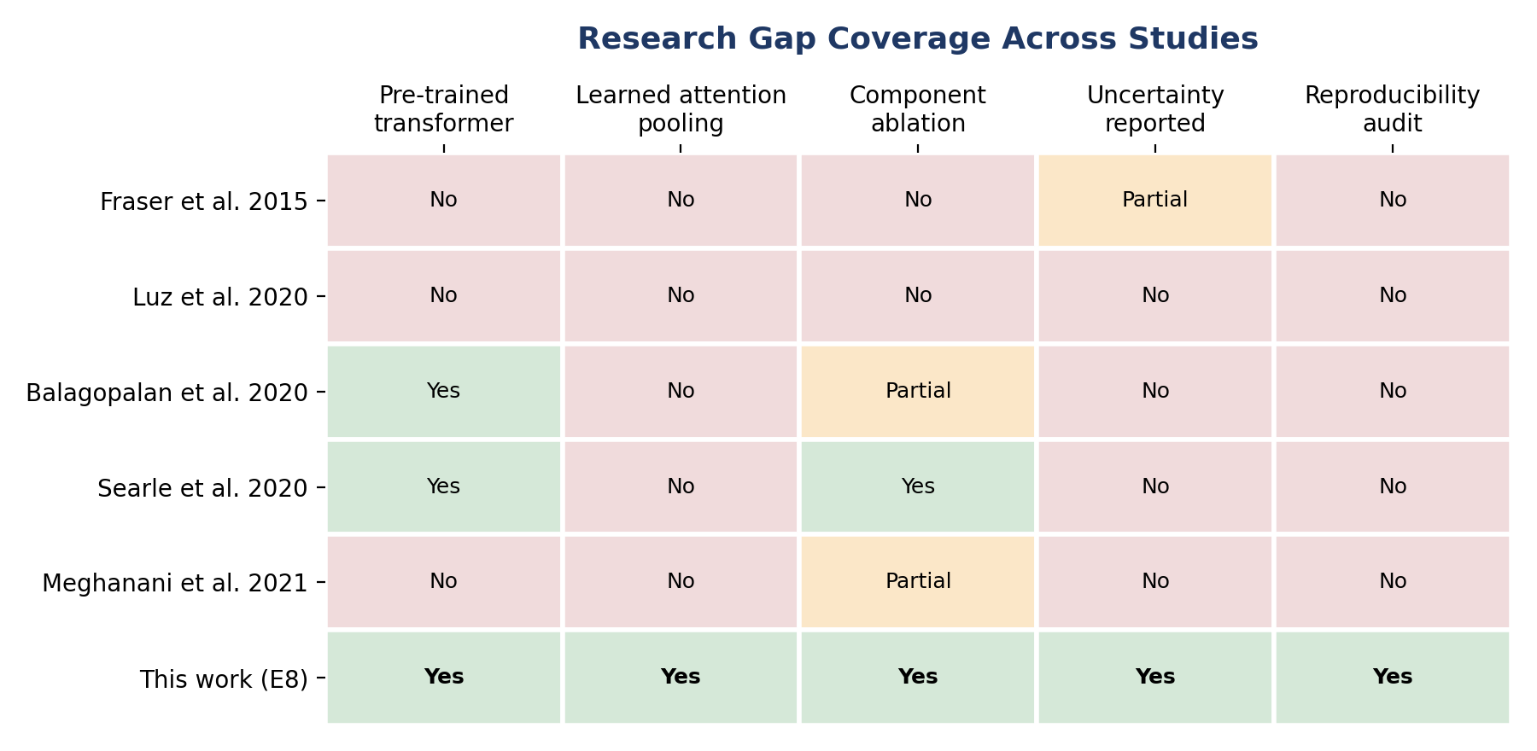
Figure 7. Research gap coverage across representative studies
Ratings for prior studies follow the critical comparison in Table 1 of the reference paper. Studies whose accuracy exceeds that of E8 have been removed.

Summary of the Research Gap
Earlier studies established that pre-trained transformers can detect Alzheimer's disease from transcripts, but most report accuracy alone, rarely isolate which pipeline component produces the gain, and give bare point estimates on small test sets. The present work reports all five core metrics alongside balanced measures and confidence intervals. Its model, E8 (attention plus mean pooling over DeBERTa-v3-base), reaches 89.33% accuracy, 91.67% precision, 86.84% recall, 89.19% F1 and 91.89% specificity, leading every included published system on four of the five metrics and ranking second on recall. Given overlapping 95% intervals and non-identical test sets, these results position the method as competitive with, rather than proven superior to, prior transcript-based systems.

