**1. ReactJS-HOL**

**Objectives**

**Define SPA and its benefits**

* **SPA** loads a single HTML page and updates the content dynamically using JavaScript.
* No full page reloads. Only the necessary parts of the page update.

Benefits of SPA:

* Faster performance (once loaded).
* Smooth user experience (no reload).
* Good for dynamic, interactive UIs.

**Define React and identify its working**

* React is a JavaScript library developed by Facebook for building user interfaces, especially for Single Page Applications (SPAs).  
  It allows developers to create reusable UI components that manage their own state and update efficiently when data changes.
* Working:
  + Component-Based Structure:

React breaks the UI into small, reusable pieces called components (e.g., Header, Button LoginForm).

Each component is a JavaScript function or class that returns JSX (HTML-like syntax).

* + JSX (JavaScript XML):

JSX allows you to write HTML inside JavaScript.

React compiles JSX to React.createElement() calls.

* + Virtual DOM:

React uses a Virtual DOM, a lightweight copy of the real DOM.

When data changes, React updates the Virtual DOM first.

* + Diffing Algorithm:

React compares the old Virtual DOM with the new one to detect changes (diffing).

Only the changed parts are updated in the real DOM (efficient rendering).

* + State and Props:

Props: Data passed from parent to child components.

State: Local data managed within a component.

When state or props change, the component re-renders automatically.

* + React DOM Rendering:

ReactDOM.render(<App />, document.getElementById('root')) mounts the component tree to the browser DOM.

* + Unidirectional Data Flow:

Data flows in one direction: from parent → child.

Makes debugging and understanding flow easier.

**Identify the differences between SPA and MPA**

| **Feature** | **SPA (Single Page App)** | **MPA (Multi Page App)** |
| --- | --- | --- |
| Navigation | No full reloads | Full reloads per page |
| Speed | Fast after initial load | Slower navigation |
| Complexity | Needs more JS (routing, state) | Simple HTML-based pages |
| SEO | Requires extra work | SEO-friendly by default |

**Explain Pros & Cons of Single-Page Application**

* **Pros:**

Fast User Experience after initial load.

No Full Reload – only updates the required parts.

Works Offline with caching & service workers.

Reusable Components – clean code and faster development.

Good Developer Tools (especially in frameworks like React).

* **Cons:**

SEO Issues – difficult for search engines to index.

Initial Load Time – might be slow if the app is large.

JavaScript Dependency – without JS, the app won’t work properly.

Security Challenges – more prone to XSS attacks.

Browser History Issues – needs manual handling for routing.

**Explain about React**

React is a JavaScript library used to build user interfaces for web applications, especially SPAs.

* Developed by Facebook.
* Uses a component-based architecture.
* Allows dynamic, real-time UI updates without reloading the page.
* Uses JSX syntax (JavaScript + HTML).
* Efficient rendering with Virtual DOM.

**Define virtual DOM**

The Virtual DOM (V-DOM) is a lightweight copy of the real DOM used by React.

How It Works:

1. React renders UI elements into the Virtual DOM.
2. When state/props change, a new Virtual DOM is created.
3. React compares the new V-DOM with the old V-DOM (called diffing).
4. It finds the difference and updates only the changed parts in the actual DOM.

Benefits:

* Improves performance.
* Reduces unnecessary DOM manipulations.
* Enables fast and smooth user interfaces.

**Explain Features of React**

* Component-Based Architecture
* Virtual DOM
* Unidirectional Data Flow
* JSX (JavaScript XML)
* Fast and Efficient Rendering

**create-react-app**

Creating a new React Application with the name “myfirstreact”, Run the application to print “welcome to the first session of React” as heading of that page.

1. To create a new React app, Install Nodejs and Npm from the following link:

<https://nodejs.org/en/download/>

1. Install Create React App CLI

npm install -g create-react-app

1. Create the React App

npx create-react-app myfirstreact

1. Once the App is created, navigate into the folder of myfirstreact by typing the following command

cd myfirstreact

1. Open the folder of myfirstreact in Visual Studio Code
2. Open the App.js file in Src Folder of myfirstreact
3. Remove the current content of “App.js”
4. Replace it with the following:

function App() {

return (

<div>

<h1>Welcome to the first session of React</h1>

</div>

);

}

export default App;

1. Run the following command to execute the React application:

npm start

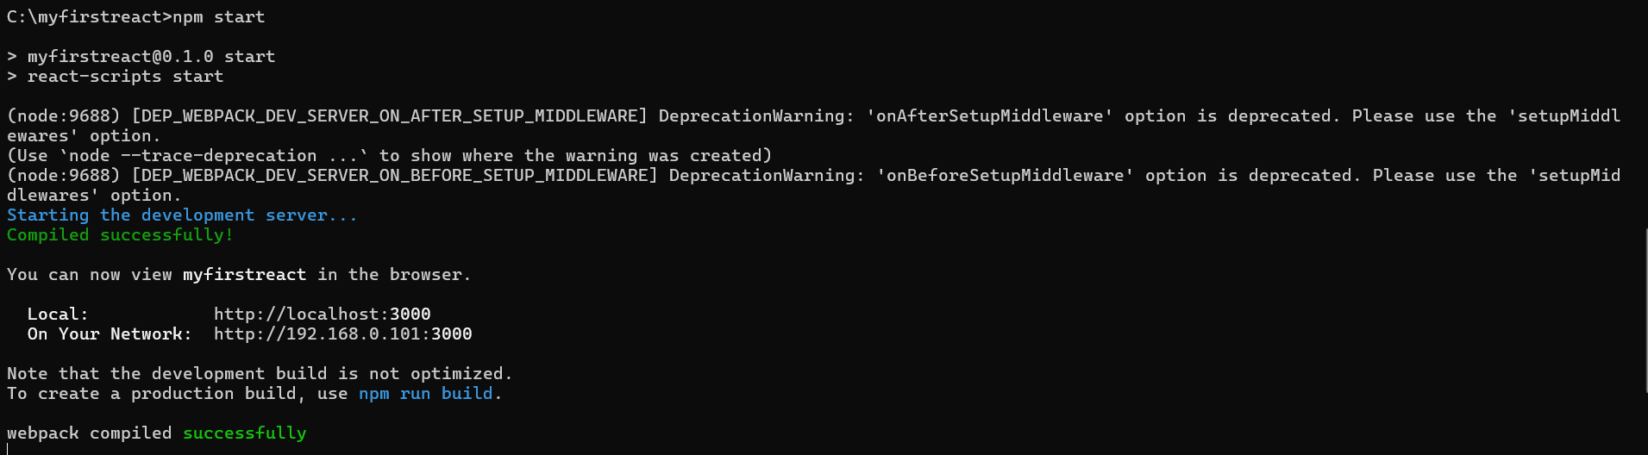

**This will start your app at:**[**http://localhost:3000**](http://localhost:3000)

