**11. ReactJS-HOL**

**Objectives**

* **Explain React events**

React uses its own event system to handle user interactions like clicks, typing, form submission, etc. These events are very similar to the DOM events in HTML, but they are wrapped in React's synthetic event system for consistency across browsers.

* **Explain about event handlers**

Event handlers are functions you define to respond to specific user actions (events).

* handleClick is an event handler.
* It's **not called** directly; React calls it when the event occurs.
* You can also write it as an arrow function
* **Define Synthetic event**

A SyntheticEvent is a cross-browser wrapper around the browser’s native event system. React uses synthetic events to ensure the event behaves the same across different browsers.

* **Identify React event naming convention**

React event names:

* Use camelCase instead of lowercase.
* Take a function reference instead of a string.

**Creating a React Application “eventexamplesapp” to handle various events of the form elements in HTML**

1. **App.js**

import React, { useState } from "react";

import "./App.css";

function App() {

const [count, setCount] = useState(1);

const [amount, setAmount] = useState("");

const [currency, setCurrency] = useState("");

const increment = () => {

setCount(count + 1);

alert("Hello! Member");

};

const decrement = () => setCount(count - 1);

const sayWelcome = () => alert("Welcome to the React App!");

const handlePress = () => alert("You clicked on me!");

const submitConversion = () =>

alert(`Converting to ${currency} Amount is ${amount * 80}`);

return (

<div className="app-container">

<div className="section">

<p className="counter-value">{count}</p>

<button onClick={increment}>Increment</button>

<button onClick={decrement}>Decrement</button>

<br />

<button onClick={sayWelcome}>Say welcome</button>

<br />

<button onClick={handlePress}>Click on me</button>

</div>

<div className="section">

<h2 className="currency-heading">Currency Convertor!!!</h2>

<label>Amount:</label>

<input

type="number"

value={amount}

onChange={(e) => setAmount(e.target.value)}

/>

<br />

<label>Currency:</label>

<textarea

value={currency}

onChange={(e) => setCurrency(e.target.value)}

/>

<br />

<button onClick={submitConversion}>Submit</button>

</div>

</div>

);

}

export default App;

1. **Counter.js**

import React, { useState } from "react";

function Counter() {

const [count, setCount] = useState(0);

const increment = () => {

setCount(count + 1);

sayHello();

};

const sayHello = () => {

console.log("Hello! Counter incremented.");

};

const decrement = () => {

setCount(count - 1);

};

return (

<div>

<h2>Counter</h2>

<p>Value: {count}</p>

<button onClick={increment}>Increment</button>{" "}

<button onClick={decrement}>Decrement</button>

</div>

);

}

export default Counter;

1. **Welcome.js**

import React from "react";

function Welcome() {

const sayWelcome = (message) => {

alert(message);

};

return (

<div>

<h2>Say Welcome</h2>

<button onClick={() => sayWelcome("Welcome to the Event App!")}>

Say Welcome

</button>

</div>

);

}

export default Welcome;

1. **ClickEvent.js**

import React from "react";

function ClickEvent() {

const handleClick = () => {

alert("I was clicked");

};

return (

<div>

<h2>Synthetic Event</h2>

<button onClick={handleClick}>OnPress</button>

</div>

);

}

export default ClickEvent;

1. **CurrencyConverter.js**

import React, { useState } from "react";

function CurrencyConvertor() {

const [amount, setAmount] = useState("");

const [currency, setCurrency] = useState("");

const handleAmountChange = (e) => {

setAmount(e.target.value);

};

const handleCurrencyChange = (e) => {

setCurrency(e.target.value);

};

const handleSubmit = (e) => {

e.preventDefault();

if (currency.toLowerCase() === "euro") {

const convertedAmount = parseFloat(amount) * 80;

alert(`Converting to Euro Amount is ${convertedAmount}`);

} else {

alert("Currency not supported");

}

};

return (

<div>

<h1 style={{ color: "green" }}>Currency Convertor!!!</h1>

<form onSubmit={handleSubmit}>

<label>

Amount:

<input

type="text"

value={amount}

onChange={handleAmountChange}

/>

</label>

<br />

<label>

Currency:

<textarea

value={currency}

onChange={handleCurrencyChange}

/>

</label>

<br />

<button type="submit">Submit</button>

</form>

</div>

);

}

export default CurrencyConvertor;

1. **Run the project**

**Npm start**

<http://localhost:3000/>

Creating “Increment” button to increase the value of the counter and “Decrement” button to decrease the value of the counter. The “Increase” button should invoke multiple methods.

* 1. To increment the value
  2. Say Hello followed by a static message.

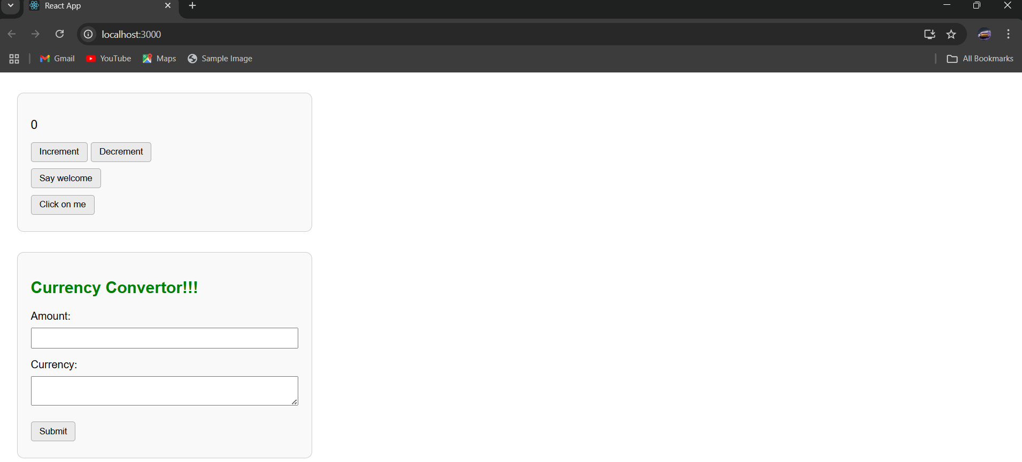

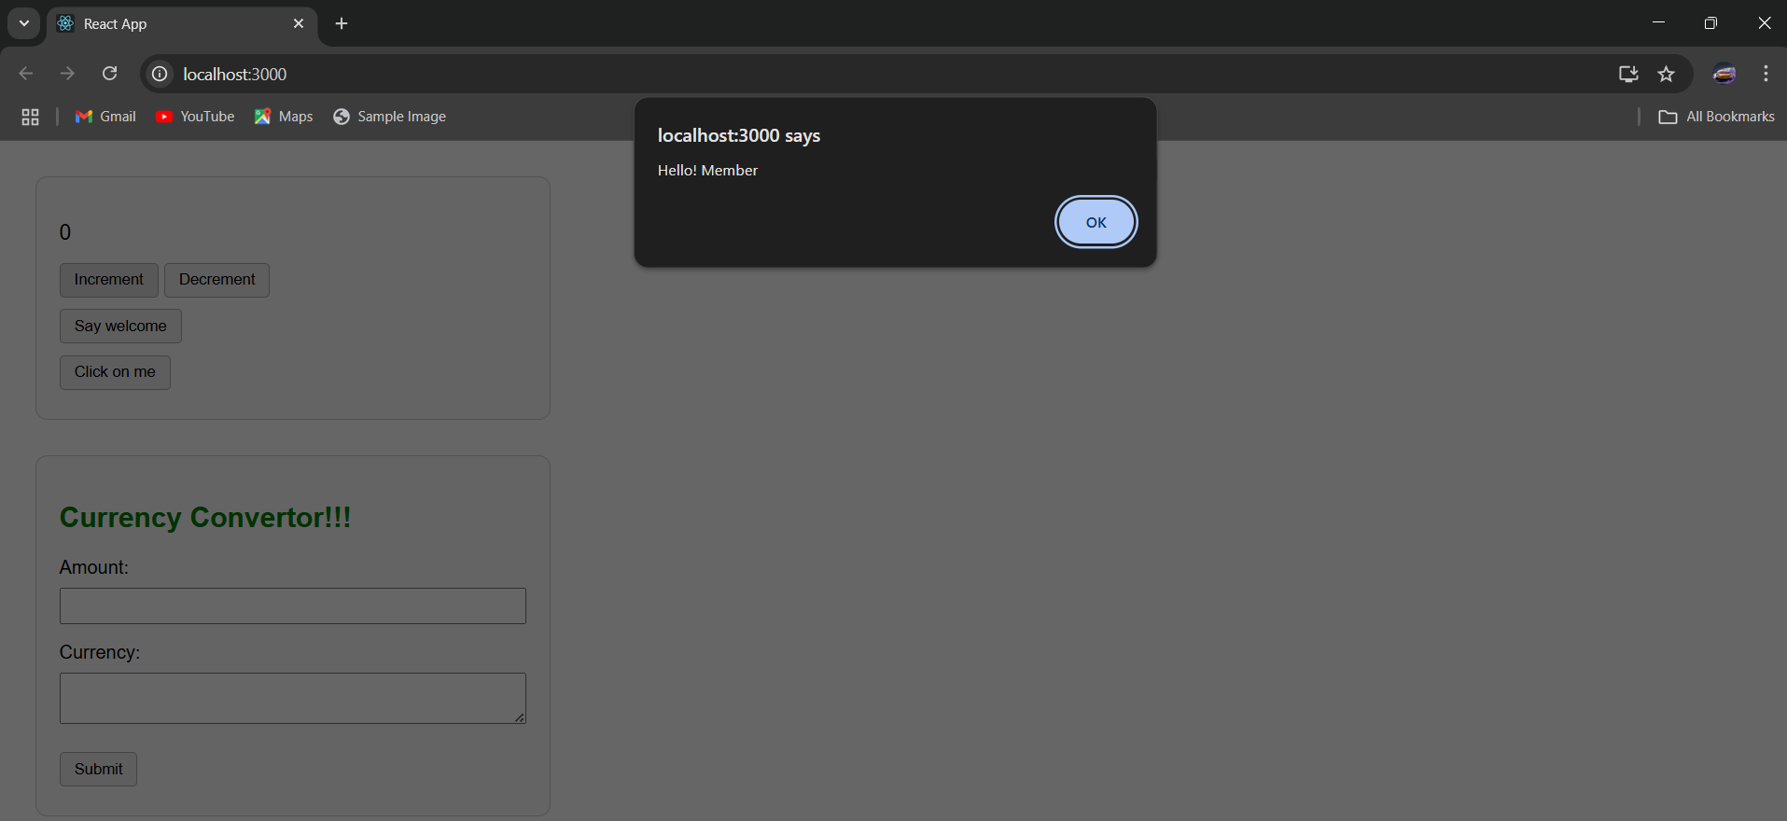

Create a button “Say Welcome” which invokes the function which takes “welcome” as an argument.

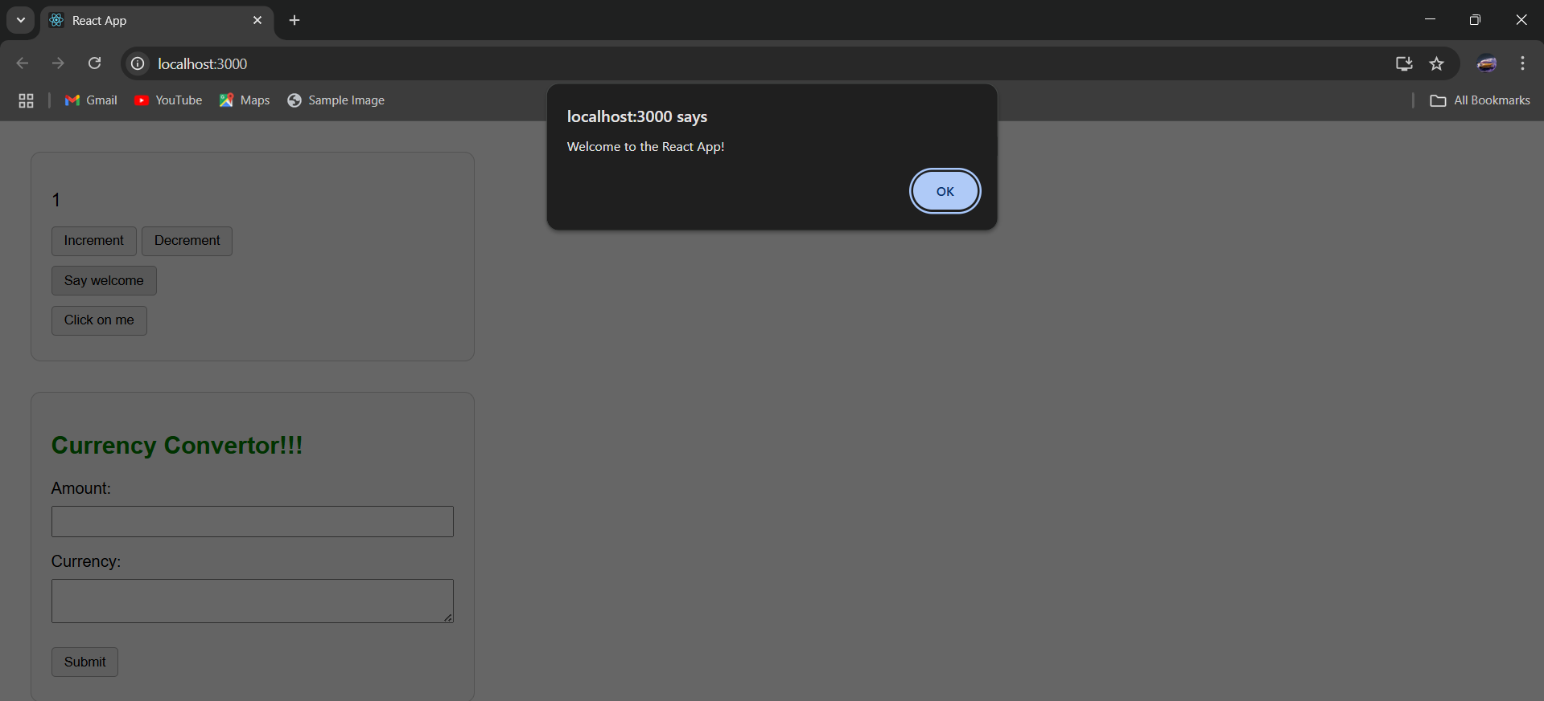

Create a button which invokes synthetic event “Click on me” which display “You clicked on me!”.

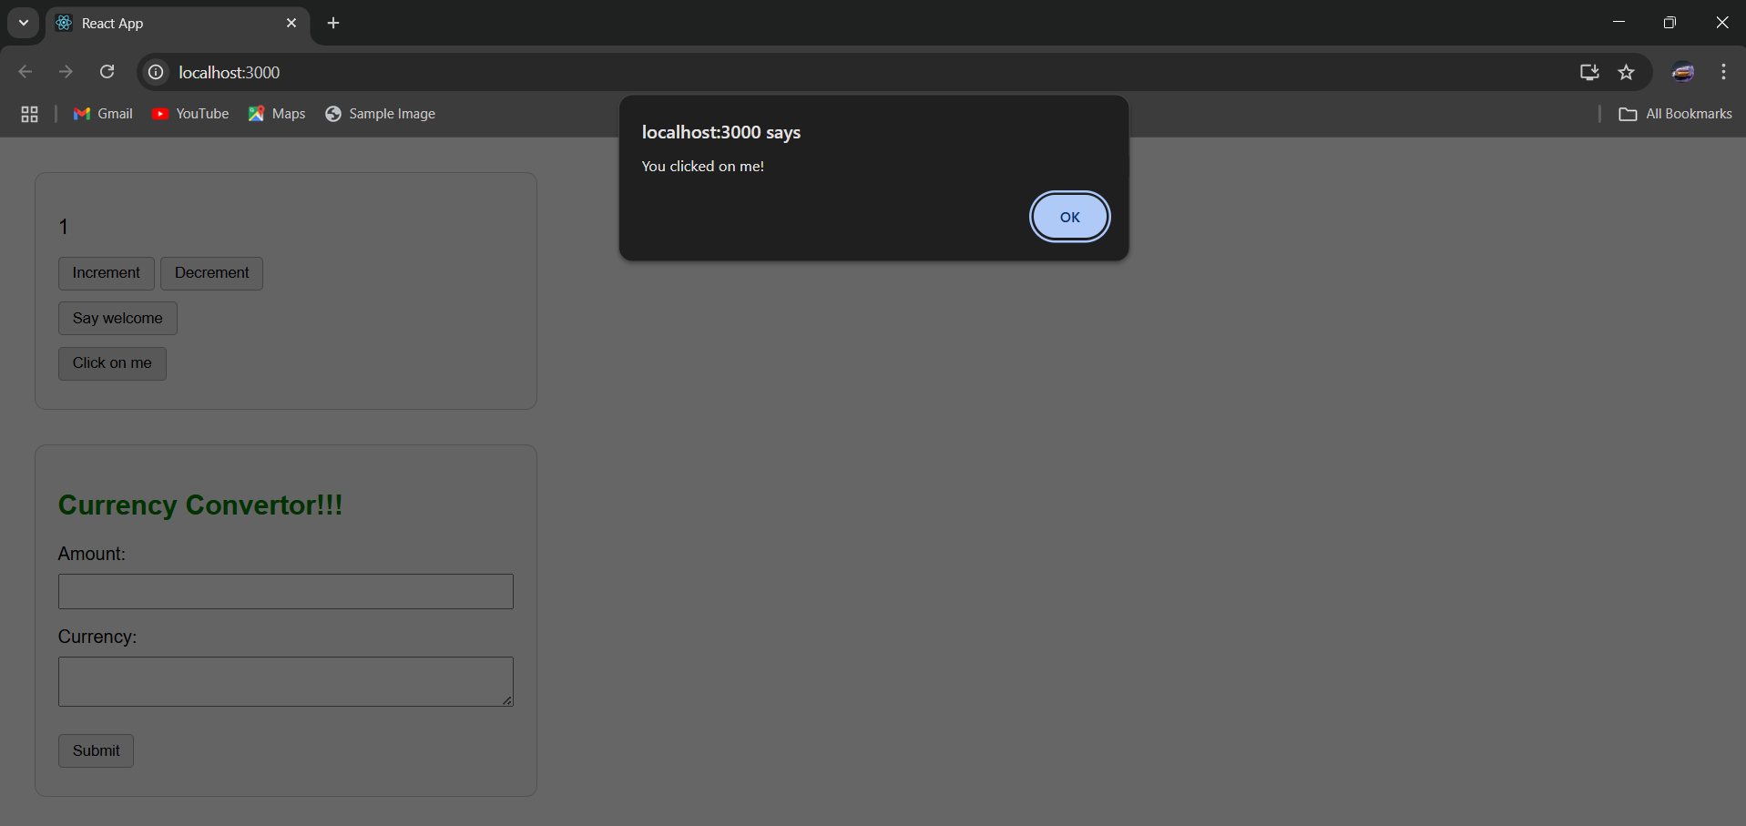

Creating a “CurrencyConvertor” component which will convert the Indian Rupees to Euro when the Convert button is clicked.

Handle the Click event of the button to invoke the handleSubmit event and handle the conversion of the euro to rupees.

