**5. Git-HOL**

## **Objectives**

* **Explain how to clean up and push back to remote Git**

To clean up and push back to remote Git:

1. Check working directory status using:

git status

This ensures there are no unwanted or untracked files. Remove or ignore files if necessary (git rm, .gitignore).

1. Pull latest changes from remote to ensure you are up-to-date:

git pull origin master

Resolve any conflicts if they appear by editing conflicted files, staging them with git add, and committing with git commit.

1. Stage and commit changes after cleanup:

git add .

git commit -m "Cleaned up repository"

1. Push changes to the remote repository:

git push origin master

This process ensures your local repository is in a clean state, synchronized with the remote, and your changes are successfully pushed back.

**Hands-on:**

1. Verify if master is in clean state.

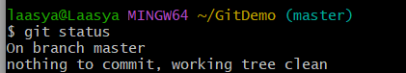

1. List out all the available branches.



1. Pull the remote git repository to the master

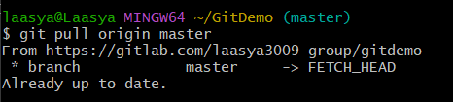

1. Push the changes, which are pending from **“Git-T03-HOL_002”** to the remote repository.

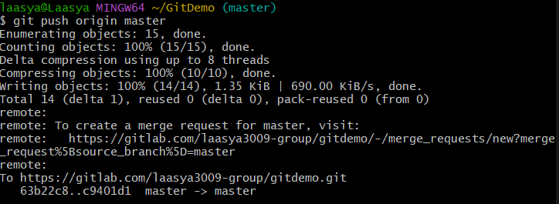

1. Observe if the changes are reflected in the remote repository.

