PROJECT REPORT ON

Smart Ambulance Traffic Clearance System

At

Review AI Tech and Solutions Internship

From 02/05/2026 to 02/08/2026

Team:

ReView v2 | Pulse

Date: 07/07/2026

Title:

Project Requirement Analysis – Smart Ambulance Traffic Clearance System

Objective:
The main objective of this phase is to understand the project requirements before starting the frontend development. Requirement analysis helps identify the users, their needs, the system functionalities, and the pages required for the web application. This ensures that the application is designed according to the project goals.

Problem Statement:
Traffic congestion is one of the major reasons for delays in ambulance transportation. During emergencies, ambulances often get stuck in traffic signals and heavy road congestion, which increases the risk to patients. The existing traffic system does not provide an efficient way to prioritize ambulances in real time.
The Smart Ambulance Traffic Clearance System aims to reduce ambulance delays by providing a web-based platform that tracks ambulances, identifies the shortest route, and sends emergency traffic clearance requests so traffic authorities can respond quickly.
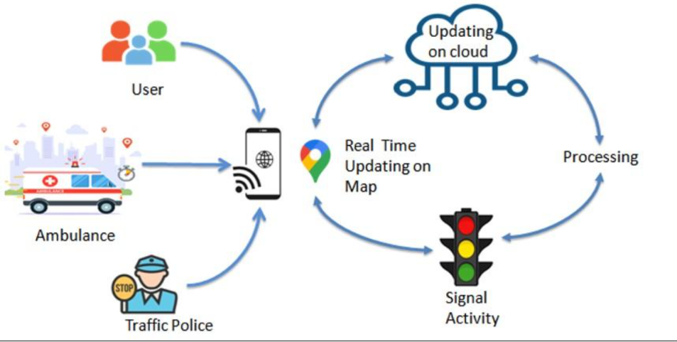

Project Objectives:
- To reduce ambulance travel time.
- To provide live ambulance tracking.
- To monitor traffic conditions.
- To recommend the shortest and fastest route.
- To notify traffic authorities during emergencies.
- To improve communication between ambulances, hospitals, and traffic management.
- To enhance patient safety through faster emergency response.

Target Users:

Administrator

Responsibilities-Manage user accounts.

Monitor ambulance movements.

View traffic status.

Manage hospitals.

View system reports.

Monitor emergency requests.

Ambulance Driver

Responsibilities-Login securely.

Send emergency requests.

Share live location.

View optimized routes.

Receive notifications.

Traffic Police

Responsibilities-Receive emergency alerts.

Monitor approaching ambulances.

Manage traffic signal clearance.

Update road conditions.

Hospital Staff

Responsibilities-View ambulance arrival status.

Prepare emergency facilities.

Track patient arrival.

Functional Requirements:
The system should provide the following functionalities:
- User Login and Authentication
- User Registration
- Dashboard
- Live Ambulance Tracking
- Emergency Alert System
- Traffic Monitoring
- Route Optimization
- Hospital Information
- Notification System
- User Profile Management
- Reports and Analytics
- Logout Functionality

Non-Functional Requirements
- User-friendly interface
- Fast response time
- Responsive design
- Secure login
- High availability
- Easy navigation
- Scalable architecture
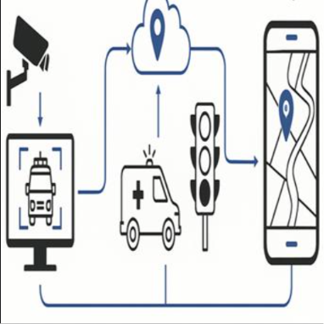

Required Frontend Pages:
Page | Purpose
Home Page | Introduces the system
Login Page | User authentication
Registration Page | New user registration
Admin Dashboard | Monitor the entire system
Ambulance Dashboard | Driver interface
Traffic Dashboard | Traffic monitoring
Live Tracking Page | Display ambulance location
Route Recommendation Page | Show shortest route
Emergency Alert Page | Send emergency requests
Hospital Details Page | Nearby hospitals
Notifications Page | Display alerts
User Profile Page | Manage account
Settings Page | Update preferences
Help Page | User guidance

Frontend Technologies Planned:
- HTML5
- CSS3
- JavaScript
- React.js
- React Router
- Bootstrap or Tailwind CSS
- Axios
- Google Maps API / Leaflet

Expected Output:
The proposed system should provide an easy-to-use web application where administrators, ambulance drivers, and traffic police can communicate efficiently. The application should display live ambulance locations, recommend the best route, generate emergency notifications, and help clear traffic quickly, thereby reducing delays and improving emergency healthcare services.

Conclusion:
The requirement analysis phase helped identify the system's objectives, users, features, and application structure. Understanding these requirements before development provides a clear roadmap for designing and implementing the frontend of the Smart Ambulance Traffic Clearance System.

