PROJECT REPORT ON

Smart Ambulance Traffic Clearance System

At

Review AI Tech and Solutions Internship

From 02/05/2026 to 02/08/2026

Team:

ReView v2 | Pulse

Date: 08/07/2026

Title:

Project UI Planning for Smart Ambulance Traffic Clearance System..

Introduction:

Project UI (User Interface) Planning is one of the most important phases in frontend development. Before writing any code, it is essential to design the layout of the application and decide how users will navigate through different pages. A well-planned UI makes the application simple, attractive, and easy to use.
For the Smart Ambulance Traffic Clearance System, the UI is designed to help different users such as administrators, ambulance drivers, traffic police, and hospital staff quickly access the information they need during emergencies. Proper planning reduces development time, improves usability, and ensures that the application provides a smooth user experience.

Objectives of UI Planning:
The main objectives of UI planning are:
- To create an attractive interface.
- To improve user experience.
- To organize information clearly.
- To reduce user confusion.
- To make navigation easier.
- To ensure responsiveness on all devices.
- To improve emergency response efficiency.

Users of the System:
The UI is designed for the following users:

Administrator-The administrator monitors the entire system, manages users, views ambulance locations, and generates reports.

Ambulance Driver-The driver updates ambulance status, shares live location, and receives route recommendations.

Traffic Police-Traffic police receive emergency notifications and monitor ambulance movement to clear traffic.

4. Hospital Staff (Optional)-Hospital staff receive ambulance arrival updates and prepare emergency treatment.

Application Layout:

The overall application layout is divided into several sections.
++---------------------------------------------------------++
Navigation Bar
++---------------------------------------------------------++
Main Dashboard Area
++---------------------------------------------------------++
Sidebar | Content Section
|------------------------------
| Cards
| Maps
| Tables
| Notifications
++---------------------------------------------------------++
Footer
++---------------------------------------------------------++

Description:
Navigation Bar
- Application logo
- Home
- Dashboard
- Notifications
- Profile
- Logout
Sidebar
- Dashboard
- Ambulance Tracking
- Traffic Status
- Emergency Alerts
- Hospitals
- Reports
- Settings
Content Area--Displays the selected page content.

Responsive Design Plan:
The application should support:
- Desktop computers
- Laptops
- Tablets
- Smartphones
Responsive design ensures users can access the application conveniently from different devices.

Navigation Flow:
Home Page
│
▼
Login Page
│
▼
Dashboard
│
┌───┼──────────────┐
│ │ │
▼ ▼ ▼
Tracking Traffic Hospitals
│
▼
Emergency Alerts
│
▼
Reports

List of Application Pages:

Page | Purpose
Home Page | Introduces the application
Login Page | User authentication
Registration Page | User account creation
Dashboard | Overview of system information,ETA,GPS
Ambulance Tracking | Displays live ambulance location
Traffic Status | Shows traffic congestion
Emergency Alerts | Sends and receives emergency requests
Hospital Information | Displays nearby hospitals
Reports | Shows system reports
User Profile | Displays user details
Settings | Allows configuration changes
Help Page | Provides user guidance

Color Theme:
The following color scheme is proposed for the application:
Color | Purpose
Red | Emergency alerts and ambulance status
Green | Safe routes and successful actions
Blue | Dashboard and navigation
White | Background
Gray | Secondary information

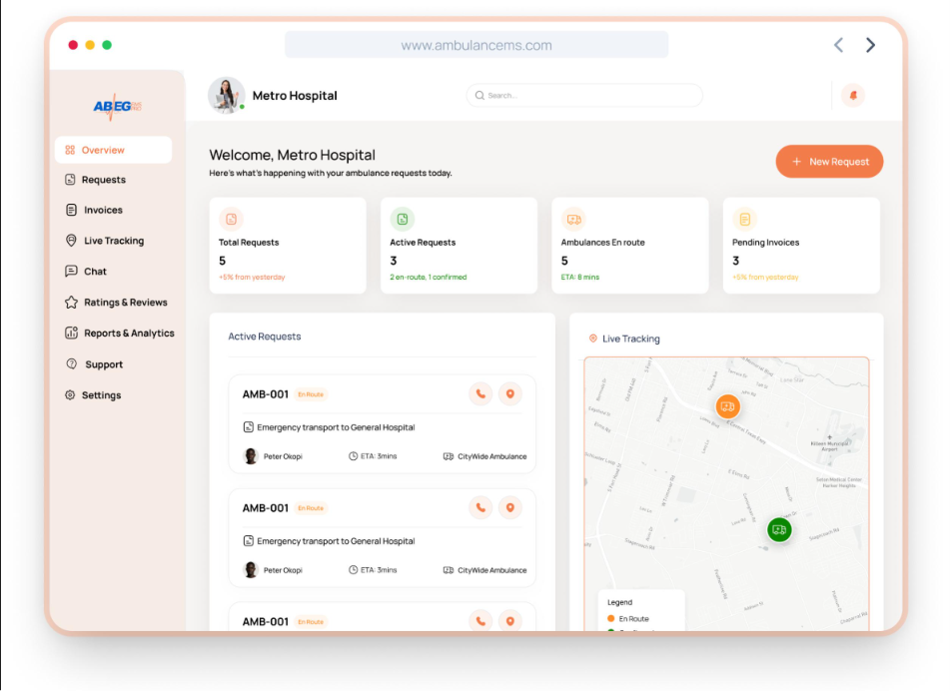

Icons:
Suggested icons include:
- 🚑 Ambulance
- 🏥 Hospital
- 🚦 Traffic Signal
- 📍 Location
- 🔔 Notifications
- 👤 User
- ⚙️ Settings
- 📊 Dashboard

Responsive Design Plan:
The application should support:
- Desktop computers
- Laptops
- Tablets
- Smartphones
Responsive design ensures users can access the application conveniently from different devices.

Advantages of UI Planning:
- Saves development time.
- Improves user experience.
- Simplifies navigation.
- Reduces design errors.
- Provides consistency across pages.
- Makes the application visually appealing.
- Supports responsive layouts.
- Enhances emergency response efficiency.
Code:(Basic Code)

<!DOCTYPE html>
<html>
<head>
<title>Smart Ambulance Traffic Clearance System</title>
</head>
<body>
<header>
<h1>Smart Ambulance Traffic Clearance System</h1>
</header>
<nav>
<a href="#">Home</a> |
<a href="#">Dashboard</a> |
<a href="#">Tracking</a> |
<a href="#">Hospitals</a> |
<a href="#">Profile</a>
</nav>
<main>
<h2>Dashboard</h2>
<p>Welcome to the Smart Ambulance Traffic Clearance System.</p>
</main>
<footer>
<p>© 2026 Smart Ambulance Traffic Clearance System</p>
</footer>
</body>
</html>

Expected Outcome:
At the end of the UI planning phase, the complete structure of the Smart Ambulance Traffic Clearance System is defined. Developers know what pages are required, how users will navigate through the application, and how information will be displayed. This planning provides a clear road map for fronted implementation.

Conclusion:
Project UI Planning is the foundation of frontend development. It helps organize the application's structure, improve usability, and ensure that every user can easily access the required features. A well-designed interface for the Smart Ambulance Traffic Clearance System enables administrators, ambulance drivers, traffic police, and hospital staff to interact efficiently, supporting faster emergency response and better traffic management.

