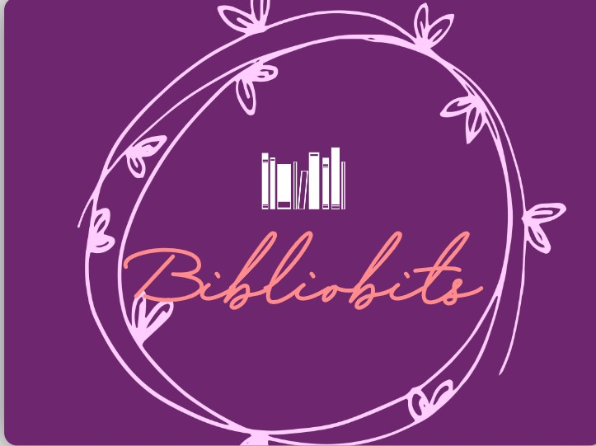

Bibliobits is an **educational website**. This website will be an e-library guide for our college and many more. Our website will include textbooks, reference books, PDFs, etc. of subjects from both **CSE and IT**. In total, our website will be having three pages: the home page, the main page , and the subject page.

The first page will be the Home Page. The Home Page will contain the following sections: a description of our website, syllabus copies of both CSE and IT, and the about page.

The second page will be the Main page. This page will include all the subjects for the first and the second year for both CSE and IT. Under these subjects, there will the **textbooks, pdfs, and reference books.**

The third page will be the Subject page. This page has the direct link to the e-commerce website for the recommend books ,the PDF/soft copy of the book along with *review of the selected link*(book/PDF).