AI Data Analysis Agent: Gemini-Powered CSV Data Analysis Assistant

Project Description:
AI Data Analysis Agent is a Generative AI application that lets users upload a CSV dataset and ask plain-English questions about it, with an AI agent automatically selecting and running the right analysis tool. The platform includes an Inspection & Overview module, which reports dataset shape, column types, missing values, and duplicate rows; a Statistics module, which calculates mean, median, minimum, maximum, and standard deviation for one or several numerical columns; a Correlation module, which measures the relationship between two numerical columns; and a Visualization module, which renders histograms, bar charts, and scatter plots on demand.
Utilizing Google's Gemini API with the gemini-3.6-flash model, the agent reads a natural-language question, decides which Python analysis function to call, and then turns the raw tool output back into a clear, human-readable answer. Built with Streamlit and deployed publicly via Ngrok, the platform gives non-technical users a conversational front end for exploratory data analysis. With secure API key management via environment variables and defensive error handling for quota, authentication, and column-lookup failures, AI Data Analysis Agent empowers analysts, students, and business users to explore data with confidence.

Scenarios
Scenario 1: A user uploads a retail sales dataset and asks “Are there any missing values in my dataset?”. The agent selects the find_missing_values tool, reports which columns contain nulls and how many, and returns a plain-language summary of the data quality issue in seconds.
Scenario 2: A user asks “What is the correlation between Sales and Discount?”. The agent selects calculate_correlation, computes the Pearson coefficient, classifies the relationship as strong, moderate, or weak, and explains the result in a short natural-language sentence.
Scenario 3: A user asks “Show me a scatter plot of Discount and Sales.” The agent selects plot_scatter, matches the requested column names against the dataset (case-insensitively), renders the chart inline with Matplotlib, and confirms which columns were plotted.

Technical Architecture:
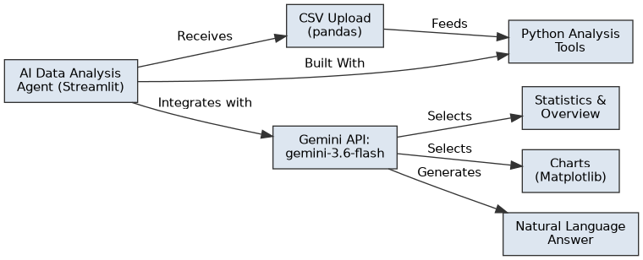
Description: AI Data Analysis Agent utilizes a modular three-tier architecture to deliver conversational, AI-driven data analysis. The frontend is a Streamlit single-page application that handles CSV upload, dataset preview, and the question-and-answer interface. A layer of Python analysis tools (pandas and Matplotlib functions) performs the actual computation — statistics, missing-value checks, correlations, and charting — directly on the in-memory DataFrame. It interfaces with the Gemini API using the gemini-3.6-flash model, which reads the user’s question, chooses the appropriate tool and columns, and later converts the raw tool result into a natural-language answer.

(Note: If you are using a database in your project, definitely add an ER Diagram along with a description)

Pre-requisites:
- Python Programming Proficiency: Python Documentation
- Pandas & Data Analysis Basics: Pandas Documentation
- Matplotlib for Visualization: Matplotlib Documentation
- Streamlit Framework Knowledge: Streamlit Documentation
- Gemini API Familiarity: Gemini API Documentation
- Version Control with Git: Git Documentation
- Ngrok for Public Deployment: Ngrok Documentation

Project Workflow:

Milestone 1: Environment Setup and Model Selection
- Activity 1.1: Install core libraries (pandas, matplotlib, openpyxl) and set up the working environment.
- Activity 1.2: Generate a Gemini API key and configure it securely using getpass / environment variables.
- Activity 1.3: Research and select the appropriate Gemini model for conversational data analysis.
- Activity 1.4: Upload a sample CSV dataset and verify it loads correctly with pandas.

Milestone 2: Core Data Analysis Tools Development
- Activity 2.1: Develop the inspect_dataset, calculate_statistics, find_missing_values, and get_unique_values functions.
- Activity 2.2: Extend the toolset with calculate_multiple_statistics and dataset_overview for multi-column and holistic summaries.

Milestone 3: AI Agent Decision Engine
- Activity 3.1: Design the agent_decide() prompt so Gemini reliably chooses a tool and column(s) from the user’s question.
- Activity 3.2: Implement run_agent() to parse the model’s decision, invoke the matching Python function, and handle unmatched or missing columns.
- Activity 3.3: Build generate_final_answer() / generate_answer() to translate raw tool output into a clear natural-language response.

Milestone 4: Visualization & Correlation Tools
- Activity 4.1: Implement plot_histogram and plot_bar_chart for single-column distributions.
- Activity 4.2: Implement calculate_correlation and plot_scatter for two-column relationships, and extend agent_decide() with routing rules to disambiguate them.

Milestone 5: Streamlit Frontend Development
- Activity 5.1: Build app.py with st.file_uploader, dataset preview, and st.metric summary cards.
- Activity 5.2: Wire the question input and Analyze button to run_agent(), displaying the agent’s decision, tool result, and final answer.

Milestone 6: Deployment
- Activity 6.1: Install streamlit and pyngrok, and configure the Gemini API key as an environment variable.
- Activity 6.2: Launch the Streamlit server and expose it publicly using pyngrok.

Milestone 7: Conclusion

Milestone 1: Environment Setup and Model Selection
In this milestone, we focus on preparing the development environment and selecting the appropriate Gemini model for conversational data analysis. This involves installing the required Python libraries, securing API access, and confirming that a sample dataset can be loaded and inspected before any AI logic is introduced.

Activity 1.1: Install Core Libraries
Before any analysis logic can be written, the notebook environment needs the packages that will do the heavy lifting: pandas for loading and manipulating tabular data, matplotlib for rendering charts, and openpyxl so Excel files can be read alongside CSVs later on. Installing these first keeps every later cell free of import errors.
Install pandas, matplotlib, and openpyxl for data loading, analysis, and charting:
!pip install -q pandas matplotlib openpyxl
Then confirm the environment is ready by importing each library and printing a simple readiness message — a quick sanity check before any dataset is touched:
import pandas as pd
import matplotlib.pyplot as plt
import os
print("Environment ready!")

Activity 1.2: Generate and Configure a Gemini API Key
Before the agent can communicate with Gemini, a valid API key is required. The google-genai SDK is installed first:
!pip install -q -U google-genai
The key is then entered securely at runtime using getpass, so it is never hard-coded or committed to source control:
from google import genai
import getpass
API_KEY = getpass.getpass("Enter your Gemini API key: ")
client = genai.Client(api_key=API_KEY)
A minimal call verifies the key and model are working before any dataset logic is added:
response = client.interactions.create(
model="gemini-3.6-flash",
input="You are a helpful data analysis assistant. Say hello in one sentence."
)
print(response.output_text)

Activity 1.3: Select the Appropriate Generative AI Model
Choosing the right model matters more than it might seem: the agent depends on Gemini following a strict output format on every single call, so raw creative quality is less important here than consistency, speed, and reliable instruction-following. This activity walks through the research needed to make that choice deliberately rather than defaulting to the first available model.
Here are the things that needed to be researched to select the best model for the project:
- Understand the Project Requirements: Review the specific needs of the agent — interpreting free-text questions, selecting analysis tools, and summarizing tabular results.
- Explore Gemini's Model Documentation: Compare available models on context window, latency, and reasoning quality for structured tool-selection tasks.
- Evaluate Model Performance: Test response consistency for the fixed TOOL / COLUMNS output format the agent depends on.
- Select the Optimal Model: Choose gemini-3.6-flash for its balance of fast responses and reliable instruction-following on structured prompts.

Activity 1.4: Upload and Inspect a Sample Dataset
With the model selected, a sample CSV is uploaded and loaded into a pandas DataFrame to confirm the pipeline works end to end:
from google.colab import files
import pandas as pd
uploaded = files.upload()
filename = list(uploaded.keys())[0]
df = pd.read_csv(filename)
print("Dataset loaded successfully!")
print("Shape:", df.shape)
display(df.head())
A quick dataset_summary string is built and passed to Gemini to sanity-check that the model can reason over real column names, data types, and missing values:
dataset_summary = f"""
Dataset Information:
Number of rows: {df.shape[0]}
Number of columns: {df.shape[1]}
Column names:
{df.columns.tolist()}
Data types:
{df.dtypes.to_string()}
Missing values:
{df.isnull().sum().to_string()}
First 5 rows:
{df.head().to_string()}
"""

Milestone 2: Core Data Analysis Tools Development
Milestone 2 focuses on building the individual Python functions the agent will later call. Each tool is a small, self-contained function that operates on the shared DataFrame and returns either a dictionary of results or a descriptive error string, keeping the agent layer simple.

Activity 2.1: Basic Inspection, Statistics, and Lookup Tools
These four functions form the foundation of the agent's toolset. Each one takes the shared DataFrame, performs a single well-defined check or calculation, and returns either a plain dictionary the frontend can display directly or a short, human-readable error string — never a raw exception — so the agent layer built in Milestone 3 never has to guess what came back.
- inspect_dataset(): Returns row/column counts, column names, missing-value counts, and data types.
- calculate_statistics(column): Returns mean, median, minimum, maximum, and standard deviation for a single numerical column, with guard clauses for missing or non-numeric columns.
- find_missing_values(): Returns only the columns that contain nulls, or a friendly message when the dataset is clean.
- get_unique_values(column): Returns the distinct values of a categorical column.
def inspect_dataset():
"""Returns basic information about the dataset."""
return {
"rows": df.shape[0],
"columns": df.shape[1],
"column_names": df.columns.tolist(),
"data_types": df.dtypes.astype(str).to_dict(),
"missing_values": df.isnull().sum().to_dict()
}
def calculate_statistics(column):
"""Calculates statistics for a numerical column."""
if column not in df.columns:
return f"Column '{column}' does not exist."
if not pd.api.types.is_numeric_dtype(df[column]):
return f"Column '{column}' is not numerical."
return {
"mean": df[column].mean(),
"median": df[column].median(),
"minimum": df[column].min(),
"maximum": df[column].max(),
"standard_deviation": df[column].std()
}

Activity 2.2: Multi-Column Statistics and Dataset Overview
calculate_multiple_statistics() extends the single-column tool to accept a list of columns, returning per-column results or per-column error messages:
def calculate_multiple_statistics(columns):
"""Calculates statistics for multiple numerical columns."""
results = {}
for column in columns:
if column not in df.columns:
results[column] = f"Column '{column}' does not exist."
continue
if not pd.api.types.is_numeric_dtype(df[column]):
results[column] = f"Column '{column}' is not numerical."
continue
results[column] = {
"mean": df[column].mean(),
"median": df[column].median(),
"minimum": df[column].min(),
"maximum": df[column].max(),
"standard_deviation": df[column].std()
}
return results
dataset_overview() rolls everything into one holistic summary — numerical vs. categorical columns, missing values, and duplicate rows:
def dataset_overview():
"""Provides an overall summary of the dataset."""
numerical_columns = df.select_dtypes(include="number").columns.tolist()
categorical_columns = df.select_dtypes(exclude="number").columns.tolist()
return {
"rows": df.shape[0],
"columns": df.shape[1],
"numerical_columns": numerical_columns,
"categorical_columns": categorical_columns,
"missing_values": df.isnull().sum().to_dict(),
"duplicate_rows": int(df.duplicated().sum())
}

Milestone 3: AI Agent Decision Engine
Milestone 3 focuses on the reasoning layer that turns a free-text question into a specific function call. In this milestone, the agent_decide() prompt, the run_agent() router, and the natural-language answer generator are built and progressively hardened.

Activity 3.1: Prompting Gemini to Choose a Tool
This is the heart of the “agent” behavior: instead of the developer hard-coding which function runs for which phrasing, Gemini itself reads the question and picks the tool. To make that choice usable in code, the prompt does two things — it lists every available tool with a short description of when to use it, and it forces the reply into an exact, parseable shape rather than free-flowing prose.
agent_decide() describes each available tool and asks Gemini to return a strict TOOL / COLUMN(S) format that the rest of the pipeline can parse reliably:
def agent_decide(user_question):
tools_description = """
Available tools:
1. inspect_dataset
- Use for dataset structure, rows, columns, data types.
2. calculate_statistics
- Use for mean, median, minimum, maximum, standard deviation.
3. find_missing_values
- Use for missing or null values.
4. get_unique_values
- Use for categories or unique values.
"""
prompt = f"""
You are an AI Data Analysis Agent.
{tools_description}
User question:
{user_question}
Decide which tool should be used.
Return your answer in exactly this format:
TOOL: tool_name
COLUMN: column_name
"""
response = client.interactions.create(
model="gemini-3.6-flash",
input=prompt
)
return response.output_text

Activity 3.2: Routing the Decision to the Correct Tool
A model decision is only useful if something reliably acts on it. This activity builds the router that bridges Gemini's text output and real Python execution: it treats agent_decide()'s reply as an instruction, not an answer, and is deliberately defensive about the many ways that text could be malformed — an unrecognized tool name, a missing column, or a column that doesn't match the dataset's exact casing.
run_agent() prints the raw decision for transparency, then matches on the TOOL name to call the corresponding Python function, extracting the COLUMN value when one is required:
def run_agent(user_question):
decision = agent_decide(user_question)
print("Agent Decision:")
print(decision)
decision_lower = decision.lower()
if "inspect_dataset" in decision_lower:
result = inspect_dataset()
elif "calculate_statistics" in decision_lower:
column = decision.split("COLUMN:")[1].strip()
result = calculate_statistics(column)
elif "find_missing_values" in decision_lower:
result = find_missing_values()
elif "get_unique_values" in decision_lower:
column = decision.split("COLUMN:")[1].strip()
result = get_unique_values(column)
else:
result = "The agent could not determine the appropriate tool."
return result
As more tools were added, this router evolved to accept a COLUMNS: column1, column2 format, match requested names against the DataFrame case-insensitively, and fall back gracefully when a column does not exist.

Activity 3.3: Turning Tool Output into a Natural-Language Answer
generate_final_answer() (and its refined version generate_answer()) takes the raw dictionary or string returned by a tool and produces a short, user-facing explanation, using only the data provided:
def generate_final_answer(user_question, tool_result):
prompt = f"""
You are an AI Data Analysis Agent.
User question:
{user_question}
Result obtained from the Python analysis tool:
{tool_result}
Using only the result above, give the user a clear and simple answer.
Do not invent any information.
"""
response = client.interactions.create(
model="gemini-3.6-flash",
input=prompt
)
return response.output_text
A lightweight, non-AI variant — generate_answer() — was also added so common result shapes (statistics, correlation, row/column counts) can be phrased instantly without an extra API call, reserving Gemini calls for tool selection.
handle_agent_error() classifies exceptions from the Gemini call — quota limits (429), missing endpoints (404), authentication issues (401/403), and bad column references — into short, actionable messages instead of raw tracebacks.

Milestone 4: Visualization & Correlation Tools
Milestone 4 focuses on giving the agent the ability to answer questions with charts, not just numbers. Histogram, bar chart, correlation, and scatter-plot tools are added, and agent_decide() is extended with explicit routing rules to distinguish a numeric correlation request from a visual scatter-plot request.

Activity 4.1: Histograms and Bar Charts
Not every question has a numeric answer — sometimes the user wants to see the shape of the data. This activity adds the two most common exploratory charts: a histogram for how a single numerical column is distributed, and a bar chart for how often each category appears in a categorical column. Both follow the same defensive pattern as the statistics tools, checking that the column exists and is the right data type before touching matplotlib.
def plot_histogram(column):
"""Plots a histogram for a numerical column."""
if column not in df.columns:
return f"Column '{column}' does not exist."
if not pd.api.types.is_numeric_dtype(df[column]):
return f"Column '{column}' is not numerical."
plt.figure(figsize=(8, 5))
plt.hist(df[column].dropna(), bins=20)
plt.xlabel(column)
plt.ylabel("Frequency")
plt.title(f"Distribution of {column}")
plt.show()
return f"Histogram created for {column}."
plot_bar_chart() mirrors this for categorical columns, using value_counts() and rejecting numerical columns with a helpful message pointing to the histogram tool instead.

Activity 4.2: Correlation and Scatter Plots
Correlation and scatter plots both describe the relationship between two numerical columns, which is exactly what makes them tricky for the agent to tell apart from a user's wording alone. This activity implements the numeric side first — a Pearson correlation coefficient — before tackling the disambiguation logic that decides when a chart is what the user actually wants instead.
def calculate_correlation(column1, column2):
"""Calculates correlation between two numerical columns."""
if column1 not in df.columns or column2 not in df.columns:
return "One or both columns do not exist."
if not pd.api.types.is_numeric_dtype(df[column1]) or not pd.api.types.is_numeric_dtype(df[column2]):
return "Both columns must be numerical."
correlation = df[column1].corr(df[column2])
return {
"column_1": column1,
"column_2": column2,
"correlation": round(correlation, 4)
}
Because both a numeric correlation and a scatter plot can answer a similar-sounding question, agent_decide() was updated with explicit disambiguation rules — a request for a value chooses calculate_correlation, a request for a graph chooses plot_scatter, and a request for both defaults to calculate_correlation — and run_agent() was extended to parse two comma-separated column names from a COLUMNS: field and match each against the DataFrame's real column names case-insensitively.

Milestone 5: Streamlit Frontend Development
Milestone 5 focuses on developing a user-friendly Streamlit interface for AI Data Analysis Agent. This involves building the CSV upload and preview experience, exposing the ten analysis tools behind a single question box, and displaying the agent's reasoning, raw result, and final answer step by step.

Activity 5.1: Building the Upload and Preview Interface
- Page Configuration: Set the page title, icon, and a wide layout with st.set_page_config().
- CSV Upload: Use st.file_uploader() restricted to .csv files, loading the result directly into a pandas DataFrame.
- Dataset Preview & Metrics: Render df.head() with st.dataframe() and surface row/column counts using st.metric() inside a two-column layout.
st.set_page_config(
page_title="AI Data Analysis Agent",
page_icon="🤖",
layout="wide"
)
uploaded_file = st.file_uploader("Upload your CSV file", type=["csv"])
if uploaded_file is not None:
df = pd.read_csv(uploaded_file)
st.success("Dataset uploaded successfully!")
st.subheader("Dataset Preview")
st.dataframe(df.head())
col1, col2 = st.columns(2)
with col1:
st.metric("Rows", df.shape[0])
with col2:
st.metric("Columns", df.shape[1])
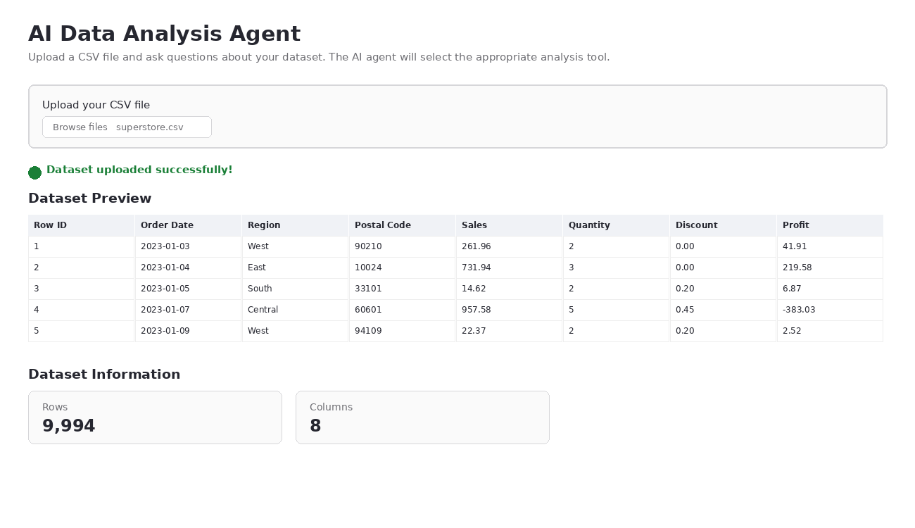
With this in place, the user has visual confirmation the file was read correctly and a quick feel for the dataset's size before writing a single question — catching an obviously wrong upload (blank file, wrong delimiter, wrong dataset) early rather than after a confusing agent response.

Activity 5.2: Wiring the Question Box to the Agent
- Question Input: A st.text_input() captures the user's question in plain English.
- Analyze Button: An st.button() triggers run_agent(user_question), guarded by a check that the question is not empty.
- Staged Output: Inside run_agent(), the agent's raw TOOL/COLUMNS decision, the tool's raw result, and the final natural-language answer are each rendered in their own st.subheader() block, with charts drawn directly onto the page using st.pyplot(fig).
st.subheader("Ask the Data Analysis Agent")
user_question = st.text_input("Enter your question:")
if st.button("Analyze", type="primary"):
if user_question.strip():
run_agent(user_question)
else:
st.warning("Please enter a question.")
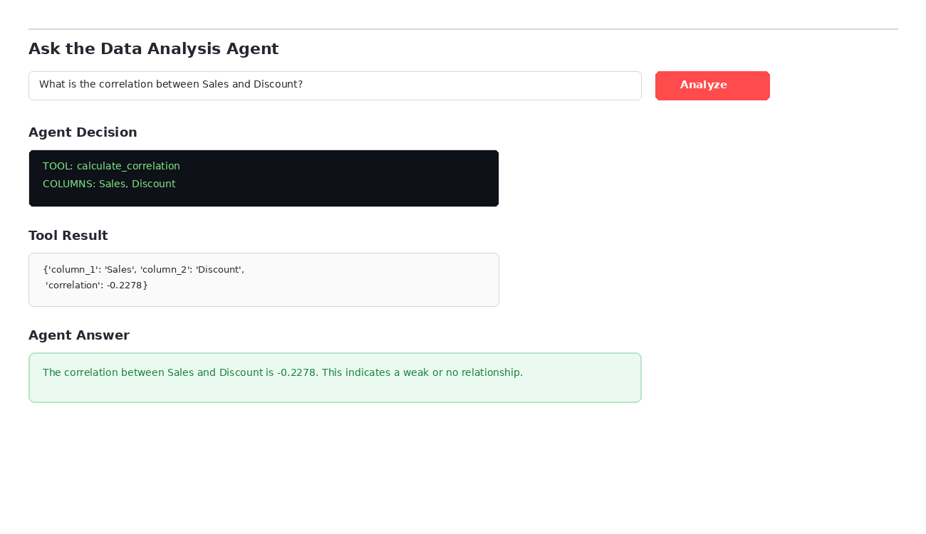
Showing the TOOL/COLUMNS decision alongside the final answer is a deliberate design choice: if the agent ever picks the wrong tool or misreads a column name, the user can see exactly why the answer looks off instead of just receiving an unexplained result.
For chart-producing tools, run_agent() renders the figure with Streamlit's own st.pyplot(fig) call and closes it immediately afterward so repeated questions don't leak memory across reruns:
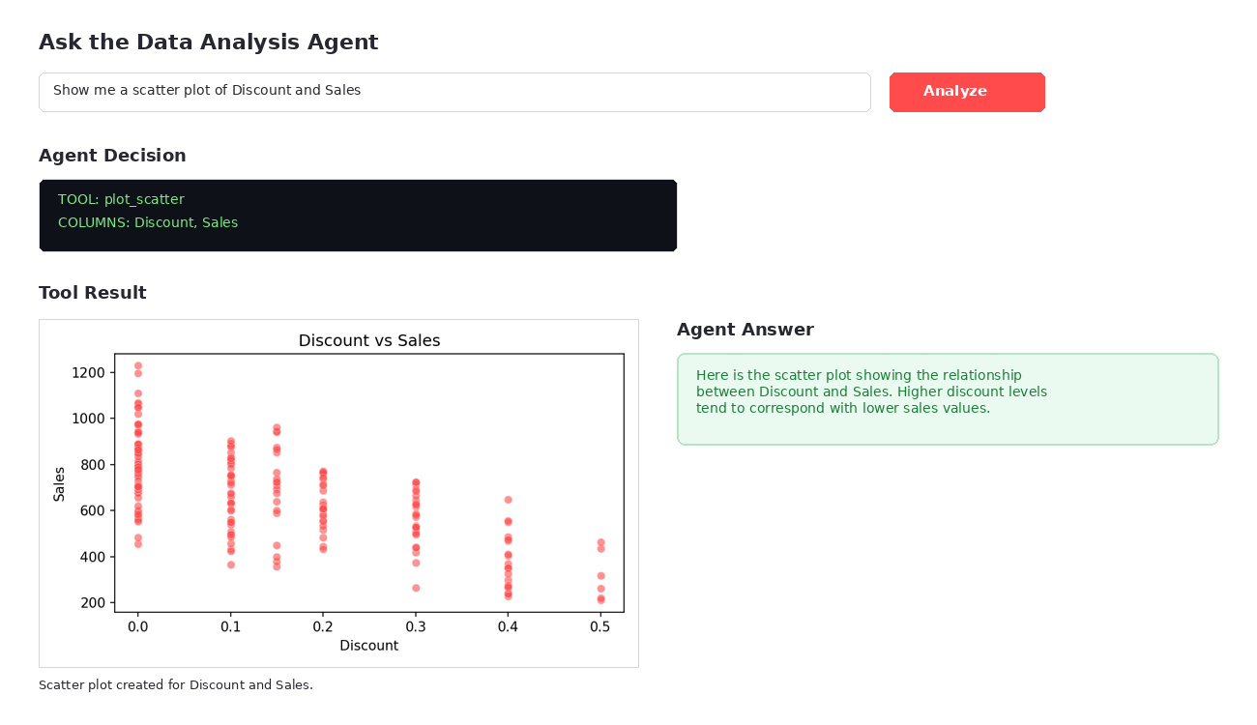
This confirms the same staged layout — decision, result, answer — holds even when the “result” is a chart rather than a number, keeping the interaction pattern consistent no matter which of the ten tools gets selected.

Milestone 6: Deployment
In Milestone 6, the focus is on installing the deployment dependencies, supplying the Gemini API key as an environment variable, launching the Streamlit server, and exposing it publicly via Ngrok so the app can be shared over a secure URL.

Activity 6.1: Preparing for Deployment
!pip install -q streamlit pyngrok
The Gemini API key is set as an environment variable so app.py can read it with os.getenv() at startup, matching how the Flask reference project loads secrets from .env:
import os
import getpass
os.environ["GEMINI_API_KEY"] = getpass.getpass(
"Enter your Gemini API key: "
)

Activity 6.2: Launching Streamlit and Exposing It via Ngrok
Any previous Streamlit process is stopped, the app is started in the background, and the log is redirected to a file for troubleshooting:
!pkill -f streamlit
!streamlit run app.py &>/content/streamlit.log &
pyngrok then opens a tunnel to Streamlit's default port and prints the public URL:
from pyngrok import ngrok
public_url = ngrok.connect(8501)
print("Your Streamlit app:")
print(public_url)
Important Notes:
- Environment Variables First: GEMINI_API_KEY must be set before streamlit run app.py starts, since the script calls st.stop() if the key is missing.
- Port Consistency: ngrok.connect(8501) must match the port Streamlit is actually serving on — 8501 is Streamlit's default.
- Session Limits: Free Ngrok tunnels expire after a period of inactivity; rerun the connect cell to obtain a fresh public URL.

Exploring the Website's Web Pages:

Upload & Dataset Preview Page:
Description: The single-page interface of AI Data Analysis Agent opens with a CSV uploader. Once a file is selected, the app confirms success, displays the first rows of the dataset in an interactive table, and surfaces row and column counts as metric cards — giving the user an immediate sense of the dataset before asking any questions.

Ask the Agent Section:
Description: Below the dataset preview, a text input and Analyze button let the user type a question in plain English. Submitting the form calls the agent, which displays its raw TOOL/COLUMNS decision, the underlying tool's result, and a final natural-language answer — making the AI's reasoning process visible at every step rather than hiding it behind a single response.

Results Section (Charts):
Description: When a question calls for a chart, the same three-step layout applies, but the tool result panel renders the actual Matplotlib figure — histogram, bar chart, or scatter plot — directly inline via st.pyplot(), followed by the agent's plain-language interpretation of what the chart shows.

Conclusion:
AI Data Analysis Agent is a generative AI platform built with Streamlit that turns exploratory data analysis into a conversation. It uses Google's Gemini API with the gemini-3.6-flash model to interpret free-text questions, select from ten Python analysis tools — covering inspection, statistics, missing values, unique values, overviews, histograms, bar charts, correlation, and scatter plots — and translate raw results back into plain-language answers for CSV datasets uploaded directly in the browser. The project, which included tool development, agent-decision prompting, and deployment via Ngrok, highlights how a structured tool-calling framework can make AI-assisted analysis accessible to non-technical users, with clear potential for future scalability.
Looking ahead, AI Data Analysis Agent offers significant opportunities for expansion, such as supporting Excel and JSON uploads alongside CSV, adding multi-turn conversational memory so follow-up questions can reference earlier results, and introducing user authentication to save analysis history across sessions. By continuously refining the tool-selection prompts and broadening the visualization library, the platform is well-positioned to evolve from a specialized notebook exercise into a comprehensive, team-ready data analysis assistant.

