AI Text Summarizer using Google Gemini API

Project Description
The AI Text Summarizer is a generative AI project that condenses any block of user-supplied text into a short, well-organized summary. Rather than training a custom classifier on a labeled dataset, the project uses Google's Gemini large language model — accessed through the google-generativeai Python library — to read the input text and generate four distinct outputs in a single response: a concise SUMMARY, a bulleted list of KEY POINTS, a set of representative KEYWORDS, and a one-line MAIN TOPIC describing what the passage is about.
The entire workflow runs inside a single Google Colab notebook. The user's Gemini API key is collected securely at runtime through an input() prompt rather than being hard-coded into the notebook, and the raw input text is validated before it is ever sent to the model, so an empty submission never reaches the API. Once a summary is generated, the notebook automatically compares the word count of the original text against the AI-generated output and reports the percentage reduction in length, giving students, researchers, and content teams a fast, dependency-light way to condense long text into an easy-to-scan format without standing up any backend infrastructure.

Scenarios
Scenario 1: A student pastes a 200-word article on renewable energy into the input cell. The notebook validates that the text is not empty, reports the original word count, builds a structured prompt, and calls the Gemini model. Within seconds the notebook prints a short SUMMARY, several KEY POINTS, a list of KEYWORDS, and a one-line MAIN TOPIC — turning the article into a scannable digest without the student needing to read it in full.
Scenario 2: A user runs the text-input cell but presses Enter without typing anything. The notebook detects that the stripped input string is empty and immediately prints "[X] No text entered!" instead of calling the Gemini API, avoiding a wasted API call and giving the user a clear signal to re-run the cell with real text.
Scenario 3: After the AI response is printed, the notebook counts the words in both the original text and the generated output, then calculates and displays the percentage reduction — for example, a 203-word article condensed into a 133-word structured output, a 34.48% reduction — giving the user a simple, quantitative sense of how much the model compressed the source text.

Technical Architecture
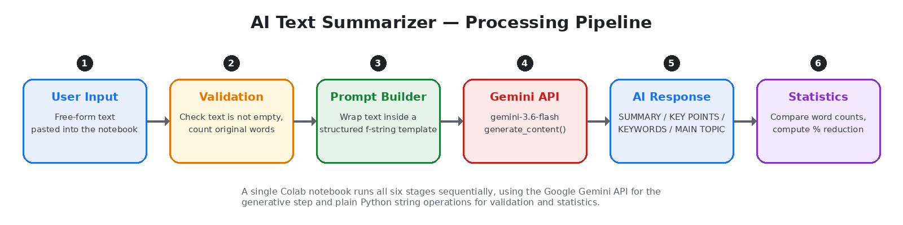

Description:
The AI Text Summarizer follows a lightweight, single-notebook generative-AI pipeline rather than a client-server web architecture. All processing happens inside Google Colab: the user supplies both a Gemini API key and the text to be summarized directly into notebook input cells. The google-generativeai library authenticates the session and exposes a GenerativeModel object that wraps the gemini-3.6-flash model. A structured prompt template embeds the raw text inside formatting instructions, the prompt is sent to the model through generate_content(), and the returned response text is printed directly to the notebook output. A final cell reuses Python's built-in string-splitting to compute and compare word counts between the input and the output.
(Note: This project does not use a database, so no ER diagram is required — the only persistent state during a run is the text and response objects held in the notebook's memory.)
Component | Technology / Method | Purpose
Programming language | Python | Implementation of the complete summarization workflow
AI library | google-generativeai | Connecting to and calling the Gemini API
Language model | Gemini (gemini-3.6-flash) | Generating the summary, key points, keywords and main topic
Authentication | API key (user input at runtime) | Authorizing requests to the Gemini API without hard-coding secrets
Prompt design | Structured prompt template (f-string) | Instructing the model to return a consistent, formatted output
Text handling | Python string operations (split, strip) | Validating input and computing word counts
Development environment | Google Colab | Running the Python notebook and entering the API key / text

Pre-requisites:
- Python Programming Fundamentals: Python Documentation
- Google Generative AI / Gemini API Familiarity: Gemini API Documentation
- Prompt Engineering Concepts: Gemini Prompting Strategies
- Google Colab Environment: Google Colab
- Basic string and text-processing skills in Python (split, strip, f-strings)
- A valid Google Gemini API key generated from Google AI Studio

Project Workflow:

Milestone 1: Environment Setup
- Activity 1.1: Install the google-generativeai library.
- Activity 1.2: Import the google.generativeai module.

Milestone 2: API Configuration and Model Initialization
- Activity 2.1: Generate a Gemini API key and configure it securely in the notebook at runtime.
- Activity 2.2: Initialize the GenerativeModel using the gemini-3.6-flash model.

Milestone 3: Text Input and Validation
- Activity 3.1: Accept a block of text from the user through an input prompt.
- Activity 3.2: Validate that the text is not empty and display the original word count.

Milestone 4: Prompt Engineering and Summarization
- Activity 4.1: Build a structured prompt requesting SUMMARY, KEY POINTS, KEYWORDS and MAIN TOPIC sections.
- Activity 4.2: Send the prompt to the Gemini model using generate_content().
- Activity 4.3: Print the AI-generated response to the notebook.

Milestone 5: Text Statistics and Evaluation
- Activity 5.1: Calculate the word count of the original text and of the AI-generated output.
- Activity 5.2: Calculate the percentage reduction in word count between the input and the output.
- Activity 5.3: Display the text statistics in a formatted summary block.

Milestone 6: Conclusion
- Activity 6.1: Review the generated summary and statistics to assess the effectiveness of the summarization pipeline.

Milestone 1: Environment Setup
This milestone prepares the Colab environment by installing and importing the single third-party library the project depends on. Because the summarizer is a thin wrapper around the Gemini API rather than a full web application, there is no framework, database, or frontend to configure here — just one Python package to bring in before any API calls can be made.

Activity 1.1: Install the Library
Run the following cell once per Colab session. The -q flag installs the package quietly, suppressing the normal pip installation log so the notebook output stays readable:
!pip -q install google-generativeai
This installs google-generativeai, the official Python SDK Google publishes for calling Gemini models, along with its supporting dependencies (protobuf, grpcio, and the underlying API client). Because Colab environments are reset between sessions, this cell needs to be re-run any time the runtime restarts.

Activity 1.2: Import the Library
import google.generativeai as genai
The library is imported under the conventional alias genai. Every subsequent call in the notebook — configuring the API key, creating the model, and generating content — goes through this single imported module, which keeps the rest of the code short and readable.

Milestone 2: API Configuration and Model Initialization
Before the notebook can talk to Gemini, it needs a valid API key and a GenerativeModel instance pointed at the right model. This milestone walks through obtaining that key from Google AI Studio and wiring it into the notebook without ever hard-coding it into the source, then creating the reusable model handle every later cell relies on.

Activity 2.1: Generate and Configure a Gemini API Key
Before the application can communicate with the Gemini model, you need a valid Gemini API key. Follow the steps below to create one and connect it securely to the notebook.
• Step 1 — Create a Google AI Studio Account: Visit https://aistudio.google.com and sign in with a Google account. No separate registration is required beyond an existing Google account.
• Step 2 — Open the API Keys Page: From the left-hand navigation, select "Get API key" to open the key-management screen.
• Step 3 — Create a New API Key: Click "Create API key" and choose (or create) a Google Cloud project to associate the key with.
• Step 4 — Copy the Key: Google AI Studio displays the key once it is generated. Copy it immediately and store it somewhere safe, such as a password manager — treat it the same way you would treat a password.
• Step 5 — Enter the Key at Runtime: Rather than pasting the key into a saved code cell, the notebook asks for it through an input() prompt each time it runs, so the key never gets written into the .ipynb file or committed to version control.
• Step 6 — Configure the Library: Run the cell below and paste the key when prompted:
API_KEY = input("Enter your Gemini API key: ")
genai.configure(api_key=API_KEY)
input() pauses the cell and waits for the user to paste their key into the prompt box. Because the key lives only in the notebook's runtime memory, it disappears the moment the Colab session ends — a lightweight equivalent to using a .env file with python-dotenv in a local Flask or Django project.
Important — never print the API_KEY variable and never paste a real key directly into a code cell that will be saved or shared publicly; always enter it through the input() prompt at runtime, and revoke any key from Google AI Studio that may have been exposed.

Activity 2.2: Initialize the Model
model = genai.GenerativeModel("gemini-3.6-flash")
print("Gemini model initialized successfully!")
genai.GenerativeModel() creates a reusable handle to the requested model — gemini-3.6-flash, a fast, lower-latency Gemini variant well suited to short, structured generation tasks like summarization. The confirmation message gives the user immediate feedback that authentication succeeded before they invest time pasting a long block of text into the next cell.

Milestone 3: Text Input and Validation
This milestone collects the raw text the user wants summarized and guards the rest of the pipeline against empty input, which would otherwise waste an API call and could produce a confusing error from the model or a downstream ZeroDivisionError when the word-reduction percentage is calculated in Milestone 5.

Activity 3.1 & 3.2: Collect and Validate Input Text
text = input("Paste the text you want to summarize:\n\n")
if not text.strip():
print("[X] No text entered!")
else:
print("\n[OK] Text received!")
print("Number of words:", len(text.split()))
text.strip() removes leading and trailing whitespace so a user who accidentally submits a blank line or a few stray spaces doesn't slip past the check. When validation fails, the notebook prints "[X] No text entered!" and none of the downstream cells reference an undefined response object. When validation succeeds, len(text.split()) gives a fast, whitespace-based word count — the same method reused later to measure the AI output — so the two totals in Milestone 5 are computed consistently.
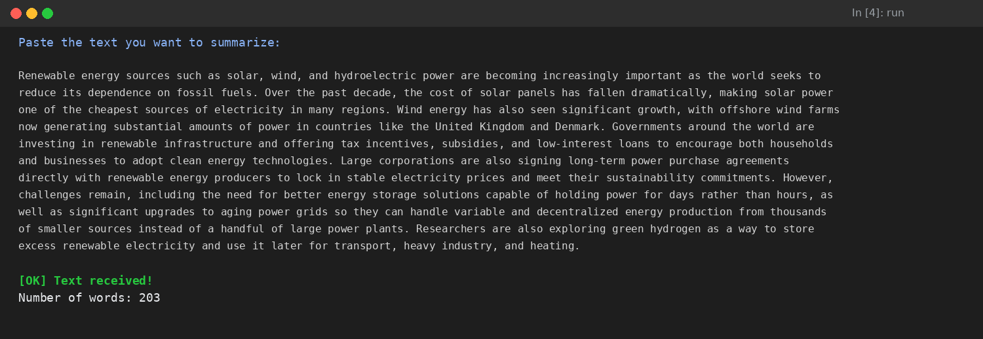
Sample notebook output — text accepted and validated.
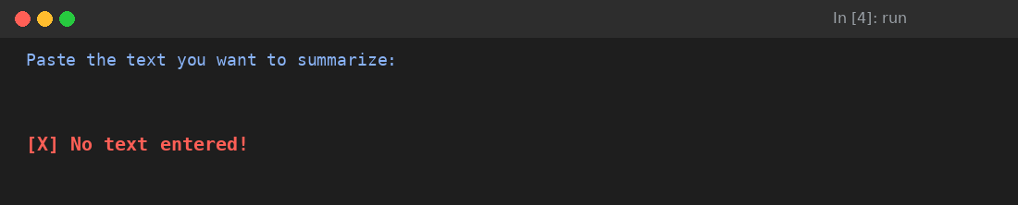
Sample notebook output — empty input rejected before any API call is made.

Milestone 4: Prompt Engineering and Summarization
The quality of a generative summarizer depends almost entirely on how the prompt is written. This milestone builds a single structured prompt that tells Gemini exactly which four sections to return and in what order, sends it to the model, and prints the result.

Activity 4.1: Build a Structured Prompt
prompt = f"""
You are an AI text summarization assistant.
Summarize the following text.
Give the output in this format:
SUMMARY:
Write a clear and concise summary.
KEY POINTS:
- Point 1
- Point 2
- Point 3
- Point 4
- Point 5
KEYWORDS:
List the important keywords.
MAIN TOPIC:
State the main topic in one sentence.
TEXT:
{text}
"""
The prompt is assembled with an f-string so the user's raw text is embedded directly under a TEXT: label at the very end of the instructions, after every formatting rule — a pattern that keeps the model from confusing instructions with content it should summarize. Each of the four output sections is deliberately named in capital letters (SUMMARY, KEY POINTS, KEYWORDS, MAIN TOPIC) so the response is easy to scan visually, and could later be split apart programmatically with simple string matching if the notebook were extended to export the four sections separately.

Activity 4.2: Send the Prompt to Gemini
response = model.generate_content(prompt)
generate_content() sends the full prompt string as a single request to the gemini-3.6-flash model and blocks until Gemini returns a response object. The generated text is exposed on response.text; the response object also carries metadata such as safety-rating and finish-reason fields that the notebook does not currently inspect.

Activity 4.3: Print the AI-Generated Response
print(response.text)
Because the prompt requests a consistent four-section format, the printed output can be read immediately without further formatting. The example below shows the notebook's output for a 203-word sample article about renewable energy:
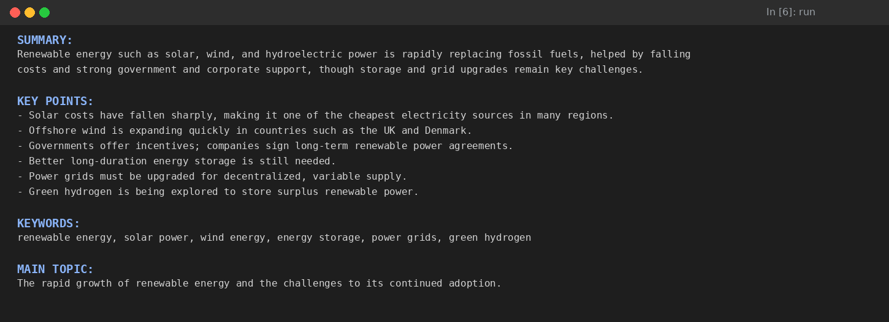
Sample notebook output — Gemini's structured SUMMARY / KEY POINTS / KEYWORDS / MAIN TOPIC response.

Milestone 5: Text Statistics and Evaluation
Since the summarizer is not being scored against a labeled dataset, the notebook substitutes a simple, transparent metric — word-count reduction — so the user can gauge how much the model condensed the source text.

Activity 5.1 – 5.3: Calculate and Display Word Statistics
original_words = len(text.split())
output_words = len(response.text.split())
print("\n" + "="*50)
print("TEXT STATISTICS")
print("="*50)
print("Original text words :", original_words)
print("AI output words :", output_words)
reduction = (1 - output_words / original_words) * 100
print("Word reduction :", round(reduction, 2), "%")
original_words and output_words both reuse the same len(text.split()) approach introduced in Milestone 3, so the comparison stays consistent across both halves of the pipeline. The reduction percentage is calculated as (1 - output_words / original_words) * 100 and rounded to two decimal places. Because the KEY POINTS and KEYWORDS sections add some structural overhead compared to plain prose, the reduction is usually smaller than a single-paragraph summary would show on its own — but it still gives a fast, repeatable sanity check that the model is condensing rather than expanding the source text.
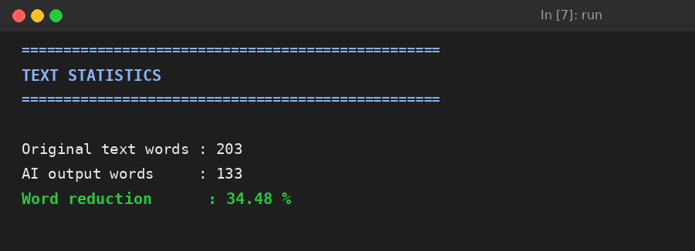
Sample notebook output — word-count comparison and reduction percentage for the renewable-energy example.
Note — because this calculation depends on whatever text the user pastes in Milestone 3, the exact word counts and reduction percentage will differ on every run; the notebook does not cache or average results across sessions, and reduction can occasionally be negative for very short inputs where the structured output is longer than the source text.

Milestone 6: Conclusion

Activity 6.1: Review the Summary and Statistics
With all five prior milestones complete, the final step is to read the printed summary and the statistics block together and judge whether the SUMMARY is accurate, the KEY POINTS are non-redundant and genuinely drawn from the text, the KEYWORDS are representative of the passage, and the word-count reduction falls in a reasonable range for the type of text supplied. Because there is no ground-truth label to compare against, this review is qualitative — the same way a human editor would judge any summary — rather than a single numeric accuracy score.

Exploring the Notebook's Outputs:

Input & Validation Cell:

Description: The first interactive cell prompts the user to paste free-form text. Once submitted, the notebook strips whitespace to confirm the text is non-empty, prints a confirmation message, and reports the exact number of words in the original passage before any API call is made.

Empty-Input Handling:

Description: If the user submits the cell without typing anything, the notebook short-circuits before reaching the Gemini API. This protects the user's API quota and gives an immediate, unambiguous signal that the cell needs to be re-run with real text.

AI-Generated Summary Cell:

Description: After the prompt is sent to gemini-3.6-flash, the model's response is printed directly beneath the cell. The fixed four-section format — SUMMARY, KEY POINTS, KEYWORDS, MAIN TOPIC — stays consistent across runs regardless of the topic or length of the source text, which is what makes the output easy to scan at a glance.

Text Statistics Cell:

Description: The final cell prints a formatted statistics block comparing the original and AI-generated word counts, followed by the percentage reduction. This gives the user a quick, quantitative companion to the qualitative summary above it.

Project Results
Unlike a trained classification model, this project does not produce a fixed accuracy score, since its output depends on the text supplied by the user in each run. The table below summarizes the type of results the notebook reports for any given execution, using the renewable-energy sample shown throughout this document as a concrete example.
Evaluation Measure | Description | Sample Value
Original text word count | Number of words in the text pasted by the user | 203
AI output word count | Number of words in the generated summary, key points, keywords and main topic | 133
Word reduction percentage | Percentage decrease from the original word count to the output word count (varies per run) | 34.48%
Output structure | Consistent SUMMARY / KEY POINTS / KEYWORDS / MAIN TOPIC format on every run | 4 / 4 sections present
Because the summarizer relies on a general-purpose language model rather than a model trained and tested on a fixed dataset, its performance is best assessed qualitatively — by reviewing whether the summary is accurate and the key points, keywords, and main topic are relevant — rather than through a single numeric accuracy figure.

Implementation Summary
The complete implementation follows a straightforward generative-AI workflow: library installation → library import → API key configuration → model initialization → text input and validation → prompt construction → summary generation → word-count statistics.
- Imports: google.generativeai
- Model: genai.GenerativeModel("gemini-3.6-flash")
- Prompt format: SUMMARY, KEY POINTS, KEYWORDS, MAIN TOPIC
- Evaluation: word count comparison and reduction percentage

Conclusion:
The AI Text Summarizer project demonstrates how a generative language model can be used to condense free-form text into a clear, structured summary. Rather than training a custom model on a labeled dataset, the project relies on the Google Gemini API, guided by a carefully structured prompt, to produce a SUMMARY, KEY POINTS, KEYWORDS, and a MAIN TOPIC for any text the user provides — all inside a single, self-contained Colab notebook with no separate frontend, backend, or deployment step required.
The notebook validates the user's input, builds a consistent prompt template, calls the Gemini model to generate the summary, and then reports simple statistics comparing the length of the original text to the AI-generated output. This workflow illustrates a practical, lightweight approach to building an AI-powered summarization tool using prompt engineering rather than traditional model training, and highlights how a small amount of validation and formatting discipline can make a general-purpose LLM behave like a dependable, single-purpose tool.
Looking ahead, the AI Text Summarizer offers several clear opportunities for expansion: handling very long documents by splitting them into chunks before summarization, adding structured error handling for invalid or expired API keys and rate-limit errors, allowing the user to choose the summary length, tone, or output language, parsing response.text into separate variables for each of the four sections so results could be exported to a file or spreadsheet, and evaluating output quality using more formal text-summarization metrics such as ROUGE scores. By continuing to refine the prompt template and adding a lightweight interface around the existing pipeline, the project is well-positioned to evolve from a single notebook into a reusable summarization utility for students, researchers, and content teams alike.

Technologies and Libraries Used
- Python
- Google Generative AI (google-generativeai)
- Gemini API (gemini-3.6-flash model)
- Google Colab

