Multi-Agent Study Assistant: AI-Powered Personalized Learning Platform

Project Description:
The Multi-Agent Study Assistant harnesses Generative AI and a multi-agent design to give students a complete, personalized study experience from a single topic. The platform is built around four specialized agents: a Planner Agent, which creates a realistic day-by-day study plan with learning, revision, and practice; a Teacher Agent, which explains the topic in simple language with definitions, real-world examples, and exam points; a Quiz Agent, which generates multiple-choice questions in strict JSON format; and a Review Agent, which analyzes the student's quiz performance and produces a personalized revision strategy.
Utilizing Google's Gemini API with the gemini-3.6-flash model, the assistant processes the student's topic, number of study days, and quiz length to deliver fast, structured learning material. Built with Streamlit inside Google Colab and deployed publicly via Ngrok, the platform offers a seamless, browser-based experience with no installation. With the API key entered securely through a password field and responsible input handling, the Multi-Agent Study Assistant empowers college students to plan, learn, practice, and review with confidence.

Scenarios
Scenario 1: A student preparing for a Machine Learning exam enters the topic "Decision Trees" with five study days and five quiz questions. The Planner Agent divides the topic into subtopics and builds a five-day plan, the Teacher Agent explains decision trees with a simple real-world example, and the Quiz Agent produces five multiple-choice questions, all within seconds.
Scenario 2: A student with only two days before a test on "Operating System Scheduling" selects a compressed plan. The Planner Agent prioritizes the most important subtopics, mixing learning, revision, and practice, while the Teacher Agent highlights exam-focused points such as scheduling algorithms and their trade-offs.
Scenario 3: After answering the quiz, a student scores 2 out of 5. The Weak Areas panel lists each incorrect question with the student's answer, the correct answer, and an explanation, and the Review Agent recommends revisiting the fundamentals with a targeted revision strategy. A student scoring 5 out of 5 instead receives advanced practice suggestions.

Technical Architecture:
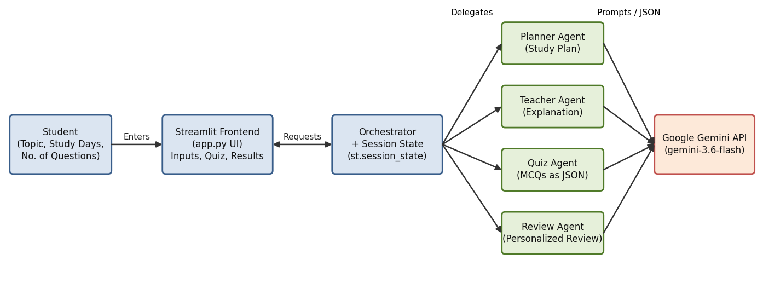
Description: The Multi-Agent Study Assistant utilizes a modular, orchestrated architecture to deliver rapid, AI-driven learning content. The Streamlit frontend collects the topic, study days, and quiz length, while the application logic acts as an orchestrator that calls four specialized agents in sequence: the Planner, Teacher, and Quiz Agents generate the study material, and the Review Agent analyzes the student's quiz results. Every agent communicates with the Gemini API using the gemini-3.6-flash model through a shared ask_gemini() function, and the intermediate results are held in Streamlit's session state. The application runs inside Google Colab and is exposed publicly through Ngrok.

(Note: No database is used in this project, so no ER diagram is required. The plan, explanation, quiz, and topic are stored temporarily in st.session_state for the duration of the study session.)

Pre-requisites:
- Streamlit Framework Knowledge: Streamlit Documentation
- Gemini API Familiarity: Gemini API Documentation
- Multi-Agent and Prompt Engineering Concepts: Prompt Engineering Guide
- Python Programming Proficiency: Python Documentation
- Google Colab Environment: Google Colab
- Version Control with Git: Git Documentation
- Ngrok for Public Deployment: Ngrok Documentation

Project Workflow:

Milestone 1: Model Selection and Architecture
- Activity 1.1: Generate a Gemini API key and configure it securely for the project.
- Activity 1.2: Research and select the appropriate generative AI model from Google Gemini for study-assistant tasks.
- Activity 1.3: Define the multi-agent architecture, detailing interactions between the frontend, the four agents, and the AI integration.
- Activity 1.4: Set up the development environment in Google Colab, installing the necessary libraries and dependencies.

Milestone 2: Multi-Agent Core Development
- Activity 2.1: Develop the four agents: Planner, Teacher, Quiz, and Review, along with the helper functions.
- Activity 2.2: Build the orchestration pipeline and test the complete study flow in the notebook, including scoring and weak-question detection.

Milestone 3: App.py Development
- Activity 3.1: Write the main Streamlit application logic in app.py, integrating all agents and the quiz workflow.

Milestone 4: Frontend Development
- Activity 4.1: Design the user interface using Streamlit components, ensuring a clear and intuitive layout.
- Activity 4.2: Create dynamic rendering with session state to display the plan, explanation, quiz, results, and review.

Milestone 5: Deployment
- Activity 5.1: Prepare the application for deployment by creating the project structure, requirements.txt, and app.py.
- Activity 5.2: Run the Streamlit server in Google Colab and verify it through the log output.
- Activity 5.3: Deploy the application publicly using Ngrok to expose the Streamlit server over a secure public URL.

Milestone 6: Conclusion

Milestone 1: Model Selection and Architecture
In this milestone, we focus on selecting the appropriate generative AI model from Google Gemini for our study-assistant needs. This involves researching the capabilities and performance of the available Gemini models, ensuring that the chosen model aligns well with the application's objectives of generating study plans, topic explanations, quizzes, and personalized reviews for college students.

Activity 1.1: Generate a Gemini API Key
Before the application can communicate with the Gemini model, you need a valid Gemini API key. Follow the steps below to create one and use it securely with the project.
• Step 1 — Open Google AI Studio: Visit https://aistudio.google.com and sign in with your Google account.
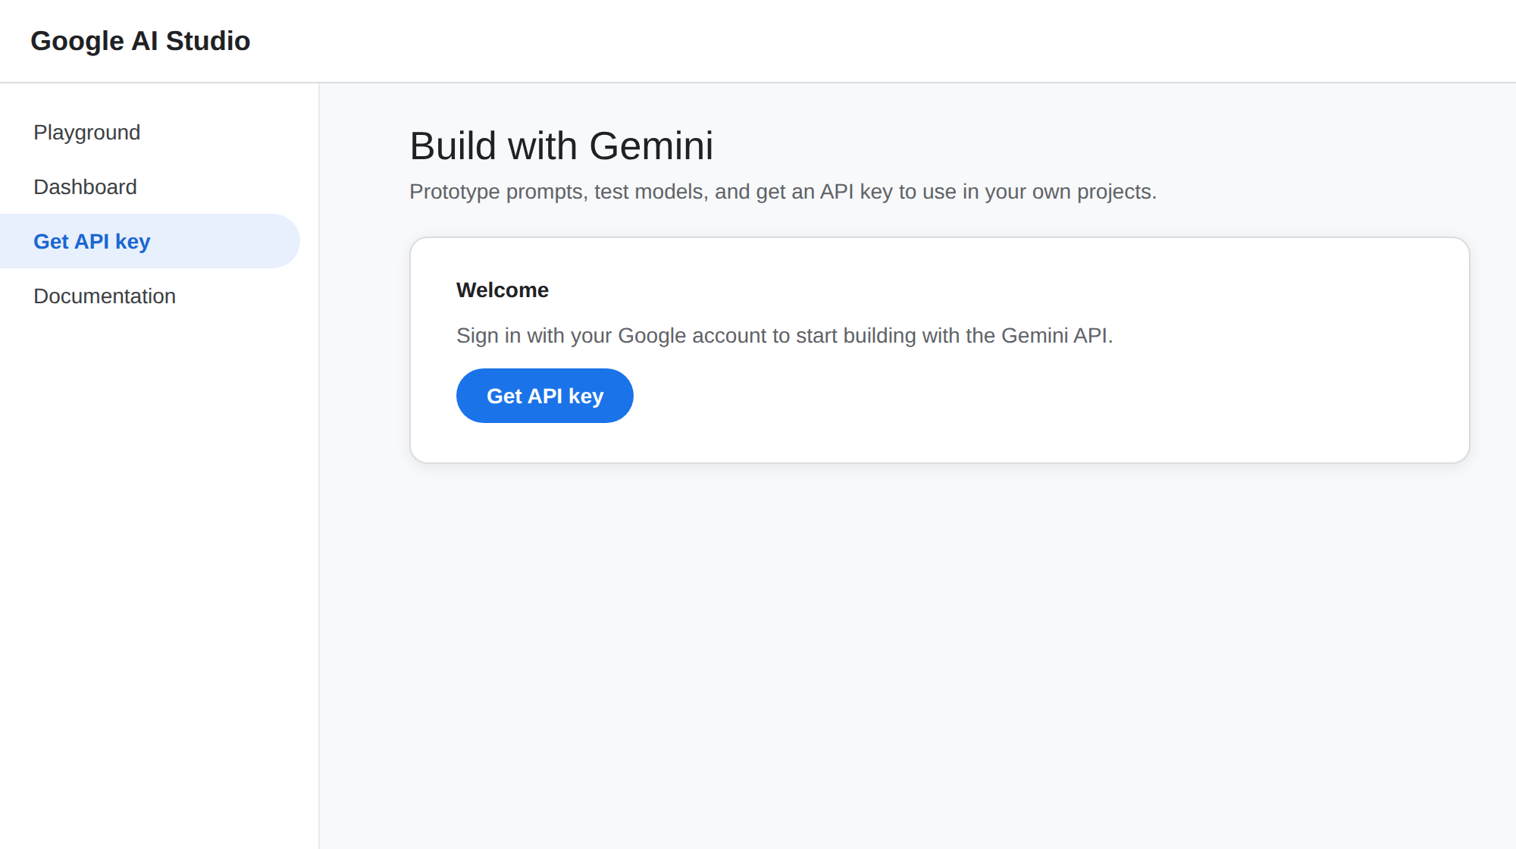
• Step 2 — Navigate to API Keys: From the left menu select "Get API key", or go directly to the API Keys page.
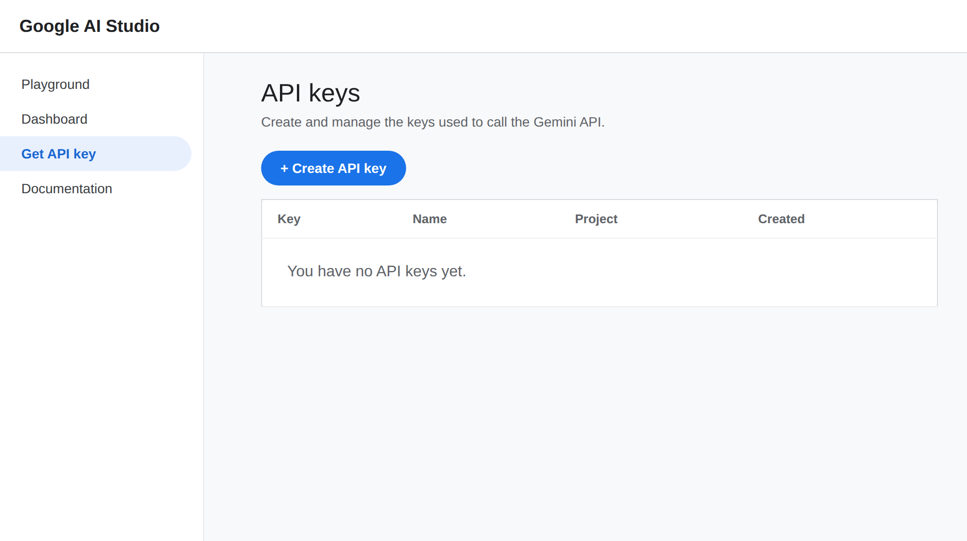
• Step 3 — Create a New API Key: Click "Create API key", choose a Google Cloud project (or create a new one), and give the key a descriptive name (e.g., multi-agent-study-key).
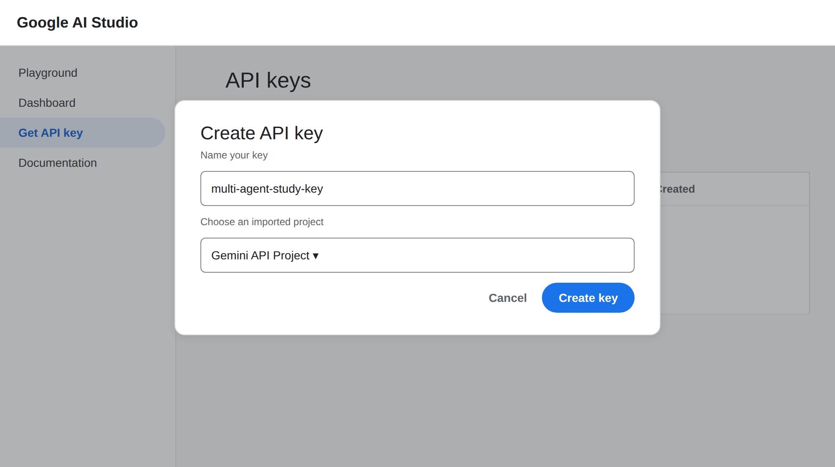
• Step 4 — Copy the API Key: Copy the generated key immediately and store it in a safe place.
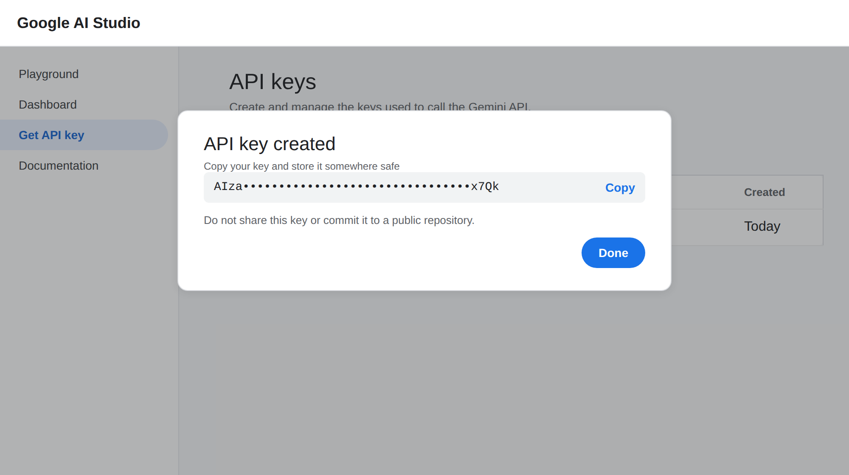
Figure: Copy the generated key and store it safely
• Step 5 — Use the Key in the Project: The notebook asks for the key at run time using input(), and the Streamlit app asks for it through a password field, so the key is never written into the source code:
API_KEY = input("Enter your Gemini API Key: ")
client = genai.Client(api_key=API_KEY)
MODEL_NAME = "gemini-3.6-flash"

• Important — Never Share or Commit Your API Key: Do not hard-code the key in notebooks or app.py, and never push it to a public repository. If a key is exposed, delete it from Google AI Studio and create a new one.

Activity 1.2: Research and Select the Appropriate Generative AI Model
Here are the things that needed to research to select a best model for the project:
- Understand the Project Requirements: Review the specific needs of the Multi-Agent Study Assistant, focusing on the types of content it will generate (study plans, explanations, structured JSON quizzes, and personalized reviews).
- Explore Gemini's Model Documentation: Visit the Gemini API documentation to examine the available models, including their functionalities, context windows, speed, and limitations.
- Evaluate Model Performance: Compare models based on response quality, generation speed, and how reliably they follow strict output formats such as JSON-only responses.
- Select the Optimal Model: Choose gemini-3.6-flash for its balance of fast responses and quality, which suits an interactive tool where four agents make several calls per study session.

Activity 1.3: Define the Architecture of the Application
- Draft an Architectural Diagram: Create a visual representation of the application architecture, including the Streamlit frontend, the orchestrator, the four agents, and the Gemini API integration.
- Detail Frontend Functionality: Outline how students interact with the application by entering a topic, choosing the number of study days and quiz questions, answering the quiz, and viewing results and review.
- Outline Agent Responsibilities: Specify the role of each agent: the Planner Agent builds the study plan, the Teacher Agent explains the topic, the Quiz Agent generates JSON multiple-choice questions, and the Review Agent analyzes performance.
- Describe AI Integration Points: Define how each agent builds a role-specific prompt, calls the Gemini model through ask_gemini(), parses the quiz JSON through clean_json_response(), and returns structured results to the frontend.
Key Design Decisions:
- One responsibility per agent: Each agent has its own prompt and output, which makes the prompts easier to test and improve independently.
- One shared model function: All agents call ask_gemini(), so changing the model or the SDK call needs a change in only one place.
- Strict JSON only for the quiz: The Quiz Agent is the only agent whose output is parsed by code, so it is told to return JSON with no Markdown or extra text.
- Sequential orchestration: The agents run in a fixed order, and the Review Agent receives the outputs of the earlier agents as context.
- State in memory: Results are kept in Streamlit session state, so no database is needed for a single study session.

Activity 1.4: Set Up the Development Environment
- Open Google Colab: Create a new notebook at colab.research.google.com. Colab provides Python and a free runtime, so no local installation is needed.
- Install the Gemini SDK: Install the Google GenAI library to interact with the Gemini API:
!pip install -U -q google-genai

- Install Streamlit and PyNgrok: Install the web framework and the tunneling wrapper used later for deployment:
!pip install -q streamlit pyngrok

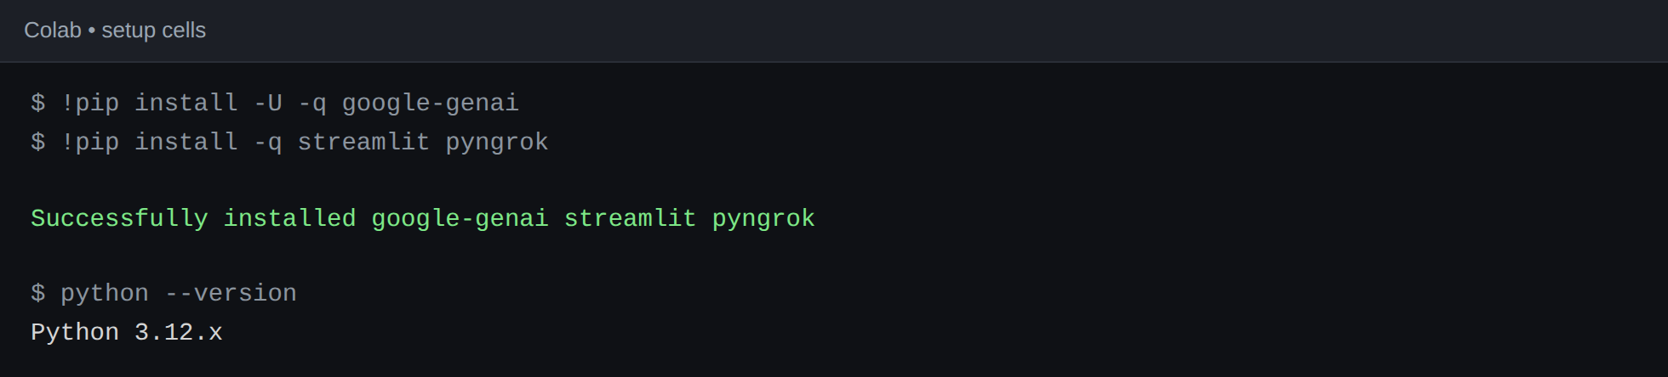
Figure: Installing the required libraries in Colab
- Import Required Libraries: Import json, re, and the genai client at the top of the notebook:
import json
import re
from google import genai

- Set Up Application Structure: Create the project folders and requirements file:
import os
os.makedirs("multi_agent_study_assistant", exist_ok=True)
os.makedirs("multi_agent_study_assistant/reports", exist_ok=True)

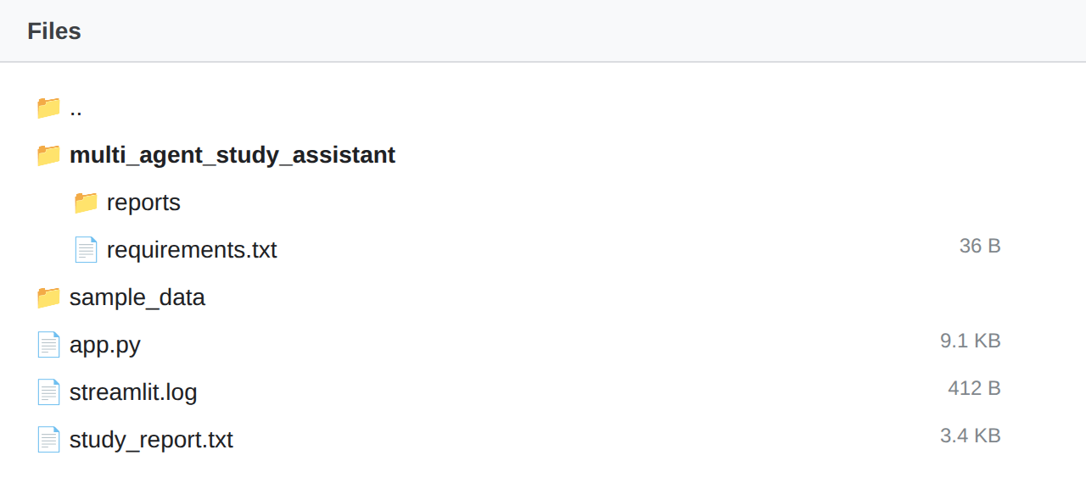

Milestone 2: Multi-Agent Core Development

Activity 2.1: Develop the Core Agents
Implement the four specialized agents and the helper functions that connect them to the Gemini model. Each agent has a single responsibility and its own role-specific prompt.
- Planner Agent: Takes the topic and the number of study days, divides the topic into subtopics, and creates a simple, realistic day-by-day plan that includes learning, revision, and practice for a college student.
- Teacher Agent: Explains the topic to a first-time learner with a simple definition, how it works, an easy real-world example, important concepts, and important exam points.
- Quiz Agent: Generates exactly the requested number of four-option multiple-choice questions and returns them as strict JSON containing the question, options A to D, the correct answer, and a short explanation.
- Review Agent: Receives the topic, plan, explanation, quiz results, and score, then returns a performance summary, incorrect questions, concepts needing revision, exam points, a personalized revision strategy, and final study advice. It recommends advanced practice for high scores, targeted revision for average scores, and revisiting the fundamentals for low scores.
Helper Functions:
- ask_gemini(prompt): a single function shared by all agents that sends a prompt to gemini-3.6-flash and returns the output text.
def ask_gemini(prompt):
interaction = client.interactions.create(
model=MODEL_NAME,
input=prompt
)
return interaction.output_text

- clean_json_response(response): removes any Markdown code fences from the model output and parses it with json.loads(), so the quiz can be used as a Python dictionary.
def clean_json_response(response):
response = response.strip()
response = re.sub(r"^```json\s*", "", response, flags=re.IGNORECASE)
response = re.sub(r"^```\s*", "", response)
response = re.sub(r"\s*```$", "", response)
return json.loads(response.strip())

- identify_weak_questions(quiz, student_answers): compares each student answer with the correct answer and returns the incorrectly answered questions with the student's answer, the correct answer, and the explanation.

Activity 2.2: Build the Orchestration Pipeline and Test the Flow
- Create the Orchestrator: The run_study_assistant() function calls the Planner, Teacher, and Quiz Agents in sequence and returns the plan, explanation, and quiz.
def run_study_assistant(topic, days, number_of_questions=5):
plan = planner_agent(topic, days)
explanation = teacher_agent(topic)
quiz = quiz_agent(topic, number_of_questions)
return plan, explanation, quiz

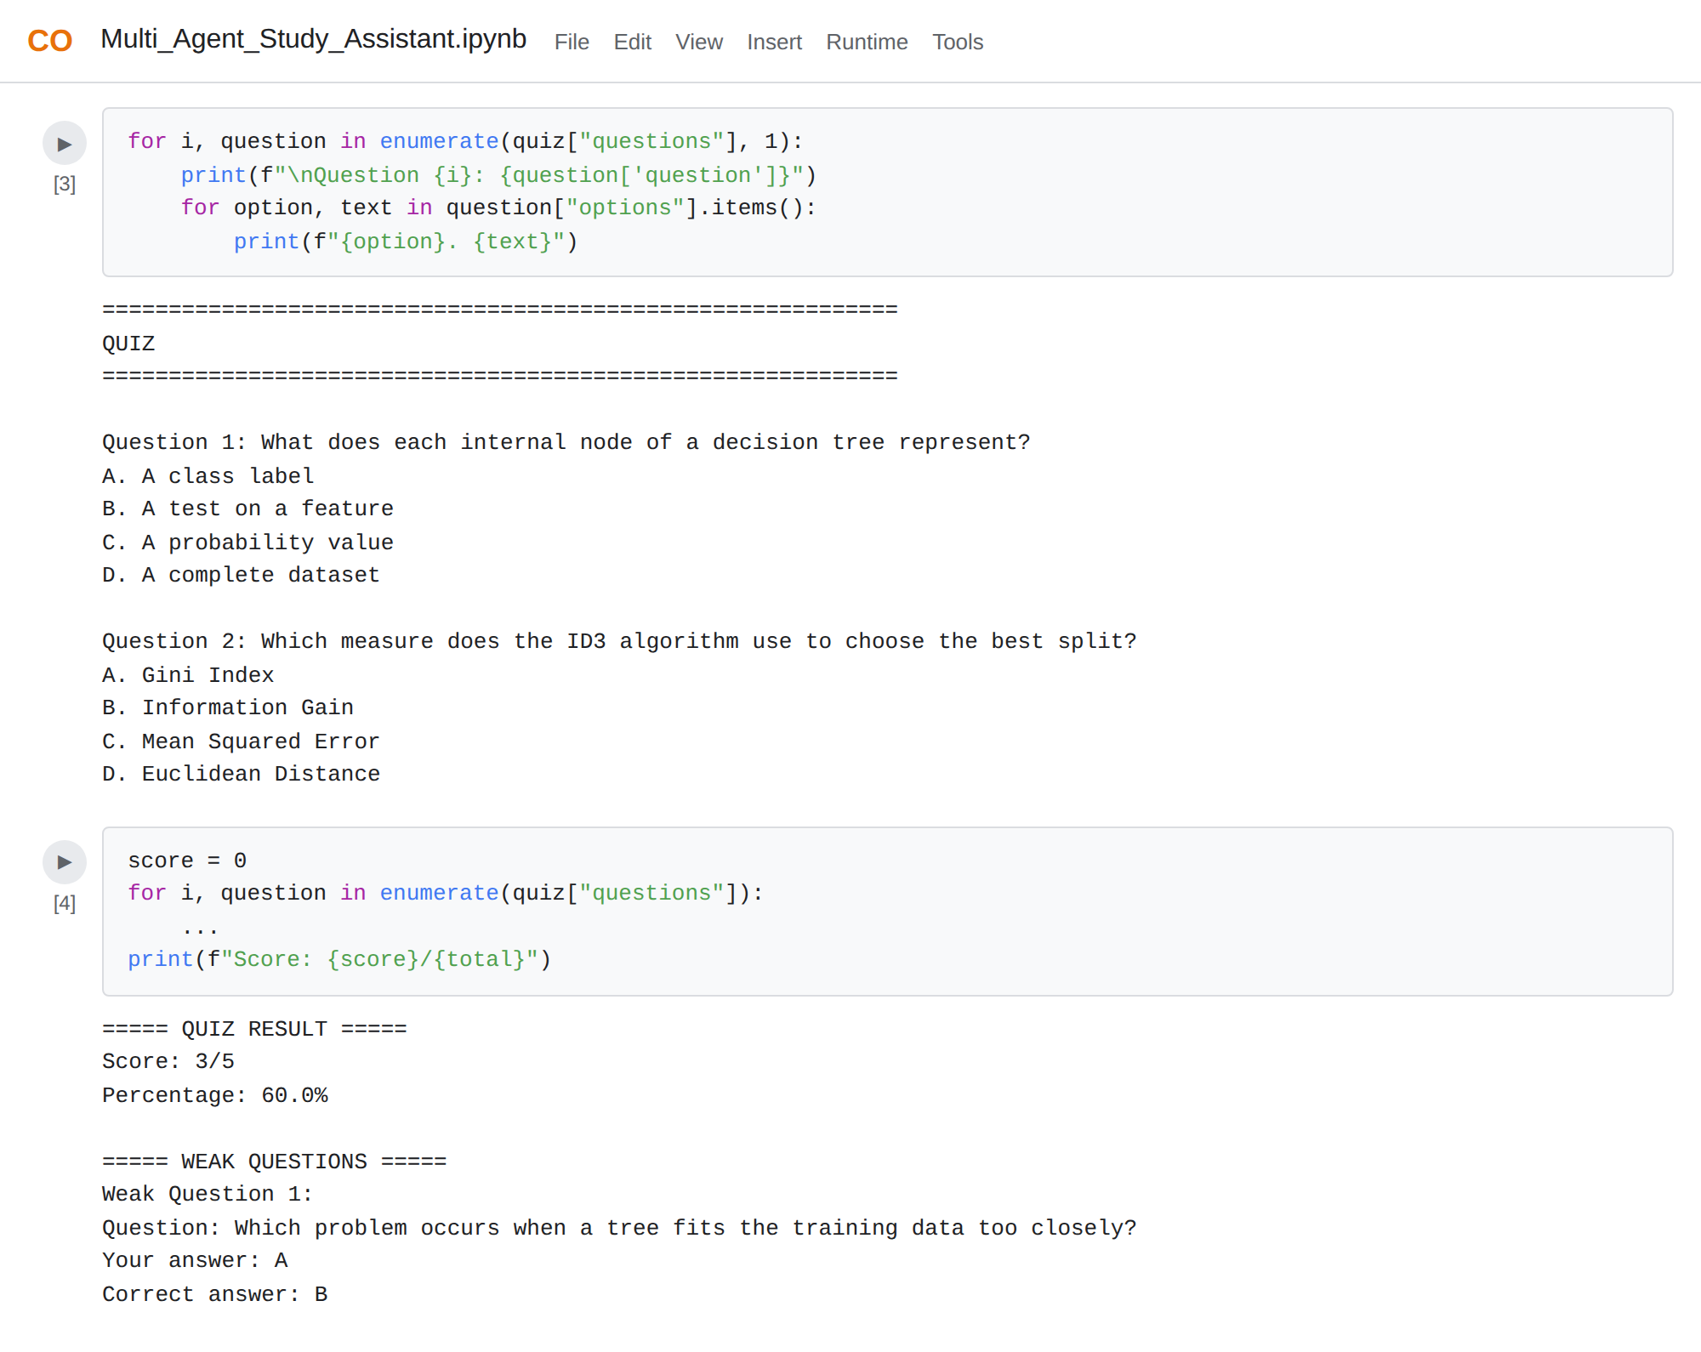
Figure: Quiz display, scoring, and weak-question output in the notebook
- Collect Quiz Answers: Display each question with its options, then accept only A, B, C, or D from the student, re-prompting on invalid input.
- Score the Quiz: Compare the answers with the correct options to calculate the score and the percentage.
- Detect Weak Areas: Call identify_weak_questions() to list the incorrect answers with explanations.
- Generate the Personalized Review: Call the Review Agent with the complete session data to produce the final review.
- Save the Study Report: Combine the plan, explanation, score, weak questions, and review into a study_report.txt file, which can be downloaded from Colab.
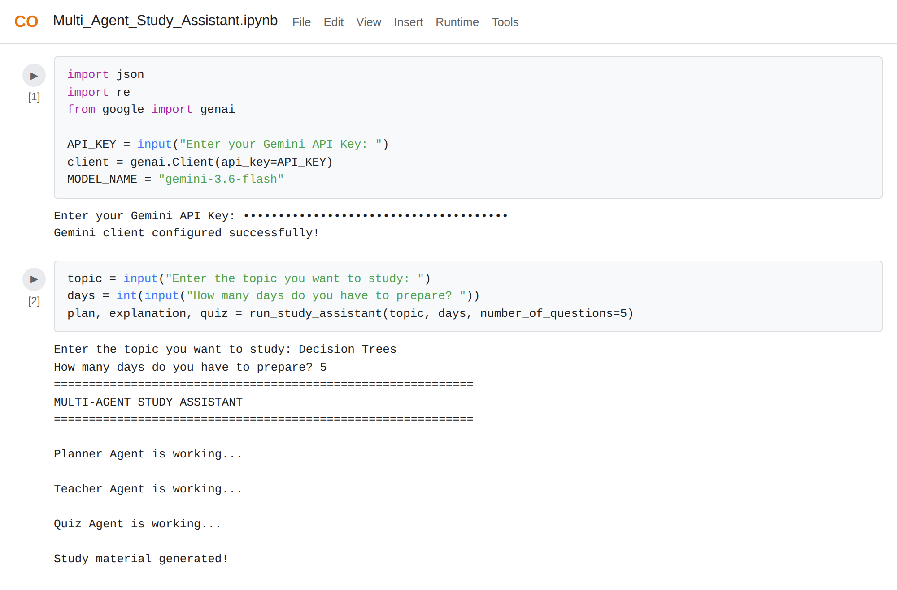

Activity 2.3: Prompt Engineering for Each Agent
The quality of each agent depends on its prompt. Every prompt follows the same pattern: a role sentence, the input values, a numbered list of requirements, and a style instruction.
Agent | Role Sentence | Key Requirements
Planner | You are the Planner Agent in a Multi-Agent Study Assistant. | Divide the topic into subtopics, build a day-by-day plan, include learning, revision, and practice, keep it suitable for a college student.
Teacher | You are the Teacher Agent in a Multi-Agent Study Assistant. | Give a simple definition, how it works, an easy real-world example, important concepts, and exam points, in simple language.
Quiz | You are the Quiz Agent in a Multi-Agent Study Assistant. | Generate exactly N questions, four options each, answer must be A, B, C, or D, return only valid JSON.
Review | You are the Review Agent in a Multi-Agent Study Assistant. | Analyze performance, list wrong answers, weak concepts, exam points, a revision strategy, and advice based on the score band.

Prompt Techniques Used:
- Role prompting: Starting each prompt with "You are the ... Agent" gives the model a clear job.
- Structured requirements: Numbered requirements make the response predictable and easy to check.
- Output format control: The Quiz Agent prompt includes the exact JSON schema, and tells the model not to include Markdown or ```json fences.
- Conditional guidance: The Review Agent prompt tells the model to recommend advanced practice for high scores, targeted revision for average scores, and revisiting fundamentals for low scores.
- Context passing: The Review Agent receives the topic, plan, explanation, and per-question results as JSON, so its advice is personalized.

Activity 2.4: Test the Agents
Before building the web app, test the notebook flow with different inputs and confirm that each step behaves as expected.
Test | Input | Expected Result
Planner Agent | Topic: Decision Trees, 5 days | A 5-day plan with subtopics, learning, revision, and practice
Teacher Agent | Topic: Decision Trees | Simple definition, example, concepts, and exam points
Quiz Agent | Topic: Decision Trees, 5 questions | Valid JSON with exactly 5 questions, each with options A to D
JSON cleaning | Response wrapped in ```json fences | Fences removed and JSON parsed into a dictionary
Answer validation | Student types "E" or leaves it blank | Input rejected with the message "Please enter A, B, C, or D."
Scoring | Answers B, B, A, A, C against key B, B, B, B, C | Score 3/5 and 60.0%
Weak questions | Same answers as above | Questions 3 and 4 listed with your answer, correct answer, and explanation
Perfect score | All answers correct | Message "Excellent! You answered all questions correctly." and advanced practice advice
Review Agent | Score 3/5 with quiz results | Targeted revision strategy based on the weak concepts

Milestone 3: App.py Development
Milestone 3 focuses on converting the tested notebook logic into app.py, the Streamlit application that serves as the backbone of the Multi-Agent Study Assistant. In this milestone, you'll set up the page, connect the agents to the interface, manage state between interactions, and verify that each step performs as expected.

Activity 3.1: Writing the Main Application Logic in app.py
Configure the Page and Collect the API Key:
- Set the page title, icon, and wide layout, then ask for the Gemini API key in a password field. The rest of the app runs only after a key is provided.
st.set_page_config(
page_title="Multi-Agent Study Assistant",
page_icon="📚",
layout="wide"
)

api_key = st.text_input("🔑 Enter your Gemini API Key", type="password")

if api_key:
client = genai.Client(api_key=api_key)
MODEL_NAME = "gemini-3.6-flash"

Define the Agents Inside the App:
- Reuse ask_gemini(), clean_json_response(), planner_agent(), teacher_agent(), quiz_agent(), identify_weak_questions(), and personalized_review_agent() from the notebook so the web app behaves exactly like the tested pipeline.
- Example: the Planner Agent prompt gives the model a clear role, the inputs, and the requirements:
def planner_agent(topic, days):
prompt = f"""
You are the Planner Agent in a Multi-Agent Study Assistant.

Student topic:
{topic}

Number of study days:
{days}

Create a simple and realistic study plan.

Requirements:
1. Divide the topic into important subtopics.
2. Create a day-by-day study plan.
3. Include learning, revision, and practice.
4. Keep it suitable for a college student.
5. Use clear and simple language.
"""
return ask_gemini(prompt)

- Example: the Quiz Agent forces JSON-only output so the response can be parsed reliably:
Return ONLY valid JSON.
Do not include Markdown.
Do not include ```json.
Do not include any text outside the JSON.

{ "questions": [ {
"question": "Question text",
"options": {"A": "...", "B": "...", "C": "...", "D": "..."},
"answer": "A",
"explanation": "Short explanation"
} ] }

Collect User Input and Generate Study Material:
- Read the topic, the number of study days (1 to 30), and the number of quiz questions (1 to 20).
- Validate that the topic is not empty, then run the Planner, Teacher, and Quiz Agents one after another and store the results in st.session_state.
if st.button("🚀 Generate Study Material"):
if topic.strip() == "":
st.warning("Please enter a topic.")
else:
with st.spinner("🗓️ Planner Agent is creating your study plan..."):
plan = planner_agent(topic, days)
with st.spinner("👨‍🏫 Teacher Agent is explaining the topic..."):
explanation = teacher_agent(topic)
with st.spinner("📝 Quiz Agent is generating questions..."):
quiz = quiz_agent(topic, number_of_questions)
st.session_state["plan"] = plan
st.session_state["explanation"] = explanation
st.session_state["quiz"] = quiz
st.session_state["topic"] = topic
st.success("✅ Study material generated successfully!")

Score the Quiz and Run the Review Agent:
- When the student clicks Submit Quiz, compare the selected options with the correct answers, calculate the score and percentage, find the weak questions, and call the Review Agent with the stored plan and explanation.
if st.button("📊 Submit Quiz"):
score = 0
for i, question in enumerate(quiz["questions"]):
correct_answer = question["answer"].strip().upper()
if student_answers[i] == correct_answer:
score += 1
total = len(quiz["questions"])
percentage = (score / total) * 100
weak_questions = identify_weak_questions(quiz, student_answers)
review = personalized_review_agent(
st.session_state["topic"], st.session_state["plan"],
st.session_state["explanation"], quiz,
student_answers, score, total)

Application Flow:
- API key → topic, days, and questions → Generate Study Material → Planner, Teacher, and Quiz output → answer quiz → Submit Quiz → score, Review Agent, and Weak Areas.
Structure of app.py:
Section | What It Does
Page settings | Sets the page title, icon, wide layout, and shows the title and introduction
Gemini API key | Collects the key through a password field and creates the genai client
Gemini function | ask_gemini() sends a prompt to the model and returns the text
JSON cleaning | clean_json_response() removes code fences and parses the quiz
Agents 1 to 3 | Planner, Teacher, and Quiz agent functions
Weak questions | identify_weak_questions() finds the incorrect answers
Agent 4 | personalized_review_agent() builds the final review
User input | Topic, study days, and number of questions
Generate study material | Runs agents 1 to 3 and stores the results in session state
Display sections | Shows the plan, explanation, and quiz from session state
Submit quiz | Scores the quiz, finds weak questions, and runs the Review Agent

Activity 3.2: Managing Session State
Streamlit reruns the whole script every time the student clicks a button or changes a widget. Without session state, the generated plan, explanation, and quiz would disappear as soon as the student selected an answer. The app therefore stores them in st.session_state.
Session Key | Stored Value | Used By
plan | Study plan text from the Planner Agent | Planner section and Review Agent
explanation | Explanation text from the Teacher Agent | Teacher section and Review Agent
quiz | Parsed quiz dictionary from the Quiz Agent | Quiz section, scoring, and weak-question detection
topic | The topic the student entered | Review Agent

- Check before display: Each section is shown only if its key exists, for example if "plan" in st.session_state.
- Widget keys: Each quiz question uses a unique key such as question_0, question_1, so answers do not overwrite each other.

Activity 3.3: Input Validation and Error Handling
- Empty topic: If the topic field is empty, the app shows a warning and does not call any agent.
- Number limits: st.number_input() restricts study days to 1 to 30 and quiz questions to 1 to 20.
- Masked API key: The key field uses type="password", and the agents run only after a key is provided.
- Answer validation in the notebook: The notebook accepts only A, B, C, or D and asks again for anything else.
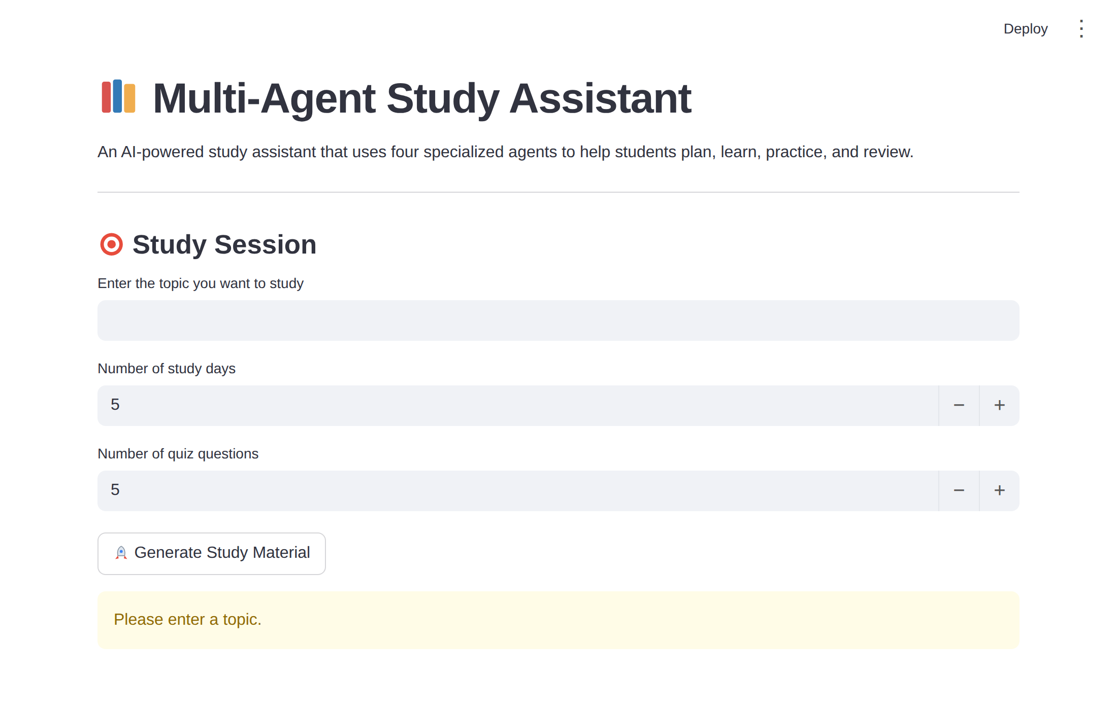
Figure: Warning shown when the topic is empty
Recommended Improvement:
- The Quiz Agent depends on the model returning valid JSON. To make the app more robust, wrap the call in a try/except block and show a friendly message if parsing fails:
try:
quiz = quiz_agent(topic, number_of_questions)
except (json.JSONDecodeError, KeyError):
st.error("The quiz could not be generated. Please try again.")
st.stop()

Milestone 4: Frontend Development
Milestone 4 focuses on developing a clean, user-friendly interface for the Multi-Agent Study Assistant. Instead of hand-written HTML and CSS, the interface is built entirely with Streamlit components, which produce a responsive, browser-based layout directly from Python code. This milestone covers the layout design and the dynamic rendering of each agent's output.

Activity 4.1: Designing and Developing the User Interface
Set Up the Base Page Structure:
- Use st.set_page_config() with a wide layout, then add st.title() and a short st.write() introduction describing the four agents.
- Use st.divider() between sections to keep the page organized and easy to scan.
- Use emojis in headings (📚, 🗓️, 👨‍🏫, 📝, 🔍) to make each agent easy to identify.
Create Input Components:
- API Key Field: st.text_input() with type="password" so the key is masked.
- Topic Field: st.text_input() where the student types the subject to study.
- Study Days and Question Count: st.number_input() with limits of 1 to 30 days (default 5) and 1 to 20 questions (default 5).
- Generate Button: st.button() that starts the Planner, Teacher, and Quiz Agents.
Create Separate Sections for Each Agent:
- Planner Agent Section: shows the day-by-day study plan.
- Teacher Agent Section: shows the simple explanation with examples and exam points.
- Quiz Agent Section: shows each question with st.radio() answer choices formatted as "A. option text".
- Review Agent Section: shows the personalized review after the quiz is submitted.
- Weak Areas Section: uses st.expander() so each incorrect question can be opened to show the student's answer, the correct answer, and the explanation.

Activity 4.2: Creating Dynamic Content Rendering with Session State
Show Progress While Agents Work:
- Wrap each agent call in st.spinner() with a message such as "Planner Agent is creating your study plan..." so the student knows which agent is running.
- Show st.success() when the material is ready and st.warning() when the topic is empty.
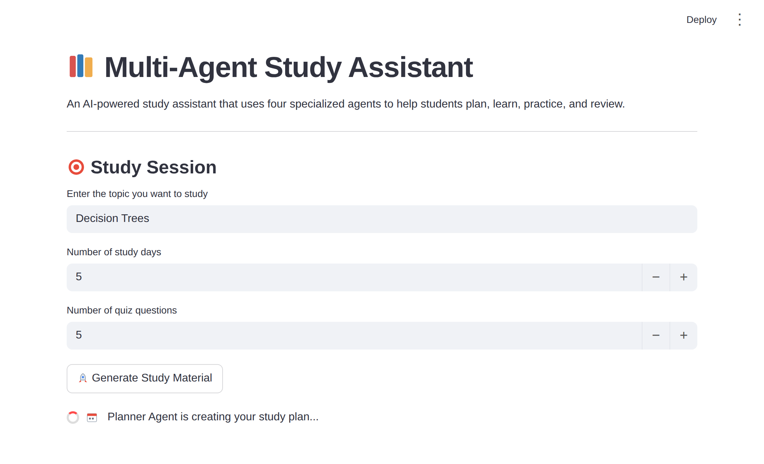
Figure: Spinner shown while the Planner Agent is working
Preserve Content Between Interactions:
- Streamlit reruns the script on every click, so the plan, explanation, quiz, and topic are stored in st.session_state and displayed only when they exist.
- This keeps the study material visible while the student answers the quiz and submits it.
Display Results Clearly:
- After submission, show the score and percentage, then the Review Agent output, then the Weak Areas panel.
- If every answer is correct, show a success message: "Excellent! You answered all questions correctly."

Activity 4.3: Component Reference
Interface Element | Streamlit Component | Purpose
Page title and description | st.title(), st.write() | Introduces the assistant and its four agents
Section separators | st.divider() | Separates the plan, explanation, quiz, and review
API key, topic | st.text_input() | Collects text; the key field is masked
Study days, questions | st.number_input() | Collects numbers within safe limits
Generate and Submit buttons | st.button() | Starts the agents and submits the quiz
Progress messages | st.spinner() | Shows which agent is currently working
Status messages | st.success(), st.warning() | Confirms success or reports missing input
Quiz answers | st.radio() | Lets the student choose A, B, C, or D
Weak areas | st.expander() | Shows each incorrect question on demand
Agent output | st.subheader(), st.write() | Displays each agent's result under its own heading

Milestone 5: Deployment
In Milestone 5, the focus is on running the Multi-Agent Study Assistant inside Google Colab to verify correct operation, and then exposing it publicly via Ngrok so it can be shared through a secure, accessible URL. This involves creating the project files, starting the Streamlit server, and launching the tunnel.

Activity 5.1: Preparing the Application for Deployment
Create the Requirements File:
- List the dependencies the application needs in requirements.txt:
google-genai
streamlit
pyngrok

Write app.py from the Notebook:
- Use the %%writefile app.py cell magic at the top of the cell that contains the Streamlit code. Colab saves the cell content as app.py in the runtime.
- Confirm the file exists:
!ls -lh app.py

Project Structure:
/content
├── app.py # Streamlit application
├── streamlit.log # Server log
├── study_report.txt # Report created by the notebook
└── multi_agent_study_assistant/
├── requirements.txt # google-genai, streamlit, pyngrok
└── reports/ # Folder for saved reports

Activity 5.2: Running and Verifying the Streamlit Server
Install the Dependencies:
!pip install -q streamlit pyngrok

Start the Streamlit Server:
- Run the app in the background and write its output to a log file:
!streamlit run app.py &>/content/streamlit.log &

- Check the log to confirm that Streamlit started without errors:
!cat /content/streamlit.log

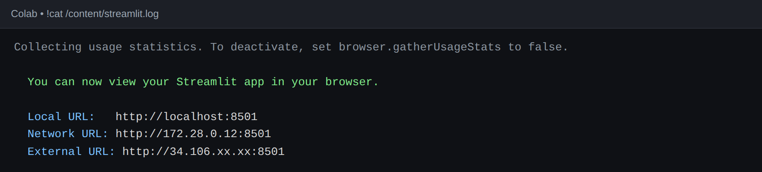

Activity 5.3: Public Deployment via Ngrok
Ngrok creates a secure tunnel from a public URL to the Streamlit server running in Colab, making the app accessible from anywhere without a cloud hosting provider.
Configure Your Ngrok Authtoken:
- Sign up at ngrok.com and copy your authtoken from the Ngrok dashboard.
- Set the token with pyngrok, replacing the placeholder with your own token:
from pyngrok import ngrok
ngrok.set_auth_token("YOUR_NGROK_AUTHTOKEN")
print("✅ ngrok authentication configured!")

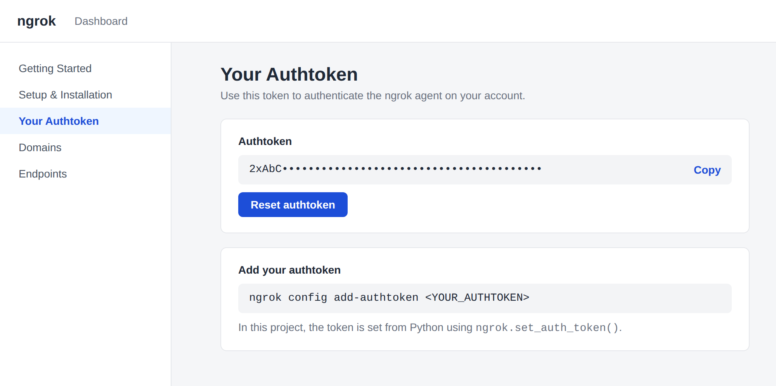
Open the Public Tunnel:
- Connect to the Streamlit port (8501) and print the public URL:
from pyngrok import ngrok
public_url = ngrok.connect(8501)
print("🌐 Open your Streamlit app:")
print(public_url)

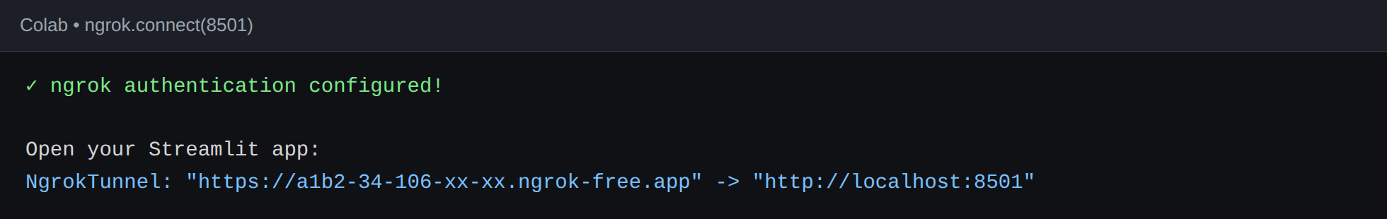
Figure: Public Ngrok URL printed in Colab
- Share the printed URL with anyone. They can open the assistant directly from their browser without any installation.
Important Notes:
- Protect your tokens: Never paste your real Ngrok authtoken or Gemini API key into a shared notebook, screenshot, or repository. Use a placeholder in shared files, or store secrets in Colab Secrets.
- The URL changes: On the free Ngrok plan, the public URL changes each time you restart the tunnel. A paid plan with a reserved domain gives a persistent URL.
- Keep the runtime active: The app is served from the Colab runtime, so it stops when the runtime disconnects. Re-run the server and tunnel cells to bring it back.
- API key entry: Each user enters their own Gemini API key in the password field of the app, so the key is not stored in the source code.

Activity 5.4: Common Issues and Troubleshooting
Problem | Likely Cause | Solution
Invalid API key error | Key copied incorrectly or deleted | Create a new key in Google AI Studio and enter it again
JSON decode error in the quiz | Model added extra text around the JSON | Click Generate again; keep the "Return ONLY valid JSON" instruction in the prompt
App page does not open | Streamlit server not running | Run !cat /content/streamlit.log and restart the server cell
Ngrok tunnel fails | Missing or wrong authtoken | Copy the token again from the Ngrok dashboard and re-run the token cell
Public URL stopped working | Colab runtime disconnected or tunnel expired | Re-run the server and Ngrok cells to get a new URL
Quiz disappears after clicking | Data not stored in session state | Store plan, explanation, quiz, and topic in st.session_state
ModuleNotFoundError | Library not installed in this runtime | Re-run the pip install cells

Exploring the Website's Web Pages:

Home / Study Session Page:
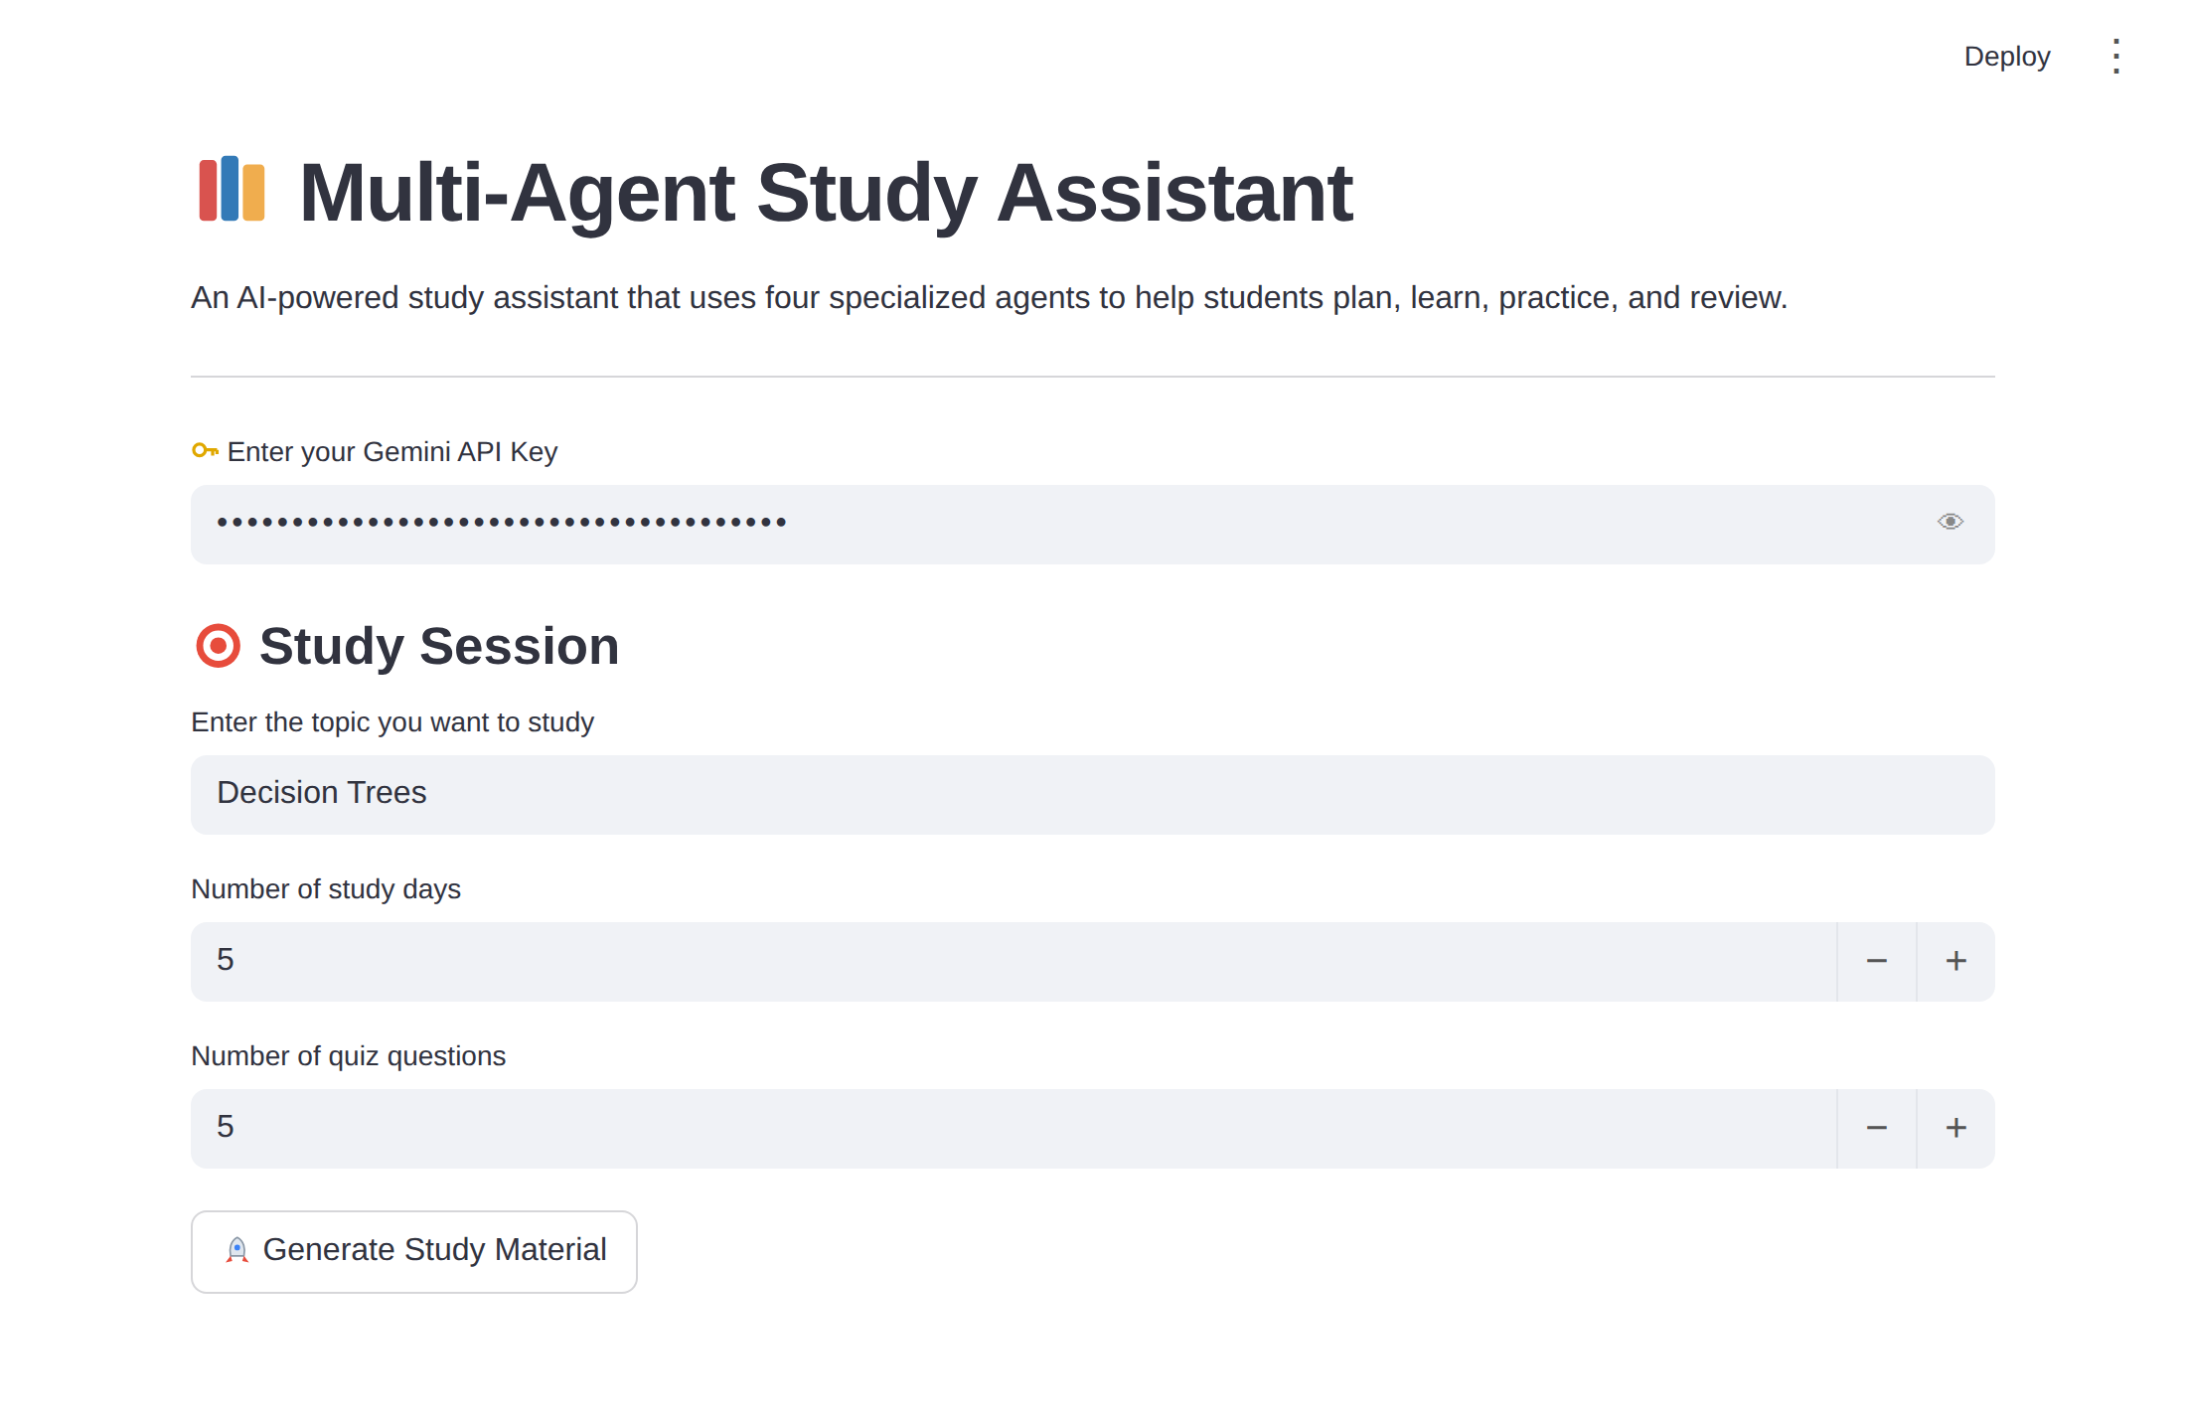
Description: The single-page interface of the Multi-Agent Study Assistant serves as both the landing page and the learning tool. It shows the 📚 title, a short description of the four agents, and a password field for the Gemini API key. Once a key is entered, the Study Session section appears with the topic field, the study days input, and the quiz question count input, followed by the Generate Study Material button.

Study Plan and Explanation Section:
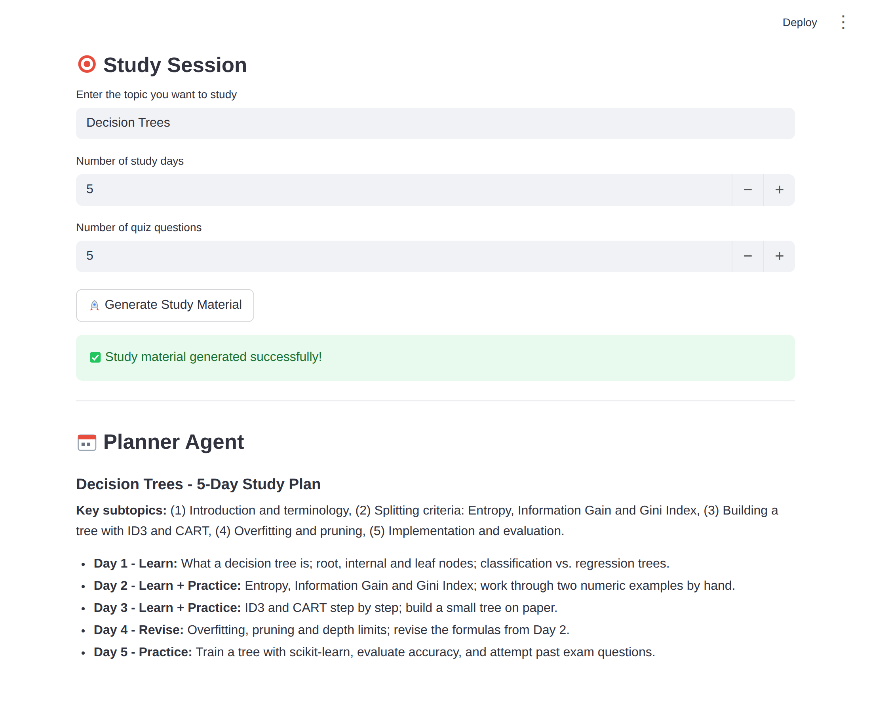
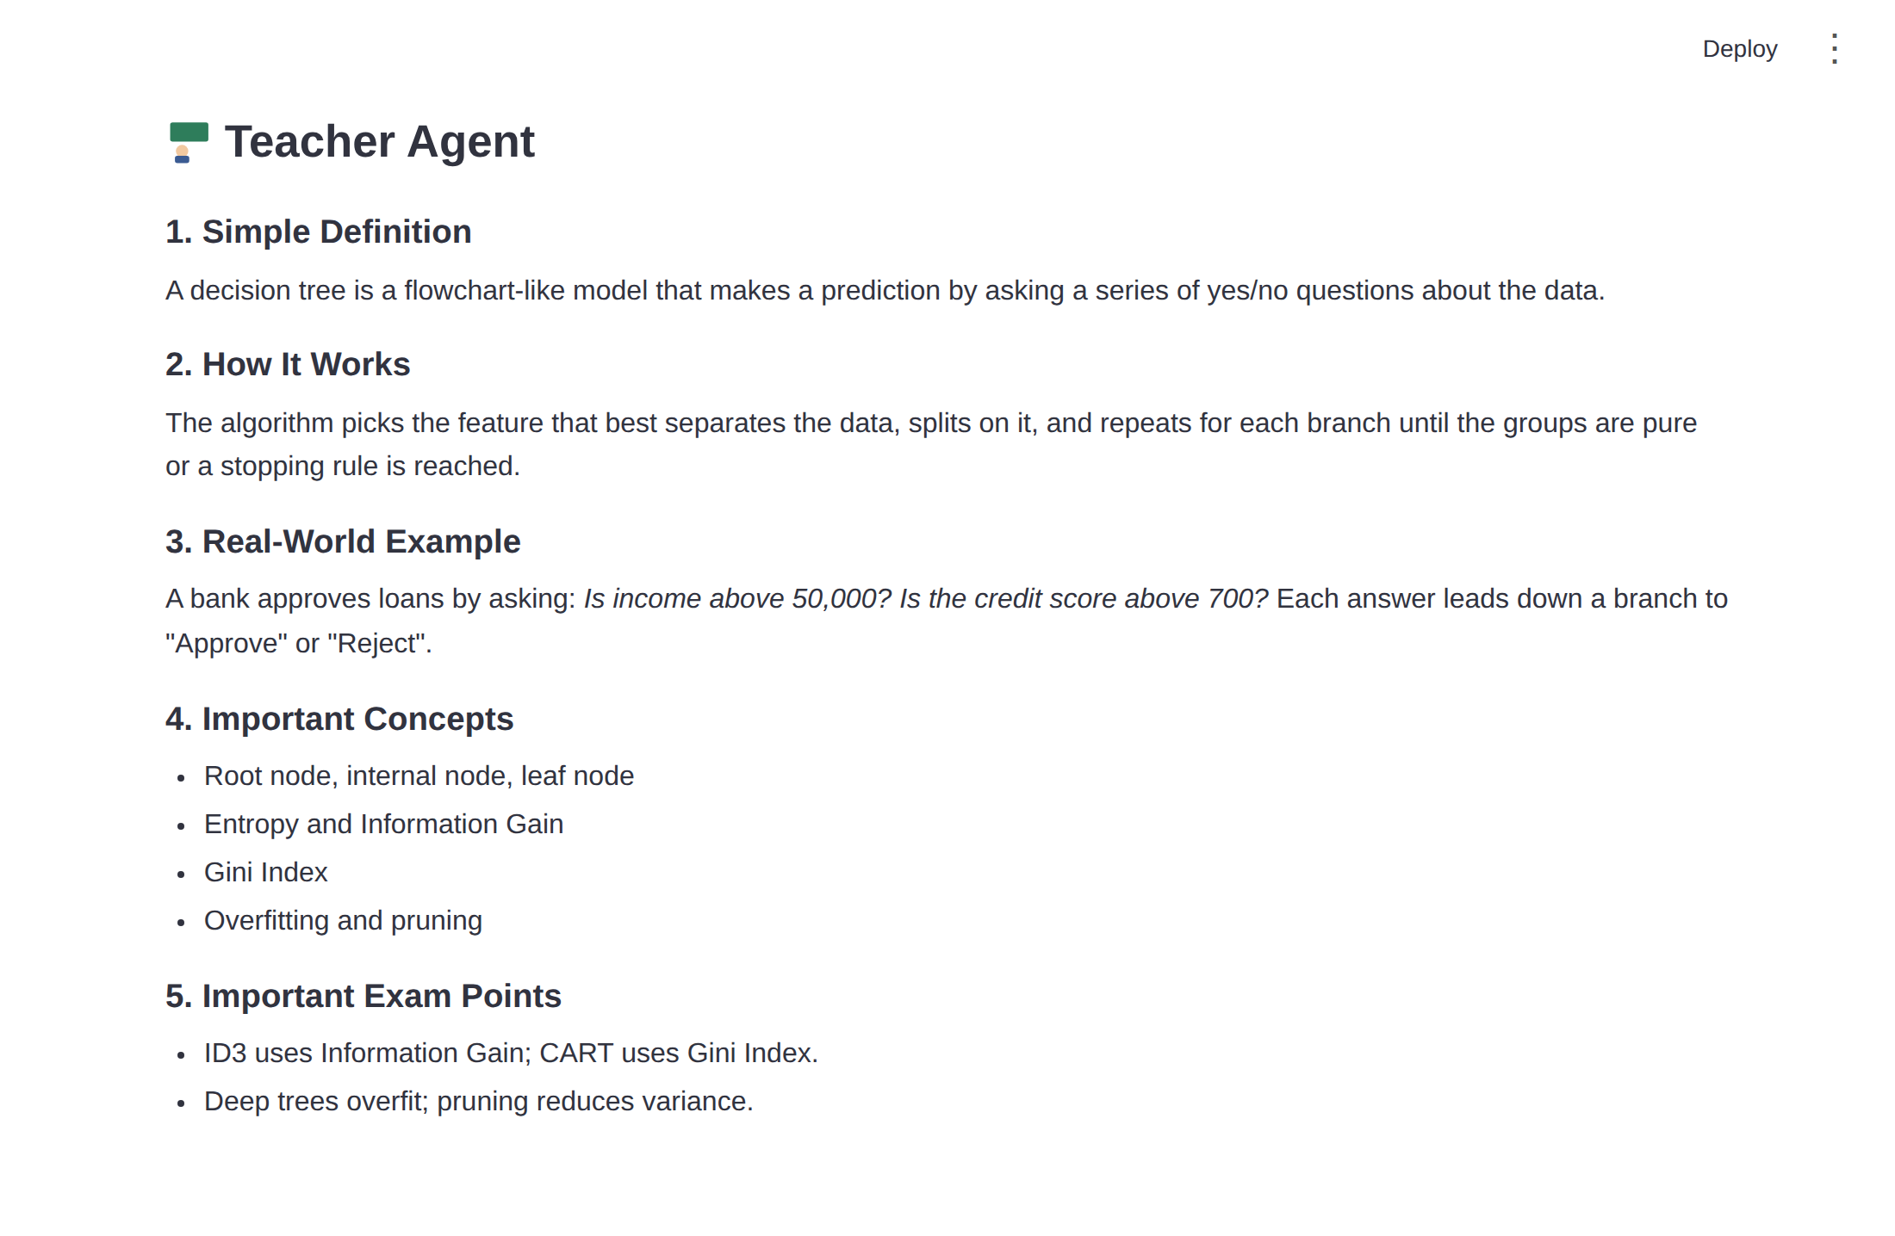
Description: After the student clicks Generate Study Material, spinners show the progress of each agent. The Planner Agent section then displays the day-by-day study plan with learning, revision, and practice, and the Teacher Agent section displays a simple definition, how the topic works, a real-world example, important concepts, and exam points.

Quiz Section:
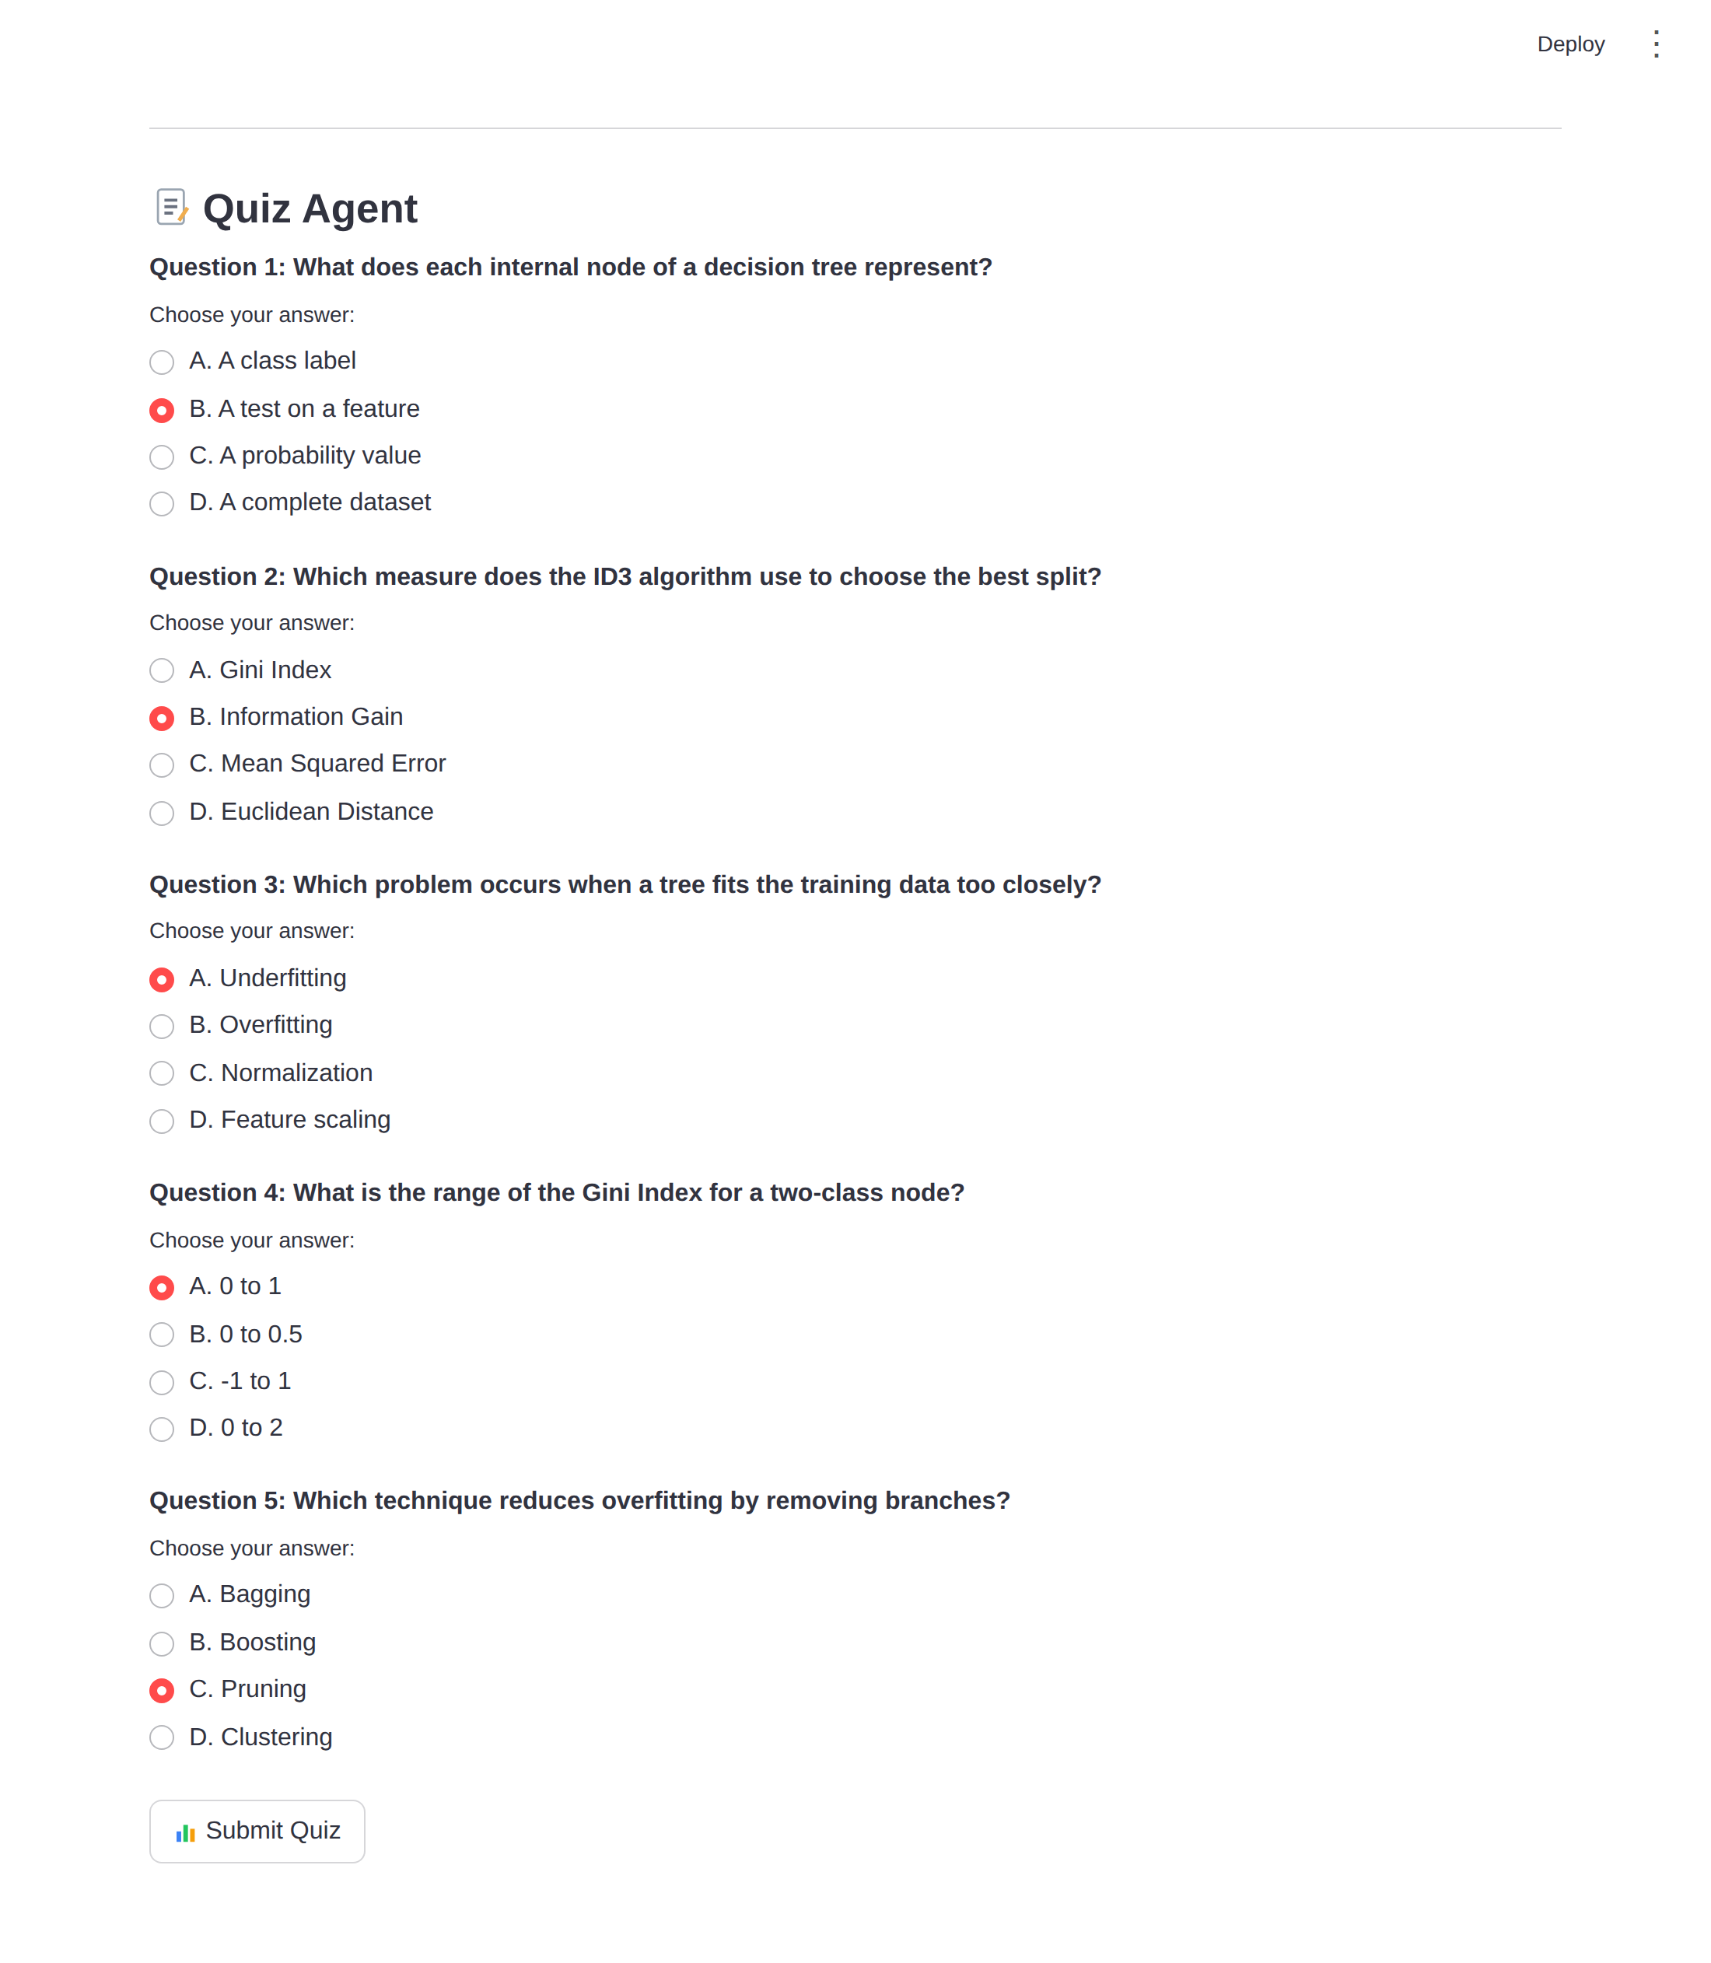
Description: The Quiz Agent section lists the generated multiple-choice questions. Each question has four radio-button options labeled A to D, and the Submit Quiz button at the bottom sends the selected answers for scoring.

Results, Review, and Weak Areas Section:
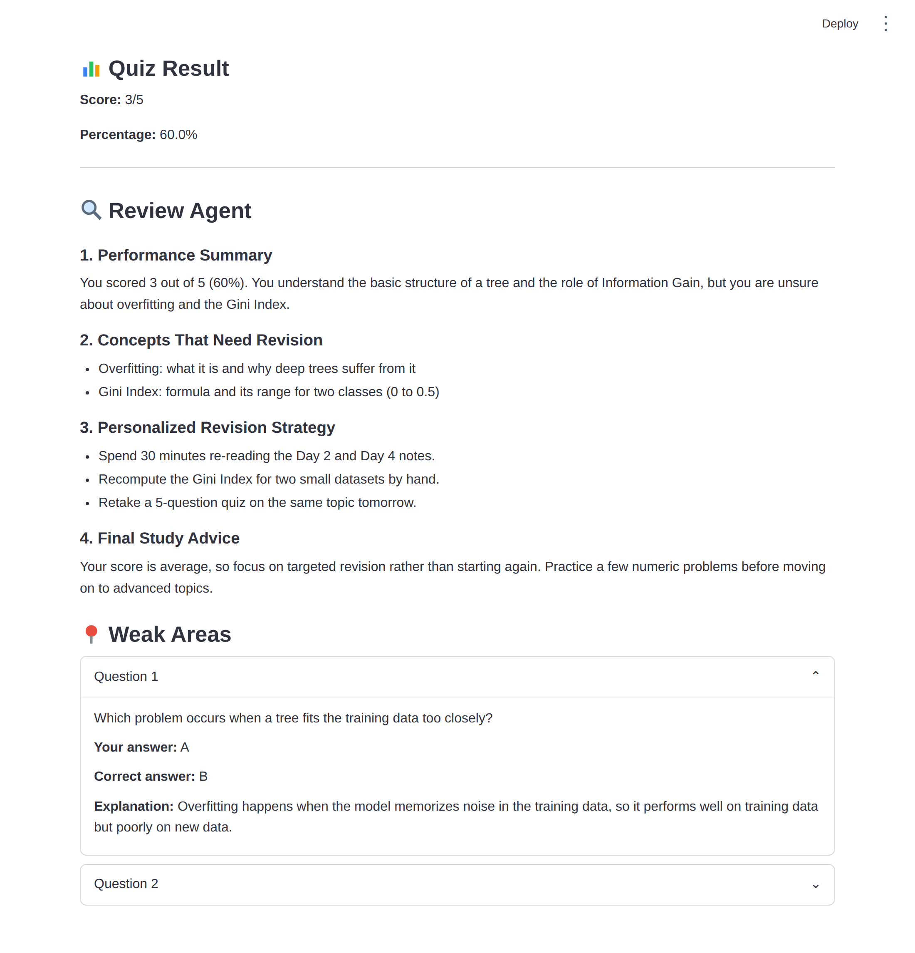
Description: Revealed after the quiz is submitted, this section shows the score and percentage, followed by the Review Agent's personalized analysis with a performance summary, concepts to revise, and a revision strategy. The Weak Areas panel lists each incorrect question in an expander that shows the question, the student's answer, the correct answer, and the explanation. If all answers are correct, a success message is shown instead.

Downloadable Study Report:
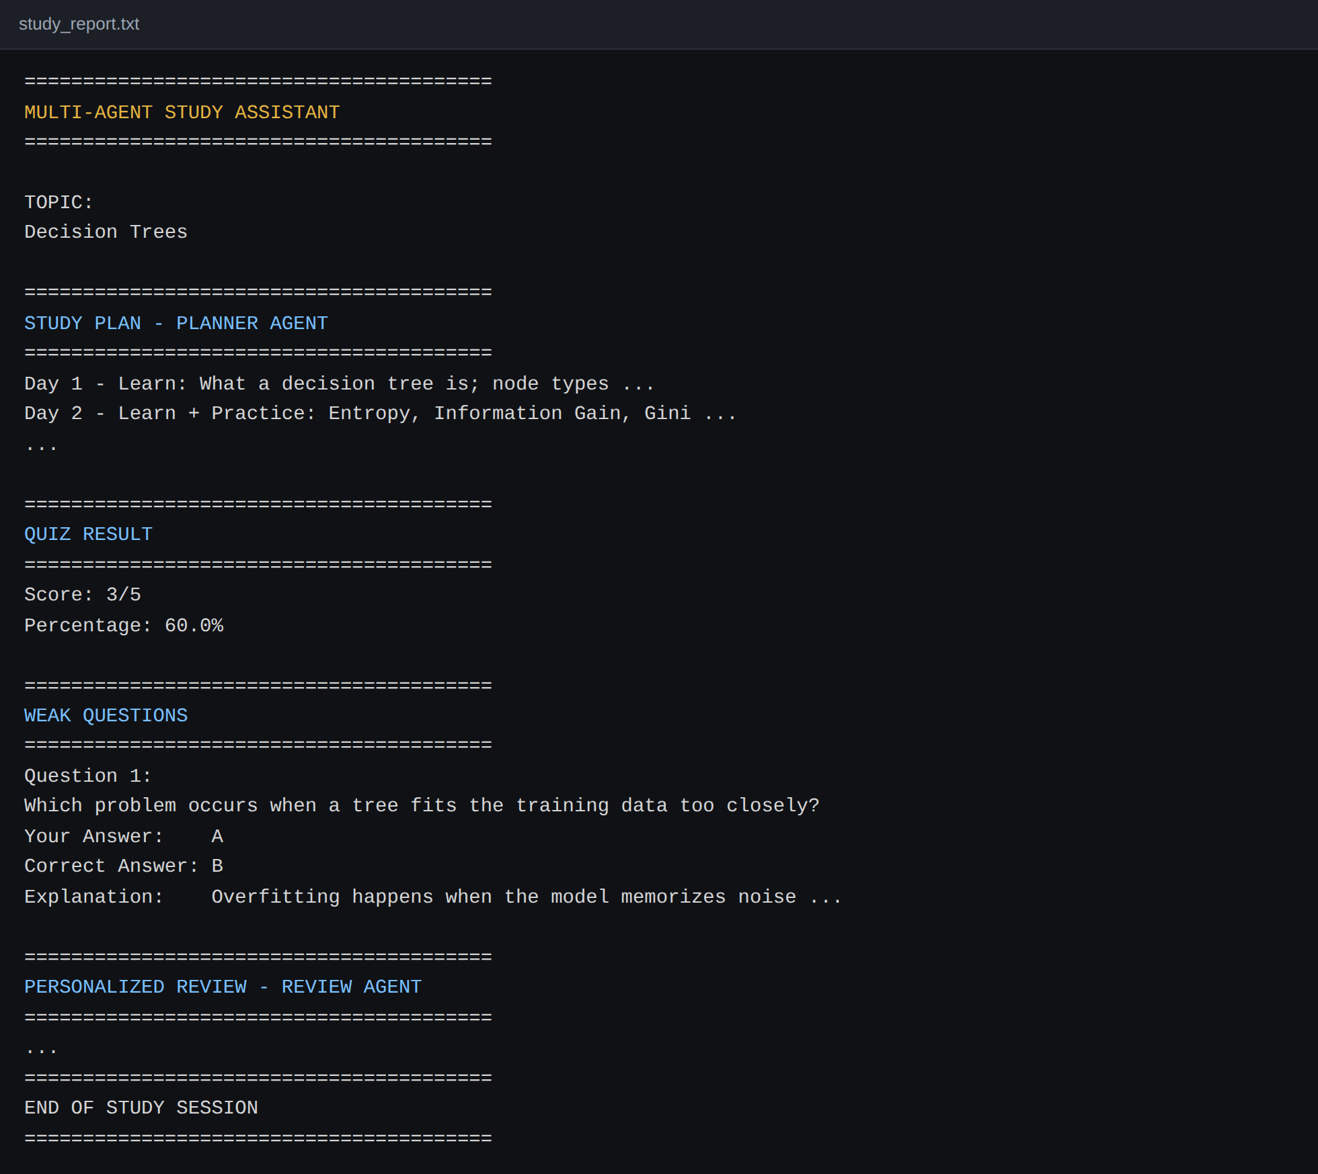
Figure: study_report.txt generated at the end of a session
Description: At the end of a notebook session, the plan, explanation, score, weak questions, and personalized review are combined into a single study_report.txt file. In Colab, the file can be downloaded with files.download(), so the student can keep it for revision.

Conclusion:
The Multi-Agent Study Assistant is a generative AI platform built with Streamlit that streamlines personalized learning by dividing the work among four specialized agents. It uses Google's Gemini API with the gemini-3.6-flash model to instantly generate a study plan, a beginner-friendly explanation, a structured multiple-choice quiz, and a personalized review based on the student's performance. The project, which included model selection, agent development, Streamlit interface design, and public deployment via Ngrok from Google Colab, highlights how focused agents and a structured workflow can make studying more organized and effective for college students, with potential for future scalability.
Key Learning Outcomes:
- Designing a multi-agent system in which each agent has a single, well-defined role.
- Writing effective prompts using role prompting, structured requirements, and strict JSON output.
- Parsing and validating LLM output safely before using it in application logic.
- Building an interactive web app with Streamlit and preserving state with st.session_state.
- Deploying a Colab-hosted app publicly with Ngrok.
Future Enhancements:
- User accounts and a database to save study history and track progress over time.
- Uploading PDFs or notes so the Teacher and Quiz agents can work from the student's own material.
- Additional question types such as true or false, fill in the blanks, and short answers.
- Difficulty levels that adapt to the student's previous score.
- Multi-language support and downloadable PDF reports.
- Retry logic and error handling around every model call.
Looking ahead, the assistant offers significant opportunities for expansion, such as adding user authentication and a database to save study history and track progress over time, supporting document or PDF uploads so the agents can teach from a student's own notes, adding more question types beyond multiple choice, and providing multi-language support. By continuously refining the agent prompts and improving the interface, the platform is well-positioned to evolve from a focused study tool into a comprehensive AI tutoring assistant for students at every level.

