RAG PDF Assistant: AI-Powered Document Question Answering System

Project Description:
The RAG PDF Assistant harnesses Retrieval-Augmented Generation (RAG) to let users ask natural-language questions about any text-based PDF and receive accurate, source-backed answers. Instead of sending an entire document to a language model, the system first breaks the PDF into small overlapping chunks, converts each chunk into a numerical embedding, and stores the embeddings in a FAISS vector index. When a question is asked, only the most relevant chunks are retrieved and passed to the model, which keeps answers grounded in the document and reduces made-up information.
Utilizing the Sentence Transformers model all-MiniLM-L6-v2 for local embeddings and Google's Gemini API for answer generation, the assistant extracts text with PyPDF, indexes it with FAISS, and presents a clean chat interface built with Streamlit. Indexing runs entirely locally with zero Gemini requests, and exactly one Gemini request is used per question. The application runs inside Google Colab and is deployed publicly through Ngrok. With the API key entered securely through a password field and responsible input handling, the RAG PDF Assistant helps students, researchers, and professionals find answers in long documents in seconds.

Scenarios
Scenario 1: A student uploads a 41-page Data Mining question bank and asks, "Which questions about OLAP are asked in Unit I?" The system retrieves the matching chunks from page 1, and Gemini lists the relevant short and long answer questions, together with the exam papers they appeared in and the page they were found on.
Scenario 2: A user asks what the star symbol means in the same document. The retrieval step finds the legend near the top of the file, and the assistant explains that a star marks a question asked in three or more papers, so it should be prepared first. The Retrieved PDF Sources panel lets the user verify the answer against the original text.
Scenario 3: A user asks something that is not in the document, such as "What is the capital of France?" Because the prompt tells the model to answer only from the supplied context, the assistant replies that the answer is not available in the uploaded PDF instead of guessing.

Technical Architecture:
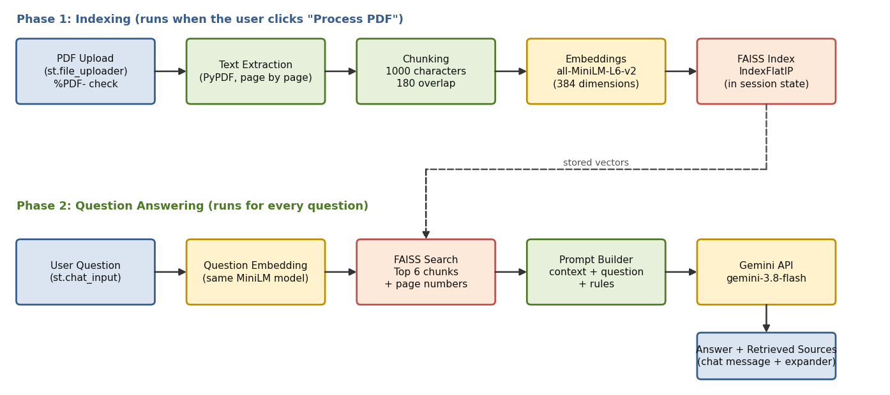
Figure: Two-phase RAG architecture (indexing and question answering)
Description: The RAG PDF Assistant utilizes a two-phase architecture. In the indexing phase, the Streamlit frontend accepts a PDF, validates it, extracts the text page by page with PyPDF, splits it into overlapping chunks, converts each chunk to a 384-dimensional vector with the all-MiniLM-L6-v2 model, and stores the vectors in a FAISS IndexFlatIP index kept in Streamlit session state. In the question-answering phase, the question is embedded with the same model, FAISS returns the six most similar chunks along with their page numbers, and a prompt that combines those chunks with the question is sent to the Gemini model. The answer is displayed as a chat message, and the retrieved chunks are shown in an expandable sources panel. The application runs inside Google Colab and is exposed publicly through Ngrok.

RAG Pipeline Stages
Stage | Tool | What Happens
1. Extract | PyPDF | Reads each page and keeps the text together with its page number
2. Chunk | Python (re, slicing) | Cleans whitespace and splits each page into 1000-character chunks with 180 characters of overlap
3. Embed | Sentence Transformers | Turns every chunk into a normalized 384-dimensional vector (runs locally)
4. Index | FAISS IndexFlatIP | Stores the vectors; inner product on normalized vectors equals cosine similarity
5. Retrieve | FAISS search | Finds the top 6 chunks closest to the question vector
6. Generate | Gemini API | Answers using only the retrieved context and mentions page numbers

Technology Stack
Layer | Technology | Purpose
Frontend | Streamlit | File uploader, sidebar, chat messages, spinners, and expanders
PDF processing | PyPDF | Extracts text from each page of a text-based PDF
Embeddings | sentence-transformers/all-MiniLM-L6-v2 | Creates local vector representations of chunks and questions
Vector search | FAISS (faiss-cpu) | Fast similarity search over the chunk vectors
Language model | Google Gemini (gemini-3.8-flash) via google-genai | Generates the final answer from the retrieved context
Runtime and access | Google Colab, Ngrok / pyngrok | Hosts the app and exposes it through a public HTTPS URL

Key Parameters
Parameter | Notebook Prototype | Streamlit App
Chunk size | 800 characters | 1000 characters
Chunk overlap | 150 characters | 180 characters
Chunks retrieved (top k) | 3 | 6
Page tracking | Added in the page-aware version | Built in (every chunk stores its page)
Gemini model | gemini-2.5-flash, later gemini-3.8-flash | gemini-3.8-flash
Retry on server error | Not included | One retry after 2 seconds on 503 / UNAVAILABLE

(Note: No database is used in this project, so no ER diagram is required. The extracted chunks, the FAISS index, and the document name are stored temporarily in st.session_state, and the vector index lives in memory for the duration of the session.)

Pre-requisites:
- Streamlit Framework Knowledge: Streamlit Documentation
- Gemini API Familiarity: Gemini API Documentation
- RAG and Embeddings Concepts: Sentence Transformers Documentation
- Vector Search with FAISS: FAISS Documentation
- PDF Text Extraction: PyPDF Documentation
- Python Programming Proficiency: Python Documentation
- Google Colab Environment: Google Colab
- Version Control with Git: Git Documentation
- Ngrok for Public Deployment: Ngrok Documentation

Project Workflow:

Milestone 1: Model Selection and Architecture
- Activity 1.1: Generate a Gemini API key and handle it securely.
- Activity 1.2: Select the embedding model, the vector index, and the Gemini model for answer generation.
- Activity 1.3: Define the two-phase RAG architecture and its parameters.
- Activity 1.4: Set up the Google Colab environment and install the required libraries.

Milestone 2: Core RAG Pipeline Development
- Activity 2.1: Upload a PDF and extract its text with page numbers.
- Activity 2.2: Split the text into overlapping chunks.
- Activity 2.3: Create embeddings and build the FAISS index.
- Activity 2.4: Retrieve relevant chunks and generate answers with Gemini.
- Activity 2.5: Add page references, build a test chatbot, and validate the pipeline.

Milestone 3: App.py Development
- Activity 3.1: Write the Streamlit application with the extraction, chunking, indexing, retrieval, and generation functions.
- Activity 3.2: Manage session state and handle errors.

Milestone 4: Frontend Development
- Activity 4.1: Design the sidebar, uploader, and processing interface.
- Activity 4.2: Build the chat interface with a retrievable-sources panel.

Milestone 5: Deployment
- Activity 5.1: Prepare app.py and install the dependencies in Colab.
- Activity 5.2: Launch Streamlit and expose it publicly with Ngrok.
- Activity 5.3: Update the model and restart the app.

Milestone 6: Conclusion

Milestone 1: Model Selection and Architecture
In this milestone, we select the models and tools that make up the RAG pipeline. A RAG system uses two kinds of models: an embedding model that turns text into vectors for searching, and a generative model that writes the final answer. We also decide how the pieces fit together before writing any code.

Activity 1.1: Generate a Gemini API Key
Before the application can generate answers, you need a valid Gemini API key. Follow the steps below to create one and use it securely with the project.
• Step 1 — Open Google AI Studio: Visit https://aistudio.google.com and sign in with your Google account.
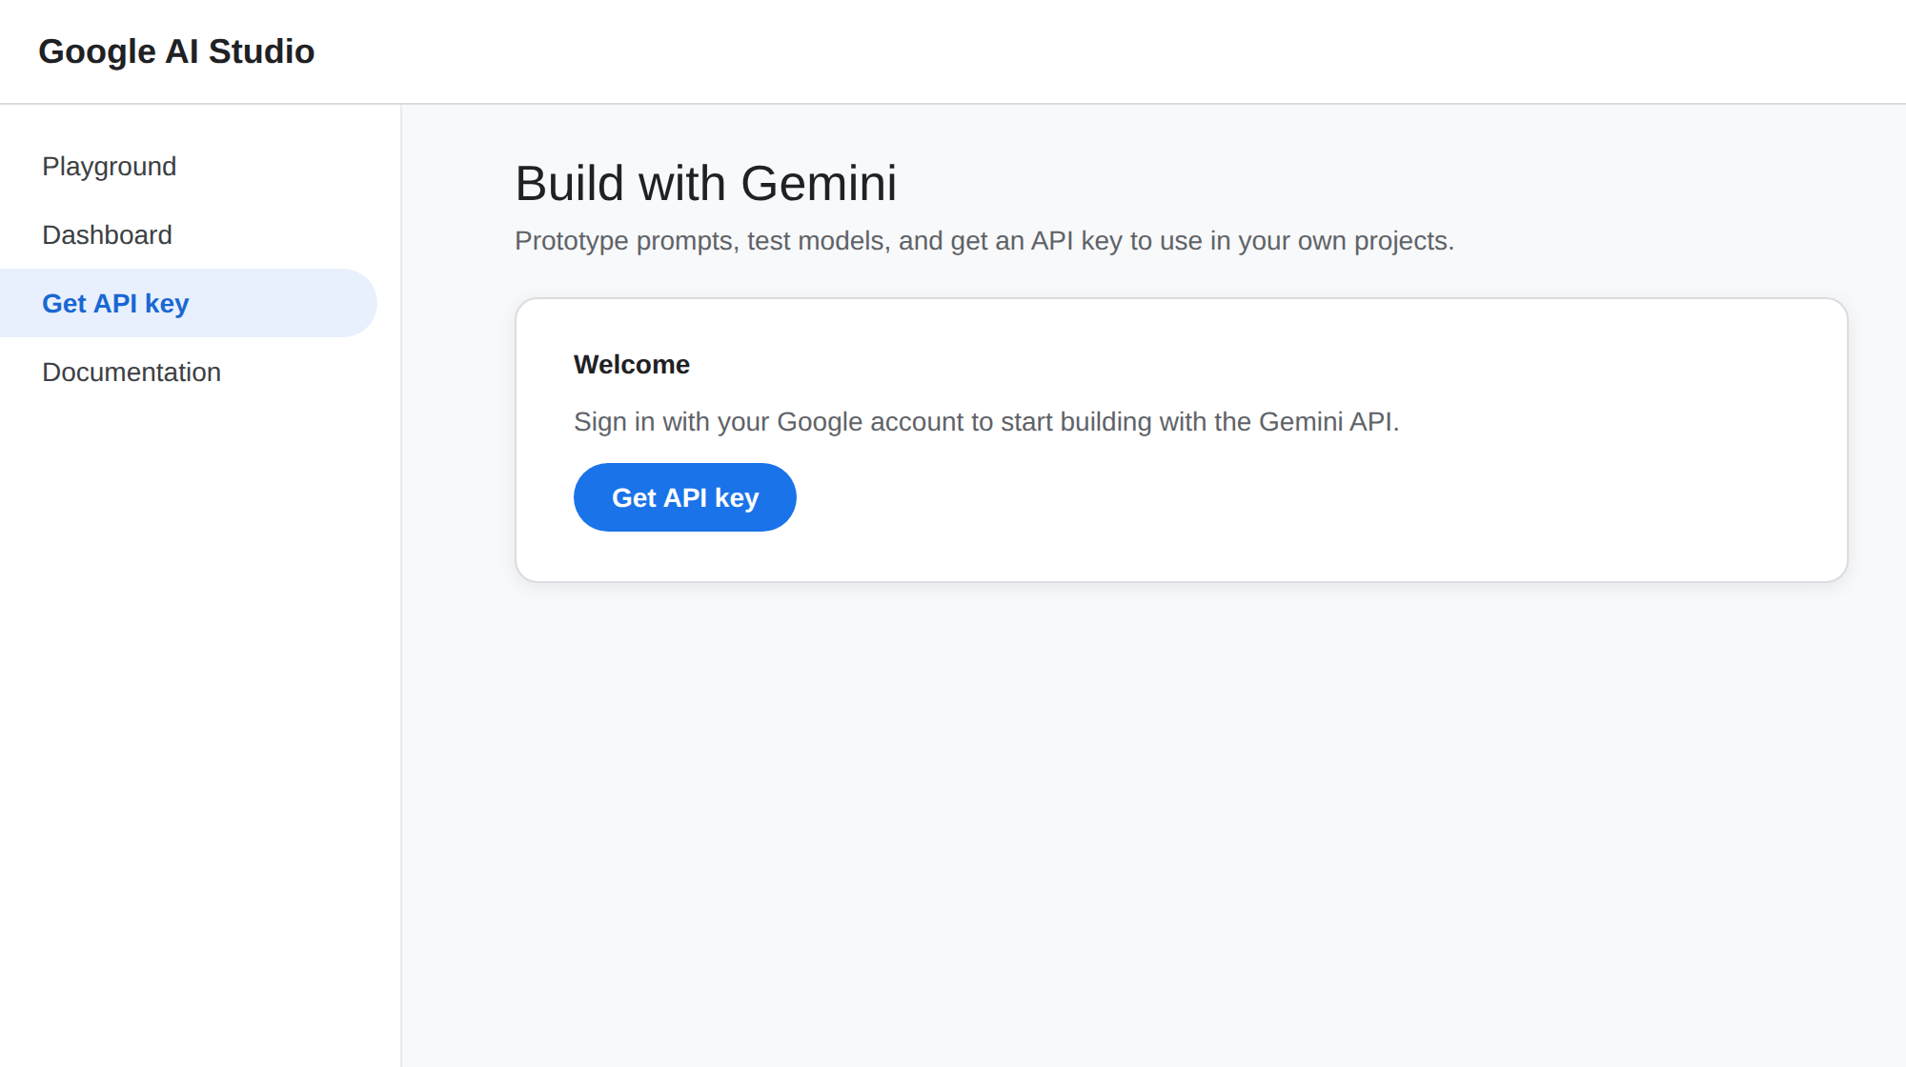
• Step 2 — Navigate to API Keys: From the left menu select "Get API key", or go directly to the API Keys page.
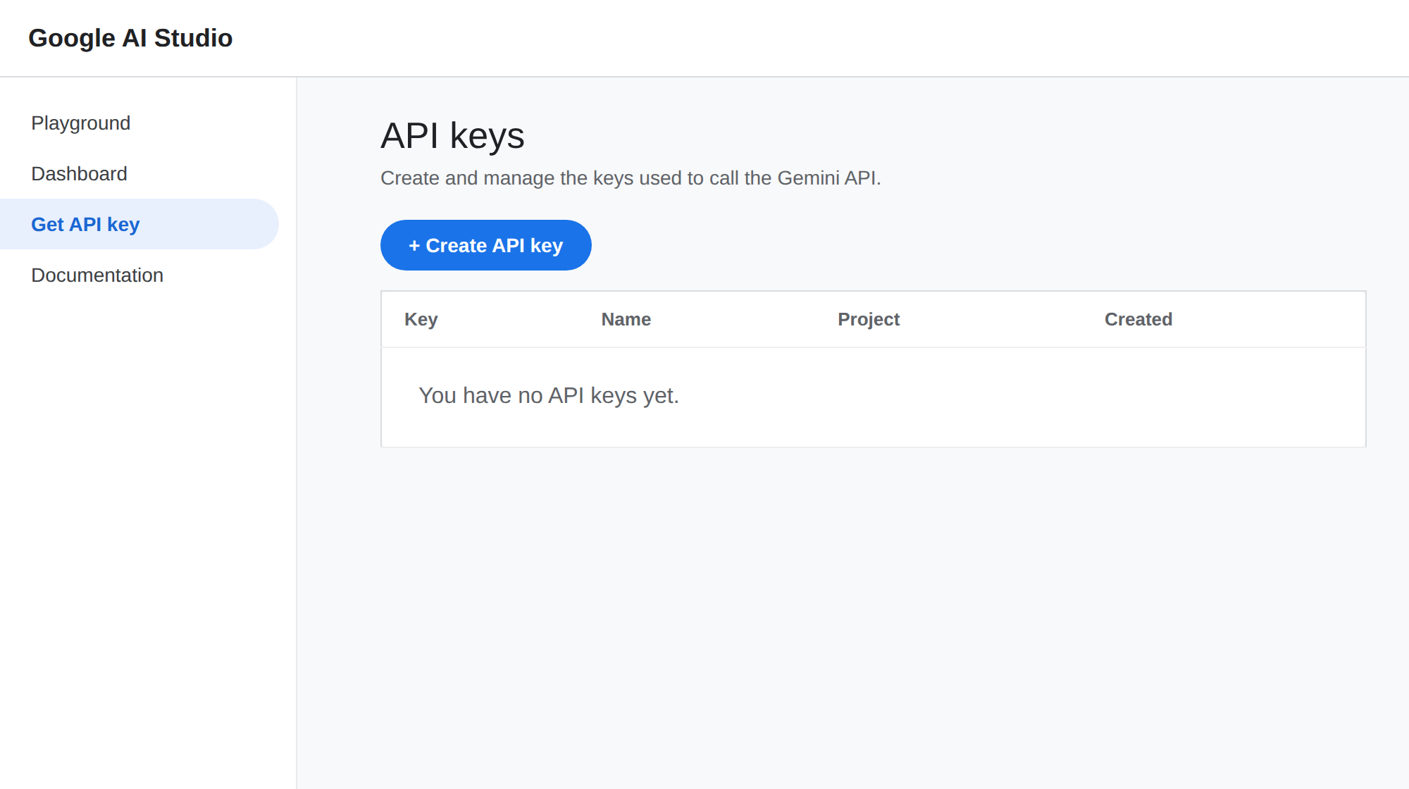
• Step 3 — Create a New API Key: Click "Create API key", choose a Google Cloud project (or create a new one), and give the key a descriptive name (e.g., rag-pdf-assistant-key).
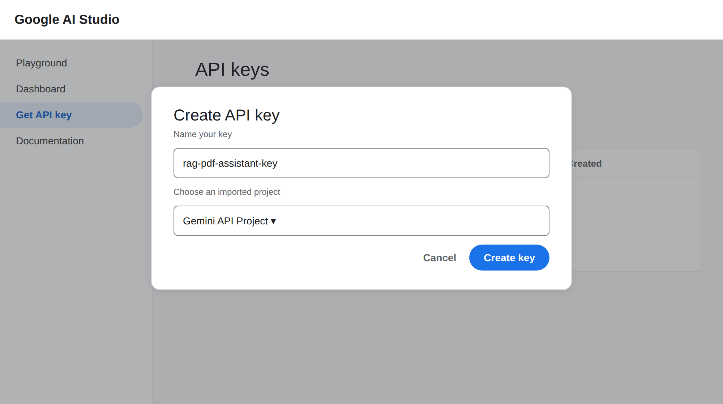
• Step 4 — Copy the API Key: Copy the generated key immediately and store it in a safe place.
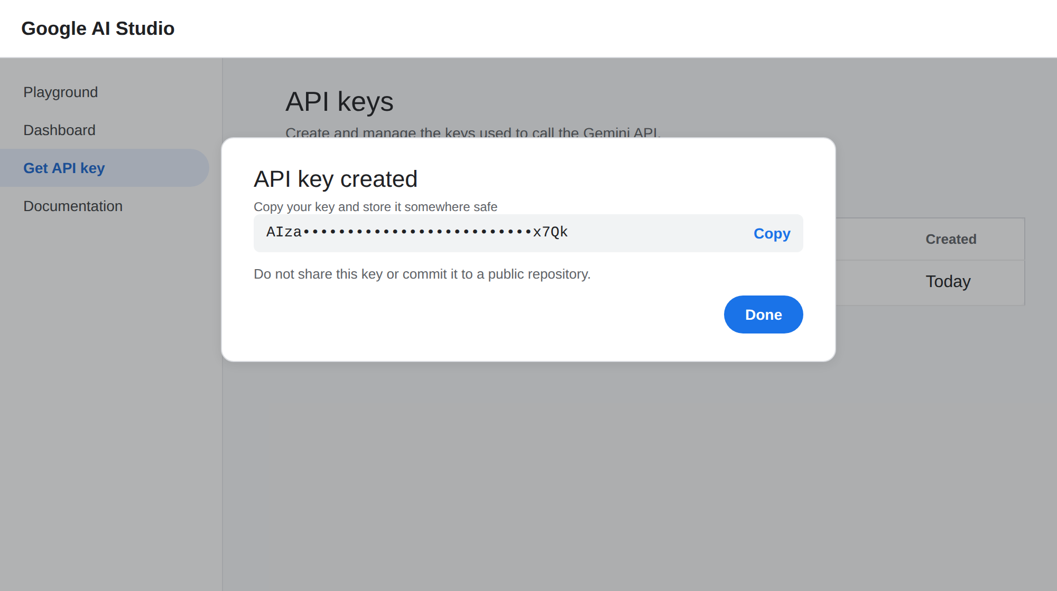
Figure: Copy the generated key and store it safely
• Step 5 — Use the Key in the Project: The notebook asks for the key at run time using getpass(), which hides what you type, and the Streamlit app asks for it in a password field in the sidebar. The key is never written into the source code:
from google import genai
from getpass import getpass

api_key = getpass("Enter your Gemini API key: ")
client = genai.Client(api_key=api_key)
print("Gemini initialized. No API request sent yet.")

• Important — Never Share or Commit Your API Key: Do not hard-code the key in notebooks or app.py, and never push it to a public repository. If a key is exposed, delete it from Google AI Studio and create a new one.

Activity 1.2: Select the Models and Tools
Here are the choices made for each part of the pipeline, and the reasons behind them:
- Embedding Model: sentence-transformers/all-MiniLM-L6-v2 is a small, fast model that produces 384-dimensional vectors and runs locally in Colab. Because it runs locally, indexing a PDF uses no Gemini requests at all.
- Vector Index: FAISS IndexFlatIP performs an exact inner-product search. Since the embeddings are normalized, the inner product is the same as cosine similarity, so higher scores mean more similar text.
- PDF Reader: PyPDF extracts text page by page, which lets every chunk remember the page it came from.
- Generative Model: Google Gemini generates the final answer from the retrieved context. The notebook prototype used gemini-2.5-flash, and the application was later updated to gemini-3.8-flash for faster, higher-quality answers.
- Interface: Streamlit provides ready-made components for file upload, chat messages, and expanders, so the whole interface can be written in Python.

Activity 1.3: Define the Architecture of the Application
- Separate Indexing from Answering: Indexing happens once per PDF when the user clicks Process PDF. Answering happens for every question and reuses the stored index.
- Keep Heavy Work Local: Text extraction, chunking, embedding, and vector search all run locally. Only the final answer generation calls the Gemini API.
- Ground the Answer: The prompt tells Gemini to use only the supplied context and to say clearly when the answer is not in the PDF.
- Show the Evidence: Every answer is accompanied by the retrieved chunks, their page numbers, and similarity scores so users can verify the response.
Key Design Decisions:
- Overlapping chunks: A 180-character overlap keeps sentences that fall on a chunk boundary from losing their meaning.
- Page numbers on every chunk: This makes it possible to cite sources and to show where each piece of evidence came from.
- Cached embedding model: The model is loaded once with st.cache_resource, so it is not reloaded every time Streamlit reruns the script.
- Index in session state: The FAISS index and chunks are stored in st.session_state, so questions can be asked repeatedly without re-processing the PDF.

Activity 1.4: Set Up the Development Environment
- Open Google Colab: Create a new notebook at colab.research.google.com. Colab provides Python and a free runtime, so no local installation is needed.
- Install the Required Libraries: One command installs the PDF reader, the embedding library, the vector index, and the Gemini SDK:
!pip -q install pypdf sentence-transformers faiss-cpu google-genai

- Upload the PDF: Use the Colab file upload widget to bring a PDF into the runtime:
from google.colab import files
uploaded = files.upload()
pdf_path = next(iter(uploaded))
print("Uploaded PDF:", pdf_path)

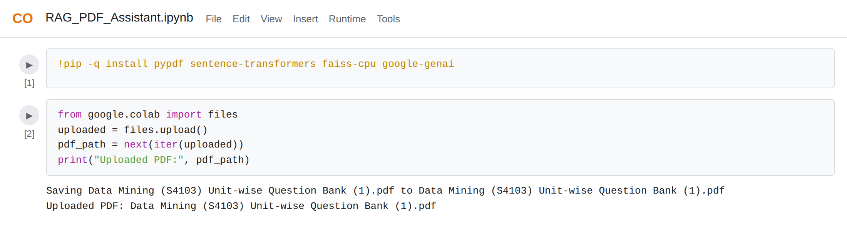
Figure: Installing libraries and uploading the PDF in Colab

Milestone 2: Core RAG Pipeline Development
Before building the web application, the full RAG pipeline is built and tested step by step in the notebook. This makes it easy to see what each stage produces and to catch problems early.

Activity 2.1: Extract Text from the PDF
- Read the PDF: PdfReader opens the uploaded file and exposes each page.
- Extract Each Page: extract_text() returns the text of a page. The "or empty string" fallback prevents errors on pages without text.
from pypdf import PdfReader
reader = PdfReader(pdf_path)
text = ""
for page in reader.pages:
text += (page.extract_text() or "") + "\n"
print(text[:2000])

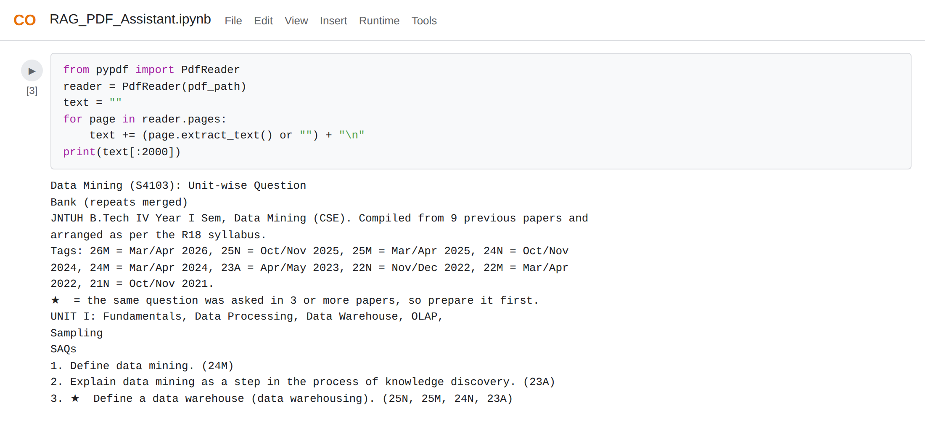
Figure: First part of the text extracted from the PDF
- Limitation: Scanned PDFs contain images instead of text, so PyPDF returns nothing. These documents need OCR, and the application warns the user when no readable text is found.

Activity 2.2: Split the Text into Chunks
A whole PDF is too long to search or send to a model at once, and one long vector would blur many topics together. The text is therefore cut into small overlapping pieces.
def split_text(text, chunk_size=800, overlap=150):
chunks = []
start = 0
while start < len(text):
chunk = text[start:start + chunk_size]
if chunk.strip():
chunks.append(chunk)
start += chunk_size - overlap
return chunks

chunks = split_text(text)
print("Total chunks:", len(chunks))

- Chunk Size: Each chunk holds up to 800 characters in the prototype, which is small enough to stay on one topic.
- Overlap: Each new chunk starts 150 characters before the previous one ends, so text on a boundary appears in two chunks.
- Result: For the sample 41-page question bank, the prototype created 127 chunks.
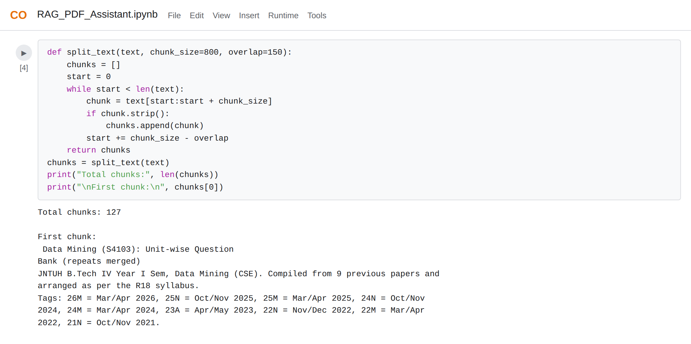
Figure: Chunk count and the first chunk

Activity 2.3: Create Embeddings and Build the FAISS Index
- Load the Embedding Model: SentenceTransformer downloads all-MiniLM-L6-v2 the first time it runs.
- Encode the Chunks: encode() converts every chunk into a vector. Setting normalize_embeddings=True makes each vector length 1.
- Create the Index: IndexFlatIP(dimension) creates an index that compares vectors with the inner product, and add() stores the vectors.
embedding_model = SentenceTransformer("sentence-transformers/all-MiniLM-L6-v2")
embeddings = embedding_model.encode(
chunks, convert_to_numpy=True, normalize_embeddings=True
)
embeddings = embeddings.astype("float32")
index = faiss.IndexFlatIP(embeddings.shape[1])
index.add(embeddings)
print("Number of stored chunks:", index.ntotal)

- float32 Conversion: FAISS expects 32-bit floating-point arrays, so the embeddings are converted before they are added.
- Initialize Gemini: The Gemini client is created next. No request is sent at this point.
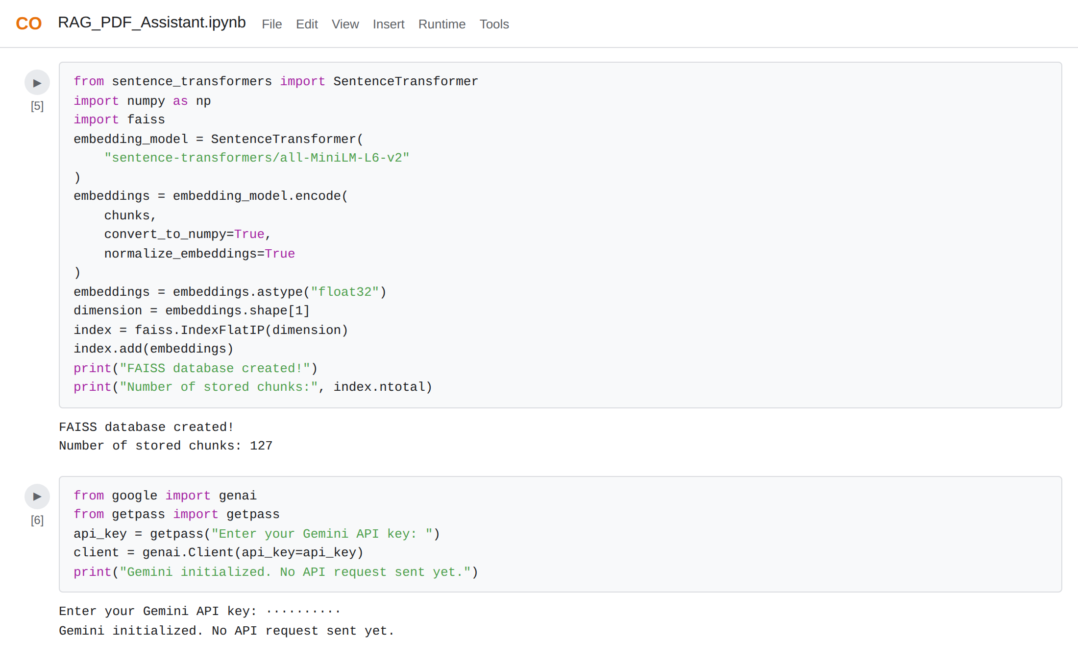
Figure: FAISS index created and the Gemini client initialized

Activity 2.4: Retrieve Relevant Chunks and Generate Answers
The ask_pdf() function ties the pipeline together. It embeds the question, searches the index, builds a prompt from the best chunks, and makes exactly one Gemini request.
def ask_pdf(question):
question_embedding = embedding_model.encode(
[question], normalize_embeddings=True
).astype("float32")

k = min(3, index.ntotal)
scores, indices = index.search(question_embedding, k)
context = "\n\n".join(chunks[i] for i in indices[0] if i >= 0)

prompt = f"""
You are a PDF question-answering assistant.
Answer using only the provided PDF context.
If the context does not contain the answer, say:
"The answer was not found in the provided PDF."
Keep the answer clear and concise.

PDF CONTEXT:
{context}

QUESTION:
{question}
"""
response = client.models.generate_content(
model="gemini-2.5-flash", contents=prompt
)
print("\nAnswer:", response.text)

Understanding the Prompt:
- Role: "You are a PDF question-answering assistant" gives the model a clear job.
- Grounding rule: "Answer using only the provided PDF context" stops the model from using outside knowledge.
- Fallback sentence: The exact "not found" sentence gives the model a safe way to respond when the context has no answer.
- Context and question: The retrieved chunks and the user's question are placed in clearly labeled sections.

Activity 2.5: Add Page References and Validate the Pipeline
- Interactive Loop: A while loop reads questions with input(), stops on "exit", skips empty input, and wraps each call in try/except so one failed request does not end the session.
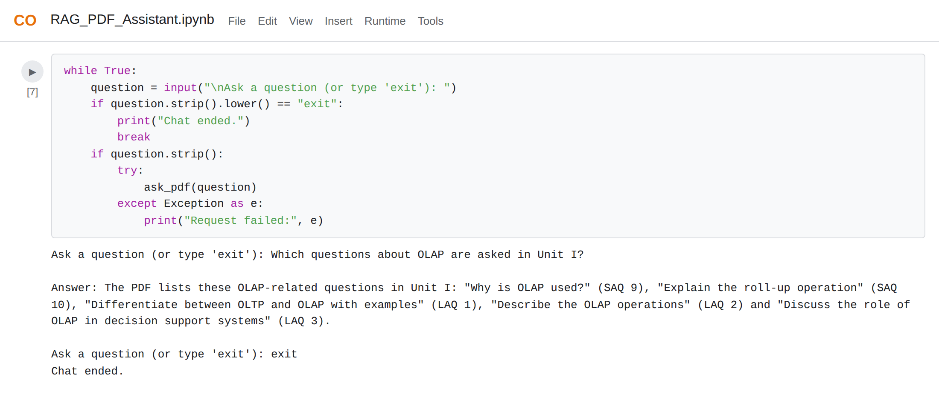
Figure: Asking a question in the notebook chatbot
- Page-Aware Version: The final notebook version stores each page's text with its page number, builds chunks as dictionaries with "text" and "page", labels the context as [PDF Page N], and prints the retrieved page numbers after every answer.
- Empty PDF Check: If no page has extractable text, the code raises a clear error that mentions OCR.
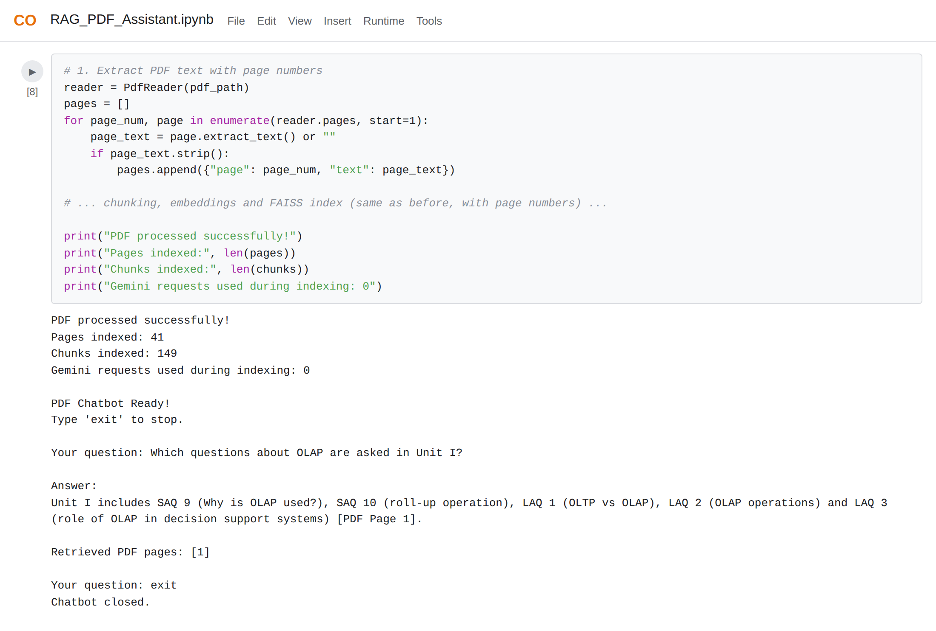
Figure: Page-aware pipeline: 41 pages indexed into 149 chunks with 0 Gemini requests
Test Cases:
Test | Input | Expected Result
Text extraction | Upload the 41-page PDF | 41 pages with extractable text
Chunking | Page text of more than 1000 characters | Several overlapping chunks, each tagged with its page number
Indexing | Process the PDF | Chunk count equals the number of vectors in the index; 0 Gemini requests
Relevant question | "Which questions about OLAP are asked in Unit I?" | Answer lists the OLAP questions and cites page 1
Meaning of a symbol | "What does the star symbol mean?" | Explains it marks questions asked in 3 or more papers
Unrelated question | "What is the capital of France?" | Reply that the answer is not available in the PDF
Empty question | Blank input | Message asking the user to enter a question
Scanned PDF | A PDF made of images | Clear message that OCR is required

Milestone 3: App.py Development
Milestone 3 converts the tested notebook pipeline into app.py, the Streamlit application that serves as the backbone of the RAG PDF Assistant. Each pipeline stage becomes a small function, and Streamlit session state keeps the results between interactions.

Activity 3.1: Writing the Main Application Logic in app.py
Configure the Page and Collect the API Key:
- Set the page title, icon, and wide layout, then place the API key field in the sidebar as a password input.
st.set_page_config(
page_title="RAG PDF Assistant",
page_icon="📚",
layout="wide"
)

st.title("📚 RAG-Based PDF Question Answering System")
st.write("Upload a PDF and ask questions based on its content.")

st.sidebar.header("Gemini API Settings")
api_key = st.sidebar.text_input("Enter Gemini API Key", type="password")
MODEL_NAME = "gemini-3.8-flash"

Load the Embedding Model Once:
- Streamlit reruns the whole script on every interaction. The @st.cache_resource decorator makes sure the model is created only once and then reused.
@st.cache_resource
def load_embedding_model():
return SentenceTransformer("sentence-transformers/all-MiniLM-L6-v2")

with st.spinner("Loading embedding model..."):
embedding_model = load_embedding_model()

Extract Text with Page Numbers:
def extract_pdf_text(pdf_bytes):
reader = PdfReader(io.BytesIO(pdf_bytes))
pages = []
for page_number, page in enumerate(reader.pages, start=1):
page_text = page.extract_text() or ""
if page_text.strip():
pages.append({"page": page_number, "text": page_text})
return pages

Create Chunks:
- The text of each page is cleaned with a regular expression that collapses repeated whitespace, then split into 1000-character chunks with 180 characters of overlap. The loop stops when the end of the page is reached.
def create_chunks(pages, chunk_size=1000, overlap=180):
chunks = []
for page in pages:
text = re.sub(r"\s+", " ", page["text"]).strip()
start = 0
while start < len(text):
end = min(start + chunk_size, len(text))
chunk_text = text[start:end]
if chunk_text.strip():
chunks.append({"text": chunk_text, "page": page["page"]})
if end == len(text):
break
start = end - overlap
return chunks

Build the FAISS Index:
def create_faiss_index(chunks):
texts = [chunk["text"] for chunk in chunks]
embeddings = embedding_model.encode(
texts, convert_to_numpy=True, normalize_embeddings=True
)
embeddings = np.asarray(embeddings, dtype="float32")
index = faiss.IndexFlatIP(embeddings.shape[1])
index.add(embeddings)
return index

Retrieve Relevant Chunks:
- The question is embedded with the same model, and the index returns the top 6 chunks along with their similarity scores. Each result keeps its text, page number, and score.
def retrieve_chunks(question, chunks, index, top_k=6):
question_embedding = embedding_model.encode(
[question], convert_to_numpy=True, normalize_embeddings=True
)
question_embedding = np.asarray(question_embedding, dtype="float32")
k = min(top_k, len(chunks))
scores, indices = index.search(question_embedding, k)
results = []
for score, idx in zip(scores[0], indices[0]):
if idx >= 0:
results.append({
"text": chunks[idx]["text"],
"page": chunks[idx]["page"],
"score": float(score)
})
return results

Generate the Answer with a Retry:
- The context is built from the retrieved chunks, each labeled with its page. If Gemini reports a temporary 503 or UNAVAILABLE error, the app waits two seconds and tries once more before showing a friendly message.
def generate_answer(client, question, retrieved_chunks):
context = "\n\n".join([
f"[Page {chunk['page']}]\n{chunk['text']}"
for chunk in retrieved_chunks
])
prompt = f"""
You are a helpful PDF question-answering assistant.
Answer the user's question using ONLY the information
provided in the PDF context below.
1. Give a clear and accurate answer.
2. Use simple language.
3. Include relevant details from the PDF.
4. Mention page numbers when possible.
5. Do not invent information.
6. If the answer is not available in the PDF, clearly say:
"The answer is not available in the uploaded PDF."
PDF CONTEXT: {context}
USER QUESTION: {question}
"""
try:
response = client.models.generate_content(model=MODEL_NAME, contents=prompt)
return response.text or "No answer was generated."
except Exception as first_error:
error_message = str(first_error)
if "503" in error_message or "UNAVAILABLE" in error_message:
time.sleep(2)
try:
response = client.models.generate_content(model=MODEL_NAME, contents=prompt)
return response.text or "No answer was generated."
except Exception:
return "Gemini is temporarily experiencing high demand. Please try again in a little while."
return f"Gemini API Error: {error_message}"

Upload, Validate, and Process the PDF:
- The uploaded file is checked to confirm that it really starts with the PDF signature %PDF-. When the user clicks Process PDF, the app extracts text, creates chunks, builds the index, and saves everything in session state.
uploaded_file = st.file_uploader("Upload your PDF document", type=["pdf"])

if uploaded_file is not None:
pdf_bytes = uploaded_file.getvalue()
if not pdf_bytes.startswith(b"%PDF-"):
st.error("This file is not a valid PDF. Please upload an actual PDF.")
else:
if st.button("Process PDF"):
try:
with st.spinner("Extracting PDF text..."):
pages = extract_pdf_text(pdf_bytes)
if not pages:
st.error("No readable text found. This may be a scanned PDF. OCR is required.")
st.stop()
with st.spinner("Creating text chunks..."):
chunks = create_chunks(pages)
with st.spinner("Creating embeddings and FAISS index..."):
index = create_faiss_index(chunks)
st.session_state["chunks"] = chunks
st.session_state["index"] = index
st.session_state["pdf_name"] = uploaded_file.name
st.success("PDF processed successfully!")
except Exception as e:
st.error(f"PDF processing error: {str(e)}")

Answer Questions:
- The chat section appears only after a PDF has been processed. It checks for the API key, retrieves chunks, generates the answer, and shows the sources.
if "chunks" in st.session_state and "index" in st.session_state:
st.divider()
st.subheader("💬 Ask Questions About Your PDF")
question = st.chat_input("Enter your question here...")

if question:
st.chat_message("user").write(question)
if not api_key:
st.warning("Please enter your Gemini API key in the sidebar.")
else:
client = genai.Client(api_key=api_key)
with st.spinner("Searching PDF and generating answer..."):
retrieved_chunks = retrieve_chunks(question,
st.session_state["chunks"], st.session_state["index"])
answer = generate_answer(client, question, retrieved_chunks)
st.chat_message("assistant").write(answer)

Activity 3.2: Session State, Validation, and Error Handling
Session State:
Session Key | Stored Value | Used By
chunks | List of chunk dictionaries (text and page) | Retrieval and source display
index | The FAISS index of chunk vectors | Similarity search for every question
pdf_name | File name of the processed PDF | Document information after processing

Validation and Error Handling:
Situation | How the App Responds
File is not a real PDF (missing %PDF- signature) | Shows "This file is not a valid PDF" and does not offer processing
PDF has no extractable text (scanned) | Shows a message that OCR is required and stops
No chunks could be created | Shows "No text chunks could be created" and stops
Any error during processing | Shows the error message inside st.error()
Question asked without an API key | Shows a warning to enter the key in the sidebar
Gemini 503 / UNAVAILABLE | Retries once after 2 seconds, then shows a high-demand message
Any other Gemini error | Shows the "Gemini API Error" text returned by the service

Application Flow:
- Enter API key (sidebar) → upload PDF → validate → Process PDF → extract, chunk, embed, index → ask a question → retrieve top 6 chunks → Gemini answer → show answer and sources.

Milestone 4: Frontend Development
Milestone 4 focuses on a clean, user-friendly interface for the RAG PDF Assistant. The interface is built entirely with Streamlit components, so no HTML or CSS needs to be written. It has a sidebar for settings and project information, and a main area for uploading, processing, and chatting.

Activity 4.1: Designing the Sidebar, Uploader, and Processing Interface
Sidebar:
- The sidebar holds the Gemini API Settings section with a masked key field, followed by an About This Project section that lists the technologies and features.
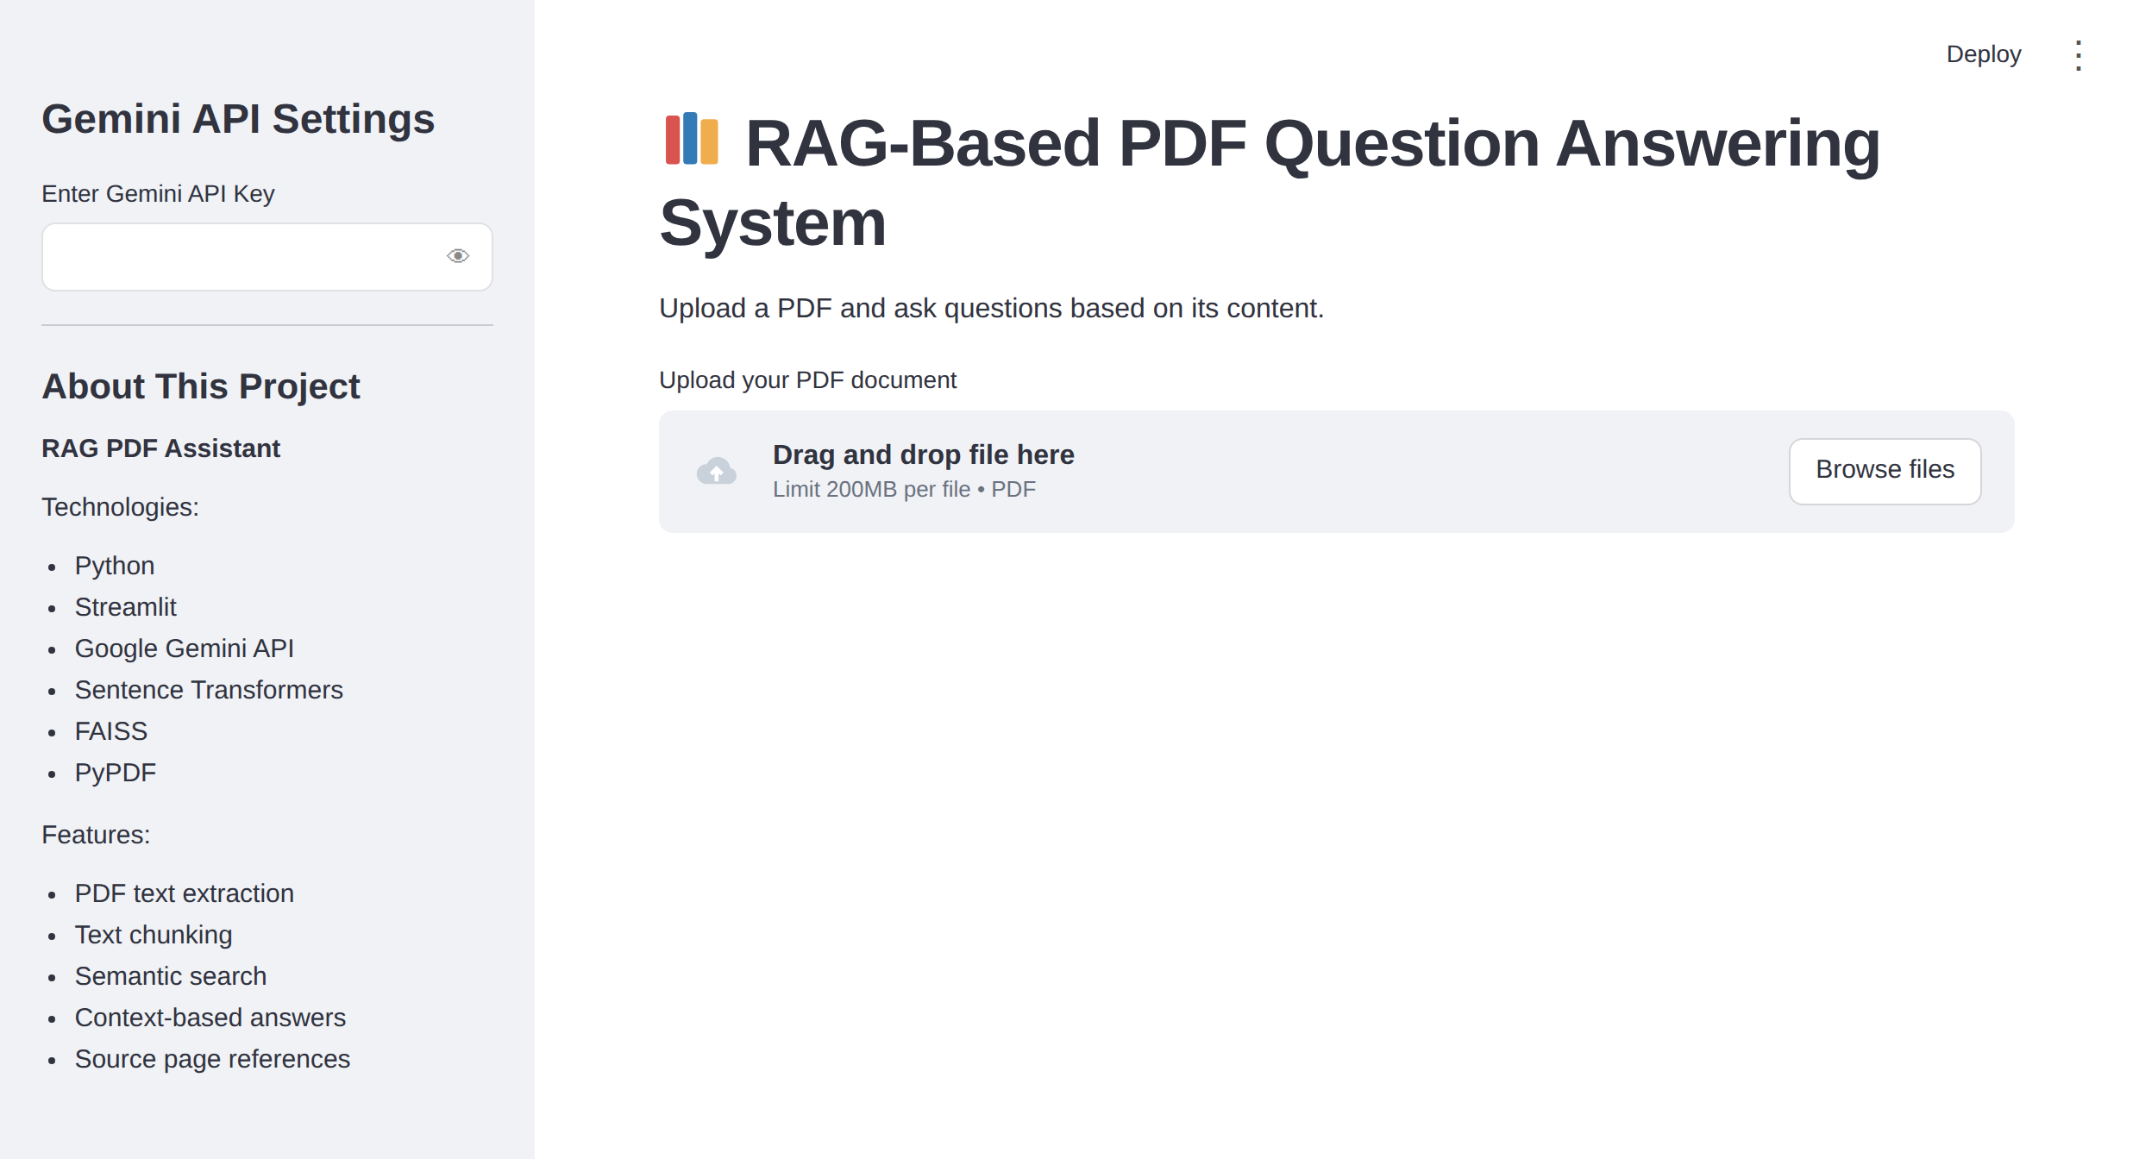
Figure: Home page with the sidebar and the PDF uploader
Upload and Process:
- st.file_uploader() accepts only PDF files. Once a file is selected, its name and size appear below the upload box and the Process PDF button becomes available.
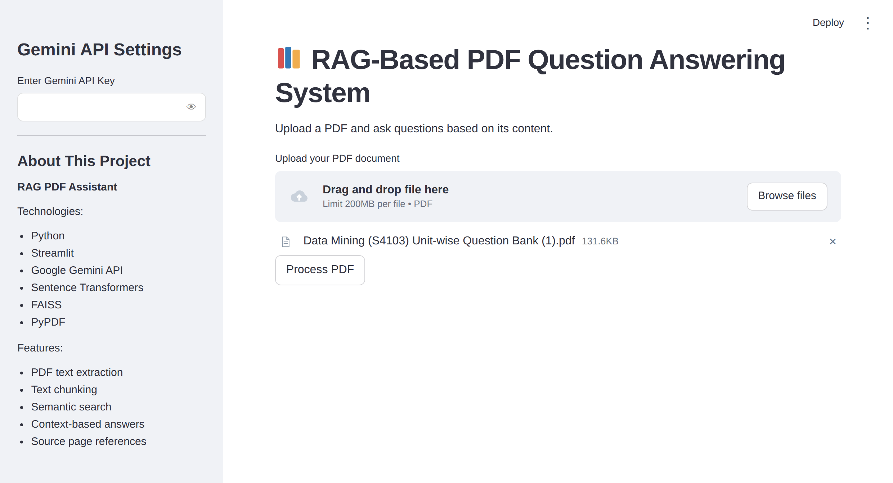
Figure: A PDF selected and ready to process
- While the PDF is being processed, each step shows its own spinner message, such as "Extracting PDF text...", "Creating text chunks...", and "Creating embeddings and FAISS index...".
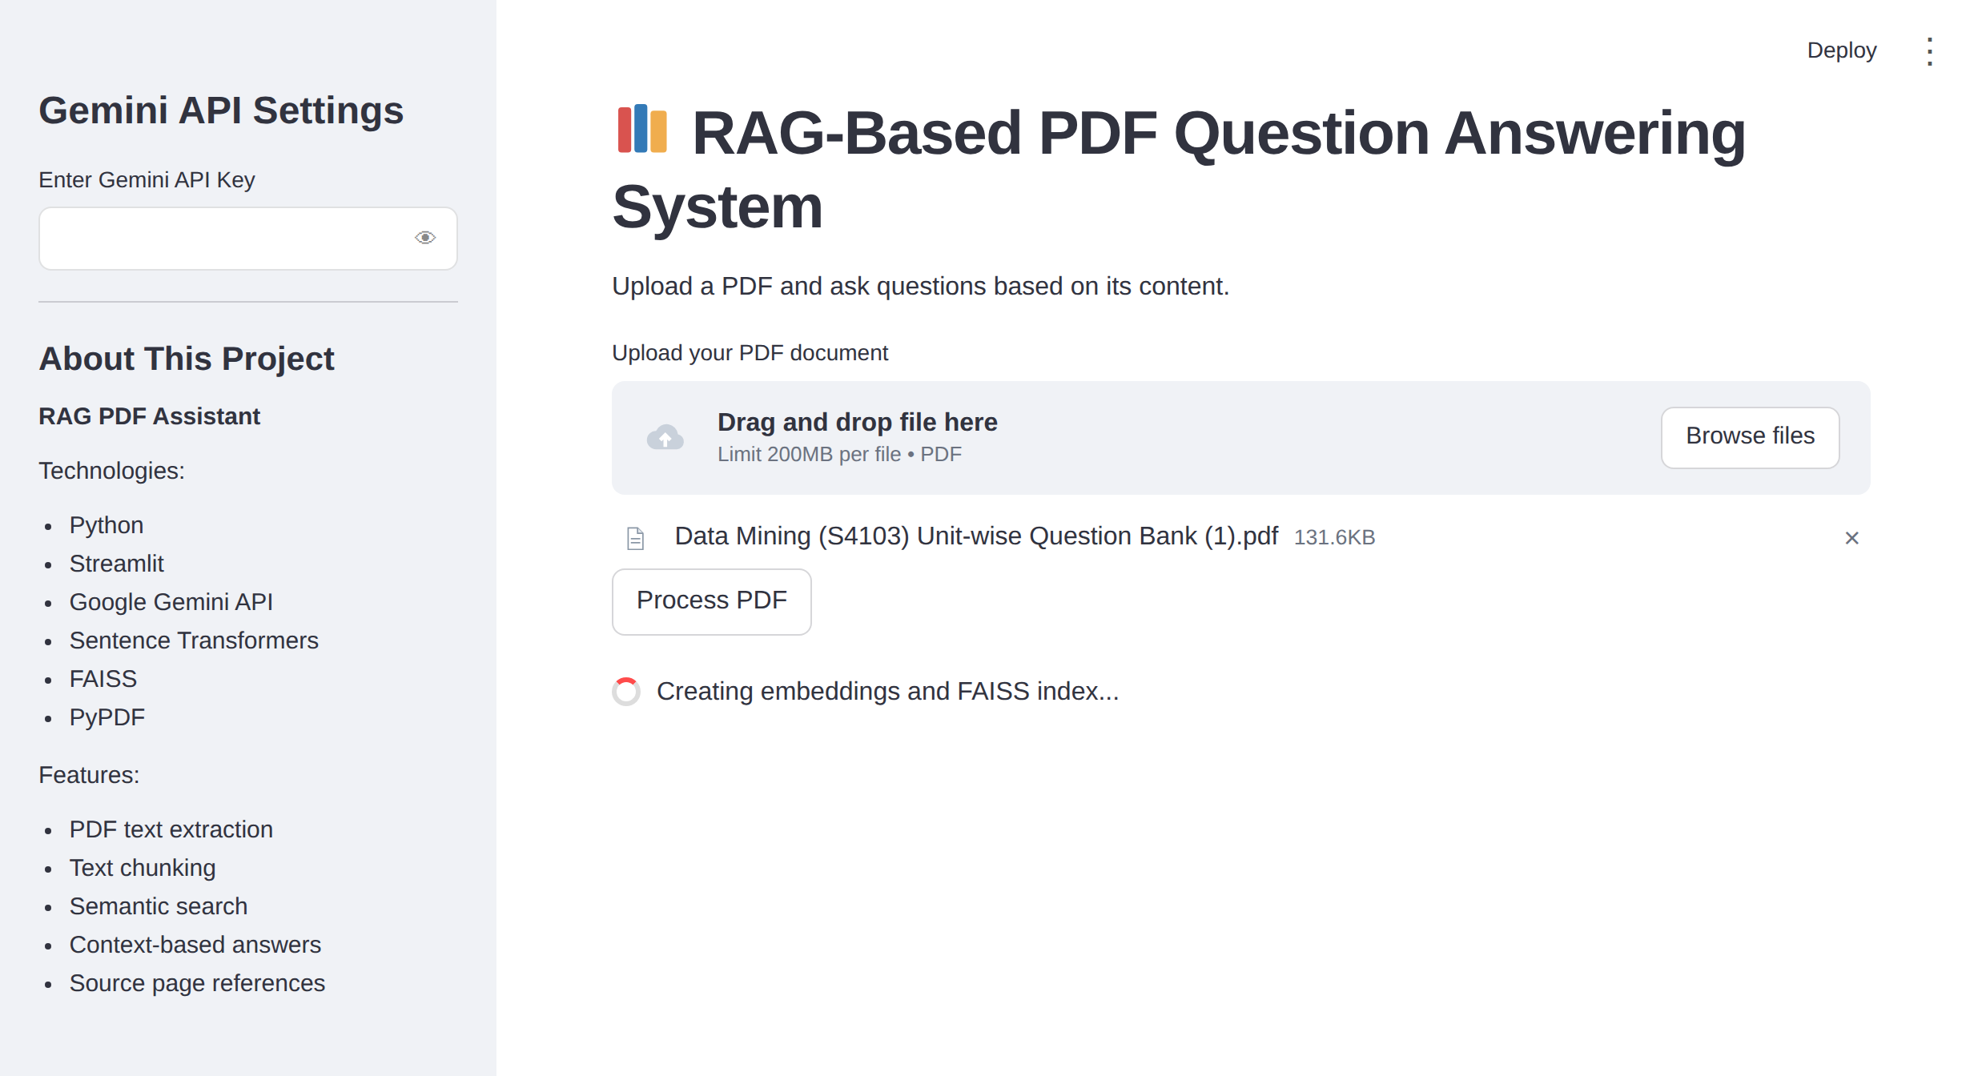
Figure: Spinner shown while the embeddings and index are created
- After processing, a success message appears with the document name, the number of pages extracted, and the number of chunks created.
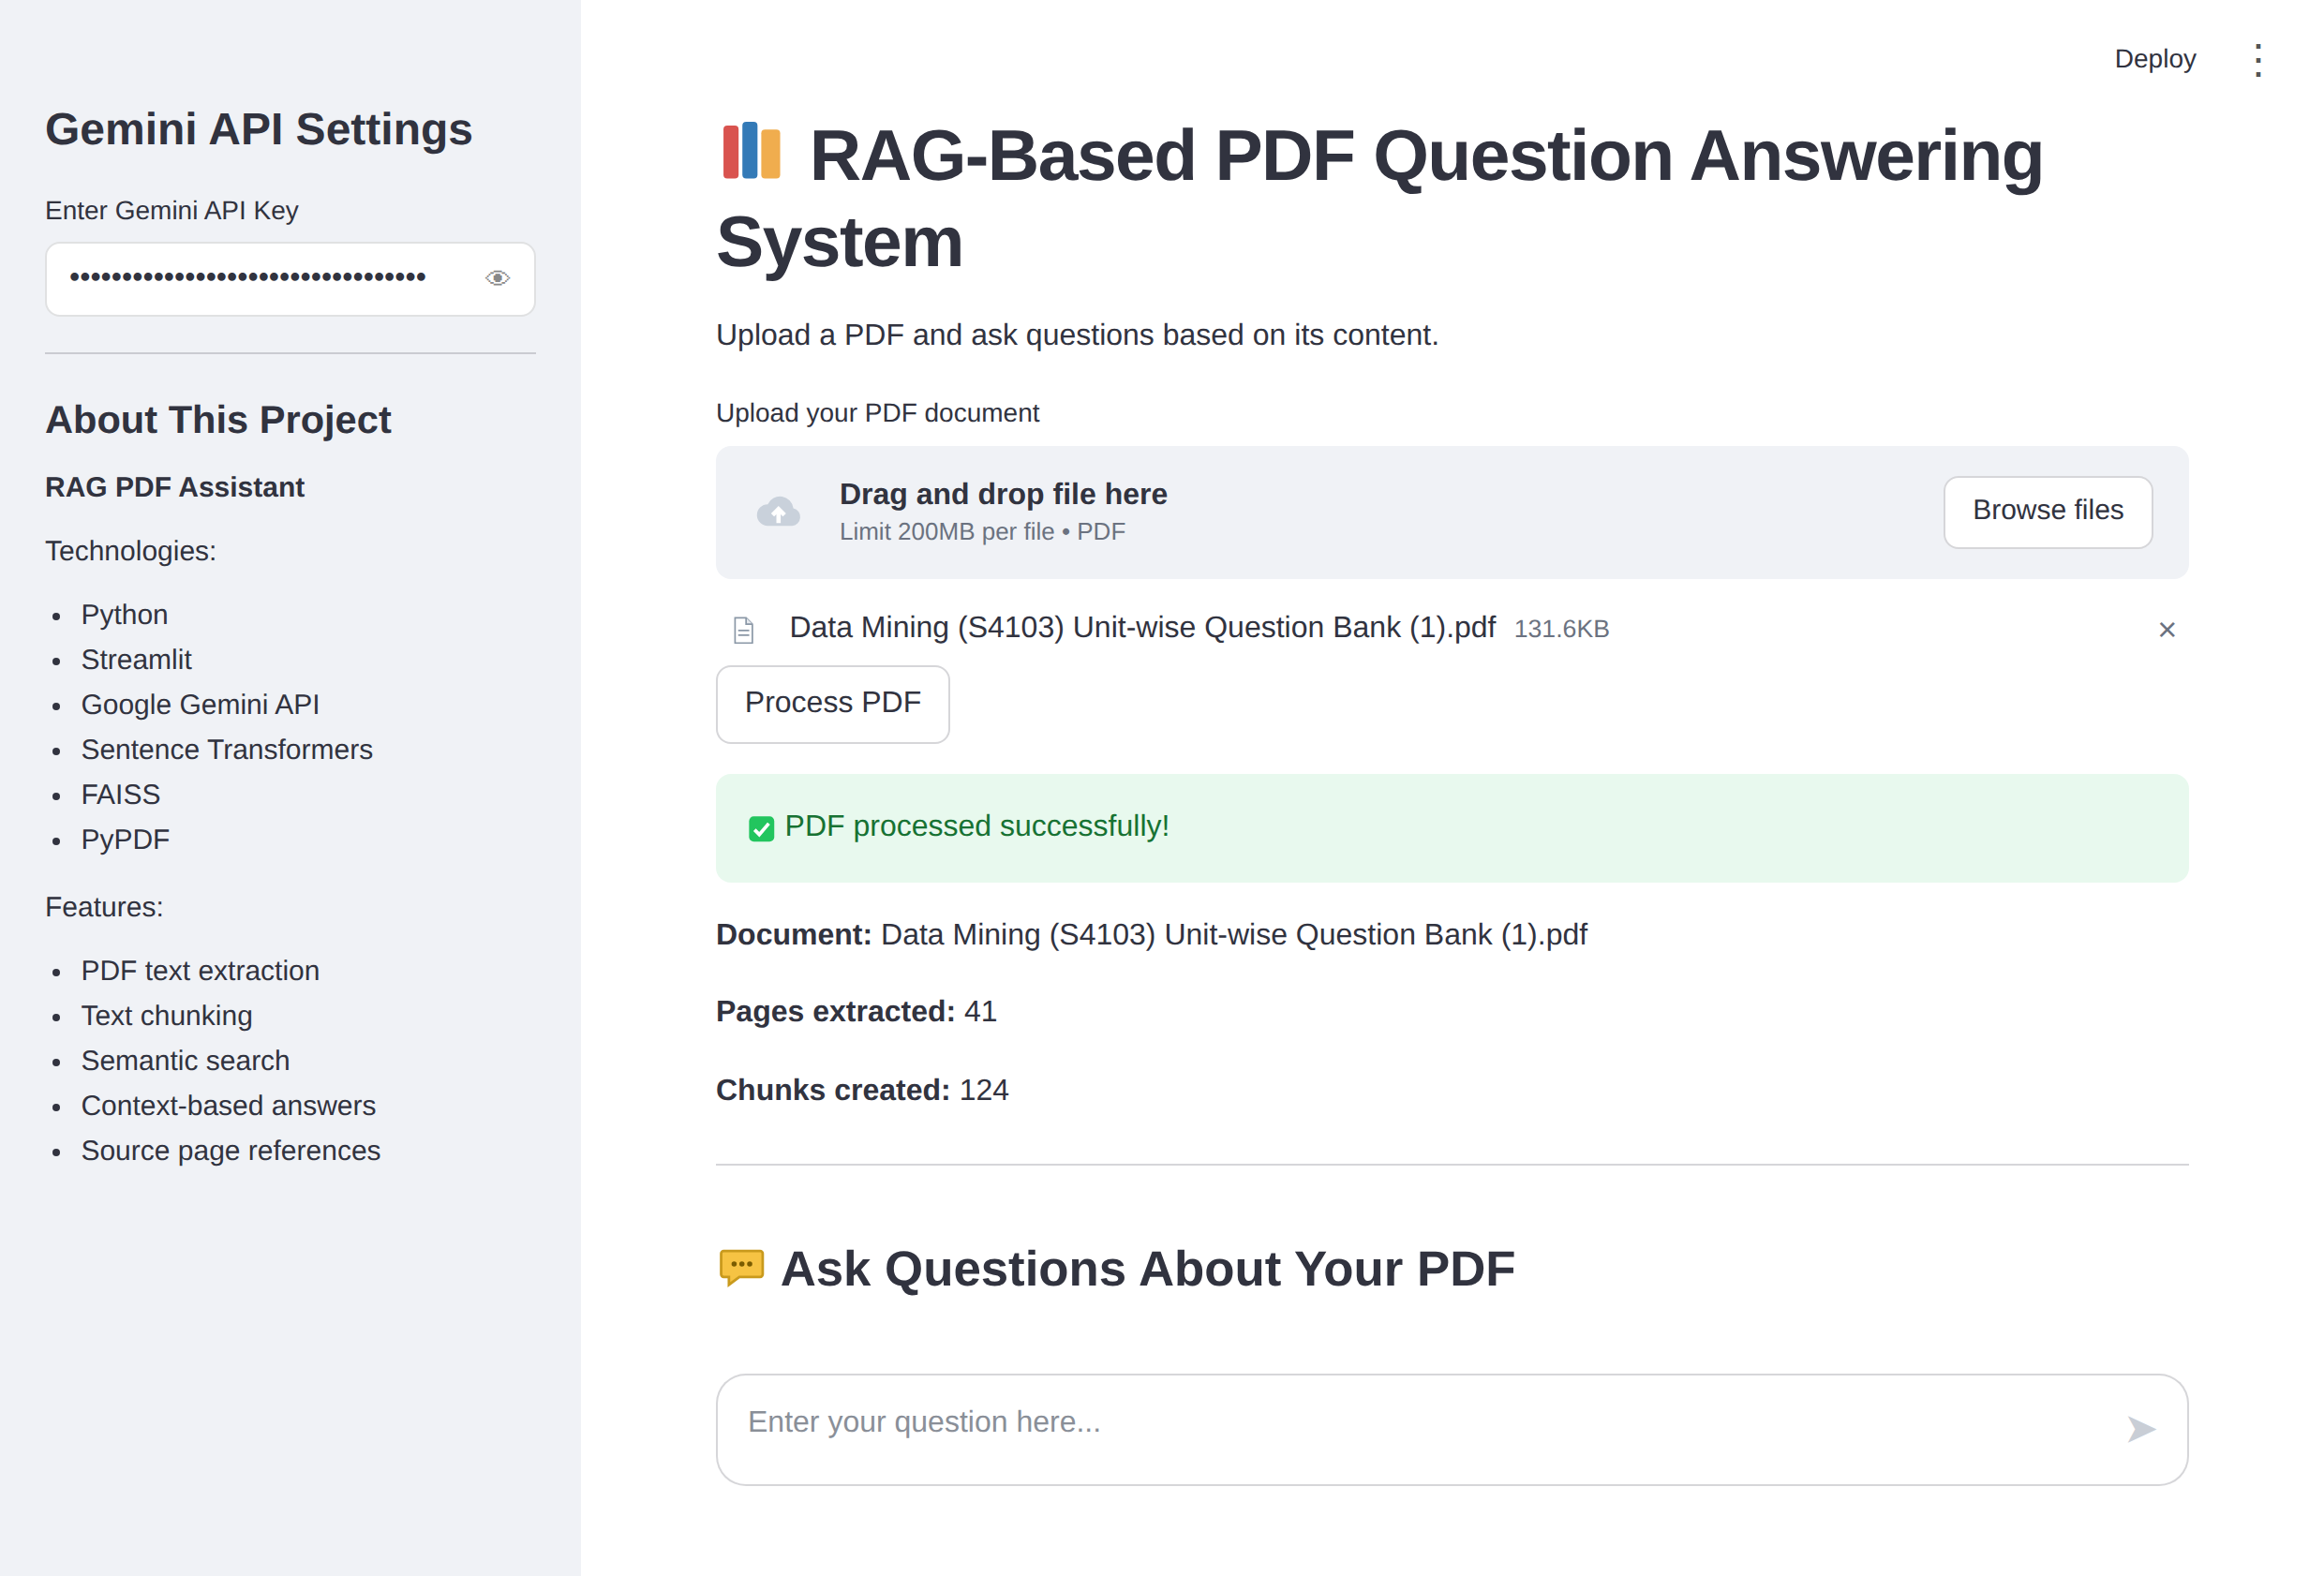
Figure: Processing complete with document statistics

Activity 4.2: Building the Chat Interface and Sources Panel
Chat:
- Question Box: st.chat_input() appears at the bottom of the page after the PDF is processed.
- Messages: st.chat_message("user") and st.chat_message("assistant") display the question and the answer with their own icons.
- Progress: A spinner with the text "Searching PDF and generating answer..." appears while retrieval and generation run.
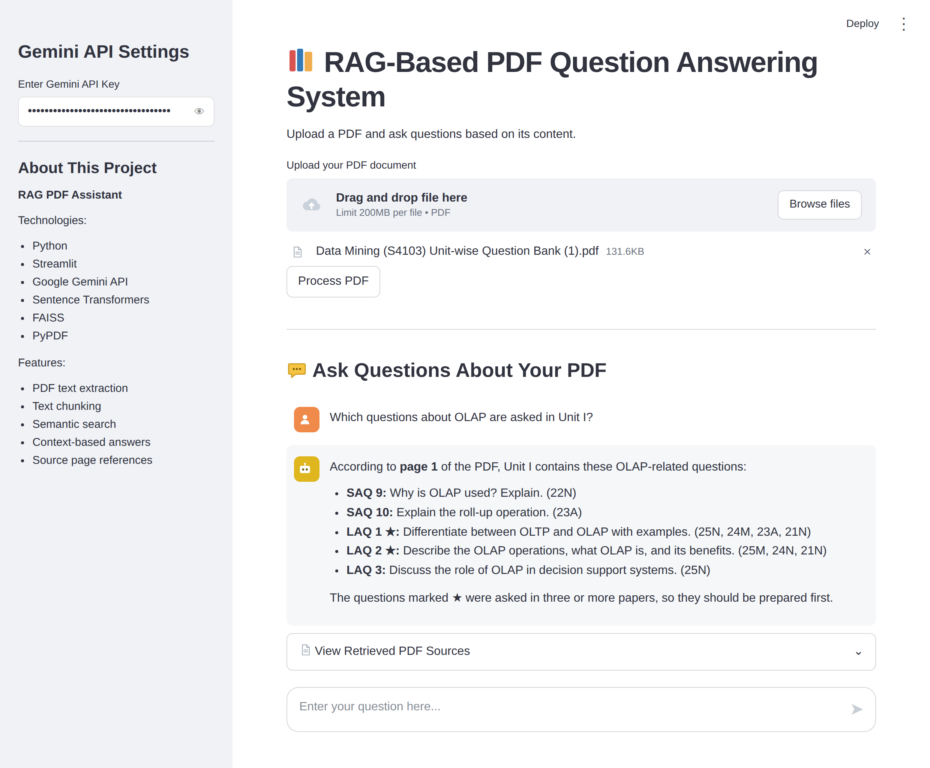
Figure: A question answered with the retrieved PDF content
Retrieved PDF Sources:
- An st.expander() titled "View Retrieved PDF Sources" lists each retrieved chunk with its source number, page number, text, and similarity score, so the user can check the answer against the original document.
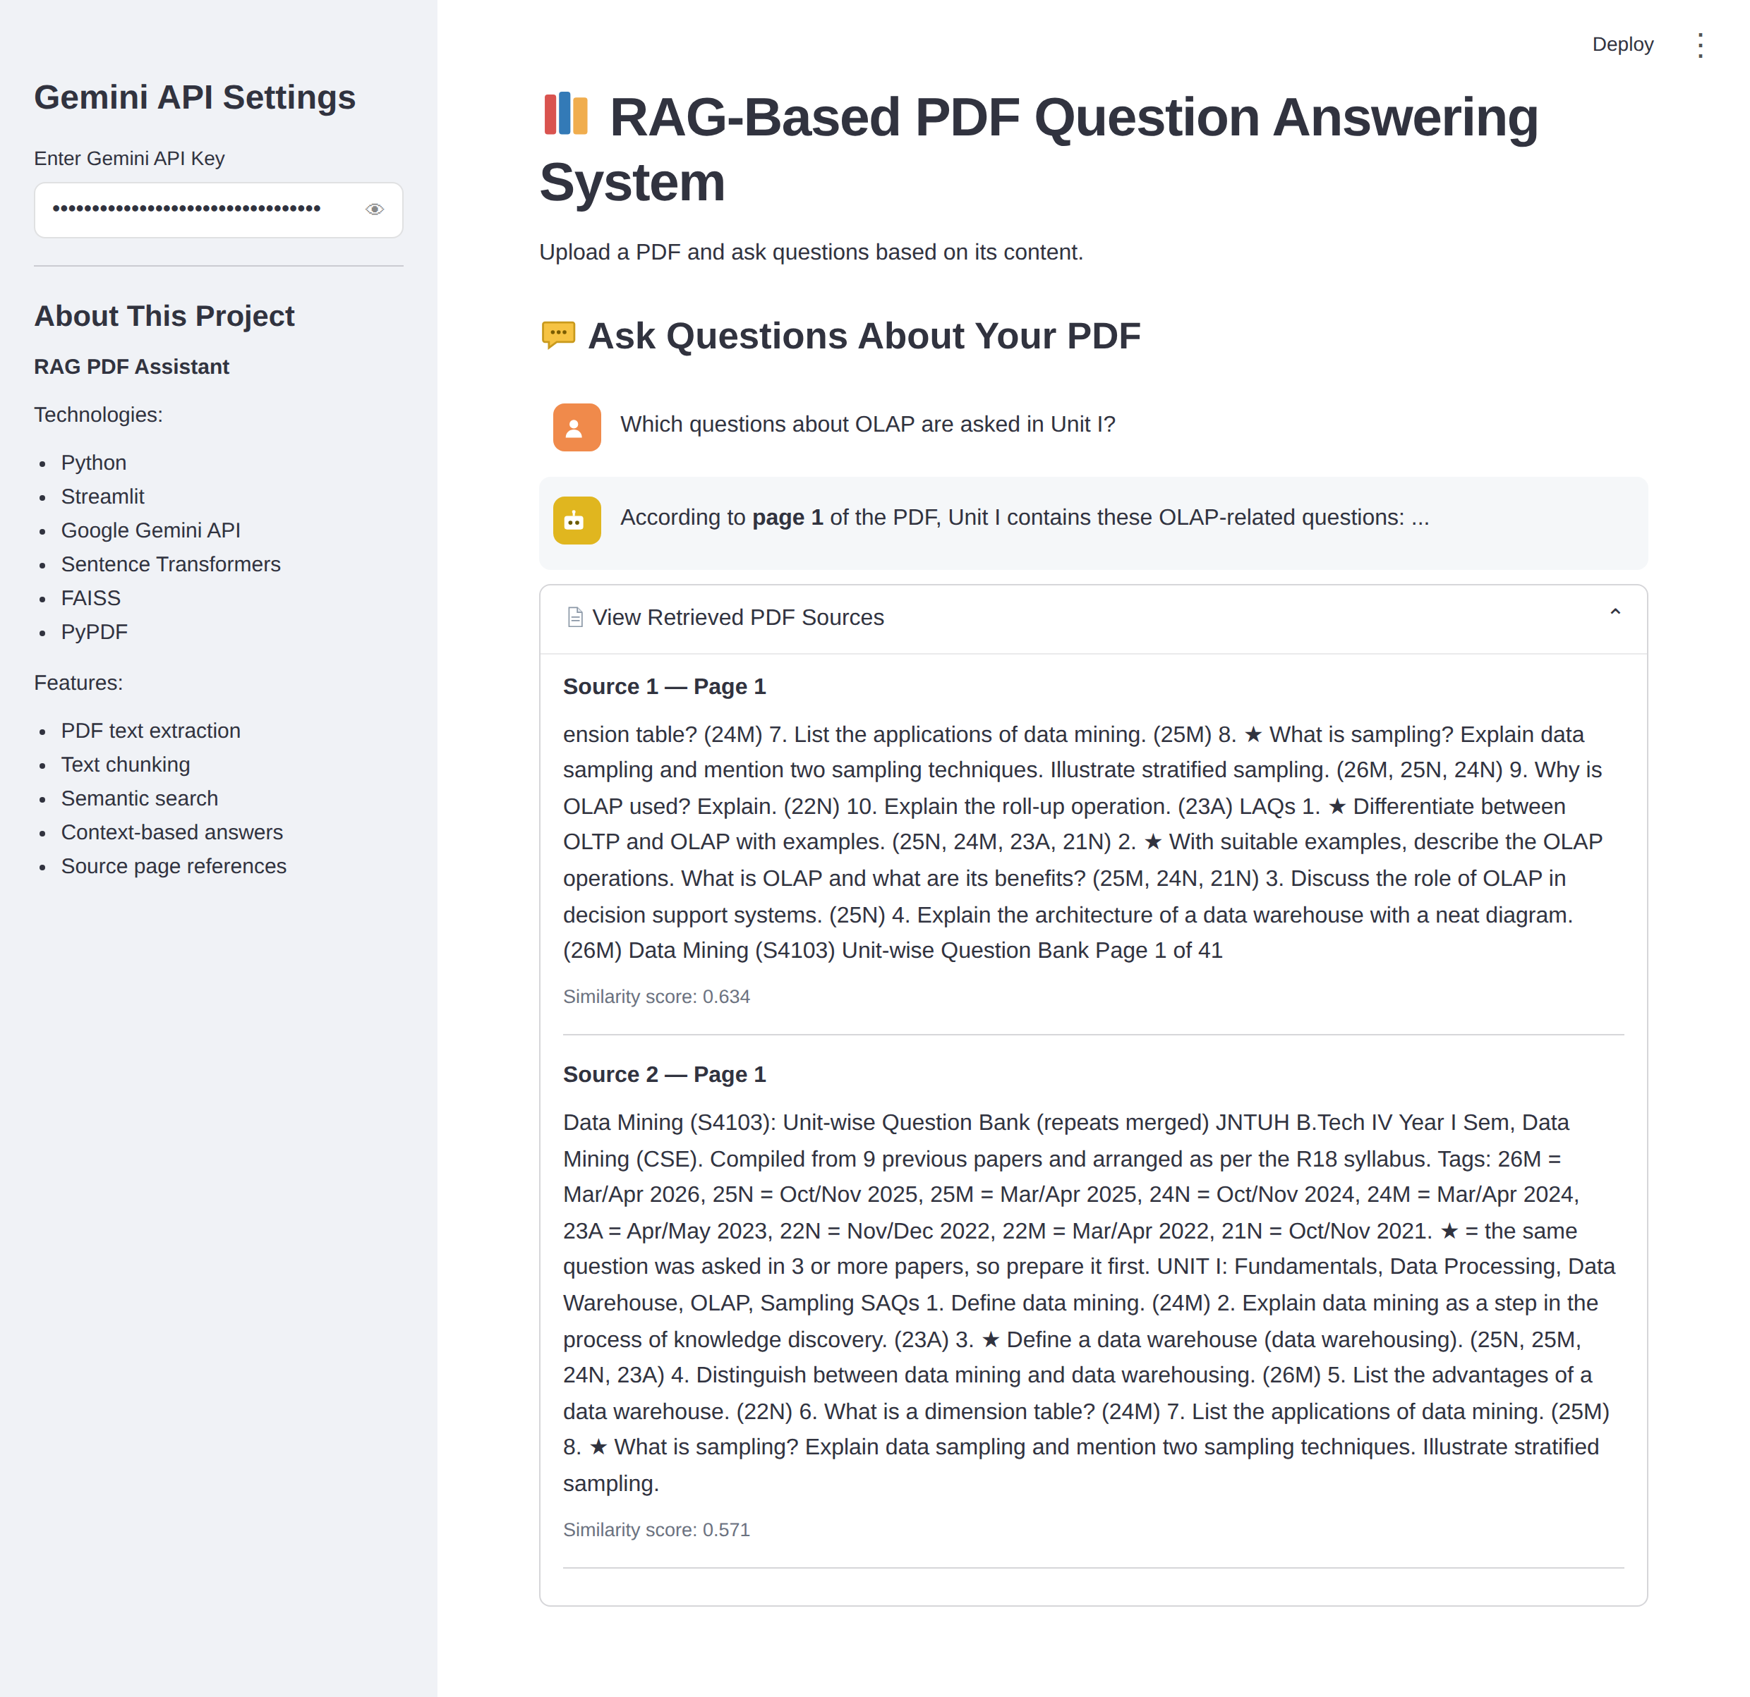
Figure: Expanded sources panel (first two of six sources shown)
Questions Outside the Document:
- When the PDF does not contain the answer, the assistant says so instead of guessing.
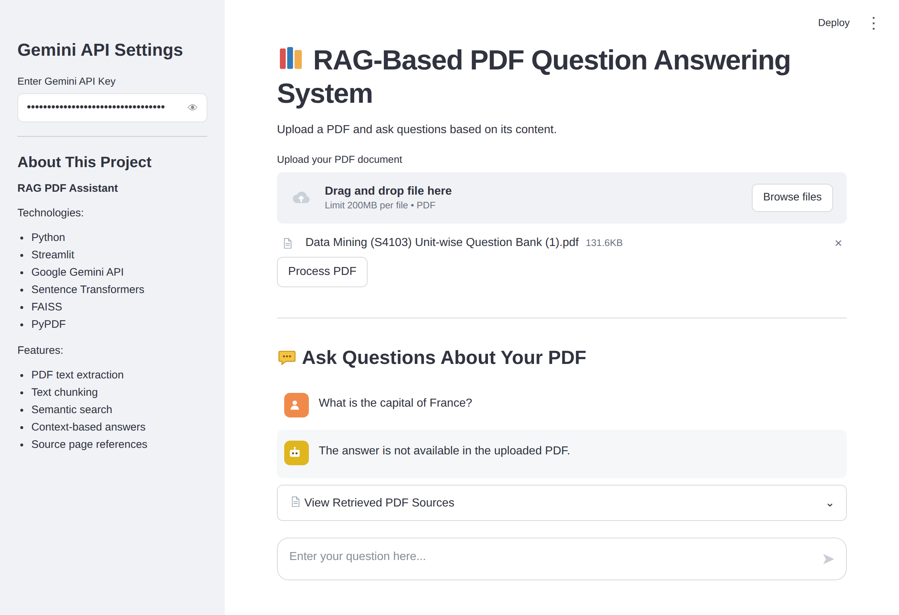
Figure: Answer for a question that is not in the PDF
Preserve Content Between Interactions:
- Because the chunks and the index are stored in st.session_state, the chat section stays available after every question. Only the latest question and answer are shown, because the app does not store chat history.

Activity 4.3: Component Reference
Interface Element | Streamlit Component | Purpose
Page title and description | st.title(), st.write() | Explains what the app does
API key field | st.sidebar.text_input(type="password") | Collects the Gemini key without showing it
About section | st.sidebar.subheader(), st.sidebar.write() | Lists the technologies and features
PDF upload | st.file_uploader(type=["pdf"]) | Accepts only PDF files
Process button | st.button() | Starts extraction, chunking, and indexing
Progress messages | st.spinner() | Shows which step is currently running
Status messages | st.success(), st.error(), st.warning() | Reports success, failure, or missing input
Separator | st.divider() | Separates the upload area from the chat area
Question box | st.chat_input() | Collects the user's question
Conversation | st.chat_message() | Displays the question and the answer
Sources panel | st.expander(), st.markdown(), st.caption() | Shows retrieved chunks, pages, and scores

Milestone 5: Deployment
In Milestone 5, the RAG PDF Assistant is run inside Google Colab and exposed publicly through Ngrok, so it can be opened from any browser through a secure URL. The Streamlit code is saved as app.py, the server is started in the background, and a tunnel connects it to the internet.

Activity 5.1: Preparing the Application for Deployment
Save the Streamlit Code as app.py:
- Put %%writefile app.py on the first line of the cell that contains the Streamlit code. Colab then saves the cell as app.py instead of running it.
%%writefile app.py
import streamlit as st
import io, time, re
import numpy as np
import faiss

from pypdf import PdfReader
from sentence_transformers import SentenceTransformer
from google import genai
# ... rest of the application code ...

Install the Deployment Libraries:
!pip -q install streamlit pyngrok

Project Structure:
/content
├── app.py # Streamlit application
├── streamlit.log # Server log
├── Data Mining (S4103) Unit-wise Question Bank.pdf # Sample PDF for testing
└── sample_data/

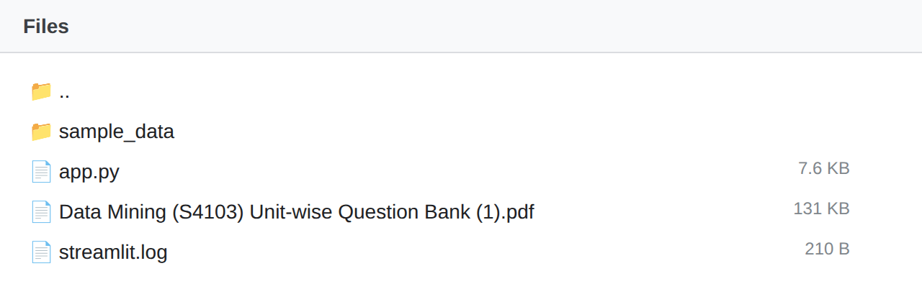
Figure: Colab file explorer showing app.py and the log

Activity 5.2: Running Streamlit and Opening the Ngrok Tunnel
• Step 1 — Get an Ngrok Authtoken: Sign up at ngrok.com and copy your authtoken from the dashboard.
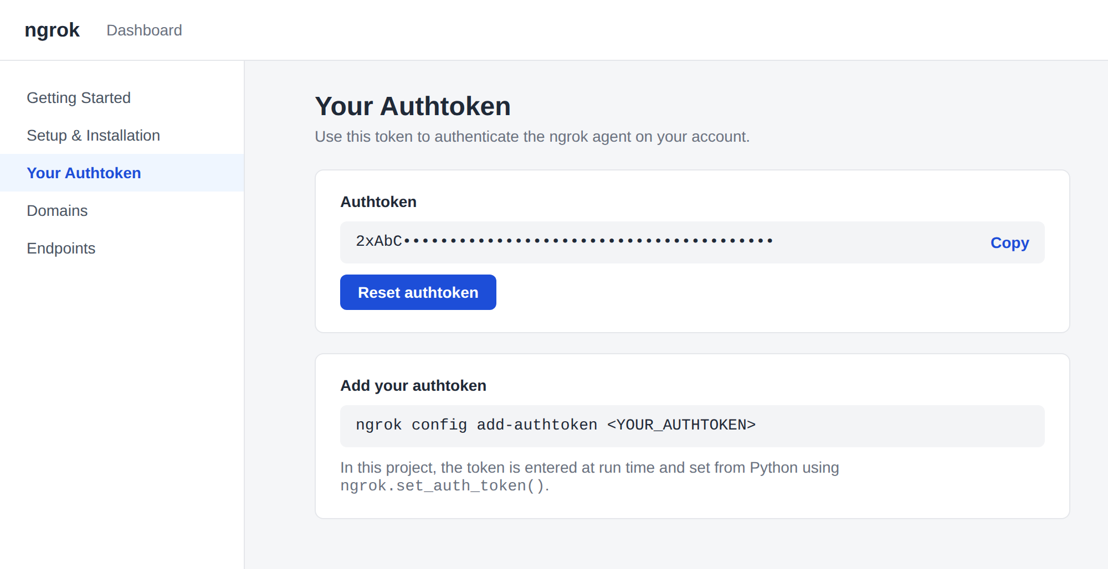
• Step 2 — Start Streamlit and the Tunnel: The launch cell reads the token with getpass(), stops any old Streamlit process, starts Streamlit in the background on port 8501, waits five seconds, and opens an Ngrok tunnel:
ngrok_token = getpass("Enter your ngrok auth token: ")
ngrok.set_auth_token(ngrok_token)

subprocess.run(["pkill", "-f", "streamlit"], capture_output=True)

process = subprocess.Popen(
["streamlit", "run", "app.py",
"--server.port", "8501",
"--server.address", "0.0.0.0",
"--server.headless", "true"],
stdout=open("/content/streamlit.log", "w"),
stderr=subprocess.STDOUT
)
time.sleep(5)
public_url = ngrok.connect(8501, "http")

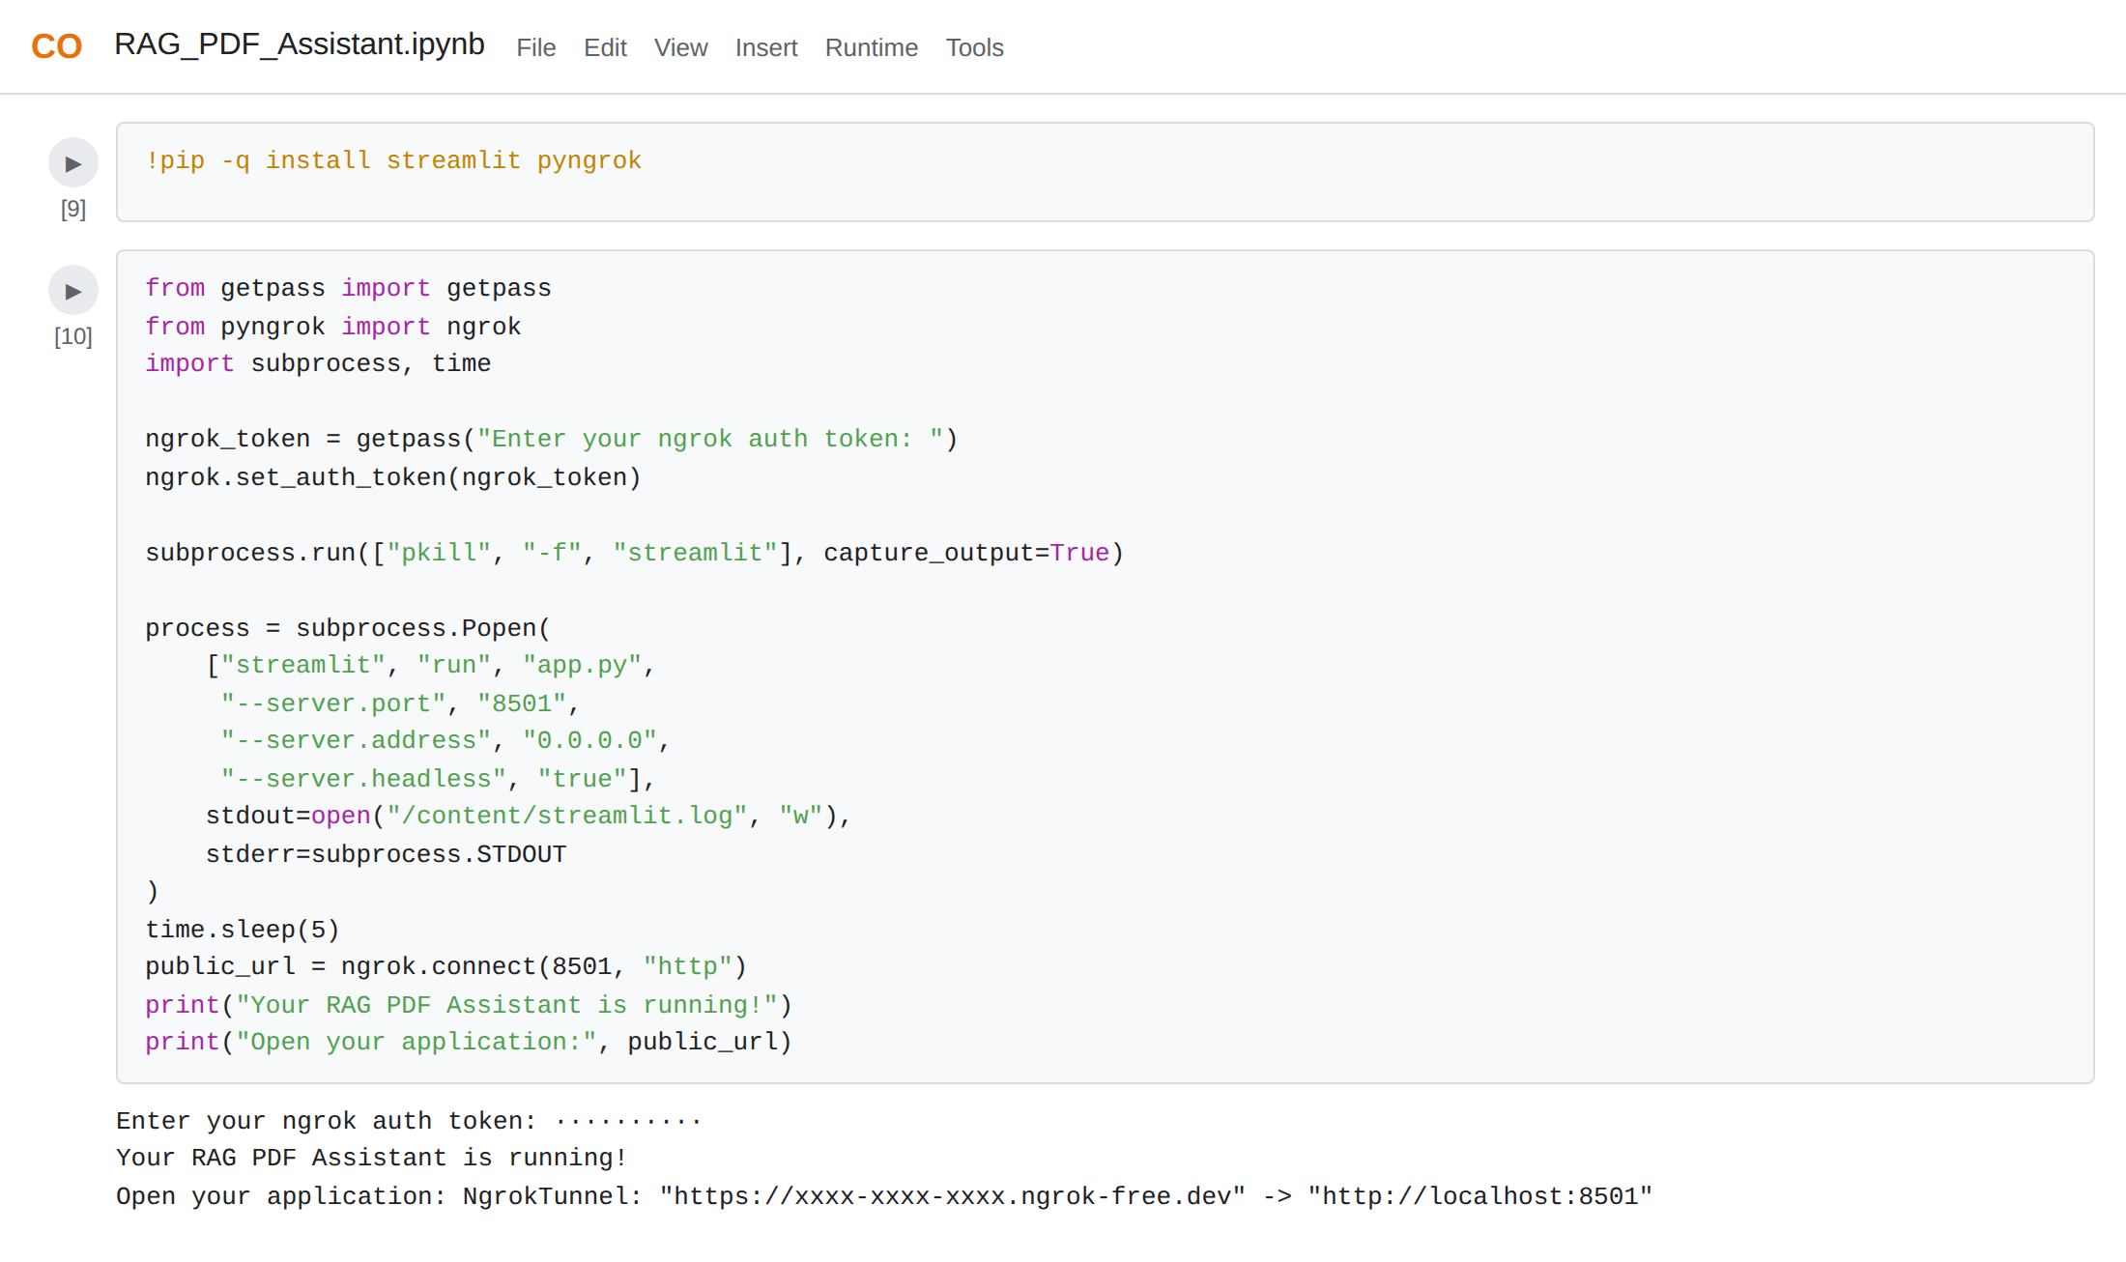
Figure: Launching the app and printing the public URL
• Step 3 — Check the Log: Because the output of Streamlit is written to /content/streamlit.log, it can be read to confirm that the server started without errors:
!cat /content/streamlit.log

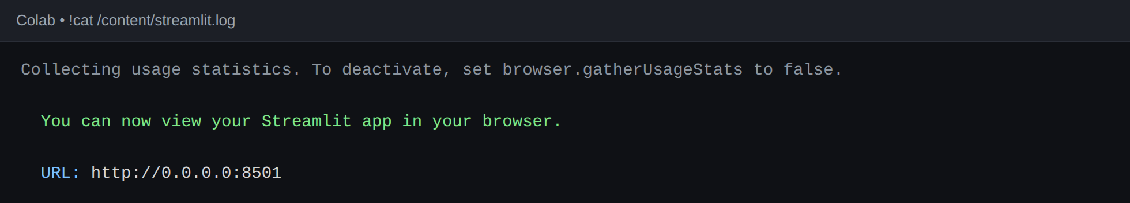
Figure: streamlit.log showing the server running on port 8501
• Step 4 — Open the App: Click the printed Ngrok URL to open the RAG PDF Assistant in a new tab. Anyone with the link can use it without installing anything.
What the Launch Options Mean:
- --server.port 8501: The port Streamlit listens on, which is the same port Ngrok forwards.
- --server.address 0.0.0.0: Allows connections from outside the notebook's own machine, which Ngrok needs.
- --server.headless true: Starts the server without trying to open a browser window, which is required in Colab.
- pkill -f streamlit: Stops a previous Streamlit process so the port is free.

Activity 5.3: Updating the Model and Restarting the App
When the model name needs to change, the app does not have to be rewritten. A short cell replaces the model name in app.py, and a second cell restarts Streamlit and the tunnel.
from pathlib import Path
path = Path("app.py")
code = path.read_text()
code = code.replace("gemini-2.5-flash", "gemini-3.8-flash")
path.write_text(code)
print("Updated Gemini model successfully!")

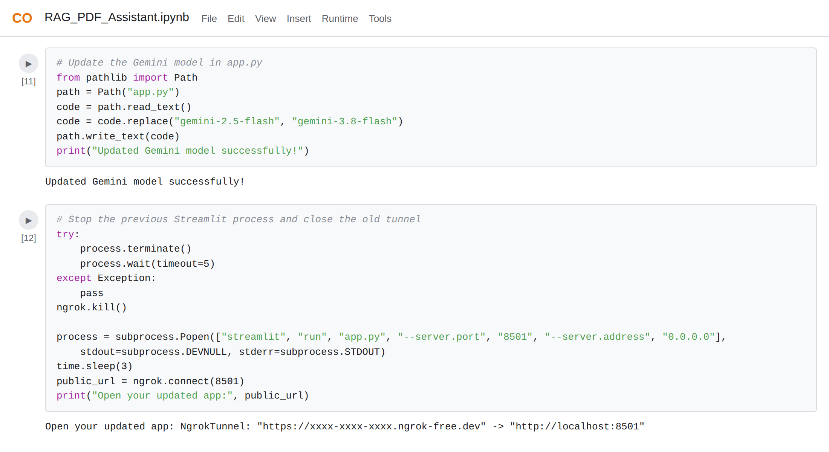
Figure: Updating the model in app.py and restarting the app
Important Notes:
- Protect your tokens: Never paste your real Ngrok authtoken or Gemini API key into a shared notebook, screenshot, or repository. Both are entered with getpass() or a password field, so they are not saved in the code.
- The URL can change: On the free Ngrok plan, the public URL may change when the tunnel is restarted.
- Keep the runtime active: The app stops when the Colab runtime disconnects. Re-run the launch cell to bring it back.
- Text-based PDFs only: The app reads the text layer of a PDF. Scanned documents need OCR before they can be used.
- Index is temporary: The index is kept in memory, so a PDF must be processed again after the app restarts.

Activity 5.4: Common Issues and Troubleshooting
Problem | Likely Cause | Solution
Invalid API key error | Key copied incorrectly or deleted | Create a new key in Google AI Studio and paste it into the sidebar
"Not a valid PDF" message | File was renamed to .pdf or is corrupted | Upload a real PDF exported from the original application
"No readable text found" | Scanned PDF with only images | Run OCR on the file first, then upload the searchable PDF
Gemini high-demand message | Temporary 503 / UNAVAILABLE error | Wait a little and ask again; the app already retries once
Answer says "not available" | The PDF really does not contain the answer, or the wording is very different | Rephrase using words from the document and check the sources panel
Port 8501 in use | An older Streamlit process is still running | Run pkill -f streamlit and start the launch cell again
App page does not open | Server did not start | Run !cat /content/streamlit.log and read the error
Ngrok tunnel fails | Missing or wrong authtoken | Copy the token again from the Ngrok dashboard and re-run the launch cell
ModuleNotFoundError | Library not installed in this runtime | Re-run the pip install cells

Exploring the Website's Web Pages:

Home Page:
Description: The single-page interface shows the title, a short description, and a PDF upload area. The sidebar contains the masked Gemini API key field and an About This Project section that lists the technologies (Python, Streamlit, Google Gemini API, Sentence Transformers, FAISS, PyPDF) and the features of the application.

PDF Processing Page:
Description: After a PDF is uploaded and the Process PDF button is clicked, the app extracts the text, creates chunks, and builds the FAISS index. A success message then confirms the work and displays the document name, the number of pages extracted, and the number of chunks created. The chat area appears below a divider.

Question Answering Page:
Description: The user types a question in the chat box. The question appears as a user message, and the assistant's answer appears below it with the relevant details and page numbers taken from the document. The collapsed "View Retrieved PDF Sources" panel sits beneath the answer.

Retrieved Sources Panel:
Description: Opening the expander shows the chunks that were sent to Gemini. Each source lists its number, its page in the PDF, the chunk text, and a similarity score, so users can verify the answer and see how closely each chunk matched the question.

Error and Warning States:
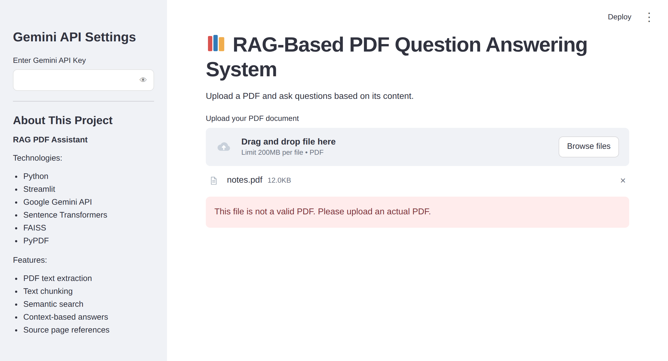
Figure: Message shown for a file that is not a real PDF
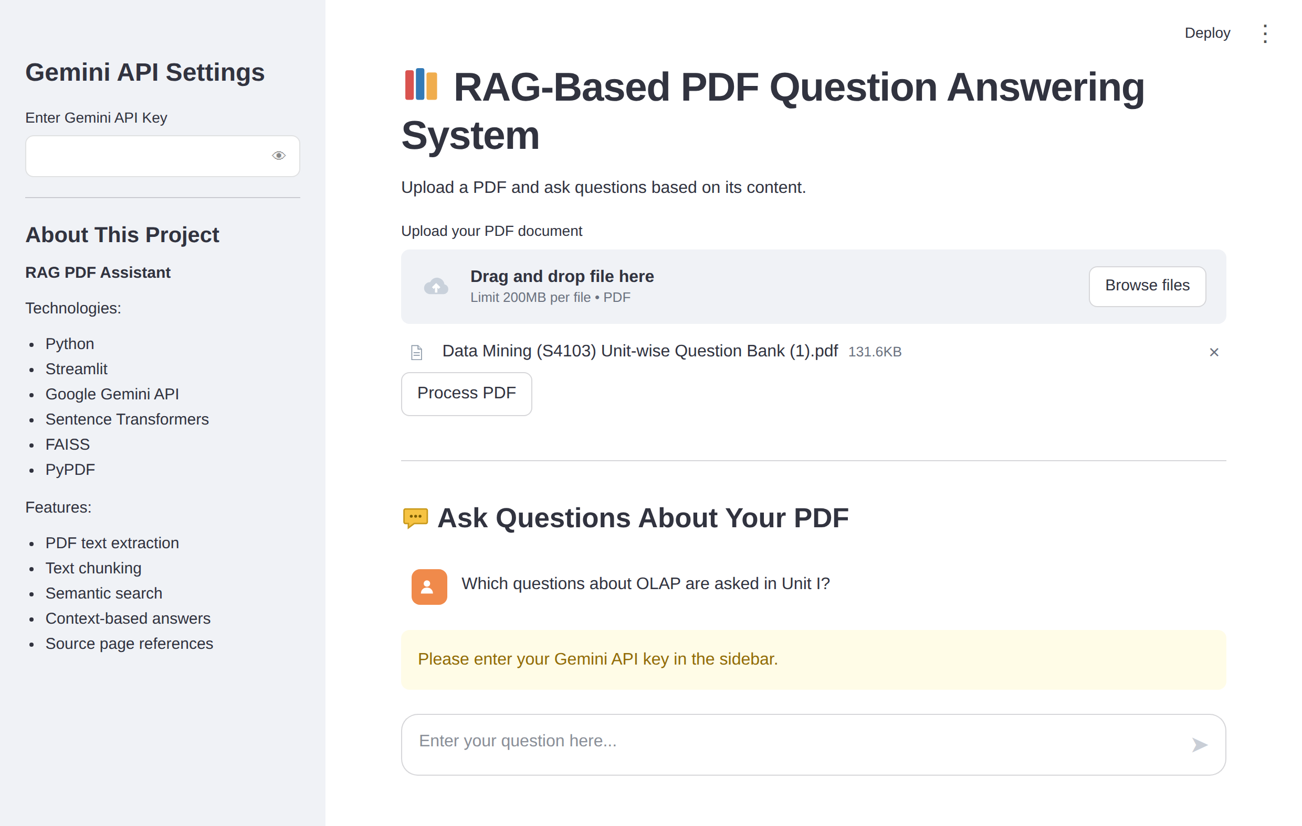
Figure: Warning shown when a question is asked without an API key
Description: The app guards against common problems. A file that is not a genuine PDF is rejected with an error message, and a question asked before the API key is entered produces a warning that points to the sidebar. Scanned PDFs without readable text are also reported with a clear message.

Conclusion:
The RAG PDF Assistant is a Retrieval-Augmented Generation application built with Streamlit that lets users ask questions about their own documents. It extracts text with PyPDF, creates local embeddings with Sentence Transformers, stores them in a FAISS index, and uses Google's Gemini API to write grounded answers from only the most relevant chunks. The project, which included model selection, pipeline development in a notebook, application development, interface design, and public deployment through Ngrok from Google Colab, shows how retrieval keeps a language model focused on the document, shows its sources, and uses only one generation request per question.
Key Learning Outcomes:
- Understanding how Retrieval-Augmented Generation combines search and generation.
- Splitting documents into overlapping chunks and tracking the page each chunk came from.
- Creating embeddings locally and searching them with a FAISS index.
- Writing prompts that keep a model grounded in the supplied context.
- Building a chat interface with Streamlit and preserving state with st.session_state.
- Handling errors such as invalid files, scanned PDFs, missing keys, and temporary service failures.
- Deploying a Colab-hosted app publicly with Ngrok.
Future Enhancements:
- OCR support so that scanned PDFs can also be used.
- Support for several PDFs and other file types at the same time.
- Chat history and follow-up questions that remember earlier answers.
- A persistent vector database so that documents do not need to be processed again.
- Re-ranking of retrieved chunks and a configurable number of sources.
- Highlighting the exact matching sentences in the sources panel.
Looking ahead, the assistant can grow from a single-document tool into a full knowledge assistant for students, researchers, and organizations, with user accounts, saved libraries of documents, and richer citations. By continuously refining the chunking strategy, the prompts, and the interface, the platform is well-positioned to become a dependable way to get answers from long documents.

