Traffic Vehicle Counting and Congestion Detection using YOLOv8

Project Description:
Traffic Vehicle Counting and Congestion Detection is a computer-vision project that analyzes traffic camera footage to detect, track, and count vehicles, and to estimate how congested a road is. The project uses the Ultralytics YOLOv8 object detection model (yolov8n.pt) to detect cars, motorcycles, buses, and trucks in every frame of a traffic video, and the BoT-SORT multi-object tracker to follow each vehicle across frames so that it is counted only once instead of being double-counted frame after frame.
Beyond simple counting, the project defines a road region of interest (ROI) on the video frame and measures what percentage of that ROI is occupied by detected vehicles in every frame. This road-occupancy percentage, together with the average number of vehicles per frame, is used to classify the current traffic condition into LOW, MEDIUM, or HIGH congestion using fixed thresholds.
The complete pipeline is wrapped into a single analyze_traffic() function that produces vehicle counts by type, traffic-density statistics, road-occupancy statistics, a congestion status, and an annotated output video with bounding boxes, vehicle IDs, and the ROI overlay. The project is then deployed as an interactive Streamlit web application, exposed to the internet through a Cloudflare Tunnel, so that a traffic video can be uploaded and analyzed directly from a browser.
The project deliberately avoids training a custom detector: yolov8n.pt already recognizes cars, motorcycles, buses, and trucks out of the box as part of the COCO dataset, so the engineering effort goes into building a reliable counting, tracking, and congestion-classification layer on top of an existing, well-tested model rather than into data collection and model training. This keeps the solution lightweight enough to run on a single Colab GPU while still producing traffic-authority-style statistics — counts, density, and occupancy — from ordinary camera footage.
- Key Capability — Detection: Frame-by-frame identification of cars, motorcycles, buses, and trucks using YOLOv8, restricted to the four relevant COCO classes with a 0.4 confidence threshold.
- Key Capability — Tracking: Persistent per-vehicle identity across frames via BoT-SORT, so a single vehicle crossing the frame is not recounted on every frame it appears in.
- Key Capability — Counting: De-duplicated totals by vehicle type, derived from filtering out tracks that appear in fewer than five frames.
- Key Capability — Congestion Analysis: Two independent, complementary metrics — vehicles-per-frame density and pixel-accurate road-ROI occupancy — each mapped to a LOW / MEDIUM / HIGH verdict.
- Key Capability — Deployment: A Streamlit web app that exposes the same analysis pipeline to non-technical users through a browser, published via a Cloudflare Tunnel.

Scenarios
Scenario 1: A traffic video is uploaded to the notebook. YOLOv8 detects vehicles in every frame and draws bounding boxes around cars, motorcycles, buses, and trucks, and the annotated video is saved for review.
Scenario 2: The same video is processed with the BoT-SORT tracker enabled. Each vehicle is assigned a persistent tracking ID across frames, and only tracks that appear in at least five frames are counted, which filters out spurious, single-frame detections.
Scenario 3: A road ROI polygon is drawn on the frame. The system calculates what percentage of that ROI is covered by vehicle bounding boxes in each frame and classifies the traffic as LOW, MEDIUM, or HIGH congestion based on the average occupancy.
Scenario 4: A user opens the deployed Streamlit web application, uploads a traffic video, and receives vehicle counts, traffic-density statistics, road-occupancy statistics, and a congestion verdict directly in the browser.

Technical Architecture:
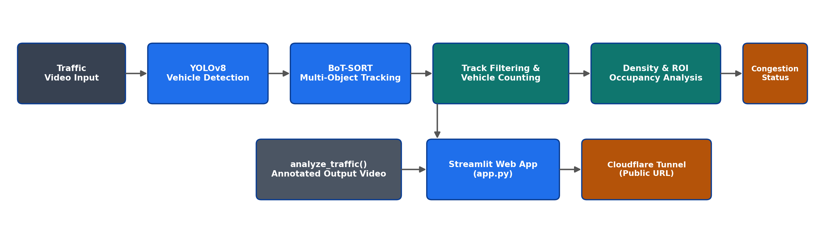

Description:
The application follows a computer-vision pipeline built around a pretrained object detector and a multi-object tracker, followed by a rule-based congestion classifier. Video frames are read with OpenCV, passed through the YOLOv8 model for detection and through BoT-SORT for tracking, and the resulting bounding boxes are used both to count unique vehicles and to compute road-occupancy percentages inside a defined ROI. The complete analysis is exposed through a Streamlit web interface tunnelled to a public URL using cloudflared, so the same analyze_traffic() logic that runs in the notebook also powers the deployed web app.
Two processing layers sit on top of raw detection. The first is an identity layer (BoT-SORT), which links detections of the same physical vehicle across consecutive frames so that counting logic can operate on unique tracks rather than raw per-frame boxes. The second is an analytics layer, which turns those tracks into three outputs: de-duplicated vehicle counts by class, a vehicles-per-frame density trend, and a pixel-accurate road-occupancy percentage inside the defined ROI. A simple, fixed-threshold rule set then converts the density and occupancy numbers into a LOW / MEDIUM / HIGH congestion label, and every stage — detection, tracking, analytics, and classification — is reused unchanged between the Colab notebook and the deployed Streamlit app.
Component | Technology / Method | Purpose
Object detection | Ultralytics YOLOv8 (yolov8n.pt) | Detects cars, motorcycles, buses, and trucks in each frame
Object tracking | BoT-SORT (tracker="botsort.yaml") | Assigns persistent IDs to vehicles to avoid double counting
Video processing | OpenCV (cv2) | Reads/writes frames, draws overlays, builds the ROI mask
Numerical computation | NumPy | Computes averages, maxima/minima, and occupancy percentages
Web application | Streamlit | Provides the browser-based upload and results interface
Public deployment | Cloudflare Tunnel (cloudflared) | Exposes the local Streamlit server through a public URL
Development environment | Google Colab (T4 GPU) | Runs the notebook with GPU-accelerated inference

Pre-requisites:
- Python Programming Proficiency: Python Documentation
- Computer Vision & OpenCV Familiarity: OpenCV Documentation
- Object Detection with YOLOv8: Ultralytics YOLOv8 Documentation
- NumPy for Numerical Computation: NumPy Documentation
- Streamlit Framework Knowledge: Streamlit Documentation
- Ngrok/Cloudflare Tunnel for Public Deployment: Cloudflare Tunnel Documentation
- Version Control with Git: Git Documentation
- Development Environment Setup: Google Colab Documentation

Project Workflow:

Milestone 1: Model Selection and Architecture
- Activity 1.1: Set up the development environment with a GPU runtime and install the required libraries (ultralytics, opencv-python, streamlit).
- Activity 1.2: Research and select the appropriate YOLOv8 model variant for vehicle detection.
- Activity 1.3: Define the architecture of the application, detailing interactions between video input, detection, tracking, analysis, and the web frontend.
- Activity 1.4: Load the pretrained model and define the vehicle classes of interest.

Milestone 2: Core Functionalities Development
- Activity 2.1: Implement vehicle detection on the traffic video using YOLOv8.
- Activity 2.2: Implement multi-object vehicle tracking using BoT-SORT.
- Activity 2.3: Implement de-duplicated vehicle counting from filtered tracks.
- Activity 2.4: Implement vehicle-count-based traffic density analysis.
- Activity 2.5: Implement road ROI-based occupancy analysis.

Milestone 3: Traffic Analysis Pipeline Development
- Activity 3.1: Combine detection, tracking, counting, density, and occupancy logic into a single analyze_traffic() function and validate it end-to-end.

Milestone 4: Frontend Development
- Activity 4.1: Design and develop the Streamlit web interface for uploading and analyzing traffic videos.
- Activity 4.2: Configure the Streamlit server to support larger video uploads.

Milestone 5: Deployment
- Activity 5.1: Prepare the application for local deployment and verify it runs correctly.
- Activity 5.2: Deploy the application publicly using a Cloudflare Tunnel to expose the local Streamlit server over a secure public URL.

Milestone 6: Conclusion

Milestone 1: Model Selection and Architecture
In this milestone, we focus on preparing the development environment and selecting the appropriate object-detection model for vehicle counting and congestion detection. This involves configuring a GPU-enabled runtime, researching the capabilities of the available YOLOv8 variants, and defining the overall architecture that connects video input, detection, tracking, analysis, and the web frontend.
Getting these foundations right matters for the rest of the project: the chosen model has to be fast enough to process every frame of a multi-minute video on a single GPU, while still being accurate enough that the counting and congestion statistics built on top of it are trustworthy. The activities below walk through installing the required libraries, confirming GPU access, evaluating the YOLOv8 model family, and sketching the end-to-end architecture before any detection code is written.

Activity 1.1: Set Up the Development Environment
Before the notebook can run YOLOv8 inference efficiently, a GPU runtime must be enabled and the required libraries installed. Follow the steps below.
- Step 1 — Open a New Notebook: Create a new notebook in Google Colab (or any Jupyter environment with GPU access).
- Step 2 — Enable the GPU Runtime: In Colab, go to Runtime → Change runtime type → Hardware accelerator → GPU (T4), then save.
- Step 3 — Install the Required Libraries: Run the installation command shown below to install Ultralytics, OpenCV, and Streamlit.
!pip install ultralytics opencv-python streamlit

- Step 4 — Verify GPU Availability: Confirm that a GPU has been allocated before running detection.
import torch
print("GPU available:", torch.cuda.is_available())
if torch.cuda.is_available():
print("GPU:", torch.cuda.get_device_name(0))

- Step 5 — Upload the Traffic Video: Upload the sample traffic footage into the Colab environment for processing.
from google.colab import files
uploaded = files.upload()

Activity 1.2: Research and Select the Appropriate Object Detection Model
Here are the things that needed to be researched to select the best model for the project:
- Understand the Project Requirements: Review the specific needs of the traffic-monitoring application, focusing on real-time vehicle detection across four classes: car, motorcycle, bus, and truck.
- Explore Ultralytics' Model Documentation: Compare the available YOLOv8 variants (nano, small, medium, large, extra-large) in terms of accuracy, inference speed, and model size.
- Evaluate Model Performance: Weigh detection accuracy against processing speed, since the model needs to run efficiently on both a Colab GPU and a lighter Streamlit deployment.
- Select the Optimal Model: Choose yolov8n.pt (YOLOv8 nano) for its balance of speed and accuracy, with detections restricted to COCO classes 2, 3, 5, and 7 and a confidence threshold of 0.4.

Activity 1.3: Define the Architecture of the Application
- Draft an Architectural Diagram: Create a visual representation of the pipeline, including video input, YOLOv8 detection, BoT-SORT tracking, counting/density/occupancy analysis, and the Streamlit frontend.
- Detail Video Processing Functionality: Outline how each frame is read with OpenCV, passed through the model, and annotated with bounding boxes, vehicle IDs, and the ROI overlay.
- Outline Analysis Responsibilities: Specify how tracked detections are filtered, aggregated into vehicle counts, and converted into density and road-occupancy statistics.
- Describe Congestion Classification Logic: Define how the average vehicles-per-frame and average ROI occupancy are compared against fixed thresholds to classify traffic as LOW, MEDIUM, or HIGH.

Activity 1.4: Load the Pretrained Model and Define Vehicle Classes
The pretrained yolov8n.pt model is loaded, and the four COCO class IDs corresponding to road vehicles are defined so that later steps can restrict detection and tracking to these classes only.
from ultralytics import YOLO
model = YOLO("yolov8n.pt")

vehicle_classes = {
2: "car",
3: "motorcycle",
5: "bus",
7: "truck"
}

Milestone 2: Core Functionalities Development
Milestone 2 focuses on building the core computer-vision functionality of the project: detecting vehicles, tracking them across frames, counting them without duplicates, and computing two complementary congestion indicators — vehicle-count density and road-occupancy percentage.
Each activity in this milestone builds directly on the previous one: detection supplies the raw bounding boxes, tracking turns those boxes into persistent vehicle identities, counting filters and aggregates those identities into totals, and the two density/occupancy analyses reuse the same tracked detections to describe how congested the road is. By the end of this milestone, every building block needed by the final analyze_traffic() function in Milestone 3 has been implemented and verified independently.

Activity 2.1: Vehicle Detection with YOLOv8
YOLOv8 runs inference on every frame of the traffic video with a confidence threshold of 0.4, and the annotated video is saved to the output/detection directory.
from ultralytics import YOLO
model = YOLO("yolov8n.pt")
results = model.predict(
source="13219337_2560_1440_24fps.mp4",
save=True,
conf=0.4,
project="output",
name="detection",
exist_ok=True
)

The raw .avi output produced by YOLO is re-encoded to H.264 MP4 with ffmpeg so it can be played back directly inside the notebook or shared.
!ffmpeg -y -i "/content/runs/detect/output/detection/13219337_2560_1440_24fps.avi" \
-c:v libx264 -pix_fmt yuv420p -c:a aac \
"/content/traffic_detected_h264.mp4"

Activity 2.2: Multi-Object Vehicle Tracking with BoT-SORT
model.track() runs detection together with the BoT-SORT tracker, restricted to the four vehicle classes. Each detected vehicle is assigned a persistent ID that is reused across frames as long as tracking is maintained.
results = model.track(
source="13219337_2560_1440_24fps.mp4",
tracker="botsort.yaml",
classes=[2, 3, 5, 7],
conf=0.4,
persist=True,
verbose=False
)
for result in results:
if result.boxes.id is not None:
ids = result.boxes.id.cpu().numpy().astype(int)
print("Tracking IDs:", ids)
break

Activity 2.3: De-duplicated Vehicle Counting
Every tracking ID is recorded together with how many frames it appears in. Tracks that appear in fewer than five frames are discarded as unreliable, and the remaining valid tracks are grouped by vehicle type to produce a final, de-duplicated vehicle count.
vehicle_tracks = {}
for result in results:
if result.boxes.id is None:
continue
classes = result.boxes.cls.cpu().numpy().astype(int)
ids = result.boxes.id.cpu().numpy().astype(int)
for cls, track_id in zip(classes, ids):
if track_id not in vehicle_tracks:
vehicle_tracks[track_id] = {"class": cls, "frames": 0}
vehicle_tracks[track_id]["frames"] += 1

valid_tracks = {
track_id: data for track_id, data in vehicle_tracks.items()
if data["frames"] >= 5
}

vehicle_counts = {"Car": 0, "Bike": 0, "Bus": 0, "Truck": 0}
for track_id, data in valid_tracks.items():
vehicle_name = class_names.get(data["class"])
if vehicle_name:
vehicle_counts[vehicle_name] += 1

On the project's sample video, this produced 55 cars, 7 bikes, 2 buses, and 1 truck, for a total of 65 unique vehicles.

Activity 2.4: Traffic Density Analysis
The number of vehicles detected in each frame is recorded across the whole video, and the average is compared against fixed thresholds to classify overall traffic density.
vehicles_per_frame = []
for result in results:
count = len(result.boxes.id) if result.boxes.id is not None else 0
vehicles_per_frame.append(count)

average_density = np.mean(vehicles_per_frame)
if average_density <= 4:
congestion_status = "LOW"
elif average_density <= 7:
congestion_status = "MEDIUM"
else:
congestion_status = "HIGH"

On the sample video, 517 frames were analyzed with an average of 6.42 vehicles per frame (maximum 11, minimum 2). Using the vehicle-count thresholds, this average places the traffic condition in the MEDIUM congestion band.

Activity 2.5: Road Occupancy (ROI-Based) Analysis
A four-point polygon is drawn over the road area of the frame to mark the region used to measure how much of the road is occupied by vehicles. Unlike the vehicle-count density metric, which treats every vehicle equally regardless of size or position, the ROI-occupancy metric weighs how much physical road surface is actually covered, so a frame with a few large trucks can register as more congested than a frame with several small motorcycles.
road_roi = np.array([
[700, 760],
[1860, 760],
[2560, 1440],
[0, 1440]
], np.int32)

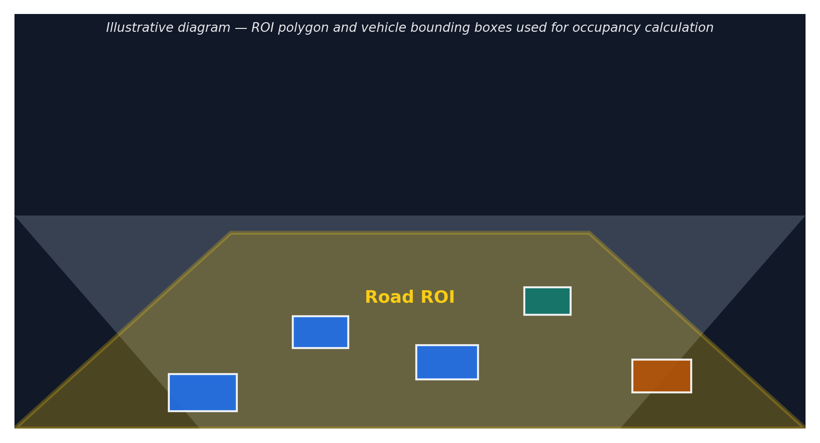
The diagram above illustrates the concept: the ROI polygon (highlighted) marks the drivable road surface, and only the portion of each vehicle's bounding box that falls inside this polygon counts toward the occupancy percentage.
An initial version estimates occupancy from raw bounding-box areas inside the ROI. This is then corrected using pixel-accurate masks: a binary mask is filled for each vehicle bounding box, intersected with the ROI mask using cv2.bitwise_and, and the occupancy percentage is computed from the actual overlapping pixel area rather than raw box area.
roi_mask = np.zeros((1440, 2560), dtype=np.uint8)
cv2.fillPoly(roi_mask, [road_roi], 255)
roi_area = cv2.countNonZero(roi_mask)

vehicle_mask = np.zeros((1440, 2560), dtype=np.uint8)
cv2.rectangle(vehicle_mask, (x1, y1), (x2, y2), 255, -1)
vehicle_mask = cv2.bitwise_and(vehicle_mask, roi_mask)
occupied_area = cv2.countNonZero(vehicle_mask)
occupancy = (occupied_area / roi_area) * 100

if average_occupancy < 20:
congestion_status = "LOW"
elif average_occupancy <= 40:
congestion_status = "MEDIUM"
else:
congestion_status = "HIGH"

On the sample video, the corrected calculation gave an average ROI occupancy of 32.28% and a maximum of 63.49%, which also places the video in the MEDIUM congestion band — consistent with the vehicle-count-based classification.

Milestone 3: Traffic Analysis Pipeline Development
Milestone 3 focuses on combining the detection, tracking, counting, density, and occupancy logic developed in Milestone 2 into a single reusable analyze_traffic() function — the equivalent of the project's core application logic. This function becomes the backbone that both the notebook and the Streamlit web app call to process a video end-to-end.
Consolidating the pipeline into one function serves two purposes: it gives the notebook a single, testable entry point for running the full analysis on a new video, and it lets the Streamlit frontend built in Milestone 4 reuse the exact same logic instead of re-implementing detection, tracking, and congestion classification inside the web app.

Activity 3.1: Build and Run the analyze_traffic() Function
analyze_traffic(video_path, output_path) opens the video, scales the ROI to the video's resolution, runs YOLOv8 tracking, draws bounding boxes, vehicle labels, center points, and the ROI overlay on every frame, writes an annotated output video, and returns a dictionary with vehicle counts, density statistics, occupancy statistics, and the final congestion status.
def analyze_traffic(video_path, output_path="/content/traffic_analysis.mp4"):
cap = cv2.VideoCapture(video_path)
width = int(cap.get(cv2.CAP_PROP_FRAME_WIDTH))
height = int(cap.get(cv2.CAP_PROP_FRAME_HEIGHT))
fps = cap.get(cv2.CAP_PROP_FPS) or 25

# scale the ROI polygon to the video's resolution
road_roi = np.array(
[[700,760],[1860,760],[2560,1440],[0,1440]], np.float32)
road_roi[:, 0] *= width / 2560
road_roi[:, 1] *= height / 1440
road_roi = road_roi.astype(np.int32)

results = model.track(
source=video_path, tracker="botsort.yaml",
classes=[2, 3, 5, 7], conf=0.4, stream=True, verbose=False
)
for result in results:
# draw boxes, labels, ROI overlay; update vehicle_tracks,
# vehicles_per_frame and occupancy_values for this frame
...

# filter valid tracks (>=5 frames), aggregate vehicle_counts,
# compute density/occupancy stats, classify congestion
return {
"cars": vehicle_counts["Car"], "bikes": vehicle_counts["Bike"],
"buses": vehicle_counts["Bus"], "trucks": vehicle_counts["Truck"],
"total_vehicles": total_vehicles,
"average_vehicles_per_frame": average_vehicles,
"average_occupancy": average_occupancy,
"maximum_occupancy": maximum_occupancy,
"congestion": congestion_status,
"output_video": output_path
}

Running the end-to-end function on the sample video reproduces the same headline results as the step-by-step analysis in Milestone 2:
Evaluation Measure | Recorded Result
Frames analyzed | 517
Cars / Bikes / Buses / Trucks counted | 55 / 7 / 2 / 1
Total unique vehicles | 65
Average vehicles per frame | 6.42 (max 11, min 2)
Average road (ROI) occupancy | 32.28% (max 63.49%)
Congestion status | MEDIUM

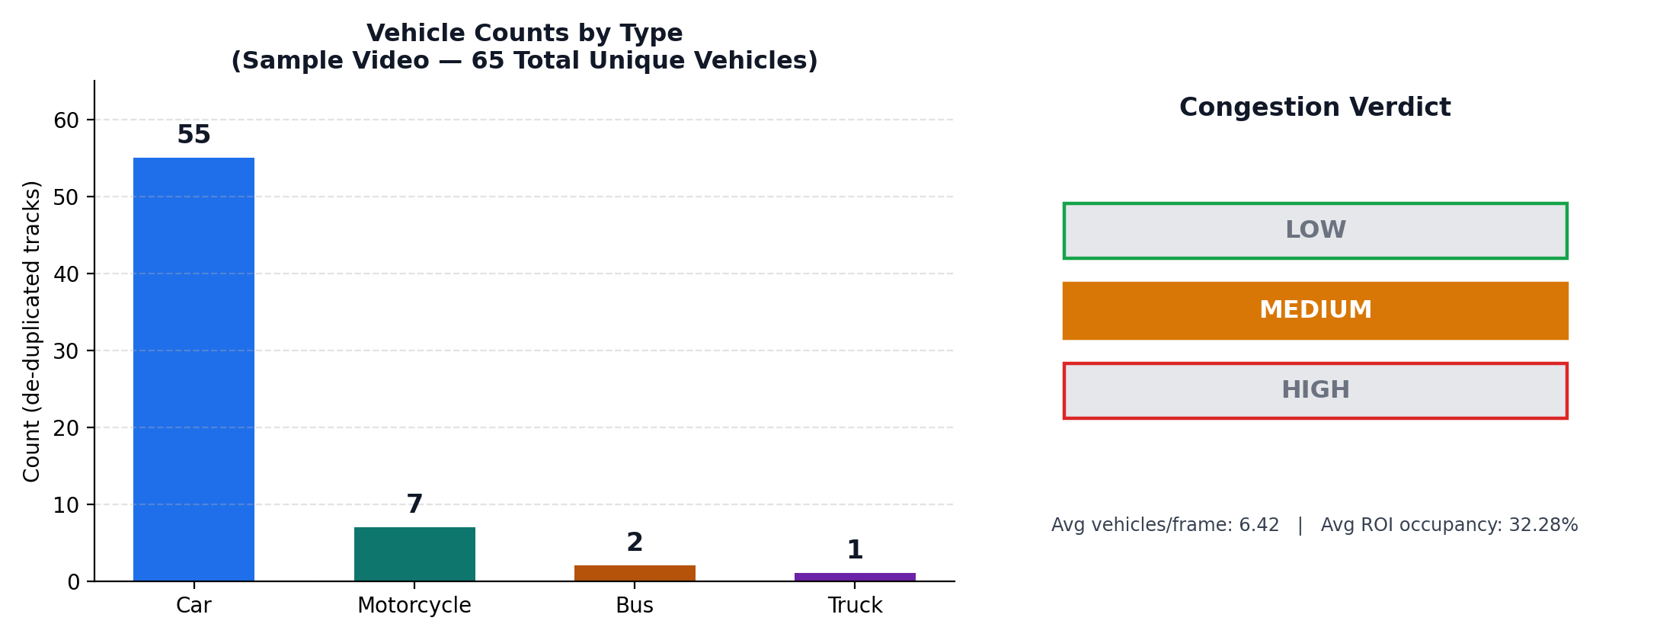
The chart above visualizes the same recorded output: the left panel breaks down the 65 unique vehicles by type, and the right panel shows where the sample video's average density (6.42 vehicles/frame) and average ROI occupancy (32.28%) land on the LOW / MEDIUM / HIGH congestion scale — both metrics independently agree on MEDIUM.

Milestone 4: Frontend Development
Milestone 4 focuses on developing a user-friendly Streamlit interface for the traffic analysis system. This involves designing a wide-layout web page for uploading a video and configuring the server so it accepts sufficiently large uploads, so that anyone can run the same analyze_traffic() pipeline from a browser without touching the notebook.
Streamlit was chosen specifically because it turns a Python analysis script into a shareable web app with very little additional code: the same load_model() and analyze_traffic() functions used in the notebook are called directly from app.py, and Streamlit handles the file upload widget, layout, and progress reporting without requiring separate HTML, CSS, or JavaScript files.

Activity 4.1: Designing and Developing the Streamlit Interface
- Set Up the Page Configuration: Configure the Streamlit page with a wide layout, a page title, and a traffic-light page icon using st.set_page_config().
- Cache the Model Load: Load the YOLOv8 model once using @st.cache_resource so it is not reloaded on every user interaction.
- Build the Upload Widget: Provide a file-upload control for the traffic video, and read its resolution, frame count, and duration with OpenCV before processing.
- Downscale Large Videos: Automatically resize videos wider than MAX_PROCESSING_WIDTH (1280 px) to keep processing responsive on modest hardware.
- Display Results: Render the vehicle counts, density statistics, ROI-occupancy statistics, and congestion verdict returned by analyze_traffic(), alongside the annotated output video, with a progress bar shown while the video is analyzed.
import streamlit as st
import cv2, os, uuid, shutil
from ultralytics import YOLO

st.set_page_config(
page_title="Traffic Analysis System",
page_icon="\U0001F6A6",
layout="wide"
)
MODEL_PATH = "yolov8n.pt"
MAX_UPLOAD_SIZE_MB = 500
MAX_PROCESSING_WIDTH = 1280
CONFIDENCE = 0.4
CLASSES = [2, 3, 5, 7]

@st.cache_resource
def load_model():
return YOLO(MODEL_PATH)

model = load_model()

Activity 4.2: Configuring the Streamlit Server
The Streamlit server configuration is raised to allow video uploads of up to 500 MB.
# .streamlit/config.toml
[server]
maxUploadSize = 500
maxMessageSize = 500

Milestone 5: Deployment
In Milestone 5, the focus is on deploying the Streamlit application, first locally to verify correct operation, and then publicly via a Cloudflare Tunnel to share the app over a secure, accessible URL. This involves configuring the server, launching it in the background, and opening a public tunnel to the local port.
Running inside Google Colab means the Streamlit server itself is not reachable from the public internet by default, since Colab only exposes the notebook interface. Cloudflare Tunnel solves this by creating an outbound connection from the Colab machine to Cloudflare's edge network, which then relays traffic from a public trycloudflare.com URL back to the local port 8501 — no port forwarding or dedicated server required.

Activity 5.1: Local Deployment and Testing
Set Up Dependencies and Stop Any Previous Instance:
!pip install -q streamlit ultralytics opencv-python-headless
!pkill -f streamlit

Launch the Streamlit Server Locally:
!nohup streamlit run app.py --server.address 0.0.0.0 --server.port 8501 > streamlit.log 2>&1 &
!curl -I http://localhost:8501

A quick curl check confirms the server is responding on port 8501 before the tunnel is opened.

Activity 5.2: Public Deployment via Cloudflare Tunnel
Cloudflare Tunnel creates a secure tunnel from a public URL to the local Streamlit server, making the app accessible from anywhere without a dedicated cloud hosting provider.
- Step 1 — Download the cloudflared Binary: Fetch the latest Linux build of cloudflared directly into the notebook environment.
!wget -q https://github.com/cloudflare/cloudflared/releases/latest/download/cloudflared-linux-amd64 -O cloudflared
!chmod +x cloudflared

- Step 2 — Open the Tunnel: Run the tunnel command, pointing it at the local Streamlit port.
!./cloudflared tunnel --url http://localhost:8501

- Step 3 — Share the Public URL: cloudflared prints a live trycloudflare.com URL in the terminal, which can be shared with anyone to access the app directly from their browser.
Important Notes:
- Free tunnels are temporary: the trycloudflare.com URL changes each time cloudflared is restarted; a persistent hostname requires a named tunnel on a Cloudflare account with a domain.
- Keep the tunnel process running: closing the notebook cell or the Colab runtime ends the tunnel, so the Streamlit server and cloudflared process must stay active for the app to remain reachable.
- Large uploads take longer: processing time scales with video length and resolution, so the configured 500 MB upload limit should be balanced against the available GPU/CPU processing time.

Exploring the Web Application's Pages:
The layouts below are illustrative mockups of the Streamlit interface, built to match the structure of app.py (page config, upload widget, metric cards, and video player), rather than literal screenshots of a live deployment.

Upload Page:
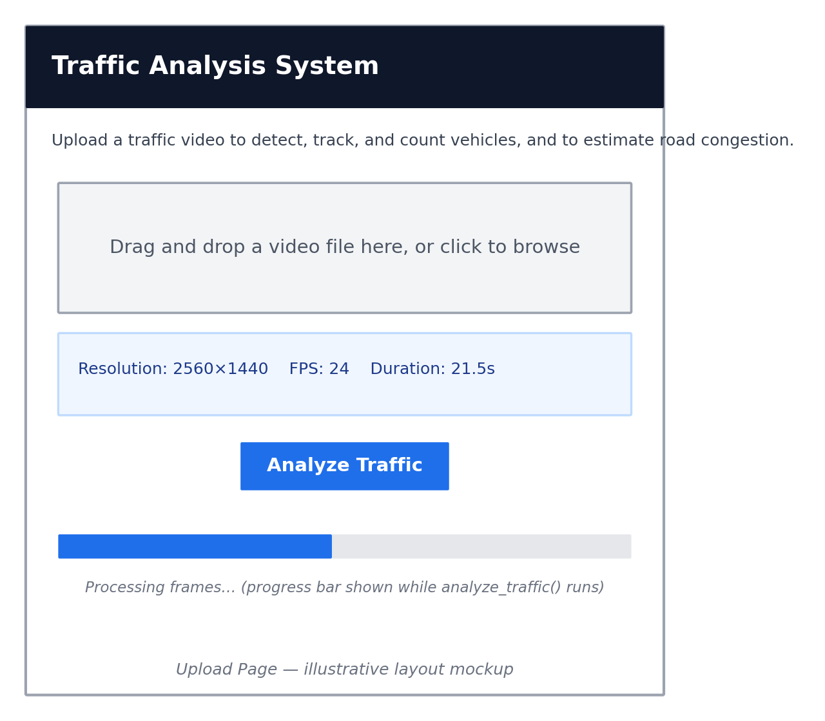
The landing view of the Streamlit app presents the Traffic Analysis System header with its traffic-light icon, a short description of what the tool does, and a file-uploader control where the user selects a traffic video from their device. Once a file is chosen, the app immediately reads and displays its resolution, frame rate, and duration using the get_video_info() helper before analysis begins, and an Analyze Traffic button starts the pipeline.

Processing / Analysis View:
After the user clicks Analyze Traffic, the app runs the analyze_traffic() pipeline on the uploaded video — resizing it first if it exceeds the MAX_PROCESSING_WIDTH of 1280 pixels — while a progress bar tracks frame-by-frame processing so the user can see that detection and tracking are underway rather than the app appearing to hang. Because the model is loaded once via @st.cache_resource, repeated analyses within the same session skip the model-loading delay and go straight to video processing.

Results Dashboard:
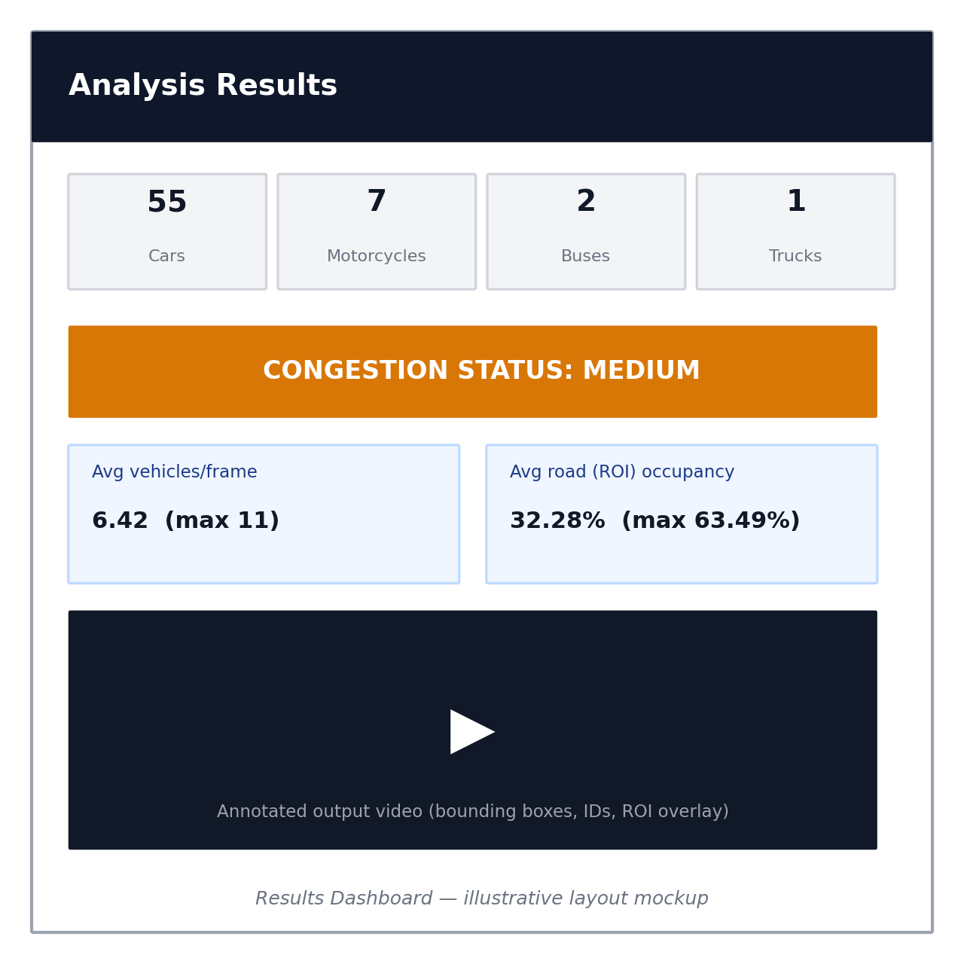
Once processing completes, the app displays the vehicle counts by type as individual metric cards, a prominent LOW/MEDIUM/HIGH congestion banner, the average and maximum vehicles per frame, the average and maximum road-ROI occupancy, and a playable copy of the annotated output video showing bounding boxes, vehicle IDs, and the ROI overlay — the same visual output produced by the notebook's analyze_traffic() call, now delivered through the browser.
For the sample video used throughout this documentation, the dashboard would show 55 cars, 7 motorcycles, 2 buses, and 1 truck, an average density of 6.42 vehicles per frame, an average ROI occupancy of 32.28%, and an overall MEDIUM congestion status, matching the results table in Milestone 3.

Conclusion:
The Traffic Vehicle Counting and Congestion Detection project demonstrates how a pretrained object detector and a multi-object tracker can be combined to build a practical traffic-monitoring tool without training a custom model. YOLOv8 identifies vehicles frame by frame, BoT-SORT keeps track of each vehicle's identity so it is only counted once, and a simple frame-filtering rule removes unreliable, short-lived detections before the final counts are produced.
By combining a straightforward vehicle-count density metric with a more precise, pixel-accurate road-occupancy metric measured inside a defined region of interest, the project classifies traffic conditions into LOW, MEDIUM, or HIGH congestion. On the sample video, both metrics agreed on a MEDIUM congestion status, with 65 unique vehicles counted across 517 frames and an average road occupancy of 32.28%.
Wrapping the pipeline in a Streamlit application and exposing it through a Cloudflare Tunnel turns the notebook analysis into an accessible web tool that anyone can use to upload a traffic video and receive an instant congestion report. The same analyze_traffic() function powers both the notebook and the browser experience, so improvements made to the detection, tracking, or congestion logic automatically carry over to the deployed app without any duplicated code.
Looking ahead, the project offers significant opportunities for expansion, such as calibrating the congestion thresholds against real traffic-authority data, supporting multiple camera angles with per-camera ROI configuration, using a larger YOLOv8 variant for higher detection accuracy, replacing the free, temporary Cloudflare tunnel with a named tunnel on a persistent domain for production use, and persisting historical traffic statistics over time so that congestion trends can be tracked hour-by-hour or day-by-day rather than for a single uploaded clip.

