**Relationship between economic and well-being measures and suicide rate in Europe**

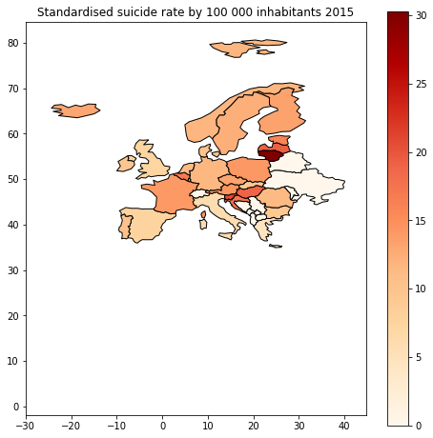

Pic.1.1

(White colour means that data wasn’t available)

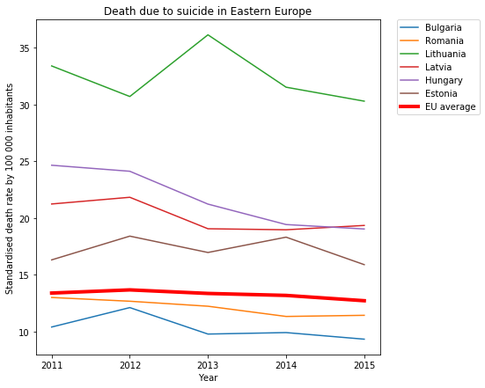

Pic. 1.2.

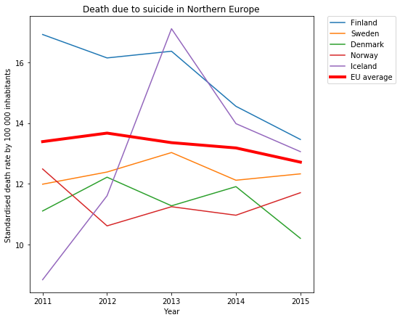

Pic 1.3.

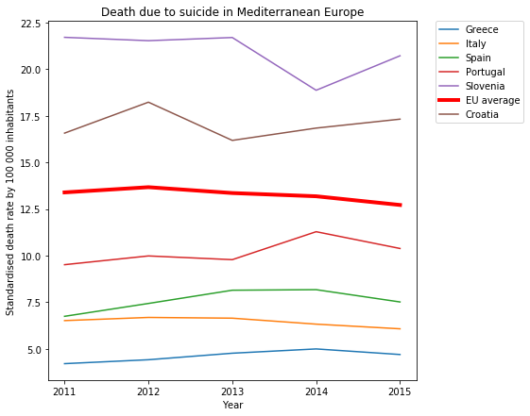

Pic 1.4.

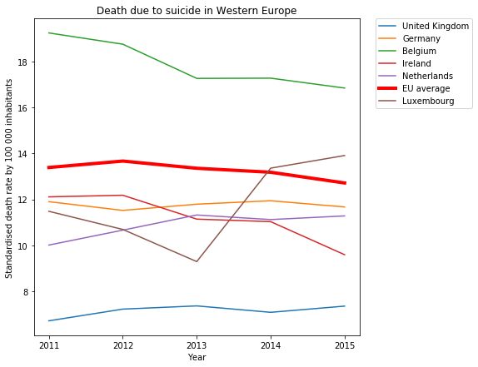

Pic. 1.5.

**Economic and wellbeing measures**

In the following plots all the values are the averages of the EU countries.

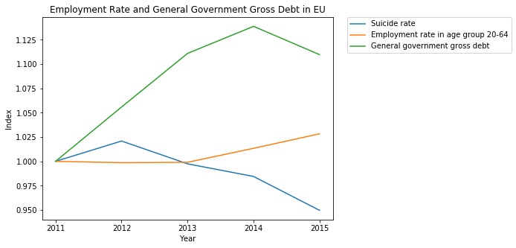

Pic 2.1.

Pic 2.2.

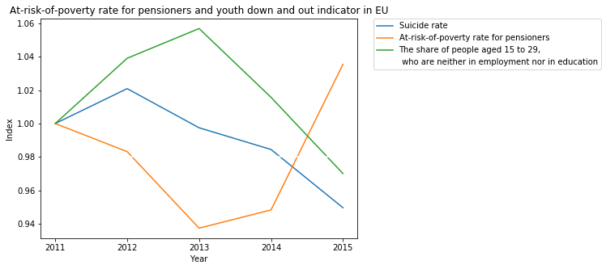

Pic 2.3.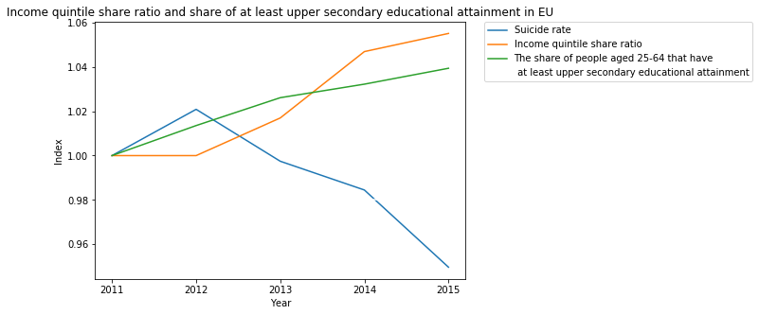

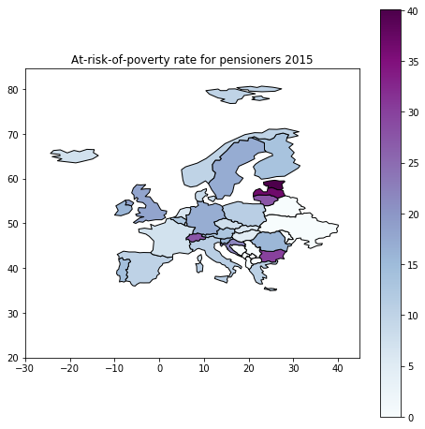

Pic. 2.4.

(White colour means that data wasn’t available)

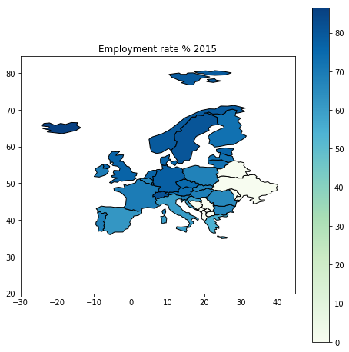

Pic 2.5.

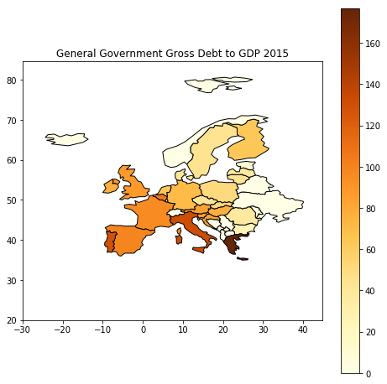

Pic 2.6.

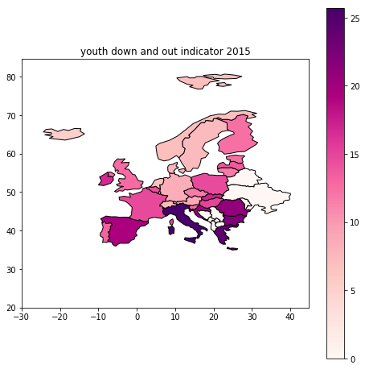

Pic 2.7.

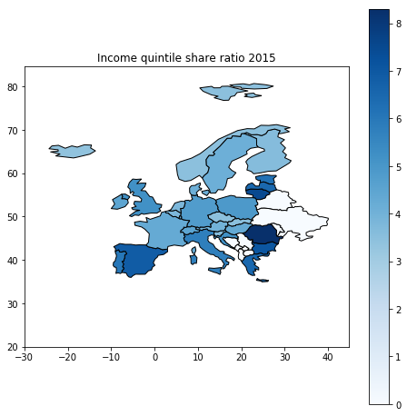

Pic. 2.8.

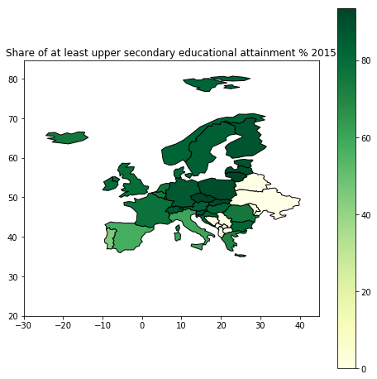

Pic 2.9.

**Our results** Pic 3.1.

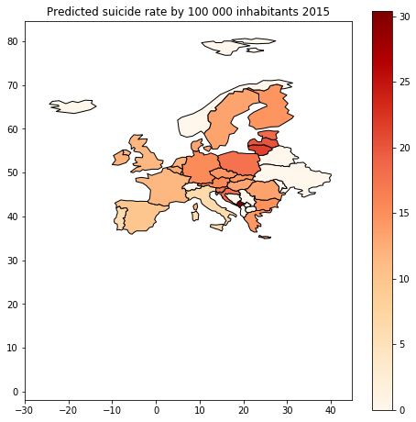

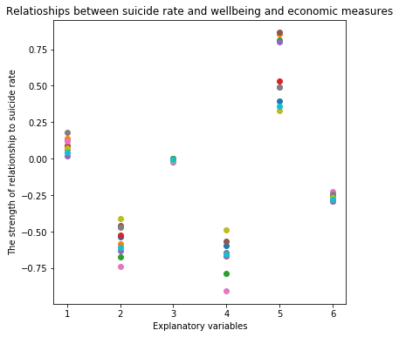

Pic. 3.2.

**Explanatory variables:**

**1 =** At-risk-of-poverty rate for pensioners

**2 =** Employment rate

**3 =** General Government Gross Debt to GDP

**4 =** Youth-down-and-out indicator

**5 =** The Income quintile share ratio

**6 =** The share of at least upper secondary educational attainment