

How to: Annotate AIF/ VOF in CTP using HiPerGator

The purpose of this guide is to introduce how to annotate the arterial input function (AIF) and venous input function (VOF) in temporal computed tomography perfusion (CTP) data on HiPerGator (HPG). **HPG is** **required** to complete this tutorial. Our annotation method is currently a **semi-automatic** method that will need your manual verification and correction (Fig.1). All results and progress will be recorded in the **Google Sheets**. You **must** have the requirements listed below to continue. This tutorial requires you use HPGs Open OnDemand service. You may need the UF VPN if you are accessing this off-campus.

* Request a HiPerGator account. [[Link](https://www.rc.ufl.edu/get-started/hipergator/request-hipergator-account/)]
* Register for an IRB account. [[Link](https://my.irb.ufl.edu/UFLIRB/sd/Rooms/DisplayPages/LayoutInitial?Container=com.webridge.entity.Entity%5bOID%5bAC482809EC03C442A46F2C8EEC4D75D3%5d%5d)]
* Complete UF IRB training. [[Link](https://irb.ufl.edu/index/requiredtraining.html)]
* **Complete the standalone annotation training.**

Optional: Download the UF VPN [[Link](https://it.ufl.edu/ict/documentation/network-infrastructure/vpn/)]

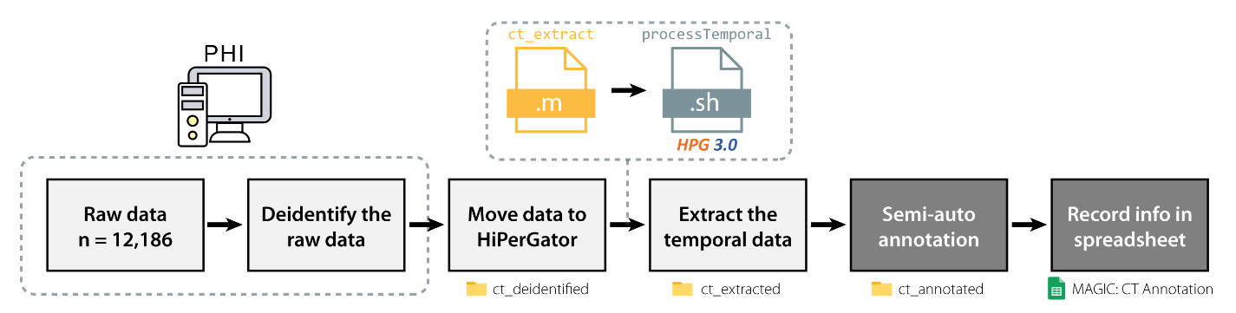

*Fig 1. Current pipeline for MAGIC annotation. The boxes in grey are covered in this tutorial.*

The standalone annotation training will help you practice proper annotation methods. The training consists of 10 training subjects. Training will be verified by the main coordinator. Once you complete the training, you will have access to the Google Sheets where you can continue annotation.

If you are new to HiPerGator, these resources may help.

* Learn basic shell commands. [[Link](https://www.educative.io/blog/bash-shell-command-cheat-sheet)]
* Learn about HiPerGator’s resources. [[Link](https://help.rc.ufl.edu/doc/Getting_Started)]
* HiPerGator training. [[Link](https://help.rc.ufl.edu/doc/New_user_training)]
* HiPerGator Open OnDemand [[Link](https://help.rc.ufl.edu/doc/Open_OnDemand)]

Section 1a: Background

**Why are we annotating AIF/VOF?** This project is based on a framework called MAGIC (Multitask, Automated Generated of Intermodal CT Perfusion Maps via Generative Adversarial Networks), originally developed by our SMILE lab alumni. MAGIC is used to synthesize contrast-free CT perfusion imaging of the brain from non-contrast enhanced CT imaging. We had acquired a dataset from UF health which includes 13,065 subjects with CT data. However, MAGIC was trained and evaluated with only a subset of 879 subjects from this dataset. The rest of the 12,186 subjects lacked a ground truth from RapidAI[1].

Recently, we acquired a new model from a collaborator that we will use to generate new ground truth comparisons for the remaining subjects. Two of the required parameters include 3D coordinates of the AIF and VOF. These are functions that show the concentration of the contrast agent in a specific region of interest over time (Fig.2)[2]. However, these parameters are not easily acquired since brain anatomy has large person-to-person variability and it normally requires manual selection. Therefore, we need annotators to help acquire these coordinates in order to help prepare the dataset.

**What is the motivation of MAGIC?** Acute ischemic stroke is the leading cause of death and disability in the US and affects more than 700,000 people each year[3]. It occurs when a blood clot restricts blood flow to the brain. This results in a corresponding loss of neurologic function. Non-contrast CT is the primary imaging modality used for treatment selection in patients with acute ischemic stroke. Non-contrast CT shows highly detailed cross-sectional images of the body but does not provide details on blood flow. CT perfusion on the other hand, can be used right after a non-contrast CT to show detailed information about the blood flow to the brain. This information can be directly used to assess and plan appropriate treatment for stroke. Fig.3 is from a paper by Lui et al. which shows a comparison between a normal subject (left) and a subject with a stroke (right)[4].

Fig 2. An example of the AIF (red) and VOF (blue) voxel and the visual placement along the main artery and vein. The graph beneath shows the concentration over time of the contrast bolus.

However, CT perfusion requires the injection of an intravenous contrast agent. This can be associated with higher costs, longer turnover time, and potential health risks. Therefore, we applied deep learning methods to synthesize contrast-free CT perfusion maps. The synthesis of contrast-free CT perfusion maps has potential significant benefits for healthcare efficiency, cost-effectiveness, and accessibility. Figure 4 shows the potential benefits of MAGIC.

|  |  |
| --- | --- |
|  |  |
| *Fig 3. (Left) Normal perfusion of the brain. (Right) Brain with large left middle cerebral artery stroke. Blue indicates lower values, while red indicates higher values. (A) Non-contrast enhanced CT scan. (B) CTP cerebral blood flow (CBF) map. The CBF map on the right shows a decrease in cerebral blood flow on the right hemisphere marked in blue. (C) CTP cerebral blood volume (CBV) map. (D) CTP mean-transit-time (MTT) map. The MTT map on the right shows a prolonged transit time of the bolus in the right hemisphere indicating delayed flow.* | |

*Fig 4. Proposed potential advantages of MAGIC compared against an estimation of the existing framework.*

Section 1b: Finding the AIF/VOF

In this section, we use anatomical guides to find the AIF and VOF in the brain. There are many axial slices we can use to find them. The **main** criteria we use to evaluate proper AIF/VOF is the **time-concentration curve**. The time-concentration curve is a graphical representation of the concentration of the contrast agent in a specific region of interest (ROI) over time. There are many arteries and veins we can use to find AIF/VOF. However, there are consistent anatomical structures we can use to guide our search.

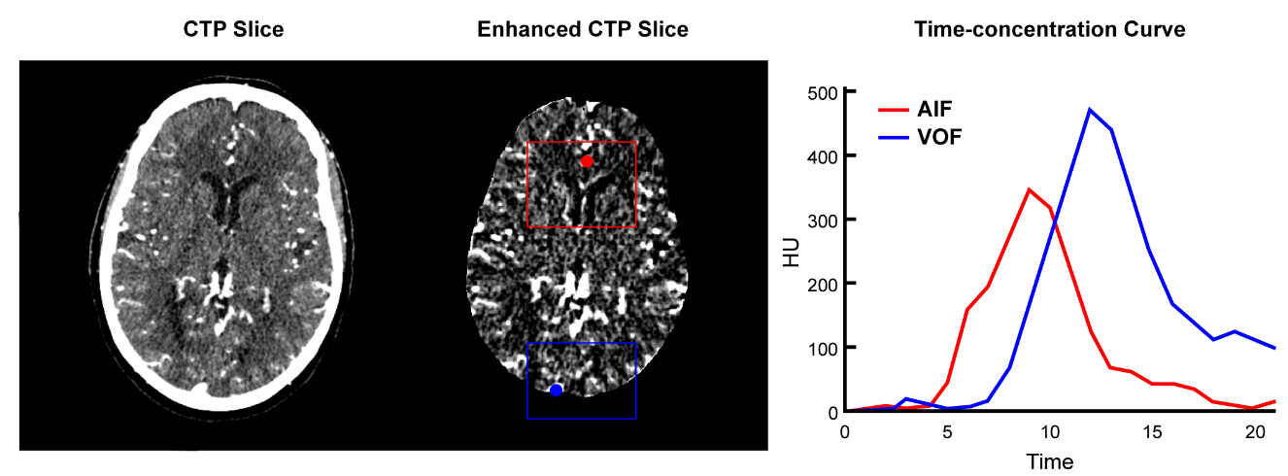

*Fig 5. Example of AIF/VOF from our automatic selection.*

To understand how to find the curves we first need to understand how to read CT images. CT images are acquired by using x-rays to generate cross-sectional, two-dimensional images of the body. The x-ray projections are reconstructed to generate structural images of the body. Each pixel in a CT image is assigned a CT number which corresponds to its attenuation value. The attenuation value is a measure of the radio density of a specific tissue or material. This value is compared to the attenuation value of water on a scale of arbitrary units named Hounsfield units (HU)(Fig.6). More negative values such as air show up darker. Higher values such as bone show up brighter. In CT perfusion maps we look for the bright regions excluding bone. The injected contrast shows up brightly in the CT scan which allows us to look at the vascular structure of the brain and to identify any abnormalities more easily. Contrast agents typically contain high concentrations of iodine, which strongly absorbs x-rays.

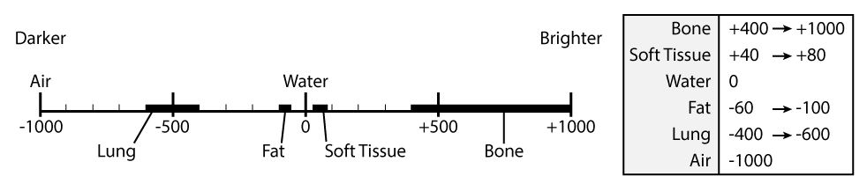

*Fig 6. Hounsfield unit scale*

The arterial input function (AIF) is defined as the concentration of the contrast medium in an artery measured over time in a region of interest. Contrary to the time-concentration curve seen in Fig.5, the curve is generally **higher**, **faster**, and **earlier** than the VOF. The curve seen in Fig.5 can be explained by the partial volume effect. This occurs when a voxel contains a mixture of two or more different materials with different attenuation values. The ideal AIF we can find is anterior to the lateral ventricle’s frontal horn and corpus callosum and posterior to the inter-hemispheric fissure (Fig.8). The artery we choose here is the anterior cerebral artery (ACA), which shows up fairly well in our scans. We can refer to this as the **ACA target.**

There is another area you can find the AIF. However, this is not as consistent as the previously mentioned AIF. You may see this in the RAPID example. The red dot in Fig.7 shows the A2 segment in the internal carotid artery (ICA) terminus. This selection is lateral to the midline of the brain. It produces a very accurate AIF curve compared to the ACA target but is unreliable to target with automatic annotation. We can refer to this as the **A2 target.**

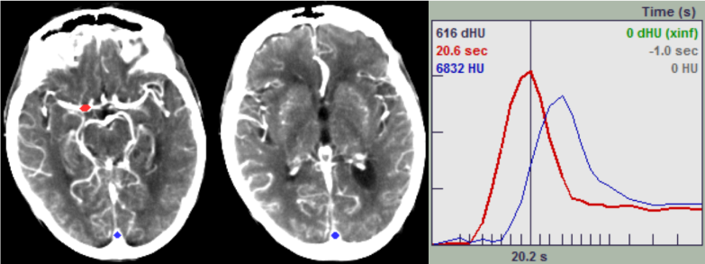

*Fig 7. Example of the AIF found in the A2 target.*

The venous output function (VOF) is defined as the concentration of the contrast medium in a vein that drains over time in a region of interest. The time-concentration curve is generally **slower** and **delayed**. The ideal VOF we can find is located at the superior sagittal sinus. The superior sagittal sinus is a large structure that is situated in the longitudinal cerebral fissure. This can easily be spotted posterior with an obvious large white spot. We can refer to this as the **SSS (superior sagittal sinus) target.**

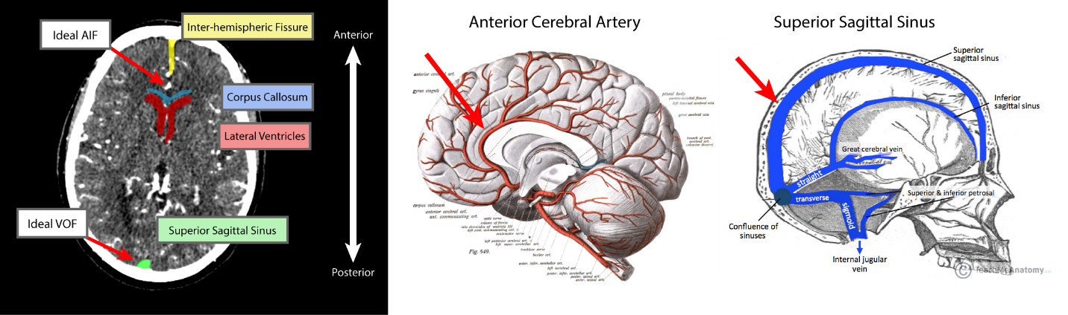

*Fig 8. Example locations of the AIF/VOF. The ideal AIF is located anterior to the corpus callosum and lateral ventricles, and posterior to the inter-hemispheric fissure. The ideal VOF is located posterior at the superior sagittal sinus.*

Section 1c: Setup (One-time)

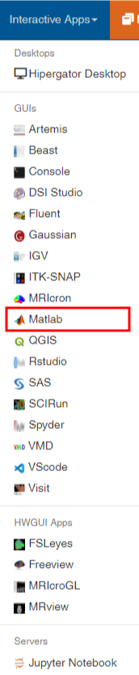In this section, we will setup the work environment. We will use the **Open OnDemand** service provided with HPG to access the tools we need. We will copy the necessary files to process and annotate the data.

1. Navigate to [Open OnDemand](https://ood.rc.ufl.edu/pun/sys/dashboard) or type ood.rc.ufl.edu in the address bar.
2. Click on the Interactive Apps tab and select MATLAB.
3. Use the following fields to launch MATLAB.

|  |  |
| --- | --- |
| General Form Fields | MATLAB |
| Number of MPI Tasks | ----- |
| MATLAB version | R2022a |
| Number of CPU cores | 2 |
| Maximum memory (GB) | 20 |
| Time Requested (hrs) | 12 |
| Cluster partition | hpg-default |
| SLURM Account | ruogu.fang |
| QoS | ruogu.fang |
| Generic Resource Request | ----- |
| Additional SLURM Options | ----- |

*Table 1. General form fields for OOD MATLAB*

1. Open a Terminal by clicking the top-left Applications button.
2. Replace USER with your HPG username and run the command below:

**cp -R /red/ruogu.fang/kylebsee/MAGIC/AIF-VOF/ /blue/ruogu.fang/USER/**

1. Using MATLAB, change the address bar to /blue/ruogu.fang/USER/
2. Open the ct_annotation.m and practice_code.m file and update the **initials** variable.

Now your workplace in MATLAB is set up. Each time you open MATLAB, you should be in the correct directory, and you have the necessary tools to start annotating CT images! The only windows you need to keep open are the MATLAB session and the Google Sheet. After the standalone training, simply move back up one directory.

Extra Tip on MATLAB Setup

A quick note on HiPerGator MATLAB. Shortcuts like copy and paste do not work the same way as your computer. You need to manually change the settings in MATLAB to make it work as normal (Fig.9). Otherwise, right-clicking your selection will achieve the same thing.

**MATLAB’s shortcut settings can be accessed by HOME > Preferences (Environment Tab)**

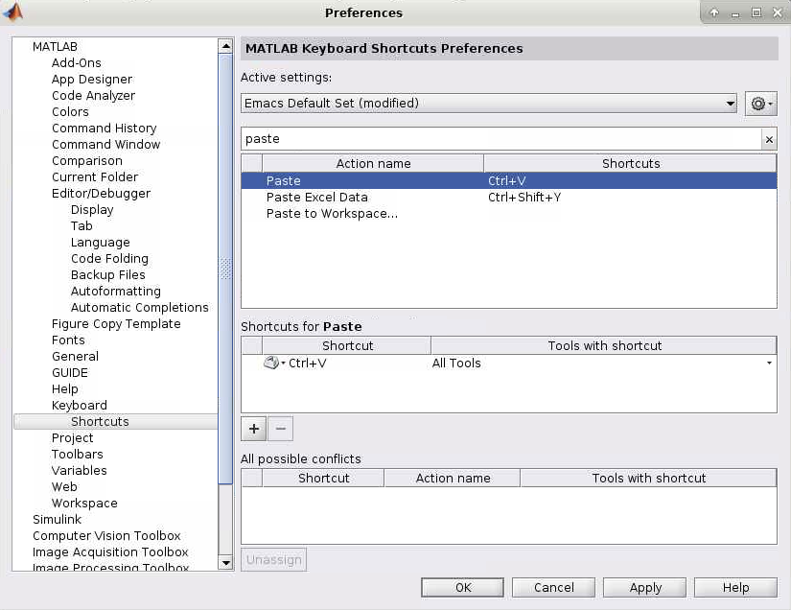

*Fig 9. Shortcut window in MATLAB’s preference settings*

Section 2: Standalone Training (One-time)

In this section, we will complete the standalone training. One of the folders copied from section 1b should include the standalone training. Here we will simply annotate the AIF/VOF of 10 subjects. The results will then be verified by the main coordinator. All annotations will follow the **ACA** and **SSS targets** (refer to section 1a). The standalone training includes the following:

* Scripts containing code for annotation. *This version only contains the manual annotation*.
* A text file which will be used to record the coordinates you find.

To begin, follow the steps to complete training.

1. Open a session of OOD MATLAB.
2. Open the **practice_code.m** script and the **practice_sheet.txt** text file in MATLAB.
3. Replace the Patient ID with a subject number found in the text file.
4. Manually annotate each subject
5. Record coordinates in **practice_sheet.txt**.
6. Once complete, notify and send the path to your folder to the main coordinator.

Once verified, you will be given access to the Google Sheet to begin annotations. You will then use **ct_annotation.m** for the annotations.

Section 3: Annotating CTP

In this section, we need both a HPG session and the Google Sheets open. Below is a quick rundown of the steps for annotating. This will closely follow the steps performed in the standalone training. The only changes are the addition of the upfront automatic selection along with using Google Sheets instead of the provided excel sheet. Following the outline is a detailed description of the process.

1. In Google Sheets, find a subject that has a green YES for the **Deidentified** and **Has CT** columns**.**
2. In MATLAB, copy the Subject ID to the patient ID variable.
3. Run the code and follow the prompts.
   * [Optional] Choose to overwrite the current file
   * Choose to accept or reject the **automatic** annotation
   * Manually select the AIF
   * Manually select the VOF
   * Choose to accept or reject your **manual** annotation
4. Record your results in the Google Sheet.

* If the image is poor quality, send the ID and notify the main coordinator.

**How to record results in the Google Sheet.** An example of Google Sheets is shown below (Fig.10). The only columns you will work with are *Annotator, Error, Manual, and XYZ Coordinates*. Below is a list of what each column means.

* Subject ID: The unique ID for each subject.
* Deidentified: Indicates if the subject has been deidentified.
* Has CTP: Indicates if the subject has CTP data.
* **Annotator:** The name of the person who generated the annotation.
* **Error:** Indicates if the image quality is too poor for annotation.
* **Manual:** Indicates if the annotation was redone manually.
* **Coordinates:** The coordinates of the AIF/VOF. Copy/pasted from MATLAB.
* Kyle S. Check: Additional verification by Kyle See once the annotation has been made.
* Done: Indicates the annotation is completed.
* 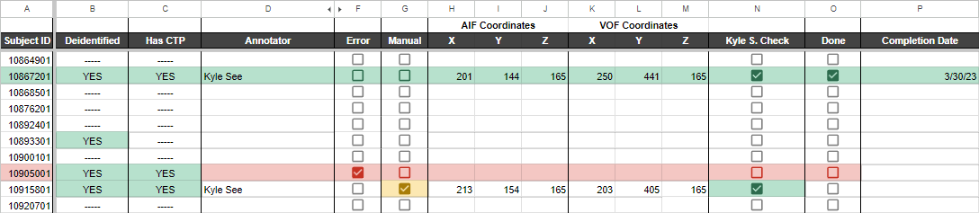Completion Date: The date the annotation was completed.

*Fig 10. Example of the Google Sheets page.*

Once you complete the automatic/manual annotation you can follow these steps:

1. Fill in the **Annotator** cell.
2. If there was any issue with the CTP map, tick the **Error** checkbox. It will flag the entire row.
3. If you have to manually redo the annotation, tick the **Manual** checkbox.
4. Copy the entire coordinate line from MATLAB’s command window.
5. Paste into **Coordinates,** click the clipboard, and select “Split text to columns” (Fig.11).

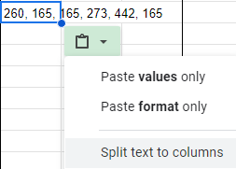

*Fig 11. Example of right-click in Google Sheets*

**Recording annotation sessions.** When you begin a session for annotating you need to record a handful of details: 1) Your name. 2) The date of the annotation session. 3) The time spent annotating. If you forget to time yourself, give your best estimation. 4) The number of annotations completed in that session. This information will be helpful to us in giving a rough estimation of how long this process will take.

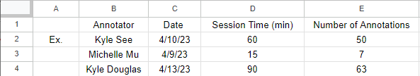

*Fig 12. Example of the annotation session page.*

**Navigating Google Sheets.** There are multiple sheets below that you can access. Below is a brief description of each sheet.

* Annotation Progress: The main annotation sheet which records all of the AIF/VOF coordinates and other important information.
* Statistics: A summary sheet that keeps track of what data we have and details the exact progress of our annotations.
* Sessions: A sheet that keeps track of the sessions from the annotators.
* Annotation Descriptions: A key for the Annotation Progress sheet to what each column means.



*Fig 13. Example of the Sheets*

Section 4: Annotation Walkthrough

This section will walk through the annotation process. This section assumes you have MATLAB open and the script ready to go. The section starts off as soon as you hit the run button after filling in the parameters.

**A description of the annotation code.** You will be prompted with a window showing an automatic selection of the AIF/VOF locations. A window will pop-up above asking if you would like to keep the selection. Make a choice depending on the quality of the AIF/VOF curve. If you accept the selection, the image will be saved under the subject ID’s folder. If you decline the selection, you will be redirected to make your own selection.

The figure below shows the following prompts if you decline the automatic selection. You will first select the AIF. Then the curve and your click will be shown in another window. A second prompt will ask if you want to keep the curve. If you decline, you will re-select the AIF. When you accept, you will move to the VOF.

*Fig 14. Manual selection of the AIF*

The figure below shows the following prompts once you select the AIF. You will now select the VOF. The VOF curve and your click will be shown in another window. A third prompt will ask if you want to keep the curve. Your previously selected AIF will also be shown. If you decline, you will re-select the VOF. When you accept, you will review your selection.

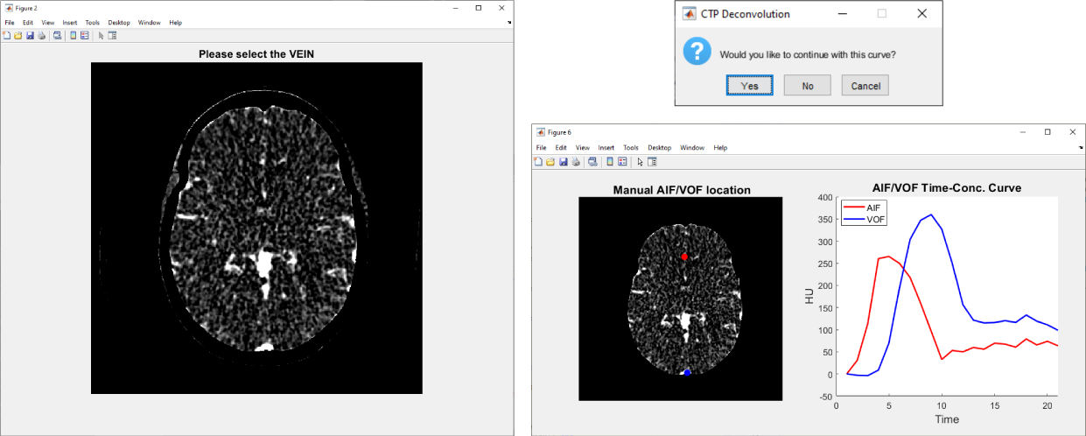

*Fig 15. Manual selection of the VOF*

Once you have selected your AIF and VOF, a final review screen will be displayed. This will be similar to the automatic selection in the beginning. You will have a chance to re-do your manual selection by selecting No on this fourth prompt.

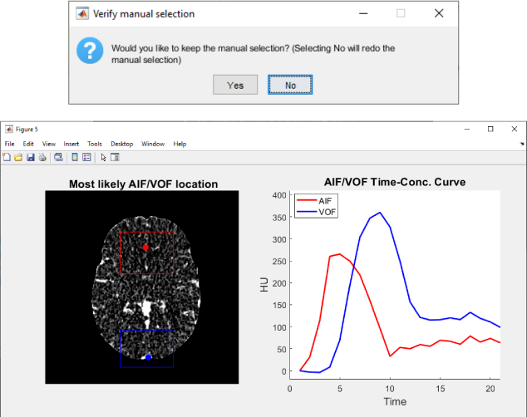

*Fig 16. Confirmation of the AIF/VOF*

Once you complete your selection, the rest of the information will show up in the command window. The coordinates for the AIF and VOF can be copy and pasted directly into the Google Sheet. Paste the coordinates into the X AIF column and select the **split text to columns** option to quickly split the coordinates. Each coordinate should end up in their respective places.

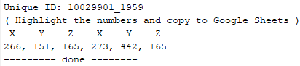

*Fig 17. AIF/VOF coordinate results*

If you need to re-do your selection afterwards or there is an existing file in the folder, a prompt will give a few options when you first run the code. You can choose to overwrite the existing annotation which will delete the current annotation and run the code normally. You can choose delete to simply delete the annotation and skip the annotation process. You can choose skip and nothing will happen.

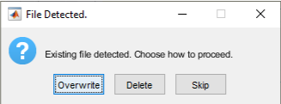

*Fig 18. File detected window.*

**How does the automatic ROI code work?** There are a few extra options available to change if needed. These are the slice and ROI variables found under the patient ID variable. A higher slice number up to 320 is superior while lower slice numbers down to 1 are more inferior. The ROI variables can be changed but will generally be in the same area. Otherwise, manual correction is normally performed. If you need to adjust the ROI for any reason, the ROIs work like this. The red boxes in Fig.19 show the coordinates for the AIF ROI. In the code, the ROI is set using [ X1, Y1, X2, Y2 ].

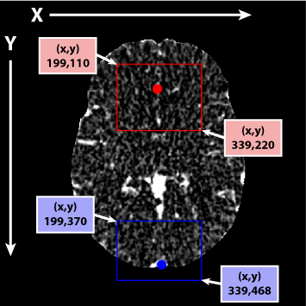

*Fig 19. Example of ROI coordinates used in automatic selection.*

1. https://www.rapidai.com/
2. https://entokey.com/arterial-input-function-and-venous-output-function/
3. https://jamanetwork.com/journals/jama/fullarticle/2789540
4. Y.W. Lui, E.R. Tang, A.M. Allmendinger and V. Spektor. American Journal of Neuroradiology October 2010, 31 (9) 1552-1563; DOI: <https://doi.org/10.3174/ajnr.A2026>