Operation Manual
Power Car Seat – Panthera Project

ABSTRACT
This document provides comprehensive operational instructions for the Panthera car seat control system. It details procedures for operating the system through physical buttons, UART communication, and CAN communication. This manual serves as a reference for users and technicians who need to interact with the system, ensuring proper usage and maximizing functionality.

Revision note
Version | Date | Author | Description of Changes
v0.1 | 2025-10-08 | Uy Nguyen Quoc | Initialize document
Contents
1 Introduction 3
2 Button Operation Instructions 4
2.1 Overview and Button Functions 4
2.2 Operation Modes 5
2.2.1 Installation Mode 6
2.2.2 Manual Mode 7
2.2.3 Recall Mode 8
3 Communication Interface 11
3.1 UART Communication 11
3.1.1 Connection Setup 11
3.1.2 Configure Software 11
3.1.3 Message Structure 11
3.1.4 Operation Procedure 13
3.2 CAN Communication 13
3.2.1 Connection Setup 13
3.2.2 Configure Software 13
3.2.3 Message Structure 15
3.2.4 Operation Procedure 17
APPENDIX 19

Figures
Figure 1. Button Layout of Panthera Seat Control System (Top view) 4
Figure 2. Seat Movement Directions Corresponding to Buttons 5
Figure 3. Activating Installation Mode by Pressing Three RECALL Buttons 6
Figure 4. Installation Sequence Diagram 7
Figure 5. Manual Control Operation Example (Button SLIDER_1) 8
Figure 6. Saving a Seat Position to Memory 9
Figure 7. Recalling a Saved Position Using RECALL Button 10
Figure 8. Connect Board with PC via UART 11
Figure 9. Connect board with PC via CAN communication 13
Figure 10. Connect USB CAN with PC 14
Figure 11. Configure baudrate for CAN communication 14
Figure 12. Configure others parameters 15
Figure 13. Example fill data transmit 16
Figure 14. Example fill data transmit 17
Figure 15. CAN communication interface 18

TABLES
Table 1. Button Functions in the Panthera Seat Control System 4
Table 2. Parameters of UART communication 11
Table 3. UART Message Frame 12
Table 4. UART message structure 12
Table 5. Example identifying the request message for UART communication 12
Table 6. Example identifying the request message for UART communication 12
Table 7. Parameters of CAN communication 13
Table 8. CAN message structure 15
Table 9. Rule to convert CAN message 15
Table 10. Example identifying the request message for CAN communication 16
Table 11. Example convert message 16
Table 12. Example identifying the request message for CAN communication 16
Table 13. Example convert message 17

1 Introduction
The Panthera Power Car Seat system provides multiple methods of operation to accommodate different use cases and integration scenarios. This manual covers three primary methods of interaction:
- Button Operation - Using the physical control buttons on the seat or control panel
- UART Communication - Interfacing with the system via serial communication
- CAN Communication - Controlling the system through automotive CAN bus networks
Each method provides complete access to the system's functionality with varying degrees of complexity and integration requirements. This document provides step-by-step instructions for all operational modes to ensure proper system usage.

2 Button Operation Instructions

2.1 Overview and Button Functions
The Panthera seat control system features a set of intuitive buttons for controlling various seat positions and memory functions. The buttons are strategically placed for easy access and operation.

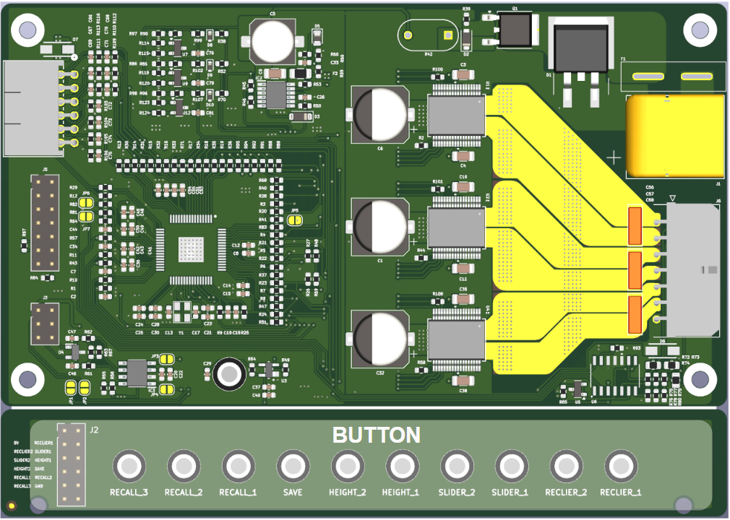
Figure 1. Button Layout of Panthera Seat Control System (Top view)
The table below provides a comprehensive overview of all buttons, their functions, and associated actions:

Table 1. Button Functions in the Panthera Seat Control System
No. | Button name | Function | Action
1 | RECLINER_1 | Seatback Upright Position | Press and hold to return seatback to upright position. Release to stop movement
2 | RECLINER_2 | Seatback Recline Position | Press and hold to recline seatback. Release to stop movement
3 | SLIDER_1 | Seat Forward Adjustment | Press and hold to move the seat forward. Release to stop movement
4 | SLIDER_2 | Seat Backward Adjustment | Press and hold to move the seat backward. Release to stop movement
5 | HEIGHT_1 | Seat Upward Movement | Press and hold to raise the seat. Release to stop movement
6 | HEIGHT_2 | Seat Downward Movement | Press and hold to lower the seat. Release to stop movement
7 | SAVE | Save Current Position | Press to begin the position saving sequence
8 | RECALL_1 | Memory Position 1 | Press and short hold to recall saved position 1 or save current position to memory slot 1
9 | RECALL_2 | Memory Position 2 | Press and short hold to recall saved position 2 or save current position to memory slot 2
10 | RECALL_3 | Memory Position 3 | Press and short hold to recall saved position 3 or save current position to memory slot 3

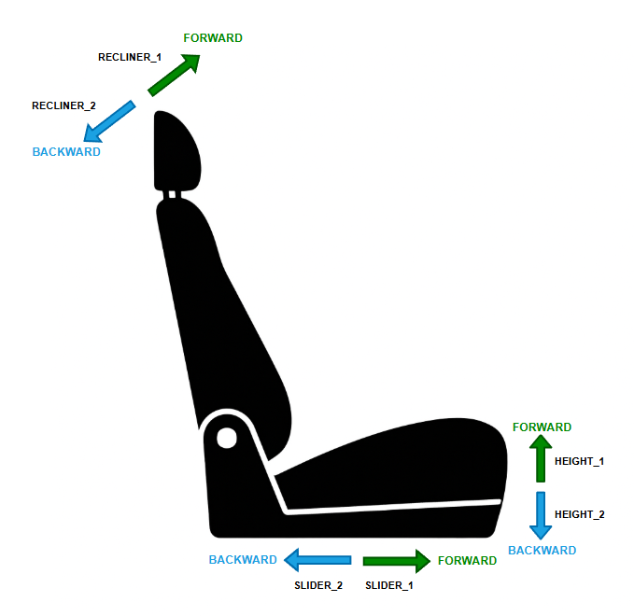
Figure 2. Seat Movement Directions Corresponding to Buttons

2.2 Operation Modes
The Panthera seat control system offers three primary operation modes:
- Installation Mode: Used for initial setup and calibration of seat movement limits.
- Manual Mode: Direct control of seat position using physical buttons.
- Recall Mode: Saving and retrieving customized seat positions from memory.

2.2.1 Installation Mode
Installation Mode is designed for initial setup and calibration of the seat control system. This mode runs an automatic calibration sequence that establishes the operational limits for all seat axes.
To Enter Installation Mode:
- Press and hold all three RECALL buttons (RECALL_1, RECALL_2, and RECALL_3).
- simultaneously until all three motors of seat move backward (Approximately 3 seconds).
- The system will begin the automatic installation sequence.
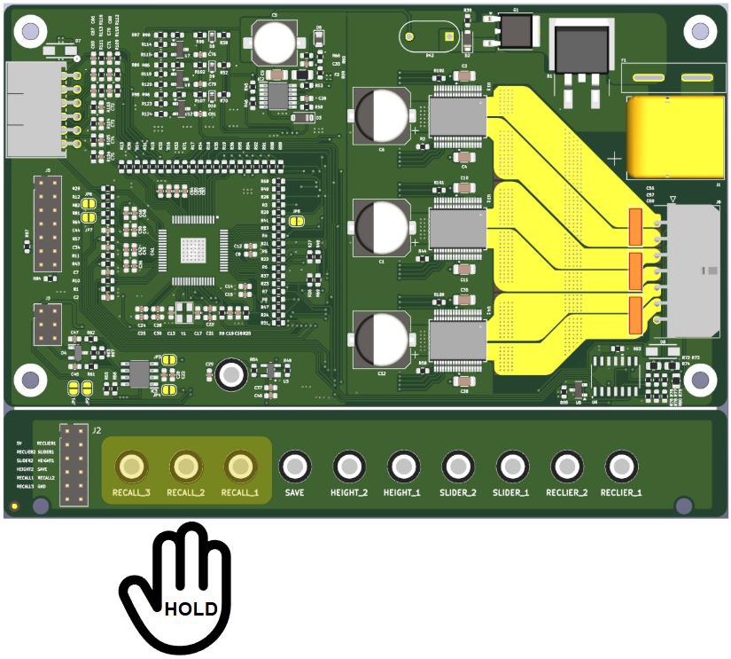
Figure 3. Activating Installation Mode by Pressing Three RECALL Buttons
Installation Sequence:
- All three axes of the seat will move backward simultaneously to find their rear limits
- Upon reaching the backward limits, the system resets the coordinate values for all three recall positions and recognizes this position as the "home" position
- All three axes then move forward to find their forward limits
- Upon reaching the forward limits, the system stores these positions as the maximum values for each axis
- The system returns to IDLE state, ready for normal operation
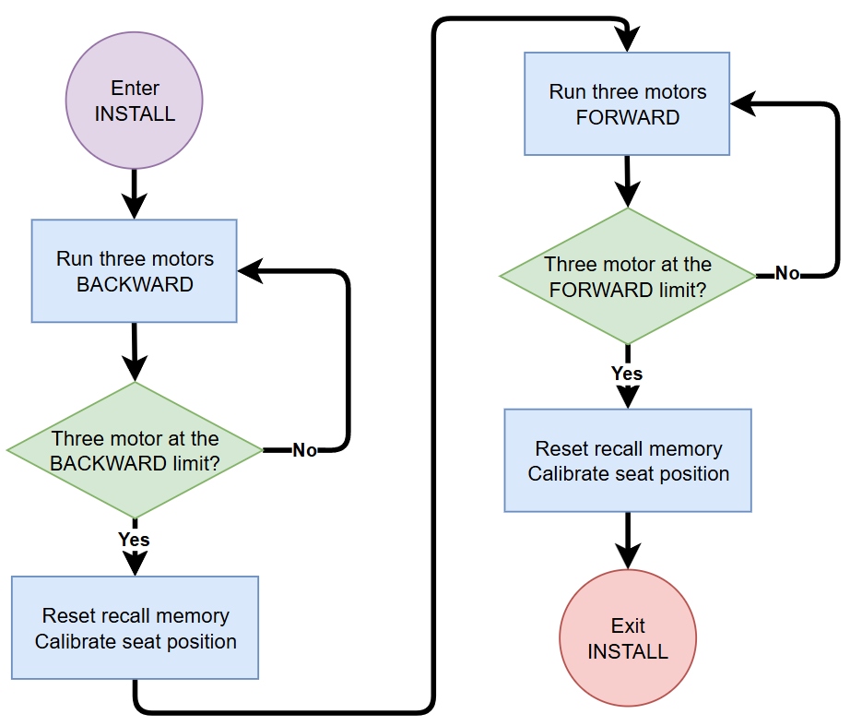
Figure 4. Installation Sequence Diagram
Note:
- Do not interrupt the installation process once it begins
- Ensure no obstacles are in the seat's path during calibration
- The entire process takes approximately 60-90 seconds to complete
- After completion, the seat will be ready for normal operation
- This process only needs to be performed once during initial installation or after maintenance

2.2.2 Manual Mode
Manual Mode is the standard operation mode for direct seat adjustment using the control buttons.
Manual Mode Operation:
- Press and hold any movement button (SLIDER_1, SLIDER_2, HEIGHT_1, HEIGHT_2, RECLINER_1, or RECLINER_2)
- The corresponding seat section will move in the indicated direction as long as the button is held.
- Multiple buttons can be pressed simultaneously for compound movements Release buttons to stop movement.
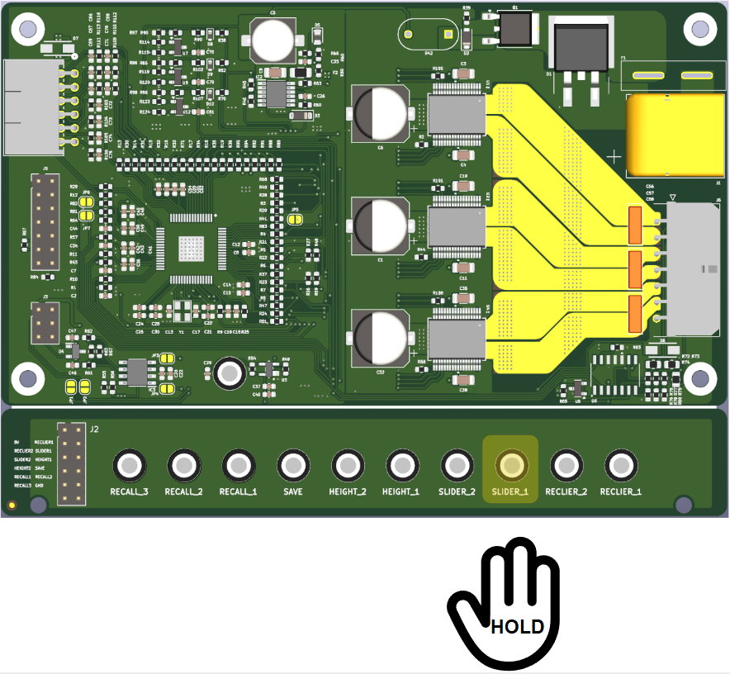
Figure 5. Manual Control Operation Example (Button SLIDER_1)

Example of Manual Operation:
To adjust the seat to a comfortable driving position:
- Press and hold SLIDER_1 to move the seat forward
- Release SLIDER_1 to stop seat at ideal position

Note:
- Movement stops immediately when button is released
- System automatically prevents movement beyond mechanical limits

2.2.3 Recall Mode
Recall Mode allows users to save and retrieve up to three customized seat positions. By default, all three recall position coordinates are initialized to 0, 0, 0, with each axis corresponding to recliner, slider, and height positions respectively.
Memory Functions:
The seat position is defined by coordinates along three axes:
- Recliner axis: Controls the angle of the seatback
- Slider axis: Controls forward/backward position of the entire seat
- Height axis: Controls the vertical position of the seat
To Save a Position:
- Adjust the seat to your desired position using Manual Mode (all three axes)
- Press the SAVE button once
- Within 0.5 seconds, press one of the RECALL buttons (1, 2, or 3) to store the current position to that memory slot
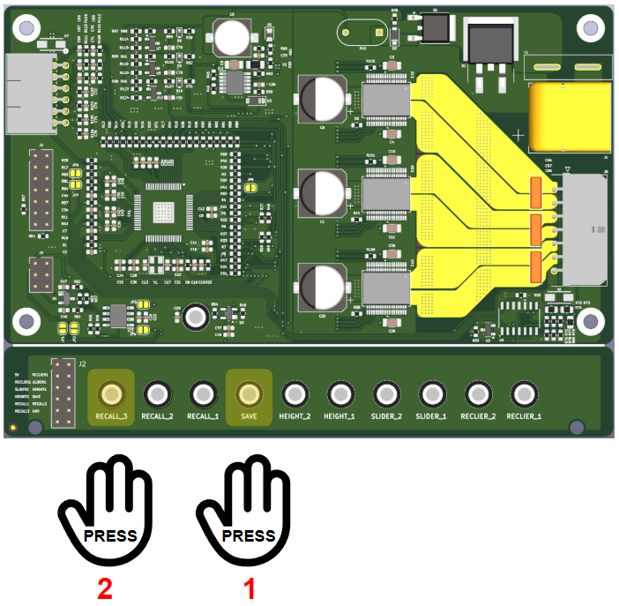
Figure 6. Saving a Seat Position to Memory

Example of Saving a Position:
To save your preferred driving position to memory slot 3:
- Use manual controls to adjust all three axes (recliner, slider, height) to your ideal driving position.
- Press the SAVE button once (system enters save mode).
- Press RECALL_3 within 0.5 seconds.
- Your preferred driving position is now stored in memory slot 3.
To Recall a Position:
- Press the corresponding RECALL button (1, 2, or 3) once.
- The seat will automatically move to the stored position, adjusting all three axes simultaneously.
- When the target position is reached, the system returns to IDLE state.
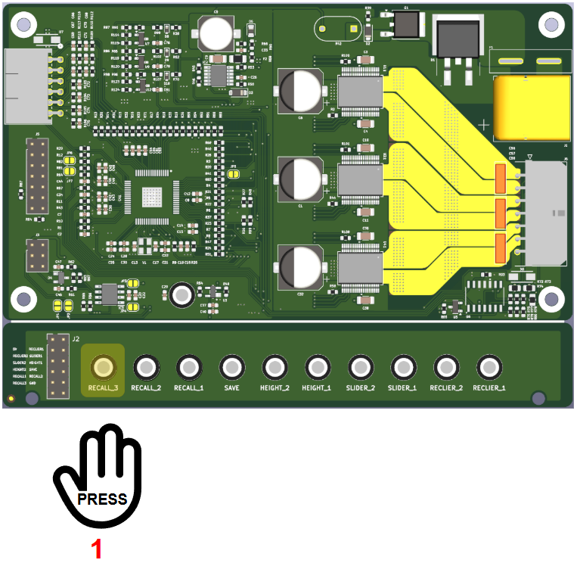
Figure 7. Recalling a Saved Position Using RECALL Button

Example of Using Recall Function:
To quickly return to your saved driving position after someone else has used the seat:
- Enter the vehicle and press RECALL_3 once (assuming your position is saved in memory slot 3)
- The seat will automatically move all three axes simultaneously to your saved position
- Once the seat reaches the saved position, it will stop automatically and be ready for use
Note:
- Each user can have their own preferred positions stored in the three memory slots.
- Saved positions are retained even when power is disconnected.
- Positions can be overwritten at any time by repeating the save procedure.

3 Communication Interface

3.1 UART Communication
UART (Universal Asynchronous Receiver-Transmitter) communication provides a simple serial interface for controlling and monitoring the Panthera system. This interface is ideal for development, testing, and integration with microcontroller-based systems.

3.1.1 Connection Setup
The UART interface requires a standard 2-wire connection plus ground. Follow these steps for proper hardware setup:
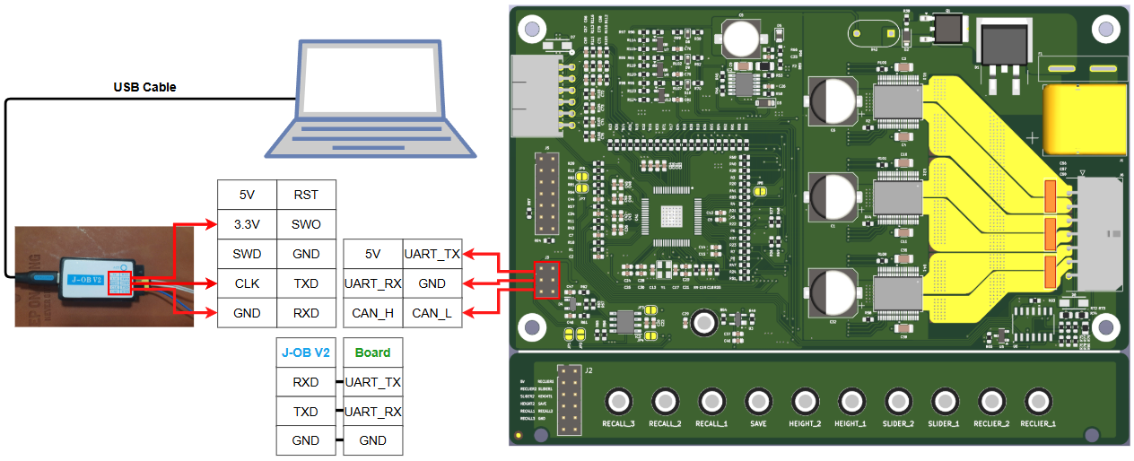
Figure 8. Connect Board with PC via UART

3.1.2 Configure Software
Software: HyperTerminal
Table 2. Parameters of UART communication
Parameter | Value
Port | Select appropriate COM port
Baud Rate | 115200
Data Bits | 8
Stop Bits | 1
Parity | None

3.1.3 Message Structure
UART commands follow a structured binary format to ensure reliable communication and error detection.
Command Frame Format:
Table 3. UART Message Frame
A | A | A | A | R/W | D

Table 4. UART message structure
Field | Size | Value
COMMAND_ID (AAAA) | 4 | Refer to APPENDIX
REQUEST (R/W) | 1 | READ = 0 / WRITE = 1
DATA (D) | 1 | 0 / 1

Example:
To hold button SLIDER_1:
Table 5. Example identifying the request message for UART communication
Field | Request | Value
COMMAND_ID (AAAA) | SLIDER_1 | 0001
REQUEST (R/W) | Hold | WRITE = 1
DATA (D) | Hold | 1

- Message: 000111

To read status of SLIDER_2
Table 6. Example identifying the request message for UART communication
Field | Request | Value
COMMAND_ID (AAAA) | SLIDER_2 | 0002
REQUEST (R/W) | Read | READ = 0
DATA (D) | Read | X (0 or 1)

- Message: 000200 or 000201

3.1.4 Operation Procedure
- Based on the requested action (Read or Write) and the target object, generate the corresponding message frame.
- Enter the generated message frame into the designated .txt file.
- Send the message frame and wait for the response.
- If the write operation is successful, the response will be “Success.”
- For read operations, the data response will be 0 or 1 depending on the current state.

3.2 CAN Communication
CAN (Controller Area Network) communication provides a robust, automotive-grade interface for integrating the Panthera system into vehicle networks. This interface supports real-time monitoring, control, and diagnostic functions suitable for production environments.

3.2.1 Connection Setup
The CAN interface requires proper hardware configuration and termination for reliable operation. Follow these steps for correct CAN bus setup:
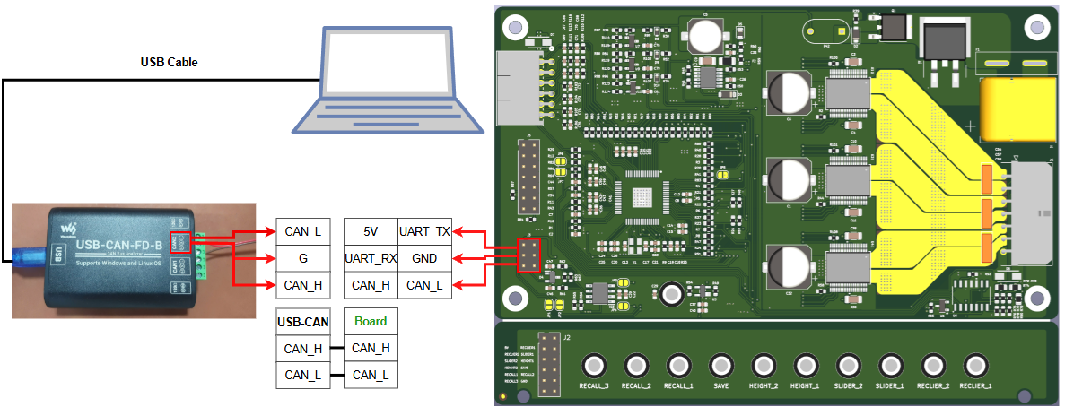
Figure 9. Connect board with PC via CAN communication

3.2.2 Configure Software
Software: USB_CANFD TOOL
Table 7. Parameters of CAN communication
Parameter | Value
Baud Rate | 100kbps
Type | Standard
Protocol | CAN
Data length | 2

Example config USB_CANFD TOOL
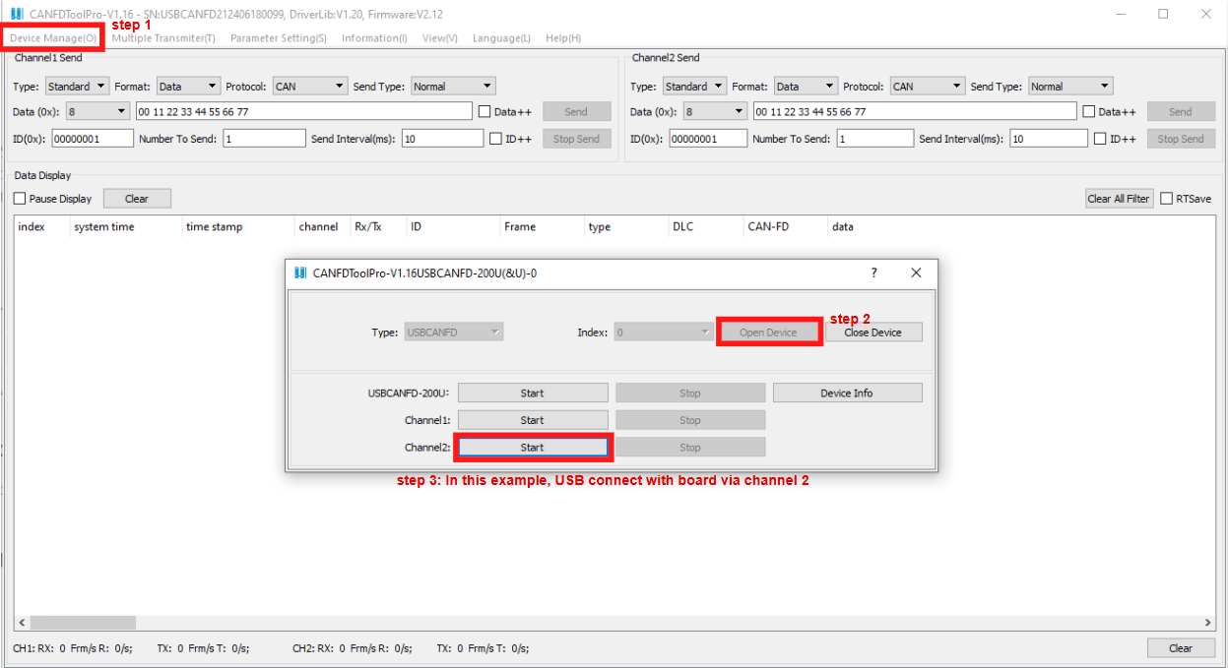
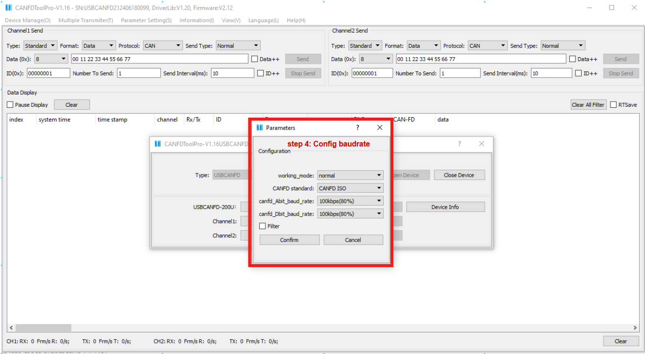
Figure 10. Connect USB CAN with PC
Figure 11. Configure baudrate for CAN communication

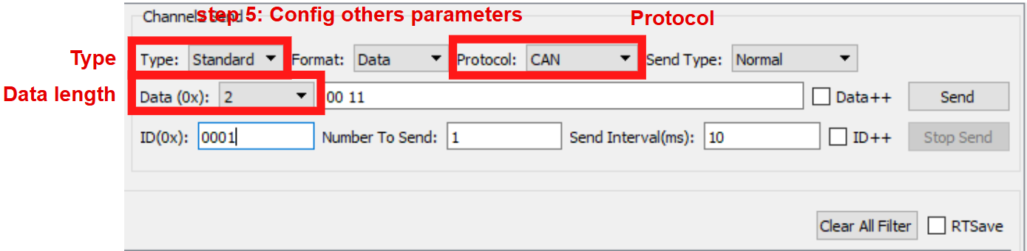
3.2.3 Message Structure
Figure 12. Configure others parameters
CAN messages use specific identifiers and data formats to organize communication between the host and Panthera system.
Table 8. CAN message structure
Field | Size | Value
COMMAND_ID (AAAA) | 4 | Refer to APPENDIX
REQUEST (R/W) | 1 | READ = 0 / WRITE = 1
DATA (D) | 1 | 0 / 1

Note:
After identifying the request message, Convert the CAN message into the appropriate format required for software input prior to transmission.
Table 9. Rule to convert CAN message
Field | Contents
COMMAND_ID (AAAA) | Convert from DEC value to HEX value
REQUEST (R/W) | 1 convert to 01 / 0 convert to 00
DATA (D) | 1 convert to 01 / 0 convert to 00

Example:
To hold button SLIDER_1:

Table 10. Example identifying the request message for CAN communication
Field | Request | Value
COMMAND_ID (AAAA) | SLIDER_1 | 0001
REQUEST (R/W) | Hold | WRITE = 1
DATA (D) | Hold | 1

- Message: 0001 11
Convert data to fill into software:
Table 11. Example convert message
Field | Value | Value
COMMAND_ID | 0001 | 01
REQUEST | 1 | 01
DATA | 1 | 01
- ID(0x) : 01 (COMMAND_ID)
- Data (0x): 01 01 (REQUEST + DATA)

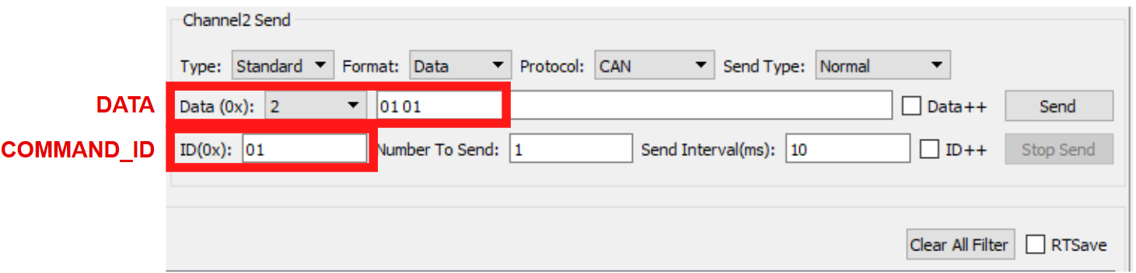
Figure 13. Example fill data transmit
To hold button Save (Memory):
Table 12. Example identifying the request message for CAN communication
Field | Request | Value
COMMAND_ID (AAAA) | MEMORY | 0017
REQUEST (R/W) | Hold | WRITE = 1
DATA (D) | Hold | 1

- Message: 0017 11
Convert data to fill into software:
Table 13. Example convert message
Field | Value | Value
COMMAND_ID | 0017 | 11
REQUEST | 1 | 01
DATA | 1 | 01
- ID(0x) : 11 (COMMAND_ID)
- Data (0x): 01 01 (REQUEST + DATA)

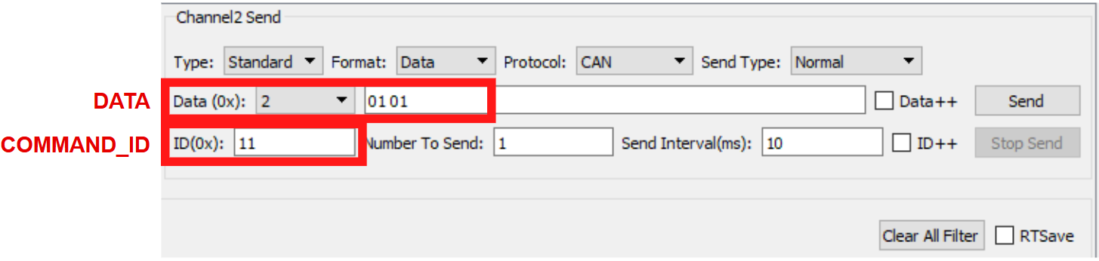
Figure 14. Example fill data transmit

3.2.4 Operation Procedure
- Identify the message ID, the requested action (Read or Write), and the corresponding data.
- Enter the message ID into the ID (0x) field.
- Enter the data (including the Read/Write request and associated data) into the Data (0x) field.
- Click Send to transmit the CAN message.
- Observe the response message:
- For Read requests, the response data will be 0 or 1 depending on the current state.
- For Write requests, a response of 00 FF indicates that the write operation was successful.
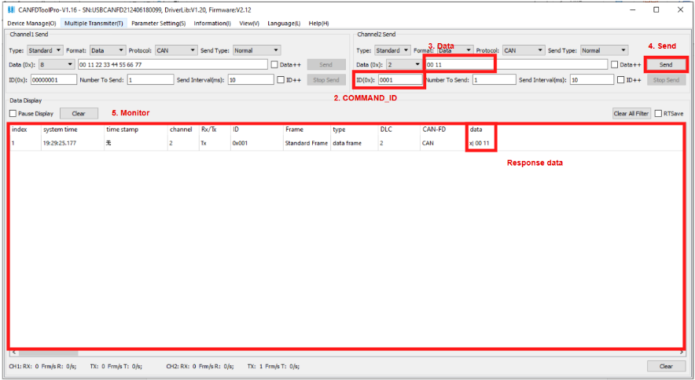
Figure 15. CAN communication interface

APPENDIX
Interface CAN & UART Communication
ID | Description | Command | Write Data Definition | Read Response Definition
0000 | Power ON | Read | NA | 1: Power ON
0001 | Positioning KEY: Seat Forword | Read/Write | 0: Button is releasd  1: Button is hold | 0: Button is releasd  1: Button is pressed
0002 | Positioning KEY: Seat Backward | Read/Write | 0: Button is releasd  1: Button is hold | 0: Button is releasd  1: Button is pressed
0003 | Positioning KEY: Seat Upward | Read/Write | 0: Button is releasd  1: Button is hold | 0: Button is releasd  1: Button is pressed
0004 | Positioning KEY: Seat Downward | Read/Write | 0: Button is releasd  1: Button is hold | 0: Button is releasd  1: Button is pressed
0005 | Positioning KEY: Seat Recliner Forword | Read/Write | 0: Button is releasd  1: Button is hold | 0: Button is releasd  1: Button is pressed
0007 | Positioning KEY: Seat Recliner Backward | Read/Write | 0: Button is releasd  1: Button is hold | 0: Button is releasd  1: Button is pressed
0010 | Seat Forword: IN1_1 | Read | NA | 0: Pin is low logic  1: Pin is high logic
0011 | Seat Backward: IN2_1 | Read | NA | 0: Pin is low logic  1: Pin is high logic
0012 | Seat Upward: IN1_2 | Read | NA | 0: Pin is low logic  1: Pin is high logic
0013 | Seat Downward: IN2_2 | Read | NA | 0: Pin is low logic  1: Pin is high logic
0014 | Seat Recliner Forword: IN1_3 | Read | NA | 0: Pin is low logic  1: Pin is high logic
0015 | Seat Recliner Backward: IN2_3 | Read | NA | 0: Pin is low logic  1: Pin is high logic
0016 | Memory | Read/Write | 0: Button is releasd  1: Button is hold | 0: Button is releasd  1: Button is pressed
0017 | Key A | Read/Write | 0: Button is releasd  1: Button is hold | 0: Button is releasd  1: Button is pressed
0020 | Key B | Read/Write | 0: Button is releasd  1: Button is hold | 0: Button is releasd  1: Button is pressed
0021 | Key C | Read/Write | 0: Button is releasd  1: Button is hold | 0: Button is releasd  1: Button is pressed
0022 | Motor HALL_1 | Read | NA | 0: Using Sensorless  1: Using Hall Sensor
0023 | Motor HALL_2 | Read | NA | 0: Using Sensorless  1: Using Hall Sensor
0024 | Motor HALL_3 | Read | NA | 0: Using Sensorless  1: Using Hall Sensor

