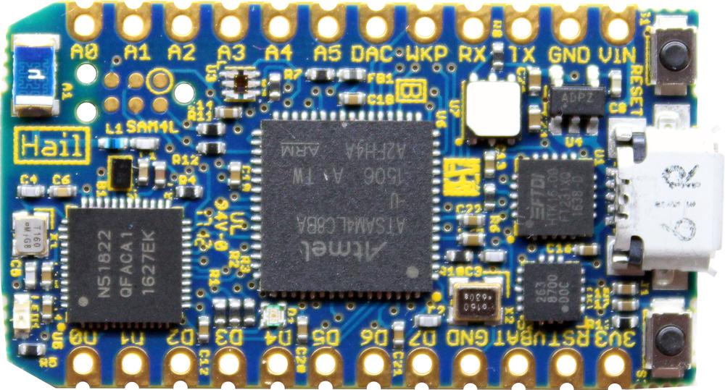Hail Development Module

Hails come pre-loaded with a Tock kernel and the hail test app. To see the current readings of the sensors:

$ pip3 install tockloader  
$ tockloader listen

For more detailed instructions and tutorials, please visit:

https://github.com/helena-project/tock/tree/master/boards/hail

https://www.tockos.org/