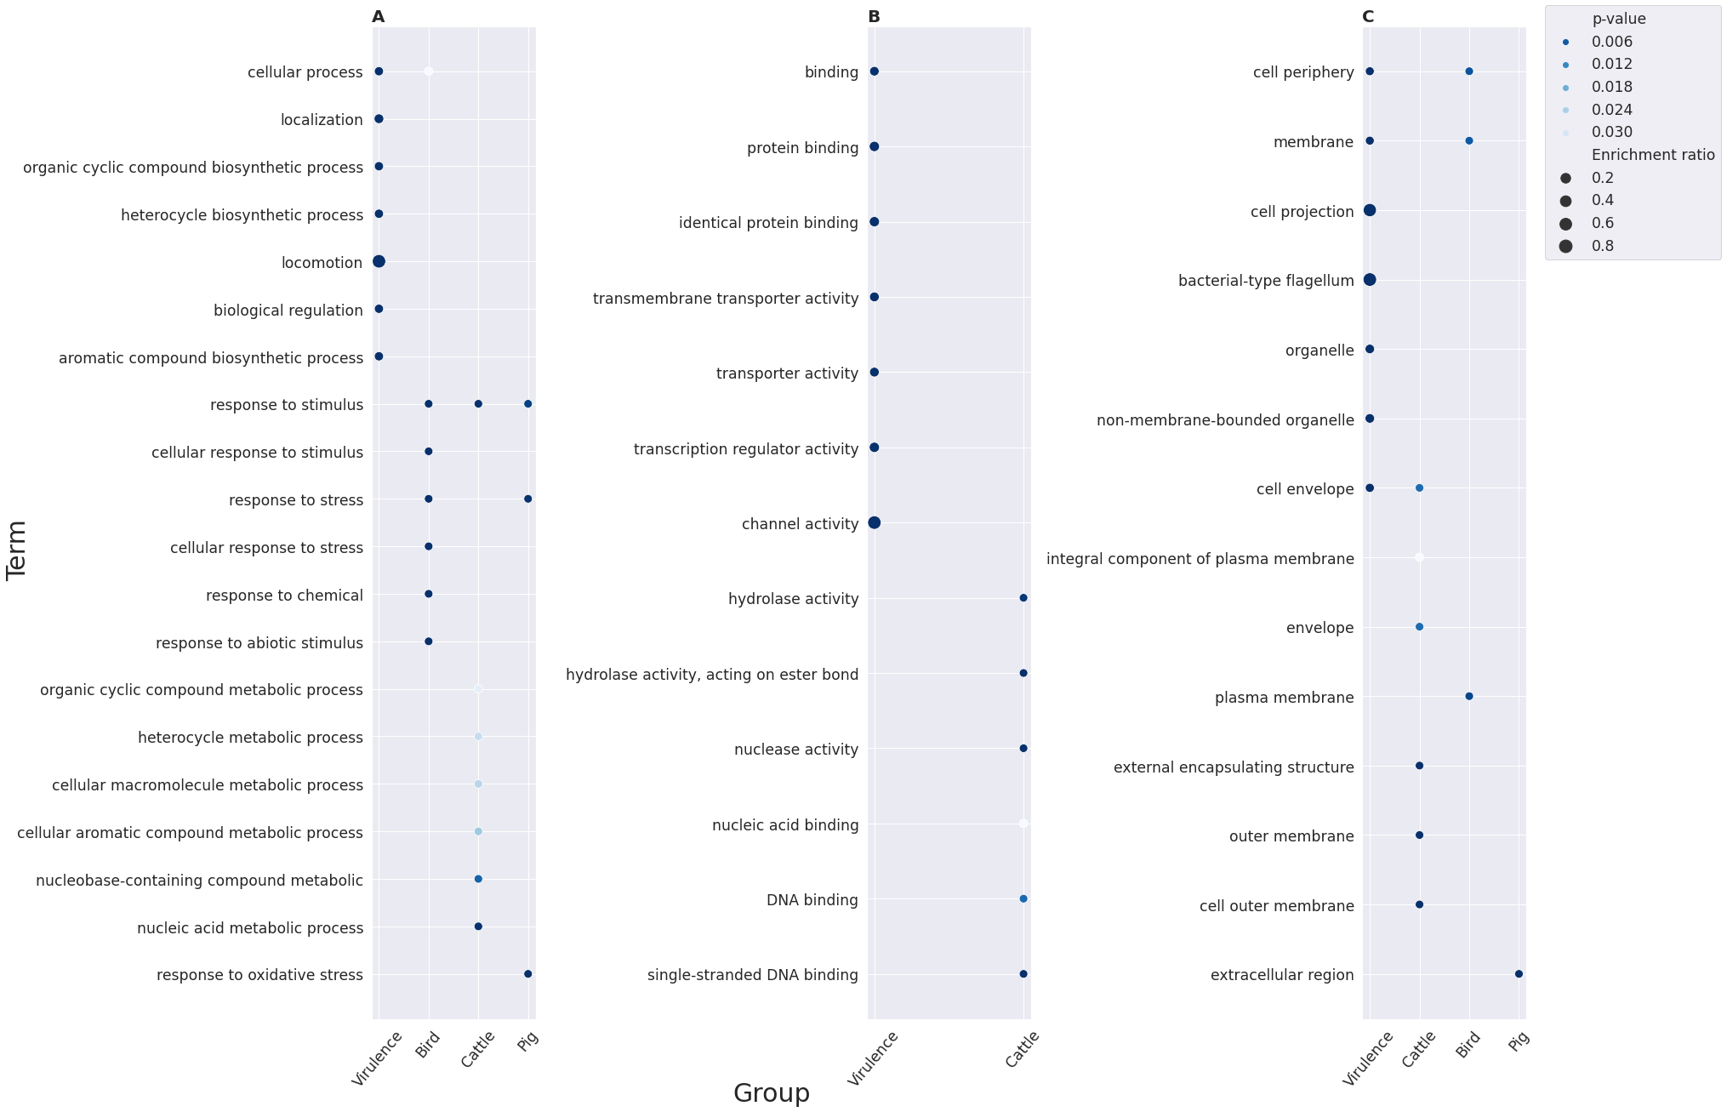

**Fig. 1** Functional annotation of host specificity factors with over-represented terms the using GO (Gene Ontology) annotation system with virulence factor. Shown are the results for the sets of pyseer-reported positive associations with certain hosts filtered according to the Benjamini-Hochberg (BH) procedure correction for multiple comparisons within the Biological processes (**A**), Molecular functions (**B**), and Cellular components (**C**) ontologies.The dot size depicts the enrichment ratio, while the intensity of the color is proportional to p-values.

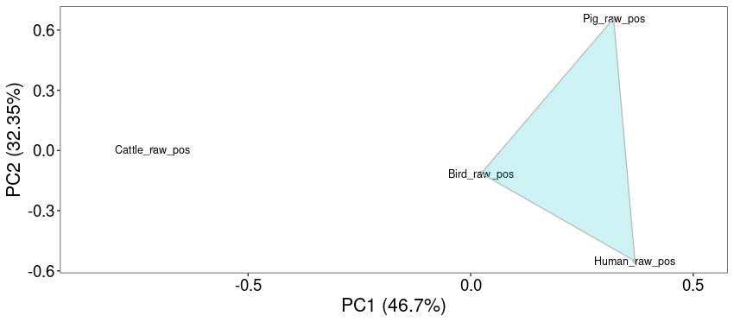

**Fig. 2.** The k-means algorithm clustering results using Shimkevich–Simpson metrics based on significant functional annotation enrichments within groups attributed to different hosts.

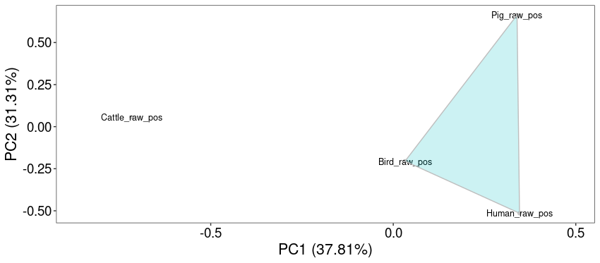

**Fig. 3.** The k-means algorithm clustering using Jaccard coefficients metrics results based on significant functional annotation enrichments within groups attributed to different hosts.