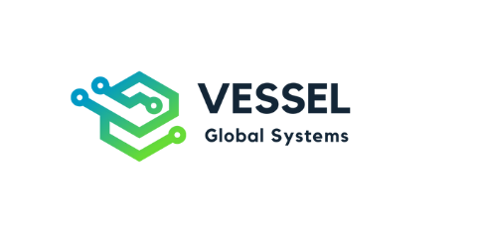
Phone: +254 731 318 075
Email: info@vesselsystems.co.ke / sales@vesselsystems.co.ke
Address: Forever Homes, Ngong Rd
www.vesselsystems.co.ke

