Predictive Modeling Using Machine Learning
Thiranex Internship — Task 2
Prepared by: Rohit Labana

1. Abstract
This project demonstrates a supervised machine-learning regression workflow that estimates a student's final score from study-related input features. It covers data inspection, missing-value handling, train/test splitting, model training, quantitative evaluation, and visual analysis.

2. Dataset and Important Limitation
The included dataset contains 500 simulated rows and five input features: daily study hours, attendance percentage, previous score, assignments completed, and nightly sleep hours. The target variable is final_score (0–100). A few input values are intentionally missing to demonstrate imputation. This is a synthetic educational dataset, not a real student dataset. The results are for demonstrating the workflow only and should not be interpreted as validated educational predictions.

3. Methodology
- Load the CSV using Pandas and separate features (X) from target (y).
- Split data into 80% training and 20% test sets using random_state=42 for reproducibility.
- Use median imputation to fill missing numeric input values. Standardize inputs for Linear Regression.
- Train and compare Linear Regression and Random Forest Regressor.
- Evaluate on the held-out test set using MAE, RMSE, and R².
- Create actual-versus-predicted, residual, and feature-importance charts.

4. Models and Evaluation Metrics
Linear Regression provides a simple baseline. Random Forest Regressor can model non-linear relationships. MAE measures the average absolute error, RMSE gives larger errors more weight, and R² compares performance with a baseline that predicts the test-set mean. Lower MAE/RMSE and higher R² generally indicate better predictions.

5. Results
Model | MAE | RMSE | R²
Linear Regression | 5.522 | 6.750 | 0.867
Random Forest Regressor | 5.539 | 7.207 | 0.848
Based on the lowest test RMSE in this run, the selected model is: Linear Regression.
These numbers are generated from the included synthetic dataset and are not evidence of performance on real-world data.

6. Visual Analysis
Figure 1. Actual vs predicted final scores. Points closer to the dashed diagonal indicate smaller prediction errors.
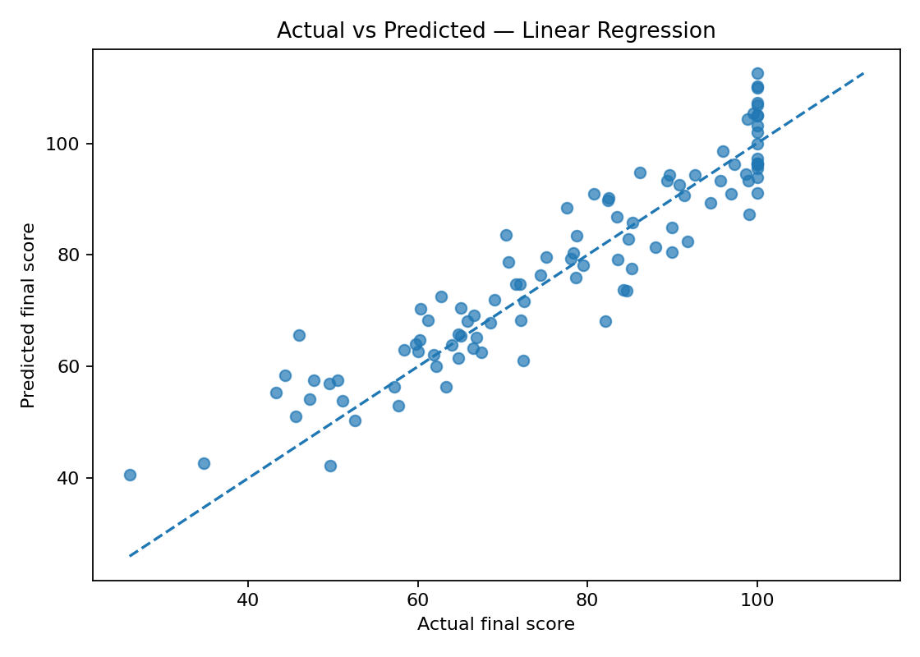
Figure 2. Residual plot. Residuals are actual scores minus predicted scores; patterns can indicate model limitations.
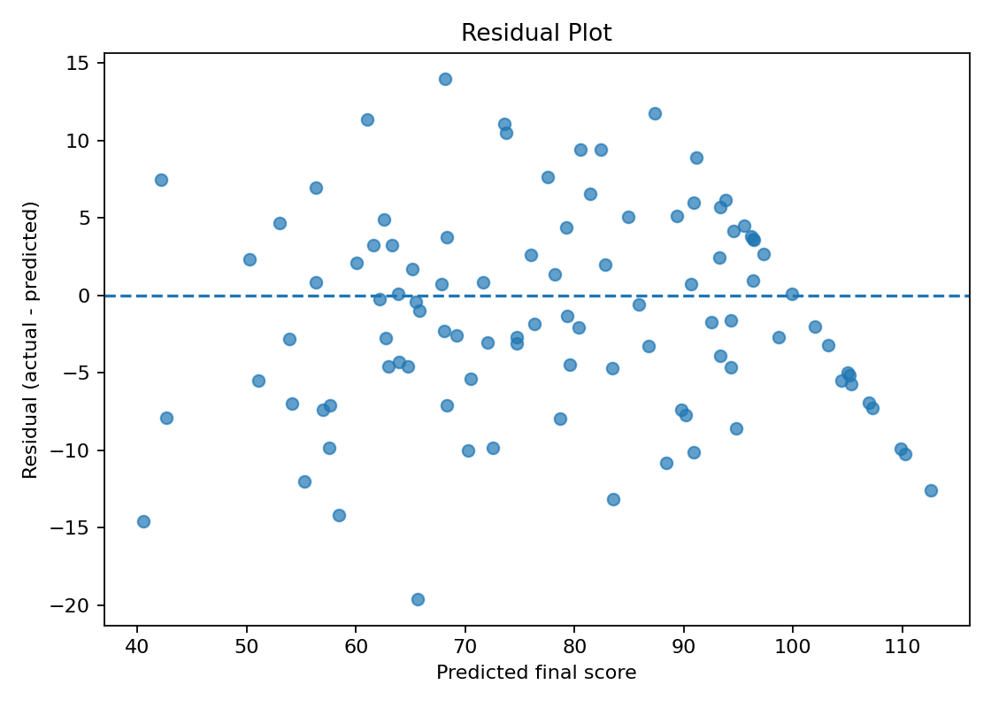
Figure 3. Relative feature importance for the selected model.
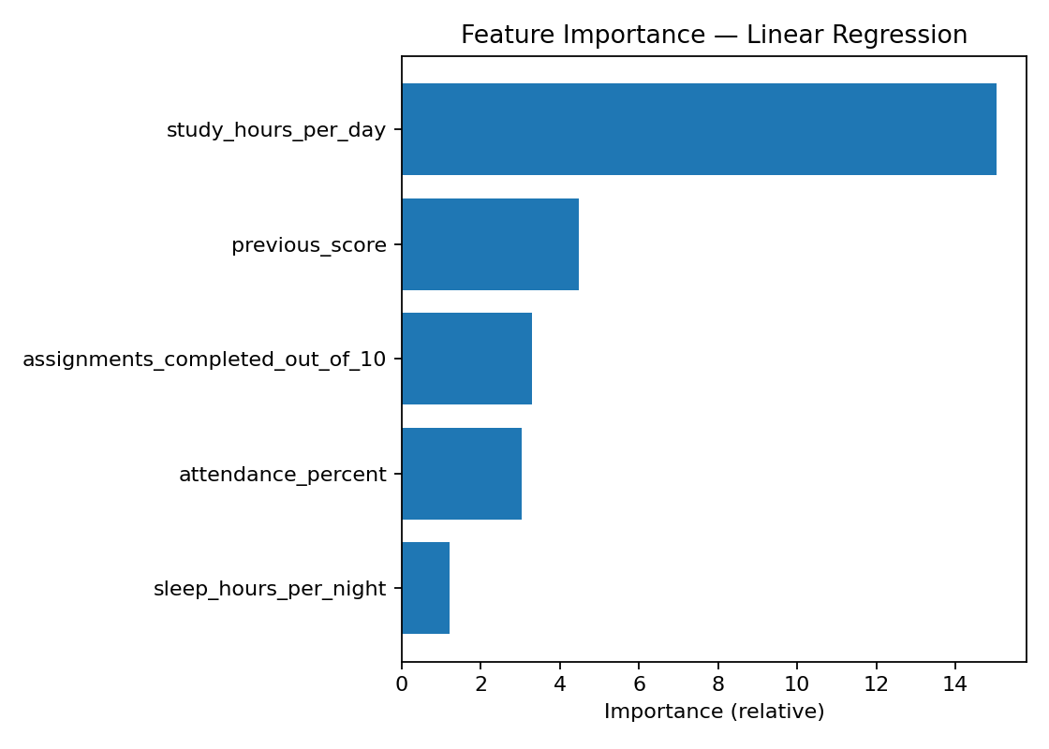

7. Conclusion
The project implements a complete introductory regression workflow and produces reproducible evaluation files and plots. A real deployment would require an approved, representative dataset, validation with a mentor, checks for data leakage and bias, and further tuning. Since the current data is simulated, the findings should be treated as a demonstration only.

8. How to Run
Install the packages listed in requirements.txt, then run `py train_model.py` from the project folder. The script saves model_metrics.csv, test_predictions.csv, and PNG plots in the outputs folder.

