**STUDENT PANEL**

**How do I sign in to GC LAMP?**

You must have an active internet connection to sign in.

* 1. Go to [lamp.gordoncollege.edu.ph](https://classroom.google.com/)
  2. Type your GC domain email and GCES password then click Log in.

If you have trouble signing in, follow these steps.

1. Go to [lamp.gordoncollege.edu.ph](https://classroom.google.com/)
2. Click forgot password link.



1. Type your Student ID, GC domain email and birth date. Then click Submit. 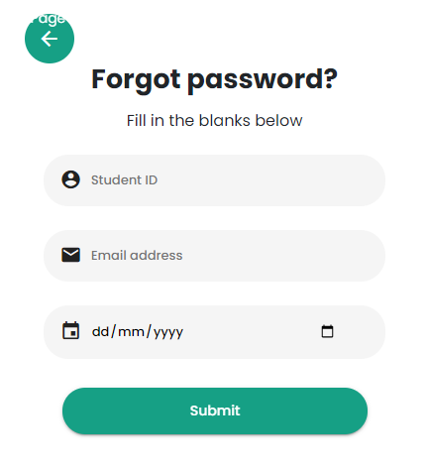
2. Check your GC domain email (and your Spam Folder as well) for your temporary password.
3. Use your temporary password to sign in.

**Unable to see Classes?**

**Could not submit activities?**

**Submitted activities not showing?**

Here’s what you can do.

1. Update to the latest version if you are using the mobile app.
2. Do a hard refresh if you are using the web app.

**How to do a Hard Refresh**

A hard refresh clears your browser cache for a specific page, which forces it to load the most recent version of that page. This could include new scripts, styles or features.

Important: Clicking the “Refresh” arrow on your browser address bar is not a hard refresh. Here’s how you can clear your cache through a hard refresh on any browser:

***Google Chrome***

1. Windows users: hold down Ctrl and then press F5 on your keyboard
2. Mac users: hold down Cmd and Shift and then press R on your keyboard

***Firefox***

1. For Windows users: hold down Ctrl and then press F5 on your keyboard
2. Mac users: hold down ? Cmd and ? Shift and then press R on your keyboard

***Safari (Mac)***

1. Go to Safari > Empty Cache, or hit Opt + Cmd + E
2. To refresh, click the refresh button on the address bar or press Cmd + R

***Internet Explorer/Microsoft Edge (Windows)***

1. Hold down Ctrl and then press F5 on your keyboard

**How do I report a problem to GC LAMP?**

1. Go to <http://bit.ly/GCLAMPRPSTUDENT>
2. Fill up the form.
3. Select which category you are having problem.
4. Describe your issue and tell what happened.
5. Include a screenshot when possible but please don't share sensitive information.

**How do I contact GC LAMP?**

1. For technical support, email us at [**gc.lamp@gordoncollege.edu.ph**](mailto:gc.lamp@gordoncollege.edu.ph)