**Barrackpore Rastraguru Surendranath College**

**B.Sc. (Hons.) in Computer Science**

**Semester-VI**



**B.Sc. Computer Science Honours Semester-VI Examination 2023**

Name : LABANI DAS

College Roll No : 2001055

Semester : SEM-VI

WBSU Reg. No. : 1032021100062

Subject : Computer Science Hons. (CMSA)

Paper Code : CMSADSE05P

Paper Name : Digital Image Processing Assignments

**INDEX**

|  |  |  |
| --- | --- | --- |
| **Program No.** | **Program Name** | **Page No.** |
| 01. | Read and display an image | 3 |
| 02. | Write down the dimensions of an image | 4 |
| 03. | Display the results of height and width reduction of an image to 30% of its current height and width | 5 |
| 04. | Display the color negative and grayscale negative of a color image | 6 |
| 05. | Display the results of flipping an image vertically and horizontally. Also rotate the image by 45 degrees and 90 degrees. | 8 |
| 06. | Display the results of down-sampling using ‘face’ and ‘rose’ image | 10 |
| 07. | Display the effects of quantization using ‘face’ and ‘rose’ image | 11 |
| 08. | Calculate mean value of a grayscale image. Convert the grayscale image to a binary image using the mean value as the threshold. Use ‘house’ image to show the results. | 13 |
| 09. | Display the smoothing effects of 3×3 and 5×5 mean filters using ‘man’ image. | 14 |
| 10. | Display the results of salt-and-pepper noise reduction by using median filter on ‘Circuit_board_noisy’ image | 16 |
| 11. | . Display the results of edge detection by Prewitt operator, using ‘house’ image | 18 |
| 12. | . Display the histograms of low-contrast, medium-constrast, and high-constrast images | 20 |

**WRITE A PYTHON PROGRAM TO :**

**PROGRAM NUMBER: 1**

Read and display an image.

**Program code:**

# importing cv2

import cv2

# Using cv2.imread() method

# Using 0 to read image in grayscale mode

img = cv2.imread("images/Catching.JPG", 0)

# Displaying the image

cv2.imshow('image', img)

# Using 1 to read image in color mode

img = cv2.imread("images/Catching.jpg", 1)

# Displaying the image

cv2.imshow('image1', img)

# Wait for the user to press a key

cv2.waitKey(0)

# Close all windows

cv2.destroyAllWindows()

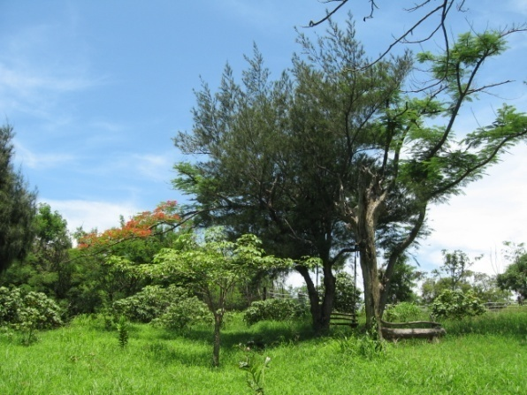**Program output:**



*color mode grayscale mode*

**PROGRAM NUMBER: 2**

Write down the dimensions of an image

**Program code:**

#Display Dimensions of image

# importing cv2

import cv2

img = cv2.imread("images/Catching.jpg")

# get dimensions of image

dimensions = img.shape

# height, width, number of channels in image

height = img.shape[0]

width = img.shape[1]

channels = img.shape[2]

print('Image Dimension    : ',dimensions)

print('Image Height       : ',height)

print('Image Width        : ',width)

print('Number of Channels : ',channels)

print('Number of Pixel : ',img.size)

**Program output:**

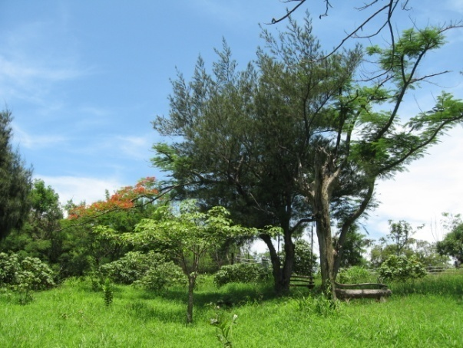

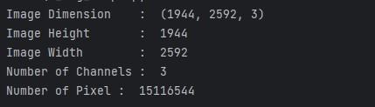

*Image dimensions*

**PROGRAM NUMBER:3**

Display the results of height and width reduction of an image to 30% of its current height and width

**Program code:**

# importing cv2

import cv2

img = cv2.imread("images/Catching.jpg")

print('Original Dimensions : ',img.shape)

scale_percent = 30 # percent of original size

width = int(img.shape[1] * scale_percent / 100)

height = int(img.shape[0] * scale_percent / 100)

dim = (width, height)

# resize image

resized = cv2.resize(img, dim, interpolation = cv2.INTER_AREA)

print('Resized Dimensions : ',resized.shape)

cv2.imshow("Resized image", resized)

# Wait for the user to press a key

cv2.waitKey(0)

# Close all windows

cv2.destroyAllWindows()

**Program output:**



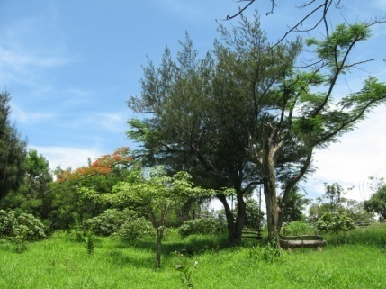

*Original size reduced size*

**PROGRAM NUMBER:4**

Display the color negative and grayscale negative of a color image.

**Program code:**

# importing cv2

import cv2

import matplotlib.pyplot as plt

img = cv2.imread("images/Catching.jpg")

gray= cv2.cvtColor(img, cv2.COLOR_BGR2GRAY)

img = cv2.cvtColor(img, cv2.COLOR_BGR2RGB)

colored_negative = abs(255-img)

gray_negative = abs(255-gray)

imgs = [img, gray, colored_negative, gray_negative]

title = ['coloured', 'gray', 'coloured-negative', 'gray-negative']

plt.subplot(2, 2, 1)

plt.title(title[0])

plt.imshow(imgs[0])

plt.xticks([])

plt.yticks([])

plt.subplot(2, 2, 2)

plt.title(title[1])

plt.imshow(imgs[1], cmap='gray')

plt.xticks([])

plt.yticks([])

plt.subplot(2, 2, 3)

plt.title(title[2])

plt.imshow(imgs[2])

plt.xticks([])

plt.yticks([])

plt.subplot(2, 2, 4)

plt.title(title[3])

plt.imshow(imgs[3], cmap='gray')

plt.xticks([])

plt.yticks([])

plt.show()

**Program output:**

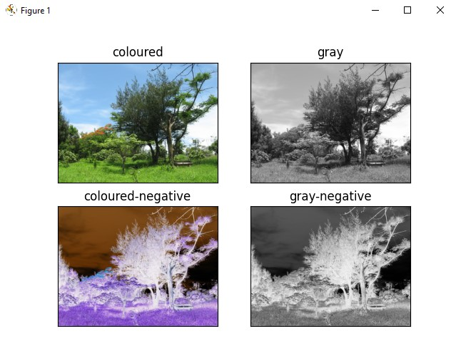

**PROGRAM NUMBER:5**

Display the results of flipping an image vertically and horizontally. Also rotate the image by 45 degrees and 90 degrees.

**Program code:**

# importing cv2

import cv2

import matplotlib.pyplot as plt

from PIL import Image

img = Image.open("images/Catching.jpg")

hori_flippedImage = img.transpose(Image.FLIP_LEFT_RIGHT)

Vert_flippedImage = img.transpose(Image.FLIP_TOP_BOTTOM)

degree_flippedImage = img.rotate(45)

degree90_flippedImage = img.transpose(Image.ROTATE_90)

imgs = [img, hori_flippedImage, Vert_flippedImage, degree_flippedImage, degree90_flippedImage]

title = ['Original', 'horizontally_flipped', 'Vertically_flipped', 'specifying degree', '90degree_flipped']

plt.subplot(2, 3, 1)

plt.title(title[0])

plt.imshow(imgs[0])

plt.xticks([])

plt.yticks([])

plt.subplot(2, 3, 2)

plt.title(title[1])

plt.imshow(imgs[1])

plt.xticks([])

plt.yticks([])

plt.subplot(2, 3, 3)

plt.title(title[2])

plt.imshow(imgs[2])

plt.xticks([])

plt.yticks([])

plt.subplot(2, 3, 4)

plt.title(title[3])

plt.imshow(imgs[3])

plt.xticks([])

plt.yticks([])

plt.subplot(2, 3, 5)

plt.title(title[4])

plt.imshow(imgs[4])

plt.xticks([])

plt.yticks([])

plt.show()

**Program output:**

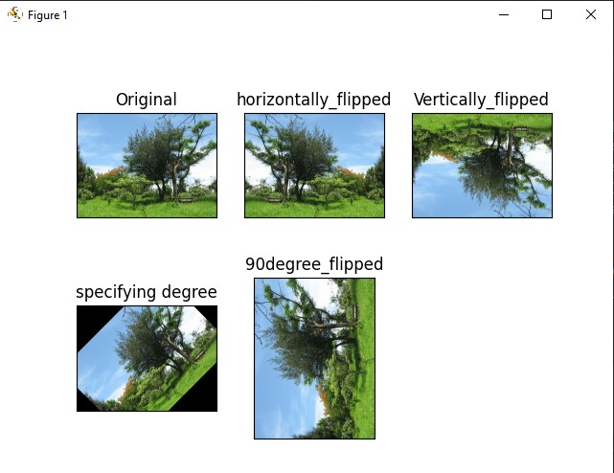

**PROGRAM NUMBER:6**

Display the results of down-sampling using ‘face’ and ‘rose’ image

**Program code:**

from PIL import Image

def downsample_image(image_path, output_path, factor):

    # Open the image

    image = Image.open(image_path)

    # Calculate the new width and height based on the downsampling factor

    width = image.width // factor

    height = image.height // factor

    # Downsample the image using the 'ANTIALIAS' filter for better quality

    downscaled_image = image.resize((width, height), Image.ANTIALIAS)

    downscaled_image.show()

def show_downsampled_image(file_name):

    input_image_path = f"Images/{file_name}"

    output_image_path = f"6/{file_name.split('.')[0]}_downsampled.jpg"

    downsampling_factor = 2

    #  downsample and save image

    downsample_image(input_image_path, output_image_path, downsampling_factor)

# face image

show_downsampled_image("face.jpg")

# rose image

show_downsampled_image("rose-512.bmp")

**Program output:**

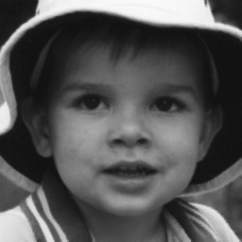



**

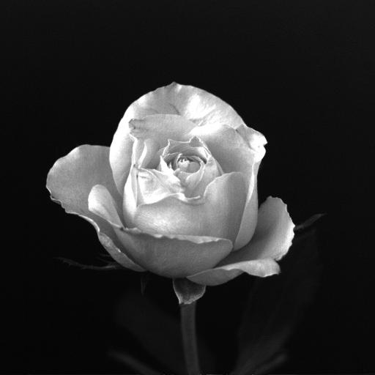

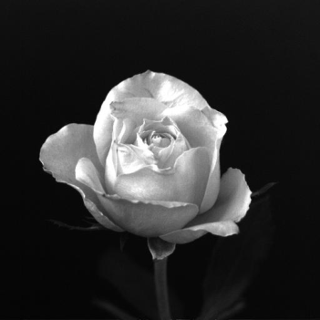



**PROGRAM NUMBER:7**

Display the effects of quantization using ‘face’ and ‘rose’ image.

**Program code:**

from PIL import Image

def quantize_image(image_path, output_path, num_colors):

    # Open the image

    image = Image.open(image_path)

    # Apply quantization by reducing the number of colors

    quantized_image = image.quantize(num_colors)

    #show image

    quantized_image.show()

def showQuantizedimage(file_name):

    input_image_path = f"images/{file_name}"

    output_image_path = f"7/{file_name.split('.')[0]}_quantized.jpg"

    num_colors = 20

    quantize_image(input_image_path, output_image_path, num_colors)

# face image

showQuantizedimage("face.jpg")

# rose image

showQuantizedimage("rose-512.bmp")

**Program output:**

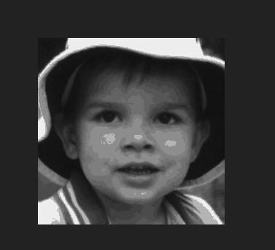

*Original image quantized image*

**

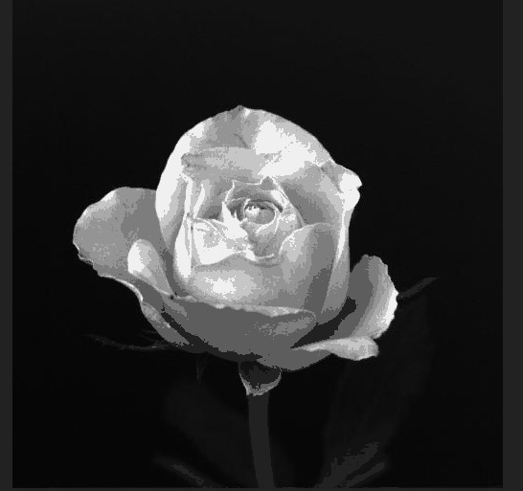

*Original image quantized image*

**PROGRAM NUMBER:8**

Calculate mean value of a grayscale image. Convert the grayscale image to a binary image using the mean value as the threshold. Use ‘house’ image to show the results.

**Program code:**

import numpy as np

from PIL import Image

# Open the image and convert it to grayscale

image = Image.open('images/house.jpg')

# Convert the image to a NumPy array

image_array = np.array(image)

# Calculate the mean value

mean_value = np.mean(image_array)

# show mean value

print("Mean value:", mean_value)

# Create a binary image by applying the threshold

# if image_array >= mean_value TRUE value assigned to that pixel is 255

# if image_array >= mean_value FALSE value assigned to that pixel is 0

binary_image = np.where(image_array >= mean_value, 255, 0).astype(np.uint8)

# Convert the NumPy array back to an image

binary_image = Image.fromarray(binary_image)

# show the binary image

binary_image.show()

**Program output:**

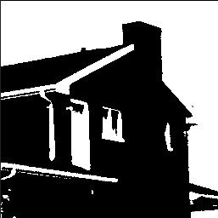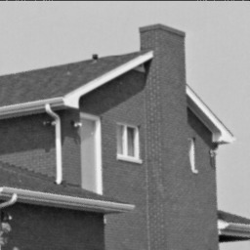

*Original image binary image*

**PROGRAM NUMBER:9**

Display the smoothing effects of 3×3 and 5×5 mean filters using ‘man’ image.

**Program code:**

import cv2

import numpy as np

from PIL import Image

import matplotlib.pyplot as plt

def apply_mean_filter(image_path, kernel_size, title):

    # Open the image using Pillow

    image = Image.open(image_path)

    # Convert the image to a NumPy array

    image_array = np.array(image)

    # Apply the mean filter

    filtered_image_array = cv2.blur(image_array, (kernel_size, kernel_size))

    # convert image array to image

    filtered_image = Image.fromarray(filtered_image_array)

    # Display the image with the specified title

    plt.imshow(filtered_image, cmap='gray')

    plt.title(title)

    plt.axis('off')

    plt.show()

# man image path

input_image_path = 'images/man.gif'

kernel_size_3x3 = 3

kernel_size_5x5 = 5

apply_mean_filter(input_image_path, kernel_size_3x3, "smoothning using 3x3 mean filter")

apply_mean_filter(input_image_path, kernel_size_5x5,"smoothning using 5x5 mean filter ")

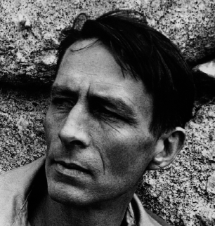**Program output:**

*original image*

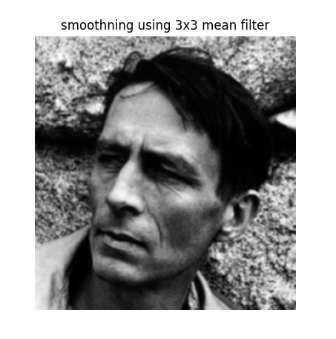

*blurred imahs using 3x3 smoothning mean filter*

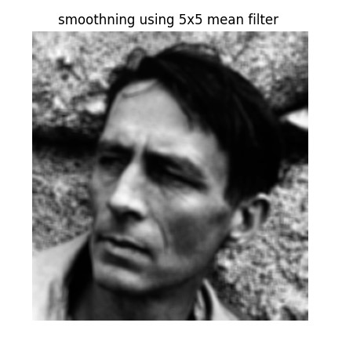

*blurred imahs using 5x5 smoothning mean filter*

**PROGRAM NUMBER:10**

Display the results of salt-and-pepper noise reduction by using median filter on ‘Circuit_board_noisy’ image.

**Program code:**

import cv2

import numpy as np

import matplotlib.pyplot as plt

def reduce_salt_and_pepper_noise(image_path,  kernel_size):

    # Load the image

    image = cv2.imread(image_path)

    # Add salt-and-pepper noise to the image

    noisy_image = add_salt_and_pepper_noise(image)

    # Apply median filter for noise reduction

    # The Median blur operation is similar to the other averaging methods.

    # Here, the central element of the image is replaced by the median of all the pixels in the kernel area.

    denoised_image = cv2.medianBlur(noisy_image, kernel_size)

    # Display the original, noisy, and denoised images

    titles = ['Original Image', 'Noisy Image', 'Denoised Image']

    images = [image, noisy_image, denoised_image]

    plt.figure(figsize=(10, 5))

    for i in range(3):

        plt.subplot(1, 3, i + 1)

        plt.imshow(cv2.cvtColor(images[i], cv2.COLOR_BGR2RGB))

        plt.title(titles[i])

        plt.axis('off')

    plt.tight_layout()

    plt.show()

def add_salt_and_pepper_noise(image, noise_prob=0.05):

    # Generate a mask for salt-and-pepper noise

    mask = np.random.choice([0, 1, 2], size=image.shape[:2], p=[1 - noise_prob, noise_prob / 2, noise_prob / 2])

    # Add salt-and-pepper noise to the image

    noisy_image = np.copy(image)

    noisy_image[mask == 1] = 255  # Salt noise

    noisy_image[mask == 2] = 0  # Pepper noise

    return noisy_image

# image path

input_image_path = 'images/Circuit_board_noisy.tif'

kernel_size = 5

reduce_salt_and_pepper_noise(input_image_path,  kernel_size)

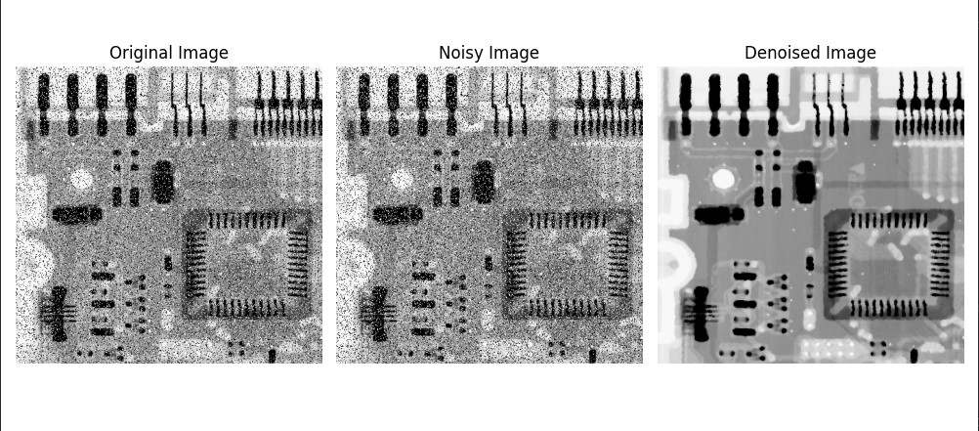**Program output:**

**PROGRAM NUMBER:11**

Display the results of edge detection by Prewitt operator, using ‘house’ image.

**Program code:**

import cv2

import numpy as np

import matplotlib.pyplot as plt

def apply_prewitt_operator(image_path):

    # Load the image

    image = cv2.imread(image_path, cv2.IMREAD_GRAYSCALE)

    # Apply the Prewitt operator

    gradient_x = cv2.Sobel(image, cv2.CV_64F, 1, 0, ksize=3)

    gradient_y = cv2.Sobel(image, cv2.CV_64F, 0, 1, ksize=3)

    # Combine the gradients to obtain the edge magnitude

    gradient_magnitude = np.sqrt(np.square(gradient_x) + np.square(gradient_y))

    # Normalize the gradient magnitude to the range [0, 255]

    gradient_magnitude_normalized = cv2.normalize(gradient_magnitude, None, 0, 255, cv2.NORM_MINMAX, dtype=cv2.CV_8U)

    # Display the original and edge-detected images

    titles = ['Original Image', 'Prewitt Edge Detection']

    images = [image, gradient_magnitude_normalized]

    plt.figure(figsize=(10, 5))

    for i in range(2):

        plt.subplot(1, 2, i + 1)

        plt.imshow(images[i], cmap='gray')

        plt.title(titles[i])

        plt.axis('off')

    plt.tight_layout()

    plt.show()

# image path

input_image_path = 'images/house.jpg'

apply_prewitt_operator(input_image_path)

**Program output:**

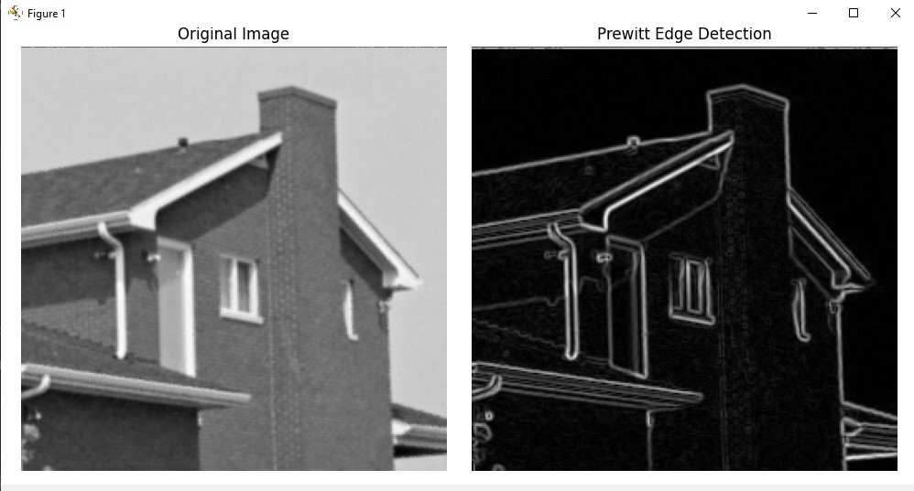

**PROGRAM NUMBER:12**

Display the histograms of low-contrast, medium-constrast, and high-constrast images

**Program code:**

import cv2

import matplotlib.pyplot as plt

def display_histogram(image_path):

    # Load the image

    image = cv2.imread(image_path, 0)

    # Calculate the histogram

    histogram = cv2.calcHist([image], [0], None, [256], [0, 256])

    # Display the histogram

    plt.figure(figsize=(8, 5))

    plt.plot(histogram, color='black')

    plt.title('Histogram')

    plt.xlabel('Pixel Value')

    plt.ylabel('Frequency')

    plt.xlim([0, 256])

    plt.show()

# Example usage

low_contrast_image_path = 'images/Einstein low contrast.tif'

medium_contrast_image_path = 'images/Einstein med contrast.tif'

high_contrast_image_path = 'images/Einstein high contrast.tif'

display_histogram(low_contrast_image_path)

display_histogram(medium_contrast_image_path)

display_histogram(high_contrast_image_path)

**Program output:**

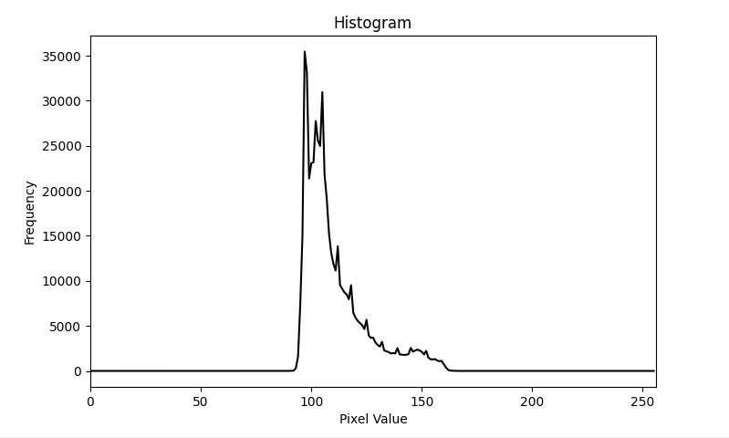**Einstein low contrast.tif**

*Low contrast image histogram*

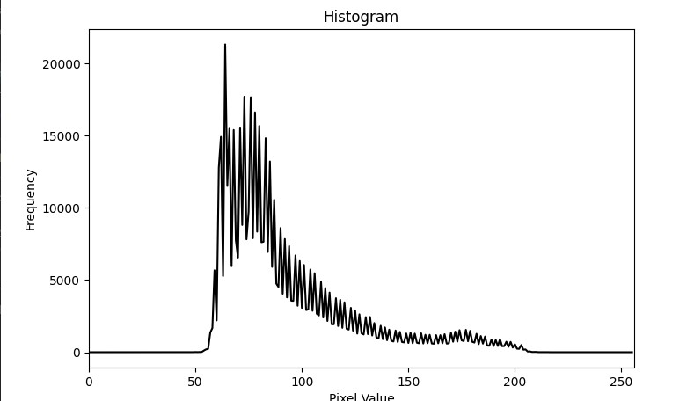

*Einstein med contrast.tifmedium contrast image histogam*

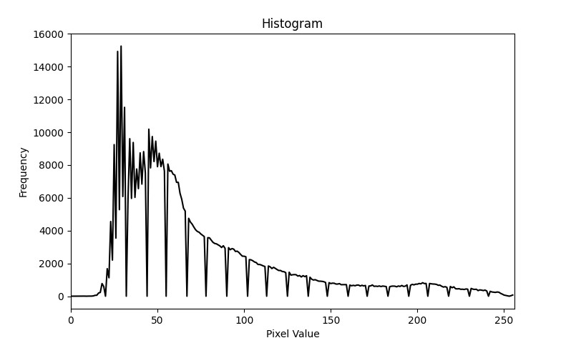**Einstein high contrast.tif***high contrast image histogam*