**IT-562 Recommendation Systems and Engines**

**Assignment-5**

**Collaborative Filtering: Estimating SVD through Stochastic Gradient Descent**

**Name**: Aashay Binaykia

**ID**: 201501155

**Group Name**: 404

**Dataset:**

The dataset that we’ve used is the Goodbooks-10K dataset with ratings of around 10,000 books by different users. The ratings have been normalized between 0-1 before putting the dataset to use for different algorithms below.

1. **Finding the Optimum Number of Folds:**

(For number of epochs 10, Learning Rate: 0.03)

**Table:**

|  |  |
| --- | --- |
| **No of Folds** | **Mean RMSE** |
| 2 | 0.3124 |
| 4 | 0.3123 |
| 5 | 0.3123 |
| 10 | 0.3123 |
| 20 | 0.3122 |

**Graph**: (Folds vs Mean RMSE)

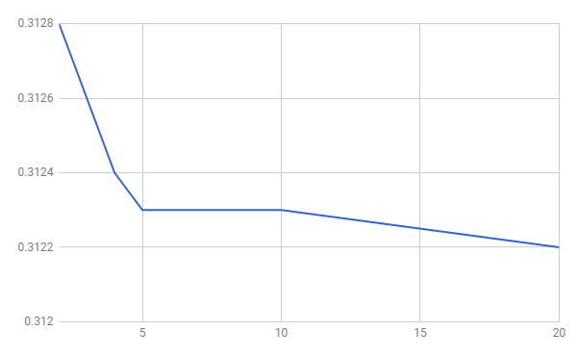

**2. Finding the Optimum Number of Epochs:**

There was no such significant difference in the RMSE on changing the number of epochs from 10 to 20 and then to 30. Also increasing the number of epochs, increased the time significantly. Thus, we have used the Number of Epochs as **10** everywhere as a trade-off between time and minute accuracy.

1. **No_of_Folds =2, Epochs: 10**

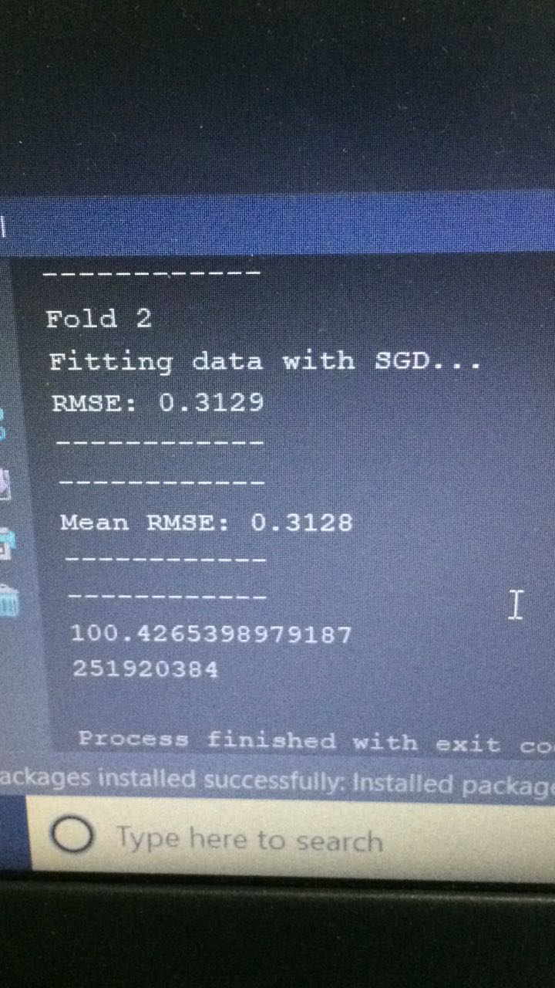

**b. No_of_Folds= 2, Epochs: 20**

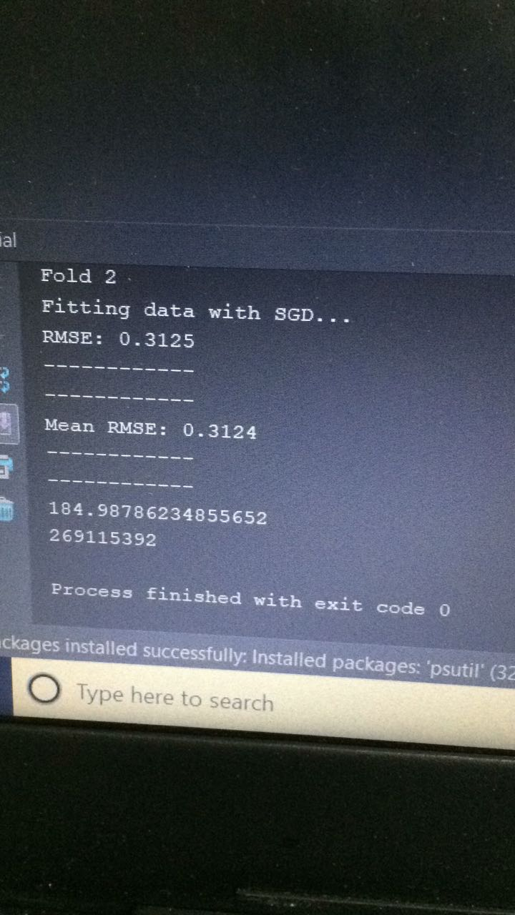

**c. No_of_Folds=5, Epochs: 10**

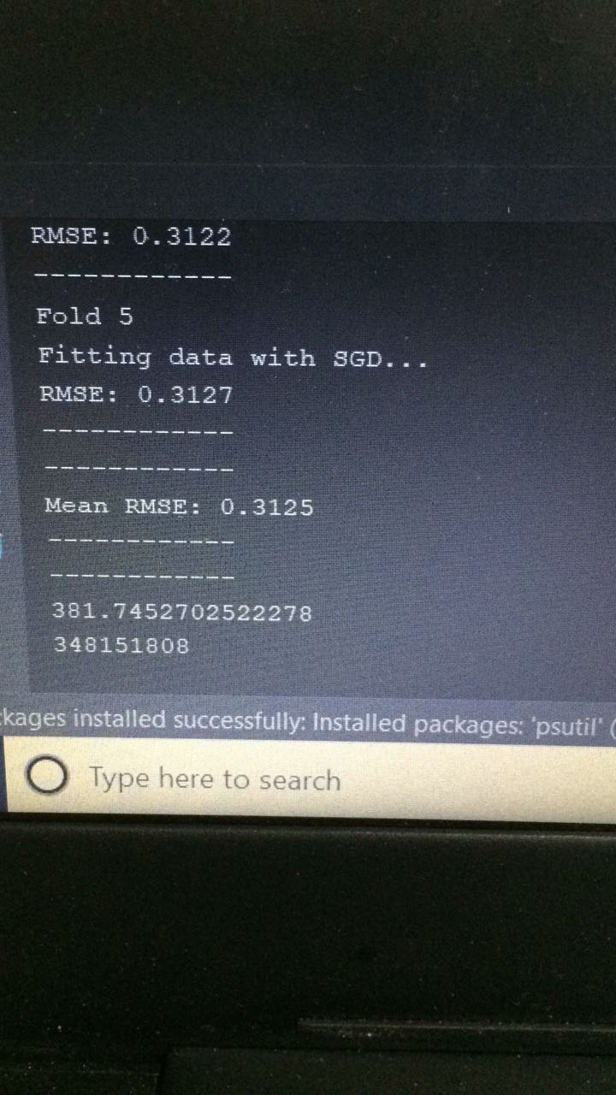

**d. No_of_Folds=5, Epochs=20**

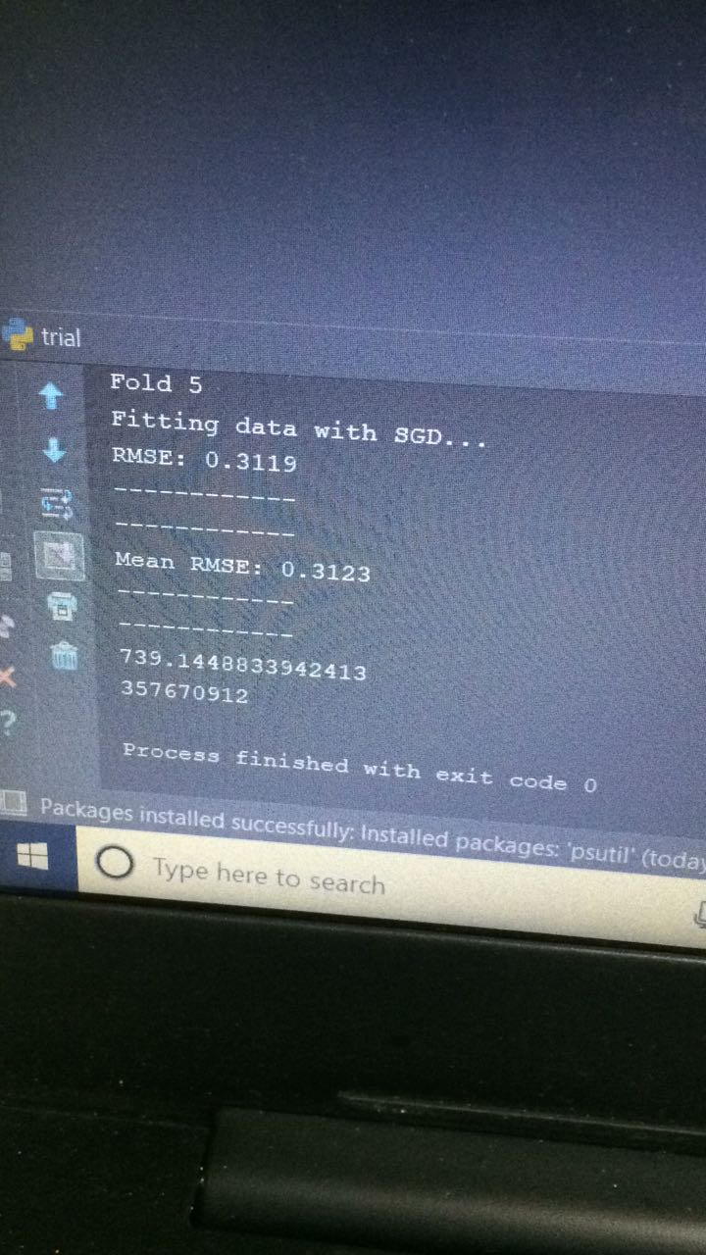

**3. Finding optimal learning rate**:

(Epoch=10, Splits=2)

|  |  |  |  |
| --- | --- | --- | --- |
| **Learning Rate** | **Mean RMSE** | **Time** | **Memory** |
| 0.005 | 0.3132 | 102.53956 | 254988288 |
| 0.01 | 0.3126 | 101.0542 | 251649841 |
| 0.02 | 0.3125 | 102.22452 | 253849600 |
| **0.03** | **0.3124** | **101.06726** | **252669952** |
| 0.04 | 0.3124 | 101.6551 | 253456384 |
| 0.05 | 0.3125 | 101.7446 | 254861312 |
| 0.08 | 0.3133 | 106.3357 | 254758912 |

**Thus, Optimum Learning Rate is 0.03.**

**4. Increasing no. of users**

**Total items = 10K**

|  |  |  |  |
| --- | --- | --- | --- |
| **No. of Users** | **Mean RMSE** | **Time (secs)** | **Memory** |
| 5K | 0.3160 | 35.945 | 111009792 |
| 10K | 0.3137 | 70.716 | 200847360 |
| 15K | 0.3129 | 101.718 | 258334720 |
| 20K | 0.3124 | 105.333 | 269963264 |
| 25K | 0.3124 | 104.266 | 270221312 |
| 30K | 0.3124 | 101.932 | 270340096 |
| 35K | 0.3124 | 102.866 | 267522048 |
| 40K | 0.3124 | 104.163 | 268574720 |
| All (42208) | 0.3124 | 103.794 | 271097856 |

**Note**: Even though the total number of users is 42.2K, the ratings data available for users having id > 16K is very less. On analysing the dataset, it turns out that the effective number of users for which we have substantial number of ratings data available is around 13K. This characteristic of the dataset is the reason we get almost constant mean RMSE after the first 20K user ids.

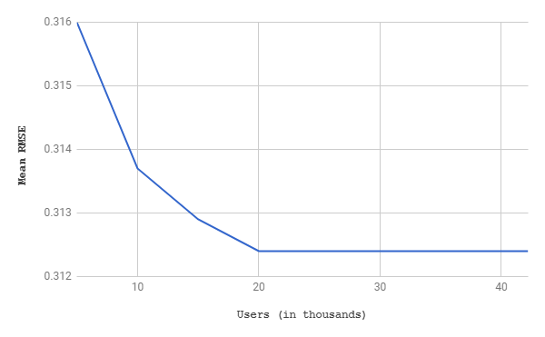

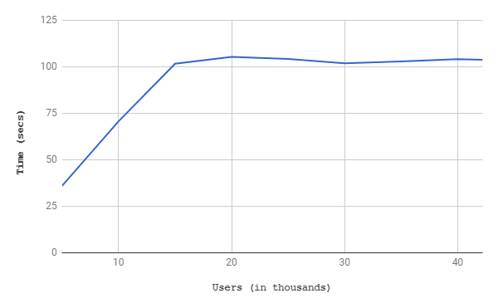

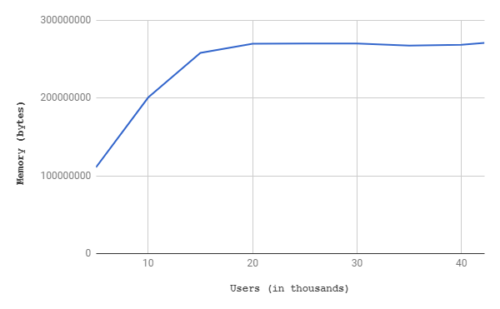

**Observation:**

* With the increase in number of users, the system gets more data to work with, and hence the results we get are more accurate (as seen by the decrease in mean RMSE).
* However, there is a cost that the system bears: that of time and memory (as seen in the graphs above).
* It is interesting to note that the rate of change of mean RMSE decreases with increase in the number of users, and becomes almost stagnant after a point, hence giving us hints to the optimum number of users that we might want to consider while training the model.

**5. Increasing no. of items**

**Total users = 42208**

|  |  |  |  |
| --- | --- | --- | --- |
| **No. of items** | **Mean RMSE** | **Time** | **Memory** |
| 2K | 0.3108 | 75.747 | 205795328 |
| 4K | 0.3114 | 86.273 | 235483136 |
| 6K | 0.3118 | 102.955 | 248844288 |
| 8K | 0.3120 | 105.180 | 260509696 |
| All (10K) | 0.3124 | 103.794 | 271097856 |

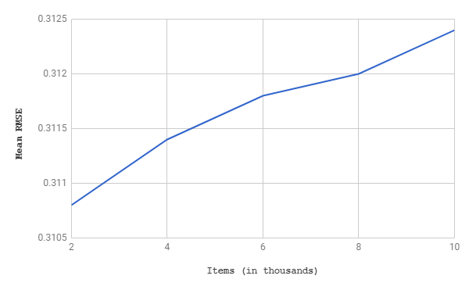

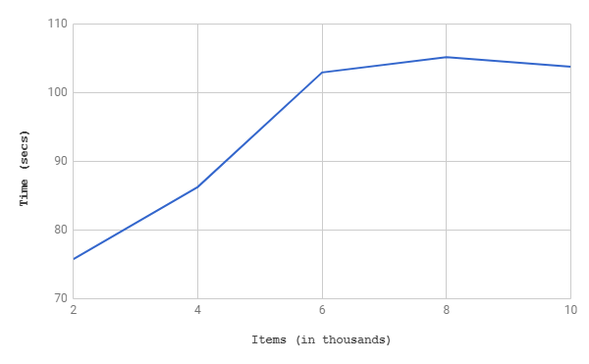

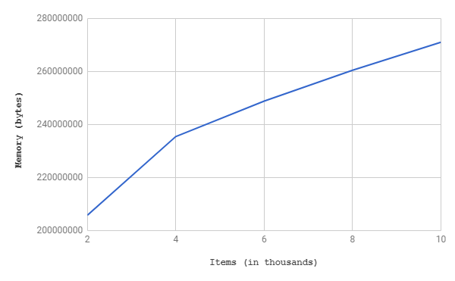

**Observations:**

* With the increase in the number of items, the trend in the mean RMSE shows that it increases and thus, accuracy decreases. One plausible reason for this trend could be that as the number of items increases, the no. of question marks that the algorithm needs to predict increases and with limited data available, the overall mean error in the prediction may increase.
* As expected, the execution time and memory consumption increases as we increase the items in the dataset provided to the algorithm.

**6. Comparison between different Methods:**

(Using all data, No of Folds: 2, epoch 10)

|  |  |  |  |
| --- | --- | --- | --- |
| **Method** | **Fold-1 RMSE** | **Fold-2 RMSE** | **Mean RMSE** |
| 1. SVD | 0.3120 | 0.3126 | 0.3123 |
| 2. SVD++ | 0.3119 | 0.3124 | 0.3122 |
| 3. NMF | 0.3118 | 0.3124 | 0.3121 |