**Running the Network Experiment on Otree**

*Assumption: You already have Python installed. If not, an online guide is available here: https://realpython.com/installing-python/

Step 1: Open “Terminal” on Mac or “Command Prompt” on Windows and type in the command *pip3 install otree*

Step 2: Assuming the NAME.otreezip file is in your Downloads folder, navigate to it by “cd ~/Downloads” on Mac or “cd Downloads” on pc

Step 3: Enter “otree unzip NAME.otreezip” where NAME is the name of the file in Downloads. Something like this should appear:

Step 4: Type in “cd NAME” and then type in “otree devserver”

Step 5: Enter http://localhost:8000/ into the web address of a web browser produces this:

Step 6: Select the lone demo and click on each of the six links that are visible. These will open up new windows and be your 6 ‘players’ for the demonstration whose pages should look like the second image below. Of course, because these are all on the local laptop, you can take the role of all (or none) of the players.

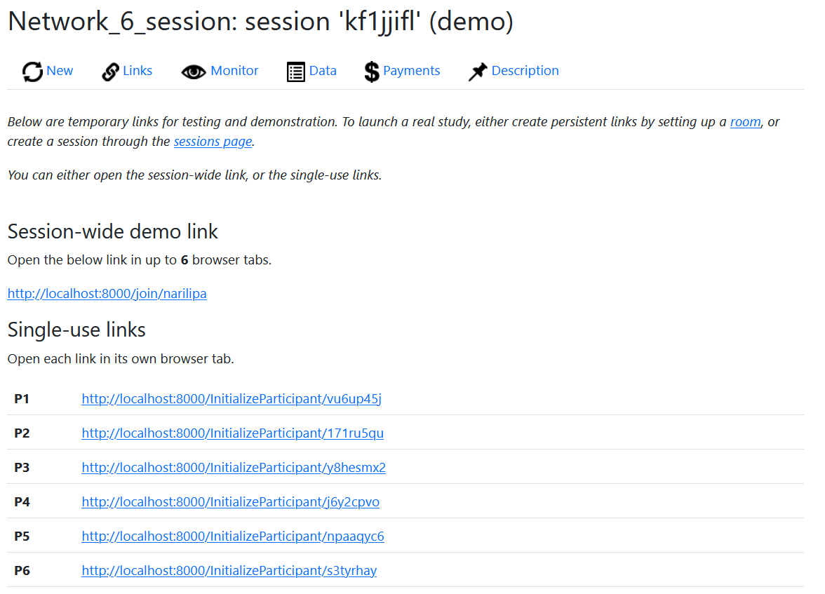

Step 7: Return to original page and select the ‘Monitor’ icon to get to the second image below.

To control the pages, either input the data on each page or select ‘Advance slowest user(s)’ on this page to advance the users automatically to the next page. Anytime the page reads ‘P01_Intro’ the individuals (whose page reads ‘Please Wait’) in large text must be moved forward via ‘Advance slowest user(s)’ on the ‘Monitor’ screen.

From here on out you can view the network game for yourself. It runs for 17 rounds (1 practice + 16 ‘real’ rounds) with the real rounds determining point totals at the end. 1 point is given no matter what, but 2 is given if the network converges. At the end of 17 rounds, you will see the point total and the point to toy conversion: 1 toy for every 10 points always rounded UP (11 points = 20 = 2 toys). HAVE FUN!